Online Sales Data: Insights to Leverage into Opportunities for Growth
With Excel
Michele McCluskey
December 2025

Online Sales Data: Insights to Leverage into Opportunities for Growth
Introduction
This analysis examines transaction data from an online retail store to identify trends in customer purchases, product performance, and payment behavior during 2018. The goal is to uncover patterns that can guide targeted marketing campaigns, promotional strategies, and product focus to improve revenue and profitability.​
The Data
The dataset, sourced from Kaggle (Online Sales Data by Samruddhi Bhosale), consists of two related tables. The Orders table contains order-level information such as order ID, order date, customer name, and location (state and city), while the Details table includes line-item information such as category, sub-category, quantity, amount, and profit. This analysis is based on a single year of historical data and does not incorporate customer level metrics such as repeat purchase rates, customer lifetime value, or marketing spend. Future work could segment customers by region and category preferences, incorporate promotional and advertising data, and explore advanced techniques (e.g., R or Python modeling) to forecast demand and simulate the impact of pricing and campaign strategies.
Methodology
Data from both tables were cleaned and standardized to ensure reliable analysis. Text fields were trimmed to remove extra spaces, date fields were converted from text to proper date formats, and numeric fields such as amount and profit were converted to numeric types and formatted as currency. Order level and line item data were then combined into a consolidated table using lookup and aggregation functions, enabling analysis by geography, category, product, and time through summary tables and pivot based visualizations.​

Analysis and Findings
Revenue and profit remain relatively steady throughout the year, with no strong seasonal spikes evident in the data (See Figure 1). This suggests that current demand patterns may be driven more by ongoing baseline demand than by targeted campaigns tied to holidays or key events, indicating an opportunity to use promotions to create deliberate peaks in sales.
Figure 1
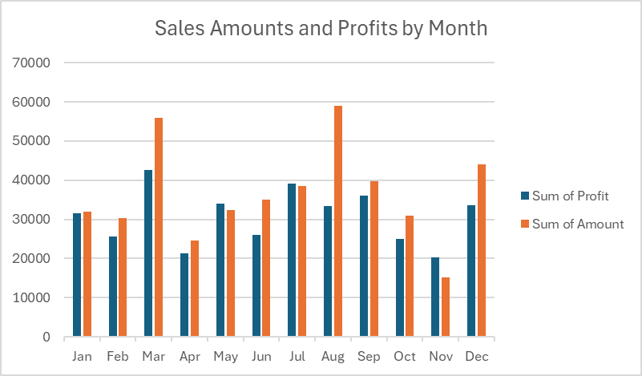
Financial performance is not evenly distributed across regions (see Figure 2), with states such as Madhya Pradesh and Maharashtra accounting for a large portion of sales and profit. These markets appear to be core contributors to current business performance and are strong candidates for both protection (service quality, inventory availability) and growth focused marketing initiatives.​

Figure 2
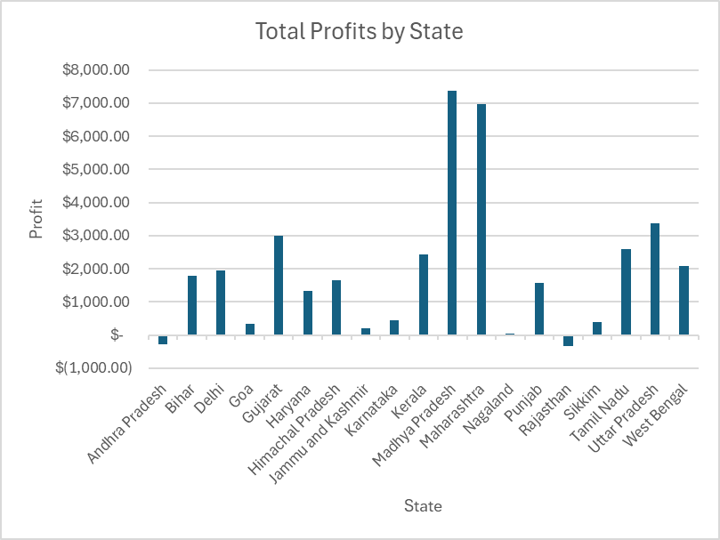
Clothing accounts for approximately 63% of total orders, making it the main driver of order volume for the business (see Figure 3). However, profit is more evenly distributed, with clothing and electronics each contributing about 36% of total profit and furniture contributing 28%, indicating that high volume does not automatically translate into higher profitability(see Figure 4).​

Figure 3
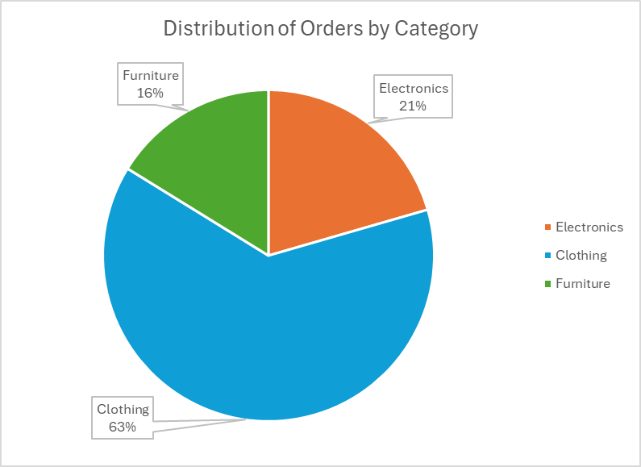
Figure 4
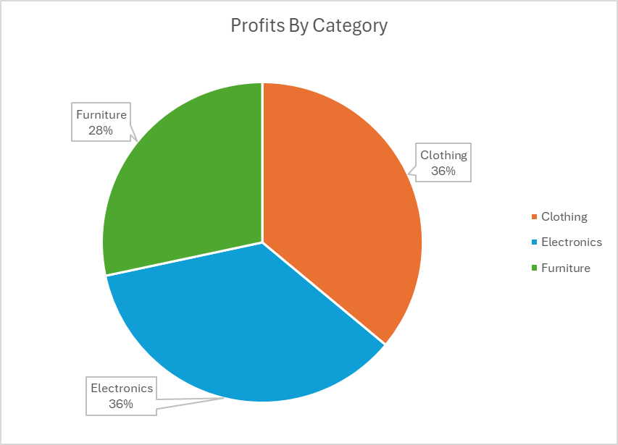
The most profitable individual products include printers (electronics), bookcases (furniture), and sarees (clothing), each representing a top contributor to overall profit within its category (see Figure 5). These items are strong candidates to anchor promotional campaigns and cross sell strategies.​
Figure 5
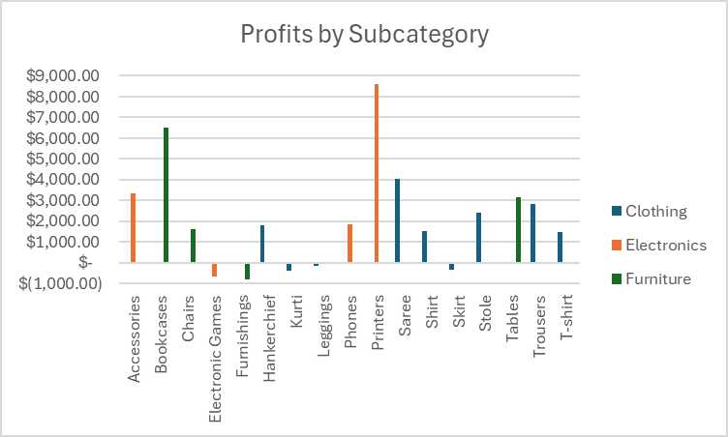

Conclusions and Recommendations
Given the relatively flat revenue trend over the year, design promotional campaigns aligned with holidays, festivals, and other key events to test whether more pronounced seasonal peaks can be created.
Strengthen presence in high performing states like Madhya Pradesh and Maharashtra through reliable stock availability, delivery speed, and localized offers. At the same time, expand targeted campaigns to other high population states such as Bihar and West Bengal.​
Focus marketing and merchandising efforts on the top profit-generating products such as printers, bookcases, and sarees across digital channels (homepage banners, email campaigns, recommendation sections) to capture more high margin demand. Highlighting these items can increase overall profitability without requiring significant growth in total orders.​

References
Bhosale, S. (n.d.). Online Sales Data. Kaggle. Retrieved December 1, 2025, from https://www.kaggle.com/datasets/samruddhi4040/online-sales-data/data

Place Rankings - Data Commons. (n.d.). https://datacommons.org/ranking/Count_Person/State/country/IND?h=wikidataId%2FQ677037

