Welcome.
I am an author, speaker, and storyteller. And I’m all about purpose.
I have a passion to awaken bold dreams and increase joy, calling every heart to step into the extraordinary story it was born to live. I create places and spaces where healing flows, courage rises, and transformation takes root through the power of vulnerability and creativity.

Your story. Your power. Your creative genius.

My Great Adventure to Helping You Find Yours
My story has been an adventure in finding purpose, and it began with my own healing journey. Transforming feelings of worthlessness into a deep sense of value ignited a fire in me—a passion to help others discover the same strength within themselves.
For 15 years, I was an elementary school teacher, and for 23 years, I served as a pastor alongside my husband, which gave me a profound compassion for people from all walks of life. This calling led me to found Releasing Generations in 2015, a non-profit where my incredible team and I empower youth and adults through workshops, retreats, and creative sessions.
I've poured my heart into my books to share the keys I've discovered along the way:
- From my healing journey in Dancing with Father,
- To pursuing big dreams in The Birth of Explicit\ Movement: Discover Keys to Fulfilling Your Purpose
- And empowering the next generation with the Dream Big Journal and the Brave Series curricula.
Everything I do is focused on helping others flourish in life and live out loud to their fullest potential.
Established in 2017, Michele Okimura Consulting has increased my capacity to live my purpose through the power of the pen and through equipping others through workshops, conferences, retreats, and coaching.

My firm belief: For every story—even the broken ones—can become a launchpad into a future full of freedom, wonder, and limitless possibility.

The treasures inside you are meant to be celebrated and can uniquely build a positive legacy for future generations. The world needs you to shine!
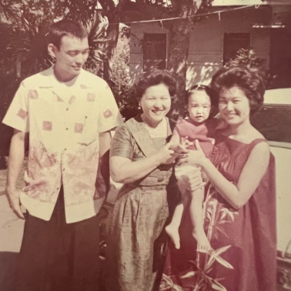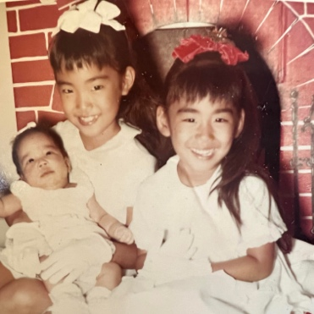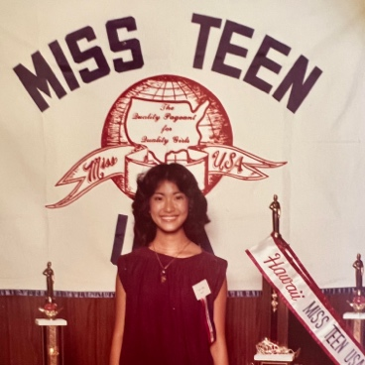
1962: Born in Honolulu, Hawaii. 1955: Oldest of two beautiful 1979: Miss Teen USA Finalist.
(My parents, grandma, and I). younger sisters. I didn’t win. But loved the
experience!

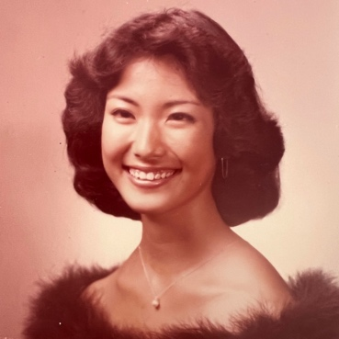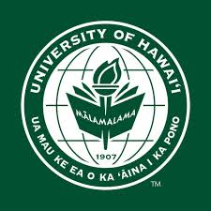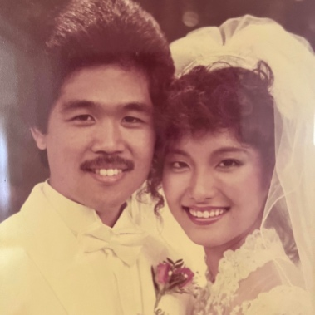
1979: Graduated from high school. 1984: Graduated from college 1984: Married Rob after
with a bachelor’s degree in dating for three years. The
Elementary Education. love of my life and best friend.

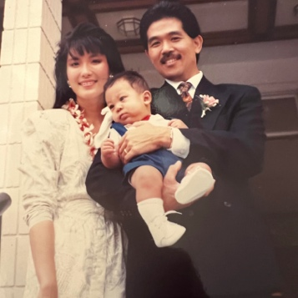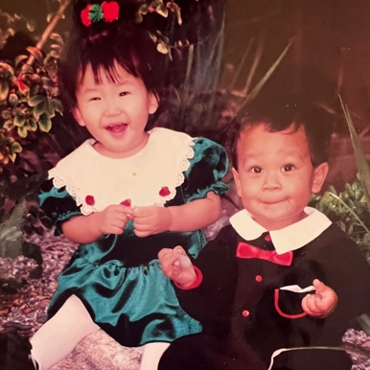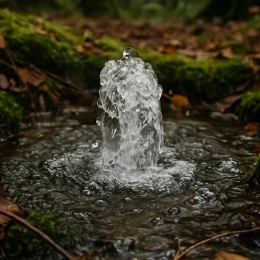
1991: Overflowing joy! 1993: More rivers of joy! 1997: Rob and I founded
Adopted our son Aaron. Adopted our daughter Lifespring Church.
Jessica…who happened I was unconventionally
to be 9 days older than qualified to be a pastor by
than Aaron! My twin-like. comedian Jim Carrey, but that is
sweeties. another story for another time.

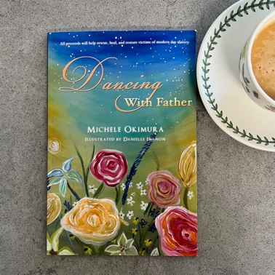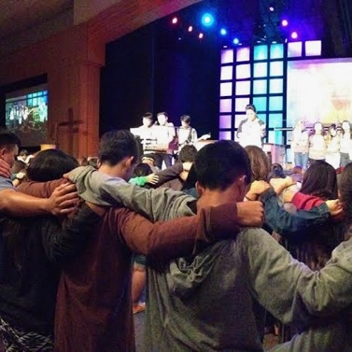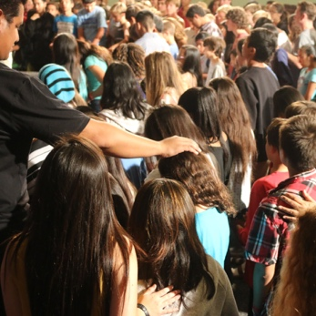

2011: Published Dancing. 2014: 2015: Our first 2015: Unexpected curve ball!
with Father. Let’s heal island-wide youth and parent. Explicit Conferences grew into a
hearts conference. Little did I know then a non-profit organization. And we
that it would grow into a movement. held our first middle school,
young adult, and parent conferences AND repeated our! high school conference. How ever did we do 4 in one year?!!

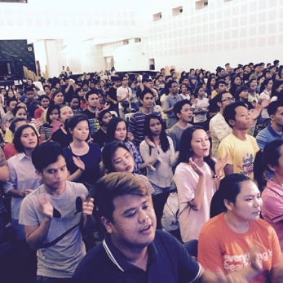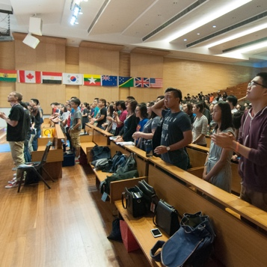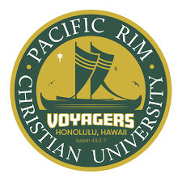
2016: Another shocker… 2016: Asia here we come! 2018: Teaching my first
going global! Philippines Youth and Parent Conference University course.
Conferences in Manila in Singapore!
and Baguio.
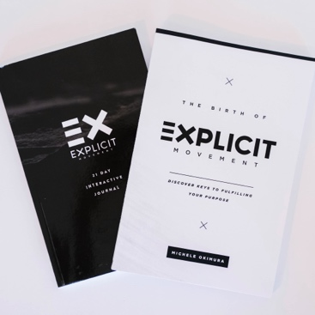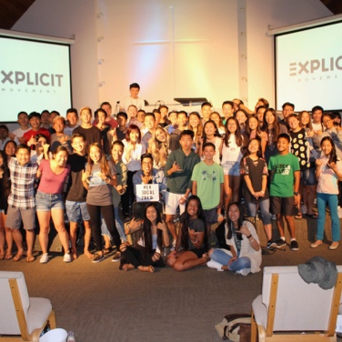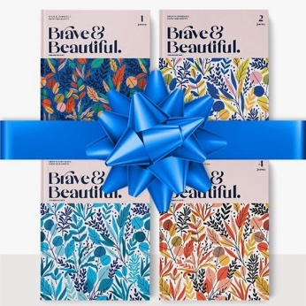
2018: Published 2018: Hello SoCal! The first 2022: Published the
The Birth of Explicit Movement: California Youth and Parent Brave & Beautiful
Discover Keys to Fulfilling Conference. Curriculum. Empowering
Your Purpose and the teen girls and women with Explicit Movement 21-Day confidence, purpose, and Journal. tools to protect
themselves from
exploitation.

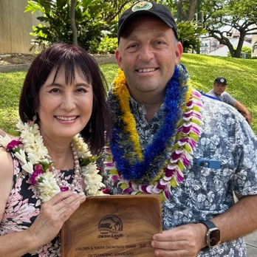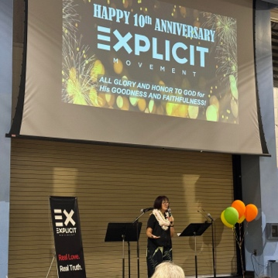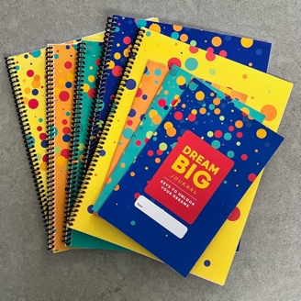
2023: SURPRISE! Awarded the 2023: Happy 10th Birthday 2023-2025: Published
Hawaii State’s 2023 ‘Outstanding to our non- profit the Dream Big Journals
Advocate for the Children and organization Releasing. curriculum.
Youth in The State of Hawaii Award’ Generations. Overwhelmed Versions created
by Mayor Blangiardi and Governor with gratitude for the journey. for Preschoolers
Green. Humbled greatly. I didn’t through adults.
even know we were nominated!

