# Get the sources

To setup FitNesse from scratch, open \\demo\share\**setup** and copy the content to a directory on your PC.

\\demo\share\setup

Username: guest

Password: (niets, rien, nada)

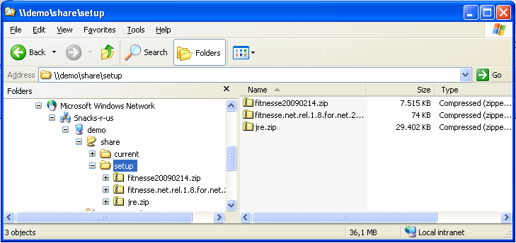

If at any moment you’re lost during this demo, you can always get the version being demoed on \\demo\share\current

If you want to download the latest version of FitNesse, go to <http://fitnesse.org/FitNesseDevelopment.DownLoad>

The .net 2.0 testrunner can be downloaded at <http://sourceforge.net/projects/fitnessedotnet/>

# Setup the project directories

Extract "fitnesse20090214.zip". This will be our FitNesse directory from here on.

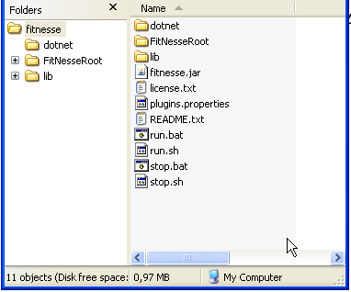

Extract "fitnesse.net.rel.1.8.for.net.2.0.zip" under FitNesse\dotnet2

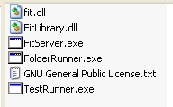Extract “jre.zip” to FitNesse\jre

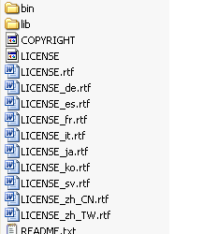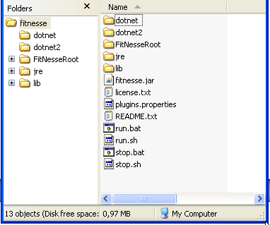

# Customize files

Edit the file FitNesse\run.bat

Change **jre\bin\**java -jar fitnesse.jar %1 %2 %3 %4 %5 **-p 8888**

This changes the following:

When you have the java runtime installed, you can run the "java" command. In this workshop, we do not assume you have the java runtime installed. That's why we copied the "jre" directory as a subdirectory of FitNesse.

The option -p changes the port on which FitNesse will run. The default is port 80. Since most .net developers already have IIS running on port 80, we randomly choose port 8888 to run FitNesse.

Make the same changes to the file FitNesse\stop.bat

**jre\bin\**java -cp fitnesse.jar fitnesse.Shutdown %1 %2 %3 %4 %5 –**p 8888**

# Setup FitNesse

We can now **start run.bat** to start FitNesse. Open your browser and go to <http://localhost:8888>. You might get a dialog box asking to open your firewall.

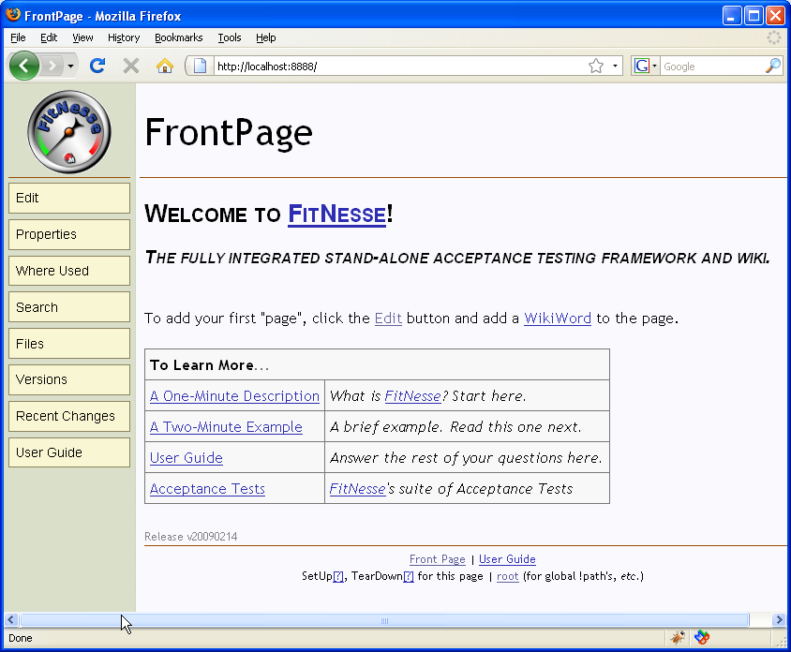

Since FitNesse is basically a java tool, we need to customize it a little. First of all, we’ll need to edit the root. Go to <http://localhost:888/?edit>

Add the following lines to the dialog box. This tells fitnesse to use the .net testrunner instead of the java one.

!path classes

!path fitnesse.jar

**!path dotnet2\*.dll**

**!define COMMAND_PATTERN {%m %p}   
!define TEST_RUNNER {dotnet2\FitServer.exe}   
!define PATH_SEPARATOR {;}**



Now go to [http://localhost:8888/](http://localhost:8888/PreparedTests). the page. Erase everything and type something along the lines of:

We're now going to add some PreparedTests

Mind the PascalCasing, because this is what FitNesse recognizes as a potential wiki page.

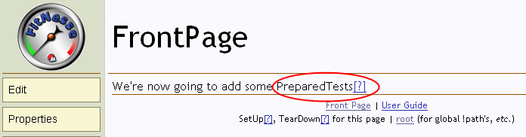Click on the [?] next to *PreparedTests*. FitNesse will tell you that this page doesn’t exist, but you will give you the choice to create it. Just accept the default, and you will have your first FitNesse page: http://localhost:8888/PreparedTests

This is where we will be building our tests before we have any implementation.