The universal guide to radio decoding world

- Preface

- Introduction to software defined radio

- Setting up softwares

- ACARS

- AFSK

Preface

Hello!
This guide would introduce you to the fantastic world of decoding radio signals.
We'll go from Acars to Pogsag to MeteoSat and so on.

Introduction to software defined radio

Introduction goes here.

Acars

ACARS = Aircraft Communication Addressing and Reporting System

ACARS is a popular system used by aircrafts to transmit data to ground.
For further infos take a look here:

http://en.wikipedia.org/wiki/Aircraft_Communications_Addressing_and_Reporting_System

So...let's try to decode ACARS!

Linux way:

Download and install this software:

https://github.com/gat3way/rtl_acars_ng

Start the program from the console with

./rtl_acars_ng -f youracarsfreq

And you'll see something like this (decoded messages will appear very soon):

Found 1 device(s):
0: Realtek, RTL2838UHIDIR, SN: 00000002
Using device 0: Generic RTL2832U OEM
Found Rafael Micro R820T tuner
Oversampling input by: 21x.
Oversampling output by: 1x.
Buffer size: 8.13ms
Tuned to 131977000 Hz.
Sampling at 1008000 Hz.
Output at 48000 Hz.
Exact sample rate is: 1008000.009613 Hz
Tuner gain set to automatic.

Loaded: 406995 aircrafts from dataset.....
Loaded: 7733 airports from dataset.....
Loaded: 110952 flights from dataset.....
Loaded: 365 ACARS message labels from dataset.....
Listening for ACARS traffic...

[BEGIN_MESSAGE]----------------------------------------------------------

RX_IDX: 0
CRC: Correct
Timestamp: 29/11/2014 13:38
ACARS mode: E
Message label: H1 (Message to/from terminal)
Aircraft reg: .G-EUUE, flight id: BA0604
Aircraft: Airbus A320-232
Registration: G-EUUE
Mode-S ID: 400980
Airline: British Airways

Block id: 57, msg. no: D03A
Source: Digital Flight Data Acquisition Unit
Message content:-
#DFBA02/A32002,1,5/CCG-EUUE,NOV29,120707,EGLL,LIRP,0604/
C106,EEE01,5000,45,0010,0,0100,43,X/
CE-247,32993,269,761,6156,297,I20A10/
CN-251,33015,269,761,6156,297/
EC010908,24295,17029,73,15,15/
EE015407,12

[END_MESSAGE ]------------------------------------------------------------

[BEGIN_MESSAGE]----------------------------------------------------------

RX_IDX: 1
CRC: Correct
Timestamp: 29/11/2014 13:38
ACARS mode: E
Message label: H1 (Message to/from terminal)
Aircraft reg: .G-EUUE, flight id: BA0604
Aircraft: Airbus A320-232
Registration: G-EUUE
Mode-S ID: 400980
Airline: British Airways

Block id: 48, msg. no: D03B
Source: Digital Flight Data Acquisition Unit
Message content:-
#DFB339,07202,73/
N11253,1253,3728,0768,0841,1180,08243/
N21253,1253,3609,0769,0833,1163,08307/
S113689,0496,1299,3925,07158,062/
S213907,0510,1325,3899,07150,062/
T1095,088,00,028,42,125,05557,-263/
T209

[END_MESSAGE ]------------------------------------------------------------

[BEGIN_MESSAGE]----------------------------------------------------------

RX_IDX: 2
CRC: Correct
Timestamp: 29/11/2014 13:38
ACARS mode: E
Message label: H1 (Message to/from terminal)
Aircraft reg: .G-EUUE, flight id: BA0604
Aircraft: Airbus A320-232
Registration: G-EUUE
Mode-S ID: 400980
Airline: British Airways

Block id: 49, msg. no: D03C
Source: Digital Flight Data Acquisition Unit
Message content:-
#DFB9,092,00,024,42,146,05576,-265/
V103D04,00208,08000,233,105,-284/
V203D04,00208,08000,232,104,-244/
V3000,002,062/
V4006,000,243/
X101412,0002,0019,0001,-0003,0013/
X201513,-001,0020,0001,-0004,0014/

[END_MESSAGE ]------------------------------------------------------------

[BEGIN_MESSAGE]----------------------------------------------------------

RX_IDX: 3
CRC: Correct
Timestamp: 29/11/2014 13:38
ACARS mode: E
Message label: H1 (Message to/from terminal)
Aircraft reg: .G-EUUE, flight id: BA0604
Aircraft: Airbus A320-232
Registration: G-EUUE
Mode-S ID: 400980
Airline: British Airways

Block id: 50, msg. no: D03D
Source: Digital Flight Data Acquisition Unit
Message content:-
#DFB
X3-002,0010,-006,-007,-004,0000,----/
X4-001,0000,-001,0000,0000,0000/
X50000,0000,0000,0000,0000,0008/
X61415,E0078,N449,029,241,-033,0519/
X71416,E0078,N449,028,241,-034,0775/

[END_MESSAGE ]------------------------------------------------------------

and so on.....

If you see no messages, start gqrx and check that you see/receive the signal.

Windows way:

AFSK

AFSK = System

AFSK is a popular system used to transmit data (almost text).

For further infos take a look here:

http://en.wikipedia.org/wiki/Frequency-shift_keying
http://info.aprs.net/index.php?title=Frequencies

So...let's try to decode AFSK!

Linux way:

Fire up GQRX, tune to a know freq. transmitting in AFSK (take a look in the second link above, for me a good freq. Is 144.800Mhz).
In the main menu of GQRX, drop down the “Tools” menu and click on “AFSK1200 Decoder”, a new window will popup decoding and showing the AFSK signal.

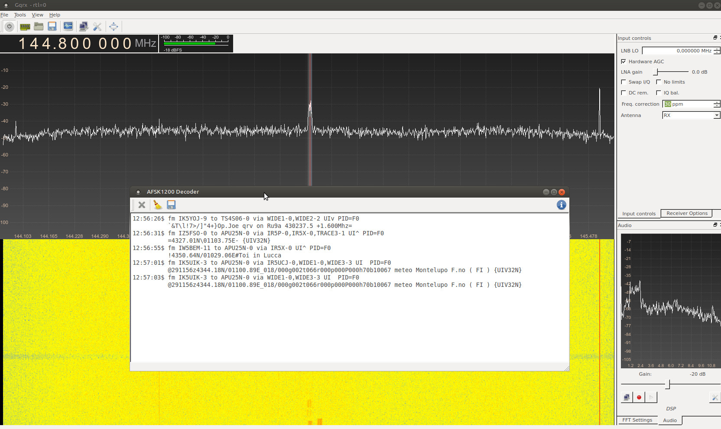

Windows way:

