**Information Systems in Healthcare - Michel Kana, PhD - Final Exam – Corrected**

**Name:** ___________________________

1. **Select the three interdisciplinary fields involved in Health Informatics. (2%)**

Modeling and simulation - Computer science – Psychology  
Information science – Signal processing – Health care

1. **What are the three types of information encountered in health care? (2%)**

Patient data

Medical knowledge

Directory information

1. **Describe the 5 main roles and responsibilities found in a health care system of most countries? (5%)**

Ministry of health

Patient

Physician

Hospital

Sickness fund (insurance)

1. **Mark the following statements as true or false (14%)**

* The BIOS is part of the software in a computer, but not of the hardware F
* A relational database organizes data in files instead of tables F
* A telemedicine software is a set of tools for helping health provider in their day-to-day operations in a medical practice F
* The CPU socket of a computer is the place where all calculations take placeF
* A network interface controller has a unique MAC address T
* Routers are network devices that control network security and access rules F
* A name server provides translation services between domain names and IP addresses T
* Reporting and population health management can be part of a clinical information system T
* Patient privacy is provided by copying and archiving computer data for the purpose of restoring to the original after a data loss event F
* After launching, the major cost of clinical information systems is generated by IT support and education programs T
* In a clinical decision rule, an intervention is a possible action that the decision support module can take T
* A medical data coder first abstracts medical information from health records, then assigns appropriate codes T
* An artificial neural network is a probabilistic graphical model that represents a set of random variables and their conditional dependencies via a directed acyclic graph F
* Given a text file with patients data (name and age), the following Linux command returns patients younger than 2 years: *awk '$2>2' patients.txt* F

1. **Select the five main services provided by an operating system in a computer (2%)**User login – Memory management – Concurrency control – Processor management  
   Device management – User interface control – File management
2. **Briefly describe the role of each layer in the TCP/IP protocol stack (4%)**

Physical layer: implements rules for transmission in basic networking hardware (e.g. network adapters, hubs, modems)

Internet layer: provides rules for hosts identification using IP addresses and packets routing over distinct networks

Transport layer: implements rules for end-to-end data communication channel

Application layer: implements high-level protocols for specific network services

1. **Indicate and name the network topologies used in the computer network illustrated below (3%)**

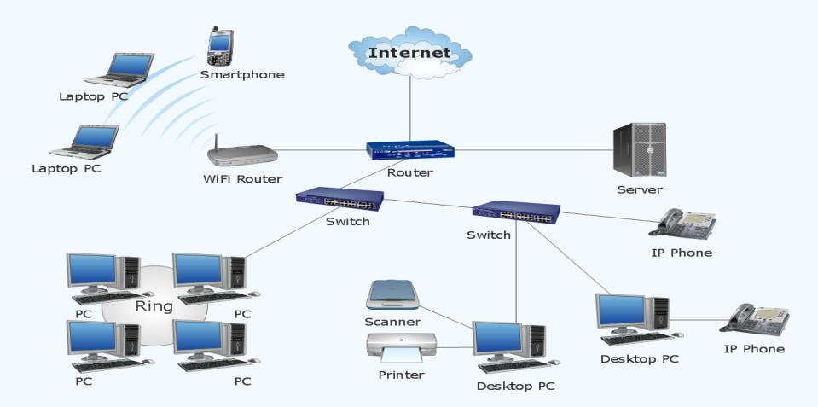

1. **Match the terms with a correct definition (7%)**

|  |  |  |
| --- | --- | --- |
| 1. Electronic health record iii. |  | 1. ordering and fulfillment system for medical practitioner instructions for the treatment of patients |
| 1. Clinical decision support system iv. |  | 1. set of tools for helping health providers in their day-to-day operations in a medical practice |
| 1. Digital signature v. |  | 1. systematic collection, processing and sharing of health information in electronic form |
| 1. Encryption system vi. |  | 1. real-time tool for diagnostic and treatment recommendations |
| 1. Computerized provider order entry i. |  | 1. demonstrates the authenticity of a digital message or document and its sender |
| 1. Primary key vii. |  | 1. Systems for encoding data in such a way that only authorized parties can read it |
| 1. Medical practice management software ii. |  | 1. column or a group of column that uniquely identify the data in a table row |

1. **Briefly describe a RAID level of your choice for data redundancy in computer storage (2%)**

RAID 0: no mirroring, no parity

RAID 1: mirroring without parity nor striping

RAID 2: bit-level striping with dedicated Hamming-code parity

RAID 3: byte-level striping with dedicated parity

RAID 4: block-level striping with dedicated parity

RAID 5: block-level striping with distributed parity

1. **What are the three types of clinical decision rules in a decision support system? (3%)**

drug-interaction checking

preventive care reminders

adverse drug event detection

1. **Describe 5 computing techniques used by clinical decision support systems, e.g. genetic algorithms (5%)**

**Rule-based (expert) systems**: system where knowledge of human experts is captured in form of IF-THEN rules.

**Artificial neural networks**: non-knowledge-based adaptive systems that use machine learning to learn from experiences and recognize patterns in clinical information

**Bayesian networks**: knowledge-based systems that show probabilistic causal relationships between sets of variables, e.g. diseases and symptoms.

**Model based systems**: systems that use individualized computational models of human pathophysiology to model the dynamics of a wide variety of tissues and organs.

**Data mining and machine learning**: systems that use a large database of existing cases in order to make probabilistic decisions, e.g. analyzing response of patients similar to current patient to decide upon the best treatment.

**Genetic algorithms**: non-knowledge-based systems that use iterative processes for finding an optimal solution based on patient data

1. **Match each key player with his typical profile within the clinical information system (2%)**

|  |  |  |
| --- | --- | --- |
| 1. Registered nurse D. |  | 1. registered nurse with an advanced level of education and training |
| 1. Medical coder B. |  | 1. works on accurate records management, billing and insurance processing |
| 1. Nurse practitioner A. |  | 1. types information from doctors' notes and patient records into official reports |
| 1. Medical transcriptionists C. |  | 1. graduated from a two to four years state-approved nursing school program |

1. **Define the following terms (9%)**

* **Patient encounter**: patient visit with a physician and details about what the patient was seen for, plus other medical information
* **Electronic materials management**: tracks and manages inventory of medical supplies, pharmaceuticals, and other materials
* **Picture archiving and communications system**: captures and integrates diagnostic and radiological images such as x-ray, MRI and CT
* **Computer network communication protocol**: set of formal rules for data exchange between computers in a network
* **Medical data coding**: administrative activity to analyze patients’ medical records and translate the written documentation into universally accepted, industry-standard medical codes using a medical classification system
* **Network-attached storage**: computer data storage connected to a computer network
* **ICD-9**: International Classification of Diseases, revision 9
* **Database 1st normal form**: A database is in first normal form if it contains only atomic values and there are no repeating groups
* **UML**: Unified Modeling Language including graphical and textual notations for modeling software

1. **OpenEMR (30%)**

Mr./Mrs. XY English is a 52-year-old teacher with chronic diabetes and arthritis (XY is your first name). His/her primary insurance is the National Czech Insurance Company. He/she visits the FBMI Clinic as a patient for the first time and is registered by Dr. XY, a clinician of that clinic (XY is your first name). Mr./Mrs. XY English’s father had diabetes as well and his/her aunt has high blood pressure. Mr./Mrs. English is a smoker and drinks alcohol as well as coffee. He is allergic to iodine and immune against rheumatic fever. He/she explains that he/she has pain in the shoulders and tingling in the hands. He/she had a nasty fall while walking two days ago. Dr. XY takes his/her vitals: 90 kg, 170 cm, 145 mmHg systolic blood pressure, 90 mmHg diastolic blood pressure, 77 beats/min pulse. After examination, Dr. XX prescribes the gel Voltaren against pain. Dr. XY associates Mr./Mrs. English’s encounter to his/her chronic arthritis. Dr. XY decides to add him/her to a new Alcohol Use Assessment program, that should remind Dr. XY to assess the level of alcohol usage for Mr./Mrs. English on a weekly basis. Finally Dr. XY decides to send him/her to the Radiology Institute of Kladno and he writes an external referral for x-ray and eventually shoulder surgery with a diagnosis of arthritis with muscular inflammation. At the end of the visit, Dr. XY performs medical coding of the encounter and creates a fee sheet for comprehensive visit with code 992.05 for $200. Mr./Mrs. English pays $50, while the remaining $150 are charged to the National Czech Insurance Company.

***Perform all steps made by Dr. XY in the* OpenEMR system http://smsos.fbmi.cvut.cz/openemr*.***

1. **GaiaEHR (7%)**

Mr./Mrs. XY English is received in the Radiology Institute of Kladno by Dr. XY who registers him/her by entering demographics, contact, provider, employment and primary insurance. Mr./Mrs. English is added to the arrival log and moved to the triage and later to the physician area. Dr. XY opens a new encounter for first visit following an external referral for x-ray and shoulder surgery with the diagnosis of arthritis with muscular inflammation. Dr. XY enters a shoulder X-Ray order. After examining the results, he later creates an order for shoulder arthroscopy surgery to be performed in the Surgical Clinic of Kladno. Dr. XY finally checkouts the encounter and moves Mr./Mrs. XY English patient to the checkout area.

***Perform all steps made by Dr. XY in the GaiaEHR system http://smsos.fbmi.cvut.cz/gaiaehr.***

1. **OpenMRS (3%)**

Mr./Mrs. XY English is received in the Surgical Clinic of Kladno by Dr. XY who registers him/her by entering demographics and current medical problems. Mr./Mrs. English is immediately hospitalized for shoulder arthroscopy surgery.

***Perform all steps made by Dr. XY in the OpenMRS system http://smsos.fbmi.cvut.cz:8080/openmrs.***