**Information Systems in Healthcare – Michel Kana, PhD - Homework**

Solution by Katarzyna Dunikowska

**1.Provide an organization chart of health care in your country.**

* **Graphical overview**
* **Description of roles and responsibilities**
* **Description of information flow between entitles**

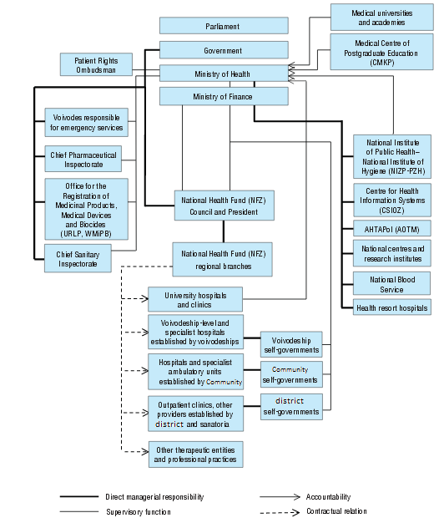

* **Description of roles and responsibilities**

The stewardship, management and financing functions in the Polish health care system are divided between the Ministry of Health, the NFZ and territorial self-governments. The NFZ is charged with financing of health care services provided to the insured population. It manages the process of contracting health services with public and non-public service providers. The operations of the NFZ are supervised by the Ministry of Health, while its finances are entrusted to the Ministry of Finance.

The Ministry of Health is also responsible for national health policy, financing of long-term public health programmes and selected highly specialized medical services, major capital investments and medical science and education.

**The Ministry of Health**

The Ministry of Health is responsibility for governance of the health sector and its organization.

It is responsible for national health policy, major capital investments and for medical research and education.

The Ministry is also responsible for supervising the training of health care personnel, for funding very expensive medical equipment (the responsibility in this area is shared with territorial self-governments) and for setting and monitoring health care standards.

The Ministry finances certain emergency medical services and

approves regional medical emergency care plans prepared by the voivodes.

The Ministry also has a number of supervisory functions. These include

the supervision of the Chief Pharmaceutical Inspectorate, the Office for Registration of Medicinal Products, Medical Devices and Biocides and the Chief Sanitary Inspectorate, which is responsible for monitoring hygiene in various areas of life, food quality and safety and sanitary conditions in health care units.

**The NFZ**

The major task of the NFZ is to finance health services provided to the entitled

population (from the collected insurance fees). It negotiates and signs contracts

for service provision with health care providers (setting their value, volume

and structure), monitors the fulfilment of contractual terms and is in charge of

contract accounting. The quality and accessibility of health care services are to

a certain extent influenced by the negotiated terms. The NFZ is also responsible

for covering the costs of health care services provided in other EU Member

States to Polish citizens.

**Territorial self- governments**

Since the introduction of the three levels of territorial administration and

self-government, territorial health authorities at each level (community, district,

voivodeship) are responsible for health tasks defined in the legislation, for the

assessment of the adequacy of service provision and health care infrastructure,

and for health promotion and prevention. In addition, voivodeship

self-governments are responsible for health care strategy and planning based

on the health needs of their populations and the voivodes are responsible for

medical emergency services in their region

**Health care providers**

Health care services are provided by public and non-public health care units as well as by individual and group medical practices. Non-public providers dominate in primary and ambulatory care. Public therapeutic entities can be established by

the authorities at the community, district,voivodeship or central level (Ministries),

by a state university active in the field of medicine or by the Medical Centre

of Postgraduate Education.

* **Description of information flow between entitles**

Data on the functioning of health care system and on population health status

are collect by various entities and by means of various information systems.

The statistical survey programme of public statistics, prepared annually by the

Statistical Council and published as a regulation of the Council of Ministers,

sets the scope, form and frequency of public data collection and designates

entities responsible for data collection . Data are analysed by the entities that

collect them and by the Central Statistical Office.

The information system operated by the NFZ is mainly used for the purpose

of contract settlement. Data on the provision of health services is electronically

transmitted by health care providers to the payer (the NFZ), which uses it to

draw up reports for the Ministry of Health on the provision of services financed

from public means.

Health care data collected within the system of public statistics are reported to

public health centres at the voivodeship level. Aggregated data are sent to the

Centre for Health Information Systems or to NIZP-PZH for national reporting. Every few

years, the Centre for Monitoring and Analysing of Population Health Status

within the NIZP-PZH publishes a report on the health status of the population.

**2. Describe a software development methodology of your choice**

A software development methodology or system development methodology in software engineering is a framework that is used to structure, plan, and control the process of developing an information system. One of kind methodology is waterfall model.

The waterfall model is a sequential design process, often used in software development processes, in which progress is seen as flowing steadily downwards (like a waterfall) through the phases of Conception, Initiation, Analysis, Design, Construction, Testing, Production/Implementation, and Maintenance.

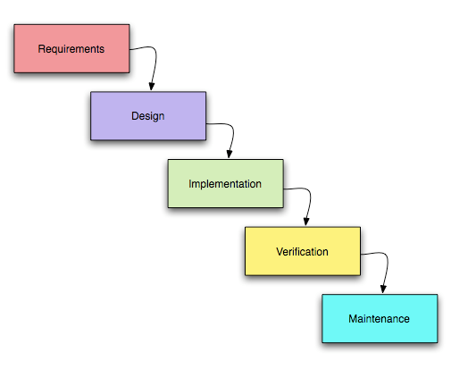

"Waterfall model". Progress flows from the top to the bottom, like a cascading waterfall.

The waterfall model is a popular version of the systems development life cycle model for software engineering. Waterfall development has distinct goals for each phase of development where each phase is completed for the next one is started and there is no turning back.

When using this methodology it is vital that all requirements are captured during the Requirements/design phase as it can be very expensive to re-visit requirements once implementation (coding) has begun.

The basic principles are:

* Project is divided into sequential phases.
* Emphasis is on planning, time schedules, target dates, budgets and implementation of an entire system at one time.
* Tight control is maintained over the life of the project via extensive written documentation, formal reviews, and approval by the user and information technology management occurring at the end of most phases before beginning the next phase.

Advantages of waterfall model:

* Simple and easy to understand and use.
* Easy to manage due to the rigidity of the model – each phase has specific deliverables and a review process.
* Phases are processed and completed one at a time.
* Works well for smaller projects where requirements are very well understood.

Disadvantages of waterfall model:

* Once an application is in the testing stage, it is very difficult to go back and change something that was not well-thought out in the concept stage.
* High amounts of risk and uncertainty.
* Not a good model for complex and object-oriented projects.
* Not suitable for the projects where requirements are at a moderate to high risk of changing.

When to use the waterfall model:

* Requirements are very well known, clear and fixed.
* Product definition is stable.
* Technology is understood.
* There are no ambiguous requirements
* Ample resources with required expertise are available freely
* The project is short.