**Information Systems in Healthcare – Michel Kana, PhD - Homework**

Solution by Katarzyna Dunikowska

1. **Compare two Linux distributions of your choice.**

Debian and Ubuntu are among the most popular Linux distributions.

**Debian:**

* Debian is an operating system composed of free software mostly carrying the GNU General Public License. Debian GNU/Linux is one of the most popular Linux distributions for personal and Internet server machines. Debian is seen as a solid Linux, and as a consequence has been used as a base for other Linux distributions
* Debian now supports two kernels, Linux and kFreeBSD. Is still primarily known as a Linux distribution with access to online repositories hosting over 37,500 software packages.

Officially hosts free software on its repositories but also allows non-free software to be installed.

* Debian includes popular programs such as LibreOffice, Evolution mail, CD/DVD writing programs, music and video players, image viewers and editors, and PDF viewers.
* The Debian Unstable branch is an opportunity for developers and experienced computer users to use, test, and develop the very latest open source software. It is not recommended for beginners or for anyone for whom reliability is a priority.

**Ubuntu:**

* Ubuntu is an operating system based on the Linux kernel and the Linux distribution Debian, with Unity as its default desktop environment. It is distributed as free and open source software. Ubuntu is the most popular Linux distribution on desktop and laptop personal computers.
* Ubuntu is composed of many software packages, the majority of which are distributed under a free software license.
* Ubuntu Desktop includes a graphical desktop environment. In versions prior to 11.04 the default GUI was GNOME Panel but it was dropped in favor of Unity, a graphical interface Canonical first developed for the Ubuntu Netbook Edition.
* GNOME (the former default desktop) offers support for more than 46 languages. Ubuntu can also run many programs designed for Microsoft Windows (such as Microsoft Office) or using a Virtual Machine (such as VMware Workstation or VirtualBox).
* Ubuntu comes installed with a wide range of software that includes LibreOffice, Firefox, Thunderbird, Empathy, Transmission, and several lightweight games (such as Sudoku and chess).
* Ubuntu is specifically designed to be easy for inexperienced users to use. Ubuntu is made to include a good combination of new and stable. Ubuntu is based off of Debian, and tries to make the distribution more user-friendly through ease of use and convenient features.

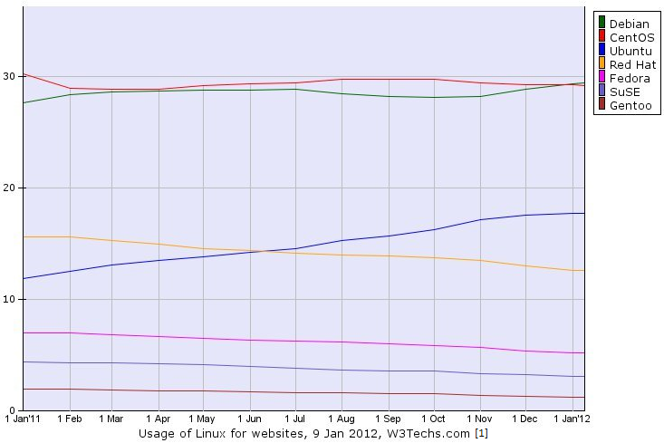

1. Name 5 different operating systems and for each of them, a healthcare information system that can run on the top.

* [Microsoft Windows](http://pl.wikipedia.org/wiki/Microsoft_Windows): AllMeds EHR and Practice Manager [5]
* [Mac OS](http://pl.wikipedia.org/wiki/Mac_OS) : Ka-medica, MedWorxs [4] [9]
* [Symbian](http://pl.wikipedia.org/wiki/Google_Chrome_OS): AdvandedMD [10]
* [Linux](http://pl.wikipedia.org/wiki/Linux) – NueMD [8]
* [Android](http://pl.wikipedia.org/wiki/Android_%28system_operacyjny%29): Epic Practice Management [7]

1. What are the major differences in operating systems on smartphones and those on personal computers regarding:

* Memory and storage management
* Processes and threads management
* Multi-users management
* Graphical user interface

|  |  |  |
| --- | --- | --- |
|  | operating systems on smartphones | operating systems on PC |
| • Memory and storage management | Some smartphones come with built-in storage, ranging from 8 GB to 64 GB. In some cases, an expansion slot may be available for adding an additional memory chip for more storage capacity. Smartphones, in general, will offer less storage capacity than a computer | Computer hard drives are already over one terabyte (TB) and continuing to increase in size. Even the most basic computer will often come with a 250 gigabyte (GB) hard drive today. |
| • Processes and threads management | multithread ARM architecture | multithread x86 architecture |
| • Multi-users management | Multi-users management it is not important. Smartphones are usually used by one person. | Management systems on PC are implicitly designed to be used by multiple users, typically one system administrator or more and an end-user community. |
| • Graphical user interface | Graphical user interface is a type of user interface that allows users to interact through graphical icons.Typically, the user interacts with information by manipulating visual widgets that allow for interactions appropriate to the kind of data they hold. | The user communicates usually use the mouse and keyboard.   The mouse is responsible for moving the cursor, indicating the desired position. |

[1]<http://www.pcworld.com/article/247845/debian_linux_named_most_popular_distro_for_web_servers.html>

[2] Wikipedia.org

[3] <http://www.computerhope.com/issues/ch001398.htm>

[4] <http://www.ka-med.com.pl/>

[5] http://www.allmeds.com/

[6] <http://www.google.pl/url?sa=t&rct=j&q=&esrc=s&source=web&cd=4&ved=0CEIQFjAD&url=http%3A%2F%2Finstructional1.calstatela.edu%2Fprosent%2FCIS%2520581%2Fchapter8.pptx&ei=JcRfUsqhPMfQtAbYxYHQDA&usg=AFQjCNGzcyeAvxSY9_sGPDF3L8wkoHgxOA&cad=rja>

[7] <http://www.epic.com/>

[8] <http://www.nuesoft.com>

[9] <http://www.medworksusa.org/>

[10] http://www.advancedmd.com/