FRAXIS
Five Row Arcade eXperience
Interactive System

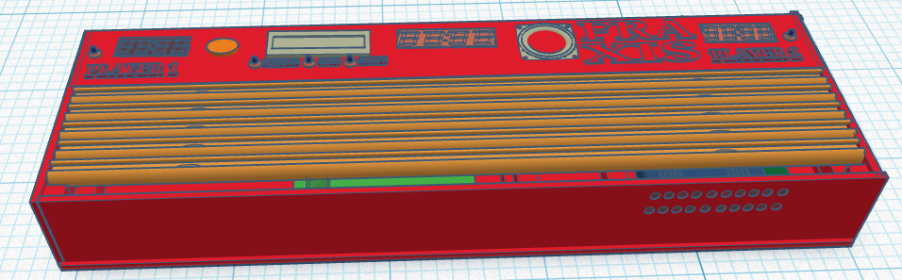
v0.12

Created by Michel Keijzers
Date July 7, 2026

Table of Content
1. Introduction
2. Device
3. Electrical
4. Games
4.1. Glossary
4.2. Solo Games
4.3. Two Player Games
4.4. Both Solo/Two Player Games
4.4.1. Pong
4.4.1.1. Description
4.4.1.2. Game Rules
4.4.1.3. Scoring
4.4.1.4. UI
4.4.2. Controls
4.4.3. Settings
4.5. SIMON MEMORY
4.5.1. Description
4.5.2. UI
4.5.3. Controls
4.5.4. Scoring
4.5.5. Settings
4.6. REACTION SPEED
4.6.1. Description
4.6.2. UI
4.6.3. Controls
4.6.4. Scoring
4.6.5. Settings
4.7. Color Patterns
4.7.1. Description
4.7.2. UI
4.7.3. Controls
4.7.4. Scoring
4.7.5. Settings
4.8. Draw
4.8.1. Description
4.8.2. UI
4.8.3. Controls
4.8.4. Scoring
4.8.5. Settings
5. UI
6. Software
6.1. SRAM Memory Usage
6.2. EEPROM Memory Usage
6.3. Flash Memory Usage
7. Electronics
7.1. Components
7.2. CPU Pin usage
7.3. Power Usage
8. Enclosure
8.1. General
8.2. Components
8.3. MDF Plate cutting

Introduction
This device is called FRAXIS: Five Rows Arcade Experience Interactive System.
The goal of the device is to play games, although there will also be graphical/sound demos and utilities available.
The base of the system are five LED strips vertically or horizontally between two players. Also one player games will be supported.

Device
The device is about 55 x 20 x 8 cm and contains:
- In the center, five 50 centimeter LED strips containing 72 * 5 RGB leds.
- To navigation the menu to select and adjust applications:
  - A text display (LCD) (for selecting game/settings)
  - Either joystick can be used for navigation.
  - Three LEDs for showing the mode or game states (play/paused).
- A central display mostly used during games with 4 digits to be able to show time.
- For each player:
  - A joystick that can be attached to the enclosure.
  - A display capable of showing 6 digits, e.g. for the score.
  - A small LED for player notifications.
- Audio control:
  - A buzzer for beeps.
  - A (mono) speaker for sound effects or better sound.
  - A (low profile) microphone for e.g. sound controlled applications.

Below is a sketch picture.

Electronics

Introduction
This chapter shows all schematics and PCB layout including many design decisions made.

Schematics

Overview
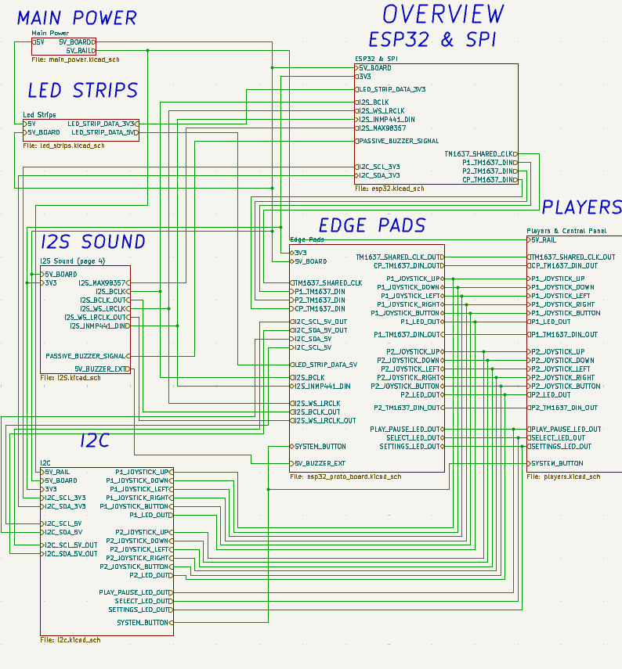
The system is built in various parts:
- Main power: Power plug, adapter, ground/5V to led strips and ESP32 proto board.
- LED Strips
- ESP32 & SPI (Micro SD Card Reader)
- I2S Sound: I2S microphone, amplifier, speaker and a passive buzzer
- Edge Pads: Edge pads of the ESP32 proto board
- Players: TM1637 displays, joysticks and LEDs
- I2C: MCP23017 GPIO expander, I2C level shifter and 1602 LED Display
The design decisions are explained in the corresponding paragraphs.

Main Power
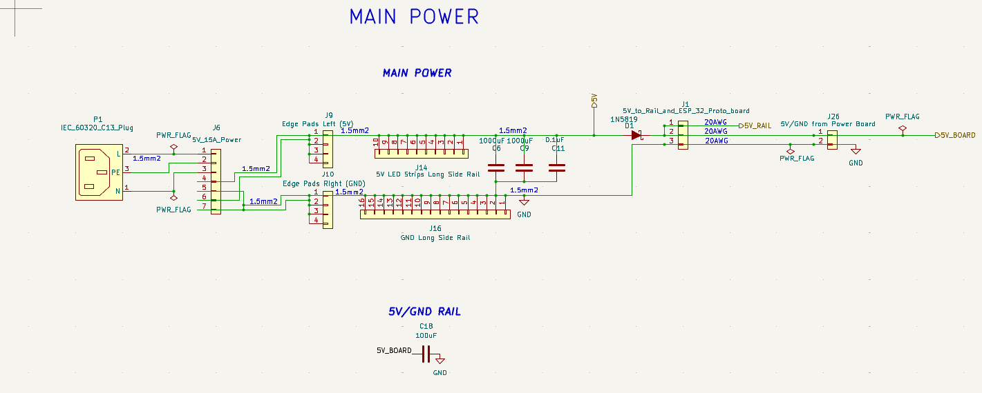

The main power comes from a IEC320 plugin to provide 220-240V/50-60 Hz. This is slightly overkill, however, that plugin comes with a builtin switch and light to see it’s switched on.
There are mainly two power consuming elements: the LED strips which take up far the most current and the processing board, called ESP32 proto board.
Since this device will not be a full display device and will be mostly used inside, full brightness is not needed. However, to be able to create interesting applications, 5 rows of 72 LEDs will be used meaning 360 LEDs. Each LED maximum can use 60 mA (20 mA) per color, resulting in 21.6 A. However, since not full brightness is needed, an adapter of 10A will be used, where the ESP32 proto board can use upto 1.5A (both 3.3V and 5V components combined) and 2A is used as headroom. This results in max 6.5A to be used for the LED strips.
The adapter has two V+ and V- output ports which are laid in parallel to each side of a small so called Power proto board where two thick copper wires are serving as 5V and GND rails.
Capacitors are added and on the side rails 5V and GND can be taken for the LED strips and 5V for devices (such as the 1602 LCD and TM1637 displays).
A special terminal block is used to provide 5V/GND towards the ESP32 proto board. This power is led through a diode to prevent accidental power reverse.
For a rough calculation of the current needs for the proto board and related 3V3 components, below is a list. As can be seen, it’s well under 1.5A, especially as the WIFI capability on the ESP32 will be used only for OTA updates and the microSD Card Reader will only be used occasionaly.
Component | Current (mA) | Comment
ESP32 | 500 | Peaks when using WIFI
MCP23017 module | 2
74AHCT125 | 5
I2C Level shifter (BSS138) | 1
I2S MAX89753 amplifier | 600
I2S INMP441 microphone | 2
MicroSD Card Reader | 100
Total | 1210

Regarding 3V3 components to be powered by the AMS1117, the list is:
Component | Current (mA) | Comment
MCP23017 module | 2
74AHCT125 | 5
I2C Level Shifter (BSS138) | 1
INMP441 microphone | 2
MicroSD Card Reader | 100
Total | 110

3.3V Power through AMS1117:
P_3.3V,load = 3.3V⋅0.11A ≈ 0.36 W

Power dissipation of AMS1117:
P_AMS1117= (5V −3.3V)⋅0.11A ≈ 0.19 W

For 0.19W, no heat sink is needed.

LED Strips
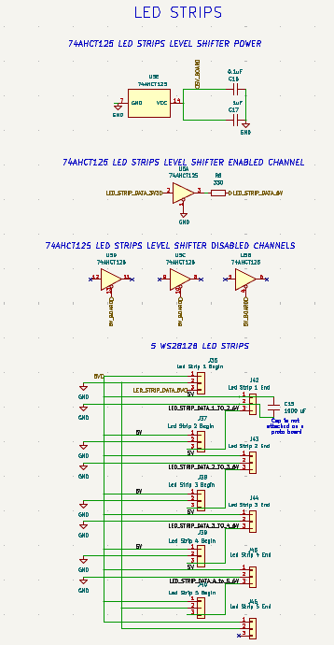
Five 50 cm WS2812B led strips will be used. Because the enclosure should not become too long but still many LEDs should be present, 144 LEDs/m strips will be used, which are cut in half resulting in 5 rows of 72 LEDs each, totalling 380 LEDs. In the Power schematics you can read about the power consumption.
WS2813 is not needed as the chance of a breaking LED is fairly low. The strips will be placed inside aluminium strips, therefore no water protection is needed, anything from IP20 will do.
The reason that five LED strips are selected have a non electronics reason (always a central row and three rows would feel too limited).
Since the LED strips are enclosured, the chance of a LED failing is low, so WS2812B is selected over WS2813.
One big chain will be used instead of five separate LED strip channels, otherwise two level shifters would be needed.
To reduce the length of the LED strip length, the begin and end of each LED strip is laid out alternated.
LED STRIP 1 Begin -------------------------------→ LED STRIP 1 END --\
/--LED STRIP 2 End ←--------------------------------- LED STRIP 2 BEGIN <-/
\->LED STRIP 3 Begin -------------------------------→ LED STRIP 3 END --\
/--LED STRIP 4 End ←--------------------------------- LED STRIP 4 BEGIN <-/
\->LED STRIP 5 Begin -------------------------------→ LED STRIP 5 END
This reduces the total length of the LED strips chain to 250 cm excluding the distance from the ESP32 proto board.
Because of this length, some measurements need to be taken:
- Big capacitors are needed and are placed both on the Power proto board and a big capacitor at the other end (where is the start of the LED strips).
- A level shifter is used: an 74AHCT125. Only one channel is used. The used channel must be connected to enable with GND. The unused channels MUST be connected (with 5V). The unused channels input/output are not allowed to be connected.
- 5V is injected at both ends of each LED strip.

I2S Sound
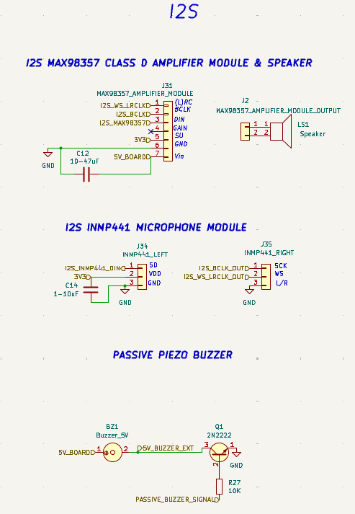
Two sound production components will be used:
- A passive buzzer, capable of making simple sounds, with varying frequencies but mostly usable for beeps and higher pitched sounds, definitely not high quality.
- A MAX89357 module connected to a 3W 4Ohm 40mm speaker for higher quality sounds, although bass quality is still limited. A special box enclosure will be made to improve the bass pressure.
The amplifier has its own output via a two pins terminal block, so it will not be broken out on an edge pad.
One microphone is used: a INMP441 microphone module.
Since I2S lines are critical, all external wires (to the microphone) will be twisted with specific GND wires.
The passive buzzer will be used with 5V to increase the power, otherwise it will be mainly overpowered with the amplifier/speaker combination:
Source | Assumptions | Approx. SPL @ 30 cm
MAX98357 + 3 W / 4 Ω speaker | Speaker sensitivity ~86 dB @ 1 W/1 m, driven near 3 W @ 5 V | ≈ 100–102 dB
Passive buzzer @ 3.3 V | Typical small piezo: ≈ 75 dB @ 10 cm at 3.3 V | ≈ 65 dB
Passive buzzer @ 5 V | +3.5 dB vs 3.3 V → ≈ 78.5 dB @ 10 cm | ≈ 69 dB

To increase the buzzer’s output (relative to the amp), the following design decisions are made:
- A transistor (2N2222) and resistor are used to be able to drive the buzzer at 5V.
- Software advice: use frequencies around the resonation spot, around 2-4 kHz.
- Enclosure advice: Place buzzer under small whole in enclosure (not on ESP32 proto board).
Note that longer wires do not affect quality and do not need to be twisted with GND.
The buzzer will be powered from the 5V rail.

I2C
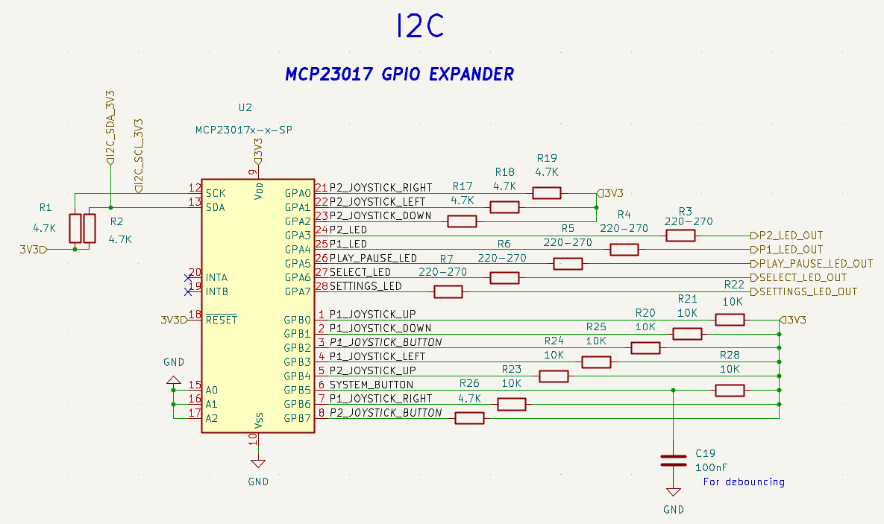
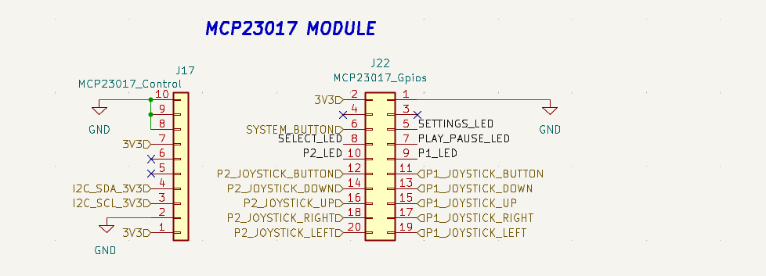
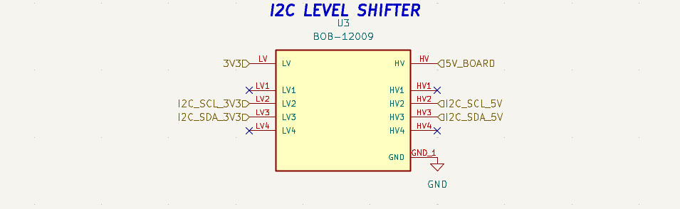

There will be two I2C components:
- An MCP23017 GPIO Expander, needed to handle the inputs of the two player joysticks and all LEDs. This is to reduce the number of pin usage on the ESP32.
- An 1602 LCD Display to be able to navigate the menu. Two lines of 16 characters each should suffice.
The MCP23017 works on 3.3V, but the 1602 LCD Display only works on 5V (otherwise at least the background display does not light). The 1602 LCD Display will be powered from the 5V rail.
Therefore a level shifter is needed, and the 74AHCT125 is not usable as it is one directional, where a BSS1338 level shifter is typically used for I2C line conversion. Only for the 3.3V side pulldowns are necessary, for the 1602 LCD Display, the existing ones built into the module will be used.
For the MCP23017, below is a table of used inputs/outputs.
Pin Function | Amount of pins | Mandatory
Joystick Player 1: Up, Down, Left, Right, Button | 5 | Yes
Joystick Player 2: Up, Down, Left, Right, Button | 5 | Yes
LED for Player 1 and 2 | 2 | Yes
Status LEDs: Select, Play/Pause, Setup | 3 | No
Unused | 1 | No

The status LEDs are used as there were pins available anyway. The exact function can be changed later when felt necessary. 220-270 ohm resistors are used, however this may depend on the color and brightness needed.
All inputs from the joystick need pullup resistors. Note that the MCP23017 has pullup resistors, however these are too weak for long wires.
The System button has a capacitor (close to the button, not MCP23017). This is to prevent the need for software debouncing.
The I2C wires need to be protected with twisted GND wires.
The joystick inputs also need to be protected, however one GND wire per joystick wire ‘bundle’ will suffice.

ESP32 & SPI
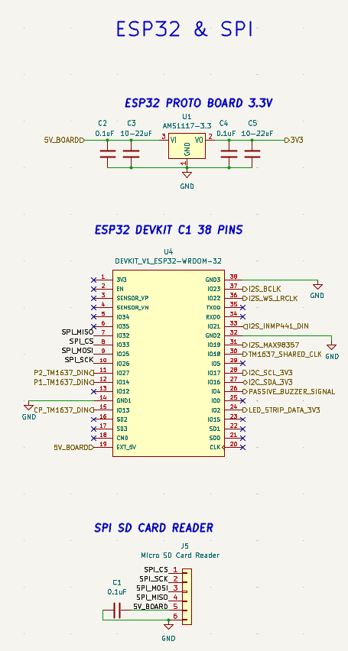
Looking at the vast amount of peripherals and pins needed, and the processing power need, and WIFI connection (for possible OTA updates), the ESP32 is a good candidate. An ESP32 Supermini C6 would be too limited regarding pins, but the ESP32 WROOM DevKit C1 has everything needed.
To prevent soldering issues, a full development board will be soldered on the ESP32 proto board (although with female pin headers for soldering heat protection and easy replacement).
To prevent using too much 3.3V power, it is not drawn directly from the ESP32.
The following components use 3.3V power:
Component | Current Consumption
MCP23017 | 2
74AHCT125 | 5
I2C Level Shifter | 1
INMP441 I2S Microphone | 2
MicroSD Card Reader | 100
I2C pullups on 3.3V | 2
Total | 112

The ESP32 DevKit C1 can produce about 250-300 mA, theorethically 500 mA but that heats up the regulator. Since the ESP32 is using 200-300 mA during a WiFi burst, there is almost no spare current left. Therefore, an AMS1117 will be used, using various capacitors around it according to the reference design.
Below is a full ESP32 pin out table including design decisions.
Pin Nr | GPIO Name | Connected | Rationale
1 | 3V3 | - | Unconnected, as the AMS1117 provides 3V3 power.
2 | EN | - | Default kept to the correct value.
3 | SENSOR_VP | -
4 | SENSOR_VN | -
5 | IO34 | -
6 | IO35 | -
7 | IO32 | SPI_MISO | SPI functions can be connected to almost any pin
8 | IO33 | SPI_CS | SPI functions can be connected to almost any pin
9 | IO25 | SPI_MOSI | SPI functions can be connected to almost any pin
10 | IO26 | SPI_SCK | SPI functions can be connected to almost any pin
11 | IO27 | P2_TM1637_DIN | TM1637 functions can be connected to almost any pin
12 | IO14 | P1_TM1637_DIN | TM1637 functions can be connected to almost any pin.
13 | IO12 | -
14 | GND1 | GND | All GND pins must be connected to ground.
15 | IO13 | CP_TM1637_DIN | TM1637 functions can be connected to almost any pin.
16 | SD2 | -
17 | SD3 | -
18 | CMD | -
19 | EXT_5V | 5V | 5V_BOARD is used, i.e. the power that comes from the Power proto board (and is diode protected).
20 | CLK | -

21 | SD0 | -
22 | SD1 | -
23 | IO15 | -
24 | IO2 | LED_STRIP_DATA_3V3 | This is a strapping pin. The LED strips keep this pin low during boot which means normal boot.
25 | IO0 | -
26 | IO4 | PASSIVE_BUZZER_  SIGNAL | This pin can be used for the passive buzzer without any limitations.
27 | IO16 | I2C_SDA_3V3 | Preferred pin for I2C SDA.
28 | IO17 | I2C_SCL_3V3 | Preferred pin for I2C SCL.
29 | IO5 | -
30 | IO18 | TM1637_SHARED_CLK | TM1637 functions can be connected to almost any pin

31 | IO19 | I2S_MAX98357 | This pin can be used for I2S without any limitations.
32 | GND2 | GND | All GND pins must be connected to ground.
33 | IO21 | I2S_INMP441_DIN | This pin can be used for I2S without any limitations.
34 | RXD0 | -
35 | TXD0 | -
36 | IO22 | I2S_BCLK | This pin can be used for I2S without any limitations.
37 | IO23 | I2S_WS_LRCLK | This pin can be used for I2S without any limitations.
38 | GND3 | GND | All GND pins must be connected to ground.

Note that I2S bus is shared. This means that the I2S frequency/sample rate is used for both the microphone and amplifier, which will be set to 16 kHz and 16 bit sampling.

Edge Pads
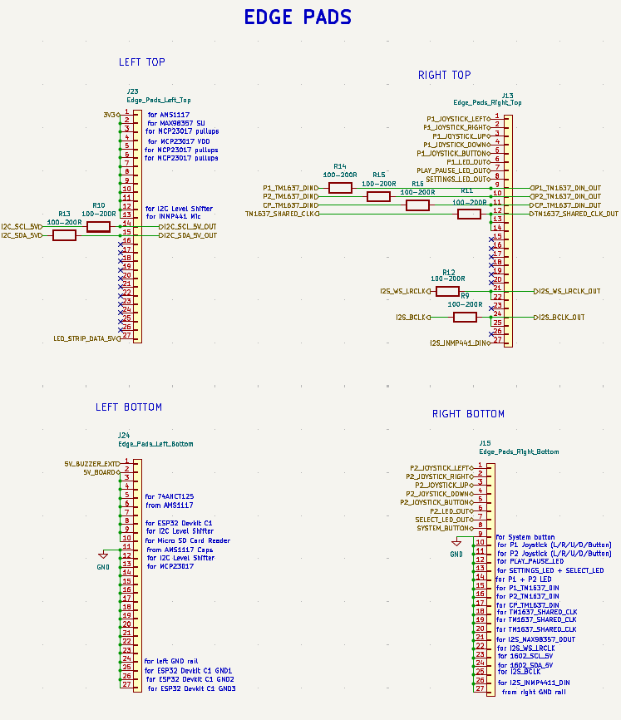

On both sides of the ESP32 proto board are edge pads, 27 in one row. Both the top and bottom side can be used, giving 27 * 2 * 2 = 108 pads.
On the left side mostly 3V3, 5V and GND is used. Some exceptions are:
- I2C: Since the converter is on that side of the proto board and the other side is pretty much filled.
- LED Strip data: The LED strip signal is important and LED strip 1 begins left of the proto board.
- Note that several pins from the left top side are blocked by the MicroSD Card Reader.
On the right side, mostly signals are used, and GND that serves as wires to twist around the signal on the other side on the top side of the edge pad. Although there are 108 pads available, the signal pins have each one pad, both for the internal routing (typically to the ESP32), and external (to the component in the enclosure top).
For various signals and due to long wires, resistors are used to keep the signal clean.
For most signals on this side, the location is to make sure wiring distance is minimal.
I2S clock pins are doubled to split between INMP4441 Microphone and MAX89357 amplifier.

Players & Central Panel
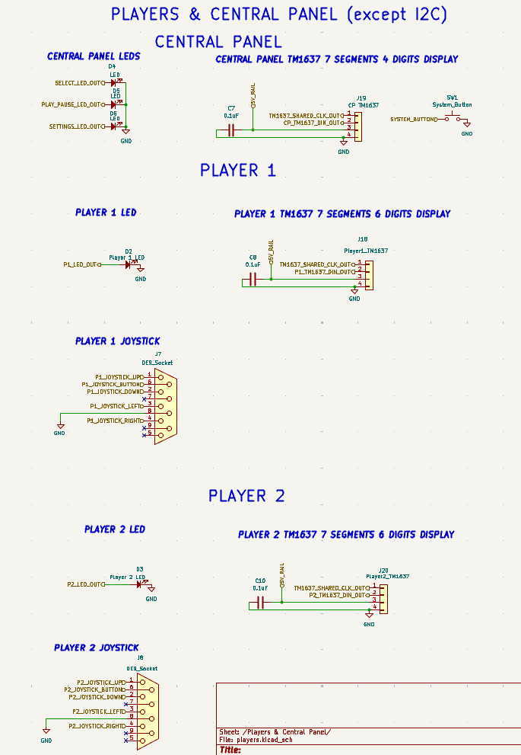
This page consists of both the player controls/feedback and central panel visual feedback with the exception of the 1602 LCD Display which is handled in the I2C section.
The following items are present:
- Central Panel LEDs: 3 LEDs with functions Select, Play/Pause and Settings, although these function can be changed during the project when necessary. Note that the limiting resistors are placed on the I2C schematics page, as they are coupled to the MCP23017.
- Central Panel: TM1637 Seven Segments display. All displays are 0.56” instead of the default 0.36” to allow for better reading during arcade games. This display can show 4 digits and has a colon in the middle so it can show time.
- Player 1 and Player 2 LED: this is a 3mm led that can be used for notifications
- Player 1 and Player 2 TM1637 Seven Segments display. This display has 6 digits so it can show higher value scores. It does not have a colon so a time would be represented as 12.34 instead of 12:34.
- Player 1 and Player 2 joysticks. These are Atari 2600 style joysticks with the micro switches for Up, Down, Left, Right, (Fire) Button. They need pullup resistors which are placed on the I2C schematics page. Software advice: likely software switch debouncing is not necessary, except for menu navigation possibly as the debounce time is 2-3 ms which can be too much for short movements. The joysticks are connected on the enclosure via DB9 connector mounted plugs.
- A system button which is used to activate the menu during a running app. E.g. in games, high likely both joysticks are active simultaneously and creating a kind of ‘tricky’ joystick combination is not intuitive and can lead to unexpected user experiences.

PCB

Overview
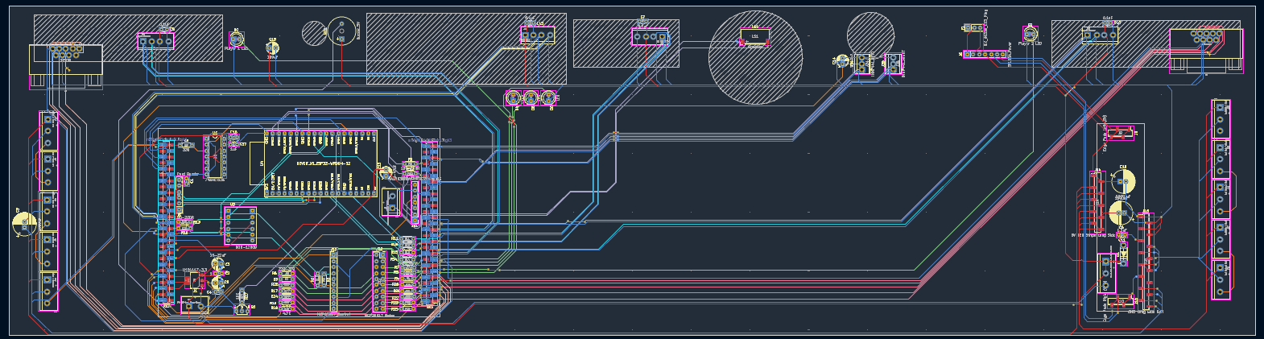
Above an overview is shown. In the top row there are the components which are visible typically for the players.
On the outmost left and right side there are five led strip begin/end headers depicting the LED strips.
On the right inwards is the Power proto board. On the left side is the ESP32 proto board.
Conventions:
- Since handsoldering and manual routing wires mean there are no layer restrictions, layers are used to be able to place wires over each other as will.
- For the ESP32 proto board, most wires have been laid around the board, even internal ones, to not clutter up the space.
- Thicker wires are 18-22AWG, otherwise 26AWG is assumed.
- The locations and dimensions are not fully according reality but show an indication.
In the next paragraphs a few closeups of specific areas are shown.

Power
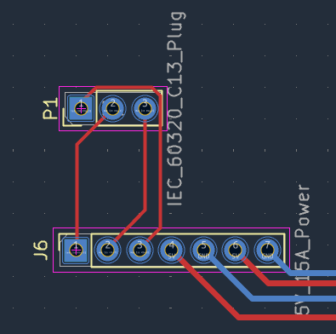
Above, the power (IEC320) plugin is shown as a 3 pin header. The 7 pin header is the 5V/10A adapter which has 220-240V Left/Right, GND pin, and two V+ and V- supplying 5V.

Power Proto Board
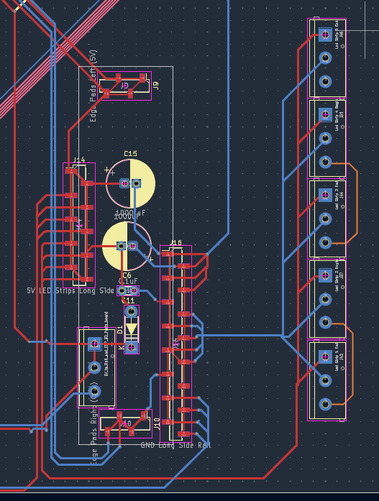
Above the Power proto board is shown. The wires in the top left are for the power adapter. Instead of the edge pads, probably a big copper strip will be solderd over each side giving more stability. These provide power for the LED strips. On the right you can see the connection from that half of the LED strips from the power proto board.

ESP32 Proto Board
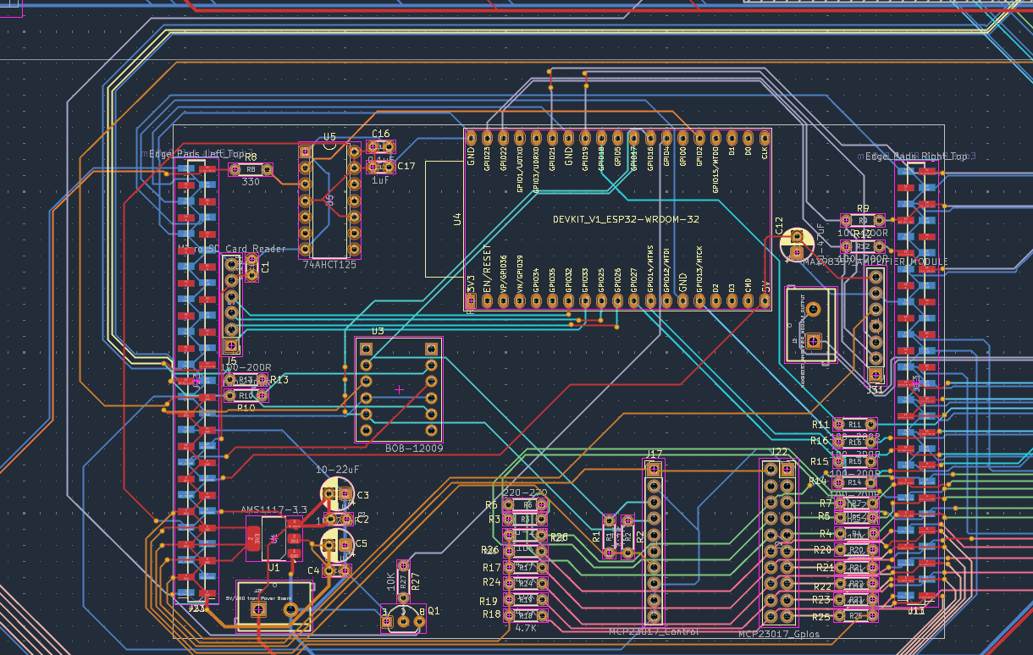
The picture above shows the ESP32 Proto Board.
- On the sides the edge pads are shown, both used on the top and bottom side for more signals.
- In the lower left the AMS1117 regularor is placed together with some capacitors.
- Right of it, pullup and line resistors are used and connected to the MSP23017 which is depicted as a 1x8 and 2x8 pin header.
- Above the right pullup resistors is the I2S amplifier module. The two gate terminal block shows the speaker in/out from that amplifier module.
- Left above the amplifier module is the ESP32 development kit WROOM C1. It is located in this way to make room for the micro USB cable in case needed and on the left to leave space for the antenna area.
- On the left of the ESP32 is the 74HC125N level shifter for the LED strips signal.
- Lower between the ESP32 and 74HC125N, the level shifter for I2C is placed.

Bill of Materials
- ESP32 WROOM DevKit C1
- 2.5m of 144 leds/m WS2812B LED strips cut in 5 times 50 cm, resulting in 250 cm having 72 * 5 = 360 LEDs.
- 5 x 50 cm LED strip holders
- 2 x 6 digit seven segments display, 0.56”, TM1637 controlled.
- 1 x 4 digit seven segments display, 0.56”, TM1637 controlled.
- 1602 LCD Display, I2C controlled by I2C
- I2C Level Shifter
- MCP23017 GPIO Expander
- MAX98357 Amplifier module.
- 4W 4ohm 40mm speaker.
- INMP441 Microphone module.
- 2 x Atari 2600 style joysticks using DB9 connectors
- 5 x 3mm LEDs, color to be decided.
- FC4 Protoboard 8x12 cm
- FC4 Protoboard 2x8 cm
- Small electronic components, like resistors, capacitors, diodes, small transistors etc.
- Tie wraps, cable markers etc.
- Wire (18-22AWG and 26AWG)
- Passive Buzzer.
- 5V adapter, 10A
- IEC320 plug.
- Wooden enclosure using MDF
- Wooden strengthening blocks/ribs.

Enclosure

Introduction
The enclosure will look like the front page which is copied here:
The picture below shows the back side:
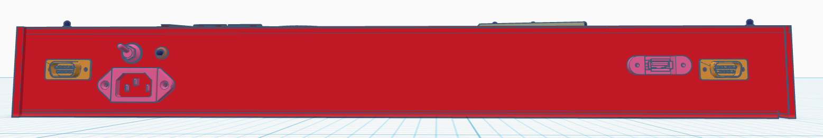
Note that the switch/LED/power plugin will be replaced by a ‘all in one’ IEC320 connector with switch and light.
On the inside, below the LED strips a wooden MDF plate will be assembled, which connects to the proto boards and adapter. Reinforcement ribs and bridges will be used. See pictures below.
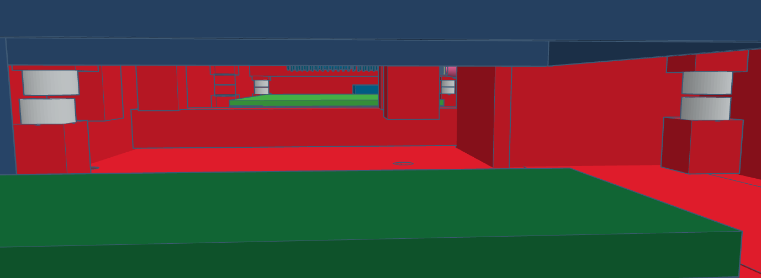
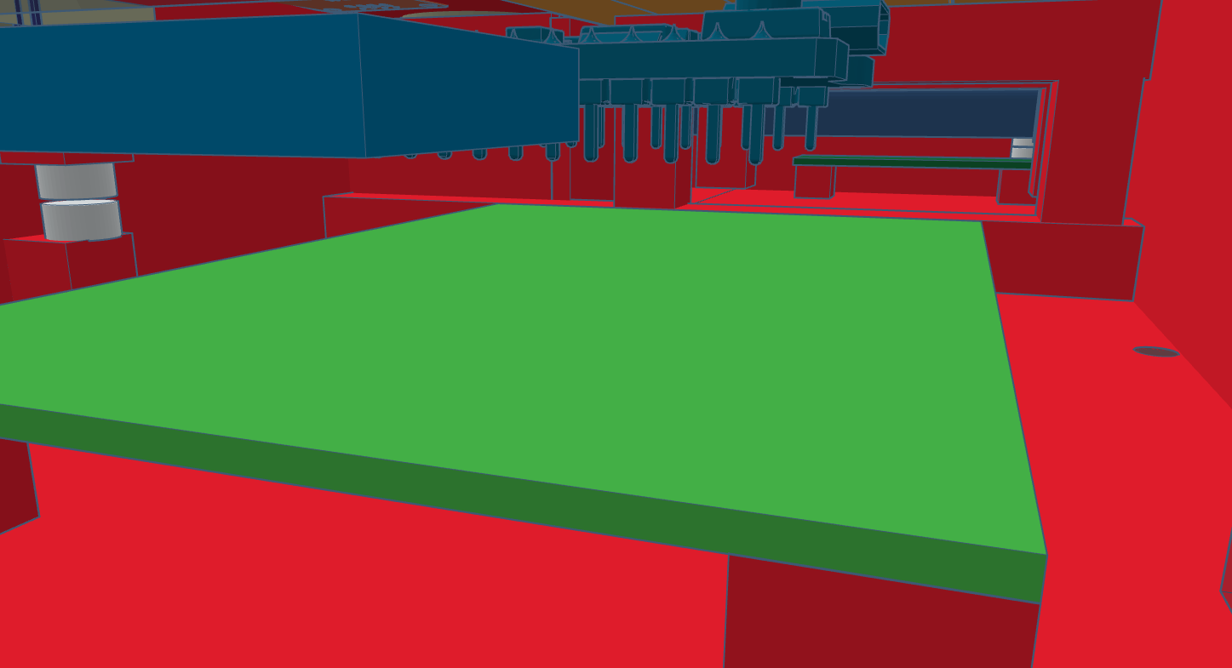
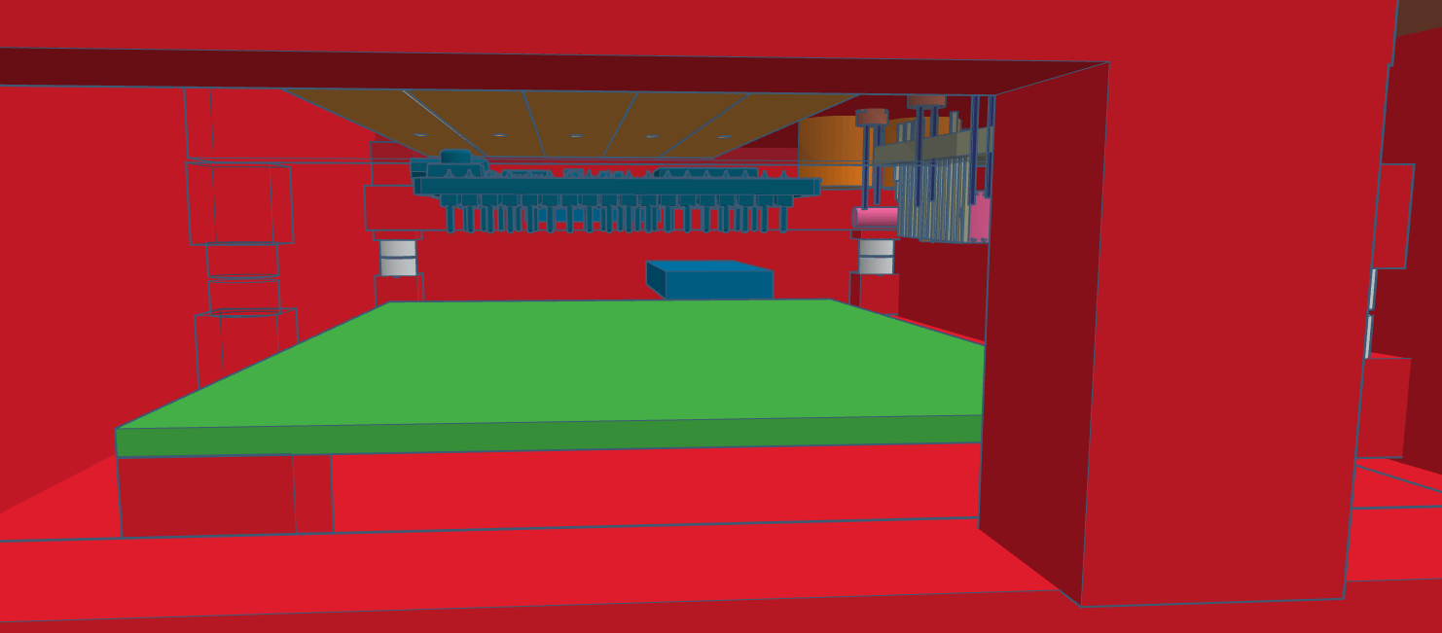
Note in these pictures, the proto board/adapter have not been connected to the top plate but still to the bottom plate.

Construction Material
No 3D printing is used although it would be the esthetically best solution, because:
- The length of the enclosure is more than 50 cm, meaning not many printers can handle this.
- The size of th enclosure would make it expensive.
- Out of scope for this project.
Therefore, wood is used. To reduce the costs, MDF will be used for most ‘platework’ and glue/corner blocks and reinforcement ribs will be made from a wooden strip.

Enclosure Opening
Since the board probably needs to be ropened for fixes/adaptations initially and creating a sort of esthetically opening on the side is hard, the entire bottom plate will be fixed with magnets. By holes in the bottom fingers can be used to pull the bottom plate by overcoming the magnetic strength.
To prevent the wires from being pulled, both proto boards and the adapter will be attached to the top instead of attached to the bottom plate. Tie wraps and/or other means will be used to fix them.

Properties
- Dimensions: approximately 530 x 180 x 70 mm
- Weight: unknown

Components
The following material is used:
- MDF wooden plate,122 x 61 cm, 4 mm
https://www.karwei.nl/assortiment/mdf-plaat-122-x-61-cm-4-mm/p/B340344
Rationale: normal wood is too heavy, 4 mm is more than enough.
- Wooden strip/batten, spruce, planed (smooth), 12 x 12 mm, 210 cm
https://www.gamma.nl/assortiment/lat-vuren-geschaafd-12x12-mm-210-cm/p/B159292
Spruce (Dutch: Vuren) is high quality wood but not too hard so easy to saw, 12 x 12 mm is a practical size for ribs/corner blocks without becoming too big. Being planed smooth (Dutch: Geschaafd) is a must.
- Wooden glue (D2/D3): The need of screws or nails is not necessary.
- Magnets: to keep the bottom plate attached to the enclosure.
- Paint (optionally).

MDF Plate
Item | Amount | Width | Length | Area
Front/back plate | 2 | 640 | 120 | 153,600
Long vertical plates | 2 | 640 | 70 | 89,600
Short vertical plates | 4 | 120 | 70 | 33,600
Strengthening blocks | 20 | 15 | 15 | 4,500
Total |  |  |  | 281,300
MDF Plate | 1 | 1,220 | 610 | 409,000
Left |  |  |  | 127,700
Left (%) |  |  |  | 31.2%

Applications

Introduction
There are various types:
- Games
- Utilities
- Demos
- Settings

Navigation
The central panel joystick can be used to navigate:
- Left returns to the parent menu
- Right moves into the selected menu.
- Up moves the menu one menu option higher
- Down moves the menu one menu option lower
- Press is unused (so far)

Structure

Introduction
The menu has the following structure:

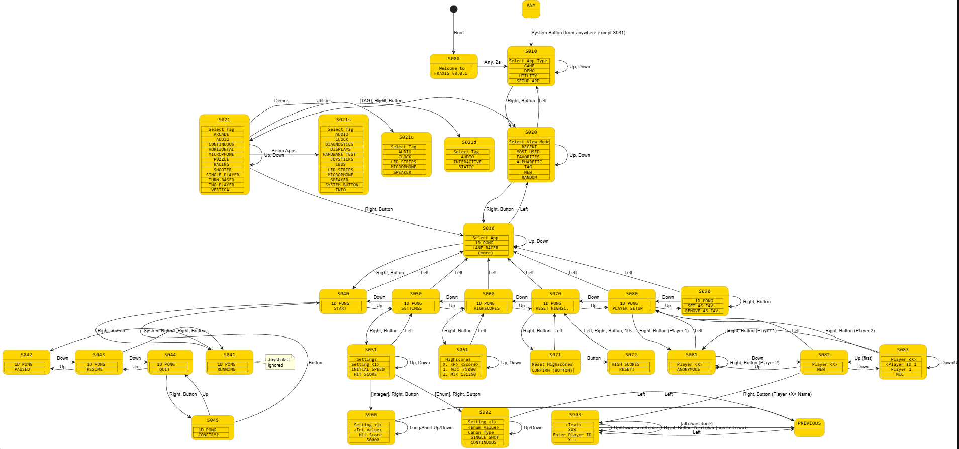

The diagram above can be split in three parts which will be covered in detail in the next paragraphs:
- App Selection
- App Execution
- App Management

App Selection
The following diagram shows the app selection part:
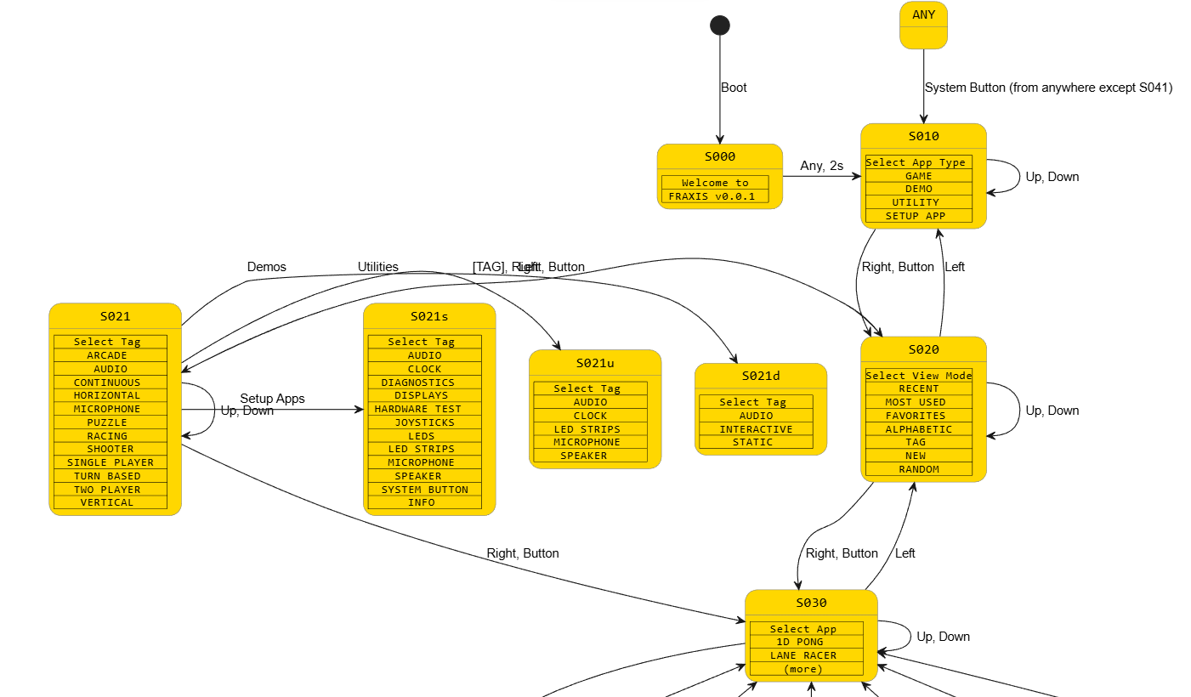
Screen S000: Welcome
┌────────────────┐
│ Welcome to │
│ FIRAXIS 0.0.1 │
└────────────────┘
After two seconds or a direction/button press, the navigation moves to screen S010.
Screen S01-S010: Select App Type
This screen selects between the application type: Game, Demo, Utility or Setup App.
┌────────────────┐
│Select App Type │
│ GAME │
└────────────────┘
┌────────────────┐
│Select App Type │
│ DEMO │
└────────────────┘
┌────────────────┐
│Select App Type │
│ UTILITY │
└────────────────┘
┌────────────────┐
│Select App Type │
│ SETUP APP │
└────────────────┘
Right/Mouse button press causes the navigation to move to screen S020.
Screen S020: View Modes
Here the view modes to select an app can be set:
View Mode | Description
RECENT | Recently used apps
MOST USED | Apps in order of total execution time
FAVORITES | Apps marked as favorites, in alphabetic order
ALPHABETIC | Apps in alphabetic order
TAG | Apps to be selected by a tag, in alphabetic order
NEW | New apps, which is a fixed list by the developer.
RANDOM | Selects a random game (no further selection is neeeded).
┌────────────────┐
│Select View Mode│
│ RECENT │
└────────────────┘
┌────────────────┐
│Select View Mode│
│ MOST USED │
└────────────────┘
┌────────────────┐
│SELECT VIEW MODE│
│ FAVORITES │
└────────────────┘
┌────────────────┐
│Select View Mode│
│ ALPHABETIC │
└────────────────┘
┌────────────────┐
│Select View Mode│
│ TAG │
└────────────────┘
┌────────────────┐
│Select View Mode│
│ NEW │
└────────────────┘
┌────────────────┐
│Select View Mode│
│ RANDOM │
└────────────────┘
Button/Right: When TAG is selected, navigation moves to screen S021 to select a tag. When RANDOM is selected, a random game is shown and navigation moves to screen S040. In all other cases, screen S030 is shown to select a game from a list.
Screen S021: Select Tag
This screen shows all existing tags for the selected app type.
The following list shows all tags per app type:
Game Tags | Demo Tags | Utility Tags | Setup App Tags
Arcade | Audio | Audio | Audio
Audio | Interactive | Clock | Clock
Continuous | Static | LED Strips | Diagnostics
Horizontal |  | Microphone | Displays
Microphone |  | Speaker | Hardware Tests
Puzzle |  |  | Joysticks
Racing |  |  | LED Strips
Shooter |  |  | Microphone
Single Player |  |  | Speaker
Turn Based |  |  | System Button
Two Player |  |  | Info
Vertical

Below are a few examples shown:
┌────────────────────┐
│ Select Tag │
│ ^ Evasive │
│ > Shooter │
│ v Single Player │
└────────────────────┘
┌────────────────────┐
│ Select Tag │
│ > Hardware Tests │
└────────────────────┘
After a tag is selected, navigation continues to screen S030.
Screen S030: Select App
In this screen the actual app can be selected. Below are a few examples:

┌────────────────┐
│ Select Game │
│ 1D PONG │
└────────────────┘
┌────────────────┐
│ Select Demo │
│ KNIGHT RIDER │
└────────────────┘
┌────────────────┐
│ Select Utility │
│COUNTDOWN TIMER │
└────────────────┘
┌────────────────┐
│Select Setup App│
│LED STRIPS TEST │
└────────────────┘

App Execution
This paragraph explains the screens related when an application is running. Typically, the app takes over the joystick control, but the System Button can be used to intervene.
Screen S040: App Start
This screen starts the application.
┌────────────────┐
│ 1D PONG │
│ START │
└────────────────┘

App Management
These screens can start app an app, make them favorite etc:
- S300: Start (Screen S400)
- S301: Settings (S500)
- S302: Highscores (S520, Games only)
- S303: Reset Highscores (S530, Games only)
- S304: Player Setup (S540, Games only)
- S305: Set as Favorite (S550 or remove from favorites if already a favorite)
┌────────────────┐
│ <Selected App> │
│▬ START ▼│
└────────────────┘
This menu assume that Game 1D Pong has been selected.
┌────────────────┐
│ 1D Pong │
│▲ START ▼│
└────────────────┘
┌────────────────┐
│ 1D Pong │
│▲ SETTINGS ▼│
└────────────────┘
┌────────────────┐
│ 1D Pong │
│▲ HIGH SCORES ▼│
└────────────────┘
┌────────────────┐
│ 1D Pong │
│▲ PLAYER SETUP ▼│
└────────────────┘
┌────────────────┐
│ 1D Pong │
│▲ SET AS FAV. ▼│
└────────────────┘
┌────────────────┐
│ 1D Pong │
│▲REMOVE AS FAV.▼│
└────────────────┘

Games

Introduction
In the games some common terms are used:
- Home: the LED closest to the player (both players have their own home).
- Home distance: The distance between some object and the home of the player.
- Center: The central LED, although due there are an even number, it is considered the middle LED closest to one player.
- Player 1: Bottom side player
- Player 2: Top side player
- Central Panel: Central control panel

Tags
Games are categorized by various tags, and a game can be part of multiple categories.
Below the games are shown including tags.

List of Games

Game Player Count Genre Game Type
1D Endless Runner
1D Pong
1D Snake
Dual Line Dodge
Lane Shooter 1 or 2 Shooter 4 Rows
Quadrows Breakout
Quadrows Endless Runner
Quadrows Pong 2 Pong 4 Rows
Quadrows Snake
Reaction Speed
Simon Memory
Tug of Light

Player Count: One Player / Two Player / One or Two Players
Genre: Shooter, Pong, Racer, Snake, Reaction, Rhythm, Puzzle, Endless, Platformer,
Arena, Dodge, Tug Of War, Breakout
Game Type: 1D, 4 Rows

Demos

Introduction

Tags

List of Demos

LED Wave Demo

Color Patterns

Description
This is not a game, but a demo of color patterns.

Knight rider
Galaxy
Fire
Stroboscope
Rainbow

Interaction via joystick

UI

Controls

Scoring

Settings

Utilities

Introduction

List of Utilities

Draw

Description
This is not a game, but a drawing program. With the pot meter a LED can be selected, and with the up/down keys the color can be changed. The select button switches the LED on or off.

UI

Controls

Scoring

Settings

CLOCK

64 LEDs, e.g 12:34:56

2 LEDs 1: 0-2
1 LED gap
5 LEDs 3: 0-5
1 LED gap
10 LEDs 4: 0-9
1 LED gap
5 LEDs 3: 0-5
1 LED gap
10 LEDs 4: 0-9

Total 35 LEDs

Even LEDs red. Uneven reds blue. Fifth green to make visibility better.

Possibly keeping hhmmss led positions constant.

Think about date.

ALARM

ime and or date alarm., or countdown

Input via LCD, alarm via led colors and LCD.

STop watch

System

LED Strips Test (+Brightness Control)

LED Segments Test (+Brightness Control)

LCD Display Tests (+Brightness Control)

Joysticks Test (+Calibration)

Audio Test (+Volume Set)

OTA Software Update

Setup Applications

Introduction

List of Setup Applications

Software Architecture

Introduction

SRAM Memory Usage

Item | Bytes
LED Strips | 64
Settings | 16
Generic variables | 64
Stack space | 80
Total | 224
Available | 2,048
Remaining | 1,824
Remaining % | 89.06%

Flash Memory Usage
Item | Bytes per item | #Items | Total
Settings | 16 | 32 | 512
Version | 10 | 1 | 10
Total |  |  | 522
Available |  |  | 1,024
Remaining |  |  | 502
Remaining % |  |  | 49.02%

Flash Memory Usage

Item | Bytes per item | #Items | Total
I/O Functionality | 1024 | 1 | 1,024
UI Functionality | 1536 | 1 | 1,536.0
Game Code | 900 | 32 | 28,800.0
Total |  |  | 31,360
Available |  |  | 32,256
Remaining |  |  | 896
Remaining % |  |  | 2.78%

Appendix A: Games

Endless Runner
A single-strip runner where obstacles scroll toward you and you survive by reacting quickly.
(Has a richer 4-row counterpart → Quadrows Runner)1D Mines
A Minesweeper-style puzzle on one LED strip where you reveal safe spots and avoid hidden mines.
(The 4-row version becomes a different game → Quadrows Mines)

1D Snake
Classic Snake on a single LED strip, growing longer as you collect food.
(The 4-row version is a different game → Quadrows Snake)

1D Sprint
A fast single-strip reaction game where obstacles appear and you must dodge or jump with precise timing.
(No meaningful 4-row version)

Center Clash
Two players fire projectiles toward the center; timing determines whether shots collide or pass through.
(No meaningful 4-row version)

Color Catch
Colored pixels fall down the rows; you must catch only the correct color while avoiding the wrong ones.
(1D and 4-row versions feel identical → same game with settings)

Dual Dash
A two-player race from top to bottom, dodging obstacles and trying to reach the finish first.
(Only makes sense in 4 rows)

Dual Defender
Each player defends their side from incoming waves of enemies or projectiles.
(Only makes sense in 4 rows)

Dual Snake Battle
Two snakes compete for food and try to force each other into collisions.
(Only makes sense in 4 rows)

Lane Racer
A forward-scrolling racing game where obstacles appear in lanes and you switch lanes to avoid them.

Lane Shooter
Targets or enemies move along the rows while you shoot vertically to clear them.

Light Harvest
Collect moving light orbs while avoiding harmful ones as they travel across the rows.

Light Memory
A Simon-style memory game where sequences of lights appear across the rows and must be repeated.

Light Runner
A fast lane-switching endless runner where obstacles appear in random lanes and you must react quickly to survive.
(This is the Quadrows Runner version of 1D Endless Runner)

Meteor Sweep
Meteors fall from the right side; you shoot them before they reach the left.

Mirror Clash
Players control reflective paddles that bounce shots back and forth until someone gets hit.
(Only meaningful in 4 rows)

Pixel Drift
A lane-switching drift game where you avoid walls and collect boosts while sliding between lanes.

Pixel Storm
A simplified bullet-hell game with patterns of projectiles moving across the rows.

Pixel Tennis
A chaotic Pong-like game where the ball can jump between lanes, making rallies unpredictable.
(Only meaningful in 4 rows)

Pong
Speed changes when hitting close enough (fast when good, slow when bad)

Pulse Arena
Waves of light pulses move toward the player; some must be dodged, others blocked depending on color.
(Only meaningful in 4 rows)

RGB Chaser
Colored blocks fall down, by selecting the right row you can shoot the right color block to stop a same color
e.g. up = Red, button = Green, bottom = Blue
https://www.youtube.com/shorts/XopU0OKFKks

Quadrows Breakout
A Breakout-style game where a bouncing ball destroys blocks arranged across four LED rows.
(The 1D version is a different game → 1D Breakout if you ever add it)

Quadrows Labyrinth
A scrolling maze where you must choose the correct lane to avoid dead ends and survive.
(The 1D version is a different game → 1D Labyrinth)

Quadrows Mines
A scrolling minefield across four rows where you must navigate safely.
(The 1D version is a different game → 1D Mines)

Quadrows Pong
A lane-switching version of Pong where the ball can travel across all four rows, adding chaos and strategy.
(The 1D version is classic Pong → different game)

Description
Classic Pong but with lane switching. Each player controls a paddle that can move left/right and switch between the 4 rows.

Game Rules
The ball starts from the center to a random home.
The player can press the button to switch the ball around in the direction of the other player.
The button only responds when the ball is on that player’s side.

A ball moves from the center towards a random home.
The player from that home has to press a button when the ball is as close as possible to its home position. When the button is not pressed at reaching the home position, points will be subtracted.

The ball switches direction anyway and the speed of the ball is increased.
Initially the speed is 50 ms per position (thus a full length of the strip takes 144 * 50 ms = 7.2 seconds. Every reversal the speed increases with a percentage, by default 2%

Scoring
The player scores points when the ball is reversed close to the player’s home position, by default:
at home: 100 points
1 position away from home: 50 points
2 positions away from home: 25 points
3 positions away from home: 10 points
4 positions away from home: 5 points
5 positions away from home: 3 points
6 positions away from home: 1 point

When the button is not pressed before the ball reaches the home position and would go one position further, points are subtracted. By default this is 100 points.

UI
The ball color is red.

The game time is only used when the win condition setting is set to Time Limit.
The score displays show the score of each player.

Controls
Any button can be used to hit the ball.

Settings

Item | Unit | Range | Step | Bytes
Player Mode | choice | Single Player,  Two Players | 1 | 1
Win Condition | choice | Misses, Time Limit | 1 | 1
Number of Misses | amount | 0-16 | 1 | 1
Time Limit | s | 30-300 | 10 | 1
Home button press score | points | 0-100 | 10 | 1
Home distance 1 score | points | 0-100 | 10 | 1
Home distance 2 score | points | 0-100 | 10 | 1
Home distance 3 score | points | 0-100 | 10 | 1
Initial speed | ms | 100-1,700 | 100 | 1
Speed increase | ms | 0-15 | 1 | 1
Total (bytes) |  |  |  | 10

Quadrows Snake

Tags
Player Count: 2, Genre: Pong, Game Type: 4 Rows

Description
Snake can move between lanes. Two-player mode allows competitive or cooperative play.

Simon Memory

Description

Remember LEDs. Every successful round one LED more to remember. Use pot to go to approximate location and press ok.

Get more points when closer to LED to remember.

UI

Controls

Scoring

Settings

Quadrows Rhythm
Notes fall down the lanes in sync with sound effects; you hit buttons in rhythm.
(The 1D version is a different game → 1D Rhythm)

Quadrows Snake
A multi-lane Snake variant where the snake can switch between rows and compete or cooperate.
(The 1D version is classic Snake → different game)

Tug of Light
A tug-of-war game where both players mash their button to pull a glowing pixel toward their side.
(Only meaningful in 1D)

Appendix B: Demos

Appendix C: Utilities

Appendix D: Setup Applications

