Prediction of hydration energies of SAMPL4 molecules based on the extended solvent-contact model

In the present test, we constructed a hydration energy function by improving the solvent contact model to predict the hydration energies of 52 SAMPL4 molecules. This energy function can be expressed in the following form.

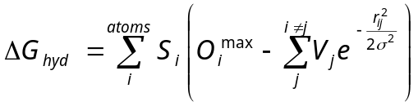 (1)

Here r_{ij} is the interatomic distance, and σ can be set equal to 3.5 Å as widely used in the literature. V_{j}, O_{i}^{max}, and S_{i} represent the atomic volume, maximum atomic occupancy, and atomic solvation parameters. Total 36 atom types were defined to differentiate the atoms in 52 SAMPL4 molecules with varying molecular sizes and shapes. Therefore, all 108 (36×3) atomic parameters should be optimized to obtain a complete form of the hydration function shown in Eq. (1). This could be accomplished by the operation of a standard genetic algorithm using the training set constructed by 88 organic molecules and their experimental hydration energy data.
The parameterization started with the definition of a generation defined with 100 vectors comprising V_{j}, O_{i}^{max}, and S_{i} parameters for all atom types under consideration, which was followed by the removal of 50 with a bias toward preserving the most fit with the lowest error. The empty 50 vectors were then filled with point mutations to alter the value of one of the parameters with probability 0.01, and with cross breeds with probability 0.6 to select some parameters from one vector to replace the elements of another vector of the top 50. The 50 new vector created in these ways were then evaluated together with the top 50. This cycle was repeated as many times as desired. To optimize the parameters, the error hypersurface was defined by the sum of the absolute values of the differences between the hydration energy measured from experiment (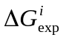) and that estimated with Eq. (1) (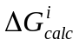). This fitness function can be written as follows.

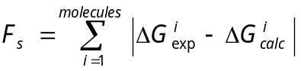 (2)

During the operation of genetic algorithm, the atomic parameters exhibited convergent behavior after 10,000 iterations with the F_{s} value of 0.42 kcal/mol. With the optimized atomic parameters in hand, the hydration energies of all 52 SAMPL4 molecules were calculated using Eq. (1).

