WEEK 3 PROGRESS REPORT
WHO DEFINES THE PROBLEM? A COMPUTATIONAL ANALYSIS OF HOW EU INSTITUTIONS FRAME ARTIFICIAL INTELLIGENCE REGULATION
11 September 2026
Project GitHub Link: https://github.com/michelle-qyh/SOSC314-Course-Project/
Division of Responsibilities
For this project stage, each group member was responsible for the following components:
Tim Maurice Steiner:
Primary responsibility: Research design and measurement strategy — cleaning rules, relevance screen, written deliverables.
Specific tasks completed this week: Specified the boilerplate, segmentation and relevance-screening rules; validated cleaned output against source documents; wrote and edited the progress report and figure.
Yuhan Qiu:
Primary responsibility: Data infrastructure and retrieval pipeline — manifestation resolution, collection, extraction.
Specific tasks completed this week: Built and ran the retrieval and extraction code (collect.py, build_corpus.py); diagnosed format availability across CELLAR; cross-checked descriptive statistics.
From Inventory to Corpus
Week 2 established an inventory of 186 in-scope documents. This week we retrieved their full texts and prepared them for analysis. The corpus now stands at 134 documents, 27,486 paragraphs and 2.03 million tokens. The two reductions — retrieval failure and relevance screening — are documented below and recorded per document in the repository.
Retrieval
CELLAR serves content at the item level, not the document level: a work has expressions (one per language), each expression manifestations (one per format), and each manifestation items holding the bytes. Content negotiation on the work identifier, used in Week 2, resolves for only part of the corpus, so we now query manifestations explicitly and fetch the item URI directly.
Format availability shapes what is retrievable. Of the 186 in-scope documents, 108 offer XHTML and 29 PDF only; 49 carry a URI manifestation alone, meaning CELLAR holds the metadata record while the file remains on the issuing institution’s register. Nine were recovered from the Council’s public register, which exposes documents at a stable endpoint. The remaining 40 — 36 Parliament committee opinions and adopted texts, 4 Council notes — sit behind an automated-access challenge on the Parliament website, which we did not circumvent. Retrieval yielded 146 documents (Figure 1). An audit of the retrieval log (03_cross_check_and_descriptive_stats.ipynb) found that documents lacking a CELLAR manifestation were absent from the log rather than recorded as unretrieved, making the true gap visible only by comparison; the log now accounts for all 186 in-scope documents. Formex XML, initially preferred as the richest format, proved to deliver only a bibliographic wrapper whose body sits in a separately referenced file; every Formex-carrying document here also offers XHTML, used instead.
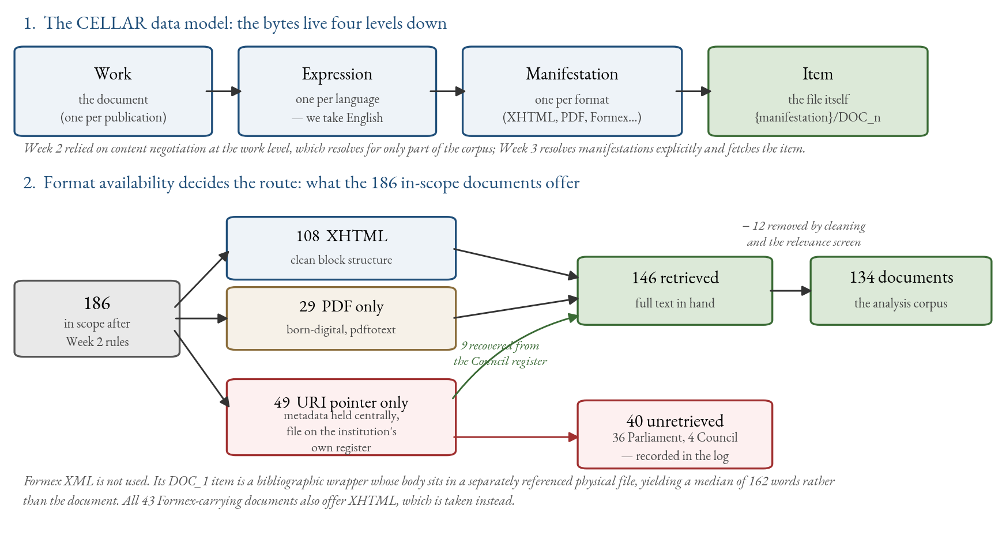
Figure 1. Retrieval. Panel 1: the CELLAR data model, in which a document's bytes are held four levels below the work identifier. Panel 2: how the 186 in-scope documents divide by available format, and the resulting retrieval outcome.
Cleaning and Preprocessing
Three decisions convert retrieved files into analysable text. First, boilerplate removal: recurring non-substantive material — publication headers, EEA-relevance notices, interinstitutional file numbers, distribution markings, pagination — is matched by pattern and dropped. Second, paragraph segmentation: documents are split on blank lines, and segments below fifteen words are discarded as fragments. Third, normalisation of whitespace and HTML entities. Preprocessing stops there deliberately: tokenisation, stopword removal and lemmatisation are model-specific and will be applied inside each analysis rather than baked into the stored corpus, keeping alternative specifications available for robustness checks.
Measurement Decisions
The unit of collection and of institutional comparison is the document; the unit of measurement is the paragraph, because institutional texts are long and mix several frames. The median paragraph runs 49 words, which is short enough to carry a single frame and long enough to classify.
Relevance is measured as AI mention density — matches of an explicit AI vocabulary per 1,000 words — rather than a raw count, so a short note naming AI twice is not penalised against a long evaluation naming it four times. The vocabulary is deliberately narrow: artificial intelligence, AI, the AI Act, machine learning, general-purpose AI, foundation and generative models, AI systems — but not generic terms such as digital, data or algorithm, which pervade EU technology policy regardless of subject. Documents below 0.5 mentions per 1,000 words, or under 200 words after cleaning, leave the corpus. The length floor follows from the measurement unit: at a median paragraph of 49 words, a document under 200 words yields too few paragraphs for a stable frame profile. A committed sensitivity analysis shows the choice is conservative in the right direction — raising the floor to 300 words would cost four Council documents and one Parliament document while leaving the Commission untouched — and that the density threshold does little work below 1.0. The screen is the systematic version of the manual check reported in Week 2. It removed 12 documents, including an 11,941-word recommendation carrying four AI mentions.
Descriptive Statistics
The corpus comprises 75 Commission, 31 Parliament and 28 Council documents. Coverage against the Week 2 inventory is uneven — 96 per cent for the Commission, 72 for the Council, 45 for Parliament — and this, rather than institutional output, now drives the imbalance (Figure 2). Median document length is 9,145 words for the Commission, 7,276 for Parliament and 4,421 for the Council, consistent with the Council’s concentration in short procedural notes; the Council’s distribution is also the most dispersed, mixing very short notes with occasional long compromise texts (Figure 3). Median paragraph counts follow the same pattern — 134 for the Commission, 97 for Parliament, 68 for the Council (Figure 4a).
AI mention density is lower for the Commission (8.9 per 1,000 words) than for the Council (13.1) or Parliament (15.0), and 37 per cent of Commission paragraphs contain an explicit AI reference against 52 and 49 respectively (Figure 4b). This may suggest that the Commission embeds AI within broader digital-policy documents while the other two institutions address it more directly, but the pattern is descriptive and will be tested rather than assumed in the analyses that follow.
Planned Analysis
Four approaches follow, in increasing order of commitment. Distinctive-language analysis (Fightin’ Words) establishes which vocabulary separates the institutions; it is interpretable and assumption-free, so it serves as the baseline against which later results are checked. Unsupervised topic modelling then identifies themes without imposing our categories, guarding against finding only the frames we expected. Frame classification at paragraph level is the direct hypothesis test, validated against a hand-coded sample before use. Similarity measures track whether language converges as legislation moves toward adoption. Because Council compromise texts reproduce Commission base text, an inherited-share variable will be computed first, and non-inherited passages analysed separately.
Limitations
Parliament coverage at 45 per cent is the principal threat to comparability, and it is systematic rather than random: the missing documents are committee opinions, amendment lists and adopted texts, precisely the genres in which Parliament states and negotiates positions. All eight amendment lists and all ten committee opinions are absent. One consequence cuts the other way: amendment lists most heavily reproduce Commission base text, so textual inheritance affects this corpus less than anticipated. Week 4 will attempt recovery through the Parliament Open Data Portal; failing that, Parliament findings will be reported as resting on resolutions and reports alone. PDF-derived text, supplying 20 of 28 Council documents, carries more formatting noise than XHTML: boilerplate stripping removes a median 1.2 per cent of words from PDF-derived documents against 0.01 per cent from XHTML. A check of ten cleaned documents prompted a revision of the patterns — Council subject-code strings and routing headers were initially surviving into the text — after which all ten yielded substantive opening paragraphs.
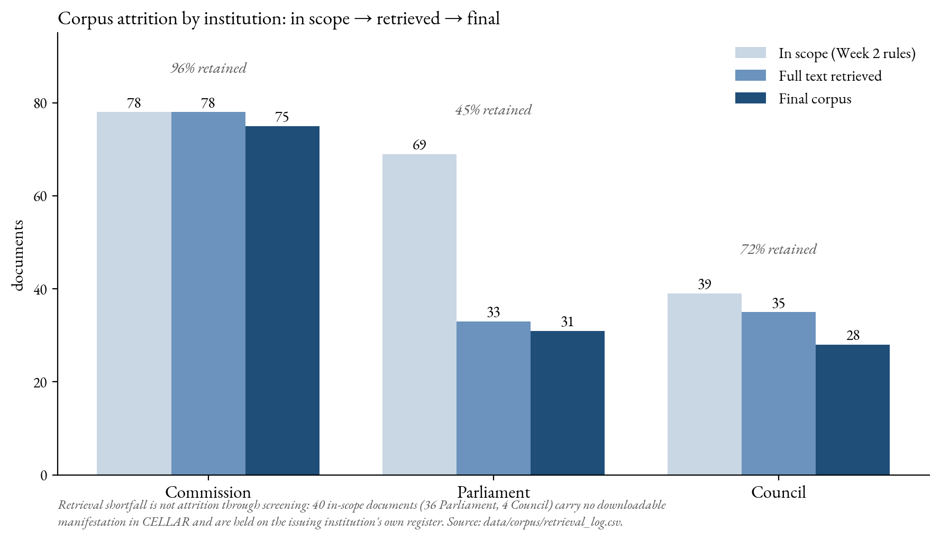
Figure 2. Corpus documents surviving each stage, by institution: in-scope inventory (Week 2 rules) → full text retrieved → analysis corpus after cleaning and relevance screening.
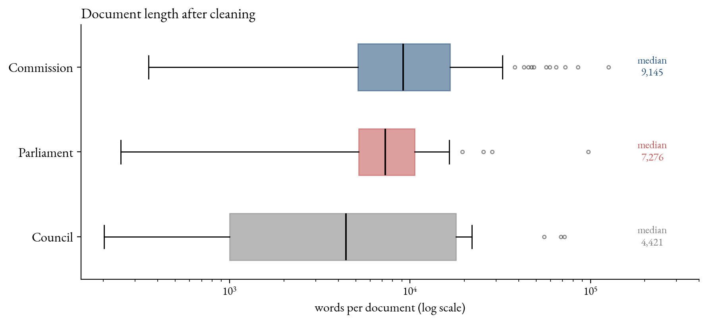
Figure 3. Document length after cleaning, by institution (log scale).
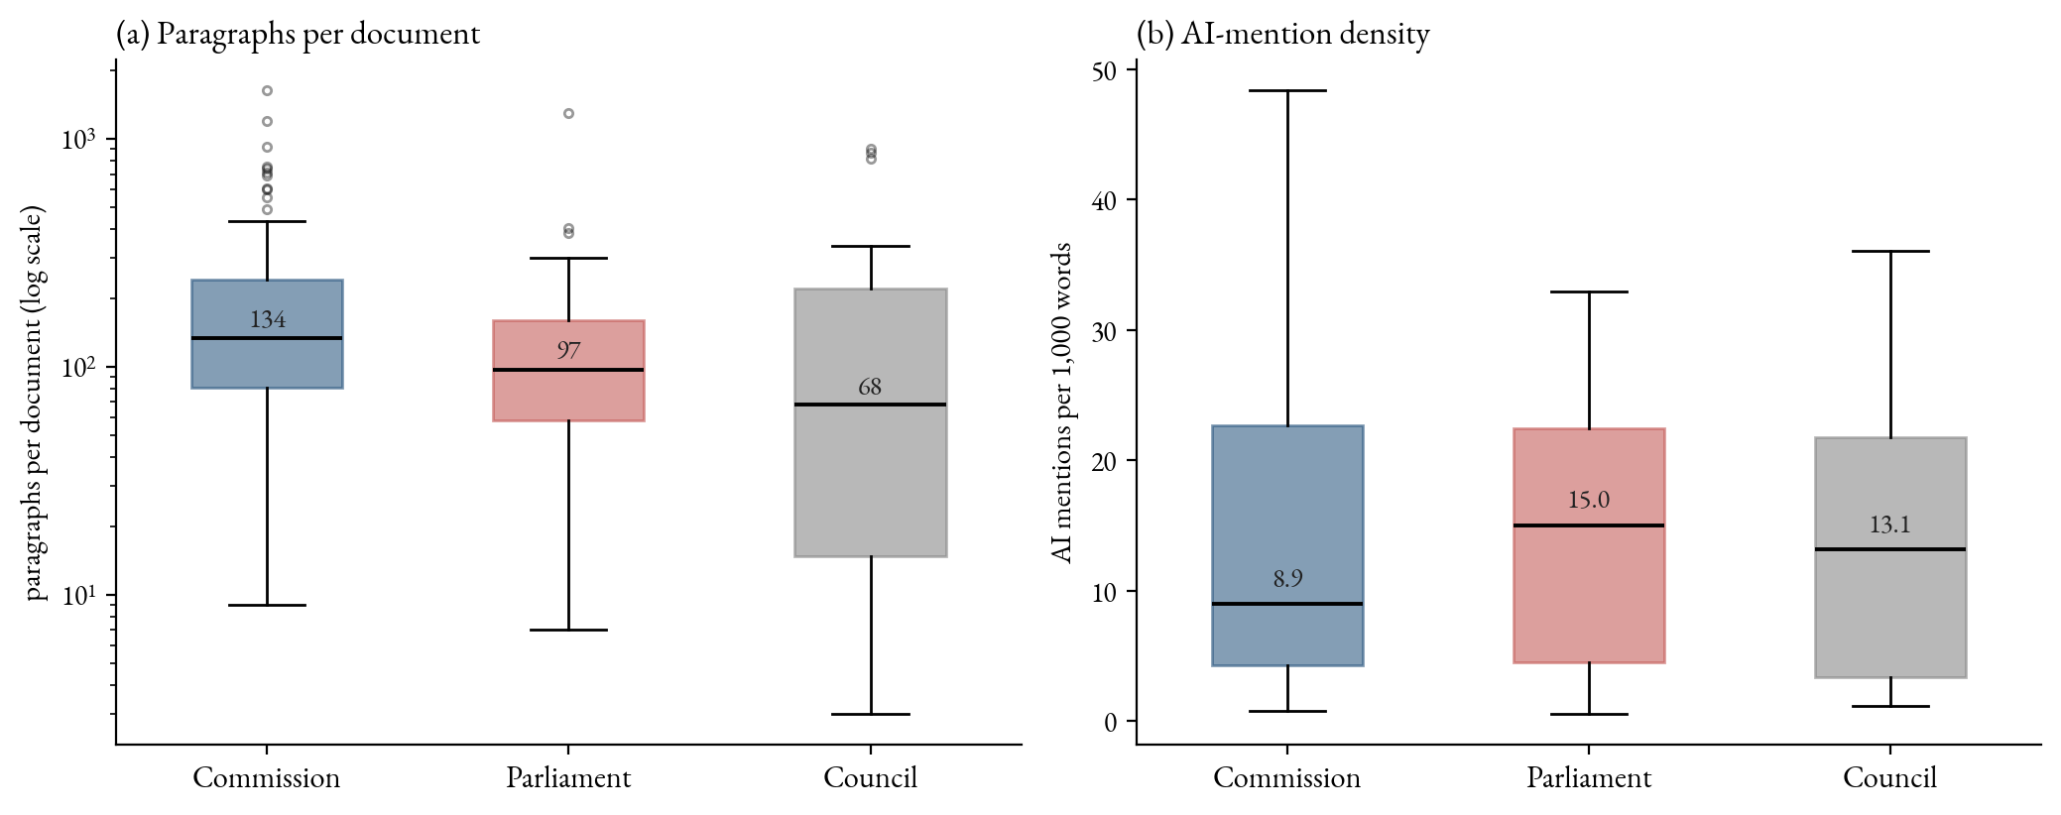
Figure 4. Panel (a): paragraphs per document, log scale. Panel (b): AI-mention density, matches per 1,000 words.

