
FDA approved Sotyktu for active PsA
Company: BMS  Drug: Sotyktu (deucravacitinib, oral TYK2 inhibitor) | Date: March 6th, 2026  Source(s): Press release, FDA label

What happened:
- On its March 6th PDUFA date, the FDA approved Sotyktu (deucravacitinib, oral TYK2 inhibitor) for the treatment of adults with active psoriatic arthritis (PsA)
  - Approval is based on the positive results from the Phase 3 POETYK PsA-1 and POETYK PsA-2 studies
  - Approved dosage: 6mg once daily in adults
  - Consistent with the PsO label, Sotyktu is associated with the following warnings and precautions: hypersensitivity reactions, infections, tuberculosis, malignancy including lymphomas, rhabdomyolysis and elevated CPK, laboratory abnormalities, immunizations, and potential risks related to JAK inhibition
- The FDA label and HCP website have been updated; the patient website has not been updated yet to reflect the approval
Impact (CI PoV): HIGH
- The FDA approval makes Sotyktu the first and only oral TYK2 inhibitor approved for adults with active PsA, expanding its 2022 approval in moderate-to-severe plaque psoriasis (PsO)
  - This approval allows BMS to establish early physician familiarity and real-world evidence ahead of emerging oral competitors such as JNJ’s Icotyde (icotrokinra, oral IL-23R antagonist) and Takeda’s Zasocitinib (TAK-279, oral TYK2 inhibitor), with approvals expected in Q1 2028 and Q3 2028, respectively
Why it matters:
- The approval offers a new once-daily oral option that may appeal to patients seeking an alternative to injectable biologics while potentially providing a more manageable safety and monitoring profile than JAK inhibitors


Tell me more:
- FDA approval is supported by the Phase 3 multicenter, randomized, double-blind, placebo-controlled POETYK-PsA-1 and POETYK-PsA-2 trials that evaluated the safety and efficacy of Sotyktu in adults with active PsA
- Study Design
  - POETYK PsA-1 included 670 patients with active PsA who were bDMARD naïve
  - POETYK PsA-2 included 624 patients with active PsA who were bDMARD naïve or had previously received TNFα inhibitor treatment; the trial also included an apremilast safety reference arm
  - Primary endpoint: ACR20 at Week 16
- Study Results
  - Efficacy:
    - Both trials met their primary endpoints, demonstrating sustained improvements across joint pain and swelling as well as psoriatic skin lesions
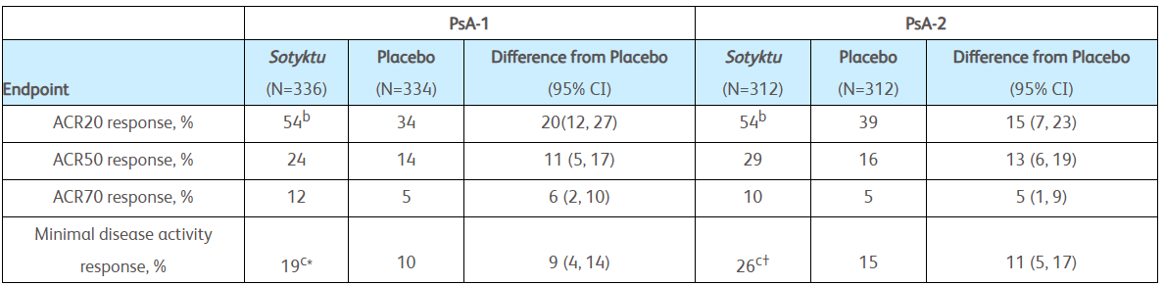

  - Safety:
    - The overall safety profile in active PsA was generally consistent with the safety profile previously seen in PsO
    - Most common adverse reactions were upper respiratory infections, increased blood creatine phosphokinase, herpes simplex, mouth ulcers, folliculitis, and acne
  - HRQoL:
    - Improvements were seen in SF-36 PCS score at Week 16 compared to placebo (key secondary endpoint)
    - Improvements were also reported across all four SF-36 PCS domain scale scores: physical functioning, role-physical, bodily pain, and general health
- Outlook:
  - Regulatory applications for Sotyktu are under review in the EU, Japan and China
  - Pediatric PsA: Phase 3 study ongoing; PCD: March 2030
  - SLE: Phase 3 POETYK-SLE-1 & POETYK-SLE-2 ongoing, with data expected in 2026; PCDs: October 2026;
  - SjD: Phase 3 POETYK-SjS-1 ongoing, with data expected in 2027; PCD: November 2026

