**<Instruction: How to set up/ open our Finance Management Website>**

1. Extract the zip files (**apache24 and php8**) and then **locate them in C:// drive** on your local machine.

2. Go to **cmd (Terminal)** and type/follow with this path: take a reference below picture. And then operate this code.

3. Go to C drive on your local machine **[C:\Apache24\bin]** and then operate **ApacheMonitor.exe**

4. Locate our project file in **[C:\Apache24\htdocs]**

**Set up Database**

1. Download **mySQL** program. (**workbench**)

2. Go to our project files named **graph.php and manage2.php**. You will find the **$pw part**. Change their password part to your password of your database (mySQL) : original Database password is set up as 1234.

3.Create database name**(schema) as ppmDB**.

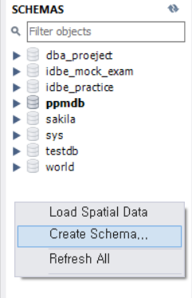

4.Download the database files that I have attached in the project files.

5.**Import the database files** in mySQL (**Server menu 🡪 Data Import**)

