**Abtract**

The project for Practical Project Management module was asked to design and develop a product for a client. The idea of our team is to build up a website which can provide a way for customers to manage their financial condition. The reason is that people used to write the company financial information in a notebook, even nowadays. Using a calculator to work out a series of numbers. Also handwriting to record the product transactions. Even if some people use Excel to document all the data, they still need to work on different places. Therefore, our team decided to build a website which could help clients to manage memory, also in a more convenient way.

**Contents**

1. Introduction

1.1 - Aims

1.2 - Objectives

1. Existing Solutions

2.1 Current Products

2.2 Product Demand

2.3 Company information

1. s
2. **Design and Development**

**4.1 Use cases**

**4.2 Website Design**

**4.3 Software Development**

**4.4 Database Software**

1. Evaluation of Production

5.1 Requirements

5.2 Website Functional Testing

5.3 Database Functional Testing

6.Evaluation of Product

Appendix 1 - Current Products

Appendix 2 - Website Function Testing

Appendix 3 - Database Function Testing

**1.0 Introduction**

1.1 Background

Money management is always a serious problem for humans. Society needs transactions to operate, and most of the transactions are made with money and products. Therefore, money has become one of the important items in the world. To prevent the inconvenience of recording finance situations on a local PC by Excel (this is the most popular way to mark down the data), for example, the company will lose information when the person in charge forgets to save it. This is the reason finance websites have been developed to address this problem, the website allows clients to input the income and outcome, records the data in the website and shows it on the screen. The other function of our website is to count all the numbers, for example the website will show the total expense and income number that the client input, and the website will calculate the balance of the client, showing is the client earning money or losing money. By showing the balance, the client can decide what is the next step of his business. Edition also allows the client to delete the incorrect data on the website.

Graphs function also available for the client to use, the website can show two types of graphs, two of the area charts and one pie chart. First area chart shows every spending of the client, the second area chart shows the income of the client. Clients can easily know the status of income and outcome by looking at the area charts, the higher point on the chart the higher the number of the client input. The pie chart shows the total income and total expense, therefore the client can realise whether the income is more or the outcome by one glance, also the pie chart will show the percentage of two types of data. There is the About us page on the website, which could tell the audience about the company. In the final page, the website provides a method for clients to contact the development team, the page also with map, address, contact number and email address.

1.2 Aims

The main aim of this project is to build a website to provide some good methods to help clients manage the company finance, reducing the time of typing same things and pay attention to the formal is the problem of nowadays people to record data. This website can totally make the data look better.

1.3 Objectives

From the beginning of designing the website, the team is aiming to achieve a variety of objectives to make the website useful and color friendly. The team has achieved the following objectives as we planned.

* The website is able to store data from client input.
* The website is able to calculate the number of stored data.
* The website can display information by charts.
* The website has a soft and dark color scheme for preventing the tiredness of client’s eyes.

The team firstly meets the objective of storing data from client input, a database is created for saving the clients’ data and displaying it on the website. The javascript allows the development team to give the function of calculation to the website, and also shows numbers on the area charts and pie charts. At the last, the development team decided to set a picture full of numbers and different charts to be the background picture.

**2.0 Existing Solutions**

2.1 - Current Products

When the team decided to create a website, the development team knew that there were many similar websites on the internet. The reason is that the website is too convenient for users to visit and still able to develop many functions. Therefore, the following products gave the inspiration to the development team to improve the website.

|  |  |  |  |
| --- | --- | --- | --- |
| Product name | Key Features | Strengths | Weaknesses |
| Excel | Provide form for user to input data and store data locally | save data without a database. | can only store data locally.  The user needs to create form and calculation by doing more action. |
| Bank | Can show income and outcome of your money | users do not need to input data, the bank will know. | Users can only see all the action on the bank, but can not record the particular type of data. |
| Mint financial management | Show income, outcome and charts | Many functions included, for example alerts setting and budgets setting. | The layout is a little complicated, will not know how to start at the beginning, and also need to register and sign in. |

2.2 Product Demand

From “The Gazette” official public record, there were a total 12,557 underlying company insolvencies in 2020 in England and Wales, compared to 2019, there was about 27 percent decrease. The data shows there are many company insolvencies these years, although the number has decreased but 12,557 is still a large number. The main reason a company goes bankrupt is the loss of money. When a company runs out of money, the company is not able to maintain normal operation. I believe that more companies look for financial management tools to avoid the money management problem.

2.3 Company information

From the investigation of the development team, many companies are still using notebooks to record the data, especially small companies like coffee shops and small restaurants. The reason is that many staff of small companies do not understand computers very well. If the staff have lack of knowledge on Excel, the boss might prefer to use pen and paper to record the income outcome every working day. For this, this developed website is simple and easy to use, less function also means high practicality, the website provides one main function so the company staff can be fully understood in a short period of training time.

**3.0 NEW IDEAS**

The project aims to solve issues with untracked income and expenses. Different applications have been developed to curb these problems. However, the group introduces the addition of new features to properly satisfy the needs of a user. The project incorporates a graphical representation and visualisation of income and expenses.

The system produces a line graph indicating income and expenses at the entered dates, showing its variation within a certain period of time. It also produces a pie chart indicating the difference between a user’s total income and expenses so far.

**3.1 Functional Requirements**

The system developed tracks a user’s income and expenses by implementing certain functionalities. The ideas for these functionalities were developed by the group, making sure to satisfy requirements of a basic finance management application.

These features are listed as follows;

FR2 – A form for income and expenses entries

FR3 – The system will insert the income and expense data into the database

FR1 – A registration form with password validations

FR3 – A page listing details of all income and expenses entered into the system as well as a total sum

FR4 – A graphical representation of all income and expenses as well as the total sum

FR5 – A contact-us form which accepts the user’s information for communicating purposes

The key functional requirements - A form for income and expenses entries (FR2) and A page listing details of all income and expenses entered into the system as well as a total sum (FR3) had to be implemented before coming up with ideas on new features and incorporating them.

The new feature added was incorporating a graphical representation of all income and expenses. Based on the research of existing products there is no finance management platform. Hence, it was decided that this system will make use of this feature. The group believes that this feature will be useful as it improves user experience of the system by simplifying analysis.

3.2 Non-Functional Requirements

The non-functional requirements of the system are listed below

NFR1 – The system should be easy to maintain

NFR2 – The system should be easy to use and navigate through

**3.2.1 Security**

It’s important for the user’s financial status to remain confidential. Therefore, the a user’s income and expenses that will be stored needs to be secure. To achieve this the users need to register before using the app. A user’s financial details will be stored in a database through which an unauthorised admin user can have no access to.

**3.2.2 Maintainability**

The application is built on HTML, CSS and PHP which is quite easy to navigate through. Changes can be made to the database schema explicitly by. Using the MySQL Workbench.

**3.2.3 Scalability**

The application is designed to be used by thousands of users as MySQL has the capabilities to store that amount of data. Moving forward, cloud technologies for storage might be considered to improve scalability of the app. The system works on any web browser for PC’s and mobile devices.

**3.2.4 Usability**

The application is usable by a wide variety of different people from students to job owners. It caters to everyone and is simple to use or navigate through pages. The color scheme of the application creates a contrast which makes it easy to read texts and buttons.

**4. 0 Design and Development**

**4.1 Concept map**

One of the first major tasks taken in the design and development stage was the creation of a concept map. A concept map is a diagram that links the different ideas of a project together. By creating one it allowed the group to visualise the tasks that needed to be completed and how the project would fit together. The concept map was broken down into the 4 major aspects of the application. As shown below:

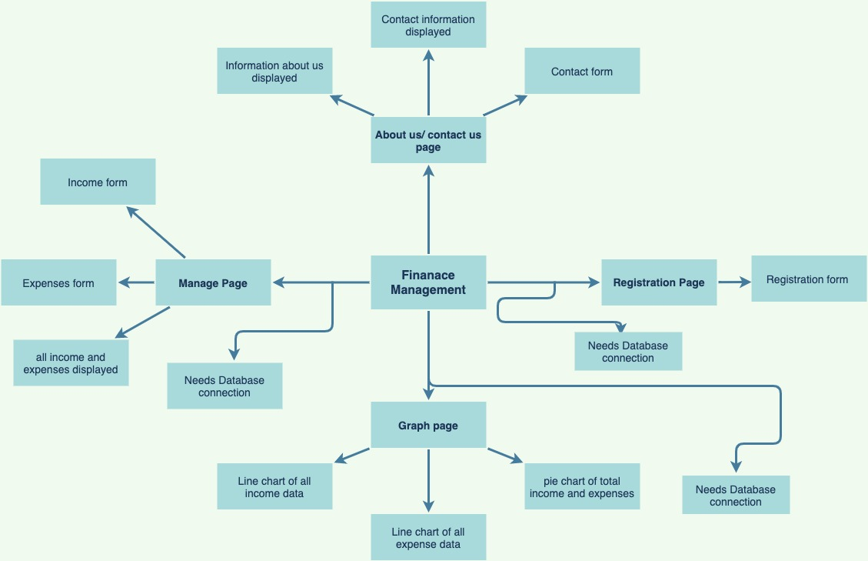

concept map

**4.2 Use cases**

One of the next stages of development was to produce the use cases. These are used to analyse the key activities that take place within the system. Use cases are determined by the systems functional requirements, however only the main processes are documented in use cases. The major use cases for our system include; measuring the power consumption, inserting the data into a database, presenting the data via a web interface, and sending the data to the user via social media. The design of the system will be based around these use cases, so it is important that they are completed before the design phase starts.

|  |  |  |  |  |  |
| --- | --- | --- | --- | --- | --- |
| ID | Use Case  Name | Short Description | Major input | Major output | Destination |
| 1 | Income form | Enter income details | ------ | ----- | Database |
| 2 | Expense form | Enter expense details | ------- | ------ | Database |

**4.3 - Data Flow Diagrams (DFD)**

Sketching a data flow diagram was another key process in the development stage. These diagrams are used to visualise how data within the system flows and are stored.

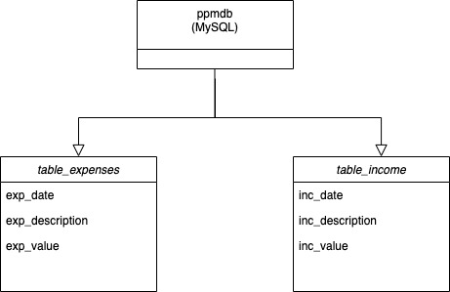

context DFD

**4.4 Website Design**

The website was designed with HTML and CSS.

Below are images of the web pages.

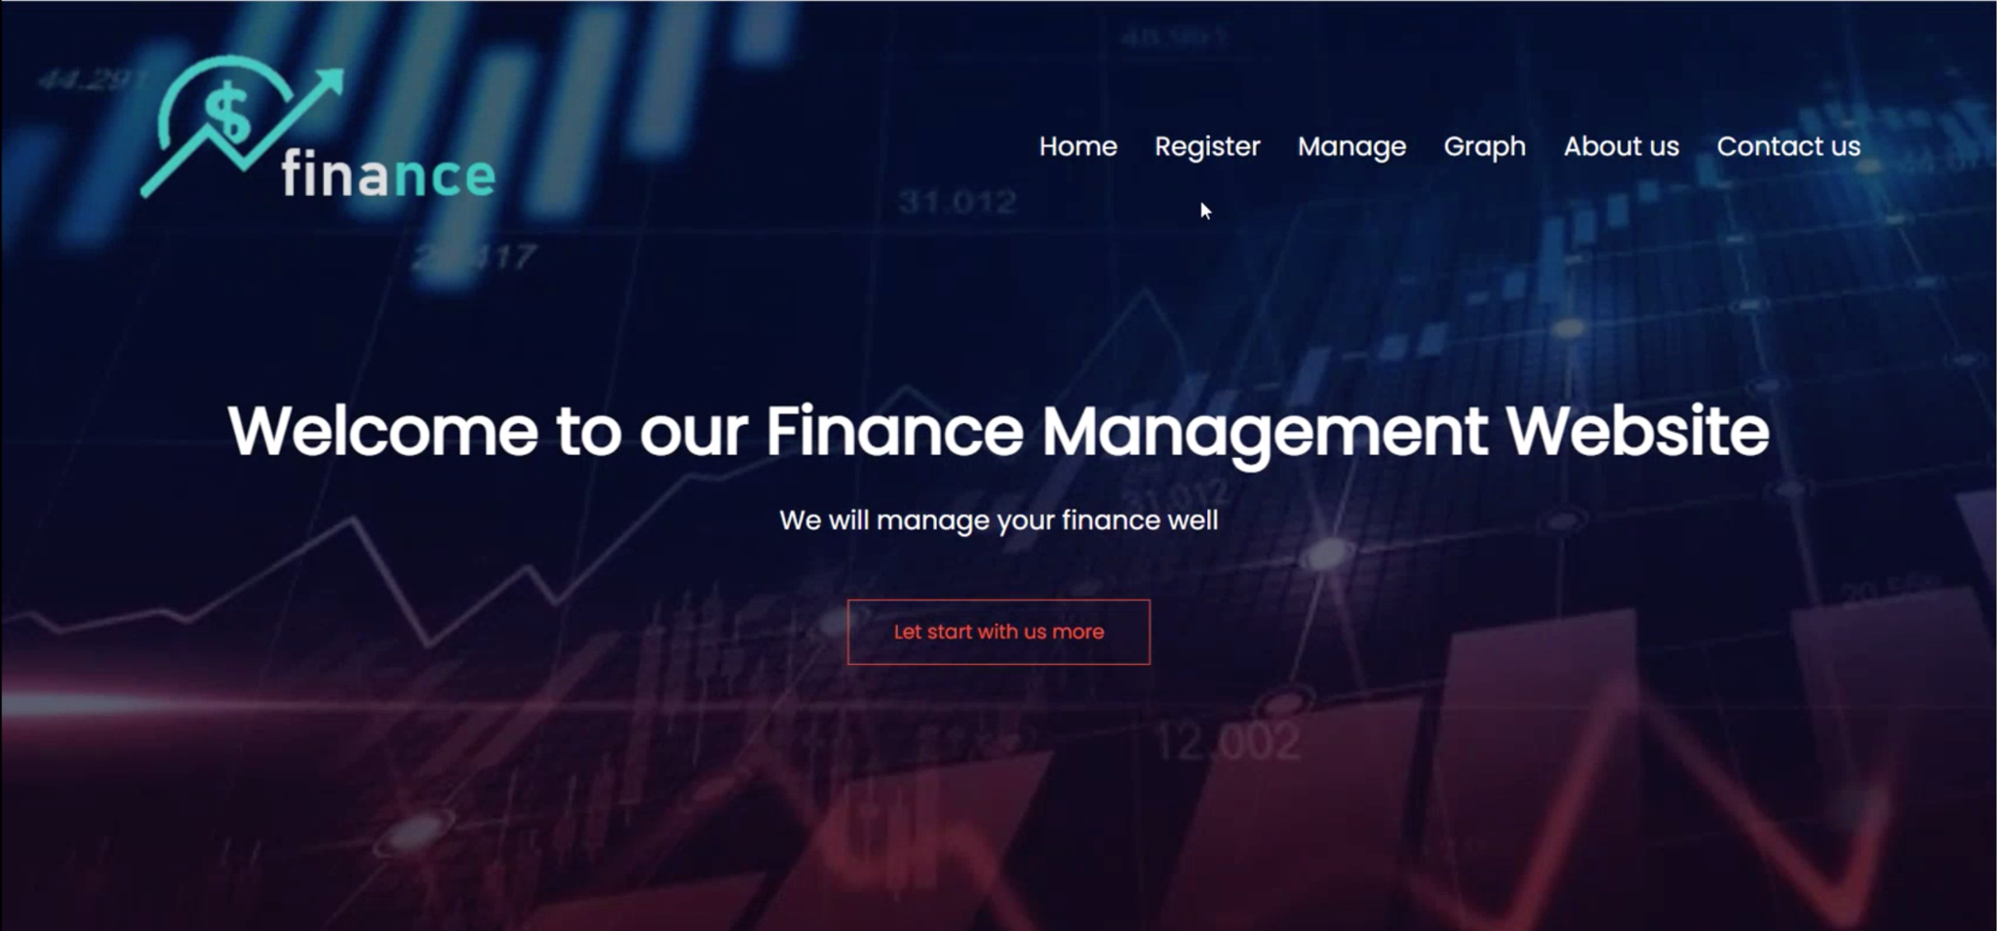

Home page

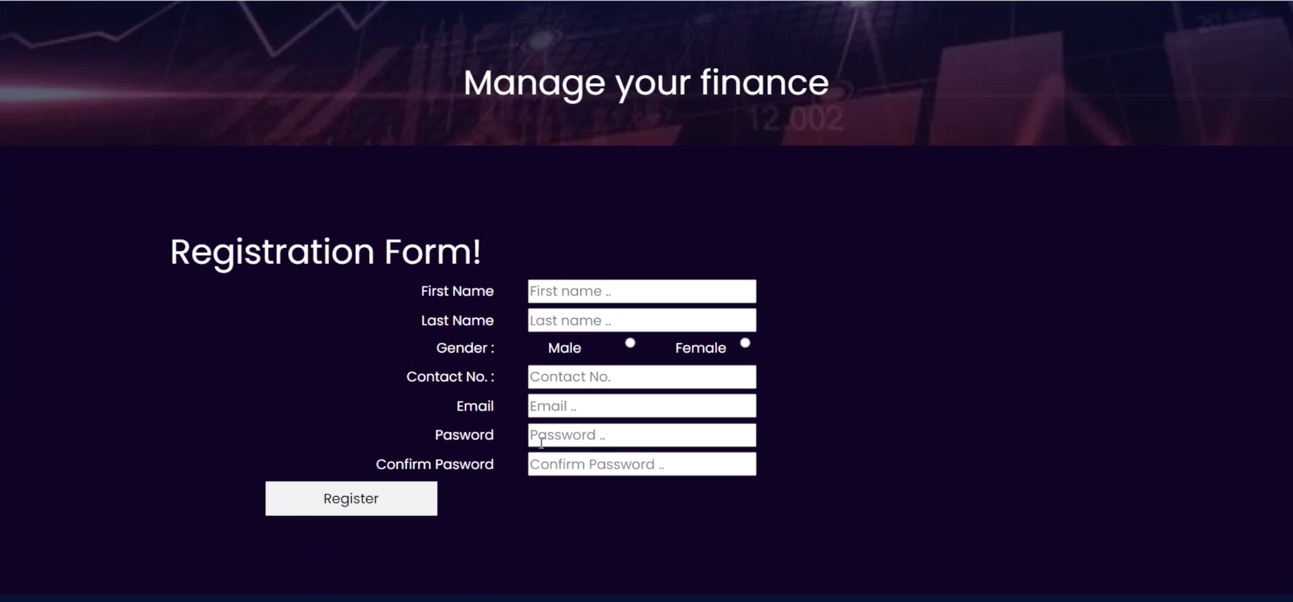

Registration form

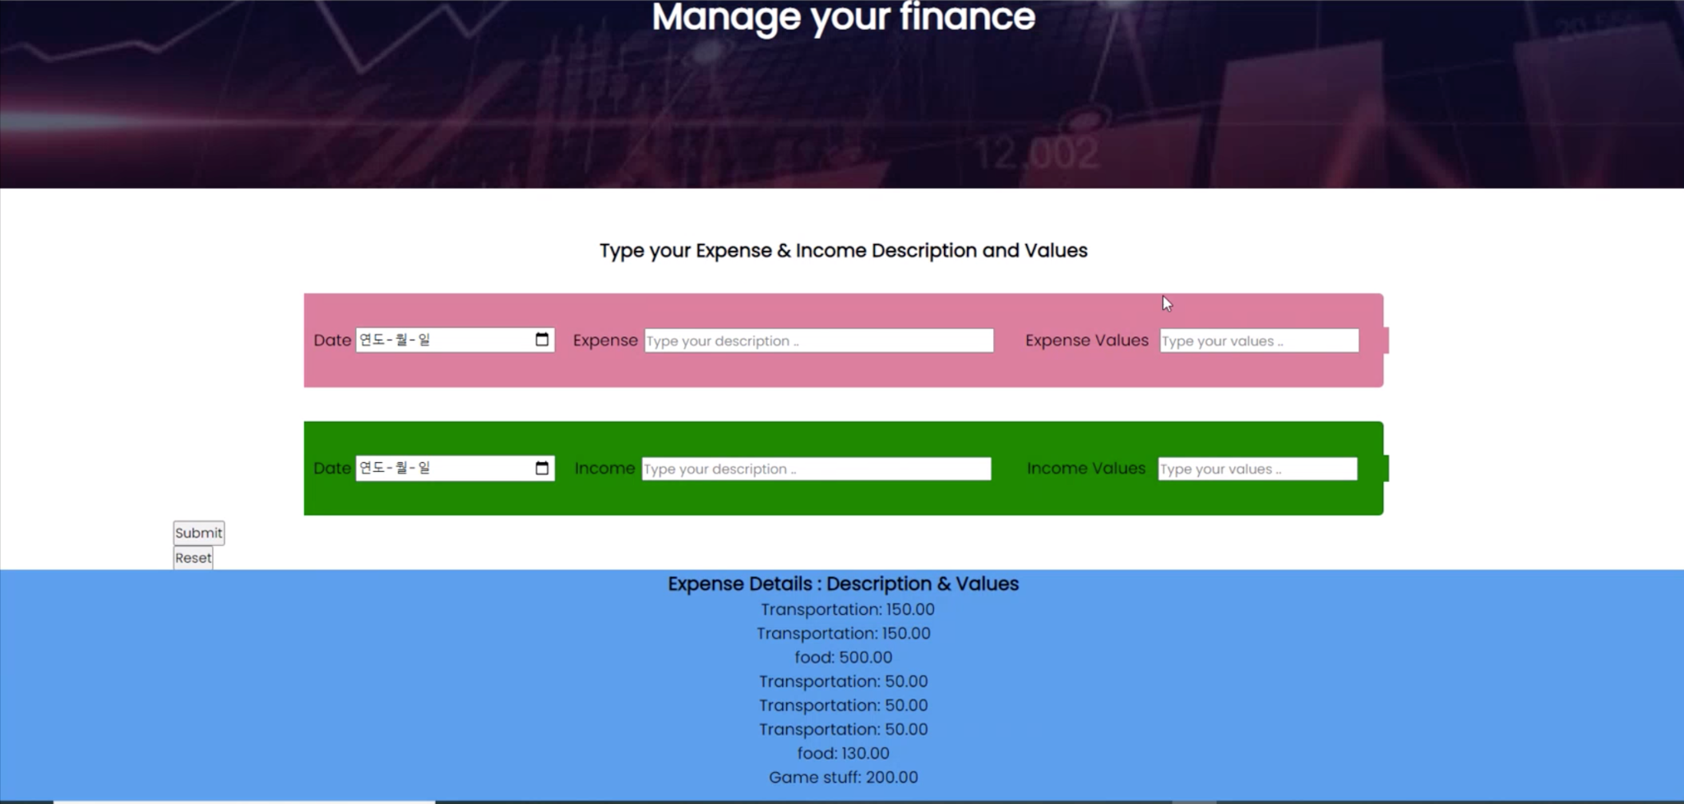

Income and expense form

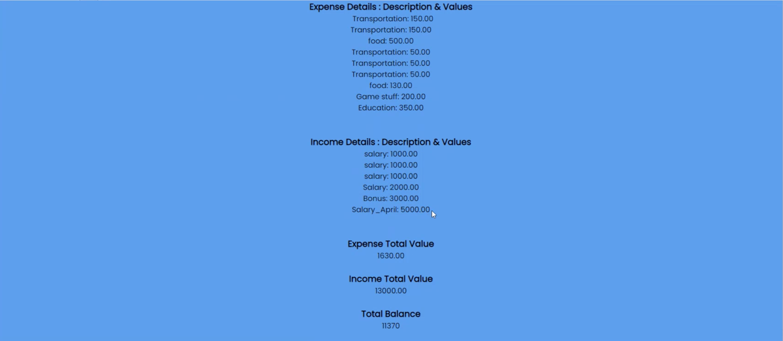

List of all filled income and expenses

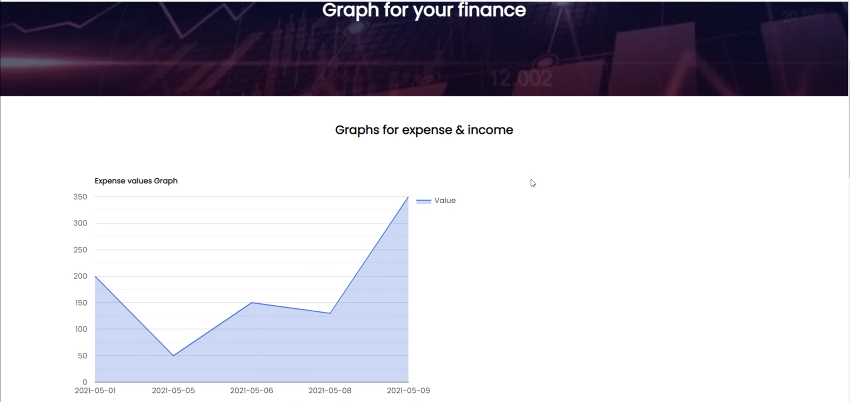

expense graph

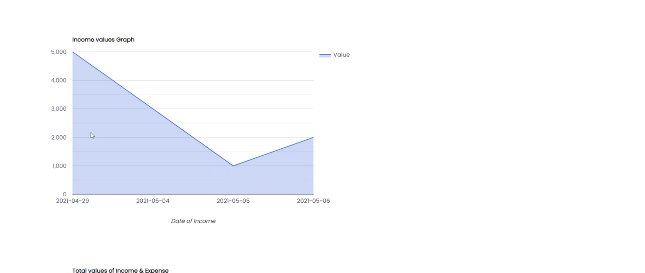

income graph

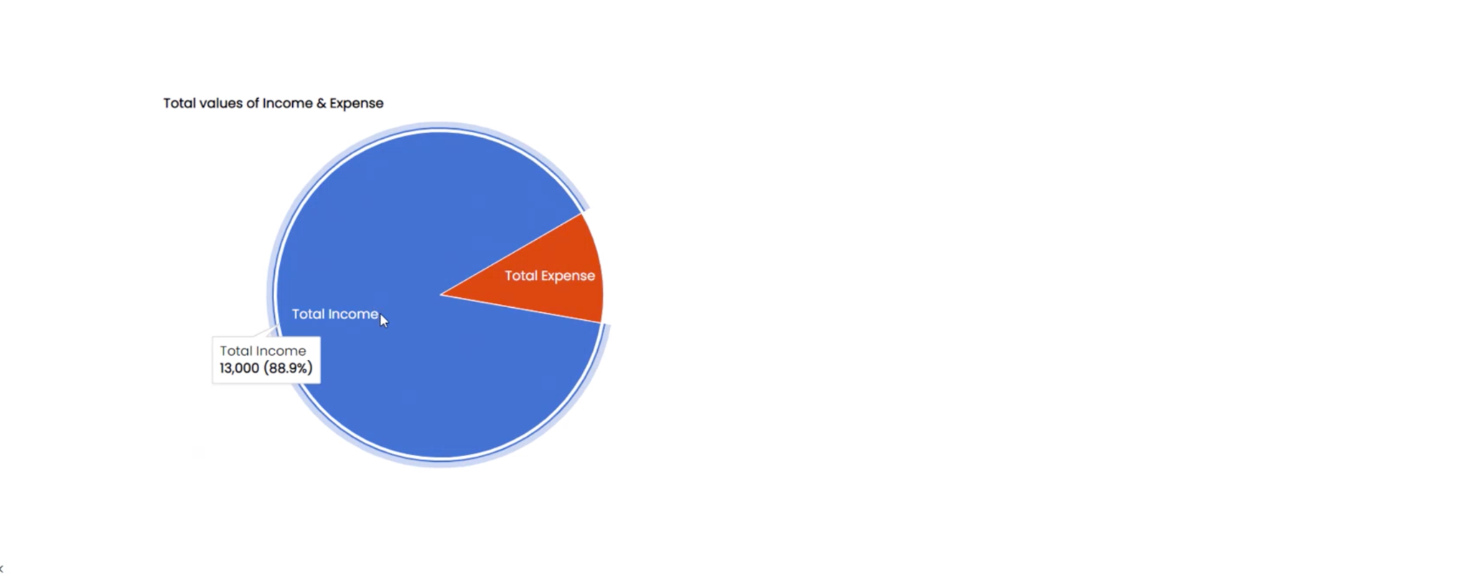

total expenses and income pie chart

**4.5 Software Development**

The entire software was developed using HTML, CSS and PHP with the visual studio code editor.

HTML – to develop web pages and contents

CSS – to style web pages

PHP – for backend scripting, to connect with database and read data from database

**4.6 Database Software**

MySQL was chosen because it is included with XMAPP which would be used to set up the website, as well as its ability to integrate with websites.

MySQL integrates well with other aspects of the system such as the web interface. This is important as the website will need to make queries on the database to display data for the user.

**5.0 – Evaluation of Production**

After the product development, one of the important steps is testing, it is an indispensable step for developing a product, the aim of product testing is to find failures, and make sure that it can run successfully and verifying that the product is suitable for using and satisfies the criteria or requirement. The appendix 2 will show the website testing and the appendix 3 will show the database testing.

● provide a User-friendly Interface

A user-friendly design clean and simple is so important for attracting users, and making sure users have a good experience for using the application. To ensure it is a user-friendly design, it is going to be tested by three testers if they are able to use it easily and without any problem.

● Users need to register in the register page

Before users want to check or manage their own stats, they must register in the register page first. For the registration, they need to enter their personal information, for example, first name, last name, contact no, email etc.

● Able to manage the user’s income and spending data

In the Mange page, users can type their expense and income description and values, so they will know what they have spending money and how they get the income. The upper part is managing the description and value, and the bottom part is showing the details.

● Able to show the user’s finance with graph

After the user enters their information, there are some graphs showing the user's finance in the graph page, so the user can check their finance clearer to know their finance changes and the percentage of income and expense.

● the website design looks professional and simply

The logo and the background are also related to finance, so once users visit the website, they will know what the website is about, and a good design can make it attractive to the user to keep using it.

● the website is connected to the database for storing data

A SQL database is connected to the website, which is a table containing the collections of records and attributes. When users enter their details of expense and income, the database will store and process the data . In the stats page and graph page, the data will correspond to the correct place with the website. For example, description of expense and income, values, date.

● The data can be modify by user

After users insert their data to the database, if users notice they made some mistake and want to make changes, they can delete or modify the data by themselves. This is very useful for users when they insert the data wrong by accident.

**5.1 Requirements**

There are all of the requirements which we fulfilled for the website:

* The website will display graph of the stats
* The website will show the stats what users inserted
* The website must have a navigation bar for different pages
* The website must allow users can type in the description of income and expense
* The website must allow users can type in the value of income and expense
* The website must allow users can type in the date of income and expense
* The website should show the information about our company
* The website should have a page for users contact us

**5.2 Website Functional Testing:**

The testing ensures all the functions of the website are working as expected and successfully. Out of the 14 tests 1 of them failed, this is about the password confirming do not have showing the message that the confirm password is not the same as the password. The notice message is not showing because the member who is coding this function is missing that. Other 13 tests were all successful.

**5.3 Database Functional Testing:**

This is the second part of testing, this website is connected to a SQL database. It is so important for the website because most of the functions are depending on the database. For the database functional testing, there are 9 tests and all of the tests were passed. All data are storing and modifying successfully.

**6.0 Discission/Conclusion**

The project is almost finished, and the website of the project is nearly complete. The website is connected to a database, and almost all the functions are fulfilled. Our website is about finance, its aim is helping users to manage their finance better. Users can check their finances easily and analyze it more conveniently. The website can let users manage their stats and make some graphics about the stats currently. All the data which users inserted will be stored in the database and the website can get the data from the database. However, the register page is not really working, it is just a form, users can input their own information, but it can not store the information to the database to register an account. Another task remains to do is the contact page, it is the same as the register page. Users can input the data, but it is not working, because it is not connected to the database.

For this project, all the group members have been able to learn about website development and design, SQL database coding and project management. After finishing the website, each member learned how a website is able to help humans in real life. From the project management, each member knows how to assign different tasks for which members are good at the tasks, so the project will be finished earlier and better. Also, set all the deadlines of different deliverable submissions, let members have enough time and a good time planning to finish their own work more perfectly.

Before the website should keep developing, there are some legal, ethical and social issues that must be considered. The first ethical issue is disclosure concerns, the privacy of everyone is one of the important things in their life, if the details disclosed, users will feel not safe and not confident in this product, so the product will get negative feedback and no more users will choose this product. Also, their privacy loss is the biggest loss for them. Therefore, the product must totally grasp the cyber safety technology to avoid customer’s privacy loss.

Under legal issues, financial websites must ensure the highest level of privacy with customers, so the company can not provide customer information to any authorities, besides the information requested by authorities in power, for example police,the court or the government. Also, this can provide some strict verification methods to make customers feel safe to visit the website.

**Appendix 1 - Current Products**

Excel has become one of the most popular software that used for storing data, however it takes too much time to input data into Excel.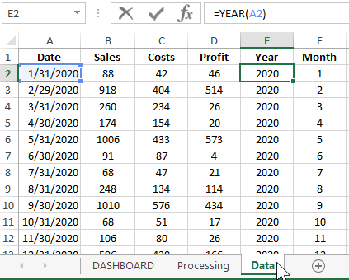

**This is the bank account, the bank website can actually show the income outcome from your activities.**

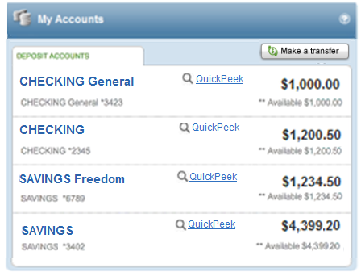

**Mint financial management website is a website that includes many functions and allows users to save what the user input, display the charts and data.**

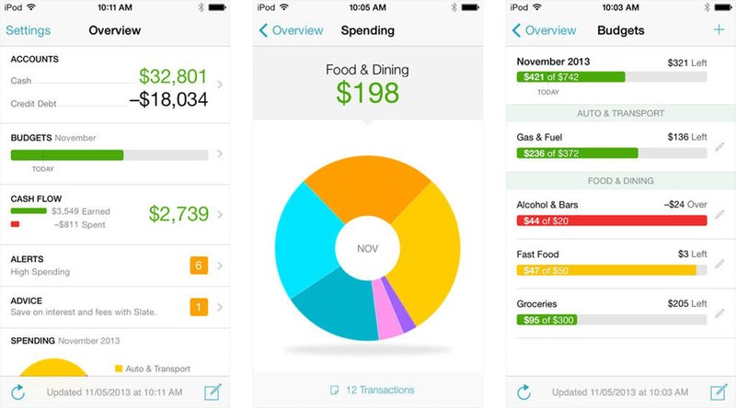

**Appendix 2 - Website Functional Testing**

|  |  |  |  |  |  |
| --- | --- | --- | --- | --- | --- |
| # | Test | Expected Result | Actual Result | Pass／Fail | Fix |
| 1 | Register page- Contact number not integer | The expected result from this test was showing the message that the contact number must be integer. | The actual result from this test was showing the message that the contact number must be integer. | Pass | N/A |
| 2 | Register page- email must include “@” | The expected result from this test was showing the message that must include “@”. | The actual result from this test was the message that must include “@”. | Pass | N/A |
| 3 | Register page-password not more than 7 numbers, 1 upper case and lower case | The expected result from this test was showing the message that must be more than 7 numbers, 1 upper case and lower case | The actual result from this test was the message that must be more than 7 numbers, 1 upper case and lower case | Pass | N/A |
| 4 | Register page-confirm password | The expected result from this test was showing the message that not same | The actual result from this test was no message saying the passwords are different. | Failed | N/A |

|  |  |  |  |  |  |
| --- | --- | --- | --- | --- | --- |
| 5 | Manage page- user can input the description of expense | The expected result from this test was insert successful | The actual result from this test was insert successful | Pass | N/A |
| 6 | Manage page- user can input the description of income | The expected result from this test was insert successful | The actual result from this test was insert successful | Pass | N/A |
| 7 | Manage page- user can input the value of expense | The expected result from this test was insert successful | The actual result from this test was insert successful | Pass | N/A |
| 8 | Manage page- user can input the value of income | The expected result from this test was insert successful | The actual result from this test was insert successful | Pass | N/A |
| 9 | Manage page- showing the details below after users submitted | The expected result from this test was showing the details below | The actual result from this test was the details below | Pass | N/A |
| 10 | Manage page- showing the expense total value | The expected result from this test was able to show the expense total value | The actual result from this test was able to show the expense total value | Pass | N/A |
| 11 | Manage page- showing the income total value | The expected result from this test was income total value | The actual result from this test was income total value | Pass | N/A |
| 12 | Manage page- showing the total balance | The expected result from this test was showing the total balance | The actual result from this test was showing the total balance | Pass | N/A |
| 13 | Graph page- showing the expense values graph | The expected result from this test was showing the expense values graph | The actual result from this test was showing the expense values graph | Pass | N/A |
| 14 | Graph page- showing the income values graph | The expected result from this test was showing the income values graph | The actual result from this test was showing  the income values graph | Pass | N/A |

**Appendix 3 - Database Functional Testing**

|  |  |  |  |  |  |
| --- | --- | --- | --- | --- | --- |
| # | Test | Expected result | Actual result | Pass/Fail | Fix |
| 1 | The database should have 2 tables, one for expense, one for income | The expected result from this test was the database should have 2 tables, one for expense, one for income | The actual result from this test was  the database should have 2 tables, one for expense, one for income | Pass | N/A |
| 2 | The expense table should hold; date,description and value of expense | The expected result from this test was for the table to hold 3 columns. | The actual result from this test was for the table to hold 3 columns. | Pass | N/A |
| 3 | The exp_date column should hold date format | The expected result from this test was  the exp_date column should hold date format | The actual result from this test was  the exp_date column should hold date format | Pass | N/A |
| 4 | The exp_description column should hold string only | The expected result from this test was the exp_description column should hold string only | The actual result from this test was the exp_description column should hold string only | Pass | N/A |
| 5 | The exp_value column should hold integer only | The expected result from this test was the exp_value column should hold integer only | The actual result from this test was the exp_value column should hold integer only | Pass | N/A |
| 6 | The income table should hold; date,description and value of income | The expected result from this test was for the table to hold 3 columns. | The actual result from this test was for the table to hold 3 columns. | Pass | N/A |
| 7 | The inc_date column should hold date format | The expected result from this test was  the inc_date column should hold date format | The actual result from this test was  the inc_date column should hold date format | Pass | N/A |
| 8 | The inc_description column should hold string only | The expected result from this test was the inc_description column should hold string only | The actual result from this test was the inc_description column should hold string only | Pass | N/A |
| 9 | The inc_value column should hold integer only | The expected result from this test was the inc_value column should hold integer only | The actual result from this test was the inc_value column should hold integer only | Pass | N/A |