Software Design Document (SDD)
Lab Assignment 05: I2C & SPI
I2C Driver — STM32F411RE
Module | I2C Driver
Version | 2.0.0
Author | Sebastian Lizalde Herrera, Michelle Urbina Carlos, Melanie Picen Hernandez
Date | 19/05/2026
Institution | CETYS Universidad

1. Introduction

1.1. Purpose
This document describes the design and architecture of the I2C driver module, based on the requirements defined in the SRS. It provides details on data structures, algorithms, and control flow to guide implementation and testing of the I2C peripheral driver for the STM32F411RE microcontroller.

1.2. Scope
The I2C driver is a self-contained, low-level bare-metal software component for the STM32F411RE embedded system. It abstracts hardware registers and provides a clean API for higher-level modules to communicate with external I2C devices such as sensors, EEPROMs, and displays. The driver supports register-based and direct device transactions across all three I2C instances (I2C1, I2C2, I2C3) without dependency on any external driver module. Runtime configuration is supplied through the i2c_config_t structure, enabling multi-instance and variable-speed operation.

1.3. Definitions and Acronyms
Term | Definition
I2C | Inter-Integrated Circuit — a two-wire serial communication protocol (SCL, SDA) for embedded systems.
SCL | Serial Clock Line — the clock signal driven by the I2C master.
SDA | Serial Data Line — the bidirectional data line of the I2C bus.
ACK | Acknowledge — signal sent by the receiver to confirm reception of a byte.
NACK | Not Acknowledge — signal indicating the receiver did not accept the byte.
START | Condition generated by the master to begin an I2C transaction.
STOP | Condition generated by the master to end an I2C transaction.
Address | 7-bit unique identifier for an I2C device on the bus.
Register | Internal memory location within an I2C device, addressed during transactions.
CCR | Clock Control Register — configures the I2C clock frequency.
TRISE | Maximum rise time register — configures the SCL rise time.
TXE | Transmit data register empty flag — set when DR is ready for a new byte.
RXNE | Receive data register not empty flag — set when a byte is ready in DR.
SRS | Software Requirements Specification.
SDD | Software Design Document.
FR | Functional Requirement.
HAL | Hardware Abstraction Layer — not used in this driver.

1.4. Requirements
All requirements specific to this module are allocated in the I2C Driver SRS. The SRS defines functional requirements FR-1 through FR-10 and non-functional requirements NFR-1 through NFR-3, which this document addresses through the design described herein.

2. System Architecture

2.1. High-Level Design
The I2C driver follows a layered architecture pattern separating application logic from hardware access:
- Application Layer: Calls I2C driver functions (i2c_init, i2c_writeRegDevice, i2c_writeDevice, i2c_readRegDevice, i2c_readDevice) to communicate with external I2C devices without any knowledge of hardware registers.
- I2C Driver Layer: Provides the public API defined in I2C_Driver.h. Implements all logic including configuration validation, clock enabling, timing configuration, and polling-based read/write transactions. All I2C protocol sequencing (START, address phase, data phase, STOP) is implemented inline within each public function. The peripheral instance to operate on is passed at call time, enabling multi-instance support.
- Hardware Layer: The STM32F411RE I2C1, I2C2, and I2C3 hardware registers accessed directly through the memory-mapped I2C_RegDef_t structure via the I2C_PERIPH() macro. RCC registers are accessed through the RCC_RegDef_t structure via the RCC_PERIPH() macro at base address 0x40023800. GPIO configuration is external to this driver.

2.2. Module Interfaces
- Public API: All user-facing functions are declared in I2C_Driver.h. The header exposes the I2C_RegDef_t and RCC_RegDef_t register map structures, the i2c_config_t configuration structure, the i2c_status_t error enumeration, and all peripheral address and configuration macros.
- Dependencies: The I2C driver is fully self-contained. RCC registers are accessed via the RCC_RegDef_t structure mapped at RCC_BASE_ADDR. GPIO configuration is not performed by this driver; pins must be configured externally before calling i2c_init. No external driver module is required, satisfying the SRS portability constraint.

3. Detailed Design

3.1. Class Diagram
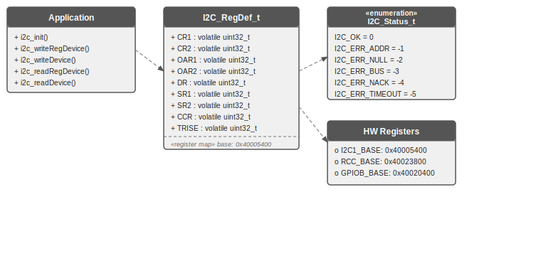
Figure 1. Class Diagram — I2C Driver

3.2. Module Behavior (Sequence Diagrams, State Machines, etc.)

3.2.1. Sequence Diagram — i2c_init
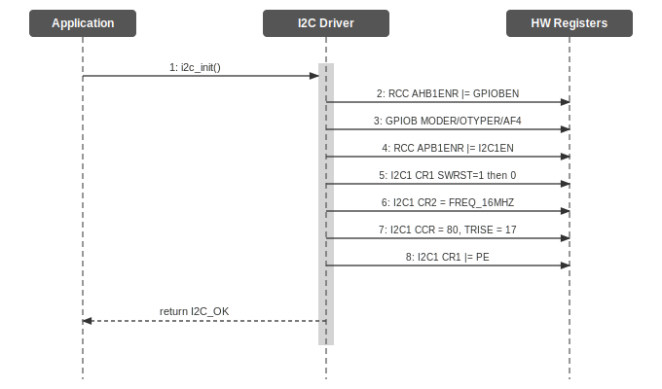
Figure 2. Sequence Diagram — i2c_init

3.2.2. Activity Diagram — i2c_init
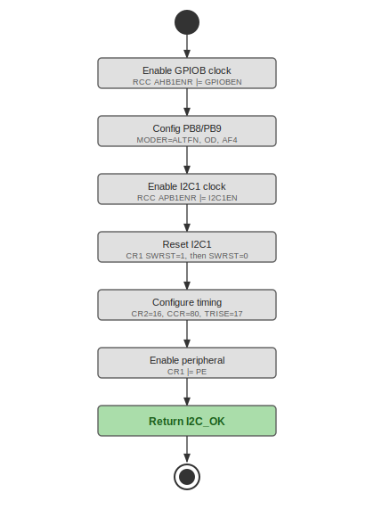
Figure 3. Activity Diagram — i2c_init

3.2.3. Sequence Diagram — i2c_writeRegDevice with Conditional
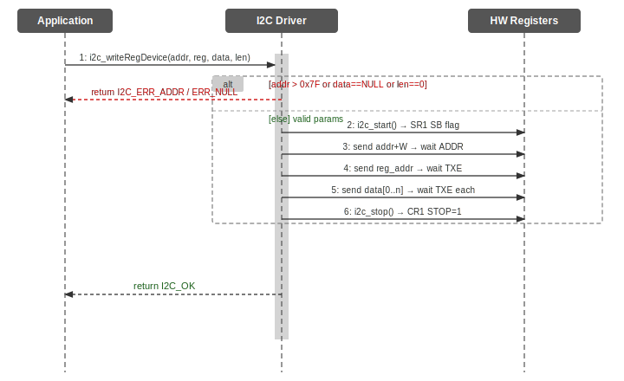
Figure 4. Sequence Diagram — i2c_writeRegDevice with Conditional

3.2.4. Activity Diagram — i2c_writeRegDevice with Conditional
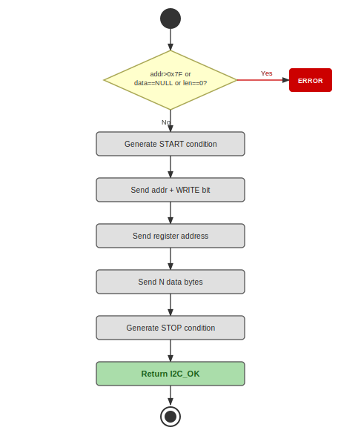
Figure 5. Activity Diagram — i2c_writeRegDevice with Conditional

3.2.5. Sequence Diagram — i2c_readRegDevice with Loop
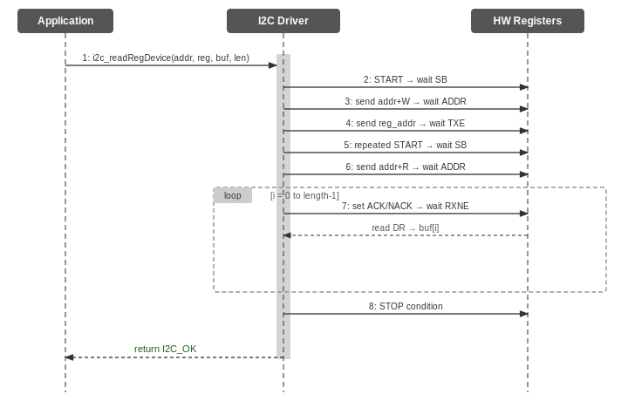
Figure 6. Sequence Diagram — i2c_readRegDevice with Loop

3.2.6. Activity Diagram — i2c_readRegDevice with Loop
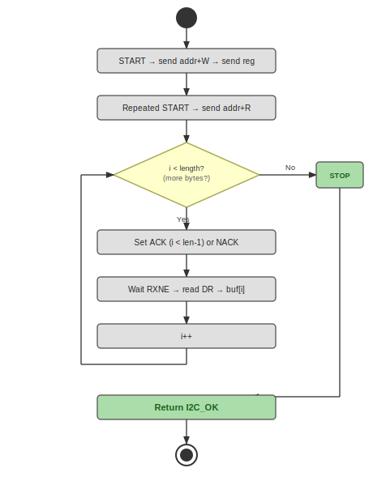
Figure 7. Activity Diagram — i2c_readRegDevice with Loop

3.2.7. State Diagram — I2C Driver
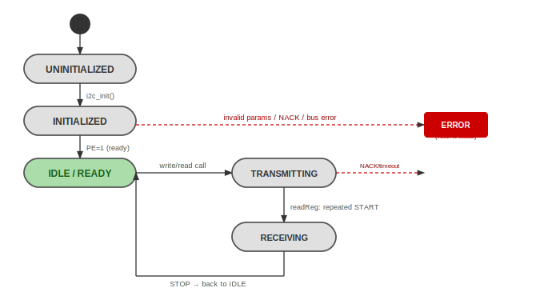
Figure 8. State Diagram — I2C Driver

3.3. I2C Driver
The I2C driver is a self-contained, bare-metal C module that directly configures and accesses STM32F411RE I2C peripherals (I2C1, I2C2, I2C3) through memory-mapped registers, as specified in RM0383.

Initialization (FR-1, FR-2): The i2c_init function accepts a const i2c_config_t pointer and validates all fields before touching any hardware — returning I2C_ERR_INVALID_ARG for a NULL pointer, an unrecognized instance, a zero or out-of-range clock speed, or an unsupported address mode. It then enables the selected peripheral clock via RCC_PERIPH()->APB1ENR (I2C1EN, I2C2EN, or I2C3EN), performs a software reset via the SWRST bit in CR1, and computes CCR and TRISE dynamically from the requested clk_speed: CCR = APB1_CLK_HZ / (2 * clk_speed) for standard mode with the FS bit cleared, or CCR = APB1_CLK_HZ / (3 * clk_speed) for fast mode with the FS bit set; TRISE = (APB1_CLK_HZ / 1 000 000) + 1 for standard mode and (APB1_CLK_HZ / 1 000 000 * 300 / 1000) + 1 for fast mode. Finally, it sets the PE bit to enable the peripheral. GPIO pin configuration is not performed by this function and must be done externally. The complete initialization sequence is illustrated in Figures 2 and 3.

Write operations (FR-3 through FR-6): Both i2c_writeRegDevice and i2c_writeDevice validate all arguments — returning I2C_ERR_INVALID_ARG for a NULL instance, a NULL data pointer, a zero length, a device address above 0x7F, or an unrecognized instance — and then poll SR2 BUSY before starting to ensure the bus is idle. i2c_writeRegDevice generates a START condition, sends the device address with the WRITE bit, sends the register address, then transmits N bytes in a loop waiting for BTF between bytes (Figures 4 and 5). i2c_writeDevice follows the same flow without the register address phase, using BTF for intermediate bytes and TXE for the last byte. Both generate a STOP condition on completion or on any NACK or timeout error.

Read operations (FR-7 through FR-10): Both i2c_readRegDevice and i2c_readDevice apply the same argument validation and SR2 BUSY check as the write functions. i2c_readRegDevice performs a write phase (START, address+W, register address), then a repeated START, sends the device address with the READ bit, and reads N bytes using a simple loop: ACK is enabled before the loop, disabled just before the last byte, STOP is set at the same point, and each byte is read by polling RXNE (Figures 6 and 7). i2c_readDevice skips the write phase and reads directly. Both functions use the same validation and error handling.

The state diagram (Figure 8) shows the driver lifecycle: UNINITIALIZED transitions to INITIALIZED after i2c_init succeeds, then to IDLE/READY once PE is set. Each write/read call first checks the BUSY flag — returning I2C_ERR_TIMEOUT if the bus is not free — then moves the driver to TRANSMITTING or RECEIVING, returning to IDLE after a successful STOP. Invalid parameters cause an immediate return of I2C_ERR_INVALID_ARG before the bus is touched. NACK or bus errors cause an immediate return with the appropriate error status code and a STOP condition to release the bus.

4. Application Programming Interfaces

4.1. Data Types and Macros
Data Types

- i2c_status_t: This enumeration represents the return status of all public I2C driver functions.
Member Name | Type / Value
I2C_OK | 0 — Operation completed successfully.
I2C_ERR_INVALID_ARG | -1 — NULL pointer or illegal parameter (invalid instance, address out of range, zero length, unsupported address mode or speed).
I2C_ERR_BUS_BUSY | -2 — Bus BUSY flag (SR2.BUSY) remained set after I2C_TIMEOUT_MAX iterations; another master is holding the bus.
I2C_ERR_NACK | -3 — Device sent NACK (AF flag in SR1). AF flag is cleared and STOP is generated.
I2C_ERR_TIMEOUT | -4 — A polling wait loop exceeded I2C_TIMEOUT_MAX iterations without the expected flag being set.
I2C_ERR_BUS_ERROR | -5 — Misplaced START or STOP detected on the bus (BERR flag in SR1).

- I2C_RegDef_t: This structure is a direct memory-mapped overlay of the STM32F411RE I2C1 peripheral registers (RM0383 Section 18.6).
Member Name | Type | Notes / Definition
CR1 | volatile uint32_t | Control Register 1. PE (bit 0), START (bit 8), STOP (bit 9), ACK (bit 10), SWRST (bit 15). Offset: 0x00.
CR2 | volatile uint32_t | Control Register 2. FREQ[5:0] peripheral clock frequency. Offset: 0x04.
OAR1 | volatile uint32_t | Own Address Register 1. Offset: 0x08.
OAR2 | volatile uint32_t | Own Address Register 2. Offset: 0x0C.
DR | volatile uint32_t | Data Register. Write to transmit; read to receive. Offset: 0x10.
SR1 | volatile uint32_t | Status Register 1. SB(0), ADDR(1), BTF(2), RXNE(6), TXE(7), BERR(8), ARLO(9), AF(10), OVR(11). Offset: 0x14.
SR2 | volatile uint32_t | Status Register 2. Read after SR1 to clear ADDR flag. Offset: 0x18.
CCR | volatile uint32_t | Clock Control Register. CCR[11:0] = 80 for 100 kHz at 16 MHz. Offset: 0x1C.
TRISE | volatile uint32_t | Maximum rise time register. TRISE = 17 for 100 kHz at 16 MHz. Offset: 0x20.
FLTR | volatile uint32_t | Filter register. Offset: 0x24.

RCC_RegDef_t: This structure is a direct memory-mapped overlay of the STM32F411RE RCC peripheral registers (RM0383 Section 6.3). Only the fields needed for I2C clock gating are defined; reserved gaps are preserved with unnamed uint32_t padding. It is accessed through the RCC_PERIPH() macro, which casts RCC_BASE_ADDR to a pointer of this type.

i2c_config_t: This structure holds all runtime configuration parameters passed to i2c_init(). It contains three fields: instance (pointer to the target I2C peripheral — I2C1, I2C2, or I2C3), clk_speed (desired bus speed in Hz, must be greater than 0 and at most I2C_SPEED_FM_HZ = 400 000 Hz), and addr_mode (I2C_ADDR_7BIT = 0 or I2C_ADDR_10BIT = 1). Passing a NULL pointer or invalid field values causes i2c_init to return I2C_ERR_INVALID_ARG without touching any hardware.

Macros

- I2C1_BASE: This I2C1_BASE represents the base address of the I2C1 peripheral in the STM32F411RE memory map (APB1 bus, RM0383 section 2.3). The I2C1_BASE value is 0x40005400UL.
- GPIOB_BASE_I2C: This GPIOB_BASE_I2C represents the base address of the GPIOB peripheral used for I2C1 pin configuration (PB8, PB9). The GPIOB_BASE_I2C value is 0x40020400UL.
- RCC_BASE_I2C: This RCC_BASE_I2C represents the base address of the RCC register block used to enable GPIOB and I2C1 clocks. The RCC_BASE_I2C value is 0x40023800UL.
- RCC_APB1ENR_I2C1EN: This RCC_APB1ENR_I2C1EN represents the clock enable bit for the I2C1 peripheral within RCC_APB1ENR (RM0383 section 6.3.11). The RCC_APB1ENR_I2C1EN value is 1U << 21.
- RCC_AHB1ENR_GPIOBEN: This RCC_AHB1ENR_GPIOBEN represents the clock enable bit for GPIOB within RCC_AHB1ENR, required to configure I2C1 pins PB8 and PB9. The RCC_AHB1ENR_GPIOBEN value is 1U << 1.
- I2C_CCR_SM_100KHZ: This I2C_CCR_SM_100KHZ represents the CCR register value for 100 kHz standard mode I2C at 16 MHz system clock, derived from RM0383 section 18.3.3. The I2C_CCR_SM_100KHZ value is 80U.
- I2C_TRISE_100KHZ: This I2C_TRISE_100KHZ represents the TRISE register value for 100 kHz standard mode at 16 MHz, calculated as (1000 ns / 62.5 ns) + 1. The I2C_TRISE_100KHZ value is 17U.
- I2C_ADDR_MAX: This I2C_ADDR_MAX represents the maximum valid 7-bit I2C device address per the I2C protocol specification. The I2C_ADDR_MAX value is 0x7FU.
- I2C_TIMEOUT_MAX: This I2C_TIMEOUT_MAX represents the maximum number of polling iterations before a timeout error is returned, used in all blocking wait loops. The I2C_TIMEOUT_MAX value is 1000000U.

4.2. Error Codes
The I2C Driver APIs have a return type of the i2c_status_t error code. Error codes relevant to this module are listed below.
Code | Notes / Definition
I2C_OK (0) | Operation completed successfully.
I2C_ERR_INVALID_ARG (-1) | NULL pointer or illegal parameter (invalid instance, address above 0x7F, zero length, unsupported address mode or speed). No transaction is initiated. No transaction is initiated.
I2C_ERR_BUS_BUSY (-2) | Bus BUSY flag (SR2.BUSY) remained set after I2C_TIMEOUT_MAX iterations. Another master is holding the bus. No transaction is initiated.
I2C_ERR_NACK (-3) | Device sent NACK (AF flag in SR1). AF flag is cleared and STOP is generated. STOP is generated.
I2C_ERR_TIMEOUT (-4) | A polling wait loop exceeded I2C_TIMEOUT_MAX iterations without the expected flag being set.
I2C_ERR_BUS_ERROR (-5) | Misplaced START or STOP detected on the bus (BERR flag in SR1).

4.3. Function Definitions

i2c_init
i2c_init
Function Name | i2c_init
Syntax | i2c_status_t i2c_init(const i2c_config_t *config)
Parameters (in) | None.
Parameters (inout) | None.
Parameters (out) | None.
Return value | i2c_status_t — Returns I2C_OK on success; I2C_ERR_INVALID_ARG if config is NULL or contains illegal values.
Description | Validates the config pointer and all fields (instance, clk_speed, addr_mode). Enables the peripheral clock for the selected instance via RCC_PERIPH()->APB1ENR. Performs a software reset via SWRST in CR1. Configures CR2 with the APB1 frequency, computes CCR dynamically for standard mode (FS=0) or fast mode (FS=1) based on clk_speed, and computes TRISE accordingly. Sets the PE bit to enable the peripheral (FR-1, FR-2). GPIO pin configuration must be performed externally before calling this function.
Constraints | System clock and GPIO pins must be configured externally before calling i2c_init. Only polling-based operation is supported; NVIC interrupts are not configured.
Available via | I2C_Driver.h

i2c_writeRegDevice
i2c_writeRegDevice
Function Name | i2c_writeRegDevice
Syntax | i2c_status_t i2c_writeRegDevice(I2C_RegDef_t *instance, uint16_t dev_addr, uint8_t reg_addr, const uint8_t *data, size_t len)
Parameters (in) | dev_addr | 7-bit I2C device address (0x00 to 0x7F).
Parameters (in) | reg_addr | Target register address within the device.
Parameters (in) | data | Pointer to the byte array to transmit.
Parameters (in) | length | Number of bytes to transmit (must be > 0).
Parameters (inout) | None.
Parameters (out) | None.
Return value | i2c_status_t — I2C_OK on success; I2C_ERR_INVALID_ARG, I2C_ERR_NACK, I2C_ERR_TIMEOUT, or I2C_ERR_BUS_ERROR on error.
Description | Validates instance, dev_addr, data pointer, and length (FR-3, NFR-2); also polls SR2 BUSY before starting. Generates START, sends device address with WRITE bit, sends register address, then transmits len bytes in a loop waiting for BTF between bytes (FR-3, FR-4). Generates STOP on completion or error.
Constraints | Blocking function. Checks SR2 BUSY before starting; returns I2C_ERR_TIMEOUT if the bus is not idle. i2c_init must be called before use.
Available via | I2C_Driver.h

i2c_writeDevice
i2c_writeDevice
Function Name | i2c_writeDevice
Syntax | i2c_status_t i2c_writeDevice(I2C_RegDef_t *instance, uint16_t dev_addr, const uint8_t *data, size_t len)
Parameters (in) | dev_addr | 7-bit I2C device address (0x00 to 0x7F).
Parameters (in) | data | Pointer to the byte array to transmit.
Parameters (in) | length | Number of bytes to transmit (must be > 0).
Parameters (inout) | None.
Parameters (out) | None.
Return value | i2c_status_t — I2C_OK on success; I2C_ERR_INVALID_ARG, I2C_ERR_NACK, I2C_ERR_TIMEOUT, or I2C_ERR_BUS_ERROR on error.
Description | Validates instance, dev_addr, data pointer, and length (FR-5, NFR-2); also polls SR2 BUSY before starting. Generates START, sends device address with WRITE bit, then transmits len bytes directly without a register address (FR-5, FR-6). Uses BTF for intermediate bytes and TXE for the last byte. Generates STOP on completion or error.
Constraints | Blocking function. Checks SR2 BUSY before starting. i2c_init must be called before use.
Available via | I2C_Driver.h

i2c_readRegDevice
i2c_readRegDevice
Function Name | i2c_readRegDevice
Syntax | i2c_status_t i2c_readRegDevice(I2C_RegDef_t *instance, uint16_t dev_addr, uint8_t reg_addr, uint8_t *buf, size_t len)
Parameters (in) | dev_addr | 7-bit I2C device address (0x00 to 0x7F).
Parameters (in) | reg_addr | Target register address within the device.
Parameters (in) | data | Pointer to the buffer to store received bytes.
Parameters (in) | length | Number of bytes to read (must be > 0).
Parameters (inout) | None.
Parameters (out) | None.
Return value | i2c_status_t — I2C_OK on success; I2C_ERR_INVALID_ARG, I2C_ERR_NACK, I2C_ERR_TIMEOUT, or I2C_ERR_BUS_ERROR on error.
Description | Validates instance, dev_addr, data pointer, and length (FR-7, NFR-2); also polls SR2 BUSY before starting. Performs a write phase (START, address+W, register address), then a repeated START, sends address+R, enables ACK, and reads len bytes into the buffer using a loop. ACK is disabled and STOP is set before the last byte; each byte is read by polling RXNE (FR-7, FR-8). Generates STOP after the last byte.
Constraints | Blocking function. Uses repeated START between write and read phases. Checks SR2 BUSY before starting. i2c_init must be called before use.
Available via | I2C_Driver.h

i2c_readDevice
i2c_readDevice
Function Name | i2c_readDevice
Syntax | i2c_status_t i2c_readDevice(I2C_RegDef_t *instance, uint16_t dev_addr, uint8_t *buf, size_t len)
Parameters (in) | dev_addr | 7-bit I2C device address (0x00 to 0x7F).
Parameters (in) | data | Pointer to the buffer to store received bytes.
Parameters (in) | length | Number of bytes to read (must be > 0).
Parameters (inout) | None.
Parameters (out) | None.
Return value | i2c_status_t — I2C_OK on success; I2C_ERR_INVALID_ARG, I2C_ERR_NACK, I2C_ERR_TIMEOUT, or I2C_ERR_BUS_ERROR on error.
Description | Validates instance, dev_addr, data pointer, and length (FR-9, NFR-2); also polls SR2 BUSY before starting. Generates START, sends device address with READ bit, enables ACK, and reads len bytes directly into the buffer without a prior write phase (FR-9, FR-10). ACK is disabled and STOP is set before the last byte. ACK is sent for all bytes except the last.
Constraints | Blocking function. Checks SR2 BUSY before starting. i2c_init must be called before use.
Available via | I2C_Driver.h

4.4. Internal Function Definitions
This driver version does not expose internal helper functions. In the previous version, the protocol sequencing was delegated to five static helpers (i2c_start, i2c_stop, i2c_sendAddr, i2c_writeByte, i2c_readByte). In the current version, all I2C protocol steps (START generation, address phase, data transmit/receive loop, ACK/NACK control, and STOP generation) are implemented inline within each public function (i2c_writeRegDevice, i2c_writeDevice, i2c_readRegDevice, i2c_readDevice). This change eliminates the helper function call overhead and makes the transaction flow self-contained and directly traceable within each function body.

5. Future Enhancements
- Interrupt-driven operation: Add ITEVTEN and ITBUFEN interrupt configuration in CR2 to allow non-blocking I2C transactions via ISR, eliminating all busy-wait loops.
- DMA support: Implement DMA-based data transfer for high-throughput I2C reads/writes, reducing CPU load during multi-byte transactions.
- 10-bit addressing: Extend the driver to support 10-bit device addresses by adding the two-byte address sequence in each public function and configuring the ADDMODE bit in OAR1.
- Fast mode (400 kHz): Add a speed parameter to i2c_init and compute CCR and TRISE values dynamically for both standard mode (100 kHz) and fast mode (400 kHz).
- Timeout mechanism based on SysTick: Replace the iteration-count timeout with a SysTick-based real-time timeout for more deterministic behavior under varying clock speeds.
- Multi-instance support: Extend the driver to support I2C2 and I2C3 by adding an instance parameter to all functions and mapping the correct base addresses and GPIO pins.
- Bus recovery: Implement I2C bus recovery (9 clock pulses) to release a device that is holding SDA low after a failed transaction.
- SMBUS support: Add SMBus protocol support by configuring the SMBUS and SMBTYPE bits in CR1 for compatibility with SMBus devices.

