Software Design Document (SDD)
Lab Assignment 05: I2C & SPI
SPI Driver — STM32F411RE
Module | SPI Driver
Version | 1.0.0
Author | Sebastian Lizalde Herrera, Michelle Urbina Carlos, Melanie Picen Hernandez
Date | 19/05/2026
Institution | CETYS Universidad

1. Introduction

1.1. Purpose
This document describes the design and architecture of the SPI driver module, based on the requirements defined in the SRS. It provides details on data structures, algorithms, and control flow to guide implementation and testing of the SPI peripheral driver for the STM32F411RE microcontroller.

1.2. Scope
The SPI driver is a self-contained, low-level bare-metal software component for the STM32F411RE embedded system. It abstracts hardware registers and provides a clean API for higher-level modules to communicate with external SPI devices such as sensors, flash memories, displays, and ADCs. The driver supports full-duplex transmission and reception using software chip-select control, without dependency on any external driver module.

1.3. Definitions and Acronyms
Term | Definition
SPI | Serial Peripheral Interface — a four-wire synchronous serial communication protocol (SCK, MOSI, MISO, CS).
SCK | Serial Clock — the clock signal driven by the SPI master.
MOSI | Master Out Slave In — data line from master to slave.
MISO | Master In Slave Out — data line from slave to master.
CS | Chip Select (active low) — selects the target SPI slave device.
CR1 | Control Register 1 — configures SPI mode, baud rate, frame format, and enables the peripheral.
CR2 | Control Register 2 — configures DMA and interrupt enables (not used in this driver).
SR | Status Register — contains TXE, RXNE, BSY, OVR, and MODF flags.
DR | Data Register — write to transmit a byte; read to receive a byte.
TXE | Transmit buffer Empty flag — set when DR can accept a new transmit byte.
RXNE | Receive buffer Not Empty flag — set when a received byte is ready in DR.
BSY | Busy flag — set while SPI is transferring data.
OVR | Overrun flag — set when received data is not read before the next frame arrives.
MODF | Mode Fault — set when SS is pulled low while SSM=0 (multi-master conflict).
AF5 | Alternate Function 5 — the GPIO alternate function mapping for SPI1 on PA5/PA6/PA7.
CPOL | Clock Polarity — defines idle state of SCK (0 = low, 1 = high).
CPHA | Clock Phase — defines data capture edge (0 = first edge, 1 = second edge).
SSM | Software Slave Management — when set, slave select is managed by software via SSI bit.
SSI | Internal Slave Select — used with SSM to force NSS high internally.
DFF | Data Frame Format — 0 = 8-bit frames, 1 = 16-bit frames.
SRS | Software Requirements Specification.
SDD | Software Design Document.
FR | Functional Requirement.
HAL | Hardware Abstraction Layer — not used in this driver.

1.4. Requirements
All requirements specific to this module are allocated in the SPI Driver SRS. The SRS defines functional requirements FR-1 through FR-8 and non-functional requirements NFR-1 through NFR-3, which this document addresses through the design described herein.

2. System Architecture

2.1. High-Level Design
The SPI driver follows a layered architecture pattern separating application logic from hardware access:
- Application Layer: Calls SPI driver functions (spi_init, spi_transmit, spi_receive, spi_csEnable, spi_csDisable) to communicate with external SPI devices without any knowledge of hardware registers.
- SPI Driver Layer: Provides the public API defined in SPI_Driver.h. Implements all logic including parameter validation, GPIO configuration, clock enabling, SPI peripheral configuration, and polling-based transmit/receive transactions. Internal helper functions (spi_waitTxEmpty, spi_waitRxNotEmpty, spi_waitNotBusy) handle flag polling with timeout protection.
- Hardware Layer: The actual STM32F411RE SPI1 peripheral registers accessed directly through the memory-mapped SPI_RegDef_t structure at base address 0x40013000. RCC and GPIOA registers are accessed via direct pointer arithmetic from their respective base addresses.

2.2. Module Interfaces
Public API: All user-facing functions are declared in SPI_Driver.h. The header exposes the SPI_RegDef_t register map structure, the SPI_Status_t error enumeration, and all peripheral address and configuration macros.
Dependencies: The SPI driver is fully self-contained. GPIO (GPIOA) and RCC registers are configured internally via direct pointer arithmetic. No external driver module is required, satisfying the SRS portability constraint.

3. Detailed Design

3.1. Class Diagram
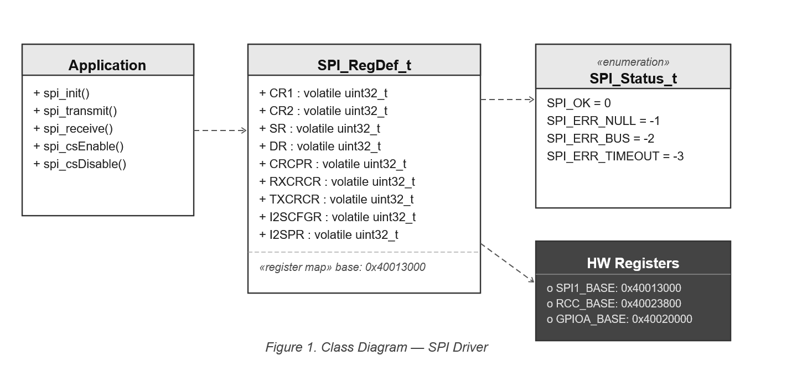
Figure 1. Class Diagram — SPI Driver

The SPI driver exposes five public functions and three static helper functions. The SPI_RegDef_t structure overlays the SPI1 register block at 0x40013000. SPI_Status_t enumerates all return codes.

3.2. Module Behavior

3.2.1. Sequence Diagram — spi_init
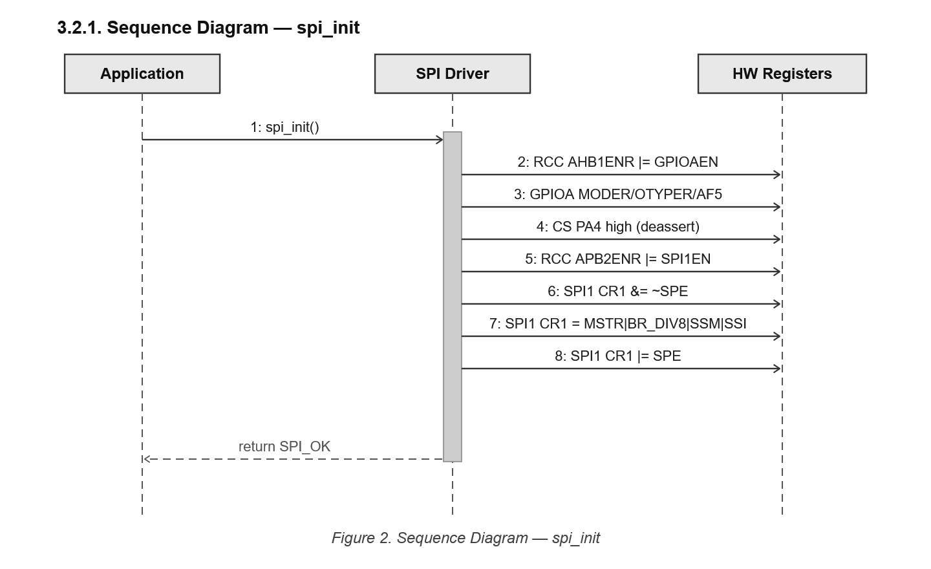
Figure 2. Sequence Diagram — spi_init

3.2.2. Activity Diagram — spi_init
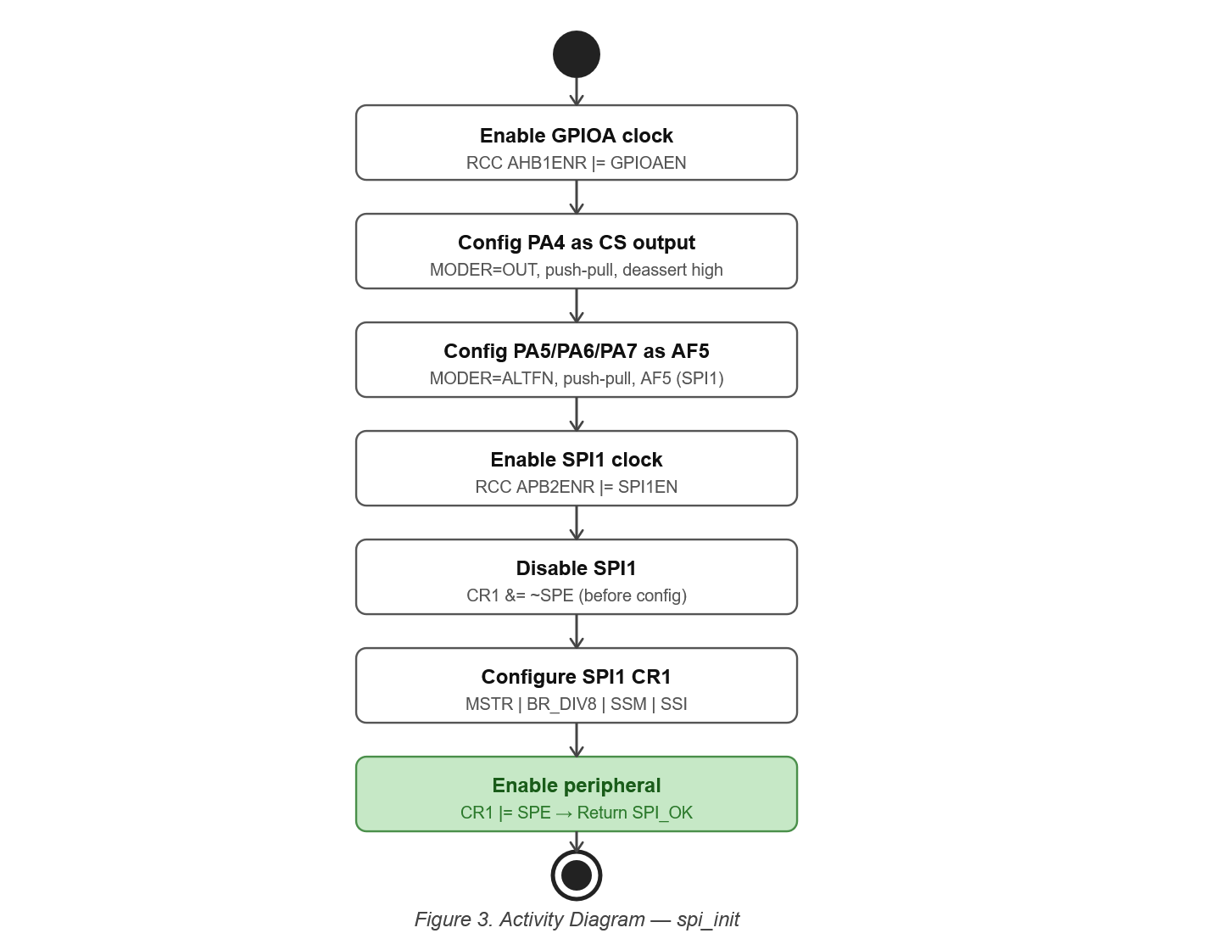
Figure 3. Activity Diagram — spi_init

3.2.3. Sequence Diagram — spi_transmit with Loop
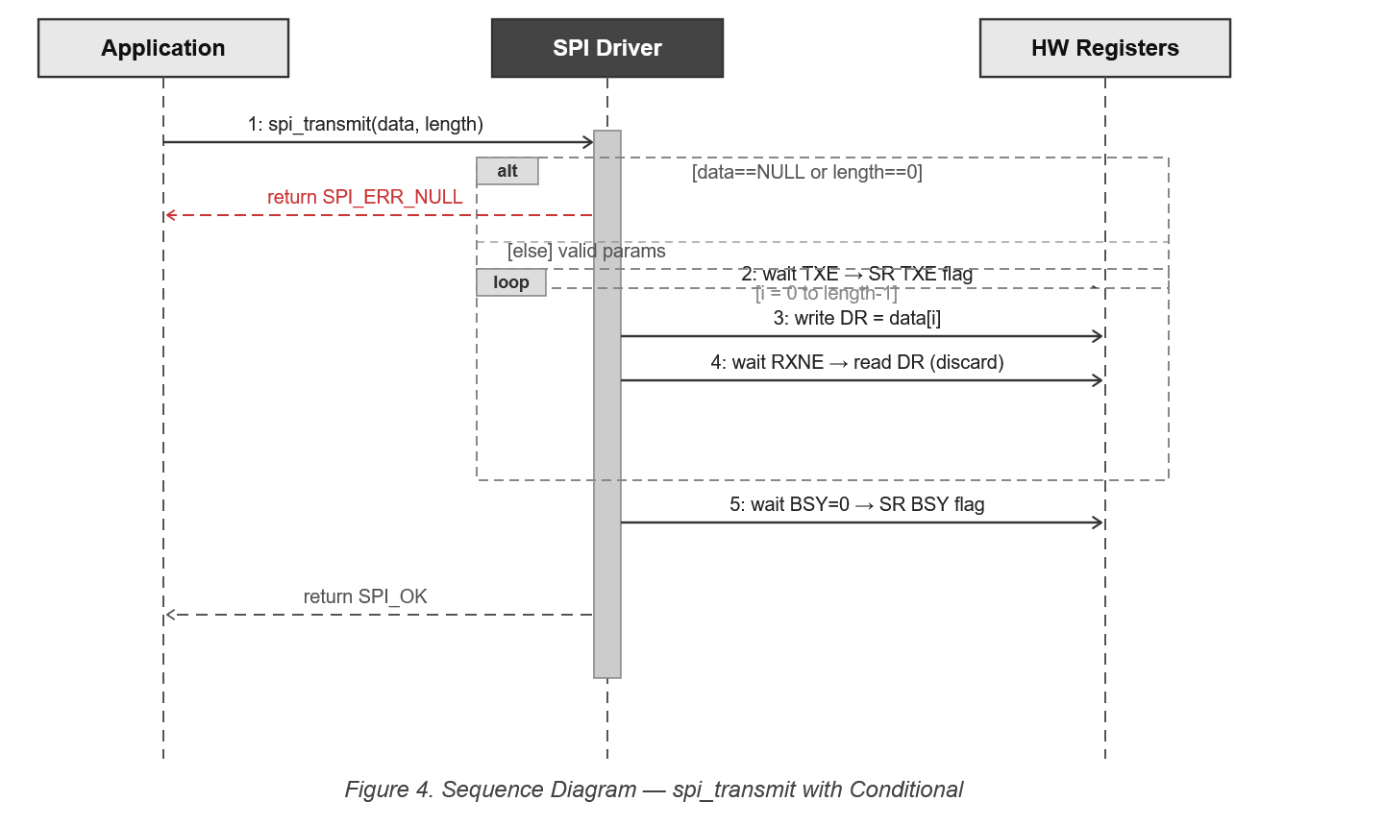
Figure 4. Sequence Diagram — spi_transmit with Loop

3.2.4. Activity Diagram — spi_transmit with Loop
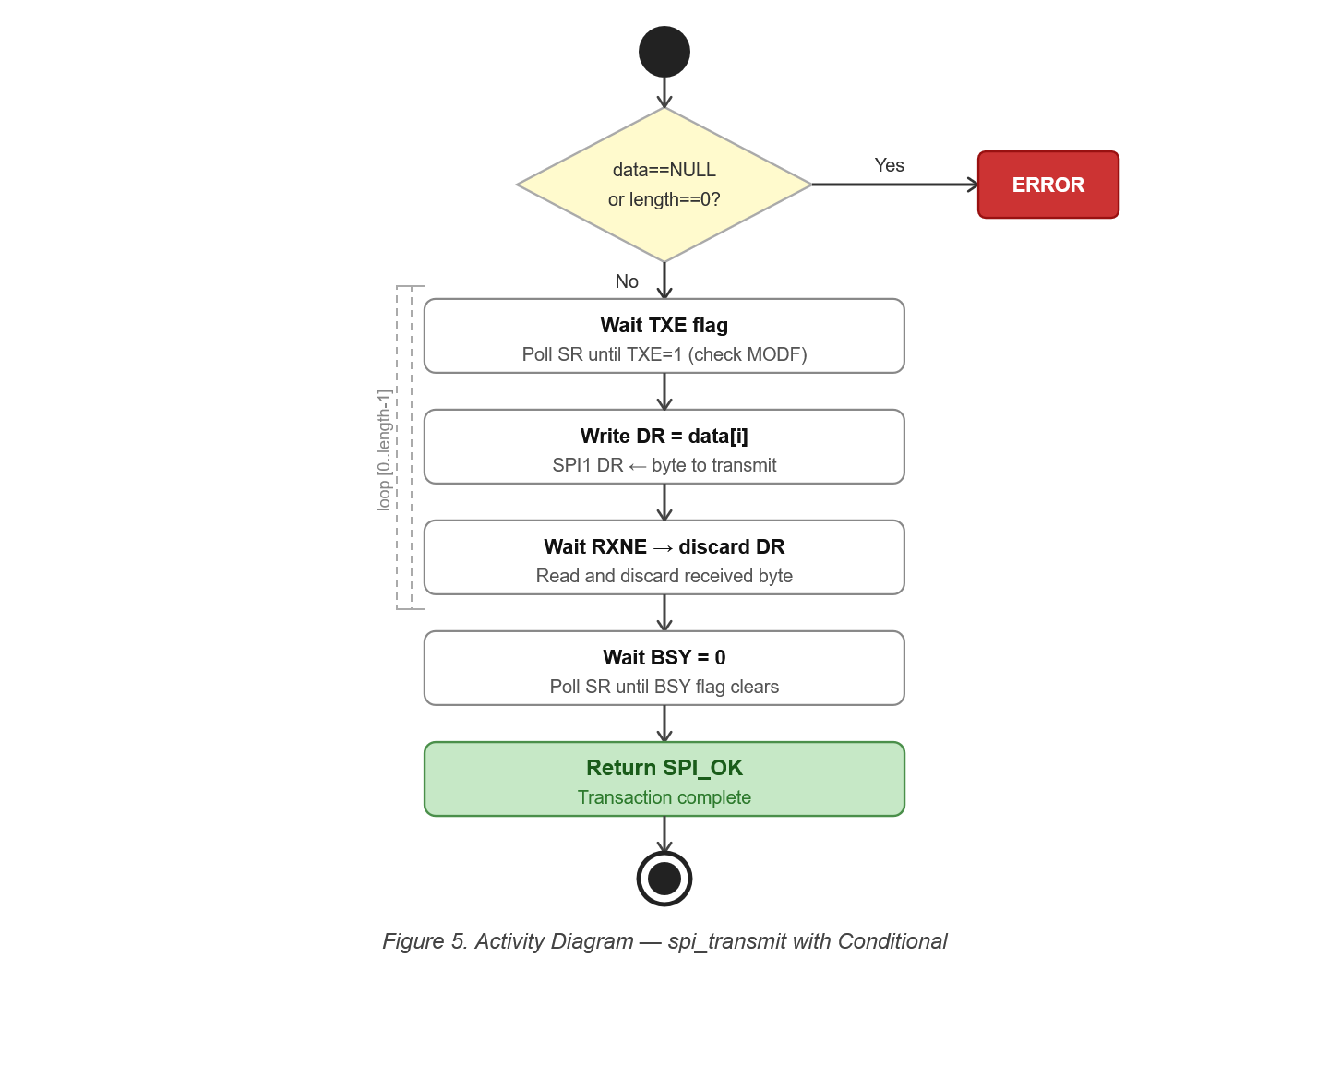
Figure 5. Activity Diagram — spi_transmit with Loop

3.2.5. Sequence Diagram — spi_receive with Loop
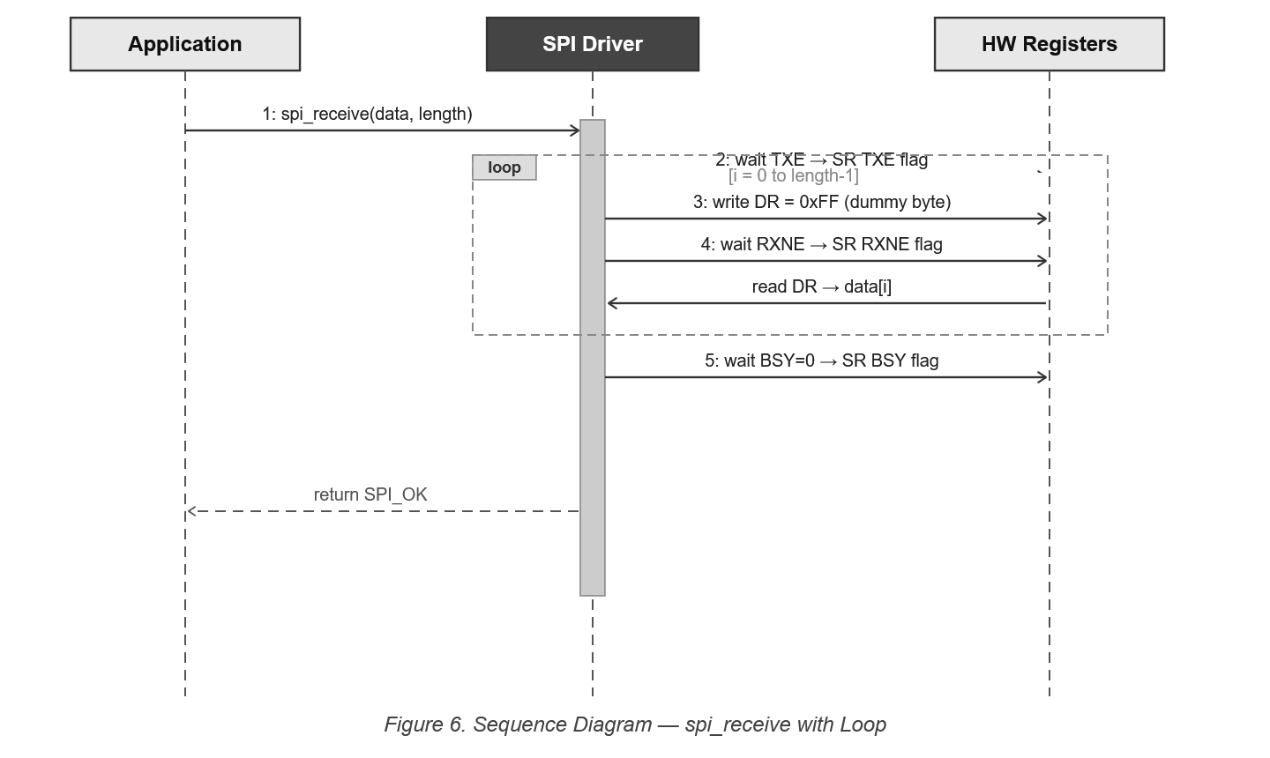
Figure 6. Sequence Diagram — spi_receive with Loop

3.2.6. Activity Diagram — spi_receive with Loop
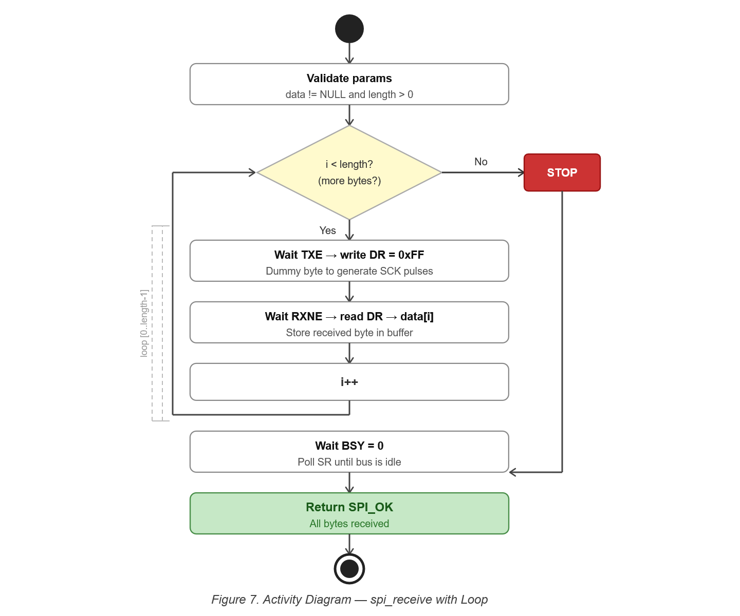
Figure 7. Activity Diagram — spi_receive with Loop

3.2.7. State Diagram — SPI Driver
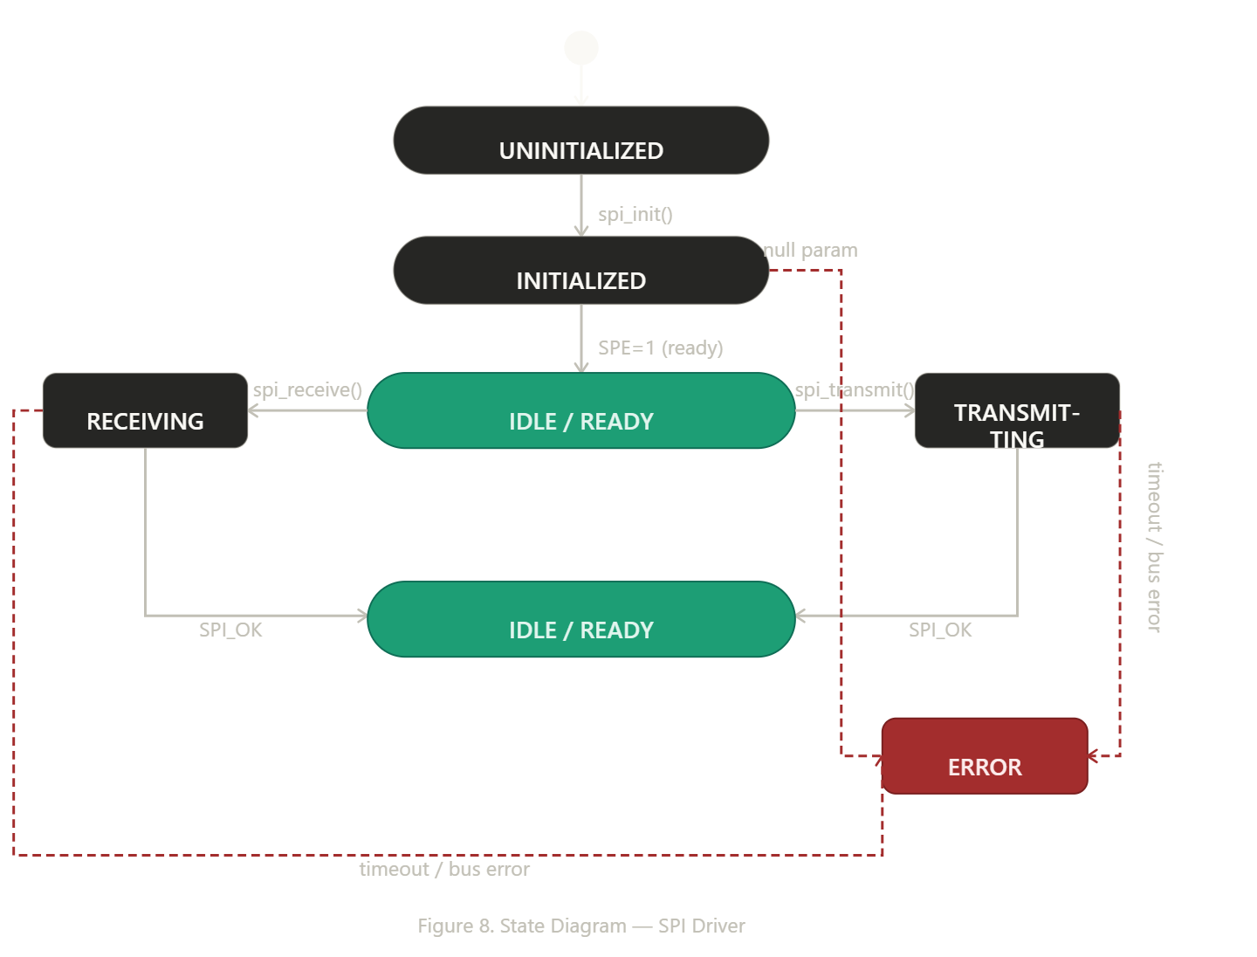
Figure 8. State Diagram — SPI Driver

3.3. SPI Driver

The SPI driver is a self-contained, bare-metal C module that directly configures and accesses the STM32F411RE SPI1 peripheral through memory-mapped registers, as specified in RM0383.

Initialization (FR-1, FR-2): The spi_init function enables the GPIOA clock via RCC_AHB1ENR, then configures PA4 as a push-pull output for software chip-select (CS). PA5 (SCK), PA6 (MISO), and PA7 (MOSI) are configured as Alternate Function 5 with push-pull output type (except MISO which defaults to input) and high-speed setting, which are the requirements for SPI1 operation on the STM32F411RE (UM1724 Table 16, datasheet Table 9). It then enables the SPI1 peripheral clock via RCC_APB2ENR bit 12 (FR-2), disables SPI before configuring CR1, sets master mode, baud rate fPCLK/8 (~2 MHz at 16 MHz), Mode 0 (CPOL=0, CPHA=0), 8-bit frames, and software slave management (SSM=1, SSI=1). Finally it sets the SPE bit to enable the peripheral. The complete initialization sequence is illustrated in Figures 2 and 3.

Transmit operation (FR-3, FR-4): spi_transmit validates the data pointer and length (NFR-2), then iterates over each byte: it waits for TXE via spi_waitTxEmpty (checking MODF for bus errors and decrementing a timeout counter), writes the byte to DR, waits for RXNE via spi_waitRxNotEmpty (checking OVR/MODF), and discards the received dummy byte to prevent overrun. After the loop it calls spi_waitNotBusy to ensure the bus is idle (FR-4). The complete flow is illustrated in Figures 4 and 5.

Receive operation (FR-5, FR-6): spi_receive validates the data pointer and length (NFR-2), then iterates over each byte: it waits for TXE, sends a dummy byte (0xFF) to generate clock pulses (FR-6), waits for RXNE, and reads the received byte from DR into the caller's buffer (FR-5). After the loop it calls spi_waitNotBusy to confirm bus idle (FR-6). The complete flow is illustrated in Figures 6 and 7.

Chip-select control (FR-7, FR-8): spi_csEnable drives PA4 low by writing GPIO_BSRR_BR4 to GPIOA BSRR, asserting the active-low CS line (FR-7). spi_csDisable drives PA4 high by writing GPIO_BSRR_BS4, deasserting CS (FR-8). Both use direct register access to the GPIOA BSRR for atomic, glitch-free pin toggling.

State diagram (Figure 8): The driver lifecycle progresses from UNINITIALIZED to INITIALIZED once spi_init configures GPIO and RCC, then to IDLE/READY once SPE is set. spi_csEnable transitions the driver to CS_ACTIVE; each transmit/receive call moves to TRANSMITTING or RECEIVING respectively, returning to CS_ACTIVE after completion. spi_csDisable returns the driver to IDLE. Invalid parameters or bus errors cause an immediate return with the appropriate error status without leaving the bus in an inconsistent state.

4. Application Programming Interfaces

4.1. Data Types and Macros

Data Types
SPI_Status_t: This enumeration represents the return status of all public SPI driver functions.
Member Name | Type / Value | Description
SPI_OK | 0 | Operation completed successfully.
SPI_ERR_NULL | -1 | Data pointer is NULL or length is zero. No transaction is initiated.
SPI_ERR_BUS | -2 | Bus error detected (OVR or MODF flag set in SR).
SPI_ERR_TIMEOUT | -3 | Polling loop exceeded SPI_TIMEOUT iterations without the expected flag.

SPI_RegDef_t: This structure is a direct memory-mapped overlay of the STM32F411RE SPI1 peripheral registers (RM0383 Section 20.5).
Member Name | Type | Notes / Definition
CR1 | volatile uint32_t | Control Register 1. CPHA(0), CPOL(1), MSTR(2), BR[5:3], SPE(6), SSI(8), SSM(9), DFF(11). Offset: 0x00.
CR2 | volatile uint32_t | Control Register 2. DMA and interrupt enables (not used by this driver). Offset: 0x04.
SR | volatile uint32_t | Status Register. RXNE(0), TXE(1), MODF(5), OVR(6), BSY(7). Offset: 0x08.
DR | volatile uint32_t | Data Register. Write to transmit; read to receive. Offset: 0x0C.
CRCPR | volatile uint32_t | CRC Polynomial Register. Offset: 0x10.
RXCRCR | volatile uint32_t | RX CRC Register. Offset: 0x14.
TXCRCR | volatile uint32_t | TX CRC Register. Offset: 0x18.
I2SCFGR | volatile uint32_t | I2S Configuration Register. Offset: 0x1C.
I2SPR | volatile uint32_t | I2S Prescaler Register. Offset: 0x20.

Macros
Macro | Value | Description
SPI1_BASE_ADDR | 0x40013000UL | Base address of the SPI1 peripheral (APB2 bus, RM0383 section 2.3).
GPIOA_BASE_SPI | 0x40020000UL | Base address of GPIOA, used for CS (PA4), SCK (PA5), MISO (PA6), MOSI (PA7).
RCC_BASE_SPI | 0x40023800UL | Base address of the RCC register block for enabling GPIOA and SPI1 clocks.
RCC_AHB1ENR_GPIOAEN | 1U << 0 | Clock enable bit for GPIOA within RCC_AHB1ENR.
RCC_APB2ENR_SPI1EN | 1U << 12 | Clock enable bit for SPI1 within RCC_APB2ENR (RM0383 section 6.3.13).
SPI_CR1_MSTR | 1U << 2 | Master selection bit in CR1 — configures SPI1 as master.
SPI_CR1_BR_DIV8 | 0x2U << 3 | Baud rate prescaler fPCLK/8, yielding ~2 MHz at 16 MHz system clock.
SPI_CR1_SPE | 1U << 6 | SPI enable bit — set after full CR1 configuration.
SPI_CR1_SSM | 1U << 9 | Software slave management — NSS managed by SSI bit.
SPI_CR1_SSI | 1U << 8 | Internal slave select — forces NSS high internally when SSM=1.
GPIO_AF5 | 0x5U | Alternate Function 5 — SPI1 mapping for PA5, PA6, PA7.
GPIO_BSRR_BS4 | 1U << 4 | Set PA4 high (CS deassert) via GPIOA BSRR.
GPIO_BSRR_BR4 | 1U << 20 | Reset PA4 low (CS assert) via GPIOA BSRR.
SPI_DUMMY_BYTE | 0xFFU | Dummy byte transmitted during receive to generate SCK clock pulses.
SPI_TIMEOUT | 10000U | Maximum polling iterations before SPI_ERR_TIMEOUT is returned.

4.2. Error Codes
Code | Notes / Definition
SPI_OK (0) | Operation completed successfully.
SPI_ERR_NULL (-1) | Data pointer is NULL or length is zero. No transaction is initiated.
SPI_ERR_BUS (-2) | Bus error detected (OVR or MODF flag in SR). Transaction is aborted.
SPI_ERR_TIMEOUT (-3) | A polling wait loop exceeded SPI_TIMEOUT iterations without the expected flag.

4.3. Function Definitions

spi_init
Field | Details
Function Name | spi_init
Syntax | SPI_Status_t spi_init(void)
Return value | SPI_Status_t — Returns SPI_OK on success.
Description | Enables GPIOA clock and configures PA4 as push-pull output for CS (active low). Configures PA5 (SCK), PA6 (MISO), PA7 (MOSI) as Alternate Function 5, push-pull, high-speed. Enables SPI1 clock via RCC_APB2ENR bit 12 (FR-2). Disables SPI1, configures CR1: master mode, baud rate fPCLK/8, Mode 0 (CPOL=0, CPHA=0), 8-bit frames, SSM=1, SSI=1. Sets SPE bit to enable the peripheral (FR-1).
Constraints | System clock must be configured externally before calling spi_init. This function does not configure NVIC interrupts; only polling-based operation is supported.
Available via | SPI_Driver.h

spi_transmit
Field | Details
Function Name | spi_transmit
Syntax | SPI_Status_t spi_transmit(const uint8_t *data, uint32_t length)
Return value | SPI_Status_t — SPI_OK on success; SPI_ERR_NULL, SPI_ERR_BUS, or SPI_ERR_TIMEOUT on error.
Description | Validates data pointer and length (FR-3, NFR-2). Iterates over each byte: waits for TXE (FR-3), writes byte to DR, waits for RXNE, discards the received dummy byte to prevent overrun. After the loop, waits for BSY to clear (FR-4). Checks MODF on each TXE poll and OVR/MODF on each RXNE poll, returning SPI_ERR_BUS immediately on detection.
Constraints | Blocking function. Will return SPI_ERR_TIMEOUT if the bus hangs. spi_init must be called before use. CS must be asserted externally via spi_csEnable before calling.
Available via | SPI_Driver.h

Direction | Name | Description
in | data | Pointer to the byte array to transmit.
in | length | Number of bytes to transmit (must be > 0).

spi_receive
Field | Details
Function Name | spi_receive
Syntax | SPI_Status_t spi_receive(uint8_t *data, uint32_t length)
Return value | SPI_Status_t — SPI_OK on success; error code on failure.
Description | Validates data pointer and length (FR-5, NFR-2). For each byte: waits for TXE, sends a dummy byte (0xFF) to generate SCK clock pulses (FR-6), waits for RXNE (FR-5), and stores the received byte in the caller's buffer. After the loop, waits for BSY to clear (FR-6).
Constraints | Blocking function. spi_init must be called before use. CS must be asserted externally before calling.
Available via | SPI_Driver.h

Direction | Name | Description
in | data | Pointer to the buffer to store received bytes.
in | length | Number of bytes to receive (must be > 0).

spi_csEnable
Field | Details
Function Name | spi_csEnable
Syntax | void spi_csEnable(void)
Return value | void — No return value.
Description | Drives PA4 low by writing GPIO_BSRR_BR4 to GPIOA BSRR, asserting the active-low CS line (FR-7). The BSRR write is atomic and glitch-free.
Constraints | spi_init must be called before use. Must be called before spi_transmit or spi_receive.
Available via | SPI_Driver.h

spi_csDisable
Field | Details
Function Name | spi_csDisable
Syntax | void spi_csDisable(void)
Return value | void — No return value.
Description | Drives PA4 high by writing GPIO_BSRR_BS4 to GPIOA BSRR, deasserting the CS line (FR-8). Must be called after completing all transmit/receive operations with the current slave.
Constraints | spi_init must be called before use. Should be called after spi_waitNotBusy has returned (i.e., after spi_transmit or spi_receive returns).
Available via | SPI_Driver.h

4.4. Internal Function Definitions

spi_waitTxEmpty
Field | Details
Function Name | spi_waitTxEmpty
Syntax | static SPI_Status_t spi_waitTxEmpty(void)
Return value | SPI_Status_t — SPI_OK when TXE flag is set; SPI_ERR_BUS if MODF is set; SPI_ERR_TIMEOUT if timeout is reached.
Description | Polls the TXE flag in SR until the transmit buffer is empty, checking for MODF (mode fault) on each iteration. Decrements a local timeout counter; returns SPI_ERR_TIMEOUT if it reaches zero.
Constraints | Polling with timeout. Must be called with SPE bit set in CR1.

spi_waitRxNotEmpty
Field | Details
Function Name | spi_waitRxNotEmpty
Syntax | static SPI_Status_t spi_waitRxNotEmpty(void)
Return value | SPI_Status_t — SPI_OK when RXNE flag is set; SPI_ERR_BUS if OVR or MODF is detected; SPI_ERR_TIMEOUT if timeout is reached.
Description | Polls the RXNE flag in SR until a received byte is ready in DR, checking for OVR and MODF errors on each iteration. Decrements a local timeout counter.
Constraints | Blocking with timeout. Must be called after writing a byte to DR.

spi_waitNotBusy
Field | Details
Function Name | spi_waitNotBusy
Syntax | static SPI_Status_t spi_waitNotBusy(void)
Return value | SPI_Status_t — SPI_OK when BSY flag clears; SPI_ERR_TIMEOUT if timeout is reached.
Description | Polls the BSY flag in SR until the SPI peripheral is no longer busy, ensuring the last frame has been fully shifted out before CS is deasserted. Decrements a local timeout counter.
Constraints | Blocking with timeout. Must be called at the end of spi_transmit and spi_receive before returning to the caller.

5. Future Enhancements
- Interrupt-driven operation: Add TXEIE and RXNEIE interrupt configuration in CR2 to allow non-blocking SPI transactions via ISR, eliminating all busy-wait loops.
- DMA support: Implement DMA-based data transfer for high-throughput SPI reads/writes, reducing CPU load during multi-byte transactions.
- 16-bit frame support: Add a frame-size parameter to spi_init and set the DFF bit in CR1 dynamically for 16-bit SPI transactions.
- Configurable baud rate: Add a speed parameter to spi_init and compute BR[2:0] dynamically for baud rates from fPCLK/2 to fPCLK/256.
- SPI Mode selection: Add CPOL and CPHA parameters to spi_init to support SPI Modes 0, 1, 2, and 3.
- Multiple CS lines: Extend the driver to manage more than one CS pin by adding a cs_pin parameter to spi_csEnable and spi_csDisable.
- Multi-instance support: Extend the driver to support SPI2 and SPI3 by adding an instance parameter to all functions and mapping the correct base addresses and GPIO pins.
- Timeout mechanism based on SysTick: Replace the iteration-count timeout with a SysTick-based real-time timeout for more deterministic behavior under varying clock speeds.
- Timeout mechanism based on SysTick: Replace the iteration-count timeout with a SysTick-based real-time timeout for more deterministic behavior under varying clock speeds.
- Full-duplex simultaneous API: Add a spi_transfer(tx, rx, length) function that transmits and captures received bytes in a single pass, useful for sensors that return data on the same transaction.

