Contacts Application Week 3
Michelle Cruz
SDC330L Advanced Object Oriented Programming Using Java Lab
Abstraction Constructors and Access Specifiers
November 1 2026

Project Purpose
I updated my Week 2 Contacts application to demonstrate abstraction, overloaded constructors, and access specifiers. The application still displays fictional business, family, and friend contacts through a repeating console menu. The main change is an abstract Contact class that shares the common display steps while requiring each contact type to supply its own category and detail.

User Interaction
The opening message identifies Week 3, the assignment topic, and my name. The user types 1 to display the directory or 2 to exit. Each record displays its category, name, phone, email, address, and category detail. Invalid selections return a helpful message and repeat the menu. End of input also closes the program.

Abstraction
Contact is now abstract and cannot be instantiated directly. Its public abstract getType() and protected abstract getDetail() methods require BusinessContact, FamilyContact, and FriendContact to provide category behavior. The final display() method prints common fields and calls these abstract methods. This keeps the shared output consistent and avoids repeating display code in each child class. A new category can implement the two methods and use the same display loop. Displayable remains the interface from Week 2.

Constructors
Contact has two protected constructors. The full constructor initializes all shared fields and creates the owned Address. The shorter constructor delegates with this() and uses Not provided for a missing email. Each concrete contact has a full constructor and a no-email overload that calls super(). The sample business contact uses the full constructor, while family and friend contacts use the shorter constructors. Address retains its four-argument constructor because a complete address fits the current design.

Class Design
Displayable is implemented by abstract Contact. BusinessContact, FamilyContact, and FriendContact extend Contact. Contact owns one Address. ContactApp creates the concrete contacts and stores them in a Displayable array.
Class or interface | Responsibility
Displayable | Declares public display().
Contact abstract | Stores private common fields; provides final display(); declares getType() and getDetail().
BusinessContact | Stores private company; supplies Business and Company detail.
FamilyContact | Stores private relationship; supplies Family and Relationship detail.
FriendContact | Stores private sharedInterest; supplies Friend and Shared interest detail.
Address | Stores private street, city, state, and ZIP; formats the address.
ContactApp | Creates sample objects and controls the menu.

Access Specifiers
All stored data remains private final so callers cannot change fields directly. Contact constructors are protected because only subclasses initialize the shared base. getDetail() is protected because it is used inside the class hierarchy. display(), getType(), concrete constructors, and Address.toString() are public because callers need them. ContactApp.main() is public for the Java launcher. The final display() method prevents subclasses from bypassing the shared output steps.

Current Scope and Future Work
This version displays sample contacts and validates menu choices. Adding, editing, removing, filtering, and database storage remain future work. A ContactManager and ContactRepository are still planned. No Week 2 instructor feedback was included with the supplied files, so this update follows the Week 3 instructions and the existing design.

Application Screenshots
The screenshots below show my application running in VS Code, including the welcome message, contact directory, invalid selection handling, and successful exit.
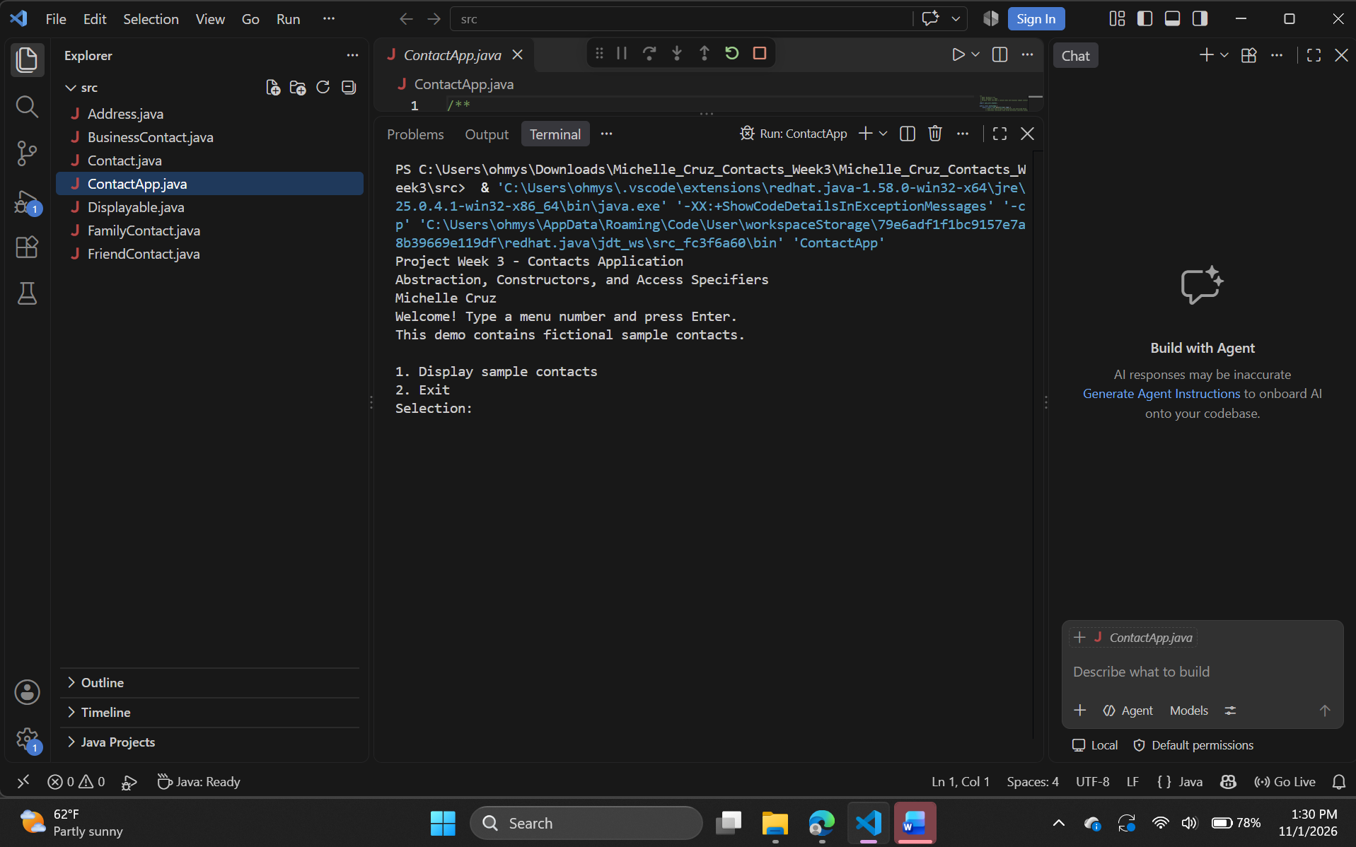
Figure 1 Week 3 welcome message and menu

Contact Directory
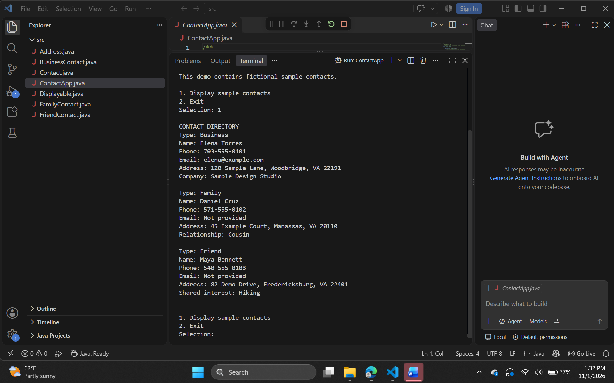
Figure 2 Complete business family and friend contact records

Menu Validation and Exit
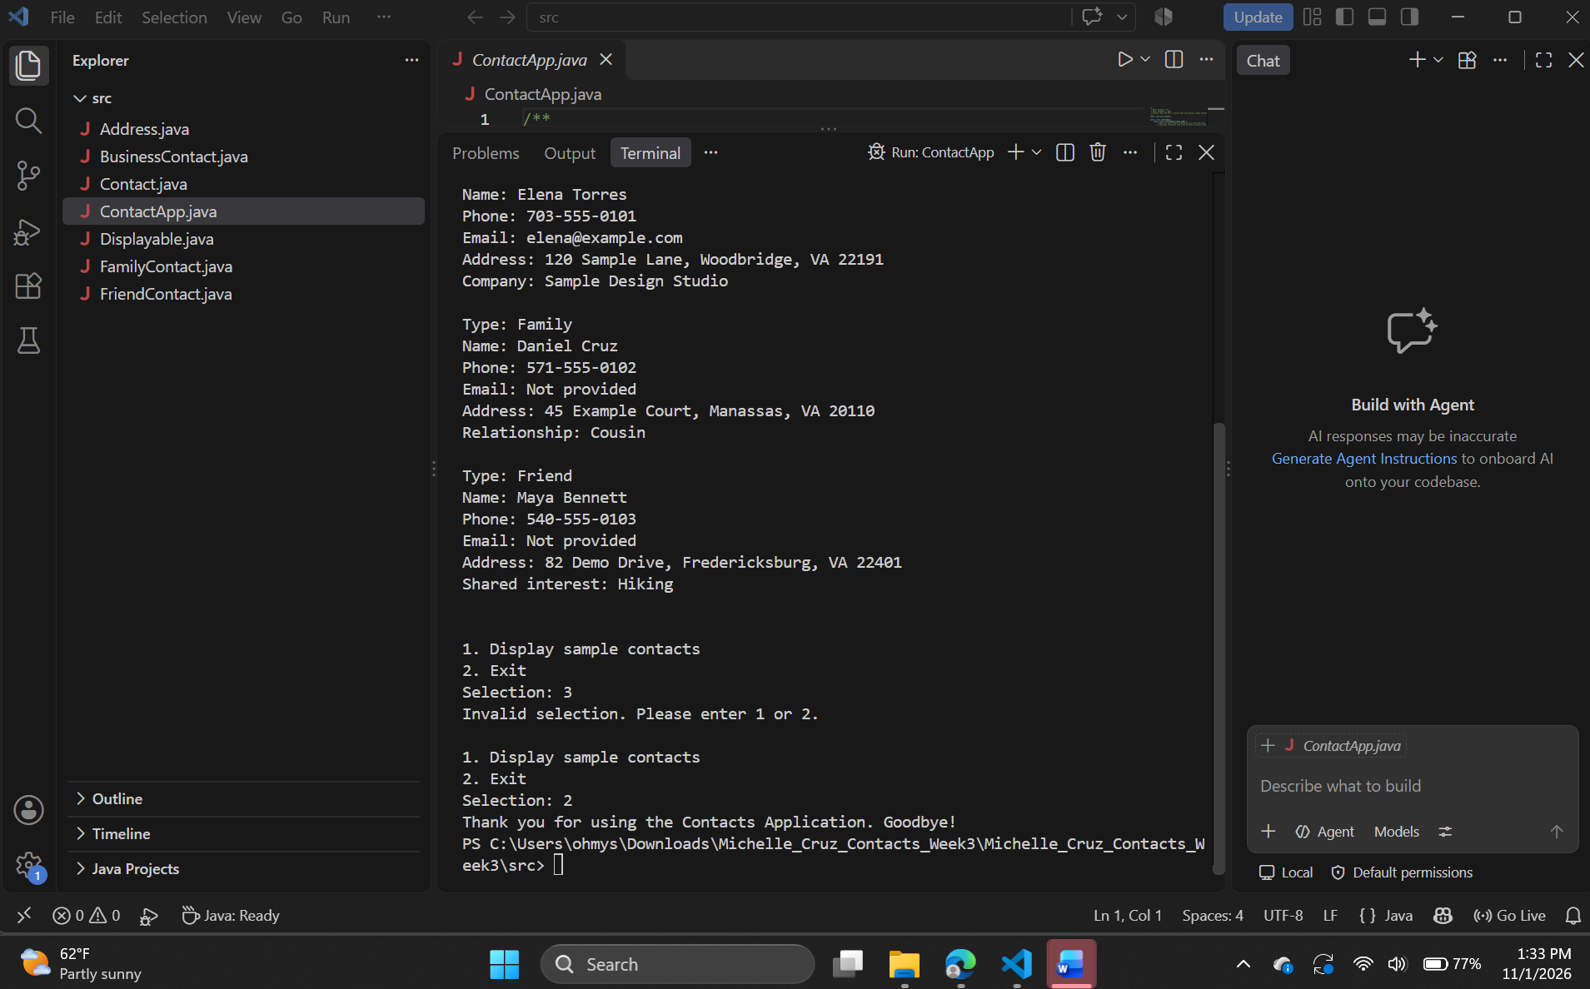
Figure 3 Invalid selection message and successful exit

Validation Results
Choosing 1 displayed the three categories and their details. The full constructor preserved the business email, and the shorter constructors displayed Not provided for the other emails. Choosing 3 displayed an error and repeated the menu. Choosing 2 printed the goodbye message and returned to the terminal prompt. The source headers include my name, date, and class purpose, and inline comments identify the Week 3 concepts.

