Contacts Application Execution Evidence
Michelle Cruz
SDC330L Advanced Object Oriented Programming Using Java Lab
Application Delivery
November 9, 2026
The Contacts application extends the Week 3 design with SQLite storage. Its terminal menu supports adding, displaying, searching, updating, and deleting business, family, and friend contacts. This document shows the application startup and the retrieval of three saved example records.

Application Startup
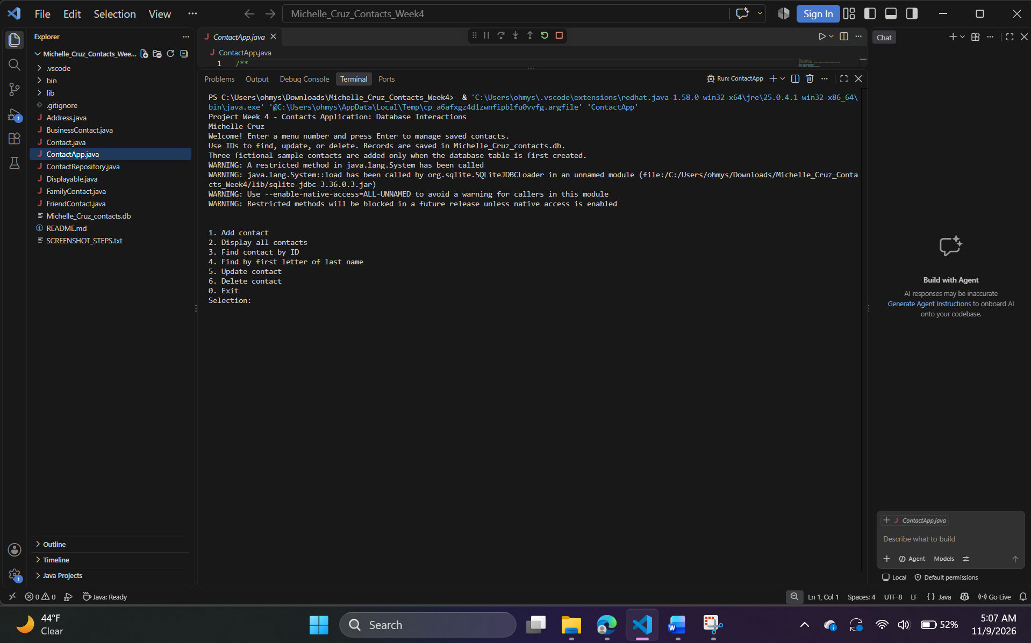
Figure 1. The running application identifies Week 4, Michelle Cruz, the database filename, and the available menu options. The menu appears after the SQLite driver loads.

Saved Contact Records
Choosing option 2 retrieves the contacts from SQLite. The directory displays Maya Bennett as a friend, Daniel Cruz as family, and Elena Torres as a business contact. Each record includes its saved ID, contact information, address, and category detail.
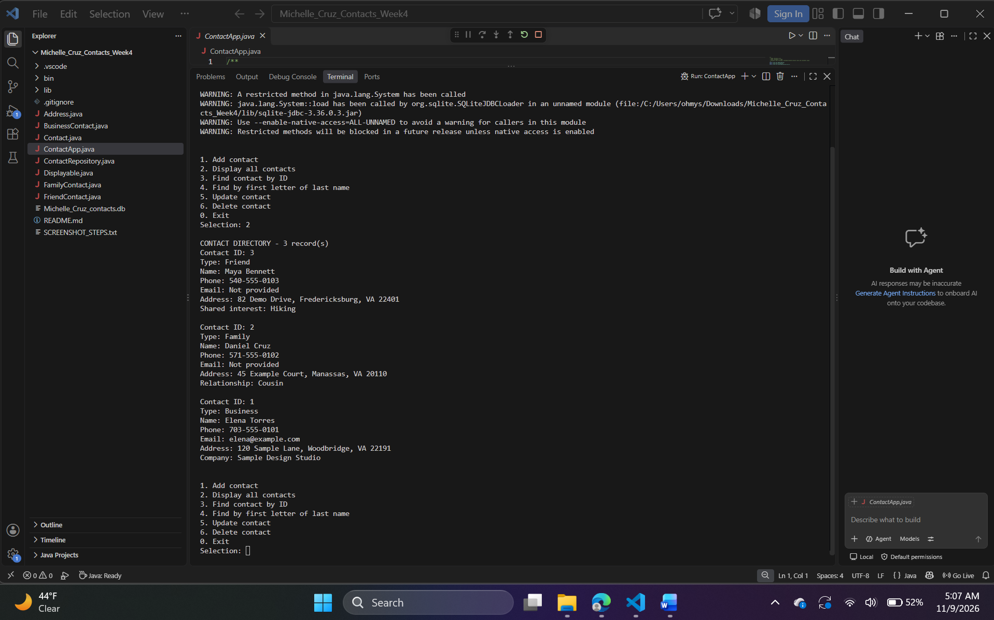
Figure 2. The database read operation displays all three contact categories and returns to the menu.

Implementation Overview
ContactRepository uses JDBC prepared statements to create, retrieve, update, and delete records in the contacts table. Query results are rebuilt as BusinessContact, FamilyContact, or FriendContact objects. The abstract Contact class preserves common display behavior, while each subtype supplies its category details. Contact owns an Address object, and the full and no-email constructors remain available.

