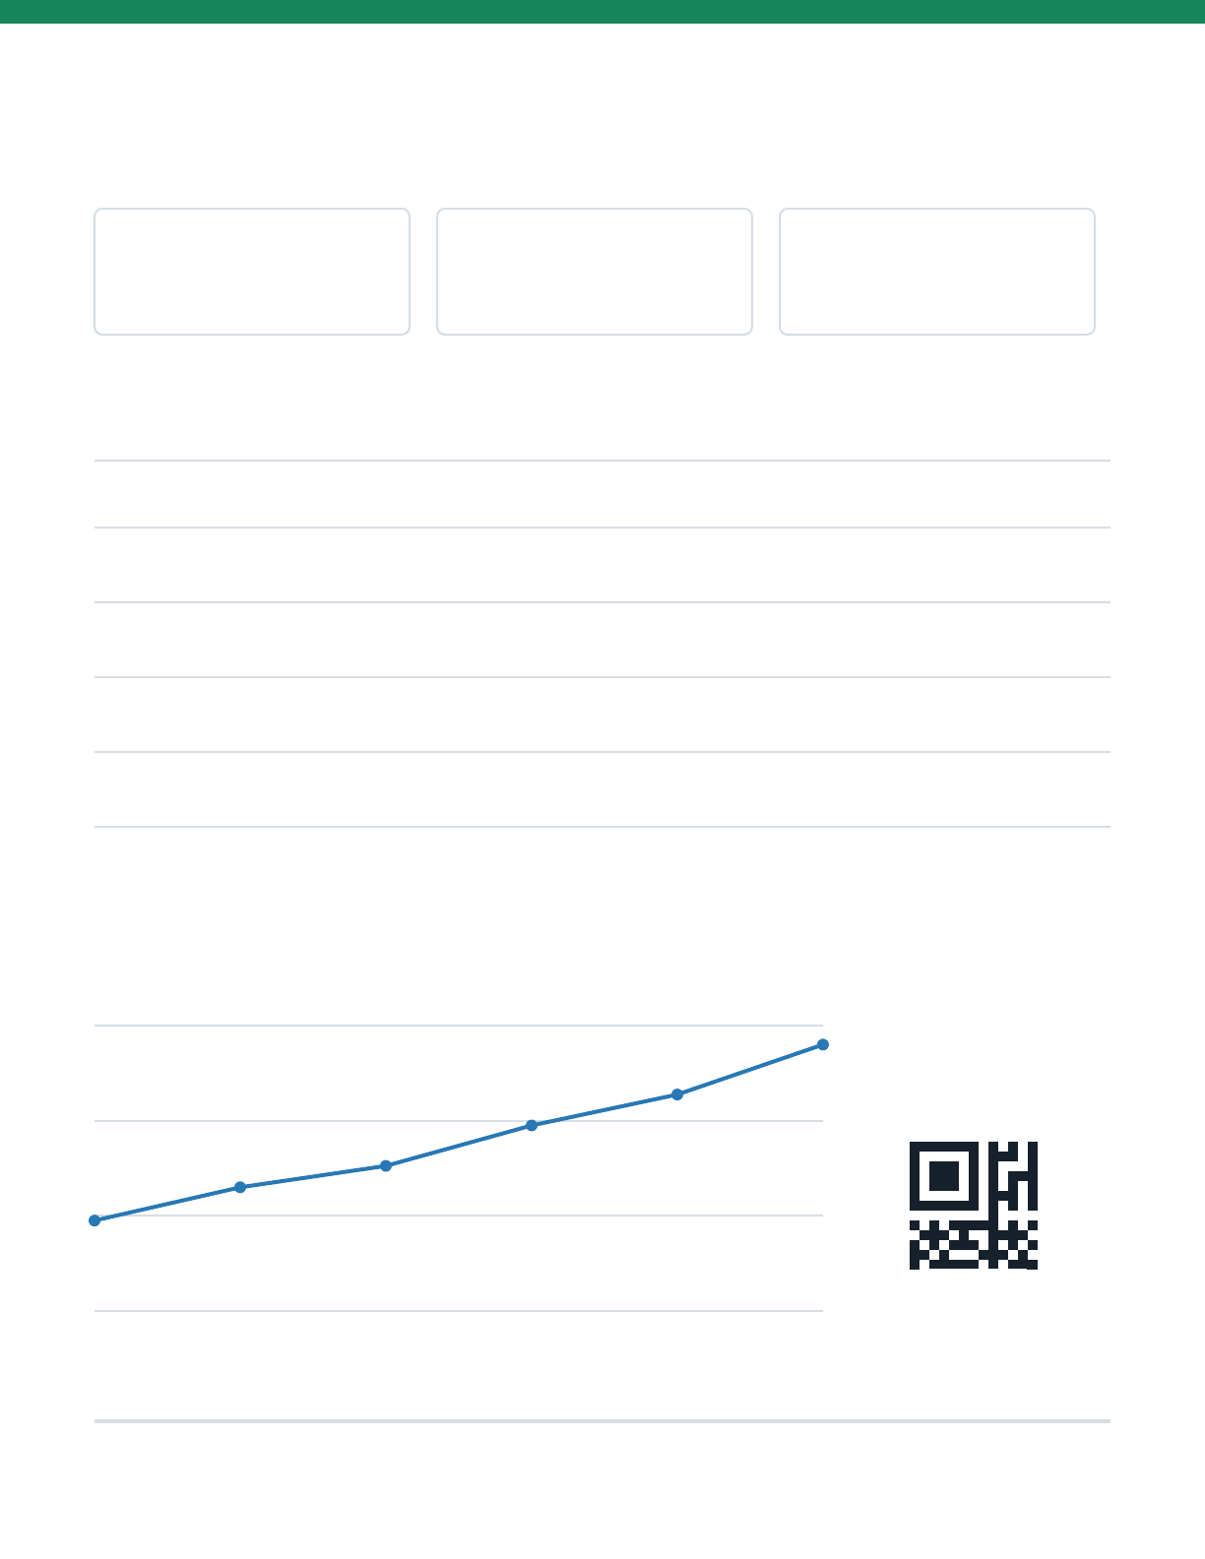
Quarterly Operations Review - Q3 2026
Synthetic demo document | Safe to redistribute | Generated locally
DOCUMENTS
1,284
+18%
SUCCESS RATE
98.7%
+1.4 pts
REVIEW TIME
24 hours
-31%
Conversion quality
CHECK
RESULT
DETAIL
Layout fidelity
Validated
Page geometry and visual structure retained
Editable text
Validated
Searchable Word text boxes created
Privacy
Local
No document upload or cloud conversion
Agent support
Portable
Codex, Claude Code, and Agent Skills
Documents processed
Jan
Feb
Mar
Apr
May
Jun
LOCAL ONLY
Generated by pdf-to-editable-word-skill | github.com/longligooo/pdf-to-editable-word-skill
1 / 1

