# Assignment 1

**Group Members:** Gerard Matthew

Michelle Mulkey

**Software System:** aTunes

**Change Request:** #1

**Modified Classes:** 1. class PlayListController

2. class PlayListHandler

**Time to Complete aTunes CR#1:**

|  |  |  |
| --- | --- | --- |
| **Phase** | **Time** | **% of Total** |
| Initiation | 55 minutes | 46% |
| Concept Location | 15 minutes | 13% |
| Impact Analysis | 10 minutes | 8% |
| Actualization | 10 minutes | 8% |
| Testing | 30 minutes | 25% |
| **Total** | **120 minutes** | **100%** |

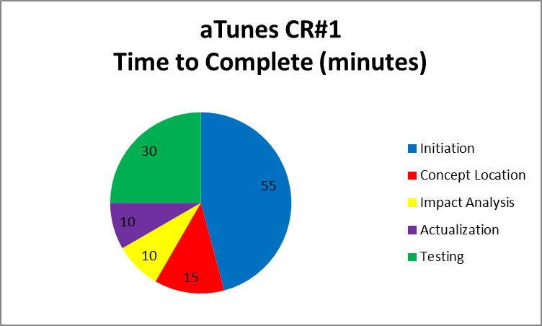

**Process followed to implement the aTunes Change Request #1:**

|  |  |
| --- | --- |
| **Phase** | **Process** |
| Initiation (55m) | 1. Get the aTunes code 2. Create a repository in GitHub 3. Clone the repository on local machine 4. Load the aTunes project in Eclipse 5. Located and download MP3 files to local machine 6. Run aTunes, load MP3 files, and verify existing column sorting |
| Concept Location (15m) | 1. Use knowledge from CR description (e.g. “possible to sort by Title”)    1. Search files for text “Title” 2. Use knowledge from CR description (e.g. “implement sort by Duration”)    1. Search files for text “Sort” 3. From the searches, identified a sort method (found the PlayListController class) for columns 4. Decided to run aTunes in debug mode to confirm the correct sort method was discovered 5. Placed a breakpoint on the columnClicked method 6. Sorted by “Title” to confirm the breakpoint is reached 7. Decided to expand the columnClicked method to include the Duration |
| Impact Analysis (10m) | 1. class PlayListHandler – add method to sort play list by duration 2. class PlayListDurationComparator – create new class 3. class PlayListController - modify the method columnClicked() to sort play list by duration |
| Actualization (10m) | 1. class AudioFile - utilize getDuration() method 2. class PlayListDurationComparator – create new class modeled after the PlayListFileComparator; return value is 0 if less, 1 if greater. 3. class PlayListHandler - add sortPlayList(PlayListDurationComparator) 4. class PlayListController - add check for duration sort in ColumnClicked() method |
| Testing (30m) | 1. Run aTunes in debug mode 2. Placed a breakpoint on the columnClicked() method 3. Sorted by Duration to confirm the breakpoint is reached 4. Sort failed, step through to confirm the SortPlayListByDuration is executed 5. Added debug statements to trouble-shoot failed sort by duration 6. Step through and discovered the array is NOT sorted correctly 7. Resorted to StackOverflow for help using comparators and learned the return value is tri-state (-1 less, 1 greater, 0 equal) 8. Corrected the sort comparator to return the tri-state values 9. Run aTunes, sort by Duration is a success! 10. Commit changes to GitHub |

**Additional Information for aTunes Change Request #1:**



**Group Members:** Gerard Matthews

Michelle Mulkey

**Software System:** aTunes

**Change Request:** #2

**Modified Classes:** 1. class PlayListControlsPanel

2. class PlayListController

3. class PlayListControlsController

4. class PlayListControlsListener

**Time to Complete aTunes CR#2a:**

|  |  |  |
| --- | --- | --- |
| **Phase** | **Time** | **% of Total** |
| Initiation | 5 minutes | 3% |
| Concept Location | 25 minutes | 12% |
| Impact Analysis | 10 minutes | 5% |
| Actualization | 65 minutes | 32% |
| Testing | 96 minutes | 48% |
| **Total** | **201 minutes** | **100%** |

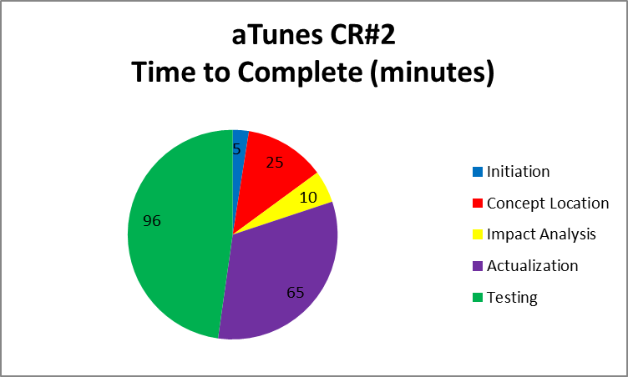

**Process followed to implement the aTunes Change Request #2:**

|  |  |
| --- | --- |
| **Phase** | **Process** |
| Initiation (5m) | 1. Run aTunes, load MP3 files, and located the Options Menu called out in the change request 2. The Options Menu located on the bottom center appears to be the one to use |
| Concept Location (25m) | 1. Use knowledge from CR description (e.g. “possible to Show Genres”)    1. Search files for text “Show Genres” 2. Find a single instance of the text string “Show Genres”. 3. Decided to replicate the Show Genres logic in order to implement the Show Duration. |
| Impact Analysis (10m) | 1. Searched for locations of the “Show Genres” code and found the following:    1. english.properties file    2. class PlayListControlsPanel    3. class PlayListController    4. class PlayListControlsController    5. class PlayListControlsListener |
| Actualization (65m) | 1. Discovered a column width calculation – not sure how it works? 2. Not sure but, appears there is a need for a new column class to represent a duration column? 3. Decided to setup some breakpoints to step through the column width calculations and learn how they work. 4. Resorted to Google to learn why the Eclipse breakpoint toolbar icons are missing. Found the short cuts for step-in, step-over, and run to line. Found them! F5 – step-in, F6 step-over, and Ctrl-R to run 5. Later, stumbled onto the debug menu layout and now have short cuts back. 6. Verified all code related to “Show Genres” is replicated for “Show Duration” |
| Testing (96m) | 1. Run aTunes but failed to show/hide duration column, not sure why? 2. Run aTunes in debug mode and discovered missing updates to the following methods (now we know how the column width calculation works):    1. adjustColumnsWidth()    2. setCurrentHeader()    3. getColumnCount() |

**Additional Information for aTunes Change Request #2:**

