# Assignment 1

**Group Members:** Gerard Matthew

Michelle Mulkey

**Software System:** jEdit

**Change Request:** #1

**Modified Classes:** 1. class RecentFilesProvider

**Time to Complete jEdit CR#1:**

|  |  |  |
| --- | --- | --- |
| **Phase** | **Time** | **% of Total** |
| Initiation | 10 minutes | 59% |
| Concept Location | 4 minutes | 23% |
| Impact Analysis | 1 minutes | 6% |
| Actualization | 1 minutes | 6% |
| Testing | 1 minutes | 6% |
| **Total** | **17 minutes** | **100%** |

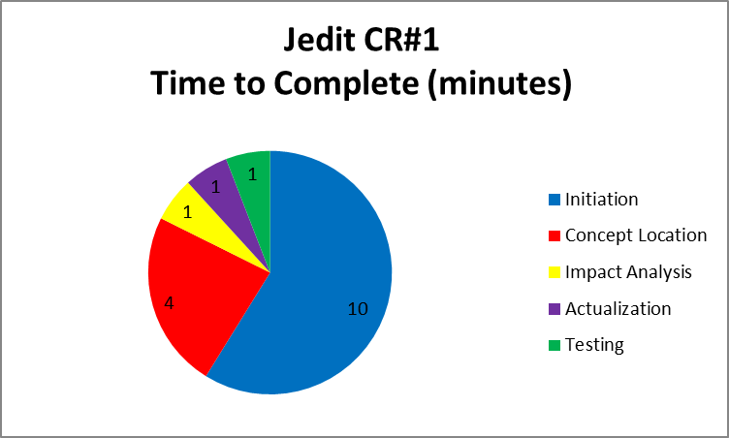

**Process followed to implement the Jedit Change Request #1:**

|  |  |
| --- | --- |
| **Phase** | **Process** |
| Initiation (10m) | 1. Get the Jedit code 2. Create a repository in GitHub 3. Clone the repository on local machine 4. Load the Jedit project in Eclipse 5. Run Jedit and become familiar with tool 6. Create some files 7. Verify the locate box works for the 1st character of the filename |
| Concept Location (4m) | 1. Use knowledge from CR description (e.g. “In the File > Recent Files main menu there is a text box…”)    1. Search files for text “Recent Files” 2. From the search, identified the RecentFileProvider class |
| Impact Analysis (1m) | 1. class RecentFileProvider |
| Actualization (1m) | 1. class RecentFileProvider – used knowledge of search string utility to replace method startsWith() with method contains() |
| Testing (1m) | 1. Run Jedit and verify the one-line change worked 2. Commit change to GitHub |

**Additional Information for Jedit Change Request #1:**



**Group Members:** Gerard Matthew

Michelle Mulkey

**Software System:** Jedit

**Change Request:** #2

**Modified Classes:**

1. Class TextArea
2. class EditPane
3. class ScrollbarOptionPane (new)

**Time to Complete Jedit CR#2:**

|  |  |  |
| --- | --- | --- |
| **Phase** | **Time** | **% of Total** |
| Initiation | 1 minutes | 1% |
| Concept Location | 79 minutes | 30% |
| Impact Analysis | 90 minutes | 35% |
| Actualization | 60 minutes | 23% |
| Testing | 30 minutes | 11% |
| **Total** | **260 minutes** | **100%** |

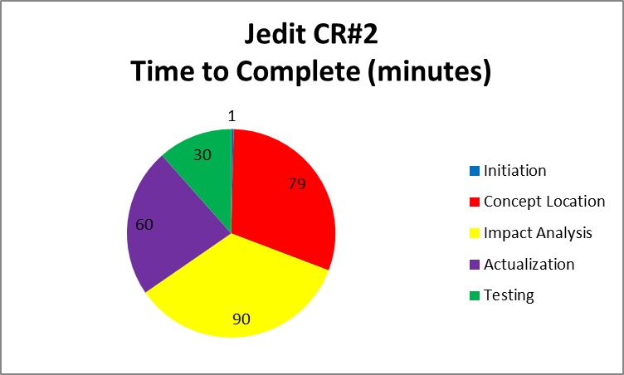

**Process followed to implement the Jedit Change Request #2:**

|  |  |
| --- | --- |
| **Phase** | **Process** |
| Initiation (1m) | 1. Run jEdit and become familiar with the Edit menu 2. Open a large text file and verify the scroll bars are displayed |
| Concept Location (79m) | 1. Use knowledge from CR description (e.g. “Implement an option in the Edit menu …hiding scrollbars.”)    1. Search files for text “Edit” 2. Use knowledge from CR description (e.g. “scrollbar”)    1. Search files for text “” 3. From the searches, identified the method where the scrollbars are created. 4. From searches, identified locations to replicate the Toggle Gutter menu item the View menu. 5. From searches, identified locations to replicate adding new menu item to the Edit Menu. Located the menu item code in class EditPane 6. From searches, identified the action handler for Toggle Gutter 7. From searches, identified changes needed to the following classes: class EnhancedMenu and JEditTextArea; however both these leads turned out to be incorrect. |
| Impact Analysis (90m) | 1. class TextArea – modify to access scrollbars and toggle scrollbars 2. class EditPane – modify to include Toggle Scrollbar menuitem 3. class EnhancedMenu – modify to include Toggle Scrollbar menuitem (in the end, this impact was erroneous.) 4. jedit.props – modify to support an action handler for Toggle Scrollbar menu item 5. jedit_gui.props - modify to include Toggle Scrollbar menuitem 6. actions.xml - modify to include an action handler for Toggle Scrollbar menu item   Note: The menu item and action handler process was very difficult to identify, locate, and trace. Watched an online video for intro to menu items. Was surprised to learn the xml file contained java code. Was surprised to learn how obscure action handlers are (i.e. buried in an .xml file versus a class named “ActionHandler”. |
| Actualization (60m) | 1. class TextArea – add method showScrollbar() to show/hide the scrollbars 2. class TextArea – add private data accessor functions getVertical() and getHorizontal() to retrieve the scrollbar handles. 3. class jedit_gui.props – modified the Edit Menu to insert a new menu item named Toggle Scrollbar. 4. actions.xml and jedit.props – modified to support a new action handler 5. Relied upon the debugger to step through working examples of Toggle gutter action handler. 6. Class ScrollbarOptionsPane – created a new class to mimic the Toggle Gutter bare minimum properties/methods needed.   Note: The menu item and action handler process was very difficult to implement. Relied upon the debugger to set breakpoints and watches to better understand how the code works. Learned that the menus are built by parsing strings; and the strings contain special fields for short cuts and actions. |
| Testing (30m) | 1. Run Jedit, verity the new menu item displays under the Edit menu. 2. Run Jedit, verify the new menu item is a Toggle Box 3. Run Jedit, toggle menuitem, and verify the scrollbars show/hide 4. Repeat steps 1-3 in the debugger until working. 5. Commit changes to GitHub |

**Additional Information for Jedit Change Request #2:**

