Dataset Overview:
This dataset contains healthcare procedure records, including patient identifiers, procedure details, payment amounts, and provider information. Each row represents a single procedure performed for a patient, with unique identifiers for patients (Person_ID) and procedures (Procedure_Concept_ID). Key text fields, such as Provider_Name, Concept_Name, and Category_According_to_Expert_Domain, have been standardized to ensure consistency, and potential duplicates have been flagged for review. All columns have been reviewed for data type, missing values, and formatting to provide a clean, consistent dataset ready for analysis, reporting, or Tableau import.
Column Name | Description | Data Type | Issues Observed/Standardization
Person_ID | Unique Identifier for patient | ID | None Observed
Procedure_Date | Date the Procedure was performed | Date | None Observed
Procedure_Concept_ID | Unique Identifier for Procedure | ID | None Observed
Concept_Name | Name of Procedure | Text | Trimmed spaces, capitalized
Amount | Indicator value used to count records (each row = 1) | Number (count) | Column name suggests monetary value
Total_Paid | Total amount paid for the procedure | Currency | None Observed
Provider_ID | Unique Identifier for Provider | ID | None Observed
Provider_Name | Name of Facility or Provider | Text | Trimmed spaces, capitalized, standardized common variations
Category_According_to_Expert_Domain | Category defined by domain expert | Categorical
  Trimmed spaces, standardized values according to mapping table

Data Cleaning / Standardization Notes

Text Fields Standardization:
Columns: Provider_Name, Concept_Name, Category_According_to_Expert_Domain
  - Trimmed extra spaces
  - Standardized capitalization (PROPER)
  - Corrected spelling / abbreviations

Numeric Fields:
Column: Amount, Total_Paid
  - Verified numeric format
  - Checked for invalid or negative values

Dates:
Column: Procedure_Date
  - Ensured Excel date format
  - Verified no impossible dates

Duplicates:
- Potential duplicates based on Person_ID + Procedure_Date + Procedure_Concept_ID flagged in helper column
- Remaining duplicates removed in final cleaned dataset

Final Dataset Notes
- All columns reviewed for type and formatting
- Dataset fully cleaned and standardized for Tableau analysis
- Ready for visualization, reporting, and further validation

Tableau Project Overview:
- Objective: Develop a Tableau dashboard that summarizes healthcare procedure volume and revenue performance to support operational and billing insights.
- Audience: Healthcare administrators, billing managers, and operational stakeholders.
- Focus: High-level KPIs, procedure mix, and volume trends over time.

Data Validation & Assumptions:
- The dataset consists of aggregated records summarized by procedure type and date.
- Procedure Count was used as the primary volume metric rather than record count.
- All KPIs were validated by reconciling Tableau outputs against raw data totals prior to visualization.
- Revenue values reflect total paid amounts aggregated at the procedure level.

Key Calculations:
- Total Procedures = SUM(Procedure Count)
- Total Revenue = SUM(Total Paid)
- Average Revenue per Procedure = Total Revenue ÷ Total Procedures

Visualization & Design Decisions:
- Single-number KPI views were used to highlight executive-level metrics at a glance.
- A bar chart was used to display procedures by type to clearly show distribution and relative volume.
- A line chart was used to illustrate procedure trends over time and identify changes in volume patterns.
- Formatting was intentionally kept clean and consistent to improve readability and dashboard usability.

Dashboard Layout & Design:
- The dashboard was designed with an executive healthcare audience in mind, prioritizing clarity, hierarchy, and ease of interpretation. Key performance indicators (Total Procedures, Total Revenue, and Average Revenue per Procedure) are displayed prominently at the top in a horizontal layout to enable quick scanning.
- Trend analysis is placed directly below the KPI section to provide temporal context for overall procedure volume. A bar chart highlighting the top procedures by volume is included at the bottom of the dashboard to focus attention on the most impactful procedure categories while avoiding unnecessary scrolling.
- Dashboard size was fixed to ensure consistent presentation across devices and for portfolio screenshots. Visual clutter was minimized by limiting gridlines, standardizing fonts, and using concise titles. Filtering to top procedures was an intentional design choice to balance completeness with readability.

Dashboard Filters & Insights:
- Interactive filtering was implemented to allow stakeholders to explore procedure volume across time and by procedure type. A global date filter enables flexible time-based analysis across all KPIs and charts, while bar-chart selection supports focused examination of individual procedures.
- The dashboard reveals that procedure volume is concentrated among a limited number of high-volume procedures, with noticeable variation across time periods. These interactive features allow users to identify trends, compare procedural demand, and quickly assess operational patterns without increasing dashboard complexity.
- Interactivity was intentionally limited to preserve usability and ensure the dashboard remains accessible to non-technical healthcare users.

Key Insights: The following insights were derived from the dashboard and highlight trends in procedure volume and revenue performance
- Procedure Concentration: Procedure volume is heavily concentrated in the Top 7 procedures, accounting for the majority of total procedures performed (see Bar Chart screenshot).
- Temporal Trends: Follow-Up consultations consistently spike at the beginning of each month, while other procedures remain more stable over time (see Dashboard filtered by date screenshot).
- Revenue Insights: Average revenue per procedure varies across procedure types. While Follow-Up consultations generate $234 per procedure, slightly below the overall average of $296.06 per procedure, indicating other procedures contribute higher per-procedure revenue. (see Dashboard interaction screenshot).

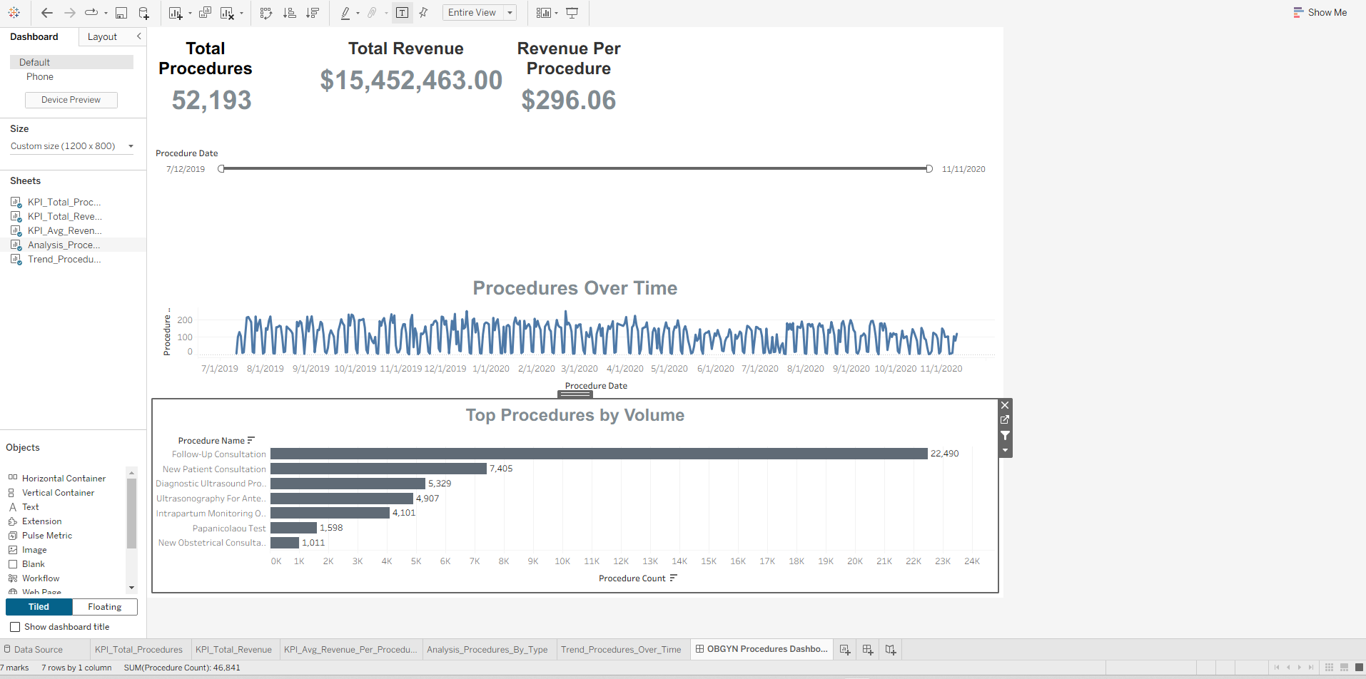
Full Dashboard Screenshot: Figure 1: Complete dashboard showing KPIs, procedure trends, and distribution across all procedure types.

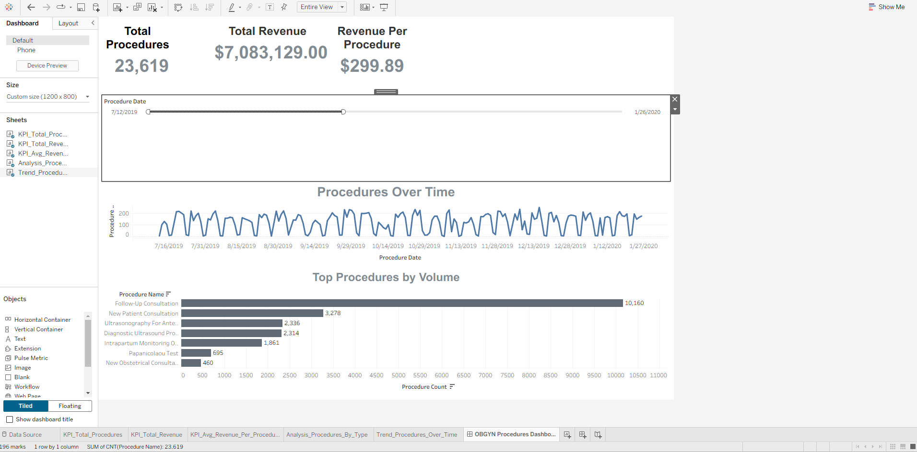
Date Filter Screenshot: Figure 2: Dashboard filtered by date showing spikes in Follow-Up consultations at the start of the month.

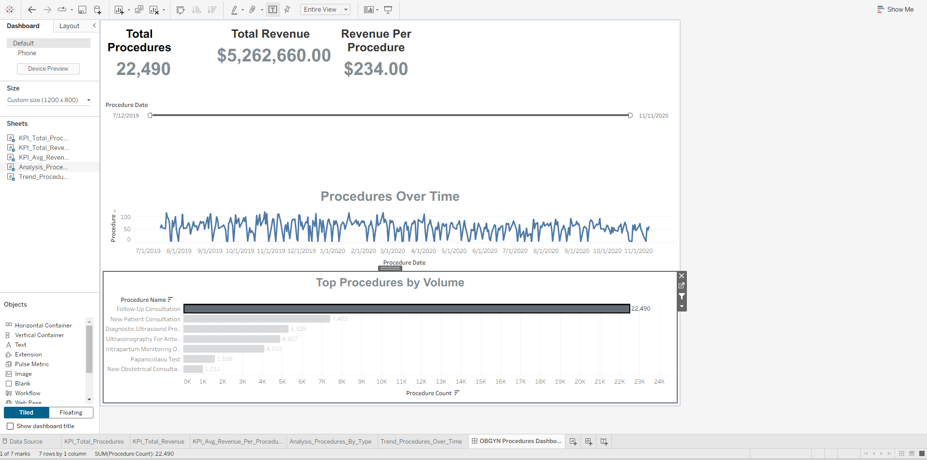
Interaction Screenshot: Figure 3: Example of dashboard interactivity, highlighting revenue and volume for a single procedure type.

Limitations & Future Enhancements
• The dataset reflects summarized procedure data rather than patient-level detail.
• Future enhancements could include analysis by payer, provider, location, or cost to support deeper operational insights.

