Steps for creating new crafter page:

Typically what I do is copying and pasting the existing page.

Log in to crafter, click developer.com(image below)

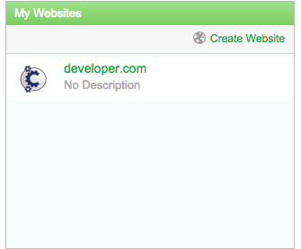

You will see “site content” on the upper left corner:

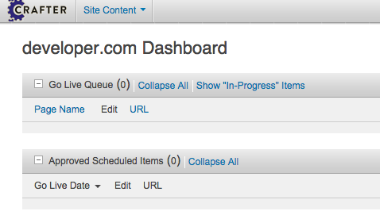

From this point it on you will find all path from this menu.

For example, to copy and paste IAM page, the path for our API docs is:

page/home/apis/in-app-messaging/vX

Right click the menu and copy and paste to the folder.

You can right click to do rename. You will see the component pages.

Under layout you will see:

V3-in-app-messaging-doc-container

This is the most outer wrapper of the components. It contains all the sub-components. And remember all the components are reference so when you copy a page it’s reference to the same sub-components. So if you need to create or modify to a new one you have to copy and paste the sub-components too. ☺

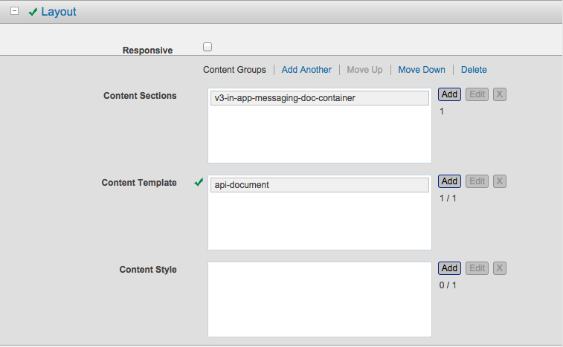

To copy and paste Components:

The path to components from Site Content menu is:

Site Contents/components/components/content/document/APIDocs

You will see all the directories for each APIs.

Each API also has sub-folder that contains the version of the API.

For quickStart I created v3, and I copy and paste all the components that is needed for Hello World project. Listed below :

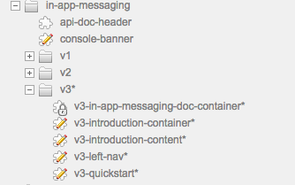

You need to copy and paste the v2 version of those components and paste it to the new v3 folder. Also goes in to each components and edit the name. From this step I suggest copy and paste the doc-container first.

Steps for update on crafter

Dependencies:

* 1. content for introductions(SME)
  2. content for quickstart diagram/codesnippet(SME/Dev)

1. Update leftnav(rearrange orders)

Using the template i provide with “Try it now” button

for example:

<aside>

<div class="fixed-scroll">

<div id="toc">

<a href="https://apigee.com/att/embed/console/ATT?v=2" target="_blank" class="button blue" title="Get started!" >Try it now!</a>

<ul class="level-1">

<li class="highlighted" id="nav_introduction"><a href="#introduction">Introduction</a></li>

<li id="nav_quickstart"><a href="#quickstart">Quickstart</a></li>

<li id="nav_sample-apps"><a href="#sample-apps">Sample Apps</a></li>

<li id="nav_codesnippets"><a href="#codesnippets">Code Snippets</a></li>

<li id="nav_authorization"><a href="#authorization">OAuth</a></li>

<li id="nav_resources"> <a href="#resources">Resources</a>

<ul class="level-2" style="display: block;">

<li id="nav_resources-create-message-index"><a href="#resources-create-message-index" id="no-responsive-tag-api-docs-content_4_Create-Message-Index">Create Message Index</a></li>

<li id="nav_resources-delete-message"><a href="#resources-delete-message" id="no-responsive-tag-api-docs-content_5_Delete-Message">Delete Message</a></li>

<li id="nav_resources-delete-messages"><a href="#resources-delete-messages" id="no-responsive-tag-api-docs-content_6_Delete-Messages">Delete Messages</a></li>

<li id="nav_resources-get-message"><a href="#resources-get-message" id="no-responsive-tag-api-docs-content_7_Get-Message">Get Message</a></li>

<li id="nav_resources-get-message-content"><a href="#resources-get-message-content" id="no-responsive-tag-api-docs-content_8_Get-Message-Content">Get Message Content</a></li>

<li id="nav_resources-get-message-index-info"><a href="#resources-get-message-index-info" id="no-responsive-tag-api-docs-content_9_Get-Message-Index-Info">Get Message Index Info</a></li>

<li id="nav_resources-get-message-list"><a href="#resources-get-message-list" id="no-responsive-tag-api-docs-content_10_Get-Message-List">Get Message List</a></li>

<li id="nav_resources-get-messages-delta"><a href="#resources-get-messages-delta" id="no-responsive-tag-api-docs-content_11_Get-Messages-Delta">Get Messages Delta</a></li>

<li id="nav_resources-get-notification-connection-details"><a href="#resources-get-notification-connection-details" id="no-responsive-tag-api-docs-content_12_Get-Notification-Connection-Details">Get Notification Connection Details</a></li>

<li id="nav_resources-send-message"><a href="#resources-send-message" id="no-responsive-tag-api-docs-content_13_Send-Message">Send Message</a></li>

<li id="nav_resources-update-message"><a href="#resources-update-message" id="no-responsive-tag-api-docs-content_14_Update-Message">Update Message</a></li>

<li id="nav_resources-update-messages"><a href="#resources-update-messages" id="no-responsive-tag-api-docs-content_15_Update-Messages">Update Messages</a></li>

</ul>

</li>

<li id="sdks-plugins-link"><a href="/sdks-plugins?api=addressbook" target="sdksWindow">SDKs & Plugins</a></li>

<li id="nav_faqs"><a href="/support/faqs/addressbook-api-faqs" target="faqsWindow">FAQs</a></li>

<li id="errors-link"><a href="/apis/errors?api=addressbook" target="errorsWindow">Errors</a></li>

</ul>

</div>

</div>

</aside>

To update this on crafter:

First go to the components

Site Contents/components/components/content/document/APIDocs

* 1. Copy v2-leftnav from v2 holder
  2. paste to v3 folder
  3. Edit (open components)
  4. You will see a new page with HTML textarea
  5. Paste the new content to HTML area
  6. Go back to (edit) in-app-messaging-doc-container
  7. Add v3-left-nav in to category items 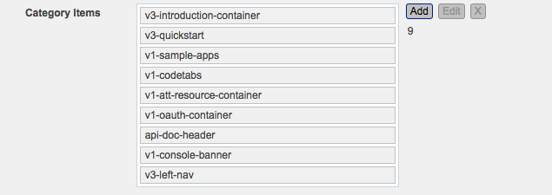
  8. Save and update

## Update doc header(use the template)

Remove API console button

template below:

<header id="api-docs-header">

<div class="inner">

<aside>

<span>API Version</span>

<select id="version" onchange="window.location = this.value">

<option value="/apis/speech/docs/v3">Version 3</option>

</select>

<a href="https://apigee.com/att/embed/console/ATT?v=2" target="_blank" class="button blue hide" title="Get started!">API Console</a>

</aside>

<div class="main">

<div class="status">

<div class="status-icon form-icon" title="alert"></div>

<div class="status-status">

<span>Active:</span>

<span>AT&amp;T version 2.</span>

</div>

</div>

</div>

</div>

</header>

-update introduction on crafter using "vX-introduction-content" components, update contents

With new content SME provide

for exmaple:

<section id="introduction" class="level-1">

<header>Introduction</header>

<section id="introduction-overview" class="level-2">

<p>The In-App Messaging API sends and retrieves SMS and MMS messages on behalf of a customer after consent. The message is sent to the recipients using the customer's phone number as the sender address. A develoepr can build apps to send and manage messages from single application.</p>

<ul>

<li>Sending messages from your app: The Send Messages (text and images) to any mobile phone number, emails and shortcodes</li>

<li>Receiving messages in your app: Responses to the messages are able to be received by the user's mobile phone </li>

</ul>

</section>

</section>

same step as leftnav the component name is api-doc-header

On this one since it’s universal(meaning all the version will use the same components) so you can just edit directly on the component instead of creating a new one.

## Create new section "Quick Start":

The diagram is really straight forward.

On the diagram you can do:

3 different classes for the arrow position:

left-half: Represent from user to DHS or DHS to user.

full: Represent from user to Gateway or Gateway to user.

right half: Represent from DHS to Gateway or Gateway to DHS.

2 classes for arrow direction:

right-arrow: request.

left-arrow: response.

For example

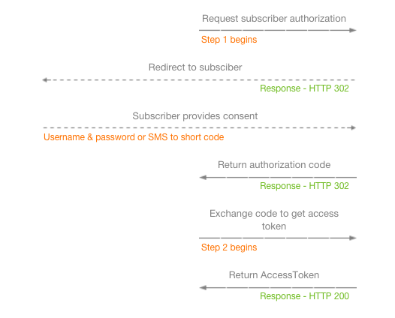

Template:

<div id="oauth-workflow" class="call-flow-container">

<div class="img-table">

<div class="cf-row-img">

<div class="cf-img cf-left">Subscriber</div>

<div class="cf-img cf-center">Developer-Hosted Server</div>

<div class="cf-img cf-right">AT&amp;T Gateway</div>

</div>

</div>

<ul>

<li class="right-half right-arrow">

<div class="cf-description"><p>Request subscriber authorization</p></div>

<div class="arrow"></div>

<div class="cf-sub-description red-left"><p>Step 1 begins</p></div>

</li>

<li class="full left-arrow">

<div class="cf-description"><p>Redirect to subsciber </p></div>

<div class="arrow"></div>

<div class="cf-sub-description green-right"><p>Response - HTTP 302</div>

</li>

<li class="full right-arrow">

<div class="cf-description"><p>Subscriber provides consent</p></div>

<div class="arrow"></div>

<div class="cf-sub-description red-left"><p>Username &amp; password or SMS to short code </p></div>

</li>

<li class="right-half left-arrow">

<div class="cf-description"><p>Return authorization code</p></div>

<div class="arrow"></div>

<div class="cf-sub-description green-right"><p>Response - HTTP 302 </p></div>

</li>

<li class="right-half right-arrow">

<div class="cf-description"><p>Exchange code to get access token</p></div>

<div class="arrow"></div>

<div class="cf-sub-description red-left"><p>Step 2 begins</p></div>

</li>

<li class="right-half left-arrow">

<div class="cf-description"><p>Return AccessToken </p></div>

<div class="arrow"></div>

<div class="cf-sub-description green-right"><p>Response - HTTP 200</p></div>

</li>

</ul>

</div>

For the code tabs, Pavel is able to generates all the codes to have syntax high lighter and is ready for crafter template. Please follow the attachment “quickstart.html” and copy and paste the html files that are generated to the right location.

The while quickstart.html will be the template that is ready for crafter.

To create this component what I did is copy and paste the introduction-content and paste it in v3 folder and name it to “v3-quickstart” copy the new content in it.

From api-doc-container add this one and place it under introduction container.



And you are done!