|  |
| --- |
| Photo displaying partial image of two pie charts on a canvas-textured page |
| Baza podataka lanca hotela |
| |  |  |  | | --- | --- | --- | | Michelle Šarić | 12/15/20 | Domaći rad 5 | |

Contents

SPECIFIKACIJE 2

ENTITETI I ATRIBUTI 2

ER DIJAGRAM 3

RELACIJSKI MODEL 3

KOD 4

KREAIRANJE TABLICA 4

UNOS 5

UPITI 6

# SPECIFIKACIJE

Napraviti bazu podataka za praćenje poslovanja lanca hotela. Hoteli imaju svoje ime, lokaciju, ime vlasnika, mobitel/telefon te email. U svakom hotelu se trebaju bilježiti informacije o svim gostima, dakle njihova imena, prezimena, datum rođenja, adresu i broj mobitela. U hotelu se vodi evidencija soba, gdje svaka soba ima svoj broj, kapacitet, kategoriju i cijenu za noćenje. Isto tako se mora voditi evidencija o zaposlenicima(Hotel ima i zaposlenike raznih uloga, od recepcionista  preko čistačica do sobne posluge.). Moraju se bilježiti njihova imena i prezimena, OIB, adresa, broj mobitela te vrsta zaposlenja, radno vrijeme i satnica. Svaki posjet svakoj sobi se bilježi i čuva u sustavu, i to na način da se ne pamti samo 'kupac' smještaja nego informacije o svim osobama koje su boravile u smještaju. Ono što osim vremena boravka definira boravak u hotelu je i to da li je osoba uzela polupansion, pansion ili obični boravak. U zapisu 'kupnje' smještaja treba biti navedeno kada je ostvarena transakcija, po kojoj je cijeni plaćeno te što je sve naručeno (koja je soba + ništa, polupansion, pansion).

# ENTITETI I ATRIBUTI

* HOTEL - ime, adresa, ime_vlasnika, broj_mobitela, broj_telefona, e-mail
* GOST - ime, prezime, spol, adresa, država, datum_rođenja, broj_osobne_iskaznice/putovnice
* SOBA - broj_sobe, kategorija, kapacitet, cijena_noćenja
* ZAPOSLENIK - ime, prezime, spol, datum_rođenja, adresa, vrsta_zaposlenja, satnica
* BORAVAK - datum_dolaska, vrijeme_dolaska, datum_odlaska, vrijeme_odlaska, vrsta_usluge, cijena_usluge
* RAČUN - ukupna_cijena_računa, datum_izdavanja

# ER DIJAGRAM

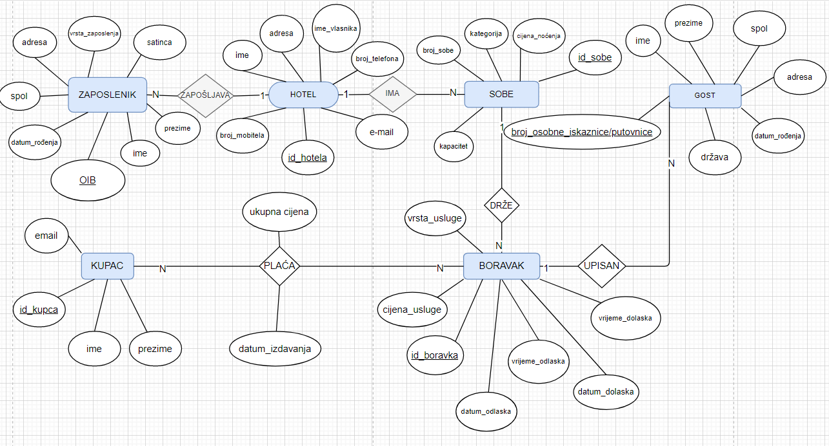

# RELACIJSKI MODEL

HOTEL(id_hotela, ime, adresa, ime_vlasnika, broj_telefona, broj_mobitela, email),

ZAPOSLENICI(id_zaposlenika, ime, prezime, datum_rođenja, spol, adresa, vrsta_zaposlenja, satnica, id_hotela),

SOBE(id_sobe, broj_sobe, kategorija, cijena_noćenja, kapacitet, id_hotela),

GOST(id_gosta, ime, prezime, spol, adresa, država, datum_rođenja, id_boravka),

BORAVAK(id_boravka, datum_dolaska, vrijeme_dolaska, datum_odlaska, vrijeme_odlaska, vrsta_usluge, cijena_usluge, id_sobe)

KUPAC(id_kupca, ime, prezime, email),

RAČUN[KUPAC-BORAVAK](id_kupca, id_boravka, ukupna_cijena, datum_izdavanja)

# KOD

## KREAIRANJE TABLICA

use Hotel

create table HotelInformation (

Id int IDENTITY(1,1) PRIMARY KEY,

Name nvarchar(200) NOT NULL,

Adress nvarchar(200) NOT NULL,

OwnerName nvarchar(100),

PhoneNumber nvarchar(12),

TelefoneNumber nvarchar(11),

Email nvarchar(200)

)

create table Employers (

OIB nvarchar(11) PRIMARY KEY,

FirstName nvarchar(100) NOT NULL,

LastName nvarchar(100) NOT NULL,

DateOfBirth date NOT NULL,

Gender nvarchar(6) NOT NULL CHECK(Gender = 'Male' OR Gender = 'Female'),

Adress nvarchar(200) NOT NULL,

TypeOfEmployment nvarchar(50) NOT NULL,

HourlyPay int NOT NULL,

HotelId int FOREIGN KEY REFERENCES HotelInformation(Id) NOT NULL

)

create table HotelRooms (

Id int IDENTITY(1,1) PRIMARY KEY,

Number int NOT NULL UNIQUE(Number),

Category nvarchar(100) NOT NULL,

AccommodationPrice int NOT NULL,

Capacity int NOT NULL CHECK(Capacity < 6),

HotelId int FOREIGN KEY REFERENCES HotelInformation(Id) NOT NULL

)

create table Accommodation (

Id int IDENTITY(1,1) PRIMARY KEY,

DateOfArrival date NOT NULL,

TimeOfArrival time NOT NULL,

DateOfDeparture date NOT NULL,

TimeOfDeparture time NOT NULL,

TypeOfService nvarchar(15) NOT NULL,

PriceOfService int NOT NULL,

HotelRoomsId int FOREIGN KEY REFERENCES HotelRooms(Id) NOT NULL,

)

create table Guests (

Id nvarchar(20) PRIMARY KEY,

FirstName nvarchar(100) NOT NULL,

LastName nvarchar(100) NOT NULL,

DateOfBirth date NOT NULL CHECK(DateOfBirth < CURRENT_TIMESTAMP),

Gender nvarchar(6) NOT NULL CHECK(Gender = 'Male' OR Gender = 'Female'),

Adress nvarchar(200) NOT NULL,

AccommodationId int

)

alter table Guests add constraint GuestKey FOREIGN KEY (AccommodationId) REFERENCES Accommodation(Id) ON DELETE CASCADE

create table Buyer (

Id int IDENTITY(1,1) PRIMARY KEY,

FirstName nvarchar(100) NOT NULL,

LastName nvarchar(100) NOT NULL,

Email nvarchar(200),

)

create table Receipt(

AccommodationId int FOREIGN KEY REFERENCES Accommodation(Id) NOT NULL,

BuyerId int FOREIGN KEY REFERENCES Buyer(Id) NOT NULL,

TotalPrice int NOT NULL,

DateOfIssue date NOT NULL,

CONSTRAINT ReceiptId PRIMARY KEY(AccommodationId, BuyerId)

)

alter table Receipt add constraint AccommodationResctriction UNIQUE(AccommodationId)

## UNOS

insert into HotelInformation(Name, Adress, OwnerName, PhoneNumber, TelefoneNumber, Email)

values

('Hotel A','Adresa 1', 'Ivan Ivić', '091-391-2000', '021-320-456', 'hotelA@gmail.com'),

('Hotel B','Adresa 2', 'Ivan Ivić', '091-392-3000', '021-453-777', 'hotelB@gmail.com'),

('Hotel C','Adresa 3', 'Lucia Vukorepa', '091-393-4000', '021-431-555', 'hotelC@gmail.com'),

('Hotel D','Adresa 4', 'Matija Matić', '091-394-5000', '021-312-222', 'hotelD@gmail.com'),

('Hotel E','Adresa 5', 'Ivan Belas', '091-391-2000', '021-901-111', 'hotelE@gmail.com')

insert into Employers(OIB, FirstName, LastName, DateOfBirth, Gender, Adress, TypeOfEmployment, HourlyPay, HotelId)

values

('12345678911', 'Ante', 'Antić', '2001-01-01', 'Male', 'Adresa A', 'Recepcionist', 30, 1),

('12345678922', 'Mate', 'Matić', '2000-02-02', 'Male', 'Adresa B', 'Portir', 26, 2),

('12345678933', 'Marija', 'Marić', '1998-03-03', 'Female', 'Adresa C', 'Čistačica', 30, 2),

('12345678944', 'Ana', 'Anić', '1998-04-04', 'Female', 'Adresa D', 'Čistačica', 30, 3),

('12345678955', 'Krešo', 'Krešić', '1995-06-06', 'Male', 'Adresa E', 'Portir', 26, 1)

insert into HotelRooms(Number, Category, AccommodationPrice, Capacity, HotelId)

values

(1, 'Kategorija A', 200, 4, 2),

(2, 'Kategorija B', 150, 3, 2),

(3, 'Kategorija E', 150, 3, 3),

(4, 'Kategorija C', 100, 2, 3),

(5, 'Kategorija A', 200, 4, 1)

insert into Accommodation(DateOfArrival, TimeOfArrival, DateOfDeparture, TimeOfDeparture, TypeOfService, PriceOfService, HotelRoomsId)

values

('2020-01-03', '10:00', '2020-01-07', '13:00', 'PoluPansion', '100', 1),

('2020-02-09', '10:00', '2020-02-13', '13:00', 'PoluPansion', '100', 1),

('2019-08-23', '10:00', '2019-08-29', '13:00', 'PuniPansion', '350', 4),

('2019-04-21', '10:00', '2019-04-29', '13:00', 'PuniPansion', '350', 2),

('2020-12-01', '10:00', '2020-12-07', '13:00', 'Regural Stay', '0', 5)

insert into Guests(Id, FirstName, LastName, DateOfBirth, Gender, Adress, AccommodationId)

values

('12345678966', 'Vedran', 'Vderić', '2001-01-09', 'Male', 'Adresa F', 4),

('12345678977', 'Horvat', 'Horvatić', '1993-02-05', 'Male', 'Adresa G', 4),

('12345678988', 'Marijana', 'Mandić', '1980-07-03', 'Female', 'Adresa N', 2),

('12345678999', 'Ana', 'Anić', '1991-12-04', 'Female', 'Adresa M', 1),

('12345678912', 'Krešo', 'Kristić', '1990-11-10', 'Male', 'Adresa O', 3)

insert into Buyer(FirstName, LastName, Email)

values

('Sanja', 'Sanjić', 'sanjasanjic@gmail.com'),

('Sanja', 'Sanjić', 'sanjasanjic@gmail.com'),

('Marko', 'Markić', 'markomarkic@gmail.com'),

('Izabela', 'Izić', 'izabelaizic@gmail.com'),

('Sani', 'Sanić', 'sanisanic@gmail.com')

insert into Receipt(AccommodationId, BuyerId, TotalPrice, DateOfIssue)

values

(1, 1, 0, '2020-01-01'),

(2, 1, 0, '2020-02-03'),

(3, 2, 0, '2019-06-15'),

(4, 4, 0, '2019-03-19'),

(5, 5, 0, '2020-11-03')

update Receipt

set Receipt.TotalPrice = (HotelRooms.AccommodationPrice + Accommodation.PriceOfService) * DATEDIFF(day, Accommodation.DateOfArrival, Accommodation.DateOfDeparture)

from Receipt inner join (HotelRooms inner join Accommodation on HotelRooms.Id = Accommodation.HotelRoomsId) on Receipt.AccommodationId = Accommodation.Id

## UPITI

1. Dohvatiti sve sobe hotela određenog imena, i to poredane uzlazno po svom broju

select Number, Category, AccommodationPrice, Capacity

from HotelInformation inner join HotelRooms

on HotelInformation.Id = HotelRooms.HotelId

where HotelInformation.Name = 'Hotel B'

order by(HotelRooms.Number)

1. Dohvatiti sve sobe u svim hotelima kojima broj počinje sa brojem 1

select *

from HotelRooms

where CAST(Number as char) LIKE '1%'

1. Dohvatiti samo ime i prezime svih čistačica u određenom hotelu

select FirstName, LastName

from HotelInformation inner join Employers

on HotelInformation.Id = Employers.HotelId

where HotelId = 2 and Employers.TypeOfEmployment = 'Čistačica'

1. Dohvatiti kupnje od 1.12.2020. koje prelaze cijenu od 1000

select *

from Receipt

where DateOfIssue > '2020-12-01' and TotalPrice > 1000

1. Dohvatiti sve boravke u svim hotelima koji su trenutno u tijeku

select *

from Accommodation

where DateOfArrival < CURRENT_TIMESTAMP and DateOfDeparture > CURRENT_TIMESTAMP

1. Izbrisati sve boravke koji su napravljeni prije 1.1.2020.

delete

from Accommodation

where DateOfDeparture < '2020-01-01'

1. Sve sobe drugog hotela po redu koje imaju kapacitet 3 povećati kapacitet na 4

update HotelRooms

set HotelRooms.Capacity = 4

from HotelInformation inner join HotelRooms on HotelInformation.Id = HotelRooms.HotelId

where HotelInformation.Id = 2 and HotelRooms.Capacity = 3

1. Dohvatiti povijesni pregled boravaka određene sobe, poredano po vremenu boravka

select DateOfArrival, TimeOfArrival, DateOfDeparture, TimeOfDeparture

from Accommodation inner join HotelRooms on Accommodation.HotelRoomsId = HotelRooms.Id

where HotelRooms.Id = 3

order by (DateOfArrival)

1. Dohvatiti sve boravke koji su bili ili pansion ili polupansion, i to samo u određenom hotelu

select DateOfArrival, TimeOfArrival, DateOfDeparture, TimeOfDeparture, TypeOfService

from Accommodation inner join (HotelInformation inner join HotelRooms on HotelInformation.Id = HotelRooms.HotelId) on Accommodation.HotelRoomsId = HotelRooms.Id

where (Accommodation.TypeOfService = 'PuniPansion' or Accommodation.TypeOfService = 'PoluPansion') and HotelInformation.Id = 3

1. Promovirati 2 zaposlenika sobne posluge u recepcioniste

insert into Employers(OIB, FirstName, LastName, DateOfBirth, Gender, Adress, TypeOfEmployment, HourlyPay, HotelId)

values

('12345678923', 'Mirko', 'Mirkić', '1997-11-20', 'Male', 'Adresa J', 'Sobna polsuga', 40, 1),

('12345678945', 'Nina', 'Ninič', '1997-11-03', 'Female', 'Adresa H', 'Sobna posluga', 40, 4)

update Employers

set TypeOfEmployment = 'Recepcionarka'

where OIB = '12345678945'

update Employers

set TypeOfEmployment = 'Recepcionar'

where OIB = '12345678923'