# SPECIFIKACIJE ZAHTJEVA

Modelirati i implementirati strukturu relacijske baze podataka koja služi rent-a-car firmi za realizaciju poslovanja. Rent-a-car ima samo jednu poslovnicu.

Rent-a-car ima vozila, od kojih je svako definirano raznim parametrima od kojih su najbitniji: marka (Suzuki), model (Swift), registracija, boja, vrsta vozila (auto, skuter, kombi…), kilometraža... Svako vozilo ima spremljeno kad je registrirano svake godine, te naravno dokad vrijedi trenutna registracija.

Zaposlenici rent-a-car-a iznajmljuju vozila kupcima. Svaki najam ima određeno trajanje koje je zaokruženo na pola dana, a najam je najmanje 1 cijeli dan (dakle, trajanje najma može bit 1 dan, 1.5 dan, 2 dana, 2.5 dana, 3 dana...).

Cijena najma se određuje u odnosu na više parametara. Prvo, slična vozila imaju istu cijenu po danu najma. Drugo, rent-a-car ima definirane zimske i ljetne tarife cijena, tako da su ljetne skuplje. Zimska tarifa se primjenjuje od 1.10. do 1.3. u godini (1.10. i 1.3. se ne ubrajaju u interval), a ljetna se primjenjuje od 1.3. do 1.10. u godini (1.3. i 1.10. se ubrajaju u interval).

Svaki najam ima uz sebe zapisane i podatke o kupcu. Sustav ne pamti kupca kao takvog jer nema nikakvog loyalty programa, bitno je da se na razini najma znaju iduće informacije o kupcu: ime, prezime, OIB, datum rođenja, broj vozačke, broj kreditne kartice iskorištene za najam.

Rent-a-car ne izdaje račune preko softvera pa stoga nema potrebe za generiranjem istih, zapis o najmu se može smatrati dokazom najma. Ono što moramo napraviti je pružiti mogućnost izračuna cijene najma na temelju kojeg će zaposlenik na zasebnom izdati račun.

# ENTITETI I ATRIBUTI

* CLASS - Class_id, Type, WinterDailyPrice, SummerDailyPrice
* VEHICLE - Vehicle_id, Model, Brand, Mileage, Type, Color
* REGISTRATION - Registration_id, Date
* EMPLOYEE - Employee_id, FirstName, LastName, DateOfBirth, Adress, PhoneNumber
* RENT - Rent_id, RentDate, EndDate, BuyerOIB, BuyerFirstName, BuyerLastName, BuyerDateOfBirth, DrivingLicenseNumber, CreditCardNumber

# ERD

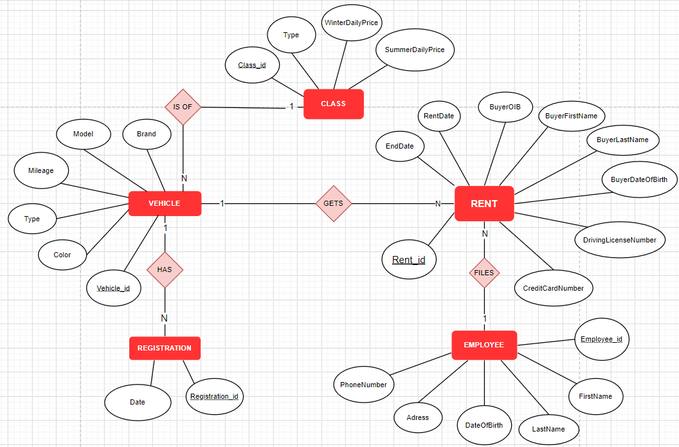

# RELACIJSKI MODEL

Class(Id, Type, WinterDailyPrice, SummerDailyPrice)

Vehicle(Id, Model, Brand, Mileage, Type, Color, ClassId)

Registration(Id, Date, VehicleId)

Employee(Id, FirstName, LastName, DateOfBirth, Adress, PhoneNumber)

Rent(Id, RentDate, EndDate, BuyerOIB, BuyerFirstName, BuyerLastName, BuyerDateOfBirth, DrivingLicenseNumber, CreditCardNumber, VehicleId, EmployeeId)

# KOD

## KREIRANJE TABLICA

CREATE DATABASE Rent_A_Car

USE Rent_A_Car

CREATE TABLE Class (

Id int IDENTITY(1,1) PRIMARY KEY,

Type nvarchar(128) NOT NULL,

WinterDailyPrice decimal(7,2) NOT NULL,

SummerDailyPrice AS WinterDailyPrice * 1.5

)

CREATE TABLE Vehicle (

Id int IDENTITY(1,1) PRIMARY KEY,

Model nvarchar(128) NOT NULL,

Brand nvarchar(128) NOT NULL,

Mileage nvarchar(128) NOT NULL,

Type nvarchar(128) NOT NULL,

Color nvarchar(16) NOT NULL,

ClassId int FOREIGN KEY REFERENCES Class(Id) NOT NULL

)

CREATE TABLE Registration(

Id int IDENTITY(1,1) PRIMARY KEY,

Date datetime NOT NULL,

EndingDate AS DATEADD(year, 1, Date),

VehicleId int FOREIGN KEY REFERENCES Vehicle(Id) NOT NULL

)

CREATE TABLE Employee (

Id int IDENTITY(1,1) PRIMARY KEY,

FirstName nvarchar(128) NOT NULL,

LastName nvarchar(128) NOT NULL,

Gender nvarchar(8) NOT NULL CHECK(Gender = 'Muškarac' OR Gender = 'Žena'),

DateOfBirth date NOT NULL,

Adress nvarchar(256) NOT NULL,

PhoneNumber nvarchar(12) NOT NULL

)

CREATE TABLE Rent(

Id int IDENTITY(1,1) PRIMARY KEY,

RentDate datetime NOT NULL,

EndDate datetime NOT NULL,

BuyerOIB nvarchar(11) NOT NULL,

BuyerFirstName nvarchar(128) NOT NULL,

BuyerLastName nvarchar(128) NOT NULL,

BuyerDateOfBirth date NOT NULL,

DrivingLicenseNumber nvarchar(8) NOT NULL,

CreditCardNumber nvarchar(16) NOT NULL,

VehicleId int FOREIGN KEY REFERENCES Vehicle(Id) NOT NULL,

EmployeeId int FOREIGN KEY REFERENCES Employee(Id) NOT NULL

)

ALTER TABLE Rent ADD CHECK (EndDate >= DATEADD(day, 1, RentDate))

ALTER TABLE Rent ADD CHECK (DATEDIFF(hour, RentDate, EndDate) % 12 = 0)

ALTER TABLE Rent ADD UNIQUE(BuyerOIB)

ALTER TABLE Rent ADD UNIQUE(DrivingLicenseNumber)

ALTER TABLE Rent ADD UNIQUE(CreditCardNumber)

## UNOS

INSERT INTO Class(Type, WinterDailyPrice)

VALUES

('A - City Car', 450.00),

('B - Niska klasa', 500.00),

('C - Srednja klasa', 580.00),

('D - Viša srednja klasa', 700.00 ),

('E - Viša klasa', 890.00),

('F - Luksuzna klasa', 1200.00),

('M - Minivan', 650.00)

INSERT INTO Vehicle(Brand, Model, Mileage, Type, Color, ClassId)

VALUES

('Citroen', 'C1', '100 000 km', 'auto', 'svijetlo-plava', 1),

('Fiat', 'Panda', '150 000 km', 'auto', 'narančasta', 1),

('Hyundai' ,'i10', '200 000km' , 'auto', 'crvena', 1),

('Hyundai' ,'i10', '100 000km' , 'auto', 'crvena', 1),

('Golf','4', '200 000km' , 'auto', 'crvena', 2),

('Golf' ,'4', '999 000km' , 'auto', 'roza', 2),

('Golf' ,'5', '350 000km' , 'auto', 'modra', 2),

('Golf' ,'5', '150 000km' , 'auto', 'crna', 2),

('Golf' ,'Karavan', '400 000km' , 'auto', 'modra', 3),

('Golf' ,'Karavan', '250 000km' , 'auto', 'modra', 3),

('Mazda' ,'6', '205 000km' , 'auto', 'crna', 4),

('Mazda' ,'6', '450 000km' , 'auto', 'crna', 4),

('Audi' ,'A8', '100 000km' , 'auto', 'siva', 4),

('Mercedes' ,'E-klasa Karavan', '200 000km' , 'auto', 'bijela', 5),

('Mercedes' ,'E-klasa Karavan', '500 000km' , 'auto', 'bijela', 5),

('Audi' ,'R8 V10 Coupe', '350 000km' , 'auto', 'plava', 6),

('Crysler' ,'Pacifica', '400 000km' , 'minivan', 'plava', 7),

('Crysler' ,'Pacifica', '250 000km' , 'minivan', 'plava', 7),

('Toyota' ,'Sienna', '600 000km' , 'minivan', 'tamno siva', 7),

('Dodge' ,'Grand Karavan', '600 000km' , 'minivan', 'siva', 7)

INSERT INTO Registration (Date, VehicleId)

VALUES

('2020-03-12 10:00', 1),

('2019-04-21 12:30', 2),

('2019-06-29 13:30', 3),

('2020-05-20 10:30', 4),

('2020-01-01 14:15', 5),

('2019-01-10 14:50', 6),

('2020-02-15 13:00', 7),

('2020-07-11 12:15', 8),

('2020-10-03 09:00', 9),

('2019-08-19 08:30', 10),

('2020-01-23 10:10', 11),

('2020-03-12 13:00', 12),

('2019-10-15 16:00', 13),

('2020-04-11 14:00', 14),

('2019-01-12 13:00', 15),

('2020-02-28 13:30', 16),

('2020-05-27 12:00', 17),

('2019-04-30 10:00', 18),

('2020-01-25 11:15', 19),

('2019-09-21 16:00', 20)

INSERT INTO Employee(FirstName, LastName, Gender, Adress, DateOfBirth, PhoneNumber)

VALUES

('Mate', 'Matić', 'Muškarac', 'Adresa A', '1986-04-09', '091-222-3333'),

('Ana', 'Anić', 'Žena', 'Adresa B','1992-10-11', '092-333-4444'),

('Željana', 'Željić', 'Žena', 'Adresa C', '1991-09-09', '099-111-3344'),

('Ante', 'Antić', 'Muškarac', 'Adresa D', '1970-01-21', '095-219-1111'),

('Matija', 'Matijić', 'Muškarac', 'Adresa E', '1996-03-10', '095-666-1234')

INSERT INTO Rent(RentDate, EndDate, BuyerOIB, BuyerFirstName, BuyerLastName, BuyerDateOfBirth, DrivingLicenseNumber,CreditCardNumber, VehicleId, EmployeeId)

VALUES

('2020-11-21 12:00', '2020-11-28 12:00', '12345678999', 'Marko', 'Markić', '1978-01-01', '12345678', '1111222233334444', 4, 2),

('2020-04-12 14:00', '2020-04-20 14:00', '12345678911', 'Marija', 'Marijić', '1990-12-03', '12345688', '1111222233335555', 2, 5),

('2020-02-10 10:00', '2020-02-13 22:00', '12345678922', 'Mirna', 'Beović', '1995-10-09', '12345677', '1111222233336666', 12, 1),

('2020-02-26 13:00', '2020-03-02 13:00', '12345678933', 'Anita', 'Anić', '1989-11-22', '12345666', '1111222233337777', 16, 3),

('2020-01-24 10:00', '2020-01-29 10:00', '12345678944', 'Snježana', 'Mucić', '1986-11-03', '12345655', '1111222233338888', 10, 2),

('2020-02-27 18:00', '2020-03-05 18:00', '12345678955', 'Ranko', 'Rankić', '1996-12-12', '12345644', '1111222233339999', 11, 3),

('2020-09-12 09:00', '2020-09-17 09:00', '12345678966', 'Anamarija', 'Šarić', '1992-12-08', '12345633', '1111222244441111', 12, 1),

('2020-01-20 19:00', '2020-02-03 19:00', '12345678977', 'Jelena', 'Jonjić', '1991-09-03', '12345622', '1111222244442222', 1, 5),

('2020-05-20 10:00', '2020-05-25 10:00', '12345678988', 'Rita', 'Šerkinić', '1970-03-03', '12345611', '1111222244443333', 20, 1),

('2020-06-01 12:00', '2020-06-10 12:00', '12345678111', 'Ružica', 'Marić', '1985-12-28', '12345111', '1111222244445555', 2, 4),

('2020-09-21 17:00', '2020-10-01 17:00', '12345678222', 'Lucia', 'Vukorepa', '1998-09-19', '12345222', '1111222244446666', 6, 1),

('2020-08-12 08:30', '2020-08-19 08:30', '12345678333', 'Ivan', 'Ivić', '1992-04-04', '12345333', '1111222244447777', 3, 4),

('2020-08-12 15:00', '2020-08-19 15:00', '12345678444', 'Tomislav', 'Smolčić', '1993-05-27', '12345444', '1111222244448888', 5, 4),

('2020-02-24 14:00', '2020-02-29 14:00', '12345678555', 'Smiljana', 'Smilić', '1987-06-06', '12345555', '1111222244449999', 14, 4),

('2020-11-21 12:00', '2020-11-28 12:00', '12345678666', 'Borna', 'Milas', '1999-02-01', '12345243', '1111222255551111', 14, 5),

('2020-03-01 10:20', '2020-03-20 22:20', '12345678777', 'Miroslav', 'Mekinić', '1979-01-24', '12345777', '1111222255552222', 7, 3),

('2020-01-02 04:00', '2020-01-10 16:00', '12345678888', 'Krešimir', 'Topić', '1998-03-04', '12345888', '1111222255553333', 17, 4),

('2020-04-12 14:30', '2020-04-23 14:30', '12345671111', 'Nikolina', 'Kucelin', '1994-11-12', '12345999', '1111222255554444', 18, 3),

('2020-08-15 13:00', '2020-08-24 13:00', '12345672222', 'Sanja', 'Rudić', '1997-03-23', '12341111', '1111222255556666', 8, 1),

('2020-12-12 10:00', '2020-12-30 10:00', '12345673333', 'Mirko', 'Katušić', '1993-09-21', '12342222', '1111222255557777', 8, 3),

('2020-09-27 15:00', '2020-10-10 15:00', '12345674444', 'Marko', 'Markić', '1990-04-17', '12343333', '1111222255558888', 13, 3)

UPITI

1. Dohvatiti sva vozila kojima je istekla registracija

SELECT

VehicleId, Brand, Model

FROM

Vehicle v

JOIN Registration r ON v.Id = r.VehicleId

GROUP BY

VehicleId, Brand, Model

HAVING

MAX(EndingDate) < CURRENT_TIMESTAMP

1. Dohvatiti sva vozila kojima registracija ističe unutar idućih mjesec dana

SELECT

VehicleId, Brand, Model

FROM

Vehicle v

JOIN Registration r ON v.Id = r.VehicleId

GROUP BY

VehicleId, Brand, Model

HAVING

MAX(EndingDate) > CURRENT_TIMESTAMP AND MAX(EndingDate) < DATEADD(month, 1, CURRENT_TIMESTAMP)

1. Dohvatiti koliko vozila postoji po vrsti

SELECT

COUNT(Id) AS NumberOfTypes, Type

FROM

Vehicle

GROUP BY

Type

1. Dohvatiti zadnjih 5 najmova koje je ostvario neki zaposlenik

SELECT TOP(5)

r.*

FROM

Employee e

JOIN Rent r ON e.Id = r.EmployeeId

WHERE

EmployeeId = 5

ORDER BY

RentDate DESC

1. Izračunati ukupnu cijenu najma za određeni najam (hint: pripaziti na najmove koji imaju miješanu zimsku i ljetnu tarifu tijekom trajanja)
2. Dohvatiti sve kupce najmova ikad, s tim da se ne ponavljaju u rezultatima

SELECT DISTINCT

BuyerOIB, BuyerFirstName, BuyerLastName, BuyerDateOfBirth, DrivingLicenseNumber, CreditCardNumber

FROM

Rent

1. Dohvatiti za svakog zaposlenika timestamp zadnjeg najma kojeg je ostvario

SELECT

EmployeeId, MAX(RentDate) AS LatestTimeStamp

FROM

Employee e

JOIN Rent r ON e.Id = r.EmployeeId

GROUP BY

EmployeeId

1. Dohvatiti broj vozila svake marke koji rent-a-car ima

SELECT

COUNT(Id) AS NumberOfModels, Brand

FROM

Vehicle

GROUP BY

Brand

1. Arhivirati sve najmove koji su završili u novu tablicu. Osim već postojećih podataka u najmu, arhivirana tablica će sadržavati i podatak koliko je taj najam koštao.
2. Pobrojati koliko je najmova bilo po mjesecu, u svakom mjesecu 2020. godine

SELECT

COUNT(Id) AS NumberOfRents, DATEPART(month, RentDate) AS Month

FROM

Rent

GROUP BY DATEPART(month, RentDate)

1. Za sva vozila određene vrste, osim informaciju o vozilu, ispisati tekstualnu informaciju treba li registrirati vozilo unutar idućih mjesec dana (‘Treba registraciju’, ‘Ne treba registraciju’)

SELECT

VehicleId, Brand, Model,

CASE

WHEN MAX(EndingDate) > CURRENT_TIMESTAMP AND MAX(EndingDate) < DATEADD(month, 1, CURRENT_TIMESTAMP) THEN 'Treba registraciju'

ELSE 'Ne treba registraciju'

END AS IsRegistrationNeeded

FROM

Vehicle v

JOIN Registration r ON v.Id = r.VehicleId

GROUP BY

VehicleId, Brand, Model

1. Dohvatiti broj najmova po vrsti vozila čija duljina najma (razdoblje) prelazi prosječnu duljinu najma

SELECT

COUNT(r.Id) AS NumberOfTypes, Type

FROM

Vehicle v

JOIN Rent r ON v.Id = r.VehicleId

WHERE

DATEDIFF(day, r.RentDate, r.EndDate) >

(SELECT

AVG(DATEDIFF(day, RentDate, EndDate))

FROM

Rent)

GROUP BY

Type