INTERNATIONAL SCIENTIFIC COMMITTEE FOR TUNA
AND TUNA-LIKE SPECIES IN THE NORTH PACIFIC
BILLFISH WORKING GROUP
DATA PREPARATORY MEETING FOR THE PACIFIC BLUE MARLIN STOCK ASSESSMENT
ANNOUNCEMENT AND DRAFT AGENDA
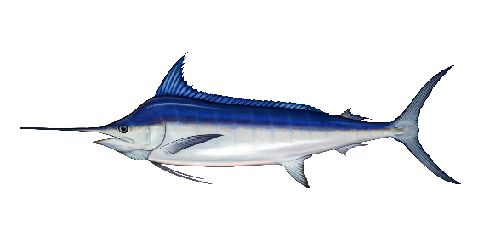
Meeting Site: | Japan Fisheries Research and Education Agency. 2-12-4 Fukuura, Kanazawa-ku, Yokohama, Kanagawa, 236-8648 JAPAN
Virtual Option: | A virtual option via WebEx will be provided for participants unable to attend in person.
Dates: | November 17-22, 2025
Goals: | The Billfish Working Group will be holding a meeting to complete the data preparation for the Pacific blue marlin (Makaira nigricans) stock assessment including catch by quarter, CPUE standardization, size frequency data, tagging data, and life history parameters. The goal is to finalize all blue marlin stock assessment data for a 2026 benchmark stock assessment at this meeting.
Working paper deadline: | Working papers must be submitted one week in advance to be considered at this meeting. Submit papers to Michelle Sculley (michelle.sculley@noaa.gov) by Monday, November 10, 2025 for distribution.
Attendance: | Please email Michelle Sculley (michelle.sculley@noaa.gov) if you plan on attending the meeting in person or online.
Contact: | Michelle Sculley (ISC BILLWG Chair)  Oceanic Fisheries Stock Assessment Program, Pacific Islands Fisheries Science Center  National Marine Fisheries Service, NOAA  Email: michelle.sculley@noaa.gov  TEL: +1 808-725-5705  Mikihiko Kai (Local Contact)  Email: kai_mikihiko61@fra.go.jp

Draft Agenda
Monday November 17, 2025 8:30AM-4:30PM JST
- Opening of the Billfish Working Group Meeting
  - Welcoming Remarks
  - Introductions
  - Standard meeting protocols
- Adoption of Agenda and assignment of rapporteurs
- Numbering of working papers
- Pacific Blue Marlin Biology
  - Biological Parameters
  - Movement and Stock Structure
Tuesday November 18, 2025 8:30AM-4:30PM JST
- Pacific Blue Marlin Biology
  - Biological Parameters
  - Movement and Stock Structure
- Abundance Indices
  - Japanese CPUE
  - Chinese Taipei CPUE
  - USA CPUE
Wednesday November 19, 2025 8:30AM-4:30PM JST
- Abundance Indices
  - Japanese CPUE
  - Chinese Taipei CPUE
  - USA CPUE
- Catch and Length Data
  - Japanese catch and length data
  - Chinese Taipei catch and length data
  - USA catch and length data
  - WCPFC and IATTC catch and length data
Thursday November 20, 2025 8:30AM-4:30PM JST
- Catch and Length Data
  - Japanese catch and length data
  - Chinese Taipei catch and length data
  - USA catch and length data
  - WCPFC and IATTC catch and length data
- Draft Conceptual Model
- Model Configuration
  - Modelling platform
  - Fleet definition and data set
  - Biological Parameters
  - Future projections
  - Sensitivity runs
Friday November 21, 2025 8:30-AM-4:30PM JST
- Model Configuration
  - Modelling platform
  - Fleet definition and data set
  - Biological Parameters
  - Future projections
  - Sensitivity runs
- Other items
  - Date and location of the next BILLWG meeting
  - Update on WCNPO SWO MSE
Saturday November 22, 2025 8:30AM-4:30PM JST
- Clearing of the meeting report
- Close of meeting

