Title

Author(s)*

*Affiliation(s)

Email:

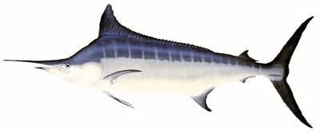

Abstract

Introduction

Methods

Results

References

Tables
CPUE:
- Annual and/or quarterly nominal and standardized CPUE with CV or SE
- Alternative model selections (optional)
Catch:
- Quarterly catch by fleet
Size data:
- Size conversion factors (if used)

Figures
CPUE:
- Nominal vs standardized CPUE with uncertainty
- Spatio-temporal distribution of nominal CPUE (grid and timestep as appropriate)
- Diagnostic Residual plots
- Diagnostic Effects plots - Show the effect of the covariate on the expected CPUE
- Diagnostic Influence plots - Show the impact of the covariate on the index over time
Catch:
- Full Historical Time Series of Catch (with in text detail on uncertainty in catch over time)
- Spatio-temportal distribution of catch (grid and timestep as appropriate)

Size frequency data
- Spatio-temportal distribution of mean size (grid and timestep as appropriate)
- Annual and quarterly mean size with distribution (i.e. violin, boxplot or similar)

