INTERNATIONAL SCIENTIFIC COMMITTEE FOR TUNA
AND TUNA-LIKE SPECIES IN THE NORTH PACIFIC
BILLFISH WORKING GROUP
DATA PREPARATORY MEETING FOR THE PACIFIC BLUE MARLIN STOCK ASSESSMENT
ANNOUNCEMENT AND AGENDA
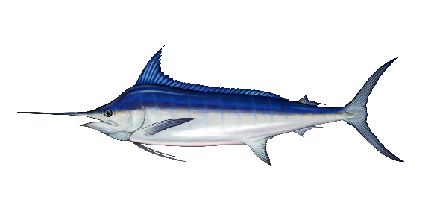
Meeting Site: | Japan Fisheries Research and Education Agency. 2-12-4 Fukuura, Kanazawa-ku, Yokohama, Kanagawa, 236-8648 JAPAN
Virtual Option: | A virtual option via WebEx will be provided for participants unable to attend in person. See the connection information for each day under the agenda.
Dates: | January 13-19, 2026
Goals: | The Billfish Working Group will be holding a meeting to complete the data preparation for the Pacific blue marlin (Makaira nigricans) stock assessment including catch by quarter, CPUE standardization, size frequency data, tagging data, and life history parameters. The goal is to finalize all blue marlin stock assessment data for a 2026 benchmark stock assessment at this meeting.
File Distribution: | Working papers, presentations, and other files are available on the BILLWG Google Drive.
Working paper deadline: | Working papers must be submitted one week in advance to be considered at this meeting. Submit papers to Michelle Sculley (michelle.sculley@noaa.gov) by Tuesday, January 6, 2026 for distribution.
Attendance: | Please email Michelle Sculley (michelle.sculley@noaa.gov) if you plan on attending the meeting in person or online.
Contact: | Michelle Sculley (ISC BILLWG Chair)  Oceanic Fisheries Stock Assessment Program, Pacific Islands Fisheries Science Center  National Marine Fisheries Service, NOAA  Email: michelle.sculley@noaa.gov  TEL: +1 808-725-5705  Mikihiko Kai (Local Contact)  Email: kai_mikihiko61@fra.go.jp

Draft Agenda
Tuesday January 13, 2026 8:30AM-4:30PM JST
Webex connection link
Meeting number (access code): 2830 281 3706
Meeting Password: mgR3TBE5Mc5
- Opening of the Billfish Working Group Meeting
  - Welcoming Remarks
  - Introductions
  - Standard meeting protocols
- Adoption of Agenda and assignment of rapporteurs
- Numbering of working papers
- Updates to IBBS Projects
- Pacific Blue Marlin Biology
  - Biological Parameters
  - Movement and Stock Structure
Wednesday January 14, 2026 8:30AM-4:30PM JST
Webex connection link
Meeting number (access code): 2828 348 9110
Meeting password: g4NwtWKiK29
- Pacific Blue Marlin Biology
  - Biological Parameters
  - Movement and Stock Structure
- Abundance Indices
  - Japanese CPUE
  - Chinese Taipei CPUE
  - USA CPUE
Thursday January 15, 2026 8:30AM-4:30PM JST
Webex connection link
Meeting number (access code): 2819 577 5505
Meeting password: aY2ujFH9Ak9
- Abundance Indices
  - Japanese CPUE
  - Chinese Taipei CPUE
  - USA CPUE
- Catch and Length Data
  - Japanese catch and length data
  - Chinese Taipei catch and length data
  - USA catch and length data
  - WCPFC and IATTC catch and length data
Friday January 16, 2026 8:30AM-4:30PM JST
Webex connection link
Meeting number (access code): 2825 764 9357
Meeting password: QyM4hwnqn33
- Catch and Length Data
  - Japanese catch and length data
  - Chinese Taipei catch and length data
  - USA catch and length data
  - WCPFC and IATTC catch and length data
- Draft Conceptual Model
- Model Configuration
  - Modelling platform
  - Fleet definition and data set
  - Biological Parameters
  - Future projections
  - Sensitivity runs
Saturday January 17, 2026 8:30-AM-4:30PM JST
Webex connection link
Meeting number (access code): 2826 395 1853
Meeting password: z62RgqPTsa3
- Model Configuration
  - Modelling platform
  - Fleet definition and data set
  - Biological Parameters
  - Future projections
  - Sensitivity runs
- Other items
  - Date and location of the next BILLWG meeting
  - Update on WCNPO SWO MSE
Sunday January 18, 2026 – Day Off
Monday January 19, 2026 8:30AM-4:30PM JST
Webex connection link
Meeting number (access code): 2820 207 9506
Meeting password: RxwpUinB238
- Clearing of the meeting report
- Close of meeting

