On the origin of citations

Emily Davenport

September 15, 2015

# Load the data

## using read.delim

counts_raw <- read.delim("data/counts-raw.txt.gz")  
counts_norm <- read.delim("data/counts-norm.txt.gz")

# Data exploration

What's the distribution of authors in all articles of our data set?

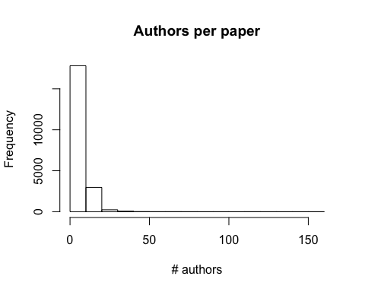

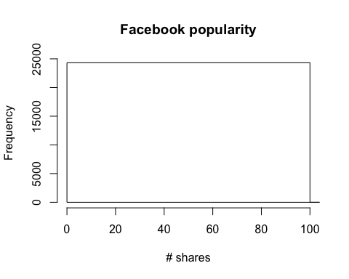

The average number of Facebook shares per paper in the data set is 0.6524187.