3D-Printable Simplified Ventilator

„CORESPONSE“ COvid19 RESPirator OpeN SourcE

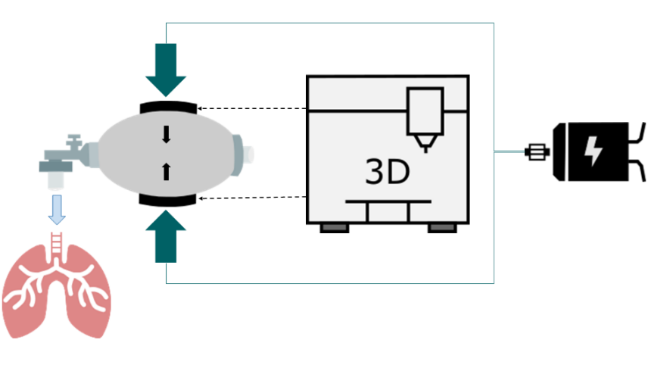

The Idea

The device is meant to provide a last resort for the possible situation when COVID19 infections outnumber the capacities of medical ventilation at healthcare facilities.

The device automatically squeezes widely available bag valve masks (BVMs, “Ambu-bags”).

The device is not developed as a medical device. It is not meant and not safe to be used without strict supervision. It is intended to be used when the situation is at a point where the only remaining alternative would be using volunteers to operate BVMs manually.

Ein Bild, das Uhr, Schild enthält.
Ein Bild, das Zeichnung, Teller enthält.

Objective  
The development of a simplified ventilation device that is built with the help of a 3D printer and a few components so that it can be easily reproduced and assembled by volunteers all over the world. This device aims to save lives during the COVID19 crisis.

More Information

www.coresponse.rwth-aachen.de

The Advantages

Main components: 3D-printable parts, bag valve mask, motor

All necessary files and building instructions will be made open source.

Anyone with access to a standard FDM 3D printer can build the device independently within one day. A large number of devices can be manufactured within a short period of time.

Who we are?

We are an interdisciplinary team consisting of engineers and clinicians from RWTH Aachen University.

Sponsors: Ambu GmbH, RS Components GmbH, HUM Gesellschaft für Homecare und Medizintechnik mbH

Ein Bild, das Tisch, drinnen, Tasse, orange enthält.

State of the project

Two different concepts are currently pursued in parallel. Both concepts should allow an adjustable breathing volume (tidal volume) and a variable respiratory rate. Additional oxygen can be administered via the BVM.

**Concept 1** uses a DC geared motor at a constant speed. This concept requires very simple electronics and no special control (“switch on and go”). The bag is operated using a 3D printed mechanism. The breathing volume is adapted by adjusting the mechanism.

**Concept 2** uses a servo or stepper motor. This concept requires slightly more complex electronics for the control of the motor, but only a very few mechanical parts. The function can be adjusted using a smartphone.

The first prototypes have already been implemented and are currently evaluated and improved with a test lung (AEROtube®).

At the same time, a homepage is set up with replication instructions and all necessary files for printing the parts.

Costs and material

* Current status of building costs: below 75 Euro (Concept 1).
* Production: decentralized by volunteers owning an FDM 3D-Printer with a build plate of 20cmx20cm (250g Filament)
* Bag valve mask
* Electric motor and power supply
* Few mechanical small parts (e.g. screws)

First prototype of Concept 1. Rapid development iterations are happening currently with improvements to the design.

3D-Printable Simplified Ventilator

„CORESPONSE“ COvid19 RESPirator OpeN SourcE

Contact

Dr.-Ing. Jonas Gesenhues  
Head of Biomedical Systems  
IRT – Institute of Automatic Control  
RWTH Aachen University, Germany  
[coresponse@irt.rwth-aachen.de](mailto:coresponse@irt.rwth-aachen.de)  
www.coresponse.rwth-aachen.de

What we need

* Contact to the authorities that currently plan for the demands due to COVID-19.
* An exceptional permission that the device might be used in exceptional situations.
* Establishment of logistics for acquisition of parts and distribution to volunteers with 3D-printers.