6PM user guide
Version 0,9
6PM is a phase modulation(PM) synthesizer made of six oscillators. That's where its name comes from. ☺
PM here is equivalent to frequency modulation (FM).
It works under Gnu-Linux system with Jack sound server and Qt5 library.
Real-time mode must be available.

Basics
An oscillator can be operator: its output is connected to sound system; it is heard directly.
It can be modulators by each five others.
It can modulators each five others.
An oscillator can also be its own modulators.
Operators and modulators layout is defined by an algorithm.
To learn more : http://en.wikipedia.org/wiki/Frequency_modulation_synthesis .

6PM is provided with 32 pre-defined algorithms, which comes from a famous japanese synthesizer of the seventies...
It gives possibility to define new user algorithms.

Installation
See README file.

Jack connections

Audio
6PM automatically connects to the two first system ports.

Midi
Connection must be made by hand with Qjackctl, Catia or other.

Settings
Each oscillator has settings for volume, base frequency, tremolo and vibrato. If oscillator is modulated, it has a setting for modulation index. If an oscillator is defined as operator it has a setting for left-right panoramic.
For each oscillator:
All settings change have an immediate effect while a sound is played,
All settings can be saved in a preset which is part of a presets bank.

All settings can be modified from a midi device: master keyboard, control surface, or from a sequencer, through midi control numbers. That's midi assignation.
Assignations set can be saved in a midi map.

Provided midi map "OscAmps" simply assigns six oscillators volume potentiometers to controls 71 to 76. Global volume slider is assigned to control 7.

Oscillator settings
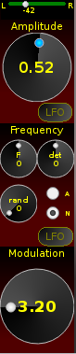


From top to bottom and left to right :
- Left – right panoramic slider. It appears only if oscillator is an operator.
- Amplitude potentiometer from 0 to 1.
- LFO : button to show or hide tremolo settings window (on the right).
Green light is on if tremolo amplitude is greater than zero.
Frequency settings
- F : Oscillator frequency from -48 to +48.
It is ratio to base frequency of played note. For instance a value of -12 makes a sound one octave below note. Scale is in semitones.
- det : Fine detune, scaled in hundreds of semitones, from -100 to +100.
- rand : Frequency random level.
- A – N : Choice between Absolute and Note.
  - Absolu : oscillator base frequency will always be the same whatever played note is. “F” button et frequency curve Y values are displayed in Hertz.
  - Note : oscillator base frequency is the same as played note.
- LFO : button to show or hide vibrato settings window (on the right)
Modulation index.
This potentiometer only appears if oscillator is modulated.

Amplitude envelope
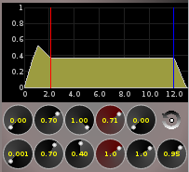
Each envelope point is is defined with two numbers: amplitude from 0 to 1 (top button) and duration in seconds (bottom button).
Red line marks sustain point set by the two slightly red potentiometers.
Blue line marks the farthest sustain point position among six oscillators.
Envelope part on the right of blue line shows sound amplitude after release of keyboard key or when receiving a "note off" midi message.
Each envelope sustain point can be chosen among all envelope points: right-click on window to pop up menu. One may choose to have no sustain point ; then envelope runs straight from beginning to end.

Duration marked for every point is duration of envelope segment before point. On the example duration before sustain point is 2.0 seconds. Duration after release is 1.0 second. Duration to reach sustain points of all oscillators is 12.0 seconds.

Button on the right of amplitude potentiometers allows to loop envelope. When this option is checked, sustain point is removed and envelope runs straight until last point and endlessly starts again until reception of a "note off" message for example by releasing midi keyboard key.

Tricks
Potentiometers may be actuated with mouse wheel or more finely with keyboard left and right arrow keys.
Double-click on a potentiometer brings it back to its default value.

Zoom
Mouse wheel allows to zoom on an envelope curve :
- on X when holding CTRL key.
- on Y when holding SHIFT key.

Frequency envelope
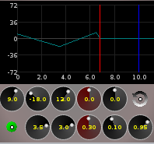
Similar to amplitude envelope. Frequency values go from +48 to -48 that is plus or minus four octaves from base frequency. Potentiometers scale is in semitones.
Amplitude and frequency envelope settings are independent, including sustain points and loops.
Bottom-left button allows to enable (green) or disable (red) frequency envelope.

Midi controls
To assign:
- right-click on potentiometer and choose "midi learn" (led flashes in red during 3 seconds),
- action a control on external midi device during these three seconds and potentiometer is assigned. Led becomes blue.

To remove assignment, right-click and "Remove assignment".
Several potentiometers may be assigned to the same midi control number.
Direction of assignment can be inverted so that potentiometer is at minimum value while control is at its maximum and vice-versa. For that, right-click and check "Invert midi cc".

Predefined controls:
Bank select: 0xB0 + 0x00 + bank number (from 0)
Preset select: : 0xC0 + preset number (from 0)

Midi maps
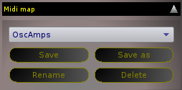
To save a "midi map": click on button "Save"in "Midi map" box, type a name text edit box hit Return key.
"Save" replaces current midi map "Save as" create another one with given name. "Rename" changes its name without creating a new one "Delete" deletes it.

Algorithms
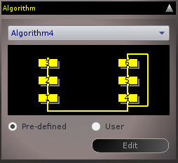
Diagram shows connections between modulators(top) and modulated(bottom)if needed with a loop.

Bottom line oscillators are operator.
Here oscillators 1 and 4 are operators. Oscillator 1 is modulated by 2 itself modulated by 3. Oscillator 4 is modulated by 5 modulated by 6 itself modulated by 4.
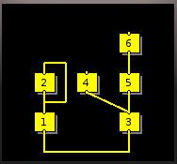
Here oscillators 1 and 3 are operators. 1 is modulated by 2 which is self-modulated. 3 is modulated by two oscillators : 4 and 5. 6 modulates 5 and is not modulated.

If "Pre-defined" is checked there are 32 predefined algorithms.
If "User" is checked one can choose one of previously user-defined and saved algorithms.

Create or modify a user algorithm
User button must be checked.
Click on Edit. A grid is displayed:
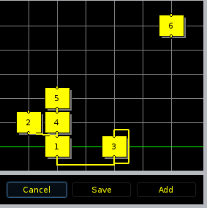
Move oscillators to wanted places.
Green line marks operators places.
To create a connection modulators – modulated, just draw it with mouse between bottom connector of modulator towards top connector of modulated oscillator.
"Save" replaces current algorithm.
"Add" adds it to user algorithms list.
“Cancel” cancels all modifications.

Banks and presets
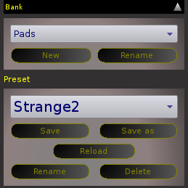
"New bank" to create an empty new bank.
"Rename" to rename current bank.
To delete bank, "Folders and files" paragraph.

Same commands for presets.
To save a preset in a different bank than current one:
- select wished bank (presets list becomes blank),
- click on "Save as" button in "Preset" box,
- type a name in text field and hit Return.

Filter
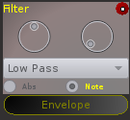
F : filter frequency. It's a ratio to note frequency if option Note is selected or a value in Hertz if option Abs is selected.
Q : filter quality factor (resonance).
Envelope to show or hide filter frequency envelope settings window.

Miscellaneous
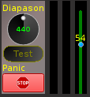
Diapason potentiometer allow to globally adjust reference frequency which is by default 440 Hertz. Setting is automatically saved.
Test button allows to hear sound of synthesizer with current settings playing A4 note.
Panic interrupts immediately all sound production.
Slider on the right adjust synthesizer global volume.

Run in console
In a terminal type :
6pm --nogui
to run 6pm without graphic user interface.
Available commands are listed with 'h' command.
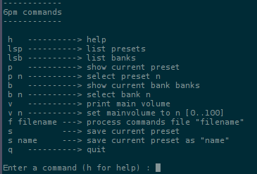

Folders and files
Global software settings (window geometry, diapason, midi channel etc.) are saved in filer ~/.config/MVSoft/6PM.conf .
User algorithms are also stored in this file.
Banks and presets are saved in folder ~/.6pm/Presets .
A bank is just a directory. Each preset is stored in a file with extension .mvpms .
These files use Qt Qsettings format.
To delete a bank, delete its directory.

