CS6650 Assignment2 Zhenyu Wang & Xuming Zhuge

Project Link: https://github.khoury.northeastern.edu/yuchenwang00/CS6650-Assignment2-LoadingTest

Client Design Overview

1. System Architecture

The load-testing client consists of three programs:
• SingleThreadMain
• ClientPart1Main
• ClientPart2Main

The purpose of the system is to generate 200,000 POST requests to a Product microservice deployed on AWS ECS and evaluate its scalability and performance under concurrent load.

The architecture separates:
• Data generation
• Network request execution
• Logging
• Statistics computation

This separation minimizes synchronization overhead and maximizes concurrency.

2. Single-Thread Baseline

The SingleThreadMain program sends 10,000 POST requests sequentially.

For each request:
• Timestamp is taken before sending.
• Timestamp is taken after response.
• Latency is recorded.

It calculates:
• Average latency
• Minimum latency
• Maximum latency
• Throughput (requests/second)

Measured Results:
• Average latency ≈ 78 ms
• Throughput ≈ 12.6 rps

Predicted 8-thread throughput:

8 × 12.6 ≈ 101 \text{ rps}

This provides a theoretical scaling baseline.
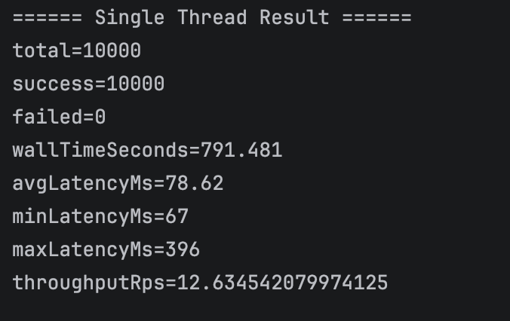

3. Client Part 1 – Multithreaded Load Generator

Design Goals
• Upload 200,000 products as fast as possible.
• Achieve near-linear scalability.
• Terminate cleanly.

Concurrency Model
• ExecutorService with fixed thread pool.
• Each request runs as an independent task.
• Each task creates its own ApiClient instance to ensure thread safety.
• LongAdder is used for success/failure counters to avoid contention.
• A progress thread prints every 1000 completed requests.

Execution Flow
1. Submit 200,000 tasks to thread pool.
2. Each task:
• Creates Product object
• Sends POST request
• Updates success/failure counter
3. Main thread waits via CountDownLatch.
4. Wall time and throughput calculated at completion.

Results (8 threads)
• Throughput ≈ 99 rps
• Theoretical prediction ≈ 101 rps

Deviation < 2%

Conclusion:

The client demonstrates near-linear scaling.
No significant client-side bottlenecks were observed.
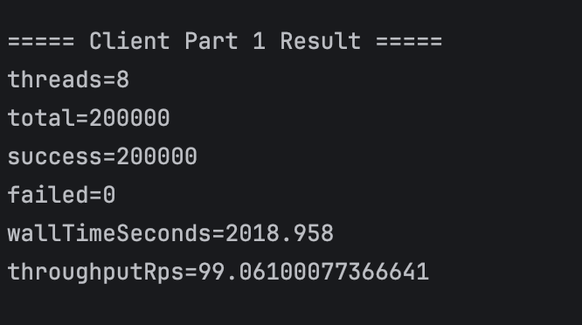

4. Client Part 2 – Instrumented Client

Part 2 extends Part 1 by collecting detailed per-request metrics without affecting upload speed.

Additional Design Components
• Dedicated Product Generator Thread
• BlockingQueue<Product> to decouple generation and posting
• Multiple PostingWorker threads consuming from queue
• BlockingQueue<LogRecord> for asynchronous logging
• Dedicated CSV Writer Thread

Data Flow

Product Generator
↓
BlockingQueue<Product>
↓
PostingWorker Threads
↓
BlockingQueue<LogRecord>
↓
CSV Writer
↓
StatsCalculator

This design ensures:
• Posting threads never block on product generation.
• Logging does not interfere with request throughput.
• Statistics are computed after execution.

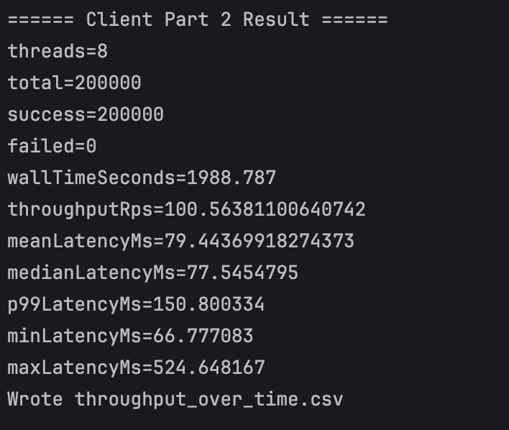

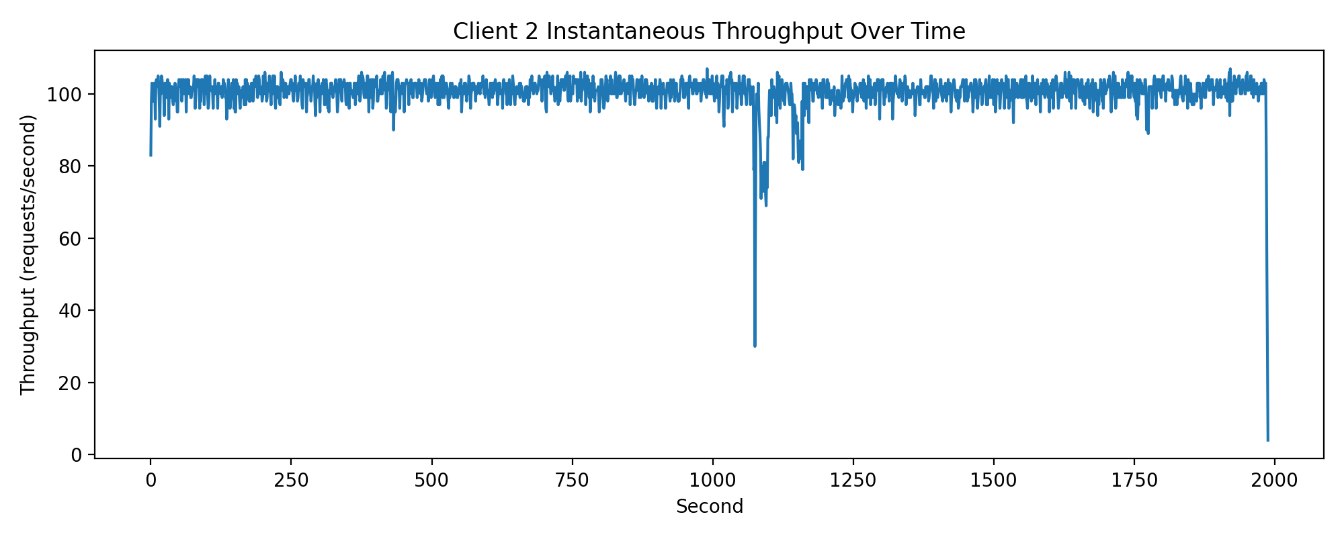

5. Performance Metrics Collected

After execution completes, the client calculates:
• Mean latency
• Median latency
• p99 latency
• Minimum latency
• Maximum latency
• Throughput
• Instantaneous throughput over time

Measured Results (8 threads):
• Mean latency ≈ 79 ms
• Median latency ≈ 78 ms
• p99 latency ≈ 150 ms
• Throughput ≈ 100 rps

Throughput closely matches predicted performance.

6. Why HTTP 201 Instead of 200?

According to REST semantics:
• 200 OK indicates a successful request.
• 201 Created indicates a new resource was created.

Since the POST endpoint creates a Product resource, the correct REST-compliant response is HTTP 201.

7. Scalability Analysis

Single-thread throughput ≈ 12.6 rps
8-thread throughput ≈ 99 rps

Theoretical: 101 rps
Measured: 99 rps

The small deviation is attributed to:
• Network latency
• Thread scheduling overhead
• AWS infrastructure variability

Conclusion:

The system achieves near-linear scalability and demonstrates correct concurrent design.

