Does a College Education provide a higher Quality of Life (QOL) within the US?

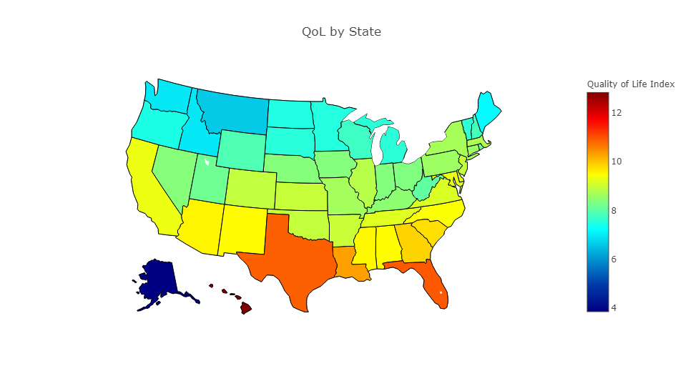

Document Revision History
Revision | Date | Rev. by: | Remarks
1.0 | 03/29/2019 | Zeinab Massudi, Michel Maniguet, Lori Brady, Jonas Haskins

Table of Contents

Introduction……………………………………………..………………4
Data Analysis……………………………………………..…………..…6
Conclusion.……………………………………………..………………25
Appendix and References…………………………………..…………27

Introduction

A commonly held belief is that educational levels directly affect quality of life. Therefore, a data-based answer is desired for the question, “How does education affect quality of life?” The hypothesis is that the higher the level of education attained, the higher the quality of life. Accordingly, the null hypothesis is that education has no effect on quality of life.

Ultimately, we wanted to know is a college education determine a better quality of life per state? We have been told for years that in order to have a high quality of life we must get a college education. Is that true? Or would work experience, certifications, and/or personal drive be enough?

How did we define College Education? We actually used 2 metrics for comparison, College Education is defined as having a bachelor’s degree or higher education and High School Education (anything lower than a degree).

What is Quality of Life (QOL)? A publication of The Economist reported in 2005 set as standard or index of measuring the quality-of-life between world countries. The metrics were limited to GDP/person, Life Expectancy, Political Stability, Divorce Rates, Community Life, Climate, Job Security, and Political Freedom. We used the same metrics to determine the QOL by state within the United States (US). A few factors were normalized (such as Political Freedom, Political Stability) since there were the same across all states.

After collecting the data, we determined there were limitations on our questions since we weren’t able to find the data required from the same year or location. Therefore, we collected data from different sources with different methodologies of collecting nor did we have a standard year comparison. We also reviewed the data in different ways, such as sorting by highest QOL and reviewed only the top and bottom 5 states for each.
We didn’t see a correlation directly to college graduates and therefore disproved our core hypothesis but brought up more questions. Such as did any of our 9 factors correlate with a college education? Yes, there were several such as: community life, gender quality, political stability, political freedom, life expectancy and GDP per person, along with divorce rate being right below 95% probability of correlation. Other factors such as climate, job security and population were the 3 metrics that did not associated with a College Education. It was also interesting to see that High School education was linked to almost the opposite factors. There was not a correlation to gender quality, divorce rate and GDP per person for Hight School, but was proven for QOL. Continue further to see the details, questions, and logical approach we took in coming to our conclusions.

Data Analysis

Data

Data Dictionary
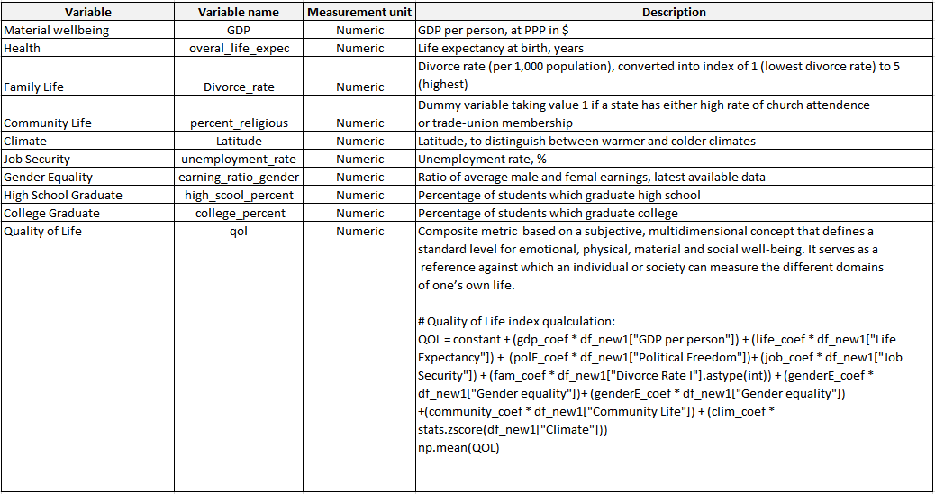

QoL Coefficients:
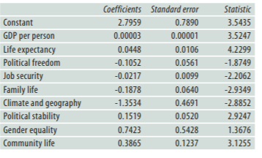

Methods
The data for our project was gathered by manually downloading CSVs for each respective variable. Due to the limited size of the data set, minimal data munging was required in construct a viable dataframe. Data input and output files used were .csv format. All data manipulation was performed using Pandas. The graphs were constructed with Matplotlib and Plotly.

Analysis and Results

The following variables were considered: High School education completion percentage, College Education completion percentage, Total Population by State, Job Security (Unemployment %), Overall Life Expectancy, Divorce Rate, Climate (Latitude), Percent Religious, Earnings Ratio between Genders (Gender Equality), GDP per Person, Divorce Rate and Community Life.
Political Stability and Human Freedom variables were technically constants since they were all the same for each state, the states being encompassed in the USA as a single country.

Manually Created Variables: QOI (Quality Of Life index or QOL was calculated as a function of these variables as previously described in the Data Dictionary section of this report.)

Metrics

Correlation Table 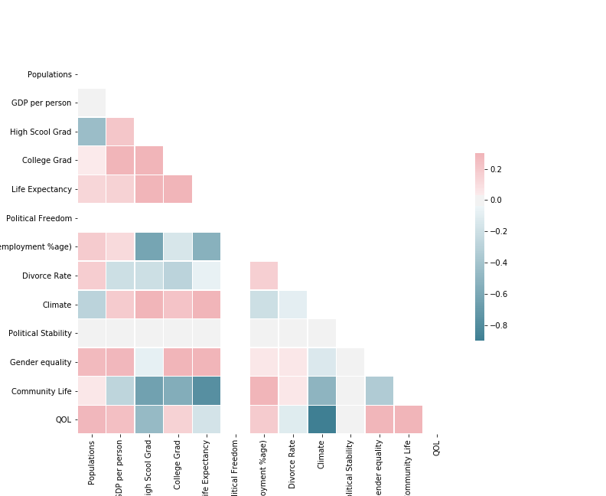

Quality of Life vs Unemployment %
Slight increase of QOL as unemployment rate increases. Counter intuitive.

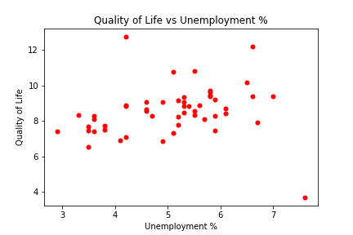

Quality of Life vs Life Expectancy
No correlation

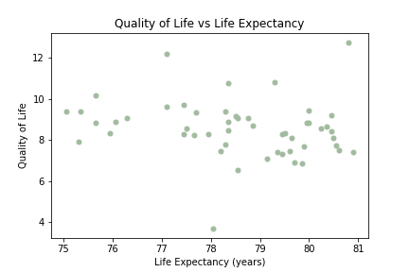

Quality of Life vs Community Life
Slight increase of QOL as community life increases
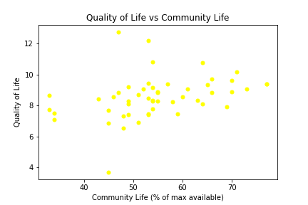

Quality of Life vs Climate (Latitude)
Strong correlation of QOL with decreasing latitude (i.e. moving southward)

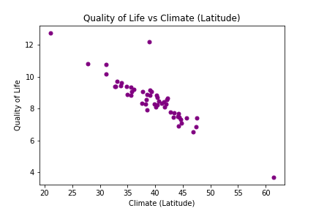
Quality of Life vs High School Education
Slight negative correlation with increased HS education. Counter intuitive.
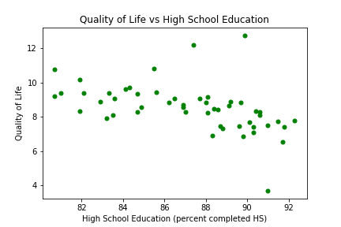

Quality of Life vs College Education
No correlation; the outlier at 50,12 is problematic

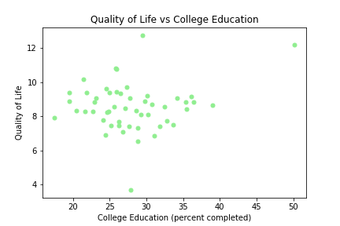
Quality of Life vs GDP per Person
No correlation, but the outlier is problematic and should be ignored (DC). The high and low outliers at $60,000 +/- $5000 are surprising.
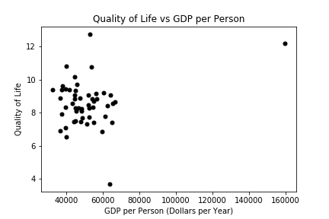

Choropeth – Quality of Life by State
Reflects strong effect of climate (latitude) on QOL

Histogram: College Graduate Percentage 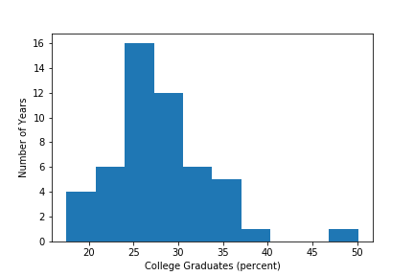
No correlation

College P-Values
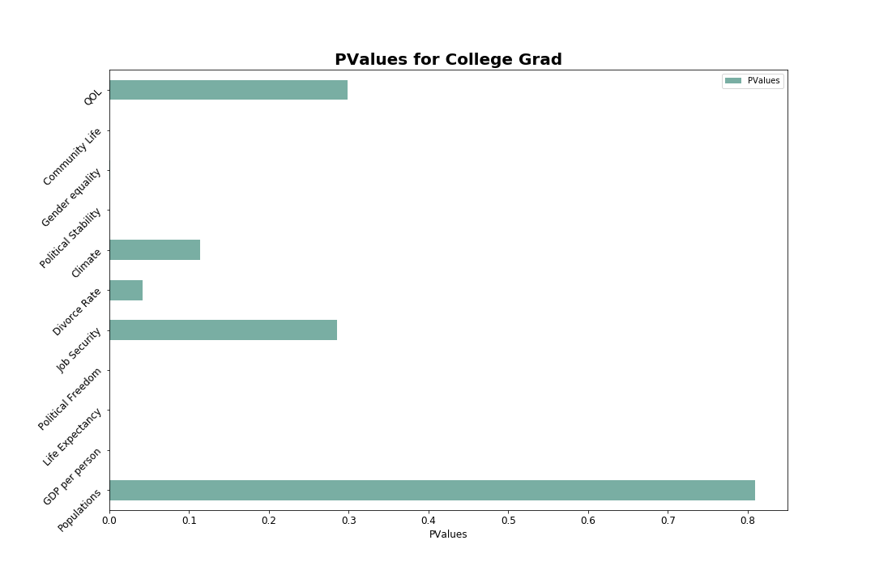
College vs All – Boxplot

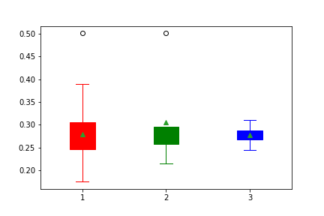

Gender vs Education – Boxplot

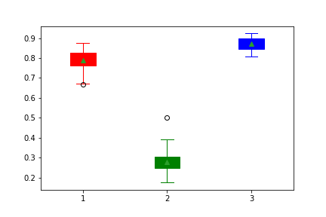

High School vs All – Boxplot

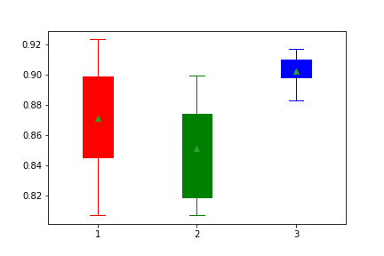

High School P-Values

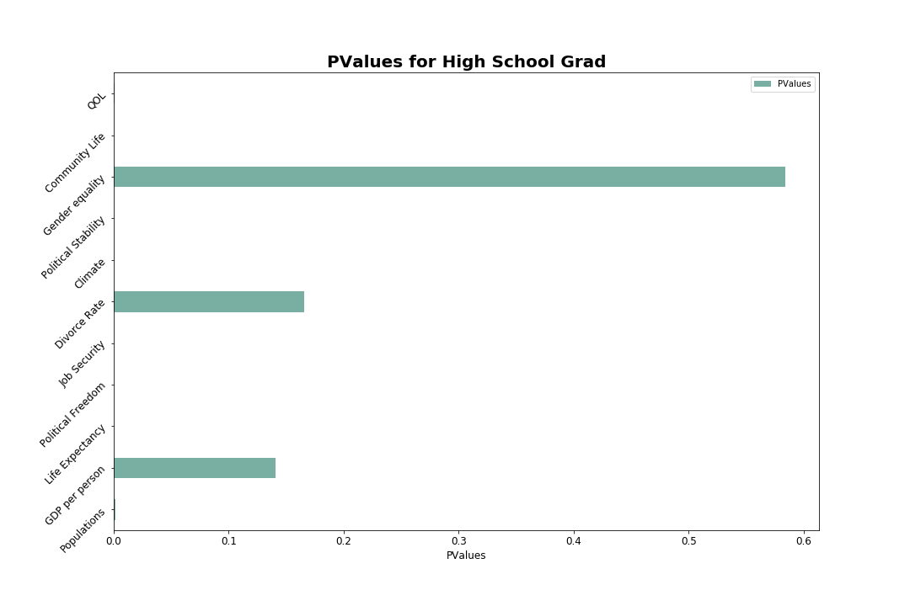

Regression 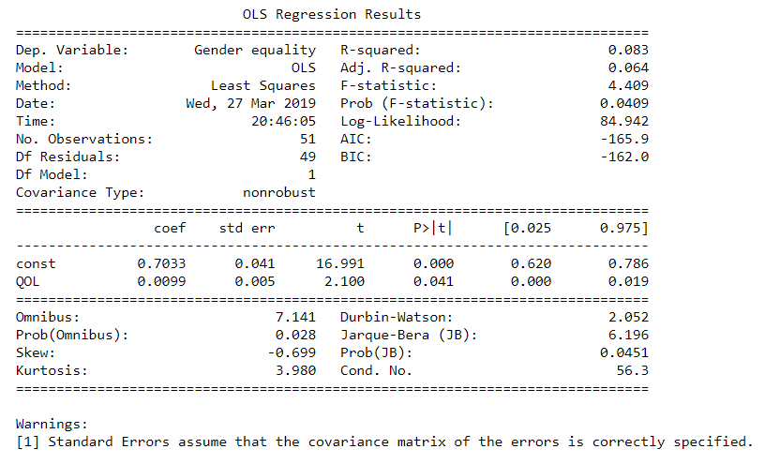

Conclusion

Could we prove our hypothesis? Unfortunately, no. We were unable to determine a correlation between Quality of Life (QOL) and a College Education. Since so many factors go into a QOL metric, there was not enough probably that all were due to a higher education. In researching, we compared the top and bottom 5 states for QOL, which showed similar factor for each. We compared each QOL factor to both College and High School educations to see if one metric played a bigger role in the outcome. It did not. While some higher population, GPD, and higher life expectancy states were both in the top and bottom 5 states.
A surprising is the District of Columbia was the only state with a College Education above 50%, as most feel with the 25-30% range. Populations did not play a factor as the two lowest populated states were Alaska (bottom 5 states) and the District of Columbia (top 5). Job security were overall lower in the bottom 5 QOL states with a midpoint of 4.2%, Alaska was at 7.6% disproving this correlation. It was interesting to see that the top 5 QOL states were all warmer climate states, with the District of Columbia being just slightly higher. Lastly since divorce rates was proven to correlate to College Education, it was unique to see a higher divorce rate did not dependent on community life ratio.
If we choose to review this topic again or dig further into the question, we would likely dig into questions like: How gender played a direct factor to each metric? Has the metric changed between multiple years? Would having data collected from the same year make the same conclusion? Would an Ivy College Education compare the same to a community or lower level College Education make a difference? Should the Cost of Living be a factor in the QOL metric? Lastly, would knowing this information determine if a person goes to college or moves to particular state?
Someone may ask: “If I am moving to a new state, which state should I pick so my child has the best life? I want a recommendation and reasons backing it up. Preferably I want a high GDP, high HS/college %, low divorce rate, high life expectancy, low unemployment rate, and high gender earnings ratio.” This is an excellent question, because it reveals a weakness of this study.

Realistically, the best answer is that an individual who is looking to make a decision as to where they would want to live in light of this study should first decide if the QOL ratings formula is consistent with their personal value system. If not, they would want to adjust that formula accordingly. Not everyone has the same value system as the UN or the Economist. For this reason, having the capability to allow a user to dynamically adjust the results in accord with their personal value system would make the program/website much more helpful to end users. The next iteration of this project should include such a capability.

Appendix & References

Determinants of quality of life the nine quality-of-life factors, and the indicators used to represent these factors, are:
1. Material wellbeing GDP per person. Source: Economist Intelligence Unit
2. Health Life expectancy at birth, years. Source: US Census Bureau
3. Political stability and security ratings. Source: Economist Intelligence Unit
4. Family Life Divorce Rate (per 1,000 population), converted into an index of 1 (lowest divorce rates) to 5 (highest). Sources: UN; Euromonitor
5. Community Life - dummy variable taking value 1 if state has either high rate of church attendance or trade-union membership; zero otherwise. Sources: International Labor Organization (ILO); World Values Survey
6. Climate and geography Latitude, to distinguish between warmer and colder climes. Source: CIA World Factbook
7. Job security Unemployment rate, %. Sources: Economist Intelligence Unit; ILO
8. Political freedom Average of indices of political and civil liberties. Scale of 1 (completely free) to 7 (unfree). Source: Freedom House
9. Human Development Report Gender Equality Ratio of average male and female earnings, latest available data.
Quality of Life: Economist Intelligence Unit https://www.economist.com/media/pdf/QUALITY_OF_LIFE.pdf

Population:
https://www.census.gov/data/datasets/time-series/demo/popest/2010s-state-total.html

GDP per State:
https://www.kaggle.com/solorzano/gdp-per-capita-in-us-states

HS Grad/College Grad:
Source: U.S. Census Bureau, American Community Survey, 2010 1-Year Estimates, Table S. 1501
https://factfinder.census.gov/faces/tableservices/jsf/pages/productview.xhtml?src=bkmk

Life Expectancy:
https://healthinequality.org/data/
limitation, from 2018

Political Freedom:
https://freedomhouse.org/report/freedom-world-2018-table-country-scores
limitation, from 2018

Job Security:
https://statusofwomendata.org/state-by-state-rankings-on-womens-and-mens-employment-and-earnings-2013/
limitation, from 2013

Divorce Rate:
https://www.cdc.gov/nchs/nvss/marriage-divorce.htm

Climate Latitude & Longitude
https://inkplant.com/code/state-latitudes-longitudes

Gender equality: Human Development Report https://iwpr.org/publications/gender-wage-gap-2017/
limitation, from 2017

Religious/Community life:
https://www.pewresearch.org/fact-tank/2016/02/29/how-religious-is-your-state/?state=alabama
Limitation: 2016

Human Freedom :
https://www.cato.org/human-freedom-index-new

