DIPLOMA THESIS
Documentation

Author(s) | Michael Hänsler, Simon Moser, Lukas Fellegger
Form, academic year | 5BHWIN, 2025/26
Topic | Digital Infopoint System for Orientation and Information Delivery at HTL Leoben
Co-operation partners | HTL Leoben

Assignment of tasks | The task is to design and implement a digital information system for school operations. The goal is to digitize the previous analog flow of information and present up-to-date details such as events, timetable changes, and the locations of teachers (according to the schedule) in a clear and organized way. In addition, announcements, a social media feed, and a CMS for content management should be provided. All functions should be accessible via a user-friendly interface optimized both for kiosk mode with touch input and for use with peripheral devices such as a mouse and keyboard.

Realisation | The system is implemented by separating it into a backend and a frontend. The backend is built with Spring Boot and provides the required REST interfaces for the frontend. It is responsible for data management and communication with the database.  The frontend accesses the data via these interfaces and visualizes it in a clear user interface. The CMS uses the same interfaces to manage content centrally. The frontend design is supported by mockups.

Results | A digital infopoint system is created with a modern, user-friendly interface that centrally displays information such as events, announcements, and room/teacher overviews. A stable backend with a REST API manages the data, while tested hardware ensures reliable operation. The system is optimized for touch interaction, easy to maintain, and supports everyday school life through quick and clear access to information.

Illustrative graph, photo  (incl. explanation) | 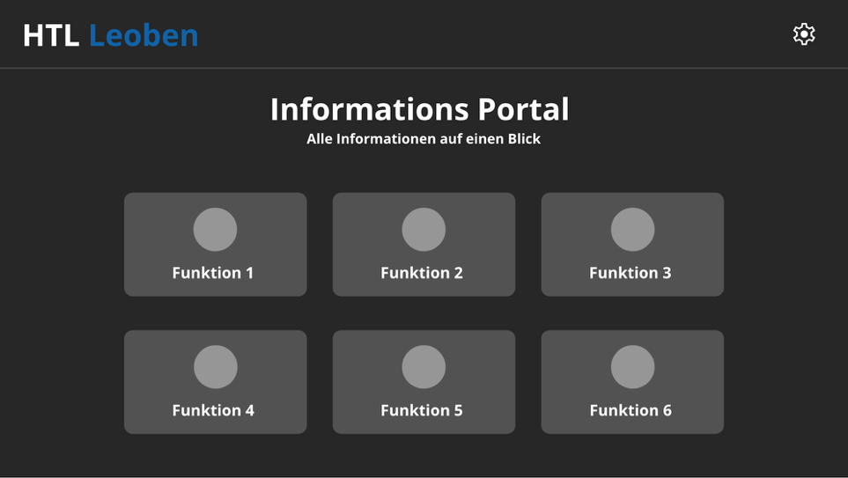  Shown here is the main page of the user interface, through which all functions (currently still in development) will be accessible.

Participation in competitions  Awards | No participation in competitions

Accessibility of the  Diploma Thesis | The diploma thesis will be archived in the HTL Leoben library and can be accessed there by anyone.

Approval  (Date / Signature) | Examiner | Head of College

