Readme: netcdf and BiodiversityLink workflow in GLOBIOM-G4M-Link
Yazhen Wu, 2024/01/31

Running the get_biodiversity.R with direct input (from an existing GLOBIOM-G4M-Link run)
[As a test, we run one scenario called “SSP2_CONS_SCEN”, one region = Argentina. In complete process of running GLOBIOM-G4M-Link pipeline, all scenarios and regions’ computation are running in parallel.]
Step1: put the additional input files from “P:\globiom\Projects\MOEJ\Result\new_ver_20240118\5_netcdf\for_running_BiodiversityLink\” into “\GLOBIOM_G4M_Link\Biodiversity_Link\”
Which include:
- Merged g4m and downscale result: G4M_DS_Link_result_3587.000000.RData
- G4m_utilization (=g4m result): area_harvest_map_ScenExplore10FP_29122023_SSP2_CONS_SCEN.csv
Step2: Put the “get_biodiversity - Copy.R” also into “\GLOBIOM_G4M_Link\Biodiversity_Link\”
Which includes modifications in a few lines to the default “get_biodiversity.R” script
Step3: Open a new Rstudio session, and open“get_biodiversity – Copy.R”, and run it from the beginning until the function definition part (= before “Get scenario”).
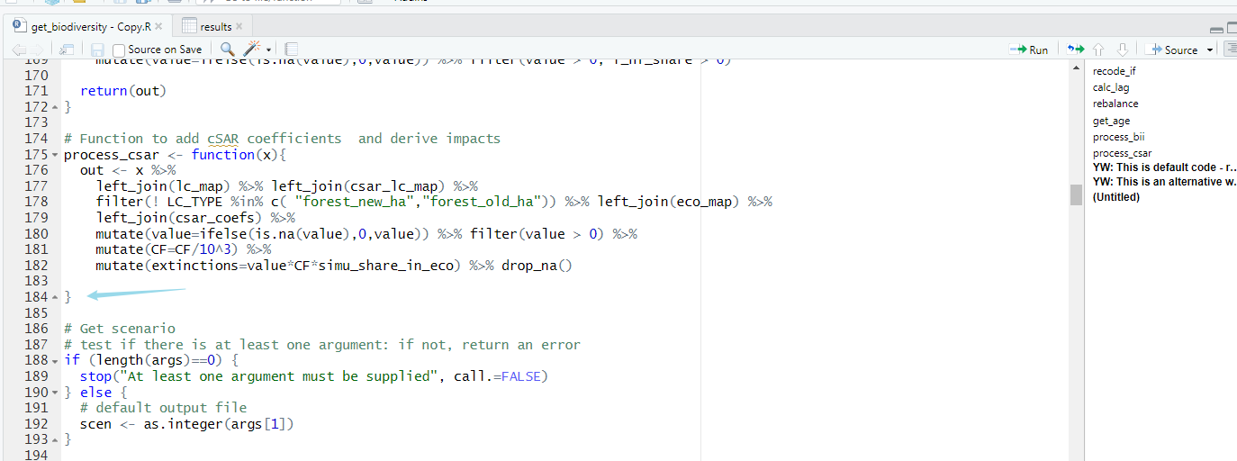
Step4. Run “setwd(dirname(rstudioapi::getSourceEditorContext()$path))” in the Rstudio Console to switch the current directory
Step5. Then start from data reading in “get_biodiversity – Copy.R” (line 233 in the fig) , and then finish to the end.
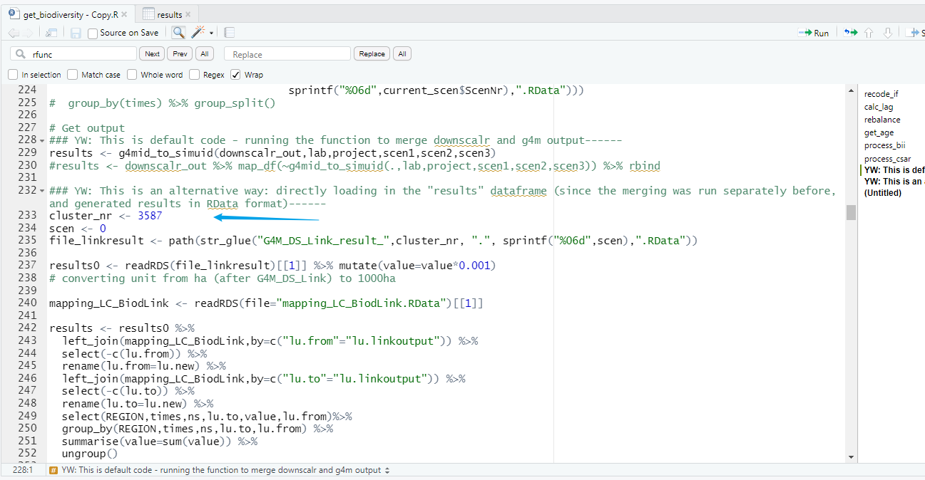

For reference: Relationship between the script, input and output:

