

Prototype-n-puzzle
10/09/14 14:13
Author: John Doe
File name: Prototype-n-puzzle.vp
Version 1.0

Site Map

01. Site Map / Prototype-n-puzzle

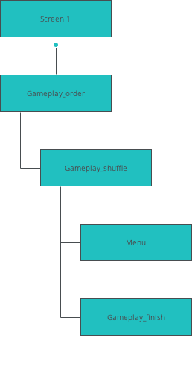

Screens

02. Screens / Prototype-n-puzzle
Gameplay_finish
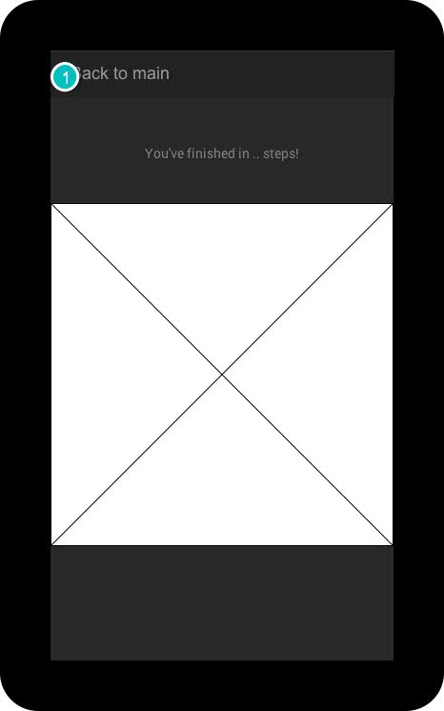

The screen a player sees when the game is finished.

Interactions

1 | on Click: goes to Screen 1 →

02. Screens / Prototype-n-puzzle
Gameplay_order
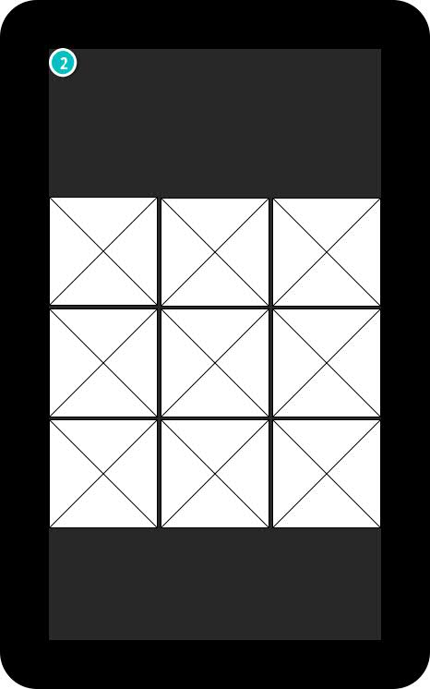

This page pauses for three seconds on page load, before linking to the shuffled picture.

Interactions

2 | on Page Load: goes to Gameplay_shuffle →

02. Screens / Prototype-n-puzzle
Gameplay_shuffle
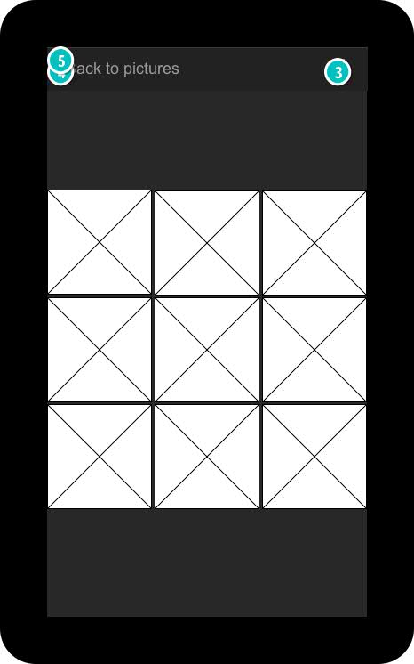

This is the screen where gameplay actually occurs. The picture is shuffled and the tiles adjacent to the empty tile can be switched with the empty tile. From this point you can open the menu by clicking in the top right corner or you can go back to pick a new picture.

Interactions

3 | on Click: goes to Menu →
4 | on Click: goes to Screen 1 →
5 | on Click: goes to Gameplay_finish →

02. Screens / Prototype-n-puzzle
Menu
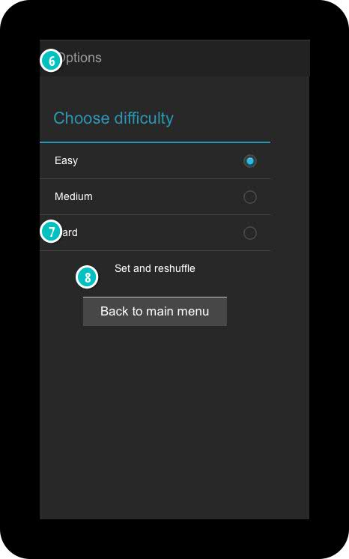

This is where you can choose the difficulty. If you press "Set and reshuffle" (whether you changed the difficulty or not) the player will be linked to the ordered state of the picture, before being linked to the shuffled state. If the players clicks in the top left corner he will be linked back to the game he was playing.

Interactions

6 | on Click: goes to Gameplay_shuffle →
7 | on Click: goes to Gameplay_order →
8 | on Click: goes to Screen 1 →

02. Screens / Prototype-n-puzzle
Screen 1
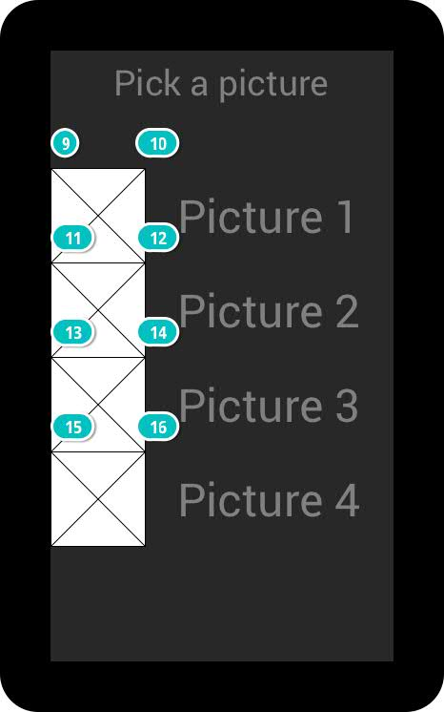

This is the screen where the player can choose a picture to play with. It is the first screen that is shown. All pictures link to the Gameplay_order screen.

Interactions

9 | on Click: goes to Gameplay_order →
10 | on Click: goes to Gameplay_order →
11 | on Click: goes to Gameplay_order →
12 | on Click: goes to Gameplay_order →
13 | on Click: goes to Gameplay_order →
14 | on Click: goes to Gameplay_order →
15 | on Click: goes to Gameplay_order →
16 | on Click: goes to Gameplay_order →

