Zambia CSIP: Scenarios and parameters for CSA options

Michiel van Dijk and Amanda Palazo

April 03, 2018

# Introduction

This document provides background information on the seven CSA options that were selected by the GLOBIOM, World Bank and CSA teams to quantify with the GLOBIOM model. These include:

* Conservation agriculture
* Agro-forestry
* Improved post-harvest loss management
* Adoption of drought resistant varieties
* Increase in irrigated area
* Diversification of crops and livestock base
* Investment in infrastructure

The sections below provides background information as well as model parameters and/or projections for each of these options. A number of sources are used to prepare the document, including FAO statistics, Zambia specific reports and scientific journal articles. The information will be used as an input into GLOBIOM to simulate the impact of adopting these options on agricultural futures in Zambia. It is expected that the data will be updated after discussions with stakeholders and new information provided by the FAO team, who will conduct and in-depth cost-benefit analysis of some of these options.

# Conservation agriculture

## Background

Conservation agriculture (CA) is build on three principles of agricultural management: (1) minimum mechanical soil disturbance, (2) crop rotation and (3) permanent organic soil cover (Haggblade and Tembo, 2003). Since 1985, CA has been promoted in Zambia as a solution to low agricultural productivity caused by intensive tillage, lack of soil cover and burning of crop residue (Baudron et al., 2007). CA in Zambia, referred to as conservation farming, has a specific interpretation and consists of a package that involves five practices (Arslan et al., 2013; Haggblade and Tembo, 2003): (1) reduced tillage on no more than 15% of the field area without soil inversion, (2) precise digging of permanent planting basins or ripping of soil with a Magoye ripper (the latter where draft animals are available), (3) retention of crop residues from the prior harvest rather than burning it on the field, (4) rotation of cereals with legumes and (5) dry season land preparation.

*Figure 1: Agro-ecological zones in Zambia*

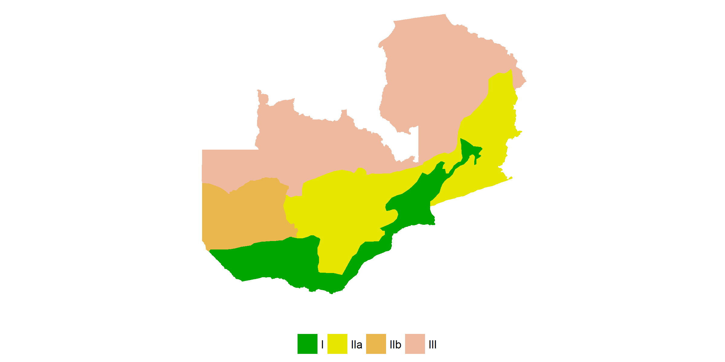

CA has mainly been promoted in the arid and moderate rainfall regions in the agro-ecological zones I, IIa and IIb (Figure 1). There are no clear guidelines for the high-rainfall zone III, for which CA seems less suitable (Baudron et al., 2007). Despite the long history of CA in Zambia and the active promotion, national adoption rates are low. Using a nationally representative household survey Zulu-mbata et al. (2016) estimated that only 3.7% of farmers fully adopted CA practices, while 1.1% partially adopted CA (i.e. minimum tillage and crop rotation or crop residue retention). The data shows that crop rotation and crop residue retention are practised widely in Zambia, while minimum tillage is much less applied, hence, is the main constraint to the use of CA. The data also show that CA adoption rates have more than doubled between 2012 and 2015 but it is unclear why this happened.

*Table 1: Percent of households using CA practices in Zambia*

|  |  |  |  |
| --- | --- | --- | --- |
| Indicator | 2012 | 2015 | source |
| Number of households | 1,380,409.0 | 1,472,886.0 | Zulu-mbata et al. (2016) |
| Minimum tillage (%) | 2.8 | 10.6 | Zulu-mbata et al. (2016) |
| Crop rotation (%) | 49.0 | 49.9 | Zulu-mbata et al. (2016) |
| Crop residue retention (%) | 60.9 | 63.3 | Zulu-mbata et al. (2016) |
| Full CA adopters (%) | 1.3 | 3.7 | Zulu-mbata et al. (2016) |
| Partial CA adopters (%) | 1.1 | 5.1 | Zulu-mbata et al. (2016) |

##### Source: Zulu-mbata et al. (2016)

A large number of studies have investigated the low adoption rate of CA in Zambia. General factors, which have found to constrain the use of CA in other countries as well as in Zambia include (Arslan et al., 2013; Giller et al., 2009): (1) Credit constraints: initial CA investment costs are high and benefits are usually realized after around four years; (2) labour: CA demands additional labour input for land preparation and weeding (although labour is saved for tillage activities) when it is implemented without pesticides (the common approach). This is regarded as the main barrier to adoption in Zambia; (3) competition for crop residues. Maintaining permanent soil cover can be costly as it demands access to seeds and residues cannot be used for other purposes such as livestock feed and fuel.

## CSA benefits and costs

CA can serve to mitigate greenhouse gas (GHG) emissions from agriculture by means of (1) enhancing soil C sequestration, (2) improving soil quality, N-use efficiency and water use efficiencies, and (3) reducing fuel consumption.

Thierfelder et al. (2013) present the results of on-station and farm trials in the Eastern and Southern provinces of Zambia to investigate the impact of CA on soil quality, soil moisture and maize yield. They find an average increase in yield between 75%-91% in comparison to plots on which conventional tilled is applied but only after six cropping seasons. They also find an average carbon increase of 12% at the on-station plots, in comparison to a decrease of 15% for conventional control. This effect was not measured on the farm plots. Erenstein et al. (2012) discuss on-farm trails in Zimbabwe and report a yield increase of 14%-81 of CA in comparison to conventional maize cropping.

## Scenarios

We propose to use the following paramters in GLOBIOM to model conservation agriculture

* Target crop: maize (but could also consider cotton as it is applied there too).
* Yield increase of 50% in comparison with convential farming systems
* Costs increase of ? in comparison to conventional farming systems [NO DATA]
* non-CO2/CO2 reduction of ? % in comparison to conventional farming systems [ONLY C sequestration, PROPOSE TO USE STEFAN’s VALUES FOR NOW]

We propose the following s-shaped diffusion pattern for conservation agriculture between 2010 and 2050.

*Figure 2: Diffusion of conservation agriculture: 2010-2050*

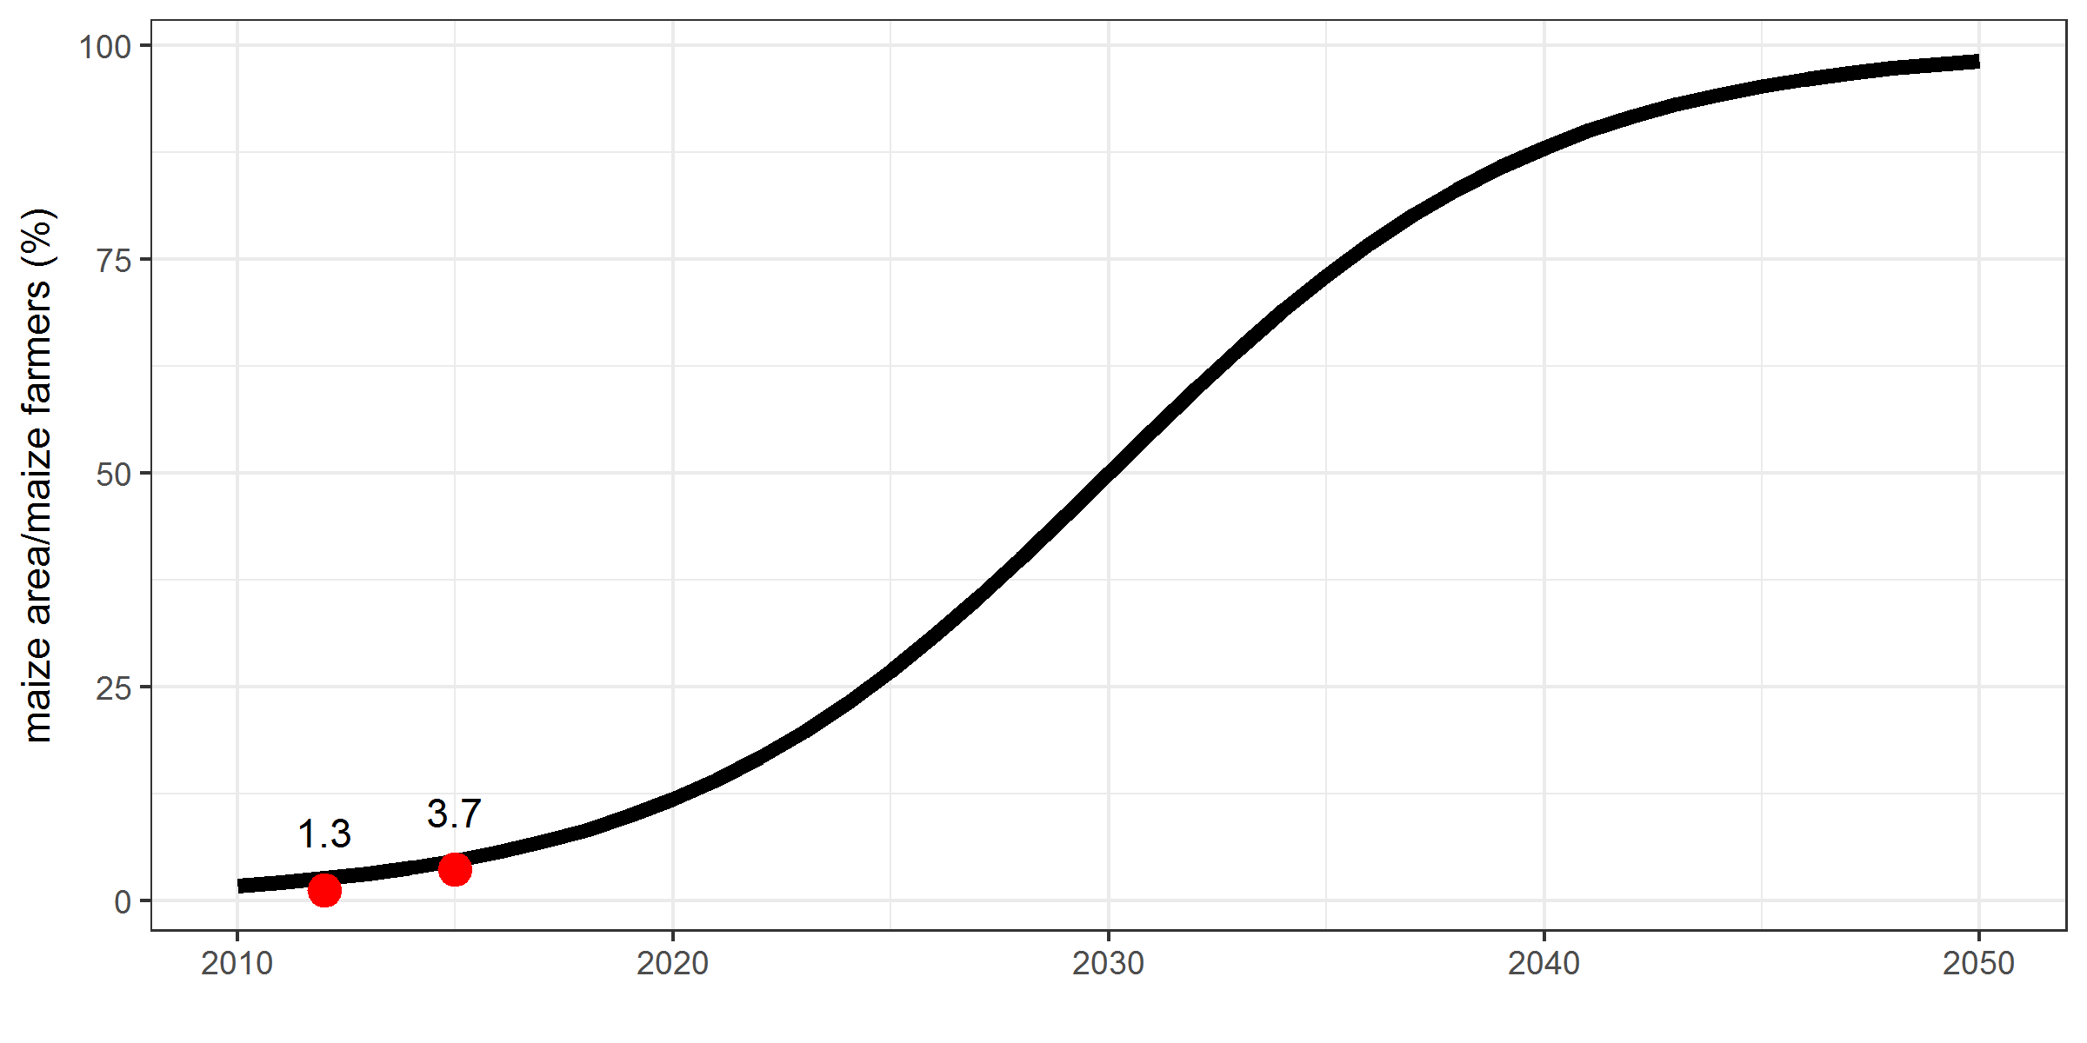

##### Source: Zulu-mbata et al. (2016) and authors

# Agro-forestry

## Background

The term agro-forestry is used for a variety of agro-forestry systems (e.g. trees mono-cropped on arable or complex agro-forest systems). Here we use the term to refer to the integration of trees into annual food crop systems. More specifically, it involves crop ration or intercropping with fast-growing nitrogen fixing trees or woody shrub species. Agro-forestry is also sometimes referred to as ‘evergreen agriculture’, which is defined as “the direct and intimate intercropping of trees within annual crop fields” (Garrity et al., 2010).

Most common agroforestry models in Zambia are: Gliricidia-maize intercropping (Gliricidia), rotation of maize with Sesbania sesban (Sesbania), rotation of maize with Tephrosia vogelii (Tephrosia) fallows and Faidherbia albida intercropping (Faidherbia) (Ajayi et al., 2009; Garrity et al., 2010; Shitumbanuma, 2012). In the first three variations, the trees are grown on fallow land for 2-3 years, followed by 1-2 years of cropping after which a new cycle starts. Gliricidia is leguminous woody species that is able to re-sprout when cut back in contrast to the other two tree types. Agro-forestry involving this tree is therefore referred to as intercropping instead of crop rotation although the fallow-crop cycle is very similar between the two groups of tree species. The Faidherbia agro-forestry system is slightly different as there is no fallow-crop cycle and trees are grown alongside crops (i.e. continuous intercropping). Initial growth of Faidherbia is slow, which means that farmers only start to benefit after 1-6 years. It is estimated that currently about 500,000 Malawian farmers have Faidherbia trees on their farms (Winterbottom et al., 2013). The Zambian CFU estimates that the tree is now cultivated in conservation farming systems over an area of 300,000 (Garrity et al., 2010)

## CSA benefits and costs

Agro-forestry has the potential to: “maintain vegetative soil cover, bolster nutrient supply through nitrogen fixation and nutrient cycling, generate greater quantities of organic matter in soil surface residues, improve soil structure and water infiltration, increase greater direct production of food, fodder, fuel, fibre and income from products produced by the intercropped trees, enhance carbon storage both above-ground and below ground, and induce more effective conservation of above and below-ground biodiversity” (Garrity et al., 2010, p 197).

A number of studies investigated some of these benefits in more detail. Shitumbanuma (2012) presents the results of intercropping trials with Faidherbia (under) in combination with four different crops in Eastern Zambia and compares the yield with conventional cropping systems (outside) (Figure 3). The impact is particularly large for maize, where yield doubles. Sileshi et al. (2008) conducted a meta-analysis to assess the effect of agro-forestry on soil fertility and maize yield in sub-Saharan Africa and presents similar improvements in production. FAO (2017) reports that mitigation impacts rangebetween the annual sequestration of 5 to 15 t CO2 per hectare but only reaches potential after 20 years.

*Figure 3: Comparison of crop yield with and with agro-forestry practices*

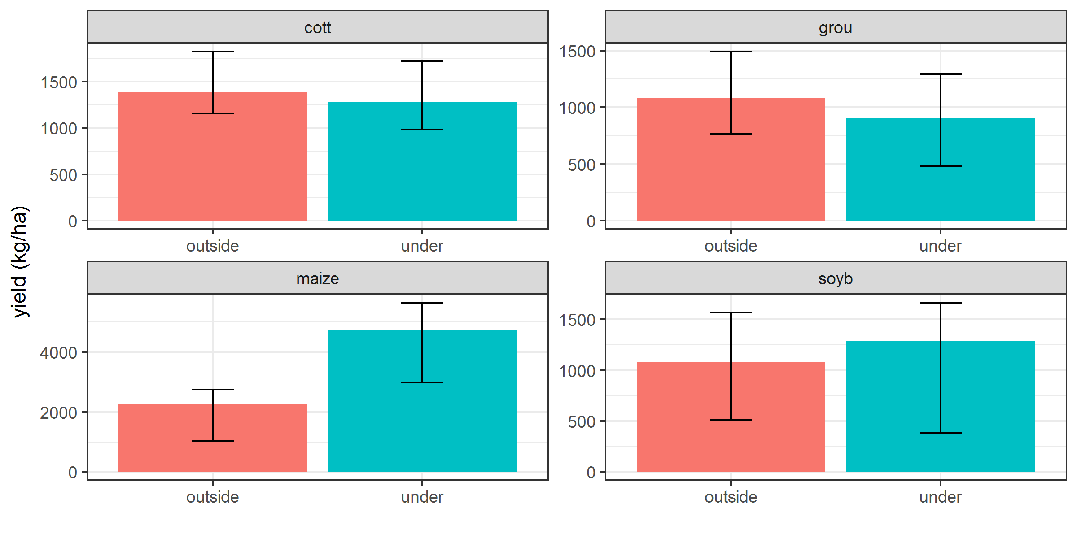

##### Source: Shitumbanuma (2012)

##### Note: Average values are for 2008-2011. Error bars indicate variations over year.

Garrity et al. (2010) cites a study that reports improved fallows with Sesbania produce between 15 and 21 t/ha of fuel wood, that were harvested after a 2-3 fallow.

Ajayi et al. (2009) estimate labour inputs and financial profitability of agro-forestry based management practices in comparison to conventional farming approaches in Eastern Zambia. The find that aggregated over a five-year cycle, labour inputs for agroforestry were lower than fertilized maize fields but higher than non-fertilised maize. The main reason for this is that labour inputs in agroforestry are concentrated in the first year during the establishment of fallows and in the third year when the fallow is cut down and the field sown with maize. For continuous maize cropping labour demands are relatively high in each year, in particular for fertilized plots where production is higher.

*Figure 4: Comparison of labour input between continous maize and agro-forestry systems*

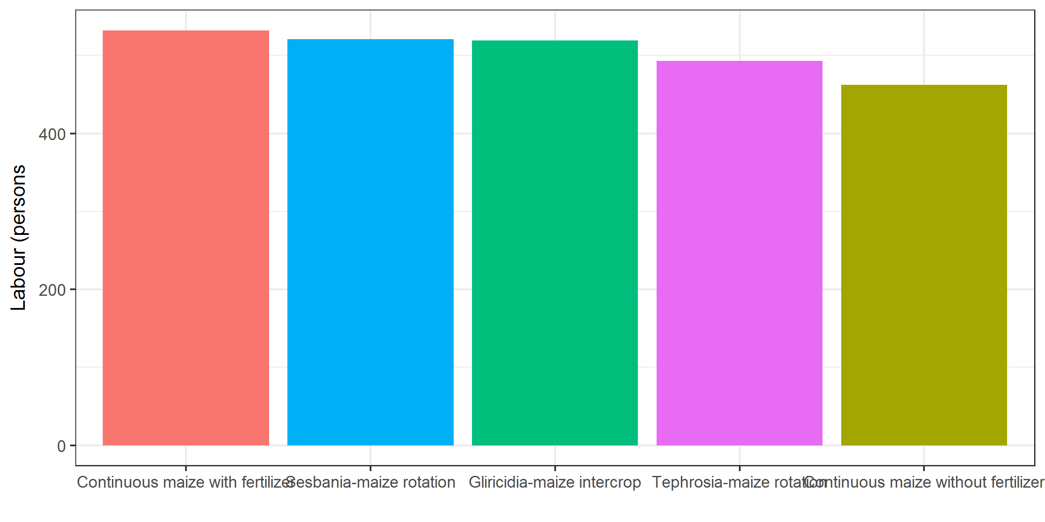

##### Source: Ajayi et al. (2009)

## Scenarios

We propose to use the following parameters in GLOBIOM to model agro-forestry systems.

* Target crop: Maize
* Yield increase of 85% in comparison with convential farming systems [NEED TO CHECK, seems high]
* Costs increase of ? in comparison to conventional farming systems [CHECK FAO]
* CO2 reduction of ? % in comparison to conventional farming systems
* CO2 reduction of 5 to 15 t CO2 per hectare [FAO DRAFT CSA REPORT CHECK]
* non-CO2 reduction of ? % in comparison to conventional farming systems

We propose the following s-shaped diffusion pattern for agro-forestry between 2010 and 2050.

*Figure 5: Projection for adoption of agro-forestry*

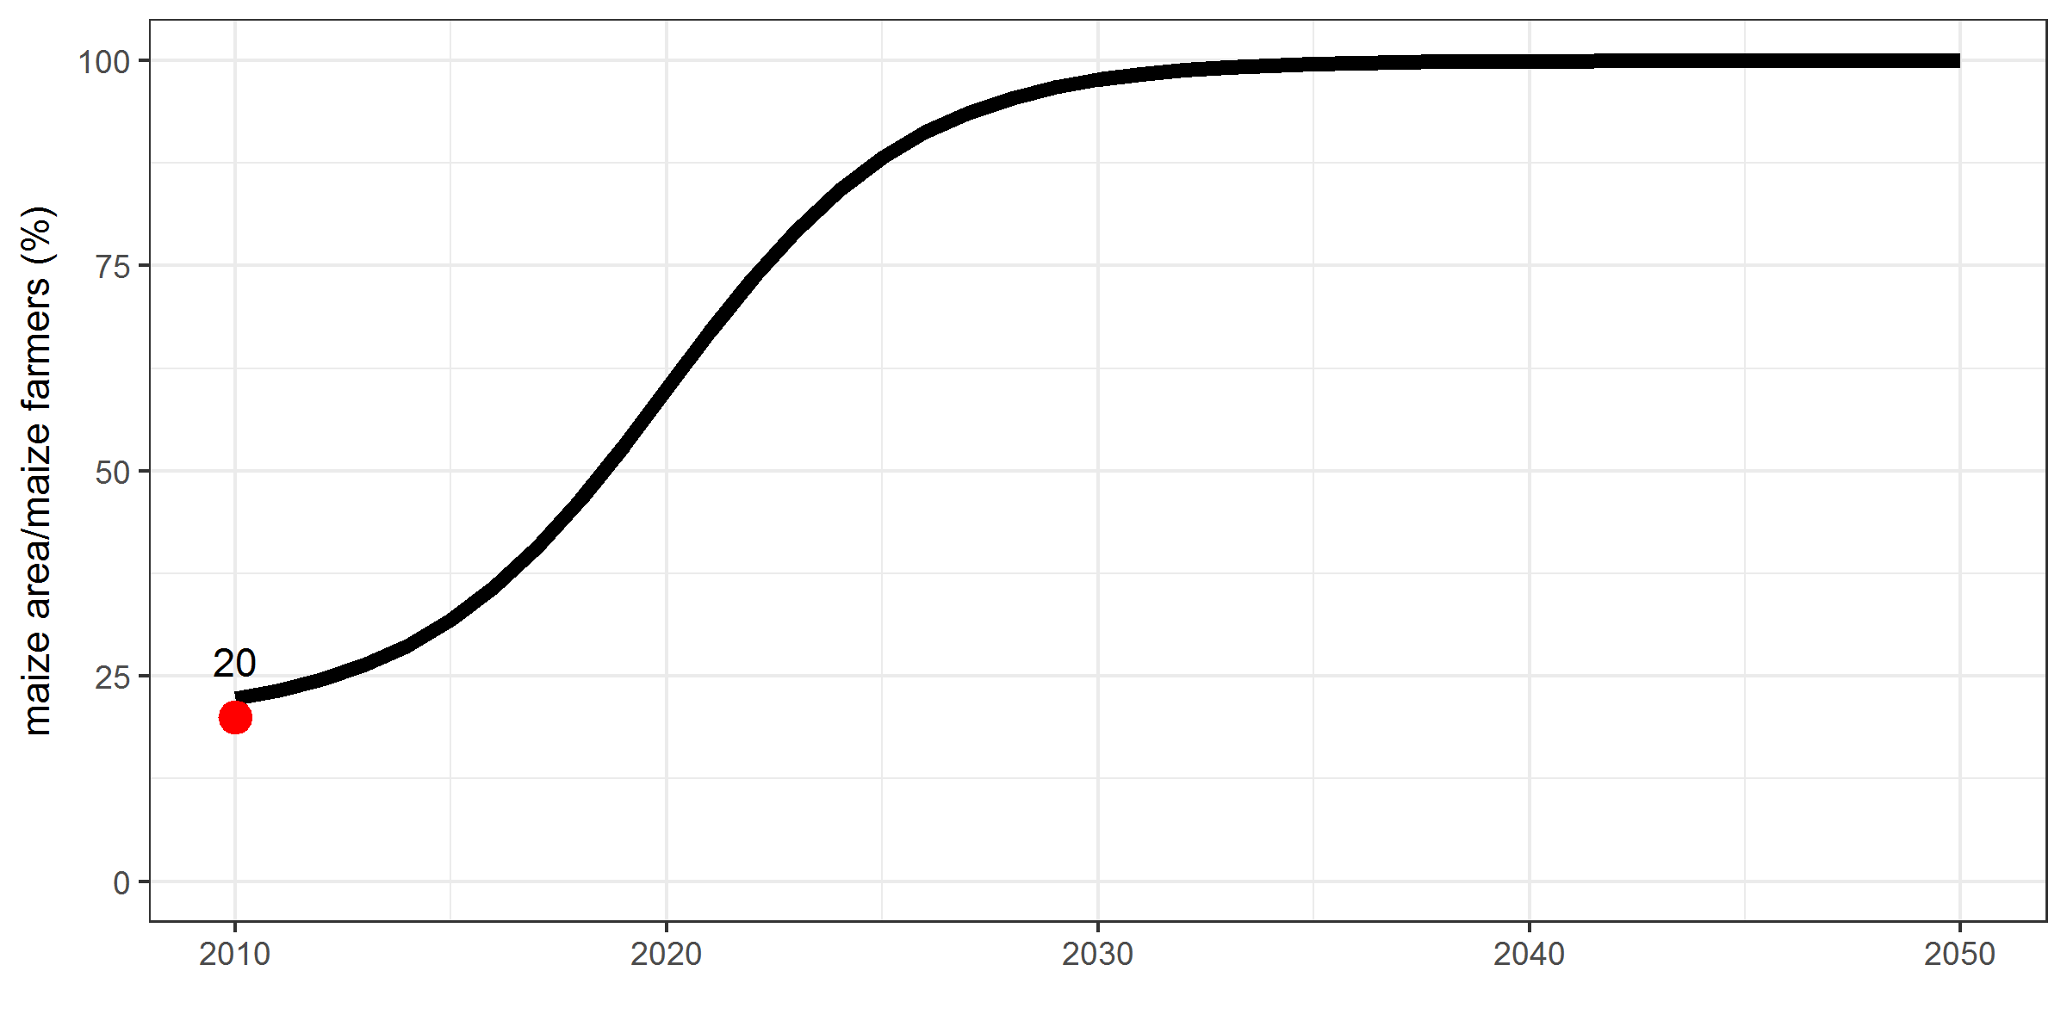

##### Source: Winterbottom et al. (2013)

# Adoption of drought-tolerant maize varieties

## Background

In view of a changing climate, drought tolerant maize (DTM) varieties are being developed that are able to deal with periods of drought and, in many cases, have other desirable characteristics, such as resistance to major diseases and high protein content. A major initiative is the CIMMYT Drought Tolerant Maize for Africa (DTMA) project, which released 160 DTM varieties in 13 African countries (including Zambia) between 2007 and 2013 (Fisher et al., 2015). All DTM varieties were bred using conventional methods and did not involve genetic modification. With 89%, the use of improved varieties of maize is high in Zambia in comparison to other countries. Following the inception of the DTMA project and the promotion of drought-tolerant varieties, the share of DTM has grown considerably from only 1% in 2006 to 23% in 2013 (Figure 7).

## CSA benefits and costs

The adoption of DTM varieties by farmers is expected to have two positive effects. First, DTMs are hybrid seeds that are expected to result in higher yields in comparison to traditional varieties. Second, DTMs are more resistant to fluctuations in precipitation, with the effect that the variance in yield is reduced over time. This is confirmed by Wossen et al. (2017), who measure the impacts of DTMs on productivity, welfare, and risk exposure using household and plot-level data from rural Nigeria. Their results show that adoption of DTMs increased maize yields by 13% and reduced the level of variance by 53%. Rovere et al. (2014) present an ex ante assessment of DTM adoption in 13 Sub-Saharan Africa countries (including Zambia), evaluating the benefits of an average yield increase as well as gains in yield stability. They find aggregate benefits in the range of USD 907-USD 1,535 million, under the assumption that DTM is adopted widely by farmers and depending whether conservative or optimistic yield improvements are used as the reference point.

Similar to other hybrid seeds, DTMs require more fertilizer in comparison to traditional varieties to realize higher yields. Labour requirements and seed costs are similar to non-DT improved varieties (Fisher et al., 2015).

Figure 6 shows the expected average yield gains of DTM varieties in comparison to that of other improved varieties. The results are based on field trials, including 273 trials in eastern and southern Africa over three years (Bänziger et al., 2006). DTM yield is expected to be around 3%-20% higher under conservative assumptions and around 10-30% under positive assumptions (i.e. the highest yielding DTM varieties). According to expert opinion, DTM yield will result in around 50% higher yield (net of fertilizer use) in comparison to traditional varieties (Rovere et al., 2014). Similar figures are presented in Setimela et al. (2017), who compare new drought tolerant maize hybrids and open pollinated varieties against the best commercial varieties in East and Southern Africa under farmer management and on-station conditions.

*Figure 6: Comparison of crop non-DTM and DTM maize yield*

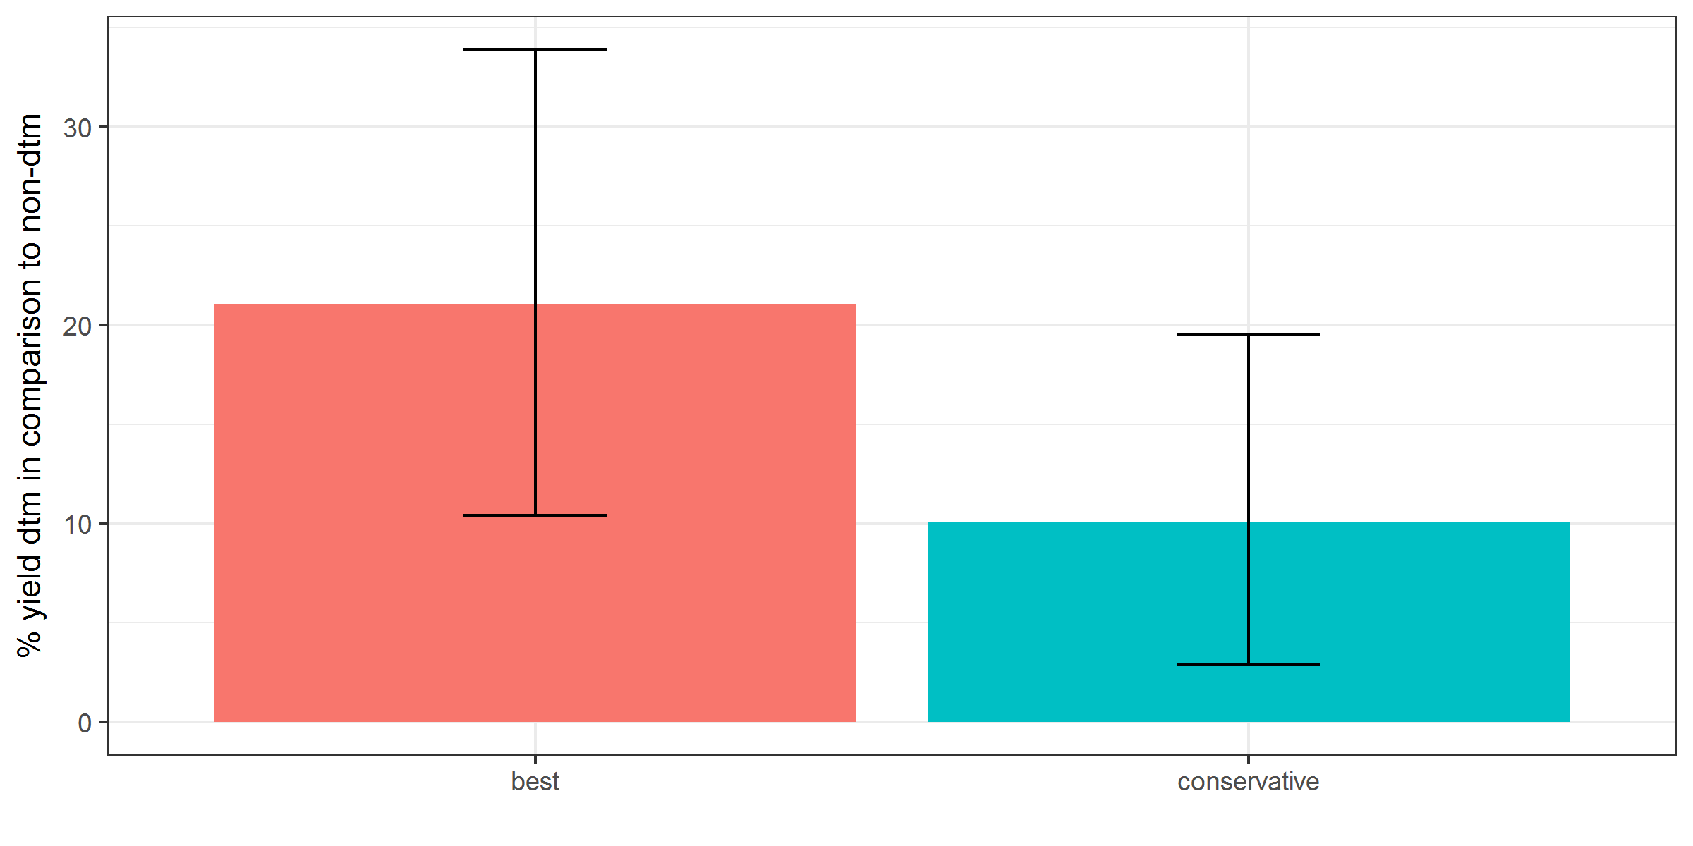

##### Source: Bänziger et al. (2006)

## Scenarios

We propose to use the following parameters in GLOBIOM to model the adoption of DTMs.

* Target crop: Maize
* Yield increase of 50% in comparison with convential (using non-improved traditional seeds) farming systems (to model this we probably should decrease the climate change shock with 50%).
* Yield increase of 20% in comparison with farming systems that use improved seeds already (idem)
* Costs increase of ? in comparison to conventional farming systems [Probably none as we already model costs for improved seeds?]
* CO2 reduction of 0 % in comparison to conventional farming systems
* non-CO2 reduction of 0 % in comparison to conventional farming systems

We propose the following s-shaped diffusion pattern for DTMs between 1997 and 2050.

*Figure 7: Projection for adoption of drough-tolerant maize varieties*

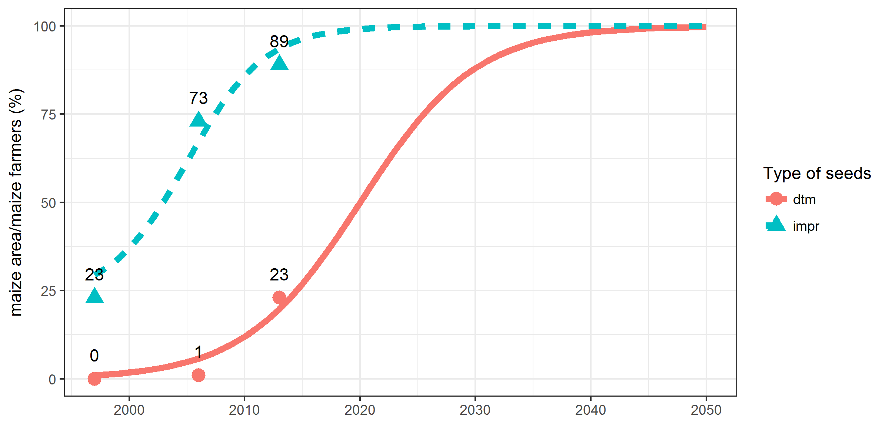

##### Source: Rovere et al. (2014), Fisher et al. (2015) and authors.

##### Note: Total improved varieties is the sum of the adoption rate of open-pollinated varieties (OPVs) and hybrids (including DTMs).

# Reducing post-harvest losses

## Background

Following the food price crisis in 2007/2008, there is a renewed interest in reducing post-harvest losses (PHL). The World Bank (World Bank, 2011), estimated that around USD 4 billion annually can be saved in Sub-Saharan Africa by reducing the PHL in grains (mainly cereals and legumes) alone. This value is more than the value of total food aid received in the region over the last decade. There are four major reasons to address PHLs (Sheahan and Barrett, 2017): (1) improve food security; (2) improve food safety; (3) reduce unnecessary input use and (4) increase profits for food value actors.

PHL can take place at all stages of the value chain between the farmers field and the consumers’ fork, which can be divided into five stages (FAO, 2011): (1) harvesting such as from mechanical damage and/or spillage, (2) postharvest handling, such as drying, winnowing, and storage (insect pests, rodents, rotting), (3) processing, (4) distribution and marketing, and (5) consumption.

## CSA benefits and costs

Most data on PHL are spotty and often of poor quality. None of the available sources provide data for Zambia specifically. FAO (2011) estimated that total PHL in Sub-Saharan Africa amount to one third of total food produced (in volume). A more comprehensive analysis is presented by Affognon et al. (2015), who conducted a literature survey of PHL in six African countries (but not including Zambia) and seven commodity categories. Figure X presents PHL estimates per crop over the total value chain. They also performed a statistical meta-analysis to provide more accurate figures. These are however only available for four crops due to lack of data. Kaminski and Christiaensen (2014) use nationally representative household surveys for Uganda, Tanzania and Malawi. They only include on-farm PHL for maize and find values in the range of 1.4%-5.9%.

There is a consensus across sources that most grains and cereals are lost during post-harvest handling and storage on-farm, while loss of fresh produce, meat, and seafood is concentrated in processing, packaging, and distribution Sheahan and Barrett (2017). In Sub-Saharan Africa, most PHL happens at the farm level (Affognon et al., 2015; FAO, 2011).

*Figure 8: Post harvest loss estimations for Sub-saharan Africa*

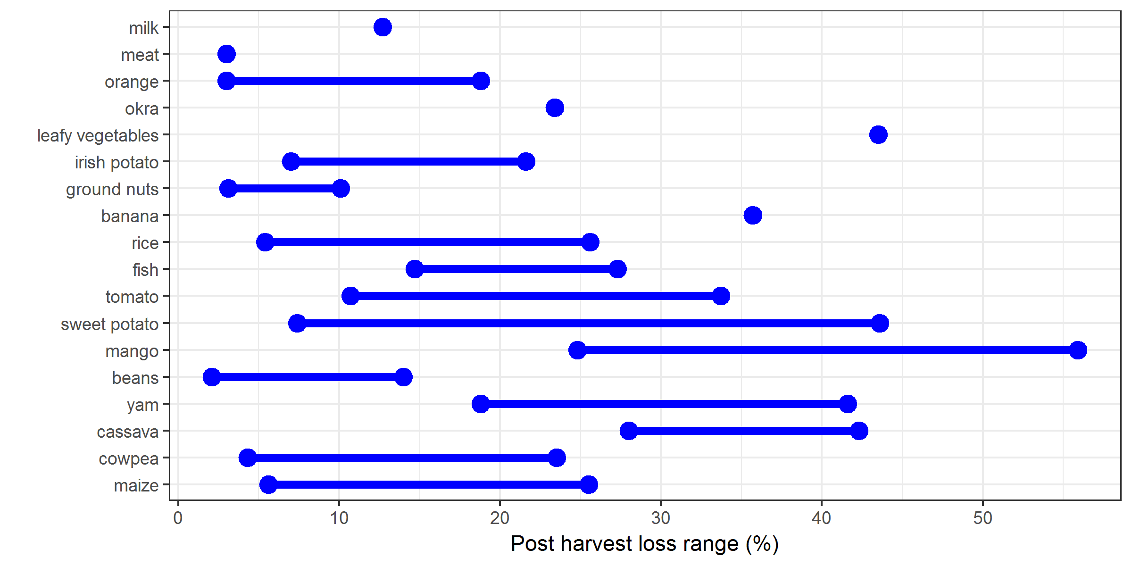

##### Source: Affognon et al. (2015)

## Scenarios

We propose to use the following parameters in GLOBIOM to model reduction in PHL.

* Target crop: All crops in GLOBIOM
* Yield increase equalt to the highest values in Figure 8 [do we model this by means of a yield shock and do we already take in to account PHL in the baseline?].
* Costs increase of ? in comparison to conventional farming systems [Maybe we should assume this is a ‘free’ technology?]
* CO2 reduction of 0 % in comparison to conventional farming systems [only indirect through land use change, etc)]
* non-CO2 reduction of 0 % in comparison to conventional farming systems

We propose the following s-shaped diffusion pattern for PHL between 2010 and 2050. [Still have to decide? Gradual improvement or immediate?]

# References

Affognon, H., Mutungi, C., Sanginga, P., Borgemeister, C., 2015. Unpacking Postharvest Losses in Sub-Saharan Africa: A Meta-Analysis. World Development 66, 49–68. <https://doi.org/10.1016/J.WORLDDEV.2014.08.002>

Ajayi, O.C., Akinnifesi, F.K., Sileshi, G., Kanjipite, W., 2009. Labour inputs and financial profitability of conventional and agroforestry-based soil fertility management practices in Zambia. Agrekon 48, 276–292. <https://doi.org/10.1080/03031853.2009.9523827>

Arslan, A., Mccarthy, N., Lipper, L., Asfah, S., Cattaneo, A., 2013. Adoption and Intensity of Adoption of Conservation Farming Practices. Working paper.

Baudron, F., Mwanza, H.M., Triomphe, B., Bwalya, M., 2007. Conservation agriculture in Zambia: a case study of Southern Province. African Conservation Tillage Network, Centre de Coopération Internationale de Recherche Agronomique pour le Développement, Food; Agriculture Organization of the United Nations, Nairobi.

Bänziger, M., Setimela, P.S., Hodson, D., Vivek, B., 2006. Breeding for improved abiotic stress tolerance in maize adapted to southern Africa. Agricultural Water Management 80, 212–224. <https://doi.org/10.1016/J.AGWAT.2005.07.014>

Erenstein, O., Sayre, K., Wall, P., Hellin, J., Dixon, J., 2012. Conservation Agriculture in Maize- and Wheat-Based Systems in the (Sub)tropics: Lessons from Adaptation Initiatives in South Asia, Mexico, and Southern Africa. Journal of Sustainable Agriculture 36, 180–206. <https://doi.org/10.1080/10440046.2011.620230>

FAO, 2017. CSA strategic framework.

FAO, 2011. Global food losses and food waste. FAO, Rome.

Fisher, M., Abate, T., Lunduka, R.W., Asnake, W., Alemayehu, Y., Madulu, R.B., 2015. Drought tolerant maize for farmer adaptation to drought in sub-Saharan Africa: Determinants of adoption in eastern and southern Africa. Climatic Change 133, 283–299. <https://doi.org/10.1007/s10584-015-1459-2>

Garrity, D.P., Akinnifesi, F.K., Ajayi, O.C., Weldesemayat, S.G., Mowo, J.G., Kalinganire, A., Larwanou, M., Bayala, J., 2010. Evergreen Agriculture: a robust approach to sustainable food security in Africa. Food Security 2, 197–214. <https://doi.org/10.1007/s12571-010-0070-7>

Giller, K.E., Witter, E., Corbeels, M., Tittonell, P., 2009. Conservation agriculture and smallholder farming in Africa: The heretics’ view. Field Crops Research 114, 23–34. <https://doi.org/10.1016/J.FCR.2009.06.017>

Haggblade, S., Tembo, G., 2003. Conservation farming in Zambia. EPTD discussion paper.

Kaminski, J., Christiaensen, L., 2014. Post-harvest loss in sub-Saharan Africa—what do farmers say? Global Food Security 3, 149–158. <https://doi.org/10.1016/J.GFS.2014.10.002>

Rovere, R.L., Abdoulaye, T., Kostandini, G., Guo, Z., Mwangi, W., MacRobert, J., Dixon, J., 2014. Economic, Production, and Poverty Impacts of Investing in Maize Tolerant to Drought in Africa: An Ex-Ante Assessment. The Journal of Developing Areas 48, 199–225. <https://doi.org/10.1353/jda.2014.0016>

Setimela, P.S., Magorokosho, C., Lunduka, R., Gasura, E., Makumbi, D., Tarekegne, A., Cairns, J.E., Ndhlela, T., Erenstein, O., Mwangi, W., 2017. On-farm yield gains with stress-tolerant maize in eastern and Southern Africa. Agronomy Journal 109, 406–417. <https://doi.org/10.2134/agronj2015.0540>

Sheahan, M., Barrett, C.B., 2017. Review: Food loss and waste in Sub-Saharan Africa. Food Policy 70, 1–12. <https://doi.org/10.1016/J.FOODPOL.2017.03.012>

Shitumbanuma, V., 2012. Analysis of crop trails under Faidherbia Albida. Conservation Farming Unit.

Sileshi, G., Akinnifesi, F.K., Ajayi, O.C., Place, F., 2008. Meta-analysis of maize yield response to woody and herbaceous legumes in sub-Saharan Africa. Plant and Soil 307, 1–19. <https://doi.org/10.1007/s11104-008-9547-y>

Thierfelder, C., Mwila, M., Rusinamhodzi, L., 2013. Conservation agriculture in eastern and southern provinces of Zambia: Long-term effects on soil quality and maize productivity. Soil and Tillage Research 126, 246–258. <https://doi.org/10.1016/J.STILL.2012.09.002>

Winterbottom, R., Reij, C., Garrity, D., Glover, J., Hellums, D., McGahuey, M., Scherr, S., 2013. Installment 4 of “Creating a Sustainable Food Future”: Improving land and water management. Working paper.

World Bank, 2011. Missing food: The Case of Postharvest Grain Losses in Sub-Saharan Africa. World Bank, Washington DC.

Wossen, T., Abdoulaye, T., Alene, A., Feleke, S., Menkir, A., Manyong, V., 2017. Measuring the impacts of adaptation strategies to drought stress: The case of drought tolerant maize varieties. Journal of Environmental Management 203, 106–113. <https://doi.org/10.1016/J.JENVMAN.2017.06.058>

Zulu-mbata, O., Chapoto, A., Hichaambwa, M., 2016. Determinants of Conservation Agriculture Adoption among Zambian Smallholder Farmers. Working paper. <https://doi.org/10.13140/RG.2.2.26850.32965>