Zambia CSIP results

Michiel van Dijk, Amanda Palazzo and Petr Havlik

May 02, 2018

*Figure X: BAU crop production*

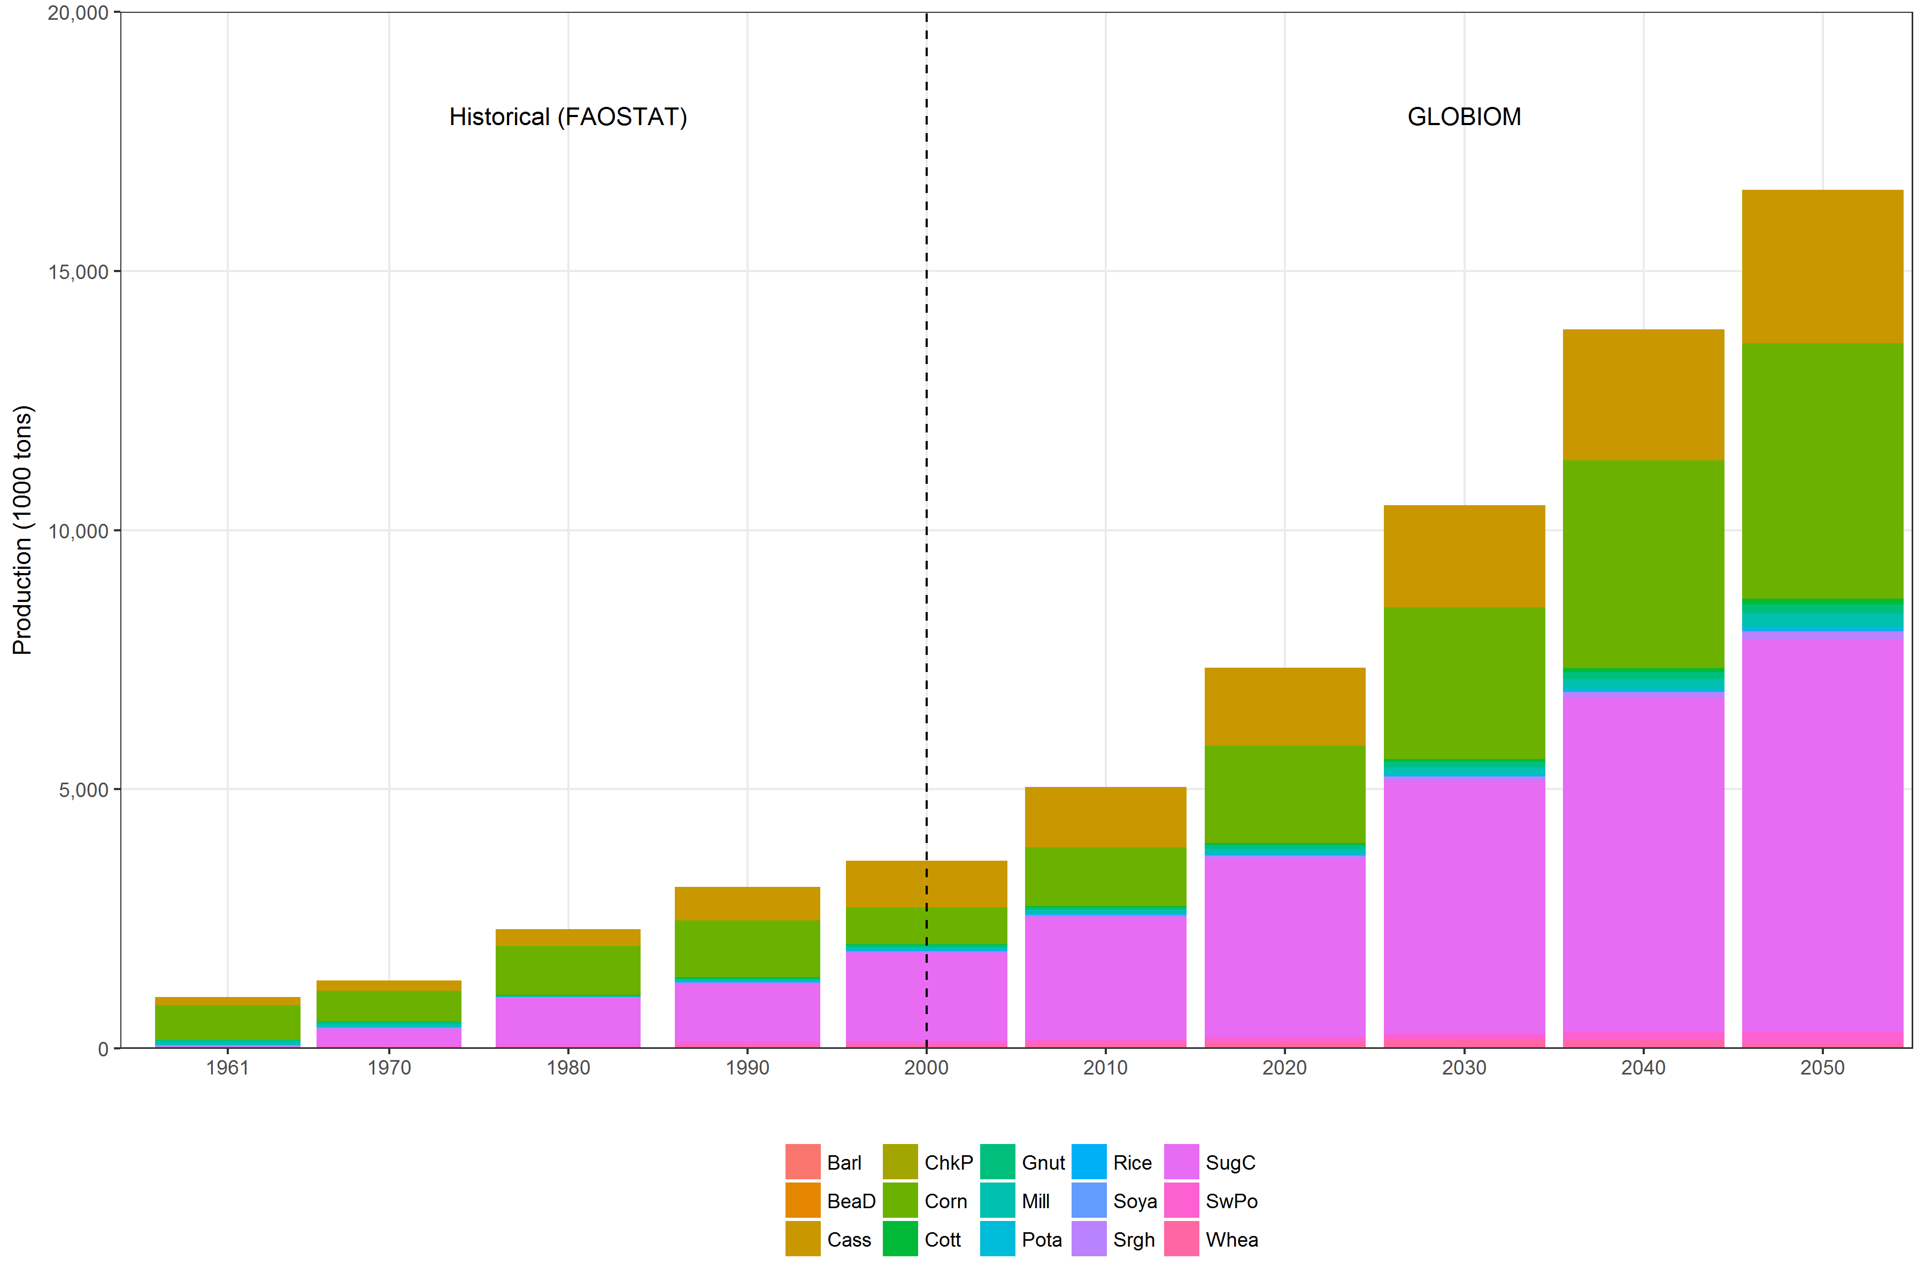

*Figure X: BAU yield*

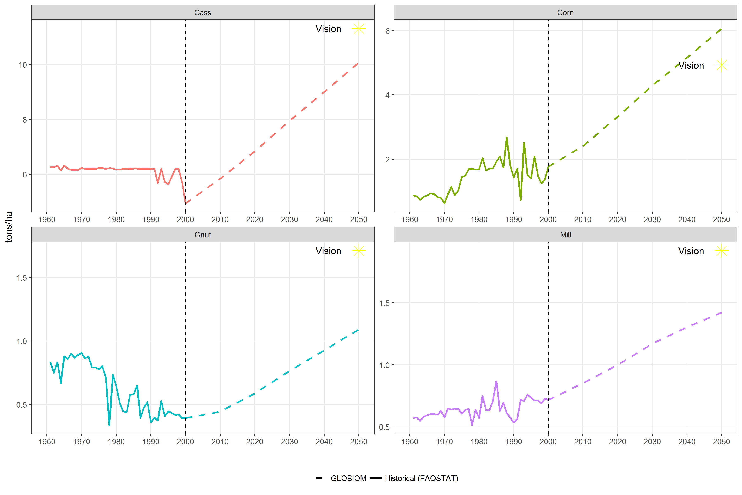

*Figure X: BAU lvst*

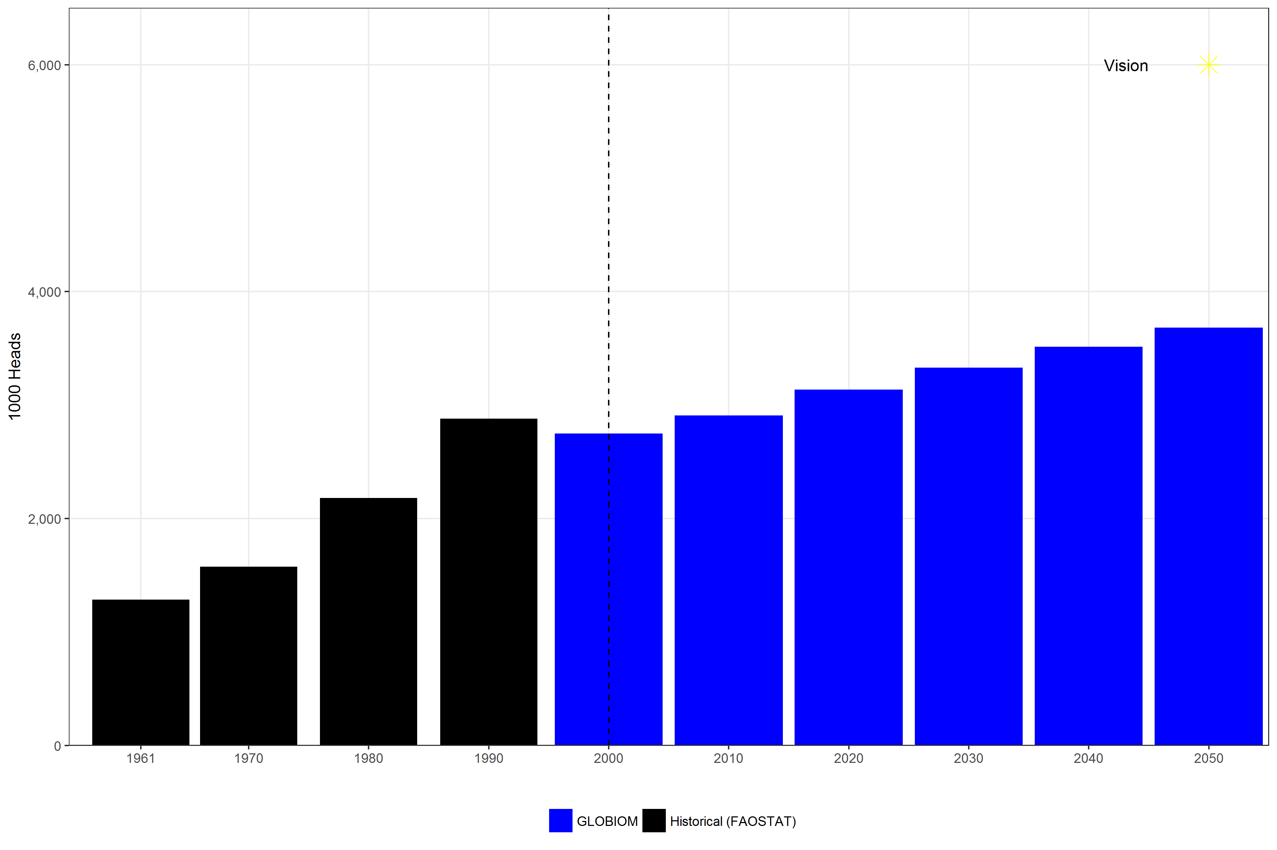

*Figure X: BAU Emissions*

*Figure X: BAU Calorie availability*

