Decomposing economic and technology yield gaps in Nigeria

Michiel van Dijk, Tom Morley, Zuzana Smeets-Kristkova

January 03, 2017

# Introduction

Yield gap is a powerful concept to illustrate the possibilities to increase future crop yield and the investigate why actual yield is lower than the biophysical potential. It is defined as the difference between potential yield and actual yield observed at the plot, farm or regional level. Despite its abundant use, the yield gap can be defined and measured in a number of ways, which has resulted in lack of consistency in yield gap analysis in the literature (Lobell, Cassman, and Field 2009). Furthermore, in a recent review of the use of yield gap analysis in key policy papers Sumberg (2012) noted that *"there is a tension between the notion of yield gap as developed in crop ecology (although even here there is no single or consistent usage) and micro-economic studies"* [p. 510].

The aim of this paper is to address some of these criticisms by integrating micro-economic and agronomic yield gap approaches into one single framework. The framework follows the reasoning of Tittonell and Giller (2013), who argue that the gap is caused by two main factors: (1) resource use intensity and (2) access and use of technology. It also extends the work of Fischer (2015), who recently reviewed definitions of crop yield and yield gaps and builds on the work of Van Dijk et al. (2016) and Silva et al. (2016), who combine agronomic and economic approaches to yield gap analysis and measurement.

We start by critically reviewing the most common crop yield and yield gap definitions and highlight a number of inconsistencies in their definition and use. We demonstrate that 'actual yield' can be measured in different ways, leading to different yield gaps. Similarly the use of 'attainable yield' is fraught with difficulties and in practice have been used to define conceptually different production levels. We continue by critically addressing the use of the term 'exploitable yield level (Cassman et al. 2003; Ittersum et al. 2013), sometimes referred to as 'economic yield level' (Fischer 2015). Exploitable yield is normally used to capture the part of the yield gap that will not be closed because of economic constraints and is normally set to 75-85% of potential yield (Cassman 1999; Cassman et al. 2003; Ittersum et al. 2013).

As pointed out by Fischer (2015), these numbers are based on "general experience" [p.11] and mainly represent to situations *"where there is no other competition for the farmers’ resources, and world prices and reasonable transport costs operate"* [p.11]. He also points out that in situations Where this does not occur, such as Sub-Saharan Africa, which is characterized by poor infrastructure and weak institutions, the exploitable yield gap is expected to be much higher. Despite its weak underpinnings the 75-80% 'rule of thumb' is applied frequently as a 'target' in studies to assess potential to increase future crop production. (Oort et al. 2015; Aramburu Merlos et al. 2015), which can be potential misleading, in particular when applied to developing countries. We argue that the definition of (true) economic yield should be rooted in neoclassical economic theory, the dominant paradigm in economics, and be estimated using information on the prices of inputs and outputs. Analogue to arguments in crop ecology, which stress the localized nature of agroclimatic conditions, we argue that economic yield levels are location specific. It is well-known that in many developing countries (sub-national) trade is limited due to poor infrastructure resulting in isolated markets and differentiated market prices (**???**).

To solve some of the inconsistencies with the existing yield and yield gap definitions our conceptual framework introduces three new yield levels that make it possible to decompose the conventional yield gap into a ' technical efficiency', 'economic', 'feasible' and 'technology'. We believe that our framework is able to capture all existing yield gap definitions and reveal the impact of resource intensity and technology on yield gaps.

To demonstrate our framework we present an application using a large nationally representative farm level survey on maize production in Nigeria. [ADD].For the integrated agronomic and economic analysis in this study we combine information from a number of sources. This section describes the various data sources and presents summary statistics for relevant variables.

The structure of the paper is as follows. Section 2 provides a conceptual framework that integrates varies definitions of yield levels and yield gap. Section 3 briefly discusses the Nigerian farm level maize data set that is used to illustrate the conceptual model. Section 4 computes the yield levels and yield gaps followed by a discussion in Section 5. Finally, Section 6 concludes.

## Conceptual framework

We use the conceptual framework developed by (**???**) to decompose the conventional yield gap. Figure 1 shows the observed input and output combinations of a number of agricultural units (e.g. field, farm or region). For purpose of illustration, we assume that the observations are small-scale farms in Africa, who produce a single output (e.g. maize) using one input (e.g fertilizer), agroecological conditions are identical for all farms and water is not limited. The *theoretical yield response function* describes the relationship between yield and inputs under perfect crop management and most advanced technology. The maximum of the function is the potential yield level. The *frontier yield response function* is estimated using actual observations from a sample of farmers or plots in a specific country or region. It measures best-practice performance at all input levels and reflects the best management practices and technology that are available in the region. The diagonal line presents the relative input () and output () market price faced by the farmers.

Figure 1 depicts the two yield levels that determine the conventional yield gap, actual yield () for farm and potential yield () as well as the associated input levels. Similar to Tittonell and Giller (2013), we argue that the yield gap is caused by two main factors. The first is resource use intensity. The relationship between resource use and yield is given by the yield response curve. Intensification will results in higher yields, represented by a movement over the curve to the right. We argue that for the majority of farmers the decision on how much inputs to use depends on economic considerations (i.e. profit maximization behavior). Under the assumption of perfect functioning agricultural markets and full information, the demand for inputs will solely depend on relative market prices of inputs and output, and production technology (Sadoulet and Janvry 1995). In developing countries, the assumption of perfect markets is not realistic because of high transaction cost, missing credit and insurance markets and lack of information on input and output prices and available technologies (Stiglitz 1989; Dillon and Barrett 2014). Under these circumstances, the demand for inputs tends to be lower than the economic optimum resulting in lower output and yield (V. Kelly, Adesina, and Gordon 2003). In some cases, farmers the input decision of farmers can be guided by other non-economic objectives such as environmental awareness or output targets [Ref to RUE Rabbinge? - Example] resulting in sub optimal economic input use.

The second major cause of yield gaps is related to the efficient use and adoption of technology. Two different aspects are relevant. The first is technical efficiency, which is defined as the farm’s ability to produce maximum output given a set of inputs and technology (Farrell 1957; Coelli et al. 2005). Best-practice farmers, who are located on the yield response frontier, are considered technically efficient. Farmers below the frontier are considered inefficient because they have a lower yield despite using the same level of inputs and experience the same agroecological conditions. Technical inefficiency implies that crop management is sub optimal, referring to differences in planting dates, spacing, weeding and form of the inputs applied, which, in turn can be related differences in experience and practices, and access to extension services (see Bravo-Ureta et al. 2007; Ogundari 2014 for reviews).

The second technology aspect is the adoption of advanced technologies. As has been pointed out by Tittonell and Giller (2013) most small-scale farmers are subsistence farmers with limited access to appropriate technologies. Even if resource availability would not be a problem and farmers would produce at best-practice level, there would still be a gap with the potential yield level. Closing this gap would require the use of advanced technologies such as precision agriculture, advanced crop management and the adoption of the latest varieties (hybrid seeds). The adoption of advanced technologies will help farmers to increase their yield to a level that previously not could be attained. The effect is an upward shift of the frontier yield response curve in the direction of the theoretical yield response curve and a reduction of the yield gap.

Figure 1 depicts the five yield levels that can be derived on the basis of the economic, technical efficiency and technology constraints discussed above:

Potential yield is defined as “the yield of a cultivar when grown in environments to which it is adapted, with nutrients and water non-limiting and with pests, diseases, weeds, lodging, and other stresses effectively controlled” (L. Evans and Fischer 1999). It depends on local climate and weather factors, including atmospheric CO2 emissions, solar radiation, temperature as well as plant characteristics but is independent of soil, which is assumed to be physically and chemically favorable to crop growth (Van Ittersum and Rabbinge 1997; Sadras et al. 2015). Water-limited potential yield is similar to potential yield but takes into account that water supply is limited, which is particularly relevant for rain fed crops such as maize in Nigeria.

* *Technical efficiency yield* measures best-practice performance for a field, farm or region at each input level and reflects the available technology and best management practices in the sample.
* *Economic yield.* is defined as the yield level where profits are maximized (Van Dijk et al. 2016). At this level, the marginal cost of acquiring an additional unit of input (e.g. fertilizer) is equal to the marginal revenue of producing an additional unit of output (e.g. tons of maize). This is a situation of allocative efficiency where Inputs and outputs are distributed in an economic optimal way. This definition of economic yield is consistent with neoclassical economic theory, the dominant paradigm in economics, which postulates that economic actors (e.g. farmers) maximize profits (not production), subject to given output prices, input costs and production technology (Sadoulet and Janvry 1995). *Economic yield* is identified by the point where the relative market price line () is tangent to the frontier yield response function. We prefer this definition over the use of *exploitable yield* and *economic yield* outlined above, which are based on a 'rule of thumb' rather than theoretical assumptions.
* *Feasible yield.* Feasible yield represents the maximum feasible yield that can be reached on a plot with the available technology and best-practice management but without any economic constraints (e.g. inputs are free). This yield level is also sometimes referred to as ‘potential farm yield’ (Datta 1981), ‘maximum attainable yield’ (FAO 2004) and ‘technical on-farm ceiling yield’ (De Bie 2000). It has the same meaning as the definition of *attainable yield* used by Sadras et al. (2015) and Tittonell and Giller (2013).
* *Exploitable yield.* is defined as 70-85% of (water-limited) potential yield. The 70-85% is used as a 'rule of thumb' to capture the empirical finding that yield levels tend to stagnate at around 70-85 percent of potential yield (Cassman 1999; Cassman et al. 2003; Lobell, Cassman, and Field 2009, Ittersum et al. (2013), Fischer (2015)). The explanation for stagnating yield levels is mainly economic. For most farmers it will not be cost-effective to purchase the large amount of inputs (e.g. fertilizer) that are needed to produce at the potential yield level (Fischer, Byerlee, and Edmeades 2014) nor will farmers be willing to pay for the additional costs that are needed to 'fine-tune' crop and soil management (Cassman et al. 2003). Fischer (2015), uses exact the same definition but calls it_economic yield_.
* *Attainable yield* is used frequently in the yield gap literature but often in a rather ad hoc and inconsistent way, meaning a variety of things. Fischer and colleagues (Fischer, Byerlee, and Edmeades 2014; Fischer 2015) equate attainable yield with *economic yield* by defining it as *'the yield attained by a farmer from average natural resources when economically optimal practices and levels of inputs have been adopted while facing the vagaries of weather'* [p.32]. Sadras et al. (2015) use the following definition: *'the best yield achieved through skilful use of the best available technology'* [p. 6]. A similar definition is provided by (Tittonell and Giller 2013), who defined coin the term 'locally attainable yield', which is *the maximum yield achievable by resource endowed farmers in their most productive fields'* [p78]. Clearly, the definition of attainable yield by Sadras et al. (2015) and (**???**) differs from that of Fischer and colleagues (Fischer, Byerlee, and Edmeades 2014; Fischer 2015) because it reflects the highest possible yield that can be reached with best available technology and not economic constraints. Finally, several researchers take an empirical approach and refer to attainable yield as the average of the (90 or 95 percentile) highest yield in the sample of observations (A. J. Hall et al. 2013; Mann and Warner 2017). In many cases, the empirically observed attainable yield is used to approximate (water-limited) potential yield when results from crop simulation, the preferred measure (Ittersum et al. 2013), are not available.

The figure also depicts the *highest farmers' yield*, which is defined as the average of the top 90 or 95 percentile actual yield observed in a sample of farmers or plots (Laborte et al. 2012; Silva et al. 2016) but displayed as a single observation for convenience. Highest farmers' yield is (**???** TO TITONELL AND GILLER) In the present situation highest farmers' yield is much higher than economic yield. This implies that, given relative market prices () the farmer with the highest yield is not producing at the economic optimum level. Potential reasons for this behavior might be [ADD]. Another reason might be that the actual relative price of the farmer is lower than the market because of (fertilizer) subsidies, which are common practice in many sub-Saharan African countries.

Hence, this particular situation demonstrates that the *highest farmers' yield* is not a good proximate for *economic yield*. On the other hand, although resource use differs considerably (the difference between and ) the *highest farmers' yield* is very close to the *feasible yield level*. A well-known observation in agronomy is that the response to inputs is decreasing (or even stagnates or becomes negative) [REF], at high levels of input use. Hence, despite constraints to resource use, the yield of farmers with the highest yield is likely to be close to the feasible yield level [WILL CHECK IF THIS IS THE CASE FOR NIGERIA]. For this reason, we argue that the _highest farmers_yield is an acceptable indicator if one is interested in having a benchmark for the maximum yield achievable on a field using the best-available technology. It is an empirical question whether actual yield, technical efficiency yield, economic yield and feasible yield are located at or close to the same point. This is further investigated below.

**Figure 1: Conceptual framework**

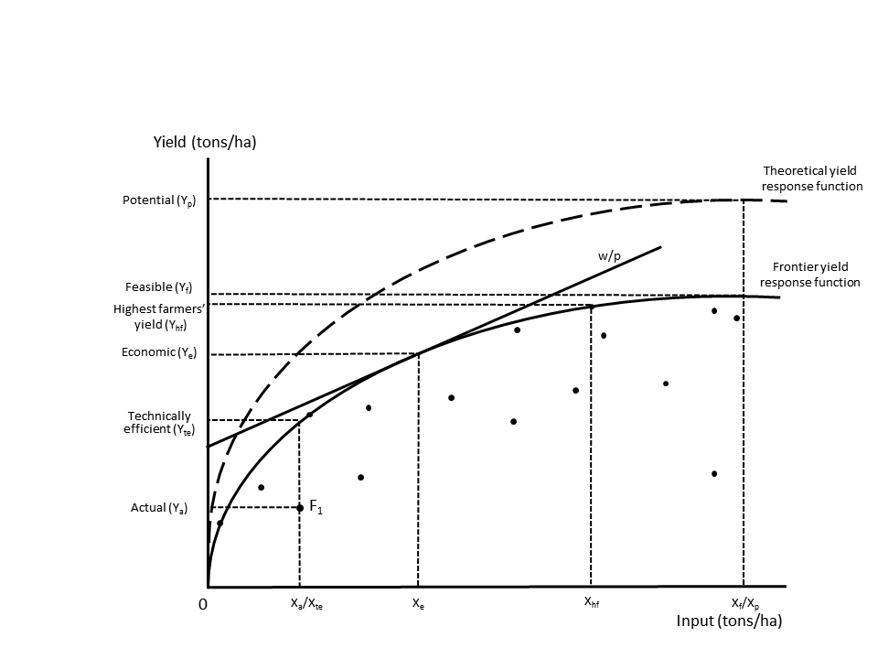

##### Source:

The total yield gap () can be decomposed in four parts: the technical efficiency yield gap (), the allocative yield gap (), the economic yield gap () and the technology yield gap () (Van Dijk et al. 2016). Table 1 summarizes the definitions and potential causes for the the five yield gaps that can be derived from Figure 1.

Global studies of yield gaps clearly show that the (total) yield gap is highest in sub-Saharan countries like Nigeria (Mueller et al. 2012; Licker et al. 2010; Neumann et al. 2010). The decomposition of the yield gap provides a deeper understanding for this finding and its causes. Knowledge constraints (e.g. access to extension services) result in technical efficiency yield gaps while pervasive market failures that characterize (agricultural) input and output markets in many sub-Saharan countries will lead to economic yield gaps. Similarly , we expect a large feasible yield gap because of the unfavorable balance between input and output prices in sub-Saharan countries. This is underscored by the high fertilizer price in many sub-Saharan countries caused poor dealer networks, high transportation costs and small market size (Morris et al. 2007). Finally, the technology yield gap is also expected to be large. [ADD evidence technology use in Africa]. The existence of (agricultural) technology gaps between rich and poor countries has been studied widely (Fagerberg 1994, Mekonnen et al. (2015), Headey, Alauddin, and Rao (2010)) and can been related to the combination of broader institutional, technological, economic and social factors.

###### PAGE BREAK

**Table 1: Yield gaps**

|  |  |  |  |  |
| --- | --- | --- | --- | --- |
| Yield gap | Estimation | Definition | Measures | Causes |
| Total yield gap (Yg) | Yp - Ya | The gap between (water-limited) potential yield and actual yield | The biophysical potential for farmers to increase actual yield in a specific agroeconomic environment | The combination of all causes below |
| Technical efficiency yield gap (TEYg) | Yte - Ya | The gap between technical efficiency yield and actual yield measured as the distance to the frontier yield response function | The potential for farmers to increase actual yield in comparison with best-practice farmers that use the same level of inputs and operate under the same agroecological conditions. | Suboptimal crop management caused by knowlegde constraints (e.g. differences in experience, practice, management skills and access to extension services) |
| Allocative yield gap (AYg) | Ye - Yte | The gap between economic yield and technical efficiency yield | The extent to which farmers can improve allocative efficiency and increase profits, given input and output prices and available technology. | Market failures caused by missing credit and insurance markets and information assymetries on input and output prices. Production objectives other than profit maximization. |
| Economic yield gap (EYg) | Yf - Ye | The gap between feasible yield and economic yield | The extent to which economic constraints prevent farmers from producing maximum feasible yield with the available technology and best-practice management | Unfavourbale balance between input and output prices farm-gate (including transport costs, taxes, subsidies and other costs associated with the purchase of inputs and sale of outputs). |
| Technology yield gap (TYg) | Yp - Yf | The distance between the frontier and theoretical yield response curve measured by the gap between (water-limited) potential yield and feasible yield | The extent to which the lack of advanced technologies prevent (best-practice) farmers from reaching potential yield. | Various national-level institutional, technological, economic and social factors that prevent the diffusion and adoption of advanced and appropriate technologies to farmers. |

##### Source:

CHECK We also estimate highest farmers' yield to assess if it is close to any of the theoretical yield levels. A major problem with using highest farmers' yield in ##is dealing with the variation in agroecological conditions across the sample. In large samples such as the LSMS-ISA for Nigeria that cover plots in all #parts of the country, potential yield in the XXX zones much lower than that of farmers in XX zones [Figure X]. Simply taking the average yield of the top 95 #percentile of the complete sample will results in a highly biased benchmark. To only way to overcome this issue would be to take averages per agroecological #zone (**???**). However, it seems that this is not done in most studies [CHECK].

# Data

## Potential yield

Potential water-limited yield is taken from the global yield gap atlas (GYGA, www.yieldgap.org). GYGA is an international project that presents consistent estimates of potential yield and yield gaps combining best available data, robust crop simulation models and a bottom-up approach (Ittersum et al. 2013, Grassini et al. (2015)) for nine major food crops in a large number of countries, including maize in Nigeria. To aggregate (simulation) results from location-specific observed data to larger spatial areas, GYGA uses a climate zonation scheme (**???**, (**???**)). Climate zones are based on a matrix of three climatic variables: (i) growing degree days (GGD, divided in 10 classes), (ii) aridity index (AI, divided into 10 classes) and (iii) temperature seasonality (3 classes) that give a total of 300 classes (of which 265 are relevant for food production). Each climate zone has an unique value that indicates the climatic characteristics. It is constructed as the sum of the three components, for example a value of 9301 refers to a GGD of 9000, an AI of 300 and a temperature seasonality of 1. Figure 2 depicts the climate zones and associated potential water-limited yield for Nigeria.

**Figure 2: Yield gap and LSMS**

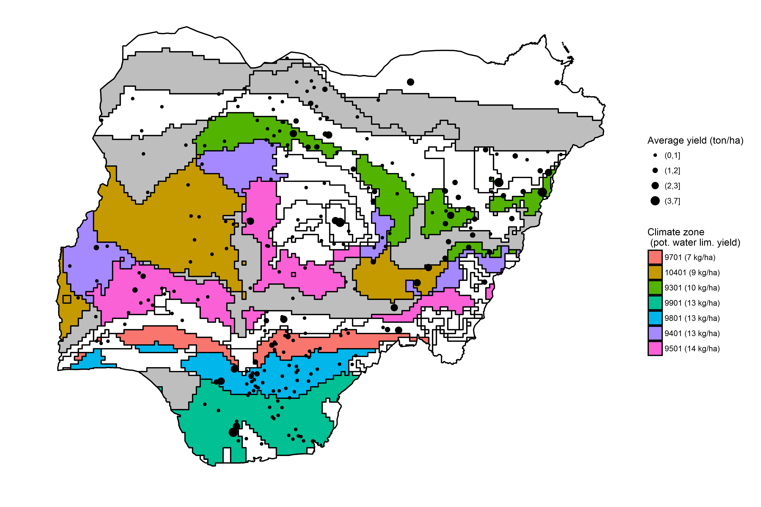

##### Source: Potential water-limited yield from GYGA and actual yield by enumeration area from the World Bank LSMS-ISA surveys.

##### Note: Coloured areas refer to the seven climate zones for which >50 observations from the LSMS-ISA are available. Grey areas indicate climate zones for GYGA presents information but for which not enough LSMS-ISA observations are available. White areas are not covered by GYGA. Actual yield is based on the pooled sample and weighted by plot size.

## Farm and plot level data

The plot and farm level data come from the nationally representative 2010-11 and 2012-13 waves of the Nigeria General Household Survey (GHS). In total the GHS is a cross section of 22,000 households, 5,000 of which were included as panel households as part of the Living Standards measurement Study Integrated Surveys in Agriculture (LSMS-ISA) initiative. The focus of the LSMS-ISA is to improve the quality of data on the agricultural sector and was conducted by the National Bureau of Statistics in partnership with the Federal Ministry of Agriculture and Rural Development, the National Food Reserve Agency, the Bill and Melinda Gates Foundation and the World Bank. In each wave, households were visited twice reflecting the post planting and post harvest visits. The data was collected at several levels, including at the plot, household and enumeration area level, and the location of each household was GPS recorded with an offset to preserve household anonymity.

### Basic information

The agricultural questionnaire of the LSMS-ISA records key information at the plot level including the quantity of crop harvested, type and quantity of fertilizer applied, seed use and the area of the plot. Plot area measurements were recorded by GPS in each wave, and where it was not possible to record the GPS area, for example due to cloudy weather, the World Bank provides a complete set of plot areas with imputed missing values. From this information maize yield, and nitrogen and seed application rates can be calculated. The LSMS-ISA also provides information on harvested crop area as assessed by the farmer, which can be used as an alternative to plot area for the estimation of maize yield. Finally, the LSMS-ISA presents information on economic production factors, including farms assets, use of animal traction and labour. As labour data is missing in the first wave, we follow the approach of Liverpool-Tasie et al. (2016) and use household adult equivalency units as a proxy. Exploratory data analysis showed that several variables clearly fell outside a plausible range. We followed the approach of other studies that use similar plot and farm level surveys (**???**) and winsored outliers that were more than three standard deviations (**???** deviations?) from the median. Winsoring involves replacing extreme values with the value at a pre-defined threshold (in this case three standard deviations) instead of than dropping the observation completely. To deal with outliers in nitrogen application rates, we follow (**???**) and cap the use of nitrogen to 700 kg per hectare, the upper-limit of inorganic fertilizer use in the United States under irrigated conditions.(**???**)

### Plot versus harvested area

In yield gap analysis it is common practice to apply the FAO definition for actual (farm) yield, which expresses yield relative to harvested land area (Fischer 2015). In a recent study Reynolds et al. (2015) argue that this definition leads to serious overestimation of actual yield because it ignores crop losses that might occur between planting and harvesting. Hence, they recommend to use a definition of yield relative to crop area. Causes for the difference in area planted and area harvested include crop management factors (e.g. poor germination, damage from pests and diseases) and economic constraints (e.g. labor and capital constraints and shortage of market opportunities). These are precisely the issues that one aims to capture with yield gap analysis. It is likely that crop management and resource use decisions of farmers are based on the total plot area that they consider for agricultural production, not only the harvested area. Yield gap assessments using a definition based on harvested area might therefore only capture a part of the yield gap.

As the LSMS-ISA provides information on both plot area and harvested area, we are able to investigate the choice of definition on yield gap measurement. The Harvested The second is a measurement problem and deals with how to measure area (planted and harvested) in the best way. It has been shown that farmer self-assessed area is characterized by systematic errors and therefore GPS measurements are recommended (Carletto, Gourlay, and Winters 2015).

The second is a measurement problem and deals with how to measure area (planted and harvested) in the best way. It has been shown that farmer self-assessed area is characterized by systematic errors and therefore GPS measurements are recommended (Carletto, Gourlay, and Winters 2015). This is also underscored by the latest generation of (large-scale) household surveys, such as the LSMS-ISA that is used in this paper and the DHS, in which GPS measures are part of the standard protocol. Similarly, there are several initiatives that support the crowd-sourcing of plot size area using GPS to strenghten the property rights of farmers. Exact (GPS) measures of harvest area are often not available because this will tend to change every year. A potential disadvantage of using GPS measures is that they often measure the total size of the plot or field, which may contain more than one crop because of multi-cropping or inter-cropping. This will likely result in an underestimation when compared to plots where all planted area is used for a single crop only.

restricted the size of the plot to XX and XX hectares,

**Table 2: Descriptive statistics per climate zone**

|  |  |  |  |  |  |  |  |  |  |
| --- | --- | --- | --- | --- | --- | --- | --- | --- | --- |
| Variable | 9301 | 9401 | 9501 | 9701 | 9801 | 9901 | 10401 | Other zones | Total |
| Yield - plot based (kg/ha) | 796.02 | 356.85 | 649.29 | 609.20 | 500.54 | 812.17 | 787.26 | 722.16 | 681.54 |
| Yield - harvested area based (kg/ha) | 894.54 | 386.86 | 735.93 | 786.77 | 629.13 | 2,701.62 | 854.03 | 841.52 | 784.54 |
| Potential water-limited yield (kg/ha) | 10,309.96 | 13,157.07 | 14,080.72 | 7,109.86 | 13,114.43 | 12,591.91 | 8,738.06 | 9,234.63 | 11,057.40 |
| Yield gap - plot based ( %) | 92.28 | 97.29 | 95.39 | 91.43 | 96.18 | 93.55 | 90.99 | 92.18 | 93.84 |
| Yield gap - harvested area based (%) | 91.32 | 97.06 | 94.77 | 88.93 | 95.20 | 78.54 | 90.23 | 90.89 | 92.90 |
| Plot area (ha) | 0.67 | 0.84 | 0.46 | 0.15 | 0.16 | 0.20 | 0.84 | 0.73 | 0.52 |
| Harvested area (ha) | 0.60 | 0.78 | 0.41 | 0.12 | 0.13 | 0.06 | 0.77 | 0.62 | 0.45 |
| Use of nitrogen (1/0) | 70.60 | 32.90 | 31.00 | 12.50 | 17.10 | 40.30 | 42.30 | 51.90 | 41.00 |
| Nitrogen applied (kg/ha)* | 106.51 | 68.87 | 65.25 | 57.95 | 66.81 | 138.17 | 80.55 | 60.25 | 86.36 |
| Number of households | 150.00 | 62.00 | 65.00 | 60.00 | 133.00 | 40.00 | 68.00 | 97.00 | 675.00 |
| Number of plots | 214.00 | 85.00 | 87.00 | 72.00 | 175.00 | 67.00 | 97.00 | 129.00 | 926.00 |
| Share of plots (%) | 23.11 | 9.18 | 9.40 | 7.78 | 18.90 | 7.24 | 10.48 | 13.93 | 100.00 |

##### Source: LSMS-ISA and GYGA

### Input and output price information

A key aspect of this study is to investigate the economic constraints to closing the yield gap, which is influenced by the relative price of maize and inputs (in this case nitrogen). The GHS presents detailed information on the value and quantity of maize sold and fertilizer purchased at the plot level. We use this information to calculate plot level prices. We winsored the prices of both maize and nitrogen to remove values that were more than three standard deviations from the median per climate zone.

Figure X shows the distribution of maize and nitrogen prices per zone in Nigeria. It demonstrates that prices vary considerably within and between geographical locations. In the Northern zones, the **interquartile?** range lies between X and X Niara, while in the Southern zones prices are on average lower. Nitrogen prices also vary across Nigeria but exhibit a similar average that around XX Naira. It

**Figure 3: Maize and Nitrogen prices**

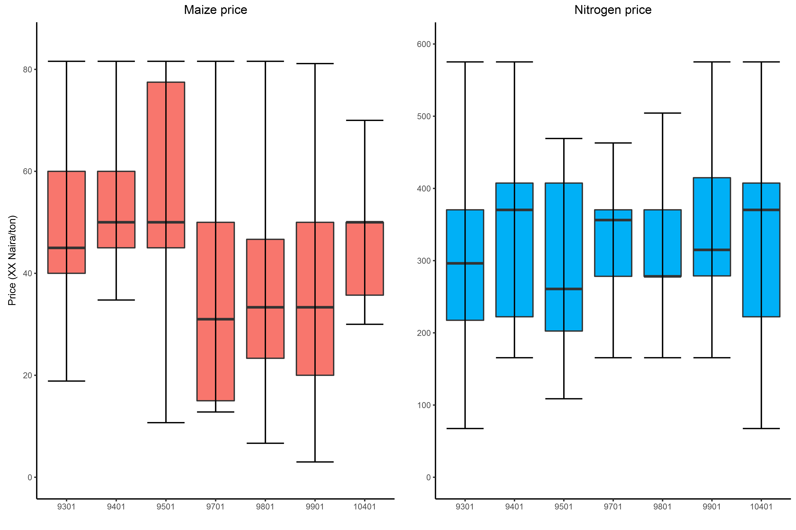

##### Source: LSMS-ISA and GYGA

(**???** Transport costs)

## Climate and soil variables

In addition the biophysical role of nitrogen on maize can also depend on soil, seed type and climate conditions, for example the carbon content of the soil (Barrett). To some extent this information is included in the GHS and the spatial and climate data that accompanies the main survey. In this report we go further by using the GPS recorded household locations to combine the GHS with external data with a finer resolution than currently provided with the GHS survey. We therefore have more accurate information on key variables to improve the analysis of the maize yield gap and the role of nitrogen application.

# Estimation of yield levels

## Technical efficiency yield

Boundary lines are often used to estimate yield gaps [REFS]. In this study we use stochastic frontier analysis (Meeusen and van Den Broeck 1977; Aigner, Lovell, and Schmidt 1977) to estimate the yield levels in Figure 1. This approach is somewhat comparable to boundary analysis as it also estimates an envelope curve that represents best-practice yield at each level of input. The advantage of stochastic frontier analysis over boundary analysis is that it simultaneously takes into account multiple inputs instead of only addressing one input as is the case in boundary analysis. Depending on the functional form of the yield response curve, inputs can be complementary or substitutes. Stochastic frontier analysis is increasingly used to estimate yield gaps (Henderson et al. 2016, Hoang (2013), Silva et al. (2016), Van Dijk et al. (2016))

We estimate a frontier yield response curve that accounts for the impact of growth defining, growth limiting and growth reducing factors on crop growth [VanIttersum1997[ as well as economic production factors (**???**, (**???**)), which all will have impact on actual yield (**???**). It is defined as follows:

where are growth defining factors, including. are growth limiting factors, are growth reducing factors and $X $ are economic production factors.

## Economic yield

## Feasible yield

## Potential yield

# Results

## Frontier yield response estimation

**Table 3: Frontier yield response curve estimation**

|  |  |  |
| --- | --- | --- |
| variable | Std. Error | Std. Error |
| (Intercept) | 1.059 | 1.111 |
| noN | 0.197 | 0.219 |
| logN | 0.042 ** | 0.046 ** |
| logasset | 0.019 | 0.021 |
| logae | 0.081 ** | 0.085 *** |
| logseedq | 0.024 *** | 0.026 * |
| logarea | 0.083 | 0.087 |
| pestherb | 0.097 | 0.100 |
| antrac | 0.108 * | 0.113 |
| slope | 0.018 | 0.018 |
| elevation | 0.000 *** | 0.000 *** |
| SOC2 | 0.017 | 0.018 |
| phdum22 | 0.178 | 0.180 |
| phdum23 | 1.058 | 1.061 |
| rain_wq | 0.003 *** | 0.003 *** |
| rain_wq2 | 0.000 *** | 0.000 *** |
| crop_count2 | 0.119 *** | 0.125 *** |
| surveyyear2 | 0.111 *** | 0.116 *** |
| sigmaSq | 0.595 *** | 0.576 *** |
| gamma | 0.007 *** | 0.008 *** |

##### Note:

# CLIMATE ZONES

To calculate potential yield, the GYGA identifies climate zones, which have similar biophysical conditions (**???**). There are in total XX Climate zones in Nigeria. Climate zones are defined by their XX number.

In this study we focus on the main maize producing area in Nigeria for which we have sufficient number of observations over space and time. Most maize is produced in seven out of the XX climate zones that are defined by the GYGA. In order to have sufficient units for our analysis we set the minimum number of observations to 50 per climate zone. Our final sample accounts for X percent of the total maize plots in Nigeria for which information is presented in the LSMS-ISA (Annex A). Most maize is produced in the cereal root crop mixed farming systems zone that forms a belt over Nigeria that expands from East till West (**???**). This zone is characterised by by XX and XX. [compare with other CZs and refer to table in Annex] (**???**). Hence, although our findings are not representative for total maize production in Nigeria, they can be considered for the main maize regions in the country.

Table x presents summary statistics for the climate zones that are located in the maize producing regions and Figure combines information from the LSMS-ISA and the GYGA (see annex X for the locations of the CZs).

**Figure 4: Yield levels: comparing models**

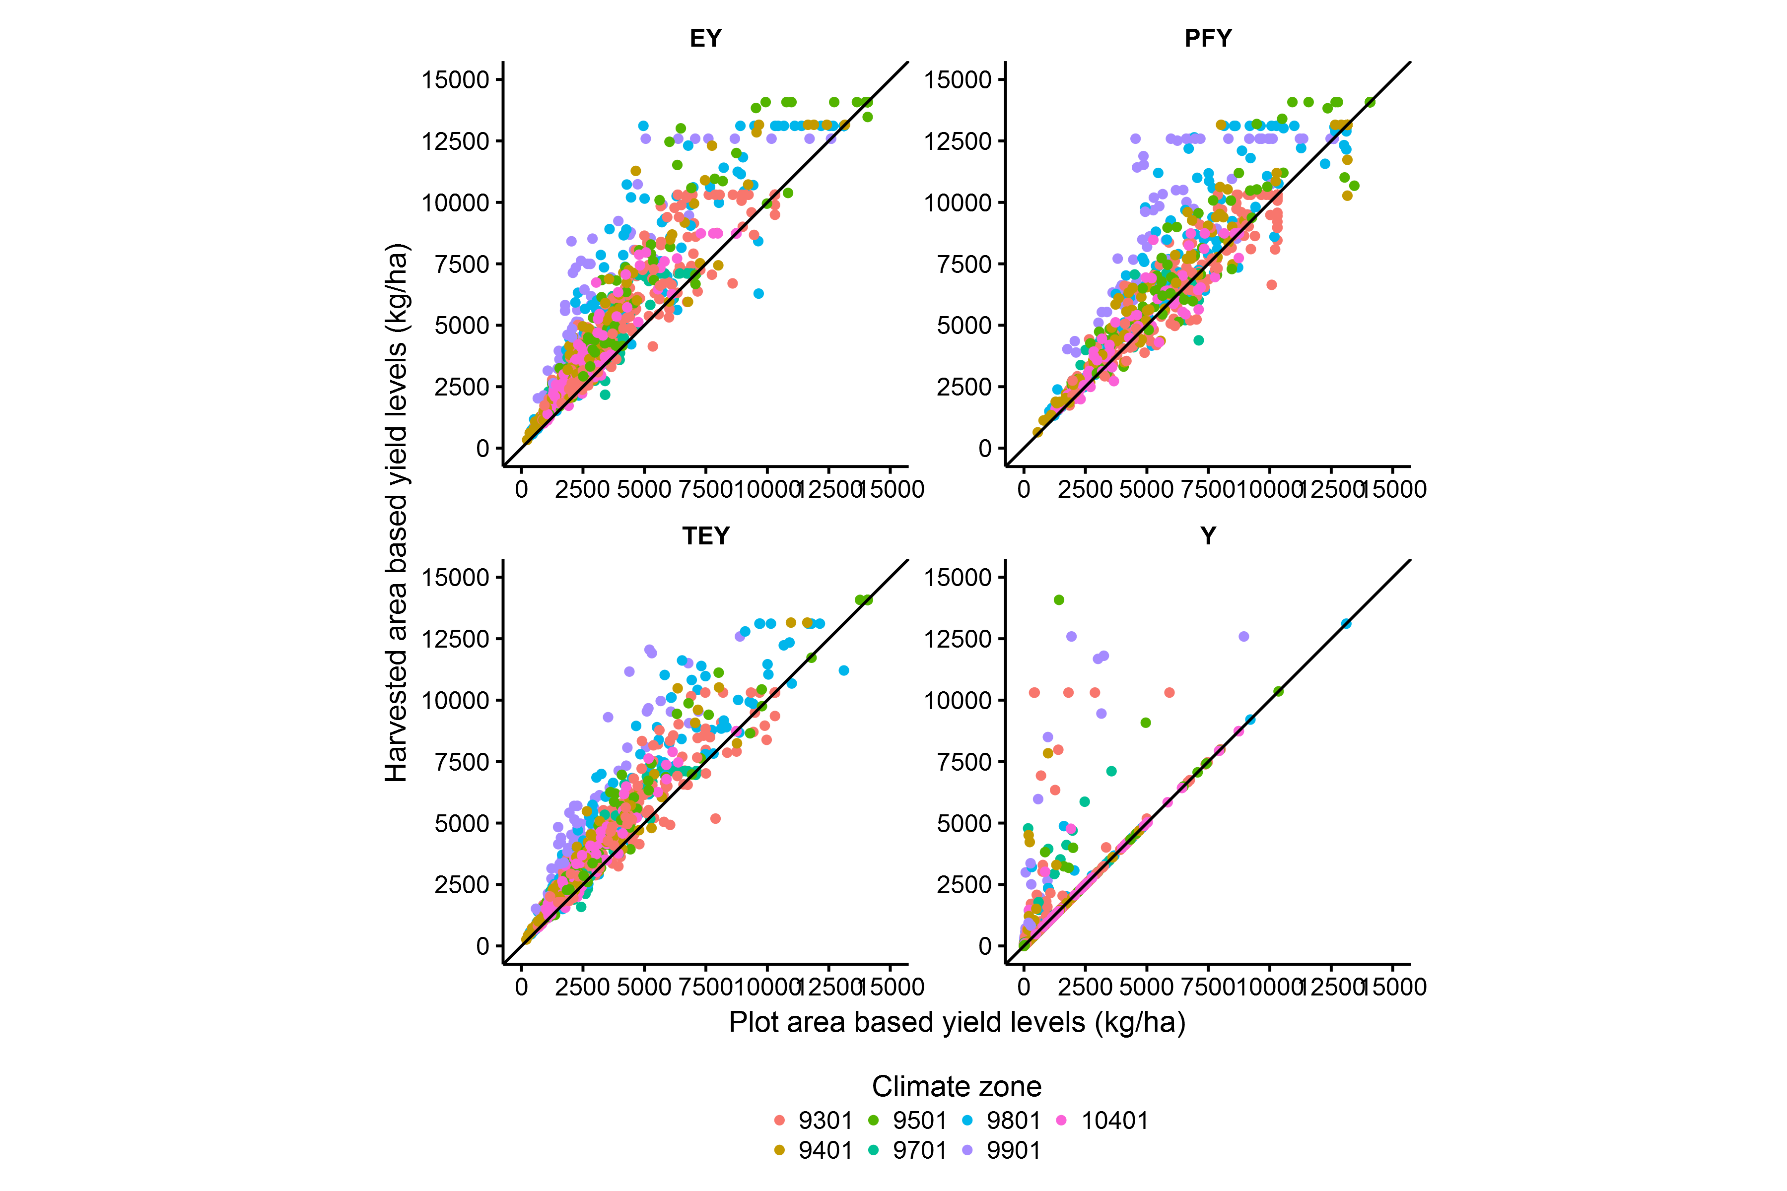

##### Source:

## Yield levels

**Figure 5: Yield levels**

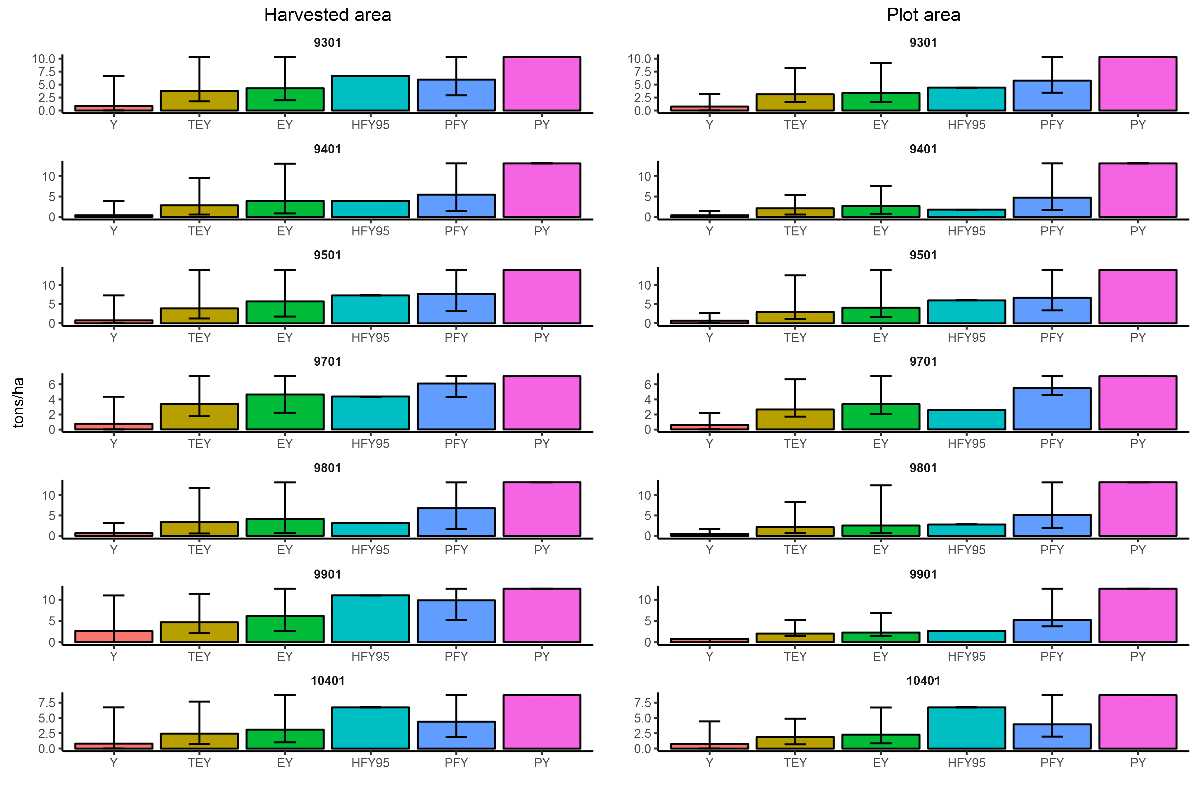

##### Source:

**Figure 6:**

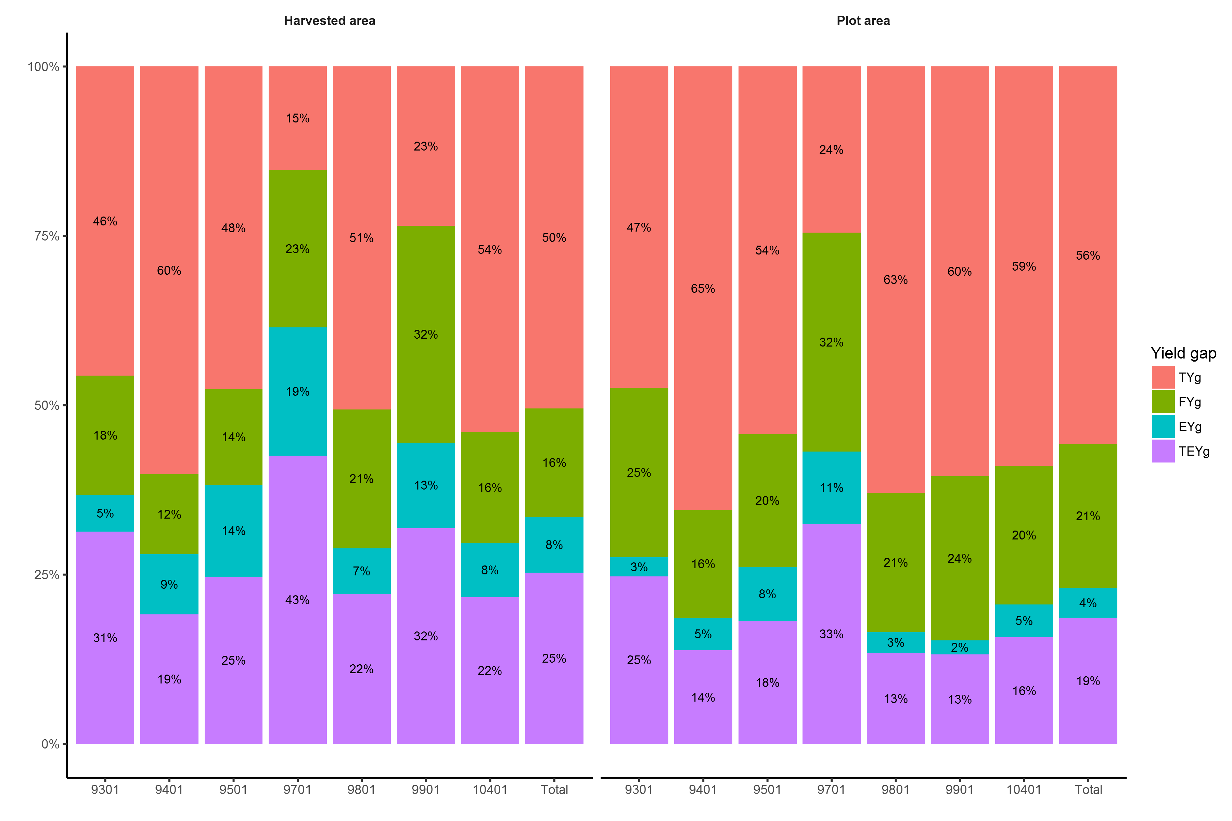

##### Note:

* calculate different yield gaps, also attainable yield gap and show differences
* Compare distributions of yield gap per zone.

Comparison with literature

Compare highest farmer yield with economic and feasible and show difference!!

# Sensitivity analysis

# Conclusions/Discussion

Main findings

* Reviewed conventional yield levels used in agronomic literature and revealed some inconsistencies in the use and definition of certain yield levels. In particular the use of attainable yield and exploitable yield.
* We present a consistent framework that decomposes the conventional yield gap into four parts that are firmly rooted in neoclassical economics and therefore provide a theoretical framework on explaining why yield falls below potential.
* We also demonstrated how the impact of actual yield definitions on yield gap.

Recommendations:

* We recommend that attainable yield gap is not used as it is a highly confusing term as it can mean: economic yield, technical efficiency yield or . We propose to use the definitions that actually. We have similar objections to the term exploitable yield, which is based on a rule of thumb. Better to use..
* We recommend that researchers are clear about their definition of actual yield. There is no perfect solution for the definition of area when measuring actual yield. Plot size is probably the best measure if one wants to capture all factors that cause the yield gap (including for example the economic or biophysical reasons, why a farmer did not harvest the full plot) but raises difficulties in situations where multiple crops are grown on one plat. On the other hand, harvest yield [ADD]. In any case researchers should properly explain which definition they used to measure actual yield.

Limitations

* study only covers two years. Recommended number of years is 5(?). Actual yield might be biased because of outliers. Better to use more years, possible in the future when LSMS is repeated.

A subsidy program did exist in Nigeria over the course of this survey. However, farmers were not asked whether they received these subsidies for the fertilizer they purchased which may also have consequences for the analysis ... # References

Aigner, Dennis, C.A.Knox Lovell, and Peter Schmidt. 1977. “Formulation and estimation of stochastic frontier production function models.” *Journal of Econometrics* 6 (1). North-Holland: 21–37. doi:[10.1016/0304-4076(77)90052-5](https://doi.org/10.1016/0304-4076(77)90052-5).

Aramburu Merlos, Fernando, Juan Pablo Monzon, Jorge L. Mercau, Miguel Taboada, Fernando H. Andrade, Antonio J. Hall, Esteban Jobbagy, Kenneth G. Cassman, and Patricio Grassini. 2015. “Potential for crop production increase in Argentina through closure of existing yield gaps.” *Field Crops Research* 184: 145–54. doi:[10.1016/j.fcr.2015.10.001](https://doi.org/10.1016/j.fcr.2015.10.001).

Bravo-Ureta, Boris E., Daniel Solís, Víctor H. Moreira López, José F. Maripani, Abdourahmane Thiam, and Teodoro Rivas. 2007. “Technical efficiency in farming: a meta-regression analysis.” *Journal of Productivity Analysis* 27 (1). Kluwer Academic Publishers-Plenum Publishers: 57–72. doi:[10.1007/s11123-006-0025-3](https://doi.org/10.1007/s11123-006-0025-3).

Carletto, Calogero, Sydney Gourlay, and Paul Winters. 2015. “From Guesstimates to GPStimates: Land Area Measurement and Implications for Agricultural Analysis.” *Journal of African Economies* 24 (5). Oxford University Press: 593–628. doi:[10.1093/jae/ejv011](https://doi.org/10.1093/jae/ejv011).

Cassman, Kenneth G. 1999. “Ecological intensification of cereal production systems: yield potential, soil quality, and precision agriculture.” *Proceedings of the National Academy of Sciences of the United States of America* 96 (11): 5952–9. doi:[DOI 10.1073/pnas.96.11.5952](https://doi.org/DOI%2010.1073/pnas.96.11.5952).

Cassman, Kenneth G., Achim Dobermann, Daniel T. Walters, and Haishun Yang. 2003. “Meeting demand while protecting natural resources and improving environmental quality.” *Annual Review of Environment and Resources* 28 (1): 315–58. doi:[10.1146/annurev.energy.28.040202.122858](https://doi.org/10.1146/annurev.energy.28.040202.122858).

Coelli, Timothy J., D. S. Prasada Rao, Christopher J. O’Donnell, and George E. Battese. 2005. *An Introduction to Efficiency and Productivity Analysis*. Second edi. New York: Springer-Verlag. doi:[10.1007/b136381](https://doi.org/10.1007/b136381).

Datta, S K De. 1981. *Principles and practice of rice production*.

De Bie, C. A J M. 2000. “Comparative performance analysis of agro-ecosystems.” ITC Dissertation.

Dillon, Brian, and Christopher B. Barrett. 2014. “Agricultural factor markets in Sub-Saharan Africa : an updated view with formal tests for market failure.” *Policy Research Working Paper Series*. The World Bank.

Evans, L.T., and R.A. Fischer. 1999. “Yield Potential.” *Crop Science* 39 (6). Crop Science Society of America: 1544. doi:[10.2135/cropsci1999.3961544x](https://doi.org/10.2135/cropsci1999.3961544x).

Fagerberg, Jan. 1994. “Technology and international differences in growth rates.” *Journal of Economic Literature* 32 (3): 1147–75. doi:[10.2307/2728605](https://doi.org/10.2307/2728605).

FAO. 2004. “Rice and narrowing the yield gap.” Rome: FAO.

Farrell, M. J. 1957. “The Measurement of Productive Efficiency.” *Journal of the Royal Statistical Society. Series A (General)* 120 (3): pp. 253–90. doi:[10.1016/S0377-2217(01)00022-4](https://doi.org/10.1016/S0377-2217(01)00022-4).

Fischer, R.A. 2015. “Definitions and determination of crop yield, yield gaps, and of rates of change.” *Field Crops Research* 182: 9–18. doi:[10.1016/j.fcr.2014.12.006](https://doi.org/10.1016/j.fcr.2014.12.006).

Fischer, R.A., Derek Byerlee, and Greg. O. Edmeades. 2014. “Crop yields and global food security: will yield increase continue to feed the world?” doi:[10.1093/erae/jbv034](https://doi.org/10.1093/erae/jbv034).

Grassini, Patricio, Lenny G.J. J van Bussel, Justin Van Wart, Joost Wolf, Lieven Claessens, Haishun Yang, Hendrik Boogaard, Hugo de Groot, Martin K. van Ittersum, and Kenneth G. Cassman. 2015. “How good is good enough? Data requirements for reliable crop yield simulations and yield-gap analysis.” *Field Crops Research* 177. Elsevier B.V.: 49–63. doi:[10.1016/j.fcr.2015.03.004](https://doi.org/10.1016/j.fcr.2015.03.004).

Hall, A. J., C. Feoli, J. Ingaramo, and M. Balzarini. 2013. “Gaps between farmer and attainable yields across rainfed sunflower growing regions of Argentina.” *Field Crops Research* 143. Elsevier B.V.: 119–29. doi:[10.1016/j.fcr.2012.05.003](https://doi.org/10.1016/j.fcr.2012.05.003).

Headey, Derek, Mohammad Alauddin, and D. S Prasada Rao. 2010. “Explaining agricultural productivity growth: An international perspective.” *Agricultural Economics* 41 (1): 1–14. doi:[10.1111/j.1574-0862.2009.00420.x](https://doi.org/10.1111/j.1574-0862.2009.00420.x).

Henderson, B., C. Godde, D. Medina-Hidalgo, M. van Wijk, S. Silvestri, S. Douxchamps, E. Stephenson, et al. 2016. “Closing system-wide yield gaps to increase food production and mitigate GHGs among mixed crop-livestock smallholders in Sub-Saharan Africa.” *Agricultural Systems* 143. Elsevier B.V.: 106–13. doi:[10.1016/j.agsy.2015.12.006](https://doi.org/10.1016/j.agsy.2015.12.006).

Hoang, Viet-Ngu. 2013. “Analysis of productive performance of crop production systems: An integrated analytical framework.” *Agricultural Systems* 116: 16–24. doi:[10.1016/j.agsy.2012.12.005](https://doi.org/10.1016/j.agsy.2012.12.005).

Ittersum, Martin K. van, Kenneth G. Cassman, Patricio Grassini, Joost Wolf, Pablo Tittonell, and Zvi Hochman. 2013. “Yield gap analysis with local to global relevance-A review.” *Field Crops Research* 143. Elsevier B.V.: 4–17. doi:[10.1016/j.fcr.2012.09.009](https://doi.org/10.1016/j.fcr.2012.09.009).

Kelly, Valerie, Akinwumi A. Adesina, and Ann Gordon. 2003. “Expanding access to agricultural inputs in Africa: A review of recent market development experience.” *Food Policy* 28 (4): 379–404. doi:[10.1016/j.foodpol.2003.08.006](https://doi.org/10.1016/j.foodpol.2003.08.006).

Laborte, Alice G., Kees C A J M de Bie, Eric M A Smaling, Piedad F. Moya, Anita A. Boling, and Martin K. Van Ittersum. 2012. “Rice yields and yield gaps in Southeast Asia: Past trends and future outlook.” *European Journal of Agronomy* 36 (1). Elsevier B.V.: 9–20. doi:[10.1016/j.eja.2011.08.005](https://doi.org/10.1016/j.eja.2011.08.005).

Licker, Rachel, Matt Johnston, Jonathan A. Foley, Carol Barford, Christopher J. Kucharik, Chad Monfreda, and Navin Ramankutty. 2010. “Mind the gap: how do climate and agricultural management explain the ‘yield gap’ of croplands around the world?” *Global Ecology and Biogeography* 19 (6). Blackwell Publishing Ltd: 769–82. doi:[10.1111/j.1466-8238.2010.00563.x](https://doi.org/10.1111/j.1466-8238.2010.00563.x).

Liverpool-Tasie, Lenis Saweda O., Bolarin T. Omonona, Awa Sanou, and Wale O. Ogunleye. 2016. “Is increasing inorganic fertilizer use for maize production in SSA a profitable proposition? evidence from Nigeria.” *Food Policy*. doi:[10.1016/j.foodpol.2016.09.011](https://doi.org/10.1016/j.foodpol.2016.09.011).

Lobell, David B., Kenneth G. Cassman, and Christopher B. Field. 2009. “Crop Yield Gaps: Their Importance, Magnitudes, and Causes.” *Annual Review of Environment and Resources* 34 (1). Annual Reviews: 179–204. doi:[10.1146/annurev.environ.041008.093740](https://doi.org/10.1146/annurev.environ.041008.093740).

Mann, Michael L., and James M. Warner. 2017. “Ethiopian wheat yield and yield gap estimation: A spatially explicit small area integrated data approach.” *Field Crops Research* 201: 60–74. doi:[10.1016/j.fcr.2016.10.014](https://doi.org/10.1016/j.fcr.2016.10.014).

Meeusen, Wim, and Julien van Den Broeck. 1977. “Efficiency Estimation from Cobb-Douglas Production Functions with Composed Error.” *International Economic Review* 18 (2): 435. doi:[10.2307/2525757](https://doi.org/10.2307/2525757).

Mekonnen, Dawit K, David J Spielman, Esendugue Greg Fonsah, and Jeffrey H Dorfman. 2015. “Innovation systems and technical efficiency in developing-country agriculture.” *Agricultural Economics* 46 (5): 689–702. doi:[10.1111/agec.12164](https://doi.org/10.1111/agec.12164).

Morris, Michael, Valerie a Kelly, Ron J Kopicki, and Derek Byerlee. 2007. *Fertilizer Use in African Agriculture*. Vol. 44. 01. doi:[10.1596/978-0-8213-6880-0](https://doi.org/10.1596/978-0-8213-6880-0).

Mueller, Nathaniel D., James S. Gerber, Matt Johnston, Deepak K. Ray, Navin Ramankutty, and Jonathan A. Foley. 2012. “Closing yield gaps through nutrient and water management.” *Nature* 490 (7419). Nature Research: 254–57. doi:[10.1038/nature11420](https://doi.org/10.1038/nature11420).

Neumann, Kathleen, Peter H. Verburg, Elke Stehfest, and Christoph Müller. 2010. “The yield gap of global grain production: A spatial analysis.” *Agricultural Systems* 103 (5): 316–26. doi:[10.1016/j.agsy.2010.02.004](https://doi.org/10.1016/j.agsy.2010.02.004).

Ogundari, Kolawole. 2014. “The Paradigm of Agricultural Efficiency and its Implication on Food Security in Africa: What Does Meta-analysis Reveal?” *World Development* 64 (1920). Elsevier Ltd: 690–702. doi:[10.1016/j.worlddev.2014.07.005](https://doi.org/10.1016/j.worlddev.2014.07.005).

Oort, P.A.J. van, K. Saito, A. Tanaka, E. Amovin-Assagba, L.G.J. Van Bussel, J. van Wart, H. de Groot, Martin K. van Ittersum, Kenneth G. Cassman, and M.C.S. Wopereis. 2015. “Assessment of rice self-sufficiency in 2025 in eight African countries.” *Global Food Security* 5: 39–49. doi:[10.1016/j.gfs.2015.01.002](https://doi.org/10.1016/j.gfs.2015.01.002).

Reynolds, Travis W, C Leigh Anderson, Elysia Slakie, Mary Kay Gugerty, and Daniel J Evans. 2015. “How Common Crop Yield Measures Misrepresent Productivity among Smallholder Farmers.”

Sadoulet, Elisabeth, and Alain De Janvry. 1995. “Quantitative development policy analaysis,” 1–438. doi:[10.2307/1243800](https://doi.org/10.2307/1243800).

Sadras, V. O., Kenneth G. Cassman, P. Grassini, Antonio J. Hall, W. G. M. Bastiaanssen, A. G. Laborte, A. E. Milne, G. Sileshi, and P. Steduto. 2015. “Yield gap analysis of field crops Methods and case studies.” Vol. 41.

Silva, João Vasco, Pytrik Reidsma, Alice G. Laborte, and Martin K. van Ittersum. 2016. “Explaining rice yields and yield gaps in Central Luzon, Philippines: An application of stochastic frontier analysis and crop modelling.” *European Journal of Agronomy*. doi:[10.1016/j.eja.2016.06.017](https://doi.org/10.1016/j.eja.2016.06.017).

Stiglitz, J. E. 1989. “Markets, market failures, and development.” doi:[Article](https://doi.org/Article).

Sumberg, James. 2012. “Mind the (yield) gap(s).” *Food Security* 4 (4): 509–18. doi:[10.1007/s12571-012-0213-0](https://doi.org/10.1007/s12571-012-0213-0).

Tittonell, Pablo, and Ken E. Giller. 2013. “When yield gaps are poverty traps: The paradigm of ecological intensification in African smallholder agriculture.” *Field Crops Research* 143. Elsevier B.V.: 76–90. doi:[10.1016/j.fcr.2012.10.007](https://doi.org/10.1016/j.fcr.2012.10.007).

Van Dijk, Michiel, Tom Morley, Roel Jongeneel, Martin K. Van Ittersum, Pytrik Reidsma, and Ruerd Ruben. 2016. “Disentangling agronomic and economic yield gaps: An integrated framework and application.” WASS Working Paper. <http://www.wageningenur.nl/wass>.

Van Ittersum, Martin K., and R. Rabbinge. 1997. “Concepts in production ecology for analysis and quantification of agricultural input-output combinations.” *Field Crops Research* 52 (3): 197–208. doi:[10.1016/S0378-4290(97)00037-3](https://doi.org/10.1016/S0378-4290(97)00037-3).