Global food security projections to 2050

Michiel van Dijk[1]

Tom Morley[2]

Marie Luise Rau[3]

Yashar Saghai[4]

March 16, 2020

**Abstract:** Ending hunger and achieving food security - one of the UN sustainable development goals - is a major global challenge. To inform the policy debate, global simulation models and statistical approaches are used to assess long-term future global food security under a range of socio-economic and climate change scenarios. However, due to differences in model design and scenario assumptions, there is uncertainty about the range of food security projections and outcomes. We reviewed 58 global food security modelling and projection studies that have been published over the last two decades and discussed the methodology and underlying drivers, and compared future trends in two key food security indicators. We found that across five representative scenarios that span divergent but plausible socio-economic futures and assume no climate change, global food demand is expected to increase by an interquartile range of +34% to +53% between 2010 and 2050, while the number of population at risk of hunger is projected to decrease by -89% to -12%. For only a limited number of scenarios, climate change impact results in significantly different food security outcomes. (**???** WHAT SPECIFICALLY). The range of food demand projections is lower than the often cited +60 to +100%, which are based on earlier reference years and methodologies that are difficult to compare. Finally, our review suggests that current modelling approaches can be improved by better incorporating several options that have been proposed to tackle global food security, in particular aquaculture and ‘future foods’, and expand the number of indicators to better cover the multiple dimensions of food security. The results of our study can be used to support the development and benchmark new global food security modelling studies, and inform policy analysis and the public debate on the future of food.

Acknowledgements: We like to thank Joke Webbink, Caterina Barrasso and Winand de Jong for their support with the systematic literature review. We like to express our gratitude to Tomoko Hasegawa, Kieth Wiebe, Daniel Mason Croz, Andrzej Tabeau and Martin von Lampe for making available unpublished data. This research was funded by John Hopkins University as part of the Global Food Ethics and Policy program and a grant from Wageningen University and Research.

# Main

More than 820 million people in the world were hungry in 2018 (**???**). The question on how to eradicate global hunger - one of the Sustainable Development Goals - and feed the future world population is a major global challenge. Since 1960 food supply nearly tripled to keep pace with the increase in food demand, triggered by a growing global population and rise in income (Bruinsma 2011). This, in turn, has resulted in the long-term decline in global undernourishment (**???**). Climate change and competing claims for natural resources raise doubt about the future balance between food demand and supply and global food security in general. A better understanding of the range in future outcomes and main driving forces will contribute to formulation of effective policies to ensure global food security.

Global assessments have mainly used four broad indicators to measure the various dimensions of food (in)security: food demand (David Tilman et al. 2011; Alexandratos and Bruinsma 2012), population at risk of hunger (Parry et al. 2004; Hasegawa et al. 2015), food prices (Baldos and Hertel 2016) and childhood undernutrition (Ishida et al. 2014). Often the results of these studies vary widely and are difficult to compare because of differences in methodology (Godfray and Robinson 2015), assumptions on driving forces (Reilly and Willenbockel 2010) and definitions of output indicators (Van Dijk and Meijerink 2014). To date, no comprehensive analysis of global food security projections has been presented.

The aim of this paper is to provide a review of recent global food security modelling studies that provide trends up to the year 2050. With food security, we mean that “all people at all times, have physical and economic access to sufficient safe and nutritious food that meets their dietary needs and food preferences for an active and healthy life” (FAO 1996). Systematically collecting and comparing quantitative scenario results to assess model uncertainty has been common practice in the climate change literature (Huppmann et al. 2018) but has not been done for global food security assessments. The key questions addressed in this review are: Which methods have been used in the modelling studies? Which drivers are mainly considered when projecting global food security? And what is the ‘bandwidth’ of future global food security projections?

To answer these questions, we conducted a systematic literature review to identify, collect and analyze relevant studies that were published between 2000 and 2018 (see Supplementary Notes for details). In comparison to standard literature reviews, systematic review approaches have the advantage that the are guided by a well-defined methodology, which reduces bias and makes it possible to draw more general conclusions (Gough, Oliver, and Thomas 2012). we identified and analyzed 58 relevant studies and constructed a database with harmonized projections for two out of the four global food security indicators used in the literature: global food demand (320 projections) and global population at risk of hunger (182 projections), representing a wide range of plausible socio-economic and climate change futures. The Global Food Security Projections Database (Van Dijk et al. 2020) is publically available and can be used by the research community to benchmark the results of new global food security modelling and projection studies.

We define projections as alternative quantitative results of running a model based on different assumptions or inputs. Although in modelling studies the term ‘scenario’ is often used to mean a projection, it is also used to refer to a plausible, comprehensive, integrated and consistent description of how the future might unfold (Nakicenovic et al. 2000). In the latter sense, scenarios have a quantitative component (including projections) and a narrative storyline that links important statements about the future that may or may not be quantifiable. This review focuses on projections and, when relevant, related broader scenarios.

# Overview of studies

The number of global food security projection studies and related projections has substantially increased over the last two decades from 1 in 2004 to 58 in 2018 (Figure 1). Between 2004, the year the first study in our database was published (Parry et al. 2004) and 2009, only a handful of studies were released. The increase in publications after 2009, can almost certainly be attributed to the renewed interest in global food and nutrition research that was triggered by the 2007-2008 global food price crisis (Headey and Fan 2008). Most of the studies that were published in the 3-5 years after the food crisis were policy reports prepared by international institutions (e.g. Msangi and Rosegrant 2009; Nelson et al. 2010) which present an immediate response to ongoing discussions on the increase in food prices and implications for long-run global food security. Subsequent to that reaction, and up to the current period, a mixture of journal articles, book chapters and reports have been published, which often provided a more scientific analysis of future food security, including more discussion on methodologies, data and model design. There has been also a transition from studies that present the results of single-model to multi-model comparisons that present and discuss the results of an ensemble of models. Many of these studies are produced as part of the Agricultural Model Intercomparison and Improvement Project (AgMIP) that was initiated in 2010 and represent “a major international effort linking the climate, crop, and economic modeling communities with cutting-edge information technology to produce improved crop and economic models and the next generation of climate impact projections for the agricultural sector” (Rosenzweig et al. 2013, p 166).

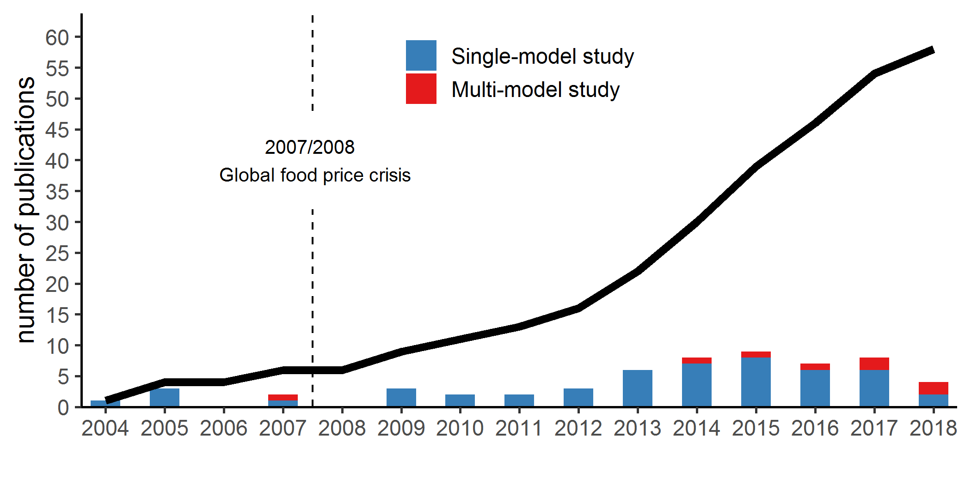

Figure 1: Total (cumulative) number and type of global food security studies per year. Bars show publication of new studies per year and type. Data for 2018 is incomplete as it only includes studies that were released in the first half of the year.

# Methodologies

Three different methodologies have been used to assess future food security (2). The majority of studies () employ simulation models, followed by statistical extrapolation () approaches that use regression techniques to estimate future food security (e.g. D Tilman et al. 2011; Bodirsky et al. 2015). Only one study (Alexandratos and Bruinsma 2012) mainly used expert input to prepare the projections. The IMPACT model (Robinson et al. 2015) is used most frequently used simulation model. This is not surprising as it was already developed in the early 1990s by the International Institute of Food Policy Research (IFPRI) to analyse long-term hunger and poverty challenges. The model therefore frequently features in global food and hunger assessments that are commissioned by international organisations such as the Millennium Ecosystem Assessment (2005) and IAASTD (2009). The set of models that form the core of the global assessment component of AgMIP are also often applied in global food security assessments. Apart from the IMPACT model, these include GLOBIOM (Havlik et al. 2014), MAGNET (Woltjer et al. 2014), AIM (Fujimori, Hasegawa, and Masui 2017), IMAGE (Stehfest et al. 2014) and MagPIE (Lotze-Campen et al. 2008). Other often applied models are SIMPLE (Baldos and Hertel 2013), BLS (Parry et al. 2004) and ENVISAGE (Mensbrugghe 2008).

The most frequently used type of models include partial equilibrium (PE) and computable general equilibrium (CGE) market simulation models. An advantage of PE models, such as IMPACT and GLOBIOM, is that they provide a detailed representation in the agri-food sector, which makes them particularly suitable for food security assessments. This might explain why they are slightly more popular than CGE models, like MAGNET and AIM, which simulate the total economy and therefore account for interactions between the agricultural sector and the rest of the economy, albeit with limited detail. Across and within PE and CGE models, various approaches are used to specify and parameterize supply and demand (Valin et al. 2014; Robinson et al. 2014). Other type of models that have been less often used to project global food security include biophysical accounting (Agribiom, FSM,and GRAFS), econometric (FEEDME and iAP) and integrated assessment (IMAGE and T21) models.

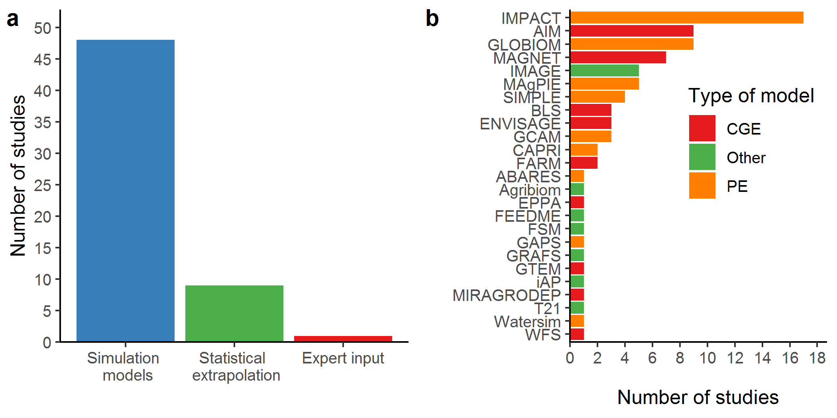

Figure 2: (a) Main methodology used per study and (b) list of simulation models used in the studies. The distinction between simulation model and statistical extrapolation is not always clear as some models use statistical techniques to estimate one or more food security indicators (S1 Text). The Other model type category include various types of models, such as biophysical, econometric and integrated assessment models.

## Drivers

Global food security is a complex issue that is determined by the interaction of a multitude of driving forces that operate both on the demand and supply side. Nearly all studies include assumptions on future population and income growth (3), which are key drivers of food demand, and technical change (including total factory productivity growth, yield increase and adoption of advanced inputs), which is the main determinant of food supply. Drivers that are covered by more than half of the studies include land availability (e.g. protected areas and land degradation), diet change, trade and climate change, while others are less frequently incorporated.

The design and sophistication of the models has clearly advanced over time. Early studies, such as Parry et al. (2004), Fischer et al. (2005) and Parry et al. (2005) were already quite advanced (e.g. simulating the impact of climate change on crop yield and land use as well as trade) but did not feature the impact of biofuels, diet change, poverty and inequality, and food waste and loss, which were introduced from around 2010 onwards. Only a very small number of studies explicitly capture the impact of aquaculture (Linehan et al. 2013; FAO 2018) and urbanization (FAO 2018) on global food supply and demand projections.

, 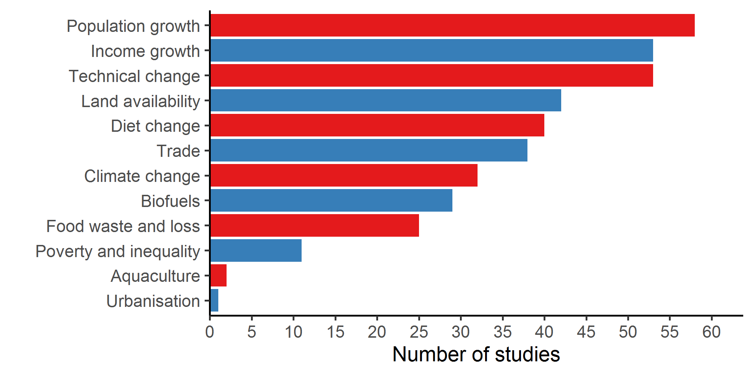

## Global food demand and population at risk of hunger projections

A large number of global food security studies present future trends on two indicators ((**???**) on indicator distribution?). The first one is future food demand, in most cases measured as the average diet per person (sum of crops, dairy, fish and meat in kcal/cap/day) or as total population food demand (in calories). A few studies present alternative indicators. Msangi and Batka (2015) presents projections for the recommended daily intake (**???** of what) to model how closely regions match healthy diet guidelines. Shutes et al. (2017) build on a set of historical food security indicators prepared by the FAO (e.g. share of calories from cereals and fruit and vegetables) to assess future global food security. Several studies present projections for protein consumption (Billen, Lassaletta, and Garnier 2015; Msangi and Batka 2015) and people at risk of protein deficiency (Medek, Schwartz, and Myers 2017).

The second indicator is future trends in the global population at risk of hunger, which implements the prevalence of undernourishment - FAO’s key statistic to measure the number of hungry people - in a forward looking framework. Prevalence of undernourishment is defined as the probability that the calorie intake of an individual is lower than the energy needed to cover his or her requirement for an active and healthy life, the so-called minimum dietary energy requirement (**???**; **???**).

Figure 4 and Figure 5 visualize the range and direction of food consumption and population at risk of hunger projections for the period 2010-2050. In order to make the projections comparable, we mapped them to the Shared Socio-economic Pathways (SSPs), a set of five scenario storylines that describe a range of potential and plausible global futures (Vuuren et al. 2017; O’Neill et al. 2017). The five scenarios include: inclusive and sustainable growth (SSP1), business as usual (SSP2), fragmentation through regional rivalry (SSP3), increasing inequality (SSP4) and resource intensive high growth (SSP5) - see Table 1 for the complete storylines. The SSPs were originally designed as a framework for the latest climate change assessments but have been increasingly used for the evaluation of other global challenges, including food security. Similar to the SSPs, we harmonized the various climate change assumptions in the projections by mapping them to the Representative Concentration Pathways (RCPs). The RCPs are a set of scenarios to reflect different potential climate outcomes (Vuuren et al. 2011) and were designed to be combined with the SSPs (Vuuren et al. 2014). We were able to extract information from 320 projections from 320 studies for food consumption and 182 projections from 13 studies for population at risk of hunger.

Table 1: Shared Socio-economic Pathways scenario storylines taken from Table 2 in Riahi et al. (2017).

|  |  |
| --- | --- |
| SSP1 | Sustainability |
| NA | The world shifts gradually, but pervasively, toward a more sustainable path, emphasizing more inclusive development that respects perceived environmental boundaries. Management of the global commons slowly improves, educational and health investments accelerate the demographic transition, and the emphasis on economic growth shifts toward a broader emphasis on human well-being. Driven by an increasing commitment to achieving development goals, inequality is reduced both across and within countries. Consumption is oriented toward low material growth and lower resource and energy intensity. |
| SSP2 | Middle of the Road |
| NA | The world follows a path in which social, economic, and technological trends do not shift markedly from historical patterns. Development and income growth proceeds unevenly, with some countries making relatively good progress while others fall short of expectations. Global and national institutions work toward but make slow progress in achieving sustainable development goals. Environmental systems experience degradation, although there are some improvements and overall the intensity of resource and energy use declines. Global population growth is moderate and levels off in the second half of the century. Income inequality persists or improves only slowly and challenges to reducing vulnerability to societal and environmental changes remain |
| SSP3 | Regional Rivalry |
| NA | A resurgent nationalism, concerns about competitiveness and security, and regional conflicts push countries to increasingly focus on domestic or, at most, regional issues. Policies shift over time to become increasingly oriented toward national and regional security issues. Countries focus on achieving energy and food security goals within their own regions at the expense of broader-based development. Investments in education and technological development decline. Economic development is slow, consumption is material-intensive, and inequalities persist or worsen over time. Population growth is low in industrialized and high in developing countries. A low international priority for addressing environmental concerns leads to strong environmental degradation in some regions |
| SSP4 | Inequality |
| NA | Highly unequal investments in human capital, combined with increasing disparities in economic opportunity and political power, lead to increasing inequalities and stratification both across and within countries. Over time, a gap widens between an internationally-connected society that contributes to knowledge- and capital-intensive sectors of the global economy, and a fragmented collection of lower-income, poorly educated societies that work in a labor intensive, low-tech economy. Social cohesion degrades and conflict and unrest become increasingly common. Technology development is high in the high-tech economy and sectors. The globally connected energy sector diversifies, with investments in both carbon-intensive fuels like coal and unconventional oil, but also low-carbon energy sources. Environmental policies focus on local issues around middle and high income areas |
| SSP5 | Fossil-fueled Development |
| NA | This world places increasing faith in competitive markets, innovation and participatory societies to produce rapid technological progress and development of human capital as the path to sustainable development. Global markets are increasingly integrated. There are also strong investments in health, education, and institutions to enhance human and social capital. At the same time, the push for economic and social development is coupled with the exploitation of abundant fossil fuel resources and the adoption of resource and energy intensive lifestyles around the world. All these factors lead to rapid growth of the global economy, while global population peaks and declines in the 21st century. Local environmental problems like air pollution are successfully managed. There is faith in the ability to effectively manage social and ecological systems, including by geo-engineering if necessary. |

The left side of the figures shows SSP baseline results for the period 2010-2050 (assuming no climate change) as well as the historical trend. Baseline projections are produced using only the core socio-economic drivers and assumptions that define the SSPs. They include both ‘pure’ SSPs, which are generated using the SSP driver database (SSP Database 2016) combined with the SSP storylines (O’Neill et al. 2017) and ‘derived’ SSPs, which belong to the same scenario families as the SSPs but use somewhat different assumptions. A small number of projections could not be mapped to the SSPs and are categorized as ‘No class’.

The right side of the figures show the distribution of the global food security projections in the year 2050 comparing SSP scenarios assuming no climate change (NOCC) with the most extreme greenhouse gas emission scenario (RCP8.5) (Riahi et al. 2011). Results for a wider number of RCPs are presented in S8-S10 Figure. Both parts of the figure are aligned horizontally and show the level of the selected food security indicator (left axis) as well as the percentage increase for the period 2010-2050 (right axis).

Figure 4 presents two indicators for the future trends in food consumption: change in per capita consumption (kcal/cap/day) and change in global food consumption (in 1e15 kcal). The latter captures the combined impact of changes in the diet and growth in population (S11 Figure). All SSP scenarios project an increase in per capita and global food consumption in comparison to the 2010 levels but their relative size differs. In future worlds that are characterized by sustainability (SSP1), business-as-usual development (SSP2) and rapid growth (SSP5), per capita consumption will increase by around 12-15% on average (see S12 Table for summary statistics). With around 5-7% the increase is much smaller in the fragmented (SSP3) and unequal (SSP4) worlds. When population growth is taken into account, total consumption increase on average is the highest in SSP2 and SSP3 (50%) and lowest in SSP1 (38%). Apart from global food projections for SSP5 (p-value < 0.05), the impact of climate change does not result to significantly different patterns in food consumption.

Figure 5 depicts the projections for population at risk of hunger. All projections point at a decrease in undernourishment in comparison to the base year. With 77-85% the decrease is highest in SSP1 and SSP5, while it is smallest in SSP2 and SSP3 (19-28%) and SSP 4 is located in the middle (49%). The SSP2 results from Dawson, Perryman, and Osborne (2016) are a clear outlier. This is mainly caused by model constraints, which are not able to account for technological change and trade, which are accounted for in most other model simulations. In two out of the three SSPs for which there is data (SSP1 and SSP3), climate change results in substantial higher levels of population at risk of hunger.

[ADD that environmental impacts differ strongly. SSP1 vs SSP5] [ADD that not climate change but income and population as well as technical change are key drivers of future population growth!!]

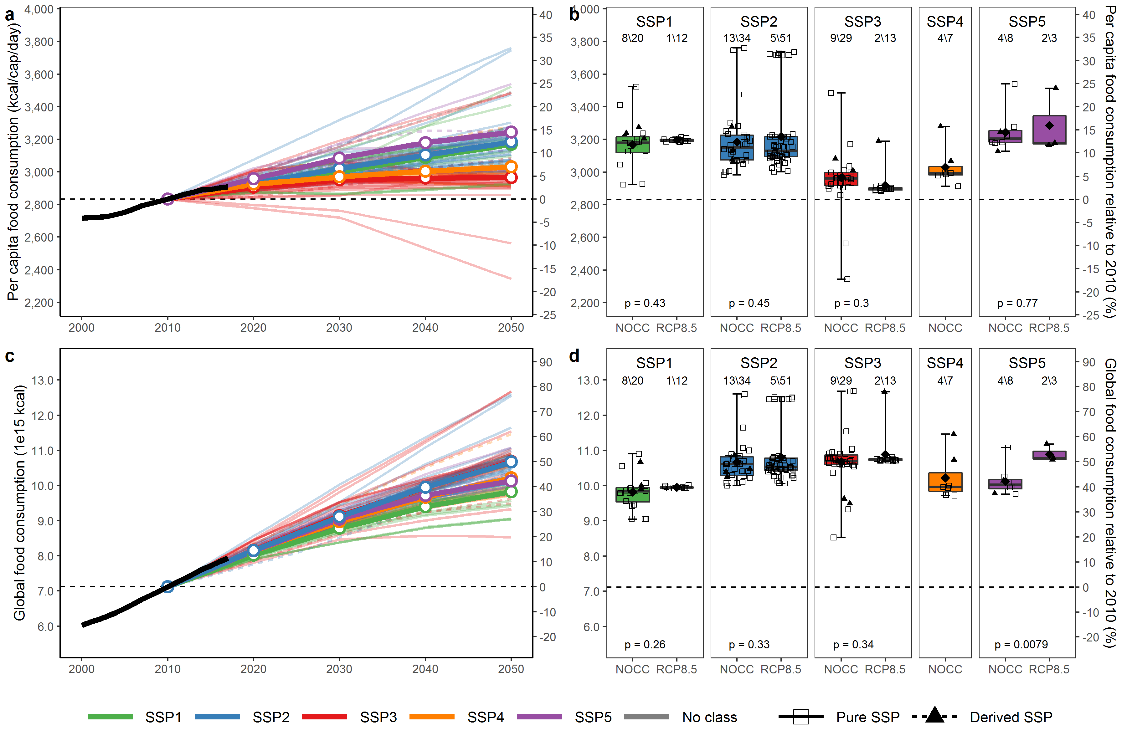

Figure 4: Per capita (a,b) and global (c,d) food consumption projections for 2010-2050. (a,c) show individual model projections for the SSPs (thin colored lines), the average for each SSP (the bold colored lines with circles) and the 3-year average historical trend (bold black line). (b,d) present boxplots comparing no climate change (NOCC) and extreme climate (RCP8.5) scenarios per SSP. The diamond in the boxplot indicates the mean value and the whiskers indicate the maximum and minimum range of observations. The numbers on top refer to the number of studies/number of projections depicted. p-values are reported for t-tests to compare the difference of the mean between the NOCC and RCP8.5 scenarios. SSP4 results for RCP8.5 are not reported because of the limited number of observations. The NOCC boxplots in (b,d) depict the same information as the values for 2050 in (a,b) and both figures are aligned horizontally. ‘Pure’ SSP are projections that take their assumptions from the SSPs, where relevant combined with RCP-based climate impact scenarios. ‘Derived’ SSPs are projections that belong to the same SSP and RCP scenario families but use somewhat different assumptions. Projections that could not be mapped to one of the SSP scenario families are labelled ‘No class’. Historical data from FAO (2020). Projections from the Global Food Security Projections Database (Van Dijk et al. 2020).

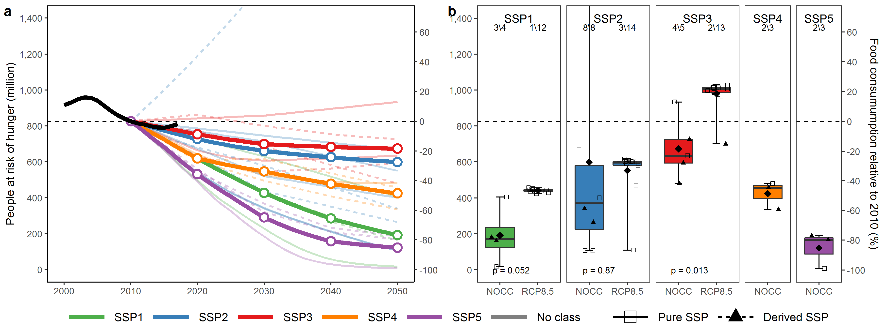

Figure 5: population at risk of hunger projections for 2010-2050. See Figure 5 for a detailed explanation of the figure elements. SSP4 and SSP5 results for RCP8.5 are not reported because of the limited number of observations. One extreme value for SSP2 is not depicted. Historical data from FAO (2020). Projections from the Global Food Security Projections Database (Van Dijk et al. 2020).

# Comparison with the prevailing discourse on future global food demand

Projections on global food demand and consumption provide information on the expected increase in food production and associated impacts on land use change, biodiversity and climate change. For this reason, these figures are frequently cited by popular media, scientists, policy makers and business. The most cited number, originating from a FAO briefing paper (FAO 2009), is that world food production needs to increase by 70% to feed the world population in 2050. Although this number was reduced to 60% in a revision (Alexandratos and Bruinsma 2012), it remains to be used as the main reference point by some companies (e.g. The John Deere Journal 2015) and scientific papers (e.g. Carvajal-Yepes et al. 2019). Another widely cited paper is David Tilman et al. (2011), who present a much higher increase in global food demand of 100% between 2005 and 2050. How do the results presented in these two papers (both are covered by our review) compare to our findings?

We find that for SSP2, which, like the FAO projections, is regarded as a business-as-usual scenario, food consumption will increase by 50% on average, with an interquartile range of 44-52%. This is substantially lower than the FAO and David Tilman et al. (2011) projections of 60%-100%. There are at least two reasons for the difference (Grethe, Dembele, and Duman 2011; Hunter et al. 2017). The main reason is that the FAO trend is estimated using the earlier base year 2005/2007 and therefore overestimates the expected increase in food consumption in comparison to the 2010 base year that is used in our review. A second reason is that it measures food consumption in value terms using food prices as weights instead of the preferred calorie based measure (Kearney 2010). The value-term measure tends to overestimate food consumption in case of a diet shift from low-prices staples towards to higher value products that might have occurred since 2005/2007.

Interestingly, the latest update of the FAO study (Alexandratos and Bruinsma 2012) also presents a figure for the global change in calories (54%), which we added to the Global Food Security Database. Using a base year of 2010, FAO projects an increase in consumption of 44% (**???**), which is within the interquartile range for SSP2. This shows that the FAO projections are comparable to other studies but results are highly sensitive to the selection of the base year. Without adding the reference period, statements about future increases in food demand and production can be misleading. However, when we consider all five SSPs, rather than one single business-as-usual scenario, the average increase in future food demand is between 34% and 53%. (**???**) is an important difference: since these scenarios depict vastly different but plausible worlds with respect to sustainability, equality, and technological development, the 37-51% range is more (**???**) than results from one type of scenario.

The projections in David Tilman et al. (2011) cannot easily be compared with most of the studies in our review because of differences in approach. In contrast to most other studies, which use diet projections, food consumption is approximated by the total crop calories. This includes both the crops that need to produce food for direct human consumption as well as the feed that is required to produce dairy, fish and meat products, resulting in much higher kcal/cap/day per capita levels. The study implicitly assumes that food and feed have the same relationship with income per capita. This deviates from most model studies, which assume an increase in feed-to-food efficiency rates (Wirsenius, Azar, and Berndes 2010) and, hence, a lower relative future demand for feed. Not accounting for potential efficiency improvements in the livestock sector might explain why the food consumption projections in David Tilman et al. (2011) are nearly twice as large in comparison to most other studies.

# Discussion

## Drivers of global food security

A number of strategies and options have been proposed to feed the 9-10 billion people by 2050, including sustainable intensification, reducing food loss and waste, shifting towards low-meat diets and expanding aquaculture (Godfray et al. 2010; Smith 2013; Keating et al. 2014; World Resources Institute 2013).

A number of studies in the SLR have simulate the impact several of these solutions - (**???**).

Nonetheless, we find that, despite recent advancements, aquaculture, listed as one of the key options to improve sustainable food production, is largely neglected by the modelling studies. In addition, none of the selected studies tries to model the impact of ‘future foods’ (Parodi et al. 2018). These are alternative food sources, such as insects, cultured meat or seaweed that are increasingly regarded as healthy and sustainable alternatives to mainstream food products. In order to adequately project global food security and assess solutions to feed the world in 2050, models need to be able to capture these issues as well as wider driving forces of food demand and supply.

## Measurement of global food security

The FAO has prepared a comprehensive list of around 25 national-level indicators that aim to capture the four dimensions of food (in)security: availability, access, stability and utilization (FAO 2020). Comparing this list with the indicators published in the selected studies suggests a very narrow view on food security. None of the studies presents and indicator on stability and only a few studies address the utilization dimension (i.e. Lloyd et al. (2011) and Ishida et al. (2014), who include a stunting indicator). Some of indicators proposed by FAO (2020) are probably difficult to model due to lack of global data (e.g. household level indicators). Others, however, can be prepared as illustrated by Shutes et al. (2017), who present projections for share of dietary energy supply derived from cereals, share of calories from fruits and vegetables and supply of protein of animal origin. Similarly, recent studies, such as Springmann et al. (2018) and Willett et al. (2019), have started to analyze the impact of a global change in diets on nutrition and health outcomes.

All model studies take a strong macro-approach and therefore only present food security results at the national or regional level. They are therefore unable to take into account differences in wealth, assets and behavior of households, which are among the main determinants of the access component of food security. Only recently model simulation studies have started to explicitly incorporate household-level food security in their analysis. Breisinger and Ecker (2014) propose a macro-micro approach in which a dynamic computable general equilibrium model is combined with household- and individual-level regression models to assess food security for the period 2012-2020 in Yemen. Another example is Laborde Debucquet et al. (2016), who combine a global CGE model with household survey data to assess the costs of ending hunger in seven African countries. It would be interesting to apply this type of approaches at global level in future food security assessments.

## Uncertainty and consistency in global food security projections

Although the range in global food security outcomes is large for some indicators, the result seems largely consistent both within and between SSPs. SSP1 and SSP5 represent futures in which global food security will improve, reflected by a sharp decrease in population at risk of hunger, high food consumption per capita levels and low global food consumption. SSP3 represents an opposite world, characterized by the highest population at risk of hunger, the lowest per capita consumption and the highest global food consumption. In most cases the results for SSP2 and SSP4 are located in the middle of these extreme scenarios.

A comparison between no climate change and RCP8.5 results showed that socio-economic drivers (as defined by the SSPs) have a much larger impact on food security outcomes than climate change scenarios (as defined by the RCPs). We only found a limited impact of climate change on future food security in comparison with no climate change baseline projections. Only for population at risk of hunger the mean was significantly different between the two sets of scenarios (**???**). This finding, however, has to be interpreted with care as we only used basic statistics to compare the difference in means. Our approach does not account for differences in sample size, nor does it control for within group effects (e.g correlation in results between projections produced by the same authors, model or study). More advanced meta-analysis approaches such as random effect models (Borenstein et al. 2009) are needed to tackle these issues and provide more in-depth analysis

A number of factors can explain the large range in food security outcomes (Van Dijk and Meijerink 2014). First, in contrast to the AgMIP exercises [(Lampe et al. 2014), where all models use harmonized assumptions on drivers and attempt to align the implementation of qualitative scenario assumptions, the input data of the studies in our review differs much more. Although many studies use the SSPs, their actual implementation might still differ, resulting in a large bandwidth of results. This is illustrated by the finding that population projections, one of the core SSP building blocks, are not the same across all ‘pure’ SSP studies (S11 Figure).

Second, differences in methodologies to model long-run global food security can strongly influence the results. Systematic model comparisons in AgMIP showed that structural differences between PE and CGE (Lampe et al. 2014), assumptions on technological change (Robinson et al. 2014) and the way food demand is modeled (Valin et al. 2014) are important factors which explain differences in model outcomes. Hertel and Baldos (2016) found that apart from technological change, assumptions for income, capital, labor and land elasticities are critical determining factors of model output although they only have received very limited attention in the literature. Godfray and Robinson (2015) discuss the strengths and weaknesses of simulation models and statistical extrapolation and how they contribute to disparity in outcomes.

Finally, differences in reporting of results are also an important factor that explains the wide range of outcomes. Although, we made an effort to make results comparable, it was not always straight-forward to resolve differences in definition, aggregation and unit and allocate projections to scenario families. Hence, some caution has to be used when interpreting the results.

(**???**) findings indicate that global food demand will increase by 37 44-5251/2% (interquartile range) between 2010 and 2050 over five highly contrasted alternative scenarios. This figure is more significant and reflective of the current state of the literature than the often cited 60-110% range. If used with care, it could better inform policy analysis and the public debate on the future of food.

base year is important. We use 2010 but since then production has increased. Can not be used to infer that production needs to be increased with 50% as is sometimes been done as does not account for production gains between 2010 and present. The increase in cereal producion, of X indicates has ben substantial. Analysis can be used to inform policies and strategies on how much to increase in sustainable production and inform by how much yield needs to be increased without expanding land (**???**)

We would like to stress that it is lower than previous estimates, does not mean [bla bla]

A shortcoming of our analysis and the resulting database is that it only includes global-level results. Food security conditions differ strongly between regions and even within countries (FAO 2019). It would therefore be interesting to expand the database with regional or national results that are presented relevant studies to conduct a more disaggregated analysis. An interesting avenues for future research would be to use meta-analytical methods to unravel the key factors explaining the spread in outcomes (**???**).

[Concluding SENTENCE]

## # Conclusions remarks?

<https://www.nature.com/articles/s43016-019-0002-4> on nutrition versus food security. Perhaps end with sense on this. or End with that 50% increase is still challenging in future of climate change and sustainabily. - which future will become reality?

# Methods

# References

Alexandratos, N., and J. Bruinsma. 2012. “World agriculture towards 2030/2050: The 2012 Revision.” ESA Working Paper. Rome: Food; Agriculture Organization of the United Nations. <https://doi.org/10.1016/S0264-8377(03)00047-4>.

Baldos, Uris Lantz C, and Thomas W. Hertel. 2013. “Looking back to move forward on model validation: insights from a global model of agricultural land use.” *Environmental Research Letters* 8 (3): 034024. <https://doi.org/10.1088/1748-9326/8/3/034024>.

———. 2016. “Debunking the ‘new normal’: Why world food prices are expected to resume their long run downward trend.” *Global Food Security* 8 (March): 27–38. <https://doi.org/10.1016/j.gfs.2016.03.002>.

Billen, G, L Lassaletta, and J Garnier. 2015. “A vast range of opportunities for feeding the world in 2050: Trade-off between diet, N contamination and international trade.” *Environmental Research Letters* 10 (2). <https://doi.org/10.1088/1748-9326/10/2/025001>.

Bodirsky, Benjamin, Susanne Rolinski, Anne Biewald, Isabelle Weindl, Alexander Popp, and Hermann Lotze-Campen. 2015. “Global Food Demand Scenarios for the 21st Century.” Edited by Andrea Belgrano. *PLOS ONE* 10 (11): e0139201. <https://doi.org/10.1371/journal.pone.0139201>.

Borenstein, Michael, Larry V. Hedges, Julian P. T. Higgins, and Hannah R. Rothstein. 2009. *Introduction to Meta-Analysis*. Chichester, UK: John Wiley & Sons, Ltd. <https://doi.org/10.1002/9780470743386>.

Breisinger, Clemens, and Olivier Ecker. 2014. “Simulating economic growth effects on food and nutrition security in Yemen: A new macro–micro modeling approach.” *Economic Modelling* 43: 100–113. <https://doi.org/10.1016/j.econmod.2014.07.029>.

Bruinsma, J. 2011. *Looking ahead in worLd food and agricuLture: Perspectives to 2050*. <https://doi.org/I2280E/1/06.11>.

Carvajal-Yepes, M., K. Cardwell, A. Nelson, K. A. Garrett, B. Giovani, D. G. O. Saunders, S. Kamoun, et al. 2019. “A global surveillance system for crop diseases.” *Science* 364 (6447): 1237–9. <https://doi.org/10.1126/science.aaw1572>.

Dawson, T P, A H Perryman, and T M Osborne. 2016. “Modelling impacts of climate change on global food security.” *Climatic Change* 134 (3): 429–40. <https://doi.org/10.1007/s10584-014-1277-y>.

FAO. 1996. “Rome declaration on world food security and world food summit plan of action.” Rome: FAO.

———. 2009. “How to feed the world in 2050.” Rome: High-Level Expert Forum; Food; Agricultural Organisation.

———. 2018. “The future of food and agriculture - alternative pathways to 2050.” Rome: Food; Agriculture Organization.

———. 2019. *The State of Food Security and Nutrition in the World 2019*. Rome: FAO. <https://doi.org/10.4060/CA5162EN>.

———. 2020. “Food security indicators.” [http://www.fao.org/economic/ess/ess-fs/ess-fadata/en/{\#}.XiYStoh7mcw](http://www.fao.org/economic/ess/ess-fs/ess-fadata/en/%7B\#%7D.XiYStoh7mcw).

Fischer, G, M Shah, F N Tubiello, and van Velhuizen H. 2005. “Socio-economic and climate change impacts on agriculture: an integrated assessment, 1990-2080.” *Philosophical Transactions of the Royal Society of London. Series B, Biological Sciences* 360 (1463): 2067–83.

Fujimori, Shinichiro, Tomoko Hasegawa, and Toshihiko Masui. 2017. “AIM/CGE V2.0: Basic Feature of the Model.” In *Post-2020 Climate Action*, 305–28. Singapore: Springer Singapore. <https://doi.org/10.1007/978-981-10-3869-3_13>.

Godfray, H Charles J, John R Beddington, Ian R Crute, Lawrence Haddad, David Lawrence, James F Muir, Jules Pretty, Sherman Robinson, Sandy M Thomas, and Camilla Toulmin. 2010. “Food security: the challenge of feeding 9 billion people.” *Science (New York, N.Y.)* 327 (5967): 812–8. <https://doi.org/10.1126/science.1185383>.

Godfray, H Charles J, and S. Robinson. 2015. “Contrasting approaches to projecting long-run global food security.” *Oxford Review of Economic Policy* 31 (1): 26–44. <https://doi.org/10.1093/oxrep/grv006>.

Gough, David, Sandy Oliver, and James Thomas, eds. 2012. *An introduction to systematic reviews*. London: Sage. <https://doi.org/10.1186/2046-4053-1-28>.

Grethe, Harald, Assa Dembele, and Nuray Duman. 2011. *How to Feed The World ’ s Growing Billions: Understanding FAO World Food Projections and their Implications*. Heinrich Böll Stiftung (Heinrich Böll Foundation); WWF Deutschland.

Hasegawa, Tomoko, Shinichiro Fujimori, Kiyoshi Takahashi, and Toshihiko Masui. 2015. “Scenarios for the risk of hunger in the twenty-first century using Shared Socioeconomic Pathways.” *Environmental Research Letters* 10 (1): 014010. <https://doi.org/10.1088/1748-9326/10/1/014010>.

Havlik, Petr, Hugo Valin, Mario Herrero, Michael Obersteiner, Erwin Schmid, Mariana C Rufino, Aline Mosnier, et al. 2014. “Climate change mitigation through livestock system transitions.” *Proceedings of the National Academy of Sciences of the United States of America* 111 (10): 3709–14. <https://doi.org/10.1073/pnas.1308044111>.

Headey, Derek, and Shenggen Fan. 2008. “Anatomy of a crisis: the causes and consequences of surging food prices.” *Agricultural Economics* 39 (s1): 375–91. <https://doi.org/10.1111/j.1574-0862.2008.00345.x>.

Hertel, Thomas W., and Uris Lantz C. Baldos. 2016. “Attaining food and environmental security in an era of globalization.” *Global Environmental Change* 41: 195–205. <https://doi.org/10.1016/j.gloenvcha.2016.10.006>.

Hunter, M C, R G Smith, M E Schipanski, L W Atwood, and D A Mortensen. 2017. “Agriculture in 2050: Recalibrating Targets for Sustainable Intensification.” *BioScience*, 386–91.

Huppmann, Daniel, Joeri Rogelj, Elmar Kriegler, Volker Krey, and Keywan Riahi. 2018. “A new scenario resource for integrated 1.5 °C research.” *Nature Climate Change*, October, 1. <https://doi.org/10.1038/s41558-018-0317-4>.

IAASTD. 2009. *Agriculture at a crossroad - global report*. Washington DC: Island Press.

Ishida, Hiroyuki, Shota Kobayashi, Shinjiro Kanae, Tomoko Hasegawa, Shinichiro Fujimori, Yonghee Shin, Kiyoshi Takahashi, Toshihiko Masui, Akemi Tanaka, and Yasushi Honda. 2014. “Global-scale projection and its sensitivity analysis of the health burden attributable to childhood undernutrition under the latest scenario framework for climate change research.” *Environmental Research Letters* 9 (2014) 0 (6): 1–9. <https://doi.org/10.1088/1748-9326/9/6/064014>.

Kearney, John. 2010. “Food consumption trends and drivers.” *Philosophical Transactions of the Royal Society B: Biological Sciences* 365 (1554): 2793–2807. <https://doi.org/10.1098/rstb.2010.0149>.

Keating, Brian A., Mario Herrero, Peter S. Carberry, John Gardner, and Martin B. Cole. 2014. “Food wedges: Framing the global food demand and supply challenge towards 2050.” *Global Food Security* 3 (3-4): 125–32. <https://doi.org/10.1016/j.gfs.2014.08.004>.

Laborde Debucquet, David, Livia Bizikiva, Tess Lallemant, and Carin Smaller. 2016. “Ending hunger what would it cost?” International Institute for Sustainable Development.

Lampe, Martin von, Dirk Willenbockel, Helal Ahammad, Elodie Blanc, Yongxia Cai, Katherine Calvin, Shinichiro Fujimori, et al. 2014. “Why do global long-term scenarios for agriculture differ? An overview of the AgMIP Global Economic Model Intercomparison.” *Agricultural Economics* 45 (1): 3–20. <https://doi.org/10.1111/agec.12086>.

Linehan, V, S Thorpe, C Gunning-Trant, E Heyhoe, K Harle, M Hormis, and K Harris-Adams. 2013. “Global food production and prices to 2050: Scenario analysis under policy assumptions.” In.

Lloyd, Simon J., R. Sari Kovats, Zaid Chalabi, R. Sari Kovats, and Zaid Chalabi. 2011. “Climate Change, Crop Yields, and Undernutrition: Development of a Model to Quantify the Impact of Climate Scenarios on Child Undernutrition.” *Environmental Health Perspectives* 119 (12): 1817–23. <https://doi.org/10.1289/ehp.1003311>.

Lotze-Campen, Hermann, Christoph Müller, Alberte Bondeau, Stefanie Rost, Alexander Popp, and Wolfgang Lucht. 2008. “Global food demand, productivity growth, and the scarcity of land and water resources: A spatially explicit mathematical programming approach.” *Agricultural Economics* 39 (3): 325–38. <https://doi.org/10.1111/j.1574-0862.2008.00336.x>.

Medek, D E, J Schwartz, and S S Myers. 2017. “Estimated Effects of Future Atmospheric CO2 Concentrations on Protein Intake and the Risk of Protein Deficiency by Country and Region.” *Environmental Health Perspectives* 125 (8): 87001–2. <https://doi.org/10.1289/ehp41>.

Mensbrugghe, Dominique van der. 2008. “The ENVironmental Impact and Sustainability Applied General Equilibrium (ENVISAGE) model.” World Bank.

Millennium Ecosystem Assessment. 2005. “Ecosystems and human well-being: synthesis.” Washington, DC: Island Press.

Msangi, S, and M Batka. 2015. “Major trends in diets and nutrition: A global perspective to 2050.” Emerald Group Publishing Ltd. <https://doi.org/10.1108/s1574-871520150000015023>.

Msangi, S, and M Rosegrant. 2009. “World agriculture in a dynamically-changing environment.”

Nakicenovic, N, Joseph Alcamo, G Davis, Bert de Vries, Joergen Fenhann, Stuart Gaffin, Kenneth Gregory, and Arnulf Grubler. 2000. “Special report on emissions scenarios (SRES).”

Nelson, GC, MW Rosegrant, A Palazzo, I Gray, C. Ingersoll, Richard Robertson, S. Tokgoz, et al. 2010. *Food security, farming, and climate change to 2050: Scenarios, results, policy options*. Washington, D.C.: International Food Policy Research Institute. <https://doi.org/10.2499/9780896291867>.

O’Neill, Brian C., Elmar Kriegler, Kristie L. Ebi, Eric Kemp-Benedict, Keywan Riahi, Dale S. Rothman, Bas J. van Ruijven, et al. 2017. “The roads ahead: Narratives for shared socioeconomic pathways describing world futures in the 21st century.” *Global Environmental Change* 42 (January): 169–80. <https://doi.org/10.1016/j.gloenvcha.2015.01.004>.

Parodi, A., A. Leip, I. J. M. De Boer, P. M. Slegers, F. Ziegler, E. H. M. Temme, M. Herrero, et al. 2018. “The potential of future foods for sustainable and healthy diets.” *Nature Sustainability* 1 (12): 782–89. <https://doi.org/10.1038/s41893-018-0189-7>.

Parry, Martin, Cynthia Rosenzweig, Matthew Livermore, and Phil Trans R Soc B. 2005. “Climate change, global food supply and risk of hunger.” *Philosophical Transactions of the Royal Society of London. Series B, Biological Sciences* 360 (1463): 2125–38. <https://doi.org/10.1098/rstb.2005.1751>.

Parry, M. L., C. Rosenzweig, A. Iglesias, M. Livermore, and G. Fischer. 2004. “Effects of climate change on global food production under SRES emissions and socio-economic scenarios.” *Global Environmental Change* 14 (1): 53–67. <https://doi.org/10.1016/j.gloenvcha.2003.10.008>.

Reilly, Michael, and Dirk Willenbockel. 2010. “Managing uncertainty: a review of food system scenario analysis and modelling.” *Philosophical Transactions of the Royal Society B* 365 (1554): 3049–63. <https://doi.org/10.1098/rstb.2010.0141>.

Riahi, Keywan, Shilpa Rao, Volker Krey, Cheolhung Cho, Vadim Chirkov, Guenther Fischer, Georg Kindermann, Nebojsa Nakicenovic, and Peter Rafaj. 2011. “RCP 8.5-A scenario of comparatively high greenhouse gas emissions.” *Climatic Change* 109 (1): 33–57. <https://doi.org/10.1007/s10584-011-0149-y>.

Riahi, Keywan, Detlef P. van Vuuren, Elmar Kriegler, Jae Edmonds, Brian C. O’Neill, Shinichiro Fujimori, Nico Bauer, et al. 2017. “The Shared Socioeconomic Pathways and their energy, land use, and greenhouse gas emissions implications: An overview.” *Global Environmental Change* 42 (January): 153–68. <https://doi.org/10.1016/J.GLOENVCHA.2016.05.009>.

Robinson, Sherman, Daniel Mason-D ’croz, Shahnila Islam, Timothy B Sulser, Richard Robertson, Tingju Zhu, Arthur Gueneau, Gauthier Pitois, and Mark Rosegrant. 2015. “The International Model for Policy Analysis of Agricultural Commodities and Trade (IMPACT): Model Description for Version 3.” IFPRI Discussion Paper. IFPRI. <https://doi.org/10.2139/ssrn.2741234>.

Robinson, Sherman, Hans van Meijl, Dirk Willenbockel, Hugo Valin, Shinichiro Fujimori, Toshihiko Masui, Ron Sands, et al. 2014. “Comparing supply-side specifications in models of global agriculture and the food system.” *Agricultural Economics* 45 (1): 21–35. <https://doi.org/10.1111/agec.12087>.

Rosenzweig, C., J. W. Jones, J. L. Hatfield, A. C. Ruane, K. J. Boote, P. Thorburn, J. M. Antle, et al. 2013. “The Agricultural Model Intercomparison and Improvement Project (AgMIP): Protocols and pilot studies.” *Agricultural and Forest Meteorology* 170: 166–82. <https://doi.org/10.1016/j.agrformet.2012.09.011>.

Shutes, L, Hugo Valin, E Stehfest, van Dijk M, M Kuiper, van Meijl H, A Tabeau, M Verma, D Oudendag, and van Zeist W J. 2017. “Food and Nutrition Security and Sustainability in Long-Term Projections: An Assessment of the FoodSecure Scenarios.”

Smith, Pete. 2013. “Delivering food security without increasing pressure on land.” *Global Food Security* 2 (1): 18–23. <https://doi.org/10.1016/J.GFS.2012.11.008>.

Springmann, Marco, Keith Wiebe, Daniel Mason-D’Croz, Timothy B Sulser, Mike Rayner, and Peter Scarborough. 2018. “Health and nutritional aspects of sustainable diet strategies and their association with environmental impacts: a global modelling analysis with country-level detail.” *The Lancet Planetary Health* 2 (10): e451–e461. <https://doi.org/10.1016/S2542-5196(18)30206-7>.

SSP Database. 2016. “SSP Database (Shared Socioeconomic Pathways) - Version 1.1.” <https://tntcat.iiasa.ac.at/SspDb>.

Stehfest, E, D van Vuuren, L Bouwman, and T Kram. 2014. *Integrated assessment of global environmental change with IMAGE 3.0: Model description and policy applications*.

The John Deere Journal. 2015. “Feed the World: A Challenge and an Opportunity.” <https://johndeerejournal.com/2015/12/smallholder-farmers-big-challenges>.

Tilman, David, Christian Balzer, Jason Hill, and Belinda L Befort. 2011. “Global food demand and the sustainable intensification of agriculture.” *Proc. Natl Acad. Sci.* 108 (50): 20260. <https://doi.org/10.1073/pnas.1116437108>.

Tilman, D, C Balzer, J Hill, and B L Befort. 2011. “Global food demand and the sustainable intensification of agriculture.” *PNAS* 108, no. 5: 20260–4.

Valin, H, R D Sands, van der Mensbrugghe D, G C Nelson, H Ahammad, E Blanc, B Bodirsky, et al. 2014. “The future of food demand: understanding differences in global economic models.” *Agricultural Economics* 45: 51–67.

Van Dijk, Michiel, and G. W. W. Meijerink. 2014. “A review of global food security scenario and assessment studies: Results, gaps and research priorities.” *Global Food Security* 3 (3-4): 227–38. <https://doi.org/10.1016/j.gfs.2014.09.004>.

Van Dijk, Michiel, Tom Morley, Marie Luise Rau, and Yashar Saghai. 2020. “Global Food Security Projections Database v1.1.”

Vuuren, Detlef P. van, Jae Edmonds, Mikiko Kainuma, Keywan Riahi, Allison Thomson, Kathy Hibbard, George C. Hurtt, et al. 2011. “The representative concentration pathways: An overview.” *Climatic Change* 109 (1): 5–31. <https://doi.org/10.1007/s10584-011-0148-z>.

Vuuren, Detlef P. van, Elmar Kriegler, Brian C. O’Neill, Kristie L. Ebi, Keywan Riahi, Timothy R. Carter, Jae Edmonds, et al. 2014. “A new scenario framework for Climate Change Research: Scenario matrix architecture.” *Climatic Change* 122 (3): 373–86. <https://doi.org/10.1007/s10584-013-0906-1>.

Vuuren, Detlef P. van, Keywan Riahi, Katherine Calvin, Rob Dellink, Johannes Emmerling, Shinichiro Fujimori, Samir KC, Elmar Kriegler, and Brian C. O’Neill. 2017. “The Shared Socio-economic Pathways: Trajectories for human development and global environmental change.” *Global Environmental Change* 42 (January): 148–52. <https://doi.org/10.1016/j.gloenvcha.2016.10.009>.

Willett, Walter, Johan Rockström, Brent Loken, Marco Springmann, Tim Lang, Sonja Vermeulen, Tara Garnett, et al. 2019. “Food in the Anthropocene: the EAT–Lancet Commission on healthy diets from sustainable food systems.” <https://doi.org/10.1016/S0140-6736(18)31788-4>.

Wirsenius, Stefan, Christian Azar, and Göran Berndes. 2010. “How much land is needed for global food production under scenarios of dietary changes and livestock productivity increases in 2030?” *Agricultural Systems* 103 (9): 621–38. <https://doi.org/10.1016/j.agsy.2010.07.005>.

Woltjer, Geert, Marijke Kuiper, Aikaterini Kavallari, Hans Van Meijl, Jeff Powell, Martine Rutten, Lindsay Shutes, and Andrzej Tabeau. 2014. “The MAGNET Model Module description.”

World Resources Institute. 2013. “Creating a Sustainable Food Future : A menu of solutions to sustainably feed more than 9 billion people by 2050.” Washington DC. <https://doi.org/10.1016/S0264-8377(03)00047-4>.

1. Wageningen Economic Research & International Institute for Applied Systems Analysis, IIASA
2. Wageningen Economic Research
3. Wageningen Economic Research
4. University of Twente