**Foxglove Studio Visualizer for remote testing:**

To open Foxglove Studio with data visualizer, there are two potions:

* In Chrome, go to <https://studio.foxglove.dev/>
* Alternatively, Visit <https://foxglove.dev/download> to download Foxglove Studio for your desktop

You can find more information about Foxglove Studio at: <https://foxglove.dev/docs/studio>

When you open Foxglove, you will be greeted by the screen shown below:

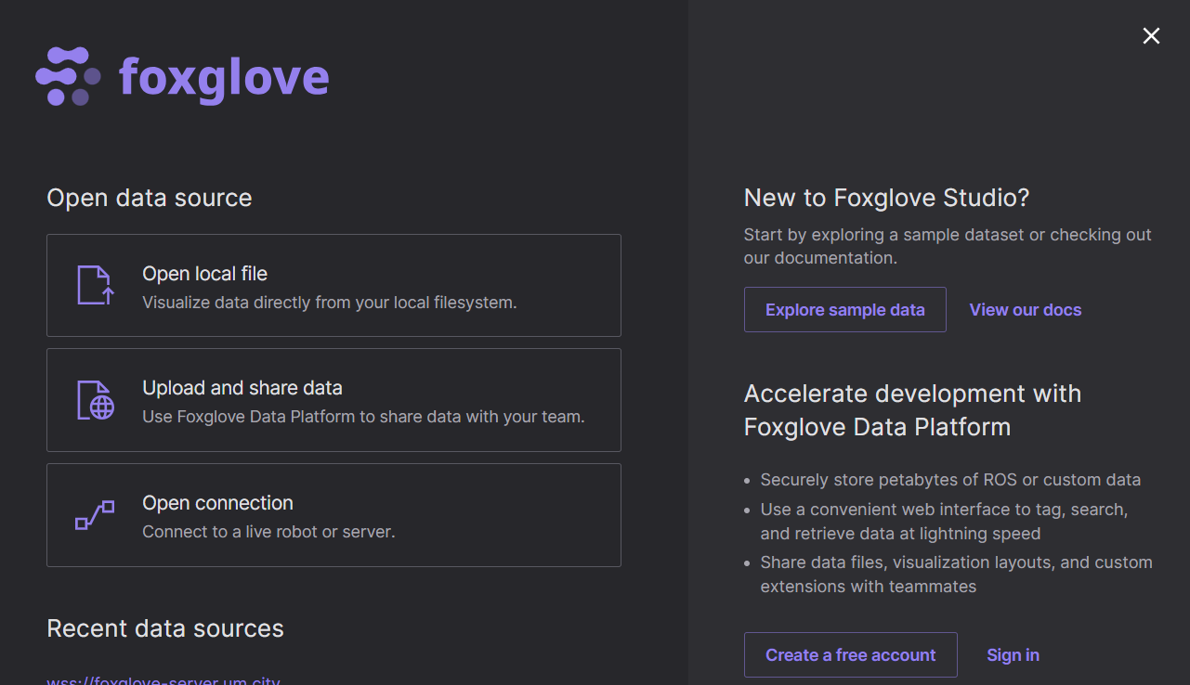

Click on the “Open connection” option. You will see the following screen:

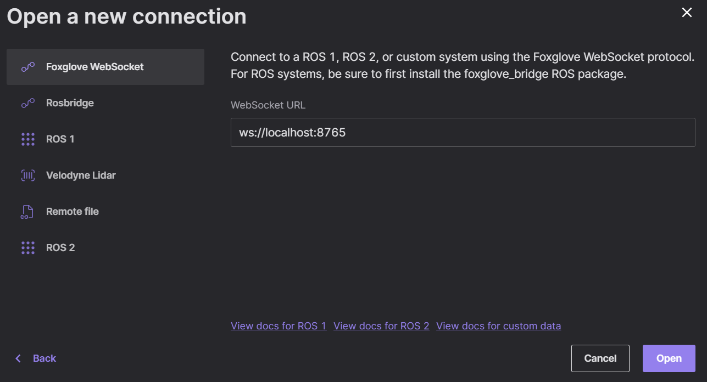

Replace the default Websocket URL with one of the following:

|  |  |  |
| --- | --- | --- |
| **Sr No** | **Testing Type** | **Visualization URL** |
| 1 | Simulation | wss://foxglove-simulation-server.um.city |
| 2 | Physical Resting | wss://foxglove-server.um.city |

Once you enter the URL and click Open, go to profile and click on Settings:

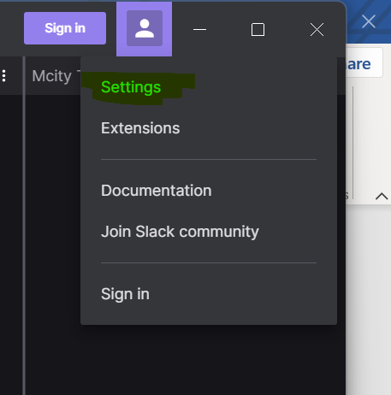

On the Settings wizard, please select Color scheme: Dark and click Done.

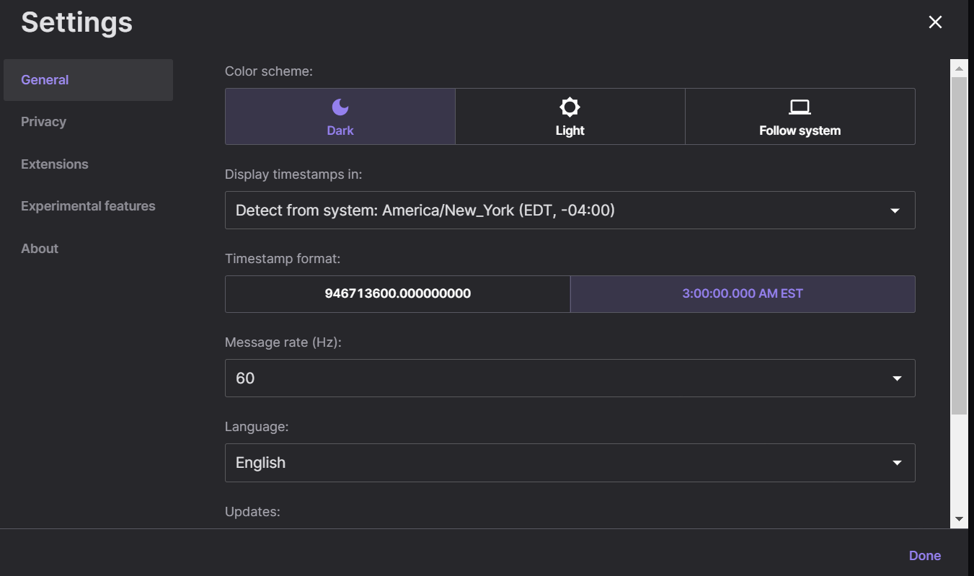

**To load the Mcity OS default layout, follow these next steps:**

There will be **two Foxglove studio sessions** (each) for both simulation & real vehicle (AV) remote testing. Here is the file you need to download locally and import as described below:

|  |  |  |  |
| --- | --- | --- | --- |
| **Sr No** | **Objective** | **Visualization URL** | **File URL** |
| 1 | Simulation Foxglove Session - 1 | wss://foxglove-simulation-server.um.city | https://github.com/michigan-traffic-lab/remote-test-visualizer/blob/main/Mcity-Remote-Visualizer-Simulation.json |
| 2 | Simulation Foxglove Session - 2 | wss://foxglove-simulation-server.um.city | https://github.com/michigan-traffic-lab/remote-test-visualizer/blob/main/Mcity-Remote-Visualizer-Plots-Simulation-v1.json |
| 3 | Mixed Reality Foxglove Session - 1 | wss://foxglove-server.um.city | https://github.com/michigan-traffic-lab/remote-test-visualizer/blob/main/Mcity-Remote-Visualizer-v3-ROS2.json |
| 4 | Mixed Reality Foxglove Session - 2 | wss://foxglove-server.um.city | https://github.com/michigan-traffic-lab/remote-test-visualizer/blob/main/Mcity-Remote-Visualizer-Plots-v1.json |

Back in the Foxglove Studio browser application, as shown below, click on the menu icon, then “View”, then click on “Import layout from file…”.

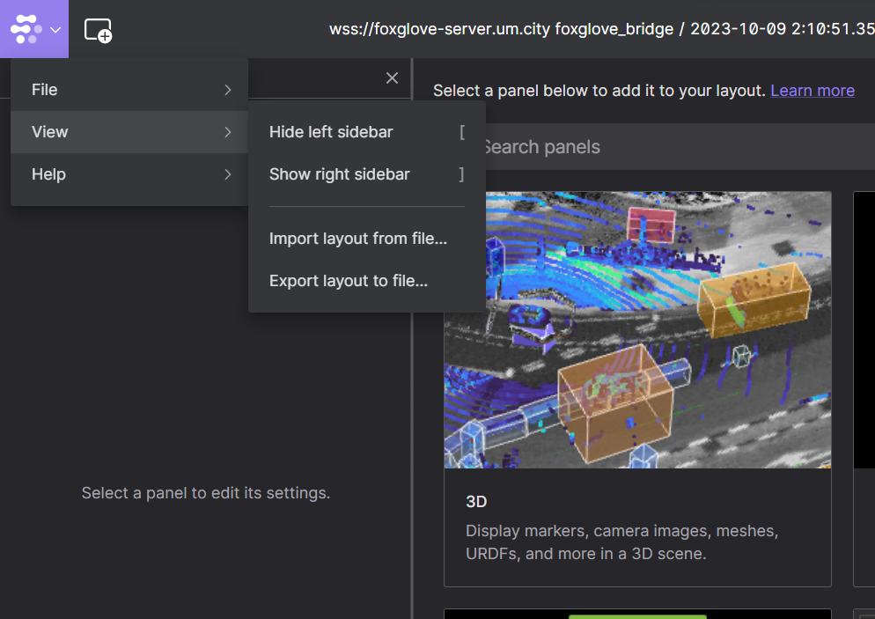

**When prompted, browse to the file you downloaded earlier. This will load the Mcity default layout for remote observation of testing at Mcity.**

**Sample Visualization screens for simulation & real vehicle (AV) remote testing**

1. **Sample Visualization - Simulation Foxglove Session** **– 1**

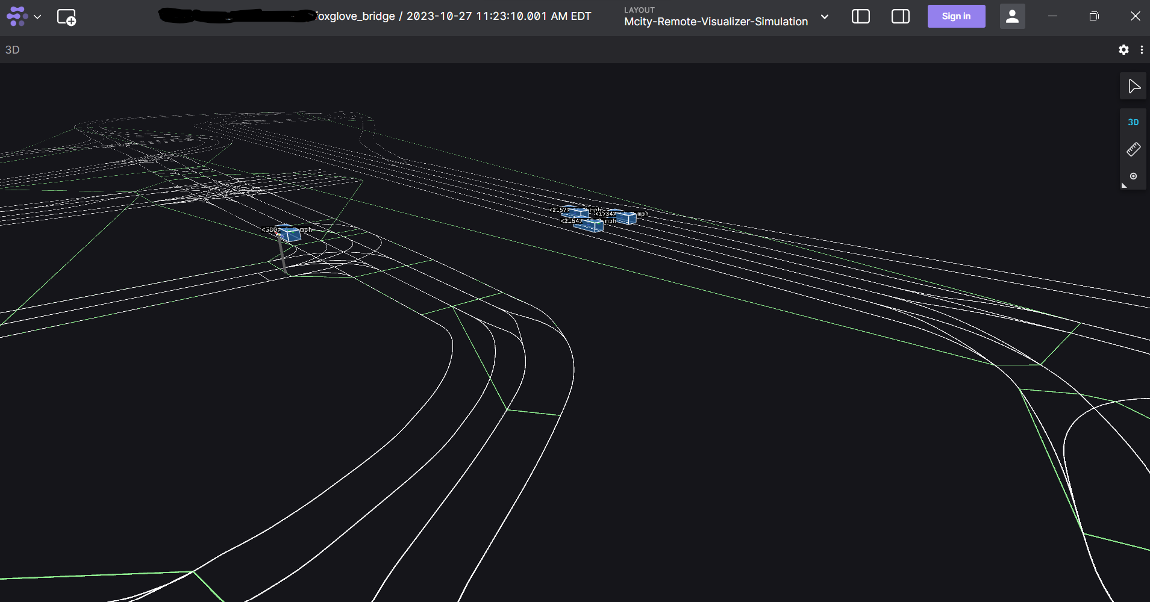

1. **Sample Visualization - Simulation Foxglove Session – 2**

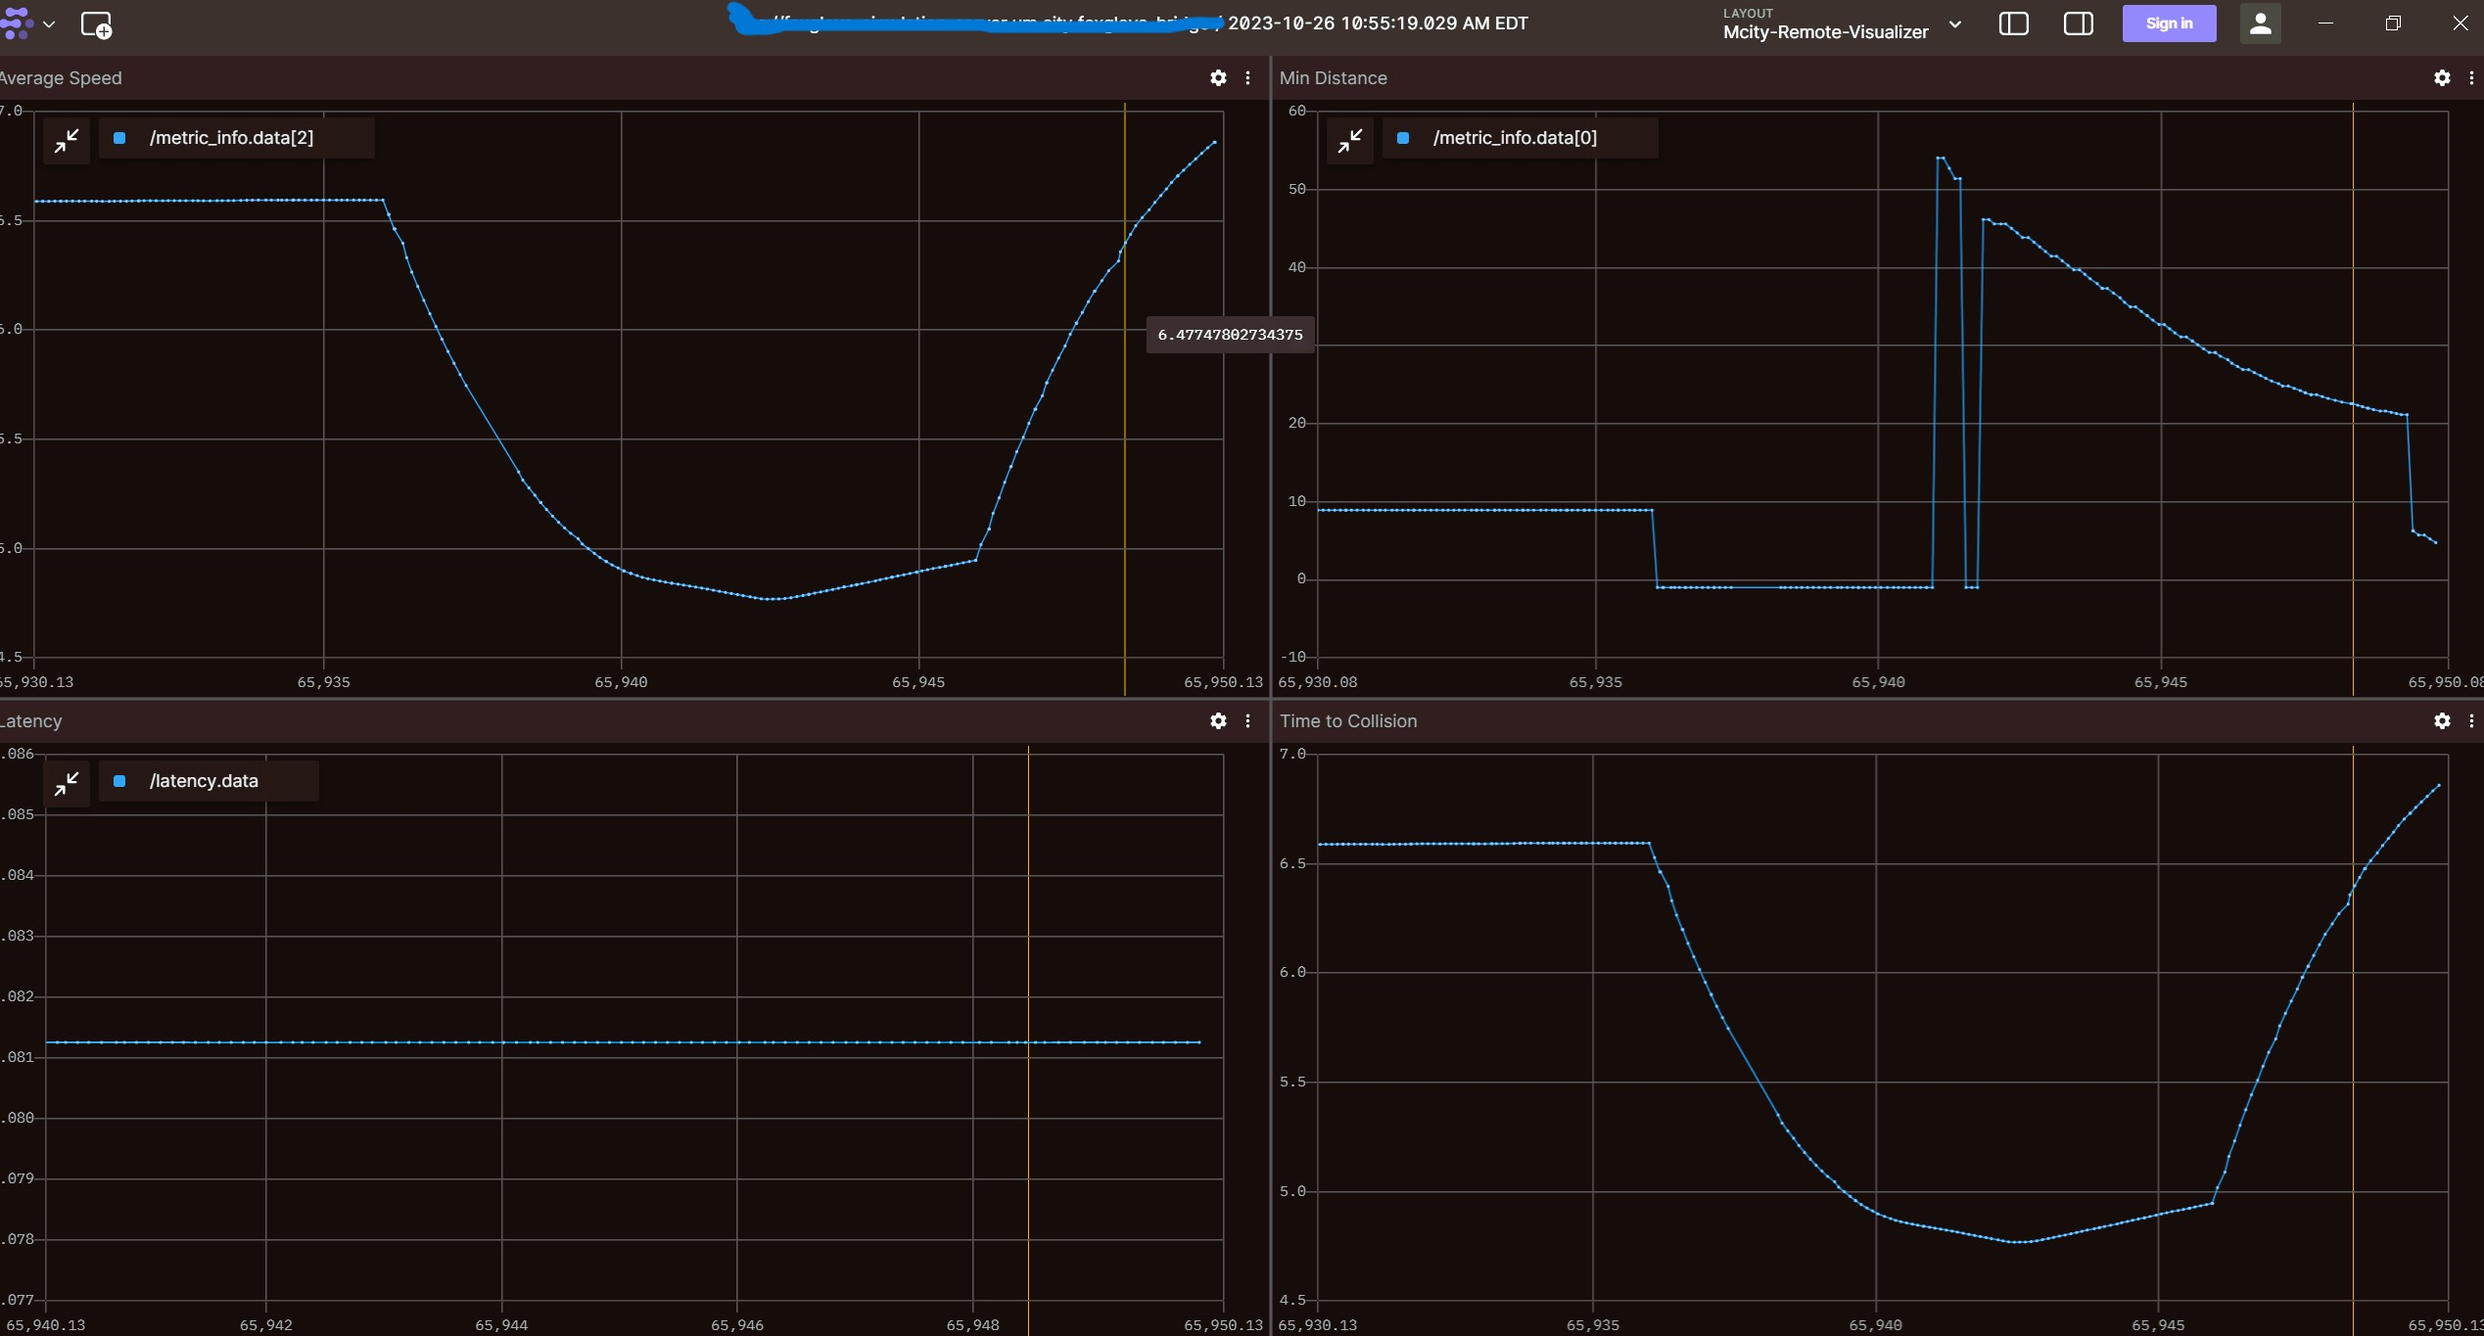

1. **Sample Visualization - Vehicle Screen – 1**

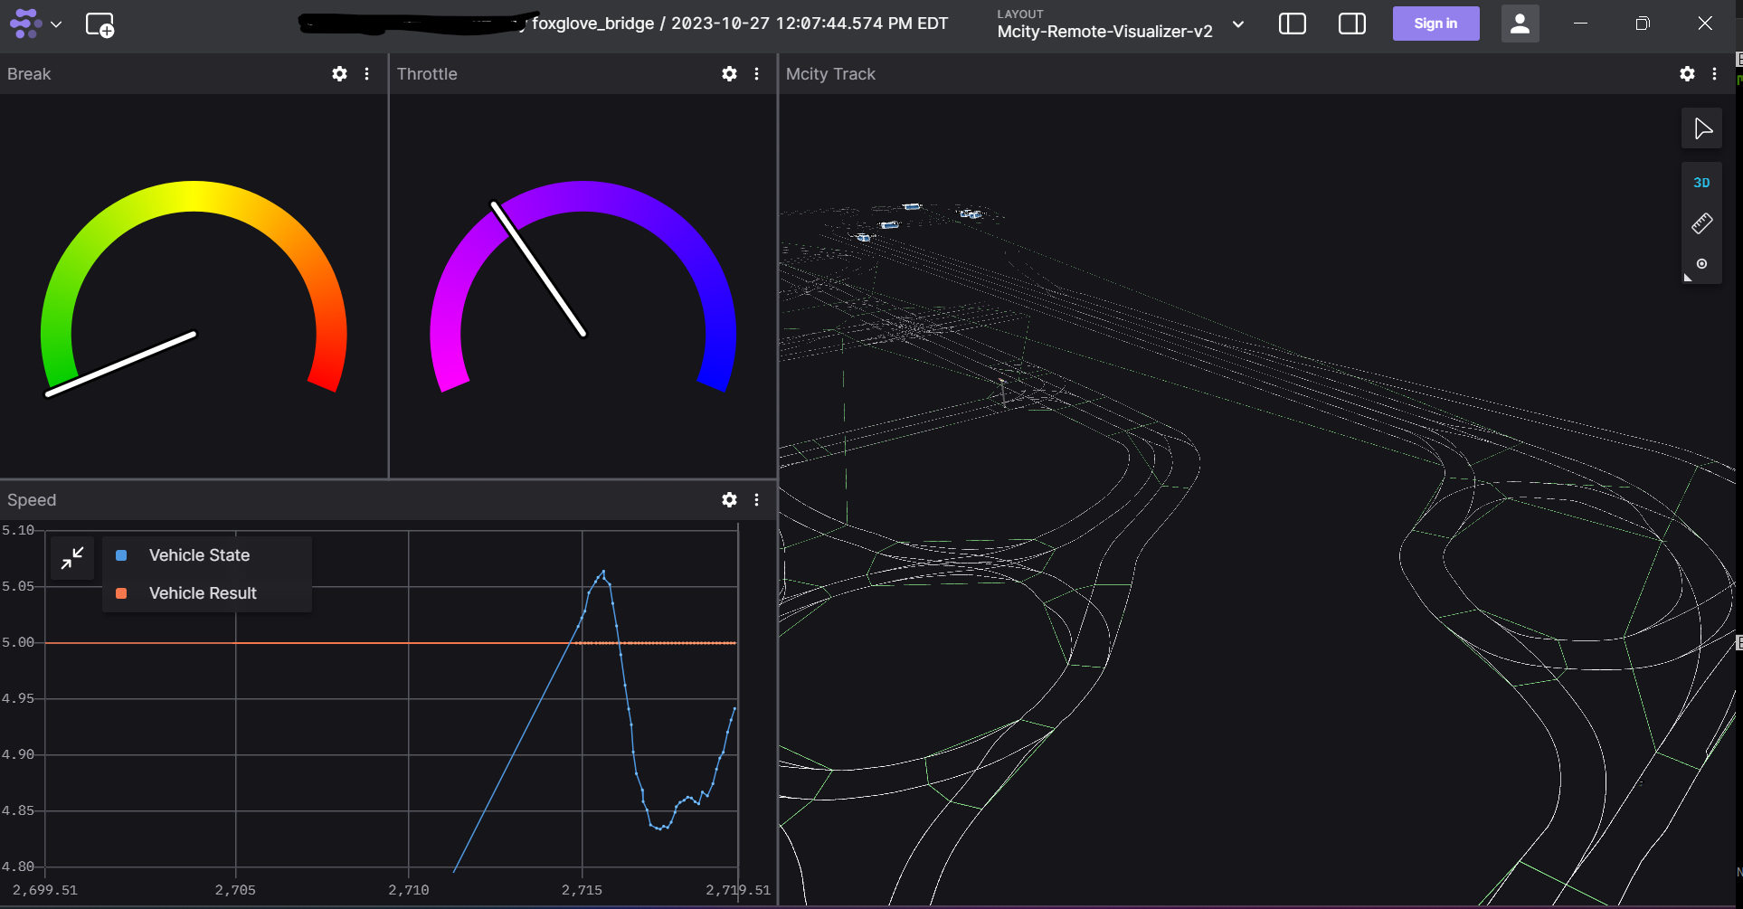

1. **Sample Visualization - Vehicle Screen – 2**

