AlloyTower Inc.
From Raw Data to Working Solution
The story of building AlloyTower's first property valuation system
A 3-week journey through data validation, model building, and stakeholder communication — written for everyone, not just data scientists.
Quick links
Try the live app or see the source code of the project. All links are listed in the next section, but feel free to skip ahead.

Author: Bright Uzosike — Data Scientist
Project: AlloyTower Centralised Data Platform — Phase 1
Audience: Project sponsors, business stakeholders, anyone curious about the work

Table of Contents
How to read this document 4
Try it yourself 4
Chapter 1 — What were we asked to build? 6
Chapter 2 — What did we get to work with? 7
Chapter 3 — What did we find when we looked at the data? 8
Finding 1 — The map coordinates were random 8
Finding 2 — The ZIP codes didn't match either 9
Finding 3 — The sale dates didn't reflect real market trends 9
Finding 4 — Physical attributes carried weak signal 10
Chapter 4 — Why did we narrow the scope? 11
Chapter 5 — How does the valuation model actually work? 13
In plain English 13
Two models, not one 13
How the explanation works 14
Chapter 6 — How accurate is it, really? 15
What the numbers mean 15
Industry context 15
How the AlloyTower models performed 16
Reading the gap honestly 16
Chapter 7 — What does the live application look like? 17
Page 1 — Get a property valuation 17
Page 2 — Market explorer 19
Page 3 — About this model 20
How it's deployed 20
Chapter 8 — What did I learn? 21
Lesson 1 — Validate before you build 21
Lesson 2 — Honest scope beats inflated promises 21
Lesson 3 — Communication is part of the technical work 21
Chapter 9 — What's next? 22
Data acquisition priorities 22
Suggested phasing 22
Closing 22

How to read this document
This is the story of a 3-week project, from receiving the brief to shipping a working web application. It's written so anyone — technical or not — can follow along and understand what happened, why decisions were made, and what the result looks like.
There are nine chapters, each answering one question a stakeholder might naturally have:
- Chapter 1: What were we asked to build?
- Chapter 2: What did we get to work with?
- Chapter 3: What did we find when we looked at the data?
- Chapter 4: Why did we narrow the scope?
- Chapter 5: How does the valuation model actually work?
- Chapter 6: How accurate is it, really?
- Chapter 7: What does the live application look like?
- Chapter 8: What did the team learn?
- Chapter 9: What's next?

Whenever a technical term comes up that might not be familiar, it's defined in plain English the first time. There are also screenshots throughout — these are spaces where the live application or supporting visuals are inserted.
A note on terminology
AVM stands for Automated Valuation Model — software that estimates property values from data, the same way Zillow's Zestimate works. We use the term throughout this document.

Try it yourself
Before reading further, you're welcome to try the project right now. The live application takes a property's details and produces a market value estimate, with a visual breakdown of how it arrived at that number.
🌐 Live application: https://alloy-avm.streamlit.app
💻 Source code on GitHub: https://github.com/michizler/alloy-tower-data-platform

First-time users — heads up
The live app runs on free hosting. If nobody has used it in the last 15 minutes, the first request will take 30–50 seconds while the system wakes up. That's normal. Once it's awake, every request after that is fast.

Chapter 1 — What were we asked to build?
AlloyTower is a real estate technology company. They wanted to build a centralised data platform — a single system that would replace the patchwork of tools and spreadsheets they were using to track properties, listings, and market data.
The original brief described five services the platform should offer:
- 1. Real Estate Marketplace — an online platform listing residential and commercial properties for sale and rent.
- 2. Property Management — tools to automate listings, track inquiries, and process rent payments.
- 3. Market Insights & Analytics — real-time pricing trends and demand data.
- 4. Smart Property Search — AI-powered recommendations based on user preferences.
- 5. AlloyTower Mortgage — integrated mortgage pre-approval and loan offers.
The work was scheduled for three weeks: design, deployment, and documentation.

From day one, this was an ambitious scope for a 3-week project. As the data scientist on the team, my first job was to understand what the data could actually support — and that turned out to be the most important question of the entire project.

Chapter 2 — What did we get to work with?
AlloyTower handed over a dataset of 2,090 US property records. Each record had 28 fields describing the property — its address, size, age, type, sale history, and tax assessment. A typical entry looked like this:
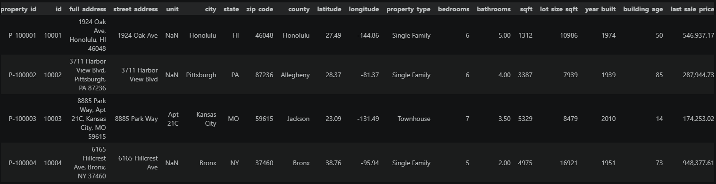
The fields covered most of what you'd expect:
- Identification — property ID, full address, owner name.
- Physical attributes — square footage, bedrooms, bathrooms, lot size, year built.
- Location — city, state, county, ZIP code, latitude, longitude.
- Sale information — last sale price, sale date, days since sale, price per square foot.
- Tax data — assessed value, annual tax, assessor ID.
On paper, this looked like a solid foundation. The dataset was the right shape for building a property valuation model, and it covered properties across many US cities.
But before building anything, I needed to verify that each field actually contained what it claimed to contain. That validation step turned out to be where the project really began.

Chapter 3 — What did we find when we looked at the data?
Data validation is a step every data project should take but many skip. The principle is simple: before building anything on top of data, check that each field is what it says it is. Run a series of sanity checks. Make sure the values make sense given the real world.
I ran twelve such checks on the AlloyTower dataset. Most of them came back clean. Four did not.

Finding 1 — The map coordinates were random
Every property had a latitude and longitude — coordinates that should pinpoint where the property sits on a map. I checked whether each property's coordinates fell inside its stated state.
Out of 841 properties I could test, only 26 (about 3%) had coordinates inside the correct state. Some examples:
- A property in Honolulu, Hawaii had coordinates that pointed to the middle of the Pacific Ocean.
- A property in Pittsburgh, Pennsylvania had coordinates pointing to central Florida.
- A property in the Bronx, New York had coordinates in central Kansas.
More damningly, two properties in the same city had completely different coordinates — ruling out a simple mapping error. The coordinates were essentially random numbers within a US-shaped region.
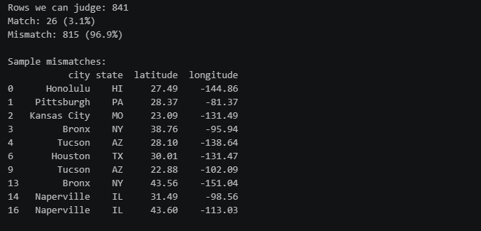

Finding 2 — The ZIP codes didn't match either
Same pattern. Of 2,090 ZIP codes, 2,064 were unique — meaning almost every property had a different ZIP. Real ZIP codes repeat (every neighbourhood shares a few). Inspection showed Honolulu paired with an Indiana ZIP, Pittsburgh paired with an unassigned New Mexico ZIP, and so on.
Like the coordinates, the ZIP codes had been generated randomly rather than reflecting real geography.

Finding 3 — The sale dates didn't reflect real market trends
US house prices rose roughly 40% between 2016 and 2026, with a peak in 2022 followed by a small correction — that's well-documented in real estate indices.
I plotted the median sale price for each year in the dataset to compare. The result was striking: prices in this dataset varied within a narrow band of $608,000 to $670,000 across the entire decade. That's about a 10% spread when the real market moved 40%. And most tellingly, 2022 — the actual market peak — was the lowest year in this dataset.
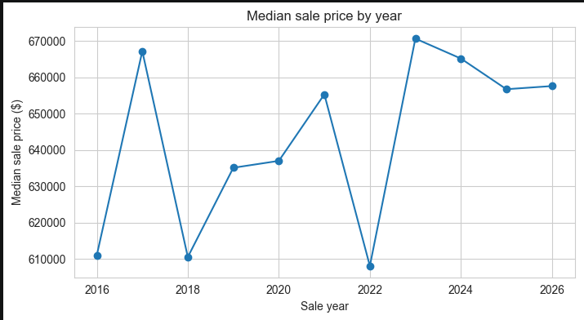
Whatever criteria the dates were assigned by, it wasn't "reflecting the actual housing market." Trying to use sale date as a meaningful feature in a valuation model would have meant teaching the model patterns that don't exist.

Finding 4 — Physical attributes carried weak signal
This one was subtler. In real US housing data, square footage is the single strongest predictor of price — bigger homes cost more, and the relationship is strong (statistically, a correlation of 0.6 to 0.8).
In this dataset, the same correlation was 0.22 — much weaker. Bedroom count and bathroom count had essentially no relationship to price. A 1-bedroom property and a 7-bedroom property had nearly identical price distributions.
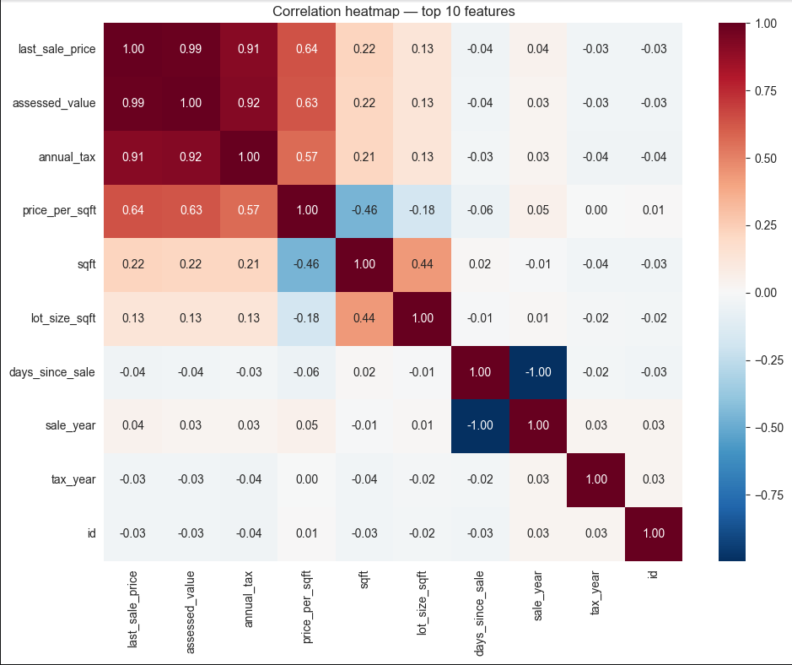
This wasn't a fatal problem — but it shaped what kind of model could realistically be built and how accurate it could be.
What this told us
The dataset's transactional core (sale prices, property attributes, tax assessments) was real and internally consistent. But the geographic identifiers (lat, long, ZIP) and the sale dates appeared to have been generated for privacy or training purposes, rather than reflecting real properties at real locations on real dates. We had a partially synthetic dataset.

Chapter 4 — Why did we narrow the scope?
With those findings on the table, I had to make a recommendation: which of the five services in the original brief could realistically be built from this data, and which couldn't?
I mapped each service against what the data could actually support:
Service in brief | Data coverage | In Phase 1?
Marketplace listings | None | Phase 2 — would need a real listings feed (active prices, photos, days on market)
Property management | None | Phase 2 — would need tenant records, leases, and rent payment data
Market analytics | Partial | Yes — historical sale data is usable for cross-sectional comparisons
Smart property search | Partial | Item-similarity yes; personalisation needs Phase 2 user data
Mortgage pre-approval | None | Phase 2 — would need borrower income, credit, loan history

Of the five services, only two had meaningful data coverage. Building all five anyway would have meant fabricating most of the platform — looking impressive at the demo, but creating problems the moment anyone tried to use it for real.
So we narrowed the scope. The Phase 1 deliverable became a focused, defensible slice of the platform: a property valuation system, an analytics layer, and an honest assessment of what the rest would need.
The decision
Phase 1 would deliver an Automated Valuation Model (AVM), a market intelligence dashboard layer, and an assessment ratio analysis — all built on the trustworthy parts of the data. The remaining services were sequenced into Phase 2, with clear notes on what data would be needed to unlock them.
This decision was documented and shared with the project's Solution Analyst before any modelling began, so that stakeholder expectations were anchored honestly from the start.
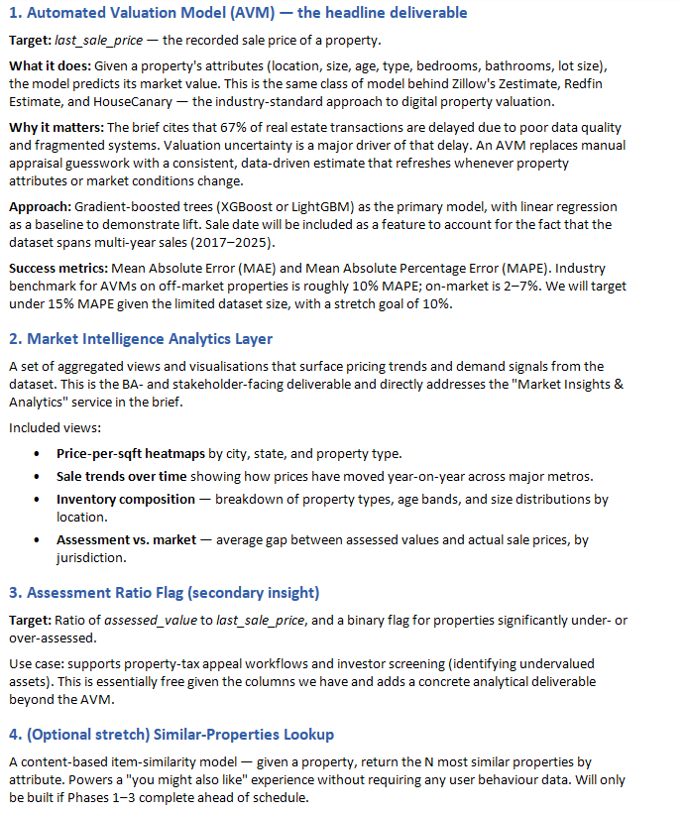

Chapter 5 — How does the valuation model actually work?
The heart of the project is a property valuation model. Given a property's details — its size, location, type, age, and a few other attributes — the model produces an estimated market value. This is the same kind of system behind Zillow's Zestimate or Redfin's Estimate, just at a smaller scale.

In plain English
The model does what an experienced real-estate agent does mentally:
- Step 1 — Look at the property's location. A 1,200 sqft condo in San Francisco is worth a lot more than the same condo in Tucson.
- Step 2 — Compare against similar properties. The model looks at thousands of recorded sales and finds patterns: "properties like this one tend to sell for around X."
- Step 3 — Adjust for the specific property's features. Larger lot? Adjust up. Older building? Maybe down, depending on where.
- Step 4 — Produce an estimate, plus a range that reflects uncertainty.
The difference is that the model does this for every property in milliseconds, consistently, and without bias from a particular human's gut feel.

Two models, not one
During modelling, I made a deliberate choice that turned out to be one of the most important decisions of the project: I built two model variants instead of one.
- Model A — Assessment-aware. Uses the property's tax assessment as one of its inputs. More accurate when the assessment is available — typical error around 8% of the actual sale price.
- Model B — Fundamentals-only. Excludes the tax assessment. Less accurate (typical error around 45%) but works for properties without an assessment, like new builds.
Why two? Because the tax assessment was so closely related to the sale price in this dataset that a model using it would essentially be doing arithmetic on the assessment, not really learning to value properties from their fundamentals. Building both lets stakeholders see what each model is actually doing.
The application picks the right model automatically: if you provide an assessed value, it uses Model A. If not, it falls back to Model B. The accuracy of each is shown clearly to set expectations.
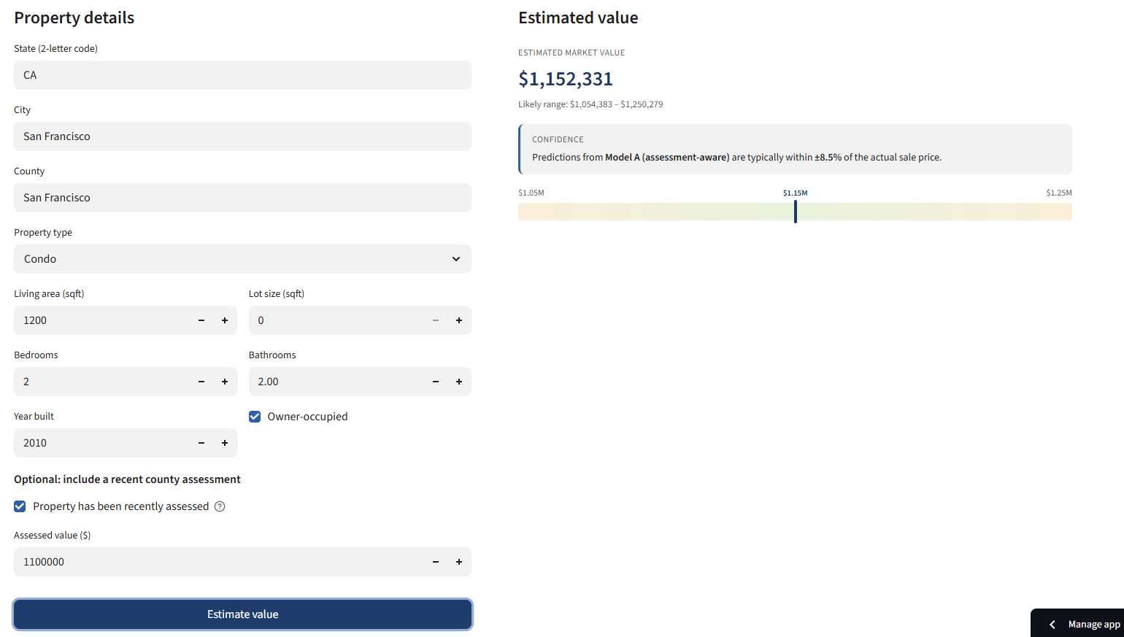

How the explanation works
A number alone doesn't build trust. So the application also shows what drove the prediction:
- Top contributing features — the four or five inputs that pushed the price up or down most. "Location: San Francisco, CA — adds significant value."
- Confidence range — a visual band showing where the model thinks the true price is likely to fall.
- Comparable properties — five real properties from the dataset most similar to the input, shown as cards with their actual sale prices.
This is intentional. A lot of AVMs show only a number, which feels authoritative but is brittle — if the user disagrees, they have nowhere to go. By showing the why, the comps, and the uncertainty, the model invites scrutiny rather than demanding belief.
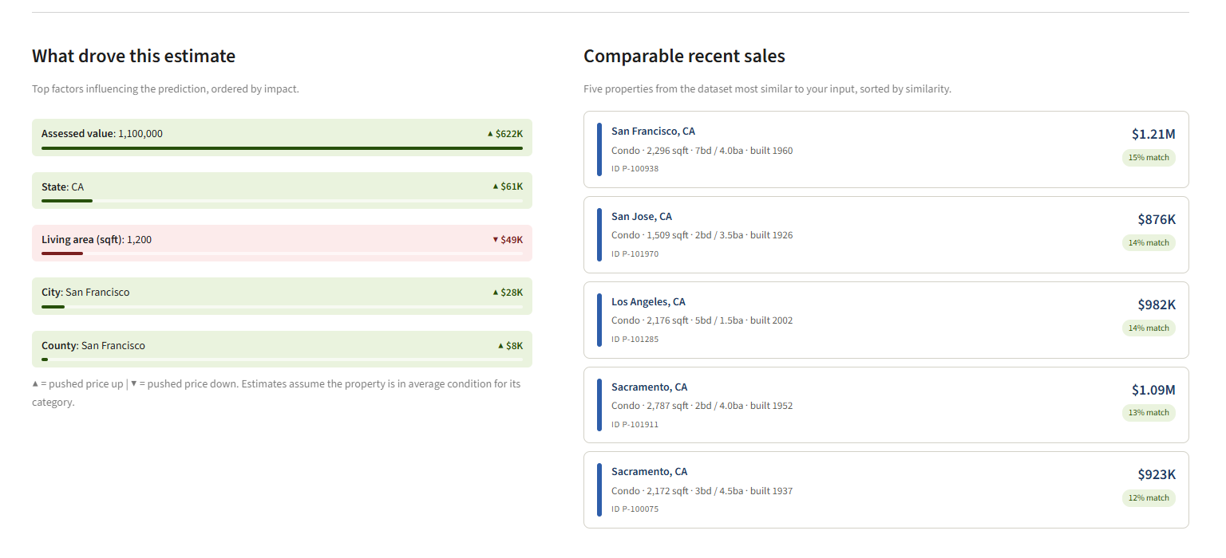

Chapter 6 — How accurate is it, really?
"How accurate?" is the natural first question. It's also a question that needs careful answering, because accuracy in property valuation is more nuanced than a single number suggests.

What the numbers mean
The standard accuracy measure for AVMs is called MAPE — Mean Absolute Percentage Error. In plain language: how far off, on average, are the model's predictions, expressed as a percentage of the actual price.
For example: if a property actually sold for $500,000 and the model estimated $460,000, the prediction was off by 8%. MAPE is the average of that percentage across many properties.

Industry context
To know whether a particular MAPE is good or bad, you need to compare against industry benchmarks:
Type of AVM | Typical accuracy (MAPE)
On-market AVMs (with full listing data) | 2 – 7%
Off-market AVMs (no listing data) | 7 – 10%
Fundamentals-only AVMs (sparse features) | 25 – 45%

How the AlloyTower models performed
Model | Typical accuracy | Industry comparison
A — Assessment-aware | 8.5% MAPE | Upper-end of off-market AVM range
B — Fundamentals-only | 45% MAPE | Within fundamentals-only range, hitting the dataset's ceiling

Both numbers are the result of cross-validation — running the model five different ways and averaging the results, which is more honest than just running it once.

Reading the gap honestly
The 37-percentage-point gap between Model A and Model B is striking, and worth explaining clearly:
Model A's strong performance is mostly the structure of the data showing through — in this dataset, tax assessments are unusually closely tied to sale prices. So Model A is doing something closer to "correct the assessment by 5%" than "value the property from scratch."
Model B is the more honest test of what the dataset's other features can teach a model. The 45% accuracy reflects a fundamental limit: the data's location features (state, city, county) are clean and useful, but the physical features (square footage, bedrooms, bathrooms) carry less signal than usual. State alone explains 57% of price variation. The other features add only a little on top of that.
This isn't a problem with the modelling — it's a property of the dataset. A larger, richer dataset with verified physical features would substantially improve Model B's performance. That's part of the Phase 2 recommendation.
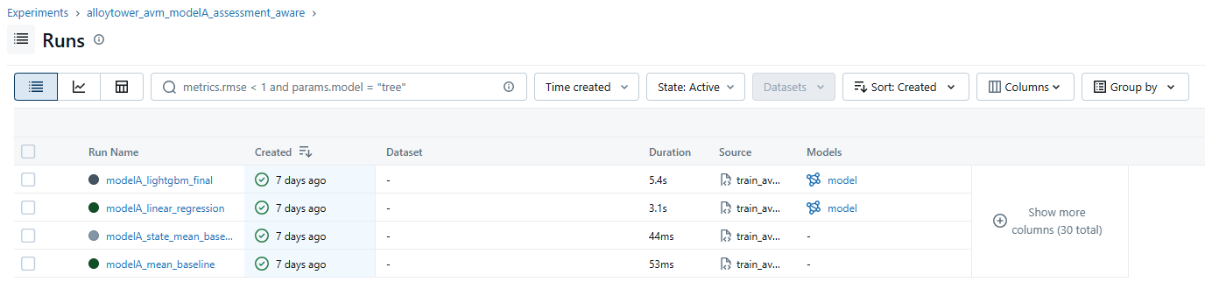

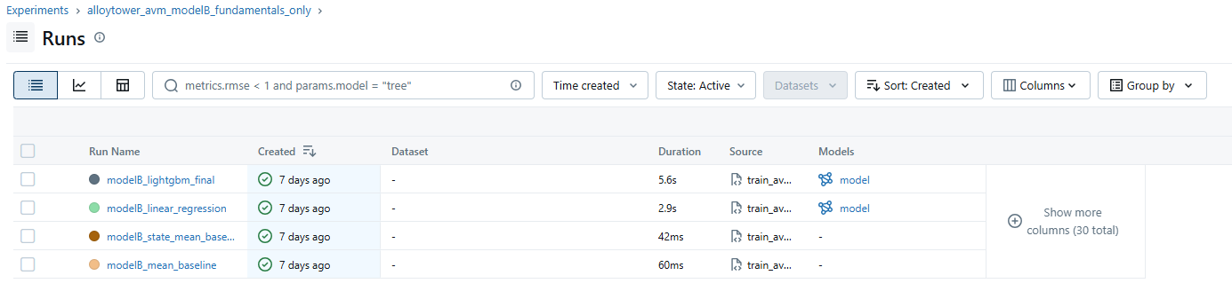

Chapter 7 — What does the live application look like?
The model lives inside a web application that anyone can use — no installation needed, just a web browser. The application has three pages.

Page 1 — Get a property valuation
This is the main page. The user enters a property's details on the left, clicks Estimate value, and gets a result on the right.
The result includes the estimated value, a likely range showing uncertainty, the top features that influenced the prediction, and five comparable properties from the dataset.
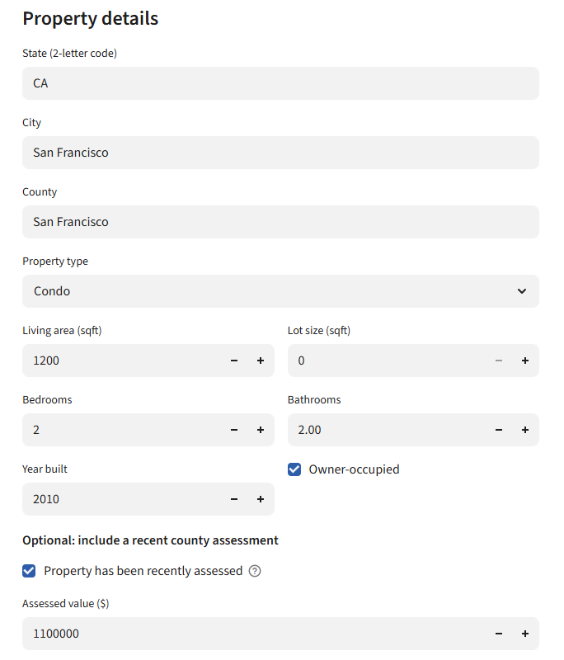

Page 2 — Market explorer
This is for users who want to browse the dataset rather than just price one property. Filters on the left let them narrow by state, property type, price band, year built, and size. The main view shows a chart of price vs. living area, plus a sortable table.
Useful for analysts checking what's in the dataset, and for stakeholders wanting to validate that the data behind the model is realistic.
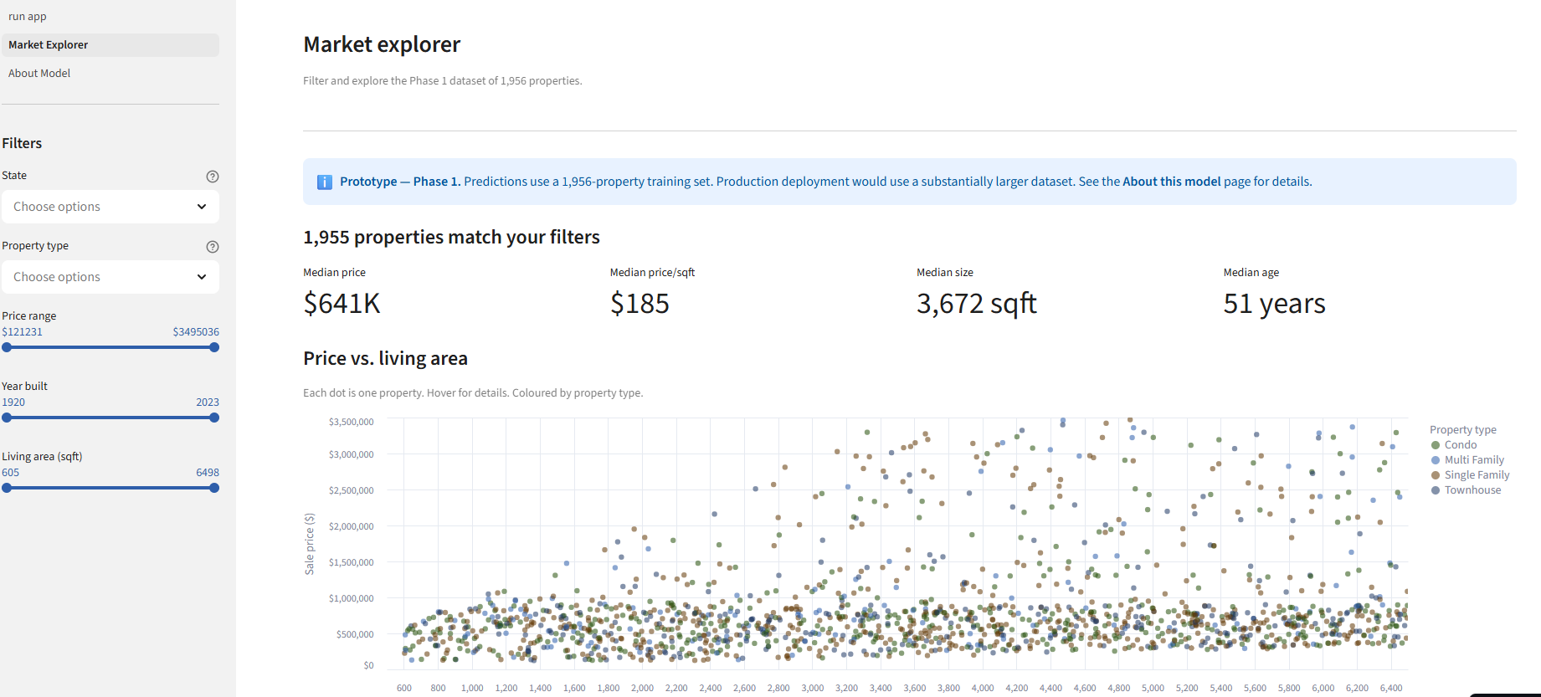

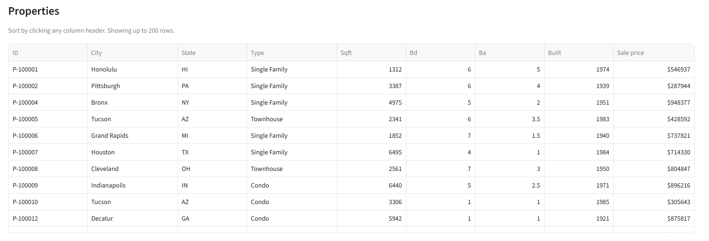

Page 3 — About this model
The credibility page. It explains in plain language how the model works, what its accuracy figures mean, what the dataset's known limitations are, and when to be sceptical of a prediction.
Stakeholders skip this page on first visit. They come back to it when they have doubts — and that's when honesty about limitations builds trust rather than eroding it.
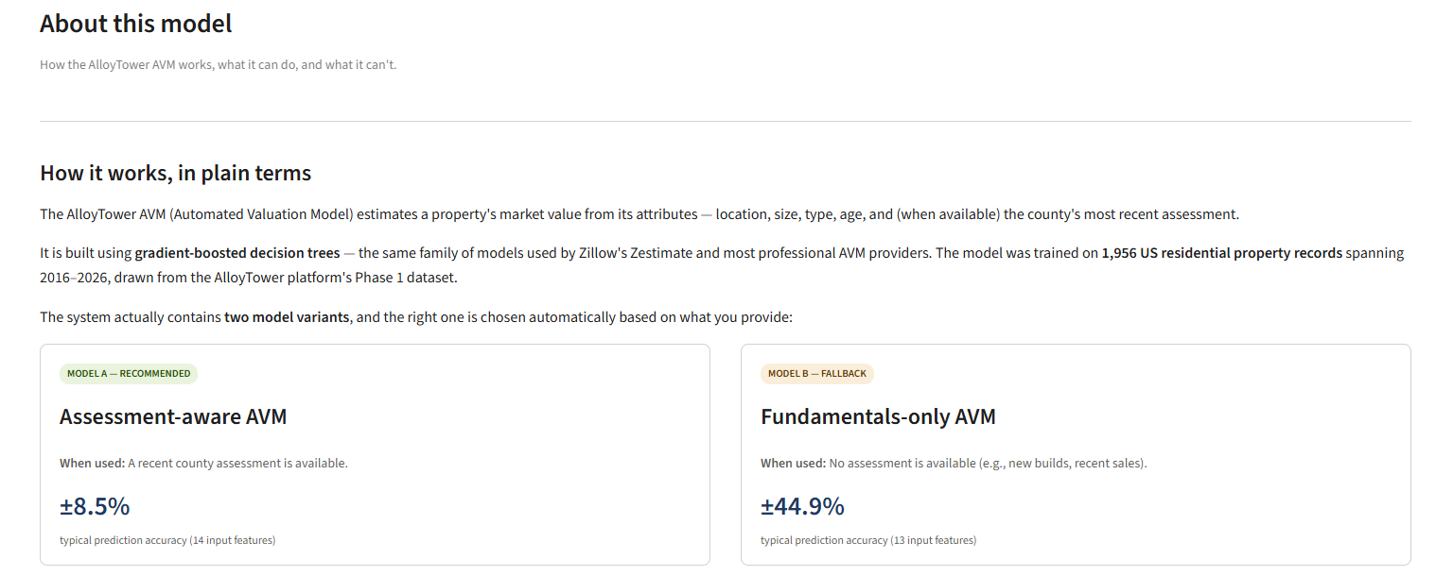

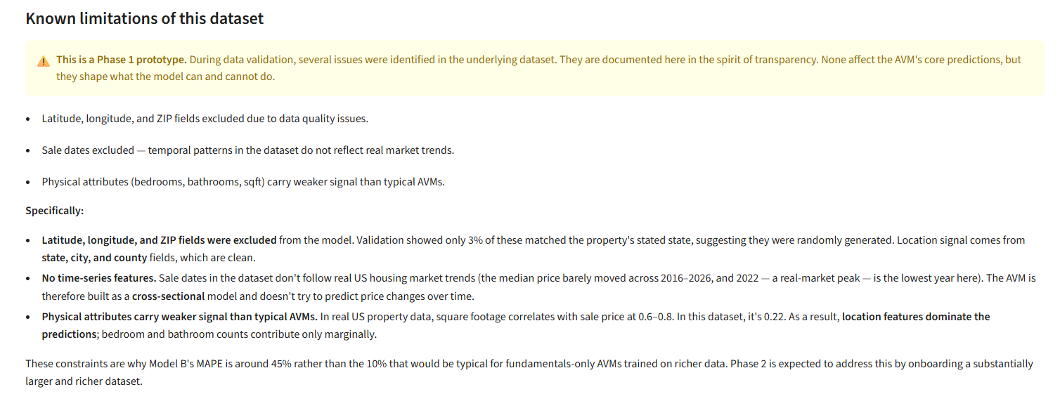

How it's deployed
The application has two parts that talk to each other:
- The frontend (what you see) lives on Streamlit Community Cloud — a free hosting service for web applications. URL: alloy-avm.streamlit.app.
- The backend (the model and the calculations) lives on Render — another free hosting service. URL: alloytower-avm-api.onrender.com.
Total monthly hosting cost: $0. The trade-off for free hosting is the 30-50 second wake-up time mentioned at the start of this document — fine for stakeholder demos, easily upgraded later if usage scales.

Chapter 8 — What did I learn?
Three lessons from this project that apply to any data-driven build.

Lesson 1 — Validate before you build
The most consequential single hour of this project was the data validation pass. Without it, the model would have been built on the assumption that lat/long, ZIP, and sale dates were trustworthy, and the results would have been silently wrong.
Future data projects at AlloyTower should treat validation as a non-negotiable first step, with documented findings before any modelling begins.

Lesson 2 — Honest scope beats inflated promises
There was a real temptation to attempt all five services in the original brief. It would have looked impressive in week one. By week three it would have produced a fragile demo with several services pretending to work.
Narrowing scope to what the data could support — and explicitly sequencing the rest into Phase 2 — produced a defensible deliverable that stakeholders can actually use, plus a clear conversation about what would unlock the rest.

Lesson 3 — Communication is part of the technical work
The hardest part of this project wasn't writing code or training models. It was writing the data quality findings report, the validation response document, and the model card — translating technical realities into plain-English language stakeholders could act on.
A perfectly accurate model that nobody trusts is worth less than a defensibly imperfect model that people understand. Most of this project's documentation exists for that reason.

Chapter 9 — What's next?
Phase 1 is a foundation. Phase 2 is what makes it a complete platform.

Data acquisition priorities
To unlock the remaining services in the original brief, the following data sources need to be onboarded:
- Real geographic identifiers — verified latitudes, longitudes, and ZIP codes. Unlocks neighbourhood-level features (school ratings, walkability, demographics) and meaningful map visualisations.
- A real listings feed — active properties, list prices, days-on-market, listing photos. Unlocks the marketplace service and on-market AVM accuracy in the 5–7% range.
- Tenant and lease data — needed for the property management service.
- Loan application data — needed for the mortgage pre-approval service.
- A larger training set — production AVMs typically train on 10,000+ records. The current 1,956 limits stability, especially in tail cases.

Suggested phasing
Phase 2 (next 1–3 months): onboard the listings feed and richer geographic identifiers. Retrain Model B with substantially better features. Build the marketplace service on the new data.
Phase 3 (3–6 months): bring in tenant, lease, and loan data. Build the property management and mortgage services. Move hosting to a paid tier with no cold starts.
Phase 4 (6+ months): real-time data ingestion, time-series features, full personalisation.
Each phase is independently shippable and adds visible value. The architecture chosen in Phase 1 — a separated backend and frontend, with an internal API — means each new service can be added without rewriting what already works.

Closing
This project started with an ambitious brief and a partially synthetic dataset. It ended with a working web application, a defensible accuracy benchmark, a documented set of data-quality findings, and a clear roadmap for the work still ahead.
None of that was inevitable. Each decision — to validate the data, to narrow the scope, to build two models instead of one, to deploy a live application rather than just a notebook — was made deliberately, in conversation with the team.
The goal of this document is to make those decisions visible to anyone who wasn't in the room when they were made.
Thank you for reading.

