  ADVANCED DATABASE  SG-G430-M0052-33386-26 | BRIGHT OZUZU UZOSIKE  STUDENT ID  @00808384

Table of Contents
Table of Contents 1
Online Banking Database: Design, Implementation & Management 3
Task 1 Report: Online Banking Database: Design, Implementation & Management 4
Introduction 4
Part 1: Database Design and Normalisation 5
1.1 Identifying Entities and Relationships 5
1.2 Normalisation to Third Normal Form 6
1.3 Entity-Relationship Diagram 6
1.4 Table Creation and Data Types 7
Constraints Applied 8
1.5 Populating the Database 14
Part 2: Database Objects and Queries 16
2.1 Searching any Accounts by Name 16
2.2 Payments Which Are Due in Less Than 5 Days 18
2.3 Inserting New Customers 20
2.4 Updating an Existing Customer 24
2.5 Snapshot View of Transactions Having Overdue Fees 27
2.6 Trigger for Closing an Account Automatically 29
2.7 Customers Having Less Than 50% Overdue Fees Repayment 32
2.8 Test Cases of Database Objects 33
2.9 Some Additional Database Objects 33
7a: Customer Account Summary Procedure 33
7b: Customer Archival Trigger 35
Additional Recommendations 38
Data Integrity and Concurrency 38
Database Security 38
Database Backup and Recovery 39
Conclusions 40
NHS Prescribing Data: SQL Querying & Analysis 41
Task 2 Report: NHS Prescribing Data: SQL Querying & Analysis 42
Introduction 42
Part 1: Database Creation and Data Import 43
1.1 Creating the Database 43
1.2 Importing the CSV Files 43
1.3 Adding Primary and Foreign Key Constraints 52
1.4 Database Diagram 52
1.5 Verifying the Import 53
Part 2: Queries and Analysis 54
2.1 Question 2: Drugs in Tablet or Capsule Form 54
2.2 Question 3: Total Quantity per Prescription 54
2.3 Question 4: Most Prescribed Chemical Substance per Month 55
2.4 Question 5: Prescriptions per BNF Chapter with Cost Statistics 56
2.5 Question 6: Most Expensive Prescription per Practice (Over £4,000) 57
2.6 Question 7: Additional Queries 58
7a: Practice Specialisation Analysis 58
7b: Bulk Purchasing Opportunities 59
7c: Unusual or Potentially Erroneous Prescriptions 60
7d: Month-on-Month Comparison of Prescribing Volumes 61
Conclusions 64
References 65

Online Banking Database: Design, Implementation & Management

Task 1 Report: Online Banking Database: Design, Implementation & Management

Introduction
The design and implementation of a relational database system for an online banking platform is documented in this report. The bank requires a system capable of managing customer information, account details, transaction records, overdue fee tracking, and repayment processing. The platform handles hundreds of transactions daily, making data integrity, consistency, and performance critical considerations throughout the design process.

The approach taken in this report follows a top-down database design methodology. Starting from the client requirements specification, the key entities were identified and their relationships mapped. The schema was then normalised to Third Normal Form (3NF) to eliminate redundancy and prevent insertion, update, and deletion anomalies. All tables, constraints, and database objects were implemented using T-SQL in Microsoft SQL Server Management Studio (SSMS) 2022.

Beyond the core requirements, the design incorporates forward-looking features such as support for joint accounts through a many-to-many relationship model, password hashing using SHA2_512 with unique salts for each user, and a customer archival mechanism for marketing data retention. These additions reflect the kind of flexibility that a production banking system would demand as requirements evolve over time.
The report is structured as follows: Part 1 covers the database design, normalisation, and table creation. Part 2 addresses the stored procedures, functions, views, triggers, and queries required by the brief. Finally, recommendations are provided on data integrity, concurrency, security, and backup and recovery, all applied specifically to this online banking scenario.

Part 1: Database Design and Normalisation

1.1 Identifying Entities and Relationships
The first step in the design process was to carefully read the client requirements and extract the entities and their attributes. Following the principles covered in the database design lecture, nouns in the specification were treated as candidate entities or attributes, while verbs were treated as candidate relationships.

The following core entities were identified from the requirements specification:
Customer - Stores personal details (name, date of birth), authentication credentials (username, password), and optional contact information (email, telephone). The brief states that customer information is retained even after account closure for marketing purposes, so an IsActive flag is used rather than deleting records.

Address - Contains the physical address fields (AddressLine1, AddressLine2, City, Postcode). This was separated from Customer to achieve Third Normal Form, since address fields are not functionally dependent on CustomerID. Two customers living at the same address (for example, family members) would otherwise cause data redundancy.

AccountType – This table had the five account types specified in the brief: Savings, Checking, Loan, Credit Card, and Investment. The type name is functionally dependent on the type itself, not on any individual account, so extracting it into a separate table follows the same normalisation principle used in the SalfordBankLtd workshop.

Account - Represents each bank account or product. Holds the account name, status (Active, Dormant, Closed, Frozen), opening date, closure date, balance, and an optional reference number for loan-type products.

CustomerAccount – This table was used to resolve the many-to-many relationship between the Customer table and the Account table. While the brief does not explicitly mention joint accounts, this design provides the flexibility to support them in future without structural changes to the schema. This follows the same pattern as the CustomerAccounts table in the Week 7 workshop.

Transaction - Records each banking transaction, linked to both an account and the customer who initiated it. Includes transaction date, due date (for loan or credit payments), and completion date (NULL if the transaction is still pending).

OverdueFee - Tracks fees charged for late payments. Each overdue fee is linked to a specific transaction and records the fee amount, the number of days overdue, the total owed, and the total repaid. The outstanding balance is implemented as a computed column (TotalOwed minus TotalRepaid), ensuring it is always mathematically consistent.

Repayment - Records individual repayments made by customers toward their overdue fees. Each repayment is linked to a specific OverdueFee record and captures the date, amount, and payment method (Bank Transfer, Card, or Cash as specified in the brief).

1.2 Normalisation to Third Normal Form
The database was designed to satisfy Third Normal Form (3NF). According to Elmasri and Navathe (2016), a relation is in 3NF if it is in 2NF and no non-prime attribute is transitively dependent on the primary key. The normalisation decisions are documented below.

First Normal Form (1NF): All tables contain only atomic values with no repeating groups. Each column holds a single value, and each row is uniquely identifiable by its primary key. For example, the Customer table stores first name and last name in separate columns rather than a single combined name field.

Second Normal Form (2NF): All non-key attributes are fully functionally dependent on the entire primary key. A case for this is seen in the CustomerAccount table.The table serves as a bridge between the Customer and Account tables, having a combination of CustomerID and AccountID columns as its primary key. The DateLinked attribute depends on the combination of both keys (composite key), not on either individually.

Third Normal Form (3NF): No transitive dependencies exist. Two key normalisation decisions were made to achieve this:
First, Address was separated from Customer. In the original flat structure, address fields such as City and Postcode are functionally dependent on AddressLine1 and Postcode (not on CustomerID). Keeping them in the Customer table would create a transitive dependency: CustomerID determines AddressID, and AddressID determines City and Postcode. By extracting addresses into their own table with a UNIQUE constraint on (AddressLine1, Postcode), this transitive dependency is removed.

Second, AccountType was extracted as a lookup table. If the type name were stored directly in the Account table, changing the name of an account type (for instance, renaming 'Checking' to 'Current Account') would require updating every row. The lookup table means the name is stored once and referenced via a foreign key, eliminating this update anomaly.

1.3 Entity-Relationship Diagram
The diagram below shows all eight tables and their relationships, including the primary keys, foreign keys, and the cardinality of each relationship.

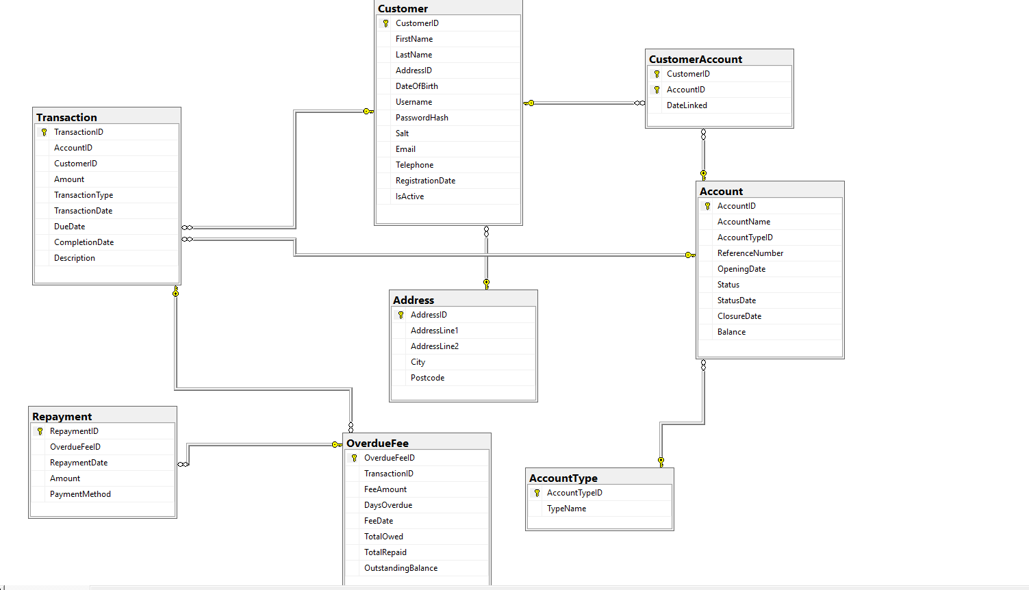

The key relationships are: Address to Customer (one-to-many), Customer to CustomerAccount (one-to-many), Account to CustomerAccount (one-to-many, forming the many-to-many link), AccountType to Account (one-to-many), Account to Transaction (one-to-many), Customer to Transaction (one-to-many), Transaction to OverdueFee (one-to-zero-or-one), and OverdueFee to Repayment (one-to-many).

1.4 Table Creation and Data Types
T-SQL statements were employed in creating all tables in the database. The tables are created in dependency order so that foreign key references always point to tables that already exist. For cases where the table names to be given were considered reserved by SMSS, ‘[]’ was used to escape it (the only case was with Transaction table). The full script is included in the accompanying SQL file. Below is a summary of each table with the reasoning behind the key design choices.

Column | Data Type | Justification
CustomerID, AccountID, etc. | INT IDENTITY(1,1) | Auto-incrementing surrogate keys provide unique identification without relying on business data that could change.
FirstName, LastName | NVARCHAR(50) | NVARCHAR supports Unicode characters for international names. 50 characters provides reasonable capacity without wasting storage.
PasswordHash | BINARY(64) | Fixed-length binary output from SHA2_512 hashing. Plain-text passwords are never stored, following security best practice.
Salt | UNIQUEIDENTIFIER | Generates a globally unique salt for each customer, preventing rainbow table attacks.
Balance, Amount | DECIMAL(18,2) | Exact numeric type for monetary values. Preferred over MONEY because DECIMAL provides explicit control over precision and scale and avoids implicit rounding during division operations.
DateOfBirth, OpeningDate | DATE | Stores date only without time component, which is appropriate for dates where time is irrelevant.
TransactionDate | DATETIME2 | Captures both date and time with higher precision than the legacy DATETIME type. Important for recording the exact moment of financial transactions.
Telephone | NVARCHAR(20) | Phone numbers can contain spaces, plus signs, and leading zeros, so they must be stored as character strings, not numeric types.
IsActive | BIT | Boolean flag (0 or 1) to indicate whether a customer's relationship with the bank is active. Supports the requirement to retain closed customer records for marketing.
OutstandingBalance | Computed Column | Defined as (TotalOwed - TotalRepaid). Automatically calculated, ensuring mathematical consistency without manual updates.

Constraints Applied
Several constraints were applied to enforce data integrity at the database level, reducing the reliance on application-level validation. These include:
PRIMARY KEY constraints on all tables to uniquely identify each row. FOREIGN KEY constraints to enforce referential integrity between related tables, ensuring that, for example, a transaction cannot reference a non-existent account. CHECK constraints to restrict column values to valid business options, such as limiting account status to 'Active', 'Dormant', 'Closed', or 'Frozen', and payment methods to 'Bank Transfer', 'Card', or 'Cash'. A CHECK constraint on the Email column validates the basic format of email addresses using a LIKE pattern. A UNIQUE filtered index on ReferenceNumber ensures that loan and credit card reference numbers are unique when provided, while allowing multiple NULL values for accounts that do not require a reference number. The DEFAULT constraint on several columns (such as Status defaulting to 'Active' and Balance defaulting to 0.00) reduces the risk of incomplete data entry.
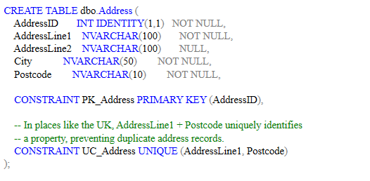
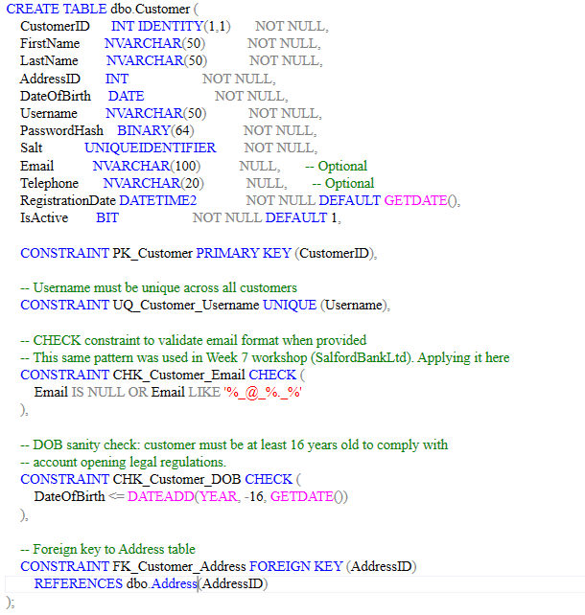
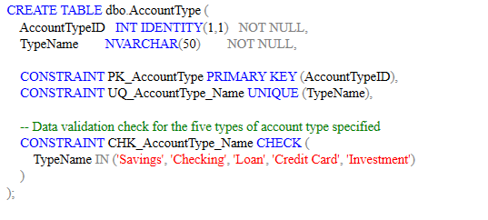
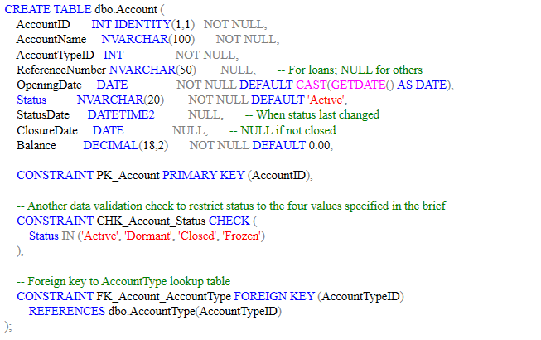
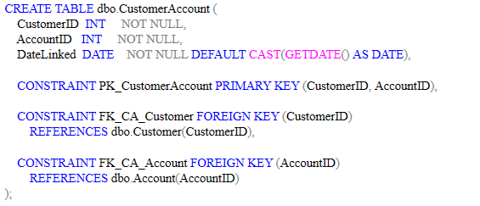
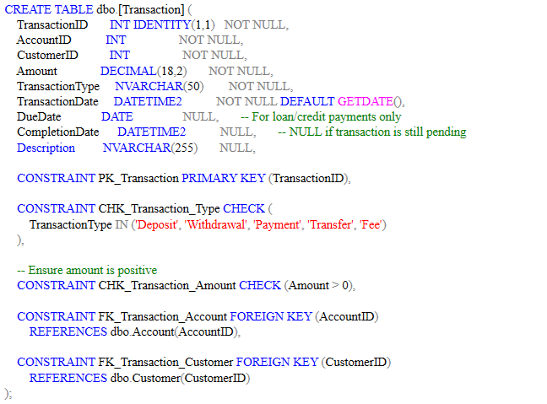
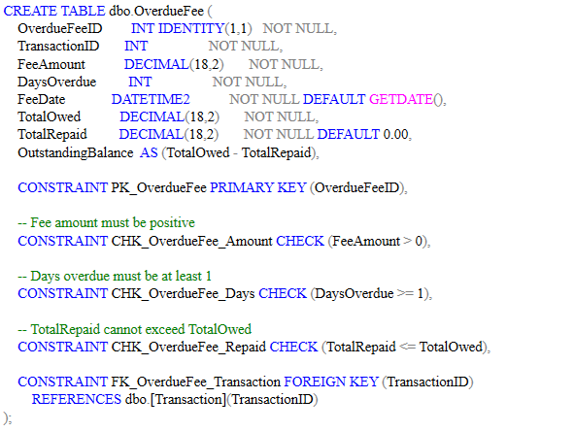
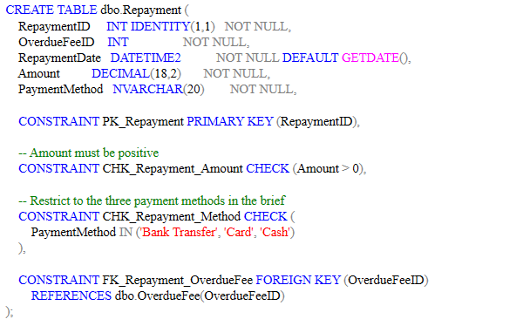
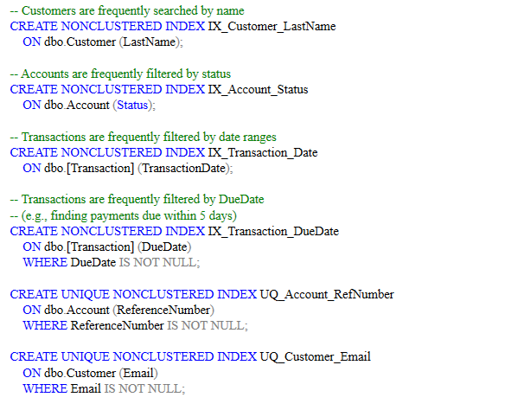
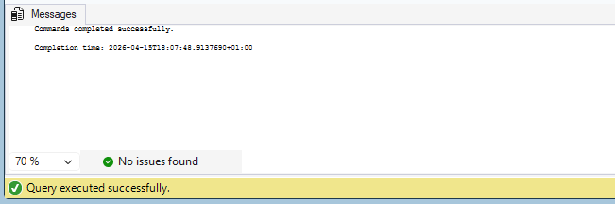
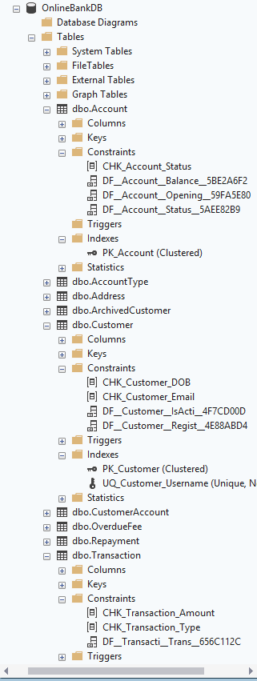

1.5 Populating the Database
The tables were populated with carefully designed test data. The data was not randomly generated but instead constructed to ensure that every subsequent query, stored procedure, trigger, and view could be meaningfully tested as suggested in the brief. Key scenarios built into the test data include:
A joint account shared by two customers (James and Sarah Harrison on Account 2), demonstrating the many-to-many relationship via the CustomerAccount junction table. Pending loan and credit card payments with due dates set relative to the current system date, ensuring the 'payments due in less than 5 days' function always returns valid results when executed. Overdue fees with varying repayment levels: Michael at 80% repaid (should pass the 50% threshold), Thomas at 33% and 0% on two fees, and Priya at 33% (both should fail the threshold). A closed account (Robert Taylor) with IsActive set to 0, retained for marketing purposes as specified in the brief. A frozen account (David's Emergency Checking) to demonstrate all four status values.

Password data is inserted using the HASHBYTES function with SHA2_512 and a unique salt generated via NEWID() for each customer, following the technique from the database security workshop.

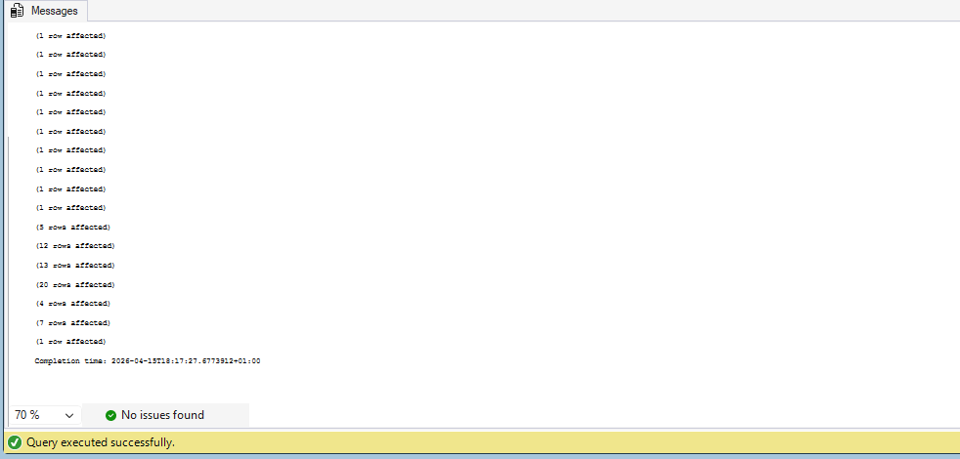
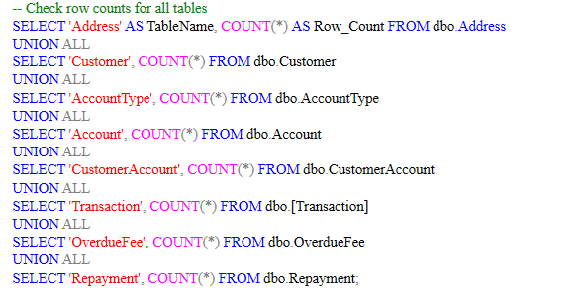
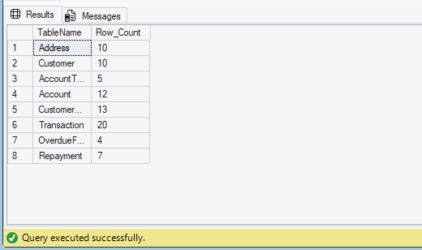
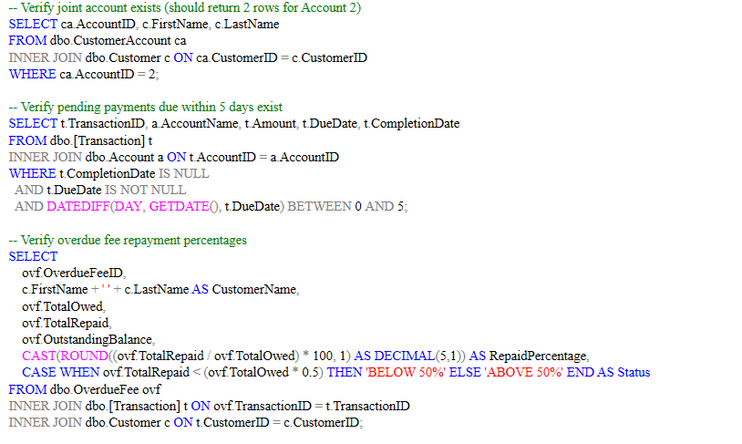
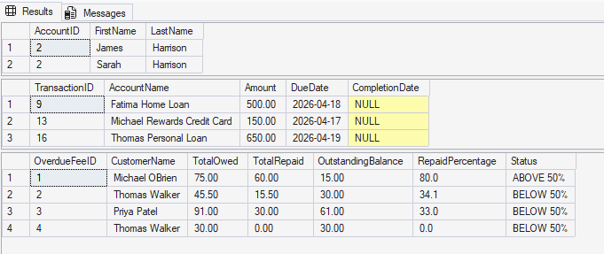

Part 2: Database Objects and Queries

2.1 Searching any Accounts by Name
A stored procedure named uspSearchAccountsByName was created to allow the bank to search for accounts or products by name. The procedure accepts a single parameter @SearchName and uses the LIKE operator with wildcards on both sides for flexible partial matching. Results are sorted by OpeningDate in descending order, so the most recently opened accounts appear first, as required by the brief.
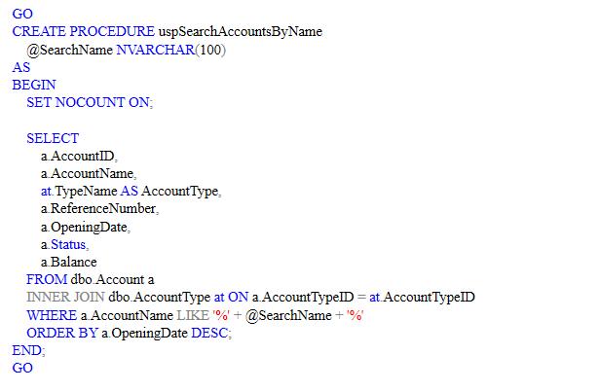The procedure was tested with several scenarios: searching for 'Savings' (returning four accounts), 'Loan' (returning two), 'Credit' (returning two), a non-existent name 'Mortgage' (returning zero rows), and a specific account name 'Emma Student' (returning one row).
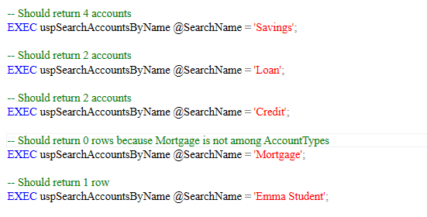
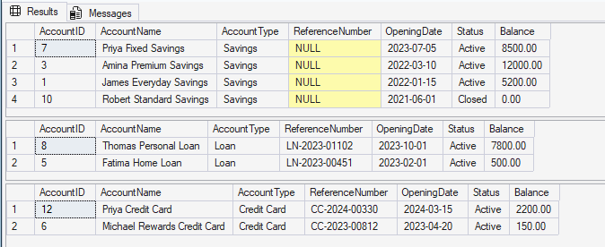

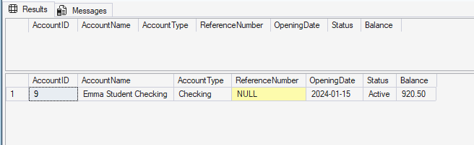

2.2 Payments Which Are Due in Less Than 5 Days
This was implemented as a table-valued function (TVF) named PaymentsDueSoon rather than a stored procedure. The rationale for choosing a function over a procedure is that a TVF returns a result set which can be used directly in SELECT statements, JOINs, and WHERE clauses, giving the bank greater flexibility in how they consume the data. For example, the bank could write SELECT * FROM PaymentsDueSoon() WHERE AccountType = 'Loan' to filter the results further.

The function filters transactions where CompletionDate IS NULL (pending), DueDate is within the next five days (using BETWEEN with CAST(GETDATE() AS DATE) and DATEADD), and the account type is either Loan or Credit Card. The DATEDIFF function is used to calculate the number of days until each payment is due.
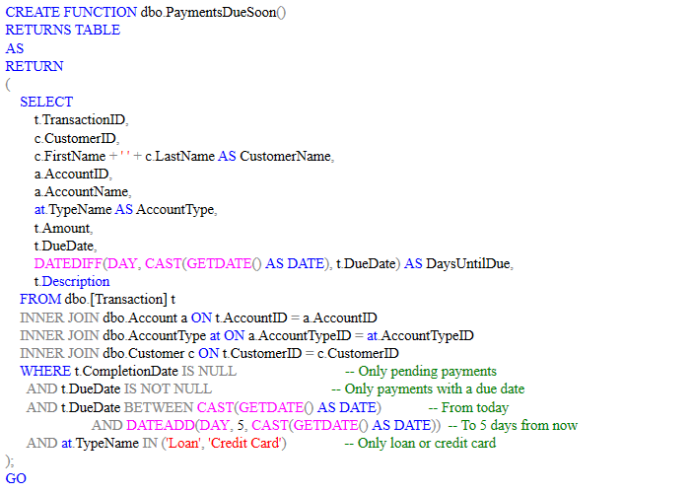
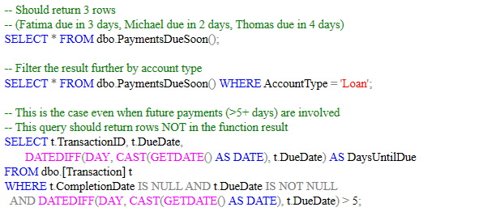
The results for these test cases were:
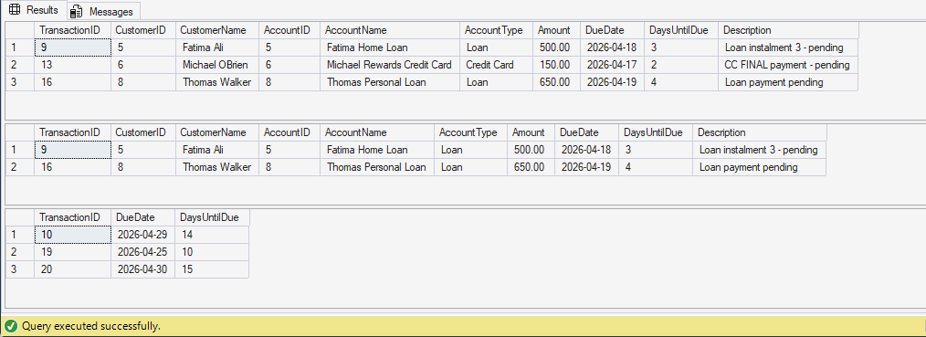

2.3 Inserting New Customers
The stored procedure uspInsertNewCustomer handles the insertion of a new bank customer. It accepts all required customer fields including the plain-text password, which is never stored directly. Instead, the procedure generates a unique salt using NEWID() and hashes the password with HASHBYTES('SHA2_512', @Password + CAST(@Salt AS NVARCHAR(36))) before inserting the hash and salt into the Customer table.

The procedure also intelligently handles addresses: it first checks whether the address already exists in the Address table (matching on AddressLine1 and Postcode). If it does, the existing AddressID is reused; if not, a new address record is created. This prevents duplicate address records while maintaining referential integrity.

ACID compliance is ensured through BEGIN TRANSACTION with TRY...CATCH error handling. If any part of the insertion fails (for example, a duplicate username), the entire transaction is rolled back and no partial data is committed. This follows the pattern established in the Week 9 workshop on transaction.
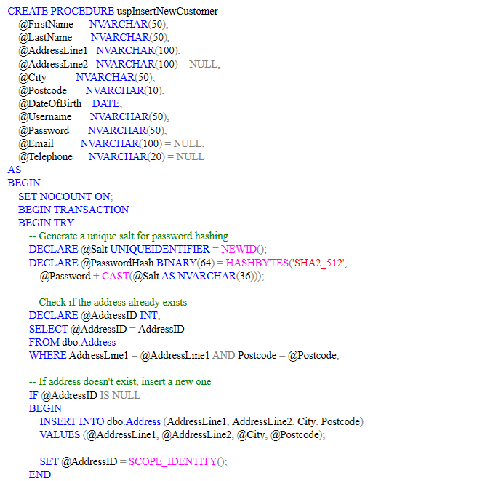

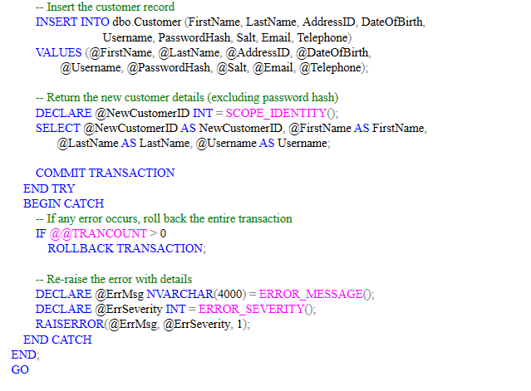

Test cases:

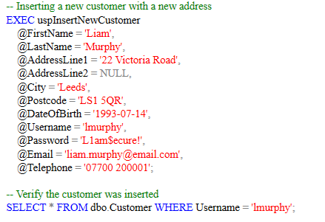
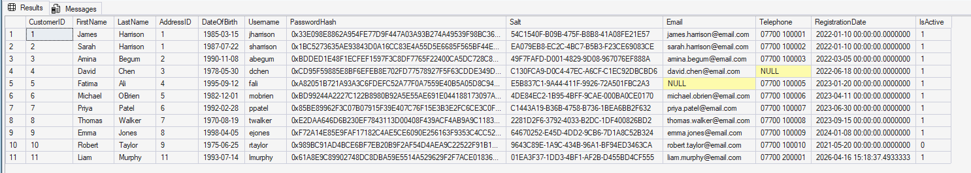
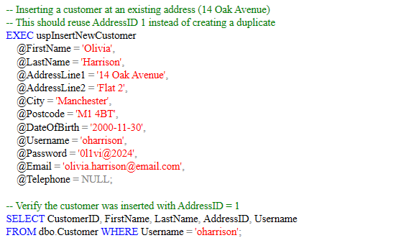

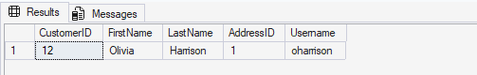

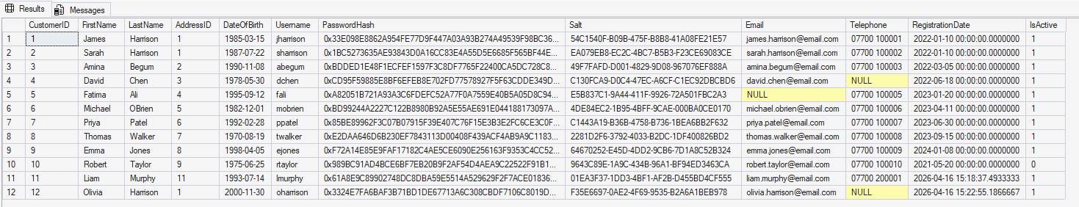

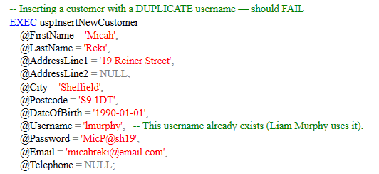
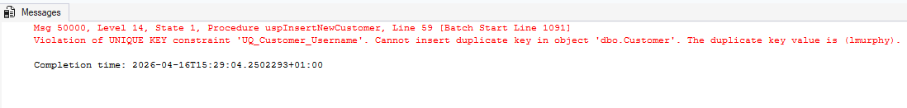
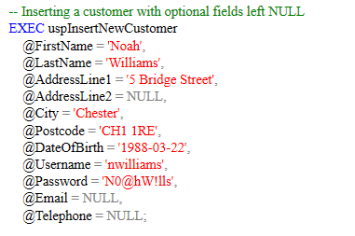

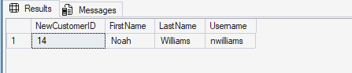

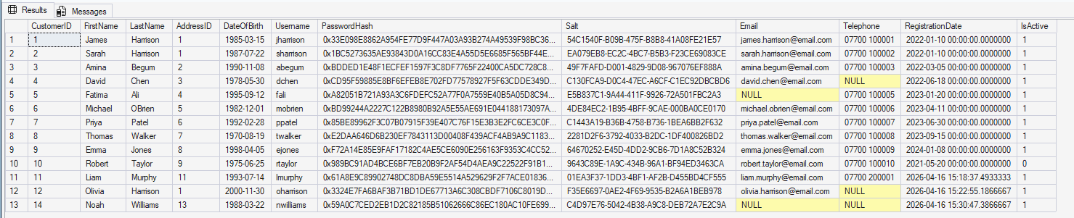

2.4 Updating an Existing Customer
The stored procedure uspUpdateCustomer allows modification of customer details that is already existing. It is designed so that only the fields provided as parameters are updated; any parameter left as NULL retains the existing value using the ISNULL function. This prevents accidental overwriting of data when the bank only needs to change a single field such as a telephone number.

The procedure first validates that the specified CustomerID exists, raising an appropriate error if it does not. For address changes, it follows the same pattern as the insert procedure, checking for existing addresses before creating new records. Like the insert procedure, it uses BEGIN TRANSACTION with TRY...CATCH for ACID compliance.
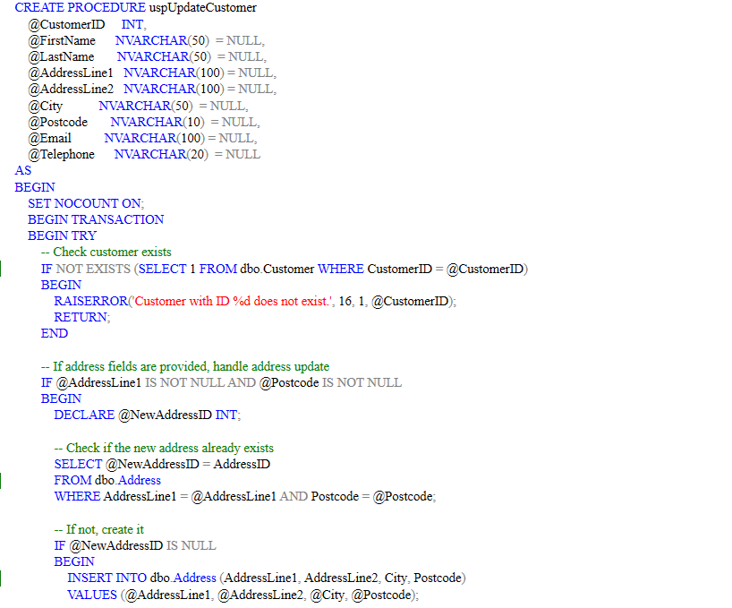
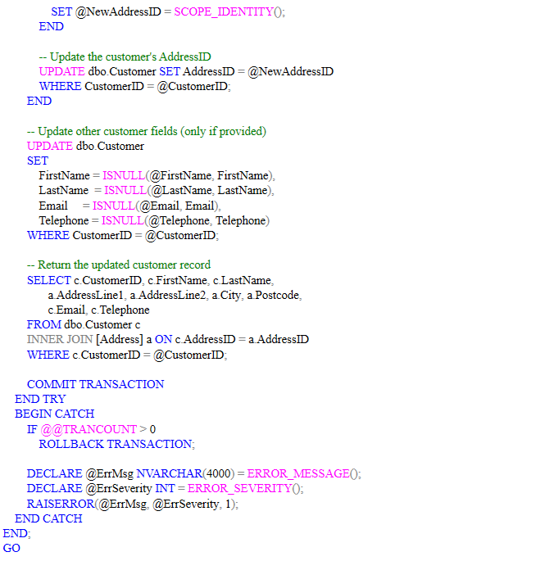

Test cases:

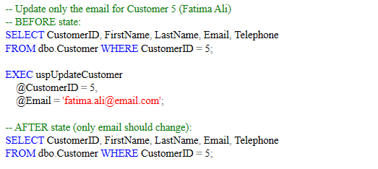
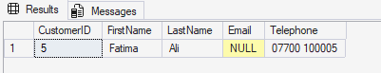
Before
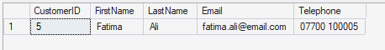
After
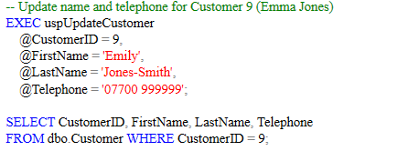

Before

Emily Jones changed to Emily Jones-Smith.

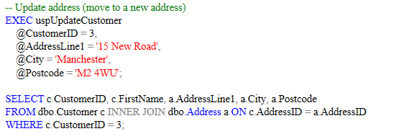
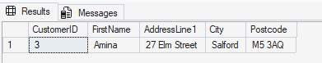
Before
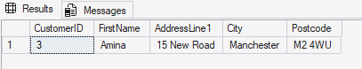
After
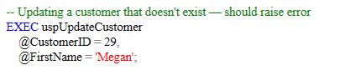
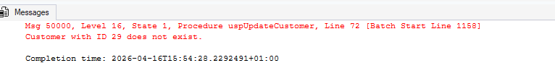

2.5 Snapshot View of Transactions Having Overdue Fees
A view named TransactionsWithOverdueFees was created to give the bank a consolidated view of all transactions along with any associated overdue fees. The view joins five tables: Transaction, Account, AccountType, Customer, and OverdueFee.

A LEFT JOIN is used on the OverdueFee table rather than an INNER JOIN, so that transactions without overdue fees are still included in the results. The view also includes a computed TransactionStatus column using a CASE expression, which classifies each transaction as 'Pending', 'Completed Late', or 'Completed On Time' based on the CompletionDate and DueDate values.

The benefits of using a view here are significant. It simplifies what would otherwise be a complex multi-table join into a single queryable object. It can also be used as a security mechanism, allowing users to query the view without requiring direct access to the underlying tables. Since only the view definition is stored and not the data itself, it introduces no storage overhead (Ramakrishnan and Gehrke, 2003).
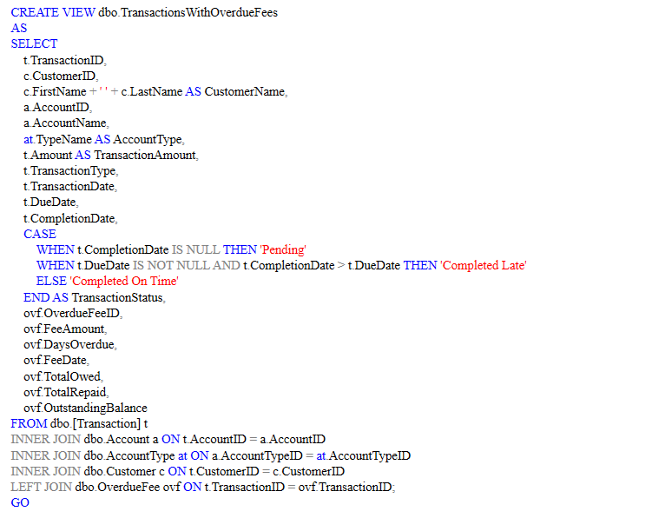

Test cases:

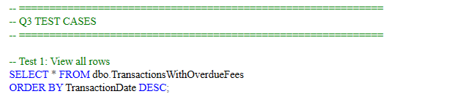
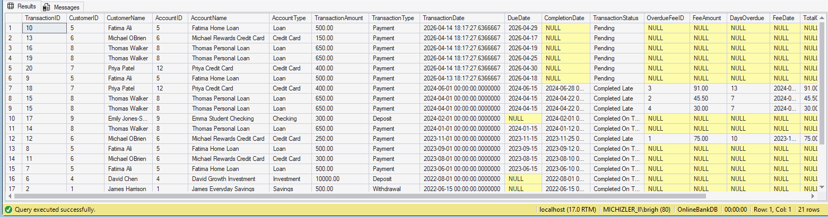

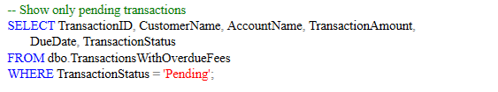
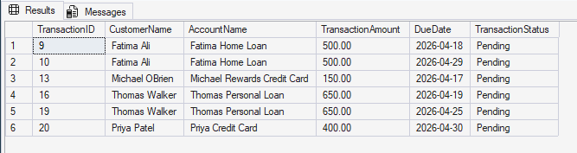
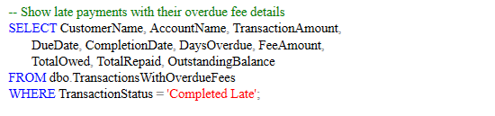
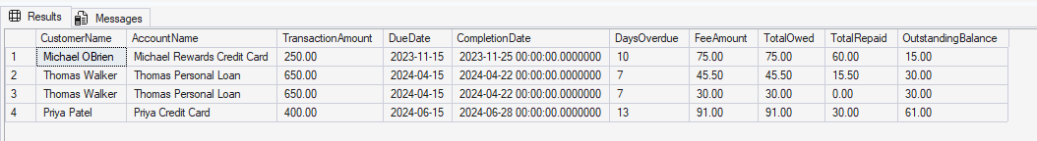

2.6 Trigger for Closing an Account Automatically
A trigger named t_AutoCloseAccount was created on the Transaction table. It fires after an UPDATE operation and implements the following business rule: when the final scheduled payment on a Loan or Credit Card account is marked as completed, the account status is changed from 'Active' to 'Closed', the date of closure is recorded, and then the account balance is set to zero.

The trigger works by checking three conditions when a transaction's CompletionDate is updated from NULL to a non-NULL value: (1) the associated account is of type Loan or Credit Card, (2) the account is currently Active, and (3) there are no remaining pending payments (transactions with CompletionDate IS NULL and a non-NULL DueDate) for that account. Only when every one of these conditions are true does the trigger change the status on the account.

The trigger was tested in two stages for Fatima's Home Loan (Account 5). First, Transaction 9 was marked as completed. Since Transaction 10 was still pending, the trigger correctly did not close the account. Then Transaction 10 (the final payment) was completed, and the trigger successfully changed the account status to 'Closed' and recorded the closure date. A second test was performed on Michael's Credit Card (Account 6), confirming the same behaviour.
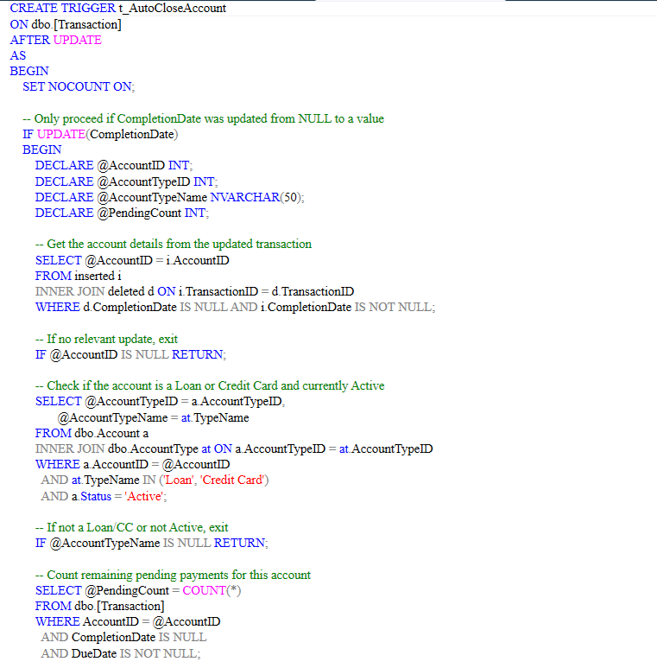
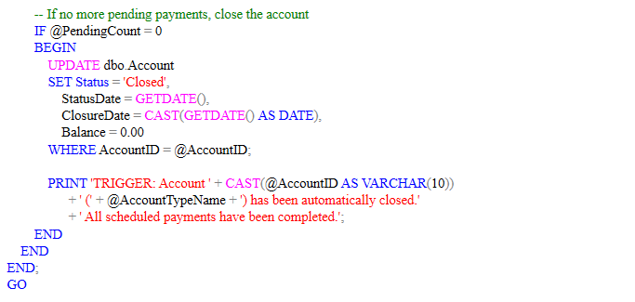

Test cases:

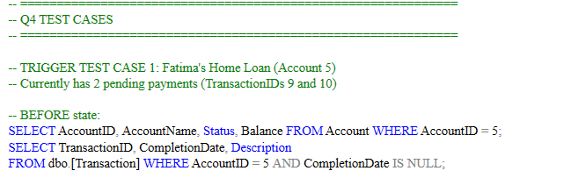
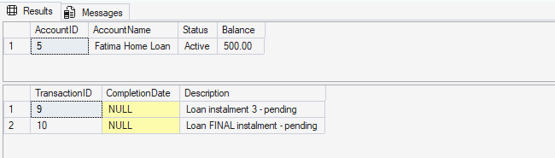
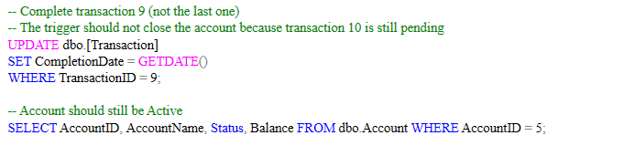
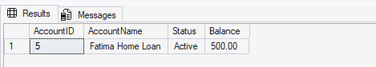
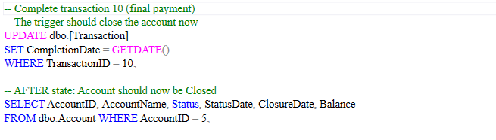
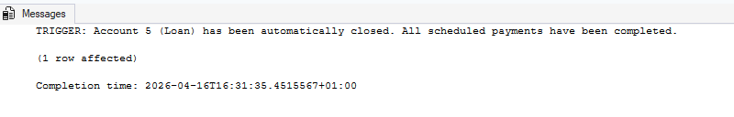
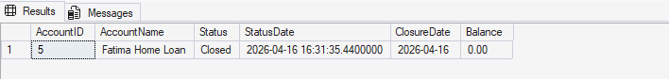
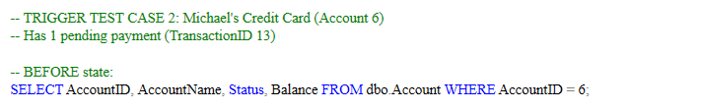
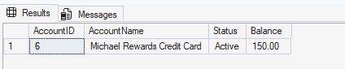
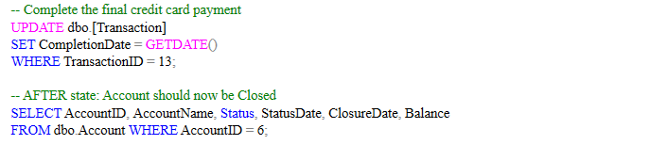
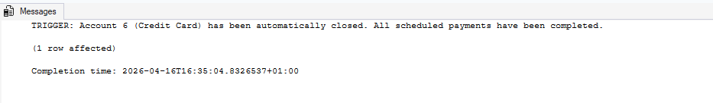
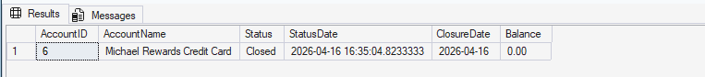

2.7 Customers Having Less Than 50% Overdue Fees Repayment
A SELECT query was written to identify customers who have repaid less than 50% of their overdue fees. The query filters at the individual fee level using the condition WHERE TotalRepaid < (TotalOwed * 0.5). The query results are then grouped by customer and the number of matching fees are counted.

The query uses NULLIF to prevent division-by-zero errors when calculating the overall repaid percentage. It also uses CAST and ROUND for clean decimal output.
The expected results, based on the test data, are: Thomas Walker with 2 under-repaid fees (Fee 2 at 34% repaid and Fee 4 at 0% repaid), and Priya Patel with 1 under-repaid fee (Fee 3 at 33% repaid). Michael O'Brien does not appear because his single fee (Fee 1) is 80% repaid, which exceeds the 50% threshold.
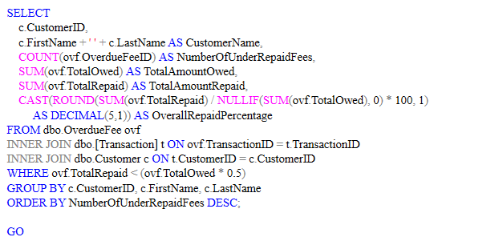
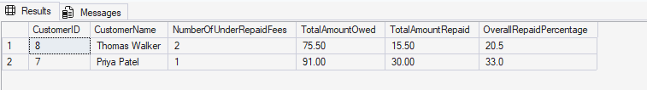

2.8 Test Cases of Database Objects
All database objects were tested using a structured approach. For each object, the test cases demonstrate both expected successful outcomes and deliberate failure scenarios to prove that error handling works correctly. The test strategy includes:
For stored procedures: execution with valid parameters, execution with edge-case values, and execution with invalid data that should trigger the CATCH block. For the trigger: a two-step test showing the trigger does not fire prematurely (when pending payments remain) and fires correctly on the final payment. For the view: queries with different filters to demonstrate all three transaction statuses. For the function: both positive results and verification that payments due beyond 5 days are excluded.

All test case screenshots are included in the relevant sections above, showing both the T-SQL execution and the result sets.

2.9 Some Additional Database Objects

7a: Customer Account Summary Procedure
A stored procedure named uspCustomerAccountSummary was created to provide a comprehensive overview for any customer. It returns three result sets: the customer's personal details and address, a summary of all their accounts with transaction counts and aggregate figures (total deposits, total withdrawals, pending payments), and any outstanding overdue fees. This would be valuable for customer service representatives handling enquiries, providing a complete picture in a single call.

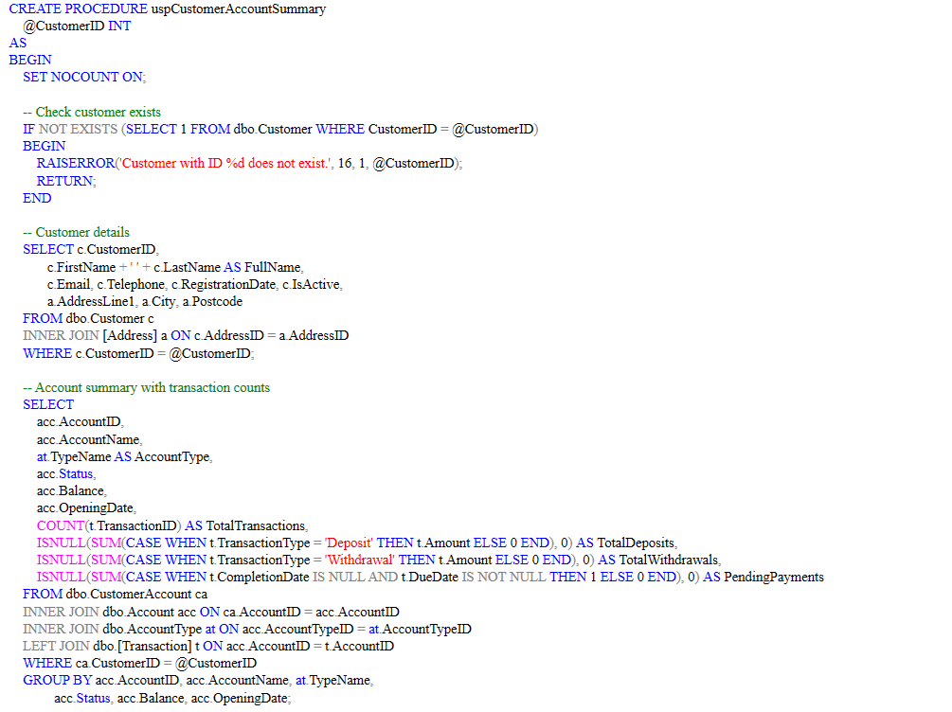
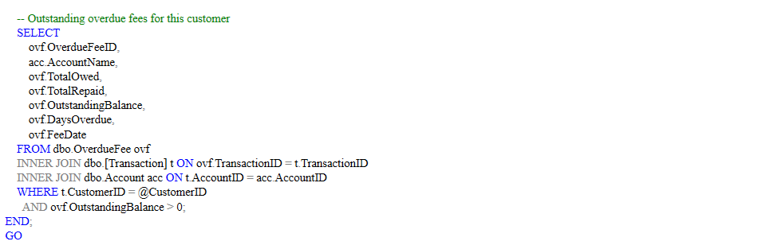

Test cases:

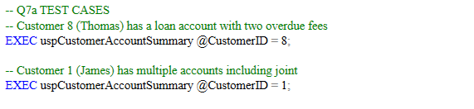
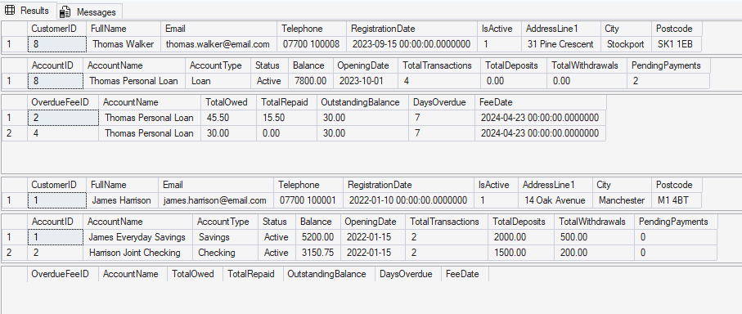
Thomas Walker has two late payments on his loan account overdue by 7 days each.
James Harrison has multiple accounts (including one joint checking account) with no loan or credit accounts. Hence, no overdue fees exist.

7b: Customer Archival Trigger
A trigger named t_ArchiveDeactivatedCustomer was created to support the brief's requirement that customer information is retained for marketing purposes when an account is closed. When a customer's IsActive flag is updated from 1 to 0, this AFTER UPDATE trigger automatically copies the customer's key details (name, email, telephone) into an ArchivedCustomer table along with a timestamp.
This approach means the customer record remains in the main Customer table (preserving referential integrity with their transactions and accounts) while a snapshot is separately stored for marketing use. The trigger follows the archive pattern demonstrated in the Week 8 workshop.

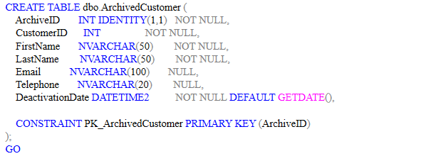
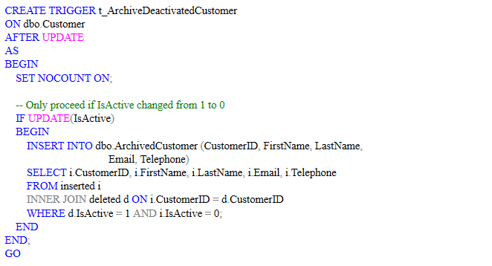

Test cases:

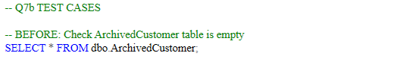


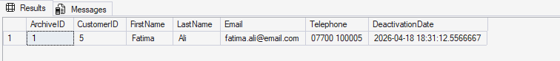

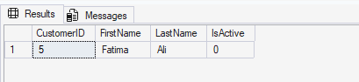
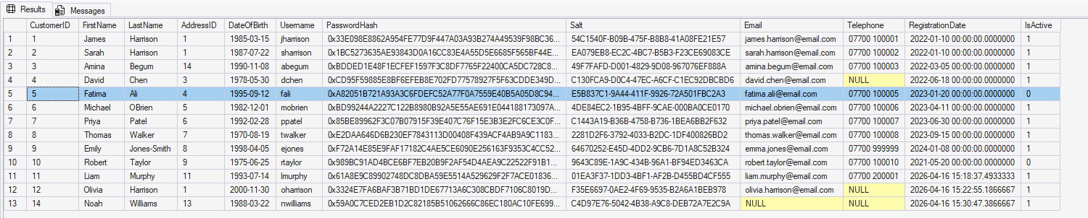

Additional Recommendations

Data Integrity and Concurrency
Data integrity in this banking system is enforced at multiple levels. At the schema level, primary key, foreign key, CHECK, UNIQUE, and NOT NULL constraints prevent invalid data from being entered. The computed column for OutstandingBalance in the OverdueFee table guarantees mathematical consistency without relying on application logic.

At the procedural level, all stored procedures that modify data use BEGIN TRANSACTION with TRY...CATCH blocks. If any statement within the transaction fails, the entire operation is rolled back, preventing partial updates that could leave the database in an inconsistent state. This ensures the atomicity and consistency properties of ACID transactions (Connolly and Begg, 2015).

For concurrency, the default transaction isolation level in SQL Server is READ COMMITTED, which prevents dirty reads by ensuring that a transaction cannot read data modified by another uncommitted transaction. For this banking scenario, READ COMMITTED is appropriate for most operations. However, for critical financial operations such as balance transfers between accounts, a higher isolation level such as SERIALIZABLE could be considered to prevent phantom reads, though this comes at the cost of reduced concurrency and potential deadlocks.

An additional consideration is the use of optimistic concurrency control for the web-facing application layer. By including a ROWVERSION column in the Account table, the application can detect if another user has modified the same record between the time it was read and the time the update is submitted, preventing lost updates without holding locks.

Database Security
Security has been addressed at several layers within this design. Authentication credentials are never stored in plain text. Passwords are hashed using the SHA2_512 algorithm with a unique salt per customer, generated via NEWID(). This approach means that even if the database were compromised, the original passwords could not be directly recovered. The salting prevents attackers from using pre-computed rainbow tables to crack the hashes (Stallings, 2017).

At the database level, SQL Server's role-based access control should be used to restrict what each user or application can do. For this banking system, the following roles are recommended: a CustomerService role with SELECT and UPDATE permissions on customer-related tables but no DELETE permissions, a Finance role with SELECT permissions on all tables for reporting purposes, and an AppUser role (created WITHOUT LOGIN) for the front-end application with tightly controlled permissions. Schemas can be used as security boundaries, grouping customer-related objects under a Customers schema and granting permissions at the schema level rather than on individual tables.

SQL injection is a significant risk for any system with a web-facing front end. All stored procedures in this design use parameterised queries rather than dynamic SQL, which is the primary defence against SQL injection attacks. The application layer should never construct SQL statements by concatenating user input.

Additionally, Transparent Data Encryption (TDE) should be enabled at the database level to encrypt the database files at rest, protecting against physical theft of storage media. For data in transit, SSL/TLS encryption should be enforced for all connections to the SQL Server instance.

Database Backup and Recovery
Given that the bank processes hundreds of transactions daily and short system downtime of a few hours is acceptable (as stated in the brief), a backup strategy using a combination of full and differential backups is recommended.

A full backup should be scheduled nightly during off-peak hours (for example, 2:00 AM). This captures the entire database state and serves as the baseline for recovery. Differential backups should be taken every four hours during business hours, capturing only the data that has changed since the last full backup. Transaction log backups should be taken every 15 to 30 minutes to enable point-in-time recovery, minimising data loss in the event of a failure.

The recovery model should be set to FULL rather than SIMPLE, as this enables point-in-time recovery from transaction log backups. With the SIMPLE recovery model, only recovery to the most recent full or differential backup is possible, which could result in the loss of several hours' worth of transactions.

Backups should be verified using the RESTORE VERIFYONLY command with the WITH CHECKSUM option to confirm they are not corrupt and can be successfully restored. A regular test restore should be performed to a separate environment at least monthly to confirm that the backup and recovery process works end to end.
For disaster recovery, backups should be stored in at least two geographically separate locations. SQL Server's backup to URL functionality can be used to store backups in cloud storage, providing off-site redundancy. A documented recovery plan, including step-by-step restore procedures and responsible personnel, should be maintained and tested periodically.

Conclusions
Microsoft SQL Server was used to implement the design of a relational database system for an online banking platform in this report. The database was normalised to Third Normal Form, with each design decision documented and justified in the context of eliminating redundancy and preventing anomalies.

The schema comprises eight tables covering all entities specified in the brief: customers, addresses, account types, accounts, transactions, overdue fees, and repayments. The inclusion of a junction table for the Customer-Account relationship provides the flexibility to support joint accounts in future, meeting the brief's requirement for a schema that can accommodate evolving client requirements.

A range of database objects were implemented, including four stored procedures and functions (for searching accounts, identifying upcoming payments, inserting new customers, and updating existing customer records), a view consolidating transactions with overdue fees, a trigger for automatically closing loan and credit card accounts upon final payment, and a query for identifying customers with under-repaid overdue fees. Two additional objects were also provided: a customer account summary procedure and an archival trigger for deactivated customers.

Throughout the implementation, data integrity was enforced through constraints, ACID-compliant transactions, and parameterised queries. Security was addressed through password hashing with unique salts, role-based access control recommendations, and defence against SQL injection. Backup and recovery recommendations were also tailored to the specific requirements of the banking scenario, including a strategy combining differential and transaction log backups alongside the FULL recovery model.

NHS Prescribing Data: SQL Querying & Analysis

Task 2 Report: NHS Prescribing Data: SQL Querying & Analysis

Introduction
This report documents the analysis of NHS prescribing data for the Bolton area using T-SQL queries in Microsoft SQL Server Management Studio (SSMS) 2022. The dataset, released by the National Health Service in England, provides detailed information on prescriptions issued by medical practices in the Bolton region. The data spans four related tables covering medical practices, prescribed drugs, individual prescriptions, and a monthly summary of prescribing activity.

The task requires creating a database, importing the four CSV files, establishing the appropriate relationships between the tables, and writing a series of analytical queries. These queries address specific business questions that a pharmaceutical company might ask when trying to understand prescribing patterns, identify commercially relevant trends, and detect data quality issues across the Bolton area.

The report is structured in two parts. Part 1 covers the database creation, data import process, and the establishment of primary and foreign key constraints. Part 2 presents each query with its T-SQL code, an explanation of the approach taken, and the result set.

Part 1: Database Creation and Data Import

1.1 Creating the Database
The database was created using the CREATE DATABASE statement with the name PrescriptionsDB as specified in the brief. The USE statement was then executed to switch the active database context.

CREATE DATABASE PrescriptionsDB;
GO
USE PrescriptionsDB;
GO



1.2 Importing the CSV Files
The four CSV files were imported into the database using the Import Flat File wizard in SSMS. This was accessed by right-clicking on the PrescriptionsDB database in the Object Explorer and selecting Tasks, then Import Flat File. For each file, the wizard was pointed to the relevant CSV, and the column data types were reviewed on the preview screen before completing the import.

The import was carried out in the following order, chosen to respect the foreign key dependencies that would later be added: Medical_Practice and Drugs were imported first as they have no dependencies on other tables, followed by Prescriptions (which references both Medical_Practice and Drugs), and finally Prescription_Summary (which references Medical_Practice).

Medical_Practice.csv:
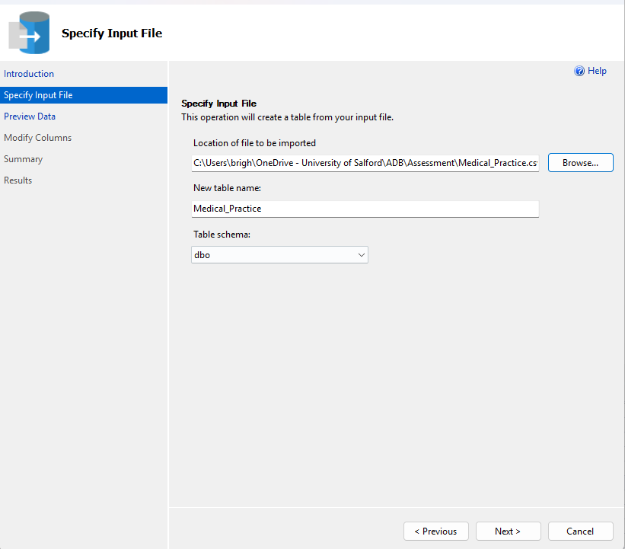
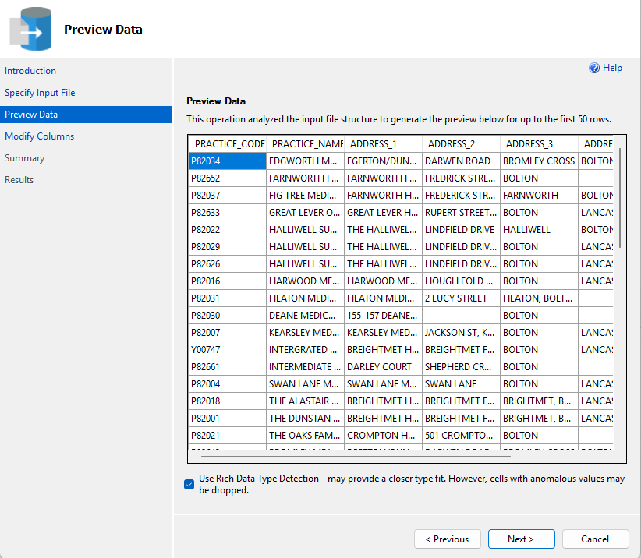
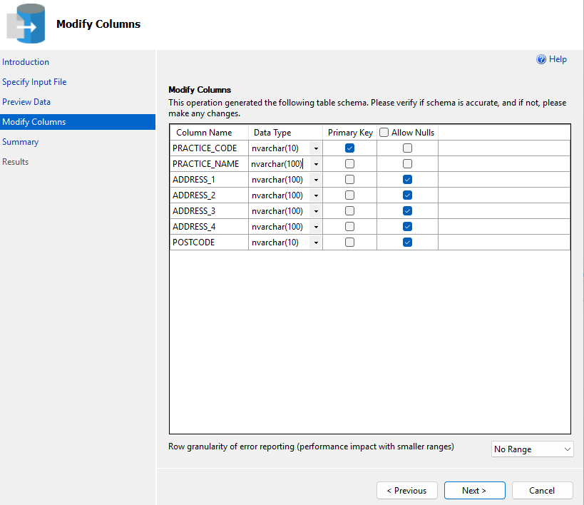
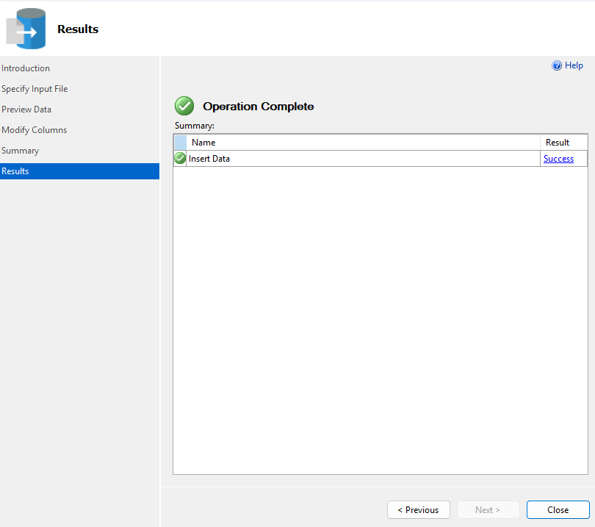

Drugs.csv:

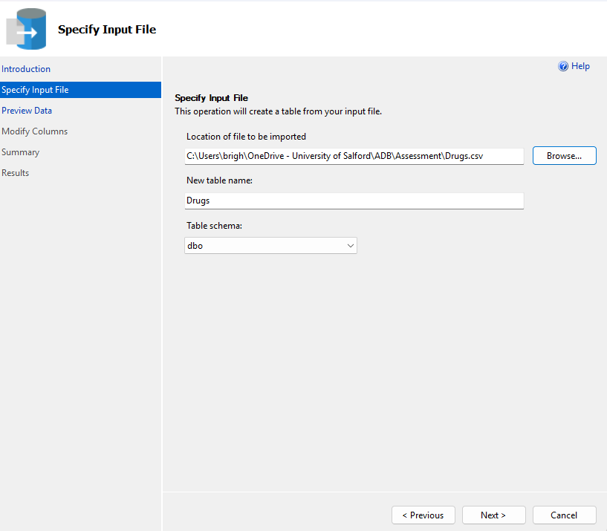
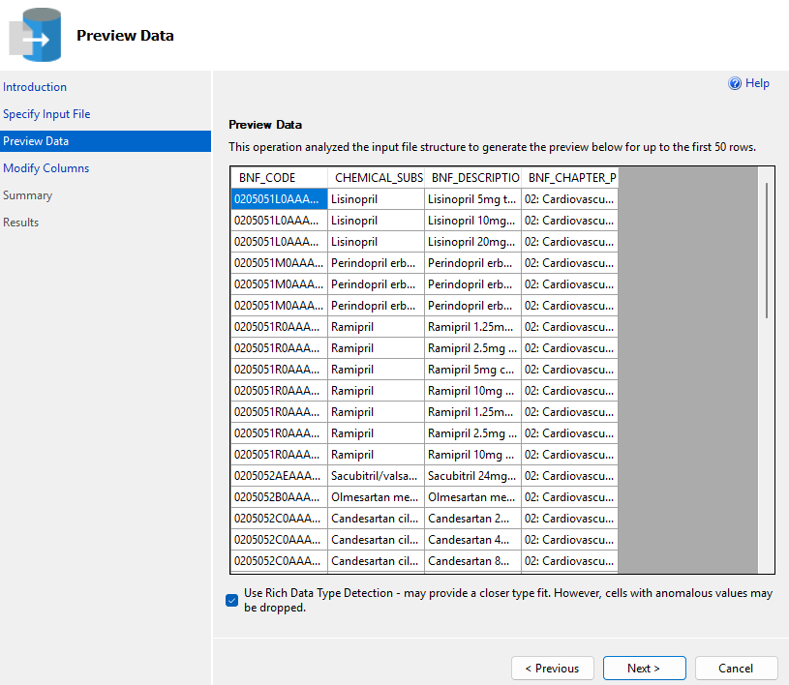
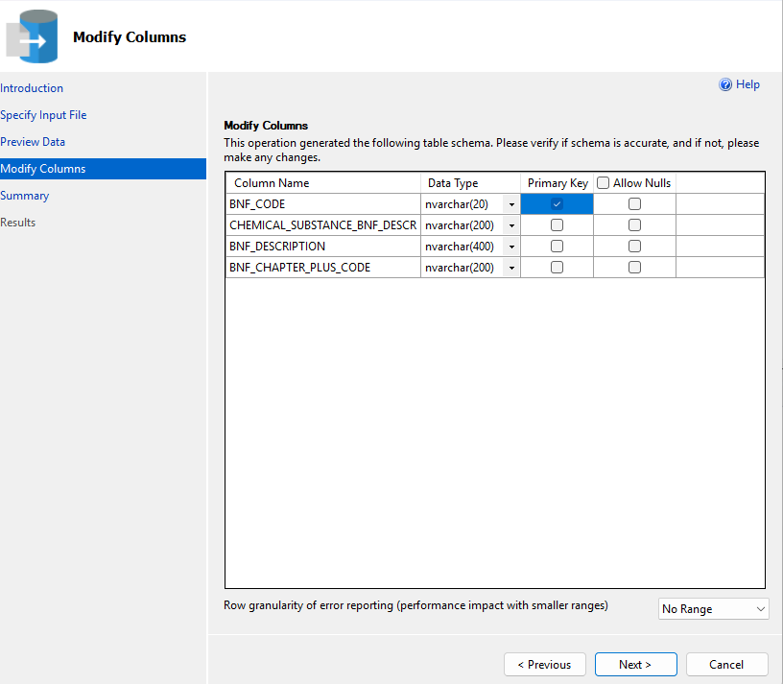


Prescriptions.csv:
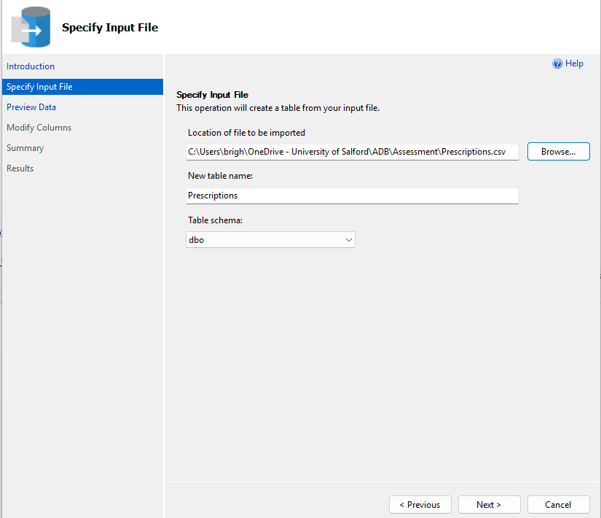
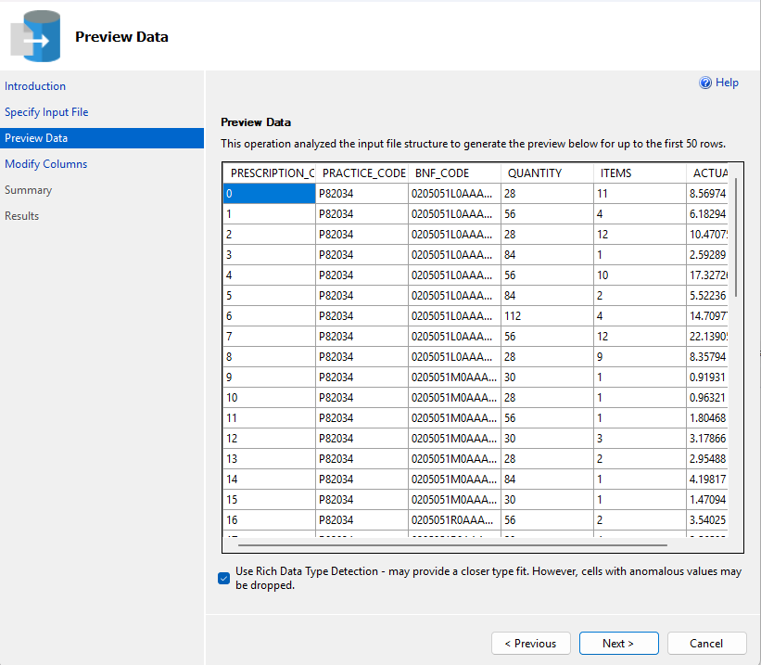
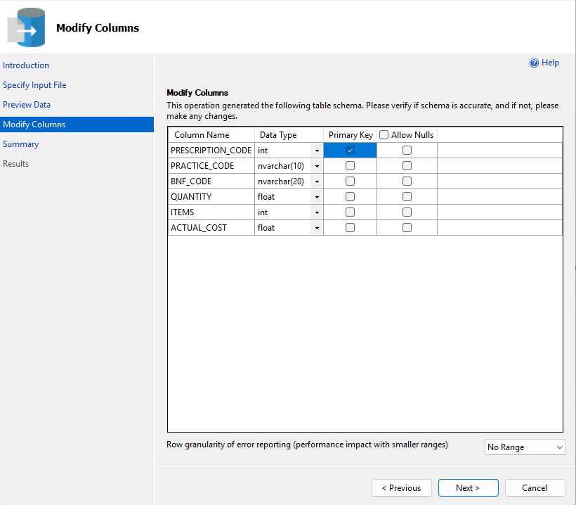


Prescription_Summary.csv:
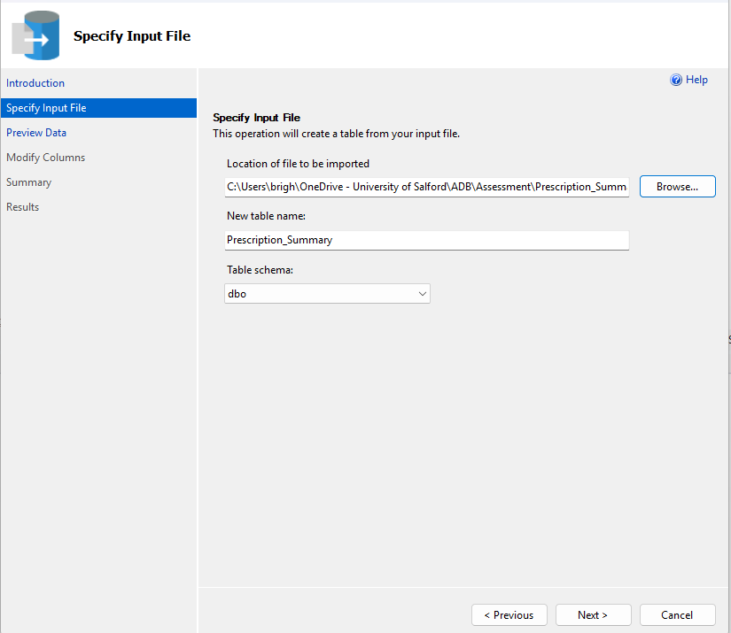
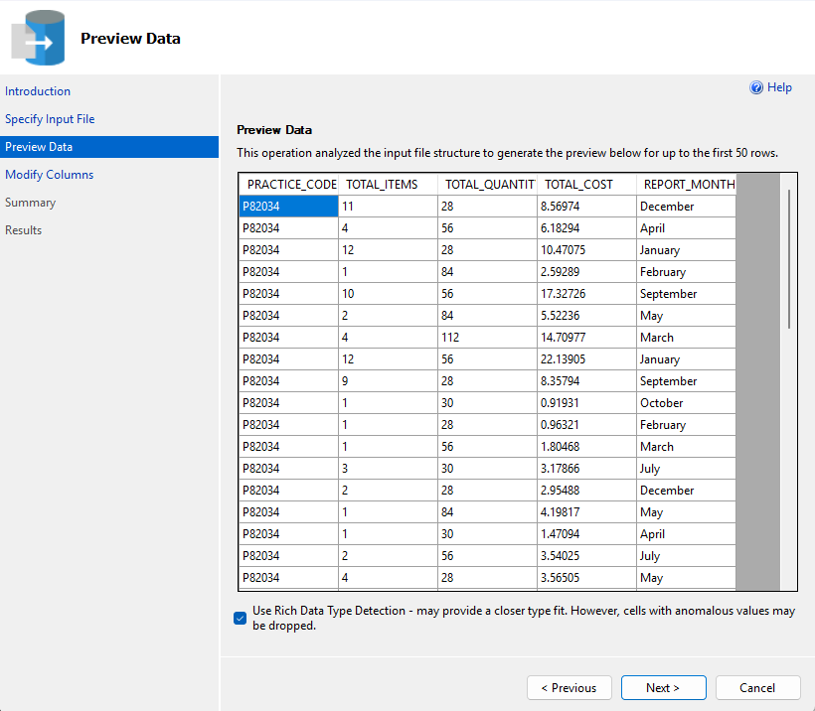
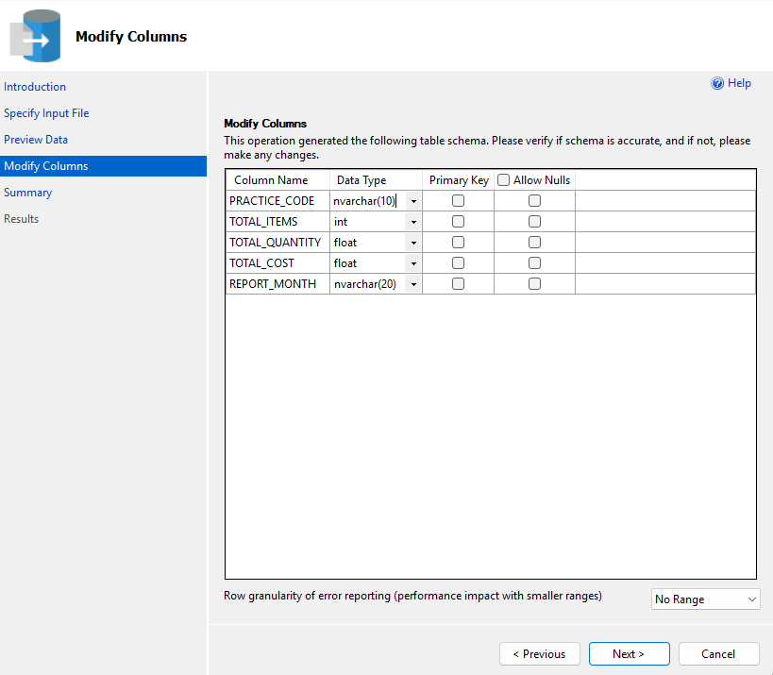


1.3 Adding Primary and Foreign Key Constraints
After the data was imported, primary and foreign key constraints were added using ALTER TABLE statements. This approach was chosen because the Import Flat File wizard creates tables without constraints by default. Adding them after import is a valid and practical approach, as it avoids potential conflicts during the bulk import process. The constraints were added as follows.

The Medical_Practice table uses PRACTICE_CODE as its primary key, uniquely identifying each of the 60 practices. The Drugs table uses BNF_CODE as its primary key, uniquely identifying each of the 6,148 drug records. The Prescriptions table uses PRESCRIPTION_CODE as its primary key, with two foreign keys linking it to Medical_Practice (via PRACTICE_CODE) and Drugs (via BNF_CODE). The Prescription_Summary table required a surrogate primary key (SUMMARY_ID) added as an IDENTITY column, since no single column in the original dataset uniquely identifies each row. It also has a foreign key linking PRACTICE_CODE back to the Medical_Practice table.

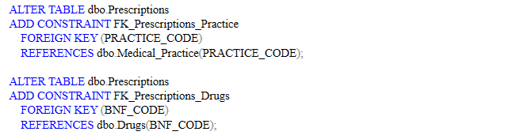
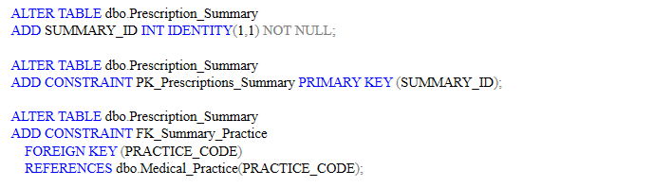

1.4 Database Diagram
The diagram below shows the four tables and their relationships. Medical_Practice sits at the centre, with one-to-many relationships to both Prescriptions and Prescription_Summary via PRACTICE_CODE. The Drugs table has a one-to-many relationship with Prescriptions via BNF_CODE.
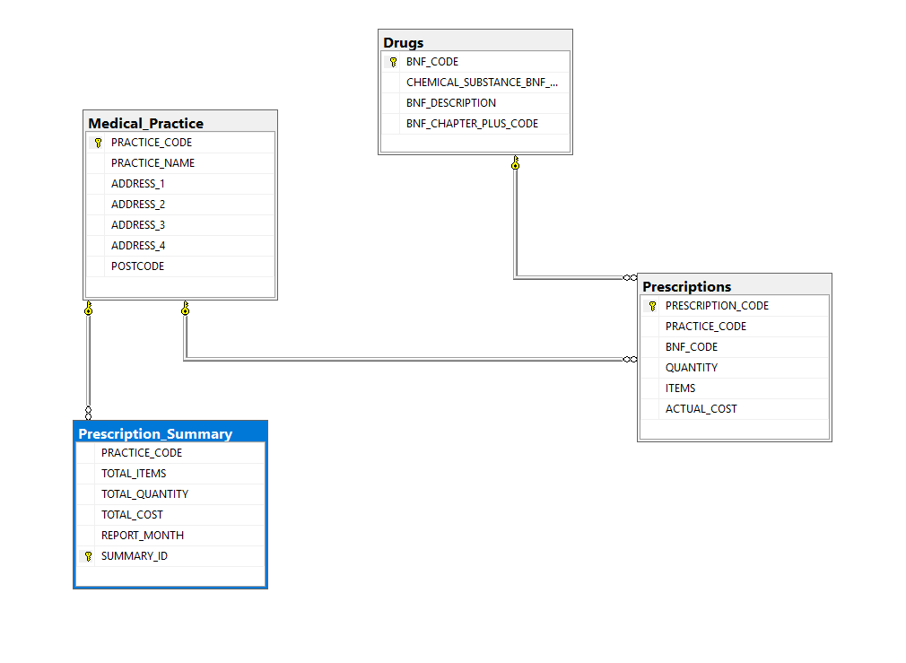

1.5 Verifying the Import
A verification query was run to confirm the row counts for each table matched the expected values from the CSV files: Medical_Practice with 60 rows, Drugs with 6,148 rows, Prescriptions with 116,815 rows, and Prescription_Summary with 116,815 rows.

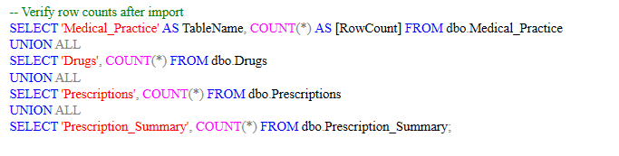
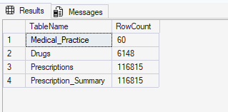

Part 2: Queries and Analysis

2.1 Question 2: Drugs in Tablet or Capsule Form
The query returned all drugs from the Drugs table where the BNF_DESCRIPTION column contains either the word 'tablet' or 'capsule'. The LIKE operator is used with the % wildcard on both sides of each search term to match the word regardless of its position within the description. The two conditions are combined with OR so that any drug matching either form is returned.

SQL Server uses a case-insensitive collation (Latin1_General_CI_AS) by default, so the query matches 'Tablets', 'tablets', and 'TABLETS' without needing additional handling. No join is required for this query as all the information comes from a single table.

SELECT BNF_CODE, CHEMICAL_SUBSTANCE_BNF_DESCR,
BNF_DESCRIPTION, BNF_CHAPTER_PLUS_CODE
FROM dbo.Drugs
WHERE BNF_DESCRIPTION LIKE '%tablet%'
OR BNF_DESCRIPTION LIKE '%capsule%';

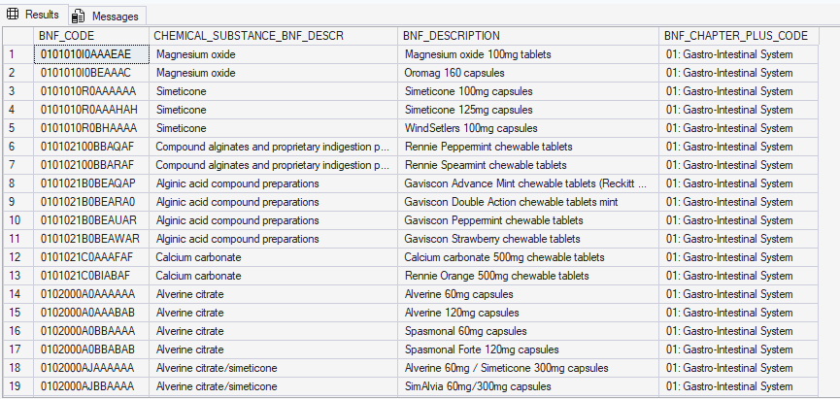

2.2 Question 3: Total Quantity per Prescription
The brief defines total quantity as the number of items (packs) multiplied by the quantity (units per pack). Since some quantities in the dataset are not integer values, the client requested the result be rounded to the nearest integer. The ROUND function handles the rounding, and CAST converts the result to INT for a clean integer output.
Two columns are provided in the output: TOTAL_QUANTITY_ROUNDED shows the result of ROUND which still returns a FLOAT type, and TOTAL_QUANTITY_INT shows the same value cast to an integer. This demonstrates awareness that ROUND alone does not change the data type of the result.

SELECT PRESCRIPTION_CODE, PRACTICE_CODE, BNF_CODE,
ITEMS, QUANTITY,
ROUND(ITEMS * QUANTITY, 0) AS TOTAL_QUANTITY_ROUNDED,
CAST(ROUND(ITEMS * QUANTITY, 0) AS INT) AS TOTAL_QUANTITY_INT
FROM dbo.Prescriptions;

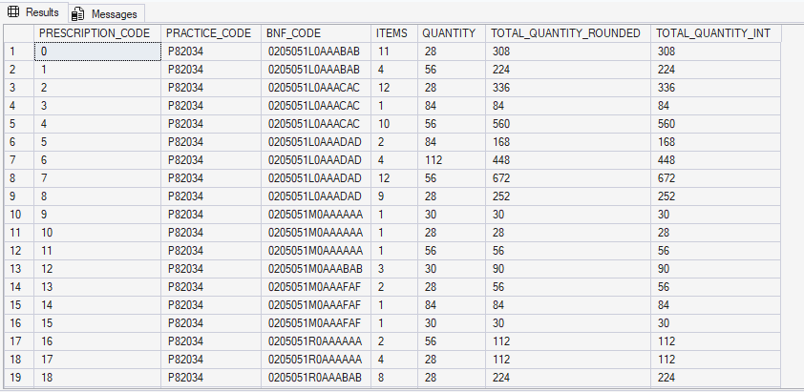

2.3 Question 4: Most Prescribed Chemical Substance per Month
The most frequently prescribed chemical substance for each month was identified with this query. A simple GROUP BY with MAX(COUNT) would return the count but not the associated substance name, so a more sophisticated approach was needed. The solution uses a Common Table Expression (CTE) combined with the ROW_NUMBER() window function.

The CTE first counts the number of prescription records for each combination of month and chemical substance. ROW_NUMBER() then assigns a rank within each month (partitioned by REPORT_MONTH), ordered by the prescription count in descending order. The outer query selects only the rows where RowNum equals 1, giving us the top substance for each month. The DISTINCT keyword is included as specified in the brief.

The query joins Prescriptions_Summary (for the month), Prescriptions (to link to drugs), and Drugs (for the chemical substance name). This three-table join is necessary because the month information exists in the summary table while the chemical substance information exists in the Drugs table, with Prescriptions acting as the link between them.

WITH MonthlySubstanceCounts AS (
SELECT ps.REPORT_MONTH,
d.CHEMICAL_SUBSTANCE_BNF_DESCR,
COUNT(*) AS PrescriptionCount,
ROW_NUMBER() OVER (
PARTITION BY ps.REPORT_MONTH
ORDER BY COUNT(*) DESC
) AS RowNum
FROM dbo.Prescription_Summary ps
INNER JOIN dbo.Prescriptions p ON ps.PRACTICE_CODE = p.PRACTICE_CODE
INNER JOIN dbo.Drugs d ON p.BNF_CODE = d.BNF_CODE
GROUP BY ps.REPORT_MONTH, d.CHEMICAL_SUBSTANCE_BNF_DESCR
)
SELECT DISTINCT REPORT_MONTH,
CHEMICAL_SUBSTANCE_BNF_DESCR AS MostPrescribedSubstance,
PrescriptionCount
FROM MonthlySubstanceCounts
WHERE RowNum = 1
ORDER BY REPORT_MONTH;

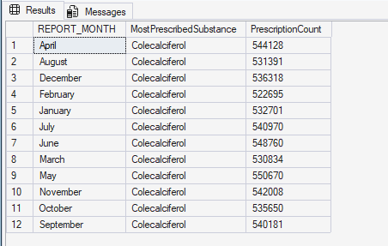

2.4 Question 5: Prescriptions per BNF Chapter with Cost Statistics
This query groups prescriptions by their BNF chapter classification (BNF_CHAPTER_PLUS_CODE from the Drugs table) and calculates four aggregate measures for each chapter: the total number of prescriptions (COUNT), the average cost (AVG), the minimum cost (MIN), and the maximum cost (MAX). The ROUND function is applied to the average for readability.

The query uses an INNER JOIN between Prescriptions and Drugs on BNF_CODE, since the chapter classification is stored in the Drugs table while the cost data is in the Prescriptions table. Results are ordered by the number of prescriptions in descending order, making it easy to identify which therapeutic areas generate the most prescribing activity in Bolton.

SELECT d.BNF_CHAPTER_PLUS_CODE,
COUNT(p.PRESCRIPTION_CODE) AS NumberOfPrescriptions,
ROUND(AVG(p.ACTUAL_COST), 2) AS AverageCost,
ROUND(MIN(p.ACTUAL_COST), 2) AS MinimumCost,
ROUND(MAX(p.ACTUAL_COST), 2) AS MaximumCost
FROM dbo.Prescriptions p
INNER JOIN dbo.Drugs d ON p.BNF_CODE = d.BNF_CODE
GROUP BY d.BNF_CHAPTER_PLUS_CODE
ORDER BY NumberOfPrescriptions DESC;
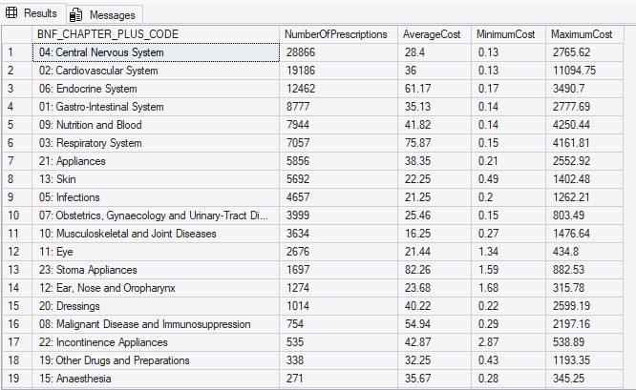

2.5 Question 6: Most Expensive Prescription per Practice (Over £4,000)
This query finds the single most expensive prescription for each practice and returns only those where the cost exceeds £4,000. The approach uses a correlated subquery: the inner SELECT finds the maximum ACTUAL_COST for the same practice, and the outer query retrieves the full details of prescriptions matching that maximum. The additional condition p.ACTUAL_COST > 4000 filters out practices whose most expensive prescription falls below the threshold.

The query joins three tables: Prescriptions for the cost data, Medical_Practice for the practice name (as required by the brief), and Drugs for the drug description. Results are sorted in descending order by prescription cost.

SELECT mp.PRACTICE_NAME, p.PRACTICE_CODE,
p.PRESCRIPTION_CODE, d.BNF_DESCRIPTION,
p.ACTUAL_COST AS PrescriptionCost
FROM dbo.Prescriptions p
INNER JOIN dbo.Medical_Practice mp ON p.PRACTICE_CODE = mp.PRACTICE_CODE
INNER JOIN dbo.Drugs d ON p.BNF_CODE = d.BNF_CODE
WHERE p.ACTUAL_COST = (
SELECT MAX(p2.ACTUAL_COST)
FROM dbo.Prescriptions p2
WHERE p2.PRACTICE_CODE = p.PRACTICE_CODE
)
AND p.ACTUAL_COST > 4000
ORDER BY p.ACTUAL_COST DESC;

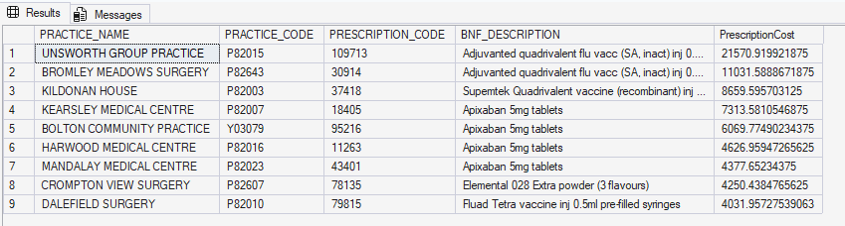

2.6 Question 7: Additional Queries

7a: Practice Specialisation Analysis
Use case: Useful for evaluating practice specialisation.
Techniques used: EXISTS, INNER JOIN, GROUP BY, HAVING, ORDER BY, COUNT DISTINCT.

This query identifies medical practices that prescribe from a limited number of BNF chapters (five or fewer), which may indicate that the practice has a degree of clinical specialisation rather than being a general practice. The EXISTS predicate is used to confirm that each practice has at least one prescription on record before it is included in the results. GROUP BY aggregates prescriptions at the practice level, and HAVING filters to only those practices with five or fewer distinct chapter codes.

From a commercial perspective, this information is valuable for the pharmaceutical company because specialist practices are more likely to be high-volume purchasers within their specific therapeutic area. Targeted marketing of specialist drugs to these practices would be more effective than a blanket approach.

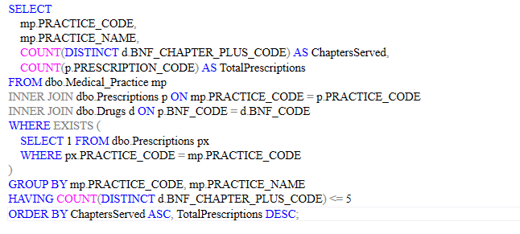
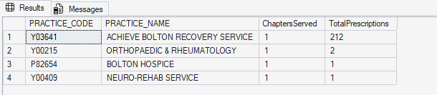

7b: Bulk Purchasing Opportunities
Use case: Can support bulk purchasing decisions.
Techniques used: IN (subquery), GROUP BY, HAVING, ORDER BY, SUM, COUNT DISTINCT, ROUND, CAST.

This query identifies drugs that are prescribed in high volumes across at least 10 different practices, suggesting widespread demand suitable for bulk purchasing negotiations. The IN subquery first filters to only those BNF codes prescribed by 10 or more distinct practices. The outer query then aggregates the total items, total units (items multiplied by quantity, rounded to the nearest integer), and total cost for each qualifying drug.

The pharmaceutical company could use these results to negotiate volume discounts with suppliers for the most widely prescribed medications in Bolton, potentially reducing procurement costs significantly across the region.

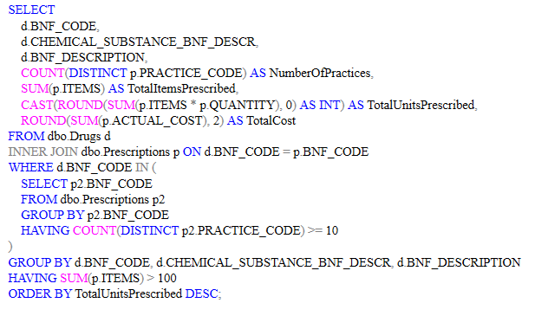
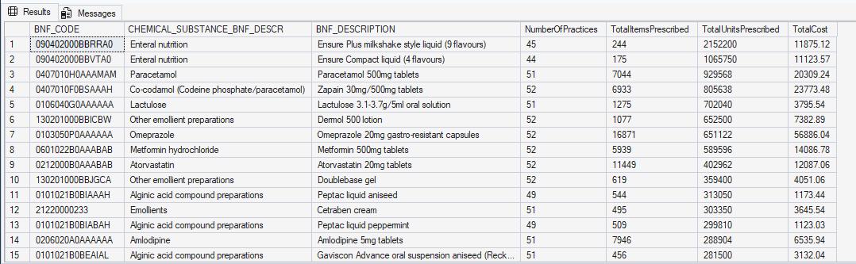

7c: Unusual or Potentially Erroneous Prescriptions
Use case: Could report errors or unusual cases.
Techniques used: CTE, INNER JOIN, system functions (AVG, STDEV, ROUND), GROUP BY, HAVING, ORDER BY.

This query uses a statistical approach to identify outlier prescriptions. A CTE first calculates the average cost and standard deviation for each drug (filtering to drugs with more than five prescriptions and a non-zero standard deviation for statistical validity). The outer query then identifies individual prescriptions where the cost exceeds three standard deviations above the mean for that drug, calculating a Z-score to quantify how far each outlier sits from the average.

These outliers could represent data entry errors (for example, a quantity entered incorrectly), unusual clinical cases requiring exceptionally large quantities, or pricing anomalies. The Z-score column allows the pharmaceutical company to prioritise investigation, starting with the most extreme outliers. This kind of quality assurance query is particularly important in healthcare data where errors can have both financial and clinical implications.

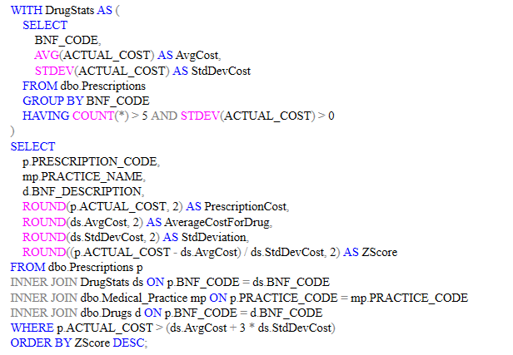

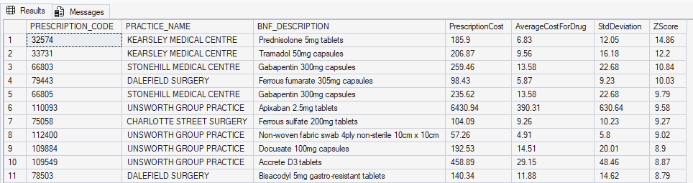

7d: Month-on-Month Comparison of Prescribing Volumes
Use case: Showing comparisons of current with previous.
Techniques used: CTE, LEFT JOIN (self-join), CASE, system functions (SUM, ROUND, ISNULL), GROUP BY, ORDER BY.

This query compares prescribing volumes between two consecutive months for each practice, calculating an absolute change and then a percentage change in total items prescribed. A CTE first aggregates the Prescriptions_Summary data to produce monthly totals per practice. The outer query then performs a self-join on the CTE using a CASE expression to map each month to its predecessor (for example, February maps to January). A LEFT JOIN is used rather than an INNER JOIN to ensure that practices appearing for the first time in a given month are still included, with ISNULL handling the NULL values that result from the absence of a previous month.

The percentage change column allows the pharmaceutical company to quickly identify practices with significant increases or decreases in prescribing activity. A sharp increase might indicate a local health concern or a new prescriber at the practice, while a significant decrease could suggest the practice has switched to an alternative drug. Both scenarios are commercially relevant for planning supply chains and informing sales strategy.

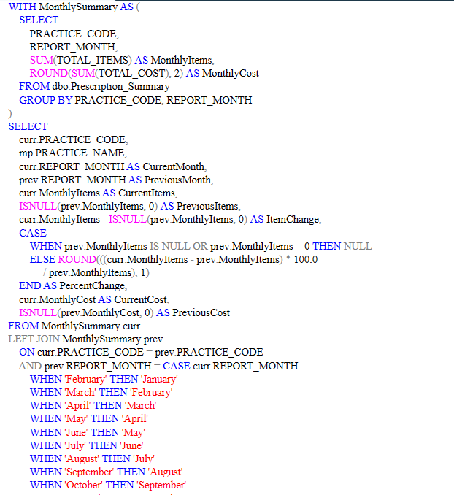
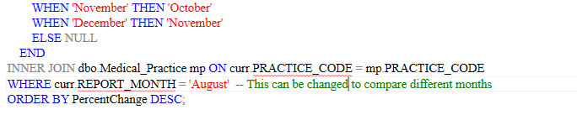
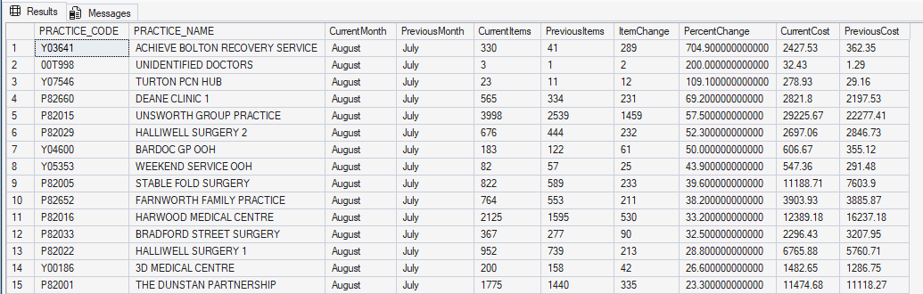
August – July
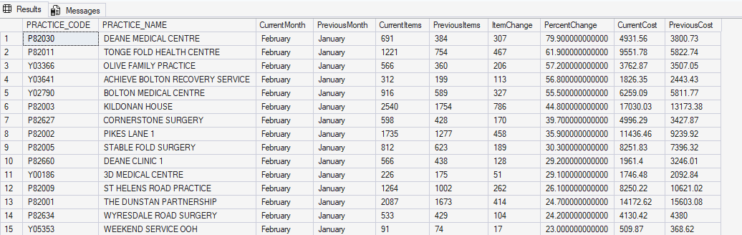
Feb-Jan

Conclusions
This report demonstrated the process of creating a relational database from four CSV files of NHS prescribing data and using T-SQL queries to extract meaningful insights from the data. The PrescriptionsDB database was created with appropriate primary and foreign key constraints to enforce referential integrity between the four tables.

The six required queries addressed a range of analytical needs, from simple filtering (tablets and capsules) and arithmetic calculations (total quantities) through to more complex aggregation with window functions (most prescribed substance per month) and correlated subqueries (most expensive prescription per practice). Each query was designed to answer a specific business question that a pharmaceutical company operating in the Bolton area would find commercially relevant.

The four additional queries extended the analysis further, demonstrating the use of EXISTS, IN with subqueries, statistical functions (STDEV for outlier detection), and self-joins for temporal comparisons. Together, these queries showcase a range of T-SQL techniques including joins, subqueries, CTEs, window functions, aggregate functions, CASE expressions, and system functions, applied to a real-world dataset to derive actionable insights for data-driven decision making.

References
- Connolly, T. and Begg, C. (2015) Database Systems: A Practical Approach to Design, Implementation, and Management. 6th edn. Harlow: Pearson Education.
- Elmasri, R. and Navathe, S.B. (2016) Fundamentals of Database Systems. 7th edn. Hoboken: Pearson.
- Microsoft (2024) SQL Server Technical Documentation. Available at: https://learn.microsoft.com/en-us/sql/sql-server/ (Accessed: 10 April 2026).
- Ramakrishnan, R. and Gehrke, J. (2003) Database Management Systems. 3rd edn. New York: McGraw-Hill.
- Stallings, W. (2017) Cryptography and Network Security: Principles and Practice. 7th edn. Harlow: Pearson.

