CE/CS/SE 3354 · Software Engineering · Fall 2026
Project Milestone P2

Analysis and High-Level Design
CometAssist
Team | Team 8, section .010
Document version | 1.6 (baseline for P2; grows from your P1 version 0.x)
Date | 11/8/2026
Repository URL | https://github.com/michmara13/CometAssist
Submitted on Canvas by | Michael Maranville

Team member | NetID | GitHub username
Michael Maranville | mrm230009 | michmara13
Himesh Anumala | Dal813094 | HimeshAnu
Yousif Al Khafaji | dal147545 | yyousif227
Saket Dwivedi | SXD240045 | Dw1vs
Huzaifa Nizami | hxn230018 | huzaifanizami

0 Revision History, Contribution Record and Changes Since P1
All three tables below are graded. The contribution record carries the individual 20% of this milestone and must agree with your repository history.
Version | Date | Author | Summary of change
0.5 | 10/18/2026 | Nathan Simpson | P1 baseline (copy your last P1 row)
1.0 | 11/2/2026 | Michael Maranville | Section 4
1.1 | 11/6/2026 | Michael Maranville | Section 5, Section 6
1.2 | 11/7/2026 | Himesh Anumala | Section 7
1.3 | 11/8/2026 | Yousif Al Khafaji | Revised and improved Section 1.4 and 3.4 based on feedback
1.4 | 11/8/2026 | Huzaifa Nizami | Section 9, 10.1 - 10.3
1.5 | 11/8/2026 | Saket Dwivedi | Section 11
1.6 | 11/8/2026 | Michael Maranville | Final look over, making sure everything looks right before submitting.

0.1 Individual contribution record (P2)
Team member | Sections and artifacts this person produced for P2 | Evidence in the repository (commit hashes, PR numbers) | Reviews given (PR numbers)
Michael Maranville | Section 4, Section 5, Section 6 | Committed Version 1.0, 1.1 | 2
Himesh Anumala | Section 7 | Committed Version 1.2 | 1
Huzaifa Nizami | Section 9, 10.1 - 10.3 | Committed Version 1.4 | 1
Saket Dwivedi | Section 11 | Committed version 1.5 | 1

1 to 3 Introduction, Overall Description and Requirements (carried forward)

1 Introduction
1.1 Purpose of this document and of the system

This document is the P1 proposal and requirements baseline for CometAssist, a student support ticketing system. It is written for the course instructors, the project team, and the students and support staff whose needs it records, and it will be expanded into a full specification for P2.

Students with technical or general questions often don’t know which office handles their issue, so requests are misrouted, delayed, or lost, and students can’t see where they stand. CometAssist routes each request to the right team by category, escalates requests that go unhandled, and lets students track progress until resolution.

1.2 Scope

In scope — we will build this | Out of scope — we will not, and why
Ticket submission with a preset category drop-down | Live chat or phone support, which needs staffing that we can't simulate.
Automatic routing of tickets to the team assigned to each category | Our own login system, since we will rely on campus SSO.
Escalation of tickets left unhandled past a set time | AI-generated answers, which are too unreliable to verify.
Ticket status tracking for students and a queue view for staff | Integration with real campus IT systems, which we don't have access to.

Why the exclusions were excluded: Each would add significant effort or depend on access and resources the team doesn’t have this semester. Leaving them out keeps the work on routing and escalation, which is the core of the project.

1.3 Definitions, acronyms and abbreviations

Term or abbreviation | Meaning as used in this project
Ticket | A single support request submitted by a student
Escalation | Moving a ticket to a higher priority and support tier when it needs to be handled quicker.
Category | A preset topic a student selects when submitting a ticket, which determines where it is routed.

1.4 References
[R1] -
UT Dallas Office of Information Technology. “How to Submit a Ticket in Atlas.” https://atlas.utdallas.edu/TDClient/30/Portal/KB/Article/544/How-to-Submit-a-Ticket-in-Atlas. Accessed November 8, 2026.

2 Overall Description
2.1 Product perspective and context

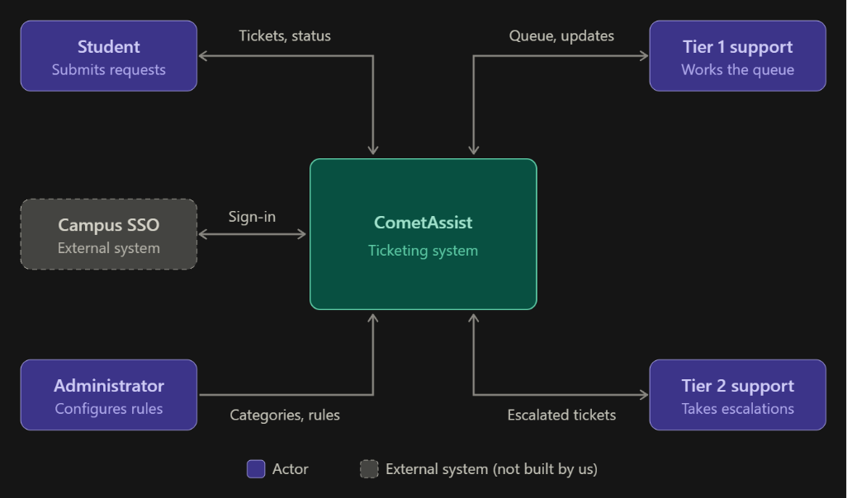
CometAssist is a standalone system covering ticket submission, category-based routing, escalation, and status tracking. Login is handled by the existing campus SSO, which sits outside the boundary because we use it but do not build it. This keeps the team’s work focused on routing and escalation.

2.2 Stakeholders and how you reached them

Stakeholder | Role in relation to the system | What they need from it | How you learned this
Students | Primary users who submit and track tickets | A simple way to get help without knowing which office to contact. | We are all students that have to go explore the UTD websites forever just to find who to contact.
Campus IT | Would operate and maintain the system | Low maintained effort plus SSO login compatibility. | Assumed
Administrators | Maintains categories and escalation rules | A way to change categories and time limits without code changes | Assumed
Support | Handle incoming tickets in their queue | Tickets that arrive in the right queue with enough detail to act on it | Assumed

2.3 User characteristics

Students. They are comfortable with web apps and SSO but can't be assumed to know how IT support is organized or which office handles what. Many will submit tickets from a phone, often while already frustrated or in a hurry. So, the form must be quick to complete on a small screen.
Support staff. Staff know the technical subject matter and work at a desktop during shifts. They need to scan and act on many tickets quickly, so the queue view matters more to them than a polished design. They can’t be assumed to have time for training on a new tool.
Administrators. Administrators are experienced IT staff who understand how support is organized. They make changes infrequently, so the configuration screens must be clear without relying on memory of how they worked last time.

2.4 Constraints

The system must use the existing campus for single sign-on service for login. The team must use free or student-licensed tools and hosting.

2.5 Assumptions and dependencies

# | Assumption or dependency | What breaks if it does not hold
A1 | Campus SSO can be used by a student project or simulated well enough for development. | Login must be built in-house, adding work and contradicting the 1.2 scope.
A2 | Support requests fall into a small, stable set of categories that students can choose between. | Routing by category fails if students can’t pick the right one, and tickets get misrouted anyway.
A3 | Support staff will check the CometAssist queue regularly without email alerts. | Tickets sit unnoticed, and escalation becomes the main way anything gets handled.

2.6 Feasibility summary

Feasibility gate | Verdict | Evidence behind the verdict
Technical | Feasible | Ticket submission, routing, and status tracking are standard web app features.
Operational | Feasible with Risk | Students already use web forms for campus services.
Schedule | Feasible if scope holds | The 1.2 exclusions keep the work to four core features.
Economic / resource | Feasible | Free or student-licensed tools and hosting cover the build.

3 Specific Requirements

3.1 Functional requirements

Tickets will have three possible statuses. Open, In Progress, and Resolved. Open means the ticket hasn’t been worked on yet. Resolved is the final status. The active queue has Open or In Progress tickets. New tickets have Normal priority. Escalation raises the priority to High and moves the ticket from Tier 1 to Tier 2 while keeping the Open status.
A ticket can be escalated when it is still Open with Normal Priority in Tier 1 and its age reaches the time limit set. Age is measured in hours from submission. The initial limit is 24 hours, and each ticket should escalate only once.
Students may only read the tickets they have submitted. Support staff may read and update the tickets only assigned to their team. Only administrators may change categories or escalation settings. Users who aren’t signed in shouldn’t have access to tickets or configuration settings.

ID | Requirement — one “shall” sentence | Priority | Source | Acceptance criterion
FR-01 | The system shall let a signed in student submit a ticket with a title, description and a category from a drop-down list. | MUST | Students Section 2.2 | Blank required fields prevent the submission. Submit two filled out tickets, and each should get a different ticket ID with Open status and Normal priority.
FR-02 | The system shall send each new ticket to the Tier 1 support team that is listed for its category. | MUST | Students and Support  Section 2.2 | Submit tickets under different categories. Each ticket appears in the queue listed for its category.
FR-03 | The system shall let students view the details and current status of their own ticket. | MUST | Students  Section 2.2 | A student can see their submitted information, status, priority, and assigned team. Their tickets remain after signing out and signing back in. Another student’s tickets are hidden.
FR-04 | The system shall let support staff view active tickets assigned to their team. | MUST | Support  Section 2.2 | Staff see only their team’s Open or In Progress tickets. High priority tickets appear first, then the oldest within each priority. Opening a ticket shows its description and current status.
FR-05 | The system shall let support staff change a ticket from Open to In Progress or from In Progress to Resolved. | MUST | Students and Support  Section 2.2 | Assigned staff make both changes. The student sees the saved status after refreshing or signing back in. Resolved tickets cannot be reopened.
FR-06 | The system shall automatically send an unhandled ticket to Tier 2 support with High priority once it reaches the set time limit. | MUST | Support  Sections 1.2 and 2.2 | Set the time limit to one hour. An Open Tier 1 ticket that reaches the one hour mark moves to Tier 2 at High Priority within five minutes. In Progress, Resolved and already escalated tickets do not move.
FR-07 | The system shall let an administrator add or edit a ticket category and the support team for that category. | MUST | Admins  Section 2.2 | Save a category name with a Tier 1 team. Reopen settings to confirm the change. New tickets follow the saved choice. A blank name or missing team prevents saving.
FR-08 | The system shall let an administrator change the time limit and Tier 2 team used for escalation. | MUST | Admins  Section 2.2 | Save a positive whole number of hours with a Tier 2 team. Sign out and back in to confirm the values. Zero, negative, fraction or missing hours and a missing team prevents the settings from being saved.

3.2 Quality requirements

ID | Requirement — with threshold, condition and method | Priority | Source | How it will be verified
QR-01 | The system shall finish a ticket submission or display a ticket list within ten seconds on the test computer with one signed in user and up to 25 stored tickets. | SHOULD | Students and Support  Section 2.3 | Time 25 actions covering ticket submission, the student ticket list and the staff queue. Each result appears within ten seconds of the action.
QR-02 | The system shall keep 100% of saved tickets and settings after a normal application restart with up to 25 stored tickets. | MUST | Students, Support, and Admins  Section 2.3 | Save 25 tickets with different statuses. Save a settings change. Close and restart the application. All saved details, statuses and settings match the values before the restart.
QR-03 | The system shall show all three ticket fields and the Submit button without sideways scrolling at widths of 360 and 1280 pixels. | SHOULD | Students  Section 2.3 | Check the ticket form at both widths. The title, description, category, and Submit button are fully visible by scrolling vertically, with no cut offs.
QR-04 | The system shall block 100% of requests that break the access rules in section 3.1 | MUST | Students, Support, and Admins  Section 2.2 | Check four cases.  - A signed out user opens a ticket  - A student opens another students ticket  - A student changes admin settings  - Staff from another team change a ticket  Each request is denied without showing protected data or saving a change.

3.3 Constraint requirements

ID | Constraint — one sentence | Source | Why it cannot be negotiated
CON-01 | The system shall use the campus SSO for signing in, with a clearly labeled simulation used. | Section 2.4 and 2.5 | The scope excludes creating a separate password system.
CON-02 | The system shall use only tools that are free to the team. | Section 2.4 | The project plan relies on free resources.

3.4 Initial use cases

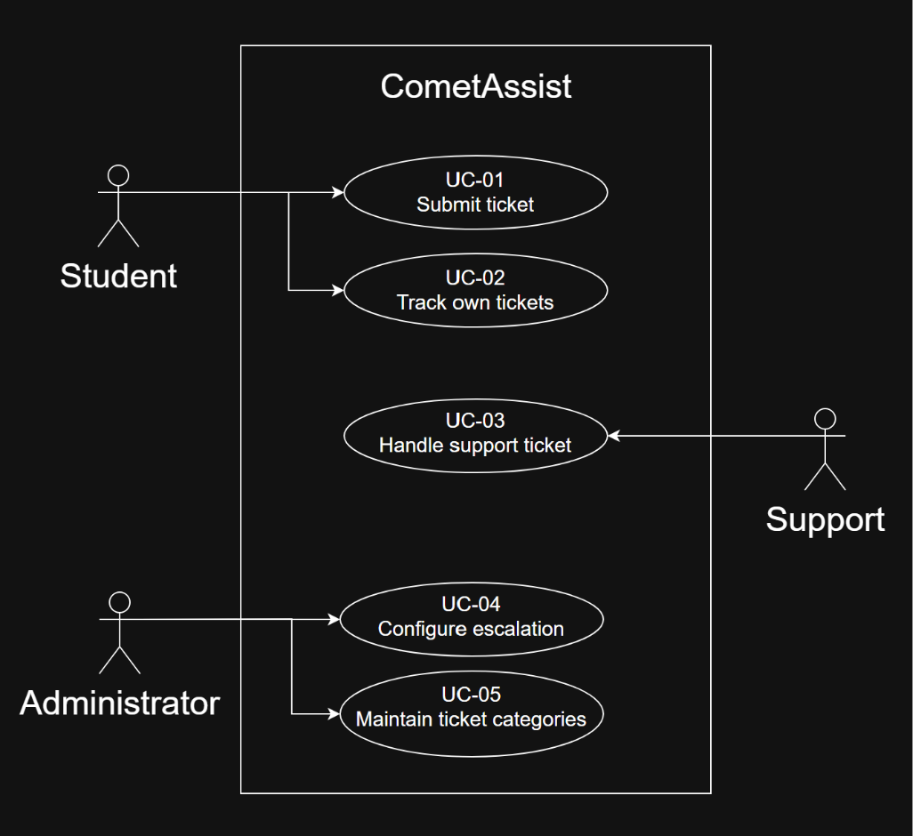

Expanded UC-03
Field | Content
Identifier and name | UC-03 Handle support ticket
Primary actor | Support staff from the assigned Tier 1 or Tier 2 team.
Supporting actors | None. Escalation is automatic system behavior supporting this goal.
Preconditions — what must be true before it starts | The staff member is signed in and belongs to a configured support team. Tickets may already exist in that team’s queue.
Trigger — what starts it | The staff member opens their team’s ticket queue.
Main success scenario — numbered steps | - The staff member opens the assigned team queue  - The system lists that team’s Open and In Progress tickets, showing High Priority first and then oldest submission first within each priority.  - The staff member selects an Open ticket.  - The system displays the ticket details and current state.  - The staff member marks the ticket In Progress when work begins.  - The system saves the new status and makes it visible to the student.  - After addressing the issue, the staff member marks the ticket Resolved.  - The system saves the resolution status for later viewing.
Alternative and exception flows | 2a. Empty queue - the system shows that no tickets are assigned, the use case ends.  3a. Already In Progress – the assigned staff member open that ticket and continues from step 7 after completing the work.  3b. Ticket moved to another team before it is opened, the access is then denied and the queue is refreshed.  6a or 8a. A save fails – the previous saved status stays and the staff member can try again.
Postconditions — what is true when it succeeds | The ticket is saved as Resolved and the submitting student can see its final state. The ticket stays stored for viewing later.
Requirements realized | FR-04, FR-05, FR-06.

Field | Content
Identifier and name | UC-04 Configure escalation
Primary actor | Administrator
Supporting actors | None.
Preconditions — what must be true before it starts | The administrator is signed in with the admin role. At least one Tier 2 support team is available for selection.
Trigger — what starts it | The administrator opens the escalation settings.
Main success scenario — numbered steps | - The system displays the current escalation time and Tier 2 destination.  - The administrator enters a positive whole number of hours.  - The administrator selects an available Tier 2 support team.  - The administrator selects Save.  - The system validates both values and stores the rule.  - The system confirms the change and displays the saved values.  - The saved rule applies to existing eligible Tier 1 tickets and new tickets.
Alternative and exception flows | 2a. Hours are missing, zero, negative, or a fraction. The saving is rejected. The system goes back to the previously saved rule.  4a. The administrator exits without saving. The existing rule stays applied.  5a. A save fails. The previous saved rule stays applied and the administrator can try again.
Postconditions — what is true when it succeeds | The rule is stored and remains available in future sessions. Open Tier 1 tickets already older than the new time limit escalate within five minutes of the change. Tickets already assigned to Tier 2 keep their assignment.
Requirements realized | FR-06 and FR-08  QR-02 and QR-04

3.5 Requirements to use case traceability

Requirement ID | Use case(s) that realize it | If blank — why, and what you will do
FR-01 | UC-01
FR-02 | UC-01
FR-03 | UC-02
FR-04 | UC-03
FR-05 | UC-03
FR-06 | UC-03, UC-04
FR-07 | UC-05
FR-08 | UC-04
QR-01 | UC-01, UC-02, UC-03
QR-02 | UC-01 to UC-05
QR-03 | UC-01
QR-04 | UC-01 to UC-05
CON-01 | UC-01 to UC-05
CON-02 | n/a | Resource constraint, checked by reviewing tools.

4 Use-Case Analysis
Chapter 7, first half. Here you take the use cases from section 3.4 and write the most important of them out turn by turn, still with the technology switched off.

4.1 Use cases selected for analysis
Use case | Name | Why it was selected | Non-trivial steps
UC-01 | Submit support ticket | Carries most of the product and involves the external sign-in service, including a failure the student can see. | 2, 4, 6
UC-03 | Handle support ticket | The main staff use case, covering queue order, status changes, and team access rules | 2, 4, 6, 8
UC-04 | Configure escalation | Controls the escalation behavior the project is built on. | 2, 4

4.2 Expanded use cases
Copy the block below once for each use case in 4.1.

UC-01 Submit support ticket
Primary actor | Student
Supporting actors and external systems | Campus sign in service
TUCBW (this use case begins when) | The student asks to submit a new support request.
TUCEW (this use case ends when) | The student sees confirmation of the new ticket with its ID, status, and assigned team.
Preconditions | At least one category exists with an assigned Tier 1 team.
Postconditions | The ticket is stored with Open status and Normal priority and is in the queue of the Tier 1 team for its category.
Traces to requirements | FR-01, FR-02, QR-01, QR-03, QR-04, CON-01

Actor input / action | System response
 | (0) The system shows the options to submit a new request or view existing requests, and shows that the student is not signed in.
(1) The student chooses to submit a new request. | (2) The system sends the student to the Campus Sign-In Service.
(3) The student signs in with their campus credentials. | (4) The system shows the request form with the list of categories and fields for a title and description.
(5) The student selects a category, enters a title and description, and submits the request. | The system confirms the ticket and shows its ID, Open status, Normal priority, and assigned Tier 1 team.

Alternate flow | At step | Condition | What happens | Ends or rejoins at
A1 | 3 | The sign-in service is unavailable | The system says sign-in is unavailable and asks the student to try again later. | Ends
A2 | 5 | The title, description, or category is missing | The system identifies the missing items and keeps what the student entered. | Rejoins 5
A3 | 2 | No Tier 2 team exists | The system says a Tier 2 team must be set up first. | Ends

UC-03 Handle Support ticket
Primary actor | Support staff member (Tier 1 or Tier 2)
Supporting actors and external systems | None
TUCBW (this use case begins when) | The staff member asks to see their team’s queue.
TUCEW (this use case ends when) | The staff member sees confirmation that the ticket is Resolved.
Preconditions | The staff member is signed in and belongs to a support team.
Postconditions | The ticket is stored as Resolved, is no longer in the active queue, and its final status is visible to the student.
Traces to requirements | FR-04, FR-05, QR-01, QR-04

Actor input / action | System response
 | (0) The system shows the staff member’s team name and the number of active tickets in its queue.
(1) The staff member asks to view the queue. | (2) The system lists the team’s Open and In Progress tickets, High priority first and then oldest first, each with its ID, title, priority, status, and age.
(3) The staff member selects a ticket. | (4) The system shows the ticket’s title, description, category, status, priority, submitter, and submission time.
(5) The staff member marks the ticket In Progress. | (6) The system confirms the ticket is In Progress.
(7) After finishing the work, the staff member marks the ticket Resolved. | (8) The system confirms the ticket is Resolved and removes it from the active queue.

Alternate flow | At step | Condition | What happens | Ends or rejoins at
A1 | 2 | The queue has no active tickets | The system says there are no active tickets. | Ends
A2 | 4 | The ticket is already In Progress | The system shows the ticket without the option to mark it In Progress. | Rejoins at (7)

UC-04 Configure escalation
Primary actor | Administrator
Supporting actors and external systems | None
TUCBW (this use case begins when) | The administrator asks to change the escalation settings.
TUCEW (this use case ends when) | The administrator sees confirmation of the saved time limit and Tier 2 team.
Preconditions | The administrator is signed in with the administrator role.
Postconditions | The new time limit and Tier 2 team are stored and govern escalation for open Tier 1 tickets. Tickets already in Tier 2 keep their assignment.
Traces to requirements | FR-08, QR-02, QR-04

Actor input / action | System response
 | (0) The system shows the administrator’s settings areas: categories and escalation.
(1) The administrator asks to change the escalation settings. | (2) The system shows the current time limit in hours, the current Tier 2 team, and the list of available Tier 2 teams.
(3) The administrator enters a new time limit, chooses a Tier 2 team, and asks to save. | (4) The system confirms the saved time limit and Tier 2 team and says they apply to all open Tier 1 tickets.

Alternate flow | At step | Condition | What happens | Ends or rejoins at
A1 | 3 | The administrator leaves without saving | The previous settings stay in effect. | Ends
A2 | 4 | The settings cannot be saved | The system says the save failed and that the previous settings are still in effect. | Rejoins at (3)

4.3 Self-review log
Use case | Check from the Lesson 13 review checklist | Defect found | How it was fixed
All | Step (0) present | The P1 versions of UC-03 and UC-04 started at the actor’s first action. | Added step (0) to each.
UC-01 | Preconditions are true assumptions | “Student is signed in” can be false during normal use. | Made sign-in part of the flow at steps (2)–(3), with failure handled in A1 and A2.
UC-01 | No technology | FR-01’s wording, “drop-down list,” describes a screen widget. | The use case says “list of categories.”
UC-03 | No background processing | The P1 version included automatic escalation, which the staff member neither sees nor waits for. | Removed escalation from UC-03. FR-06 is now recorded as a gap in section 9.
UC-04 | No background processing | The P1 step “the saved rule applies to existing tickets” happened out of the actor’s view. | Moved it to the postconditions.
UC-04 | Preconditions are true assumptions | “At least one Tier 2 team exists” can be false, for example before any teams are set up. | Changed it to alternate flow A1.
All | End with an acknowledgment | None. Each use case ends with a confirmation the actor can see. | —
All | One turn per row | None found. | —
All | Items in the actor column appear in the domain model | UC-01 step (3) names campus credentials, which are not in the domain model | Left out deliberately: credentials belong to the external Campus Sign-In Service and are never stored by CometAssist. Recorded in 5.3 K1.

5 Analysis Models
Chapter 7, second half. What has to exist inside the system for the use cases in section 4 to happen, and how those parts talk to each other.

5.1 Domain model
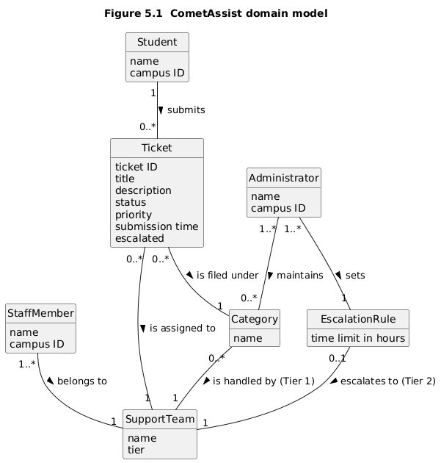

Figure 5.1 Domain model (conceptual classes, attributes, associations with multiplicities)

Class | What it represents (one line) | Key attributes | Associations (with multiplicity)
Class | What it represents | Key attributes | Associations (with multiplicity)
Student | A student who submits requests | name, campus ID | Student 1 submits 0..* Ticket
Ticket | One support request from submission to resolution | ticket ID, title, description, status, priority, submission time, escalated | Ticket 0..* is filed under 1 Category; Ticket 0..* is assigned to 1 SupportTeam
Category | A preset topic a ticket is filed under | name | Category 0..* is handled by 1 SupportTeam (Tier 1)
SupportTeam | A group of staff at one support tier | name, tier | SupportTeam 1 has 1..* StaffMember
StaffMember | A support staff member on one team | name, campus ID | StaffMember 1..* belongs to 1 SupportTeam
EscalationRule | The time limit and destination for escalation | time limit in hours | EscalationRule 0..1 escalates to 1 SupportTeam (Tier 2)
Administrator | A user who maintains categories and escalation | name, campus ID | Administrator 1..* maintains 0..* Category; Administrator 1..* sets 1 EscalationRule

5.2 Object interaction models
Copy the block below for at least two of the use cases in 4.1; preferably including your riskiest.

5.2.x UC-xx [Use case name]
(a) Non-trivial steps. List the steps from 4.2 that need objects inside the system, and say in one line why each of the others is trivial.
Step | Subject (who acts) | Subject action (what it does) | Other data / objects (what is used) | Object acted upon (who receives)
1 | Student | asks to submit a new request | — | StudentUI
2.1 | StudentUI | forwards the request to submit | — | SubmitTicketHandler
2.2 | SubmitTicketHandler | asks for the student to be identified | — | Campus Sign-In Service
3 | Student | signs in with campus credentials | campus credentials | Campus Sign-In Service
4.1 | Campus Sign-In Service | confirms the student’s identity | name, campus ID | SubmitTicketHandler
4.2 | SubmitTicketHandler | asks for the list of categories | — | Category
4.3 | SubmitTicketHandler | sends the request form with the categories | category names | StudentUI
5 | Student | submits category, title, and description | category, title, description | StudentUI
6.1 | StudentUI | passes the request details | category, title, description | SubmitTicketHandler
6.2 | SubmitTicketHandler | asks which Tier 1 team handles the category | category | Category
6.3 | SubmitTicketHandler | creates the ticket as Open, Normal priority, assigned to that team | title, description, category, campus ID, team, submission time | Ticket
6.4 | SubmitTicketHandler | sends the confirmation | ticket ID, status, priority, team name | StudentUI

(b) Scenario table.
Step | Subject | Subject action | Other data / objects | Object acted upon
1 | Staff member | asks to view the queue | — | StaffUI
2.1 | StaffUI | asks for the team’s active tickets | campus ID | QueueHandler
2.2 | QueueHandler | asks which team the staff member belongs to | campus ID | StaffMember
2.3 | QueueHandler | asks for the team’s Open and In Progress tickets | team | SupportTeam
2.4 | QueueHandler | orders the tickets, High priority first and then oldest first | priority, submission time | QueueHandler
2.5 | QueueHandler | sends the ordered queue | ID, title, priority, status, age | StaffUI
3 | Staff member | selects a ticket | ticket ID | StaffUI
4.1 | StaffUI | asks for the ticket’s details | ticket ID | QueueHandler
4.2 | QueueHandler | asks for the ticket’s details and assigned team | ticket ID | Ticket
4.3 | QueueHandler | sends the ticket details | title, description, category, status, priority, submitter, submission time | StaffUI
5 | Staff member | marks the ticket In Progress | ticket ID | StaffUI
6.1 | StaffUI | passes the status change | ticket ID, In Progress | QueueHandler
6.2 | QueueHandler | sets the status to In Progress | In Progress | Ticket
6.3 | QueueHandler | confirms the new status | status | StaffUI
7 | Staff member | marks the ticket Resolved | ticket ID | StaffUI
8.1 | StaffUI | passes the status change | ticket ID, Resolved | QueueHandler
8.2 | QueueHandler | sets the status to Resolved | Resolved | Ticket
8.3 | QueueHandler | confirms Resolved and sends the queue without it | status, remaining tickets | StaffUI

(c) Analysis sequence diagram.
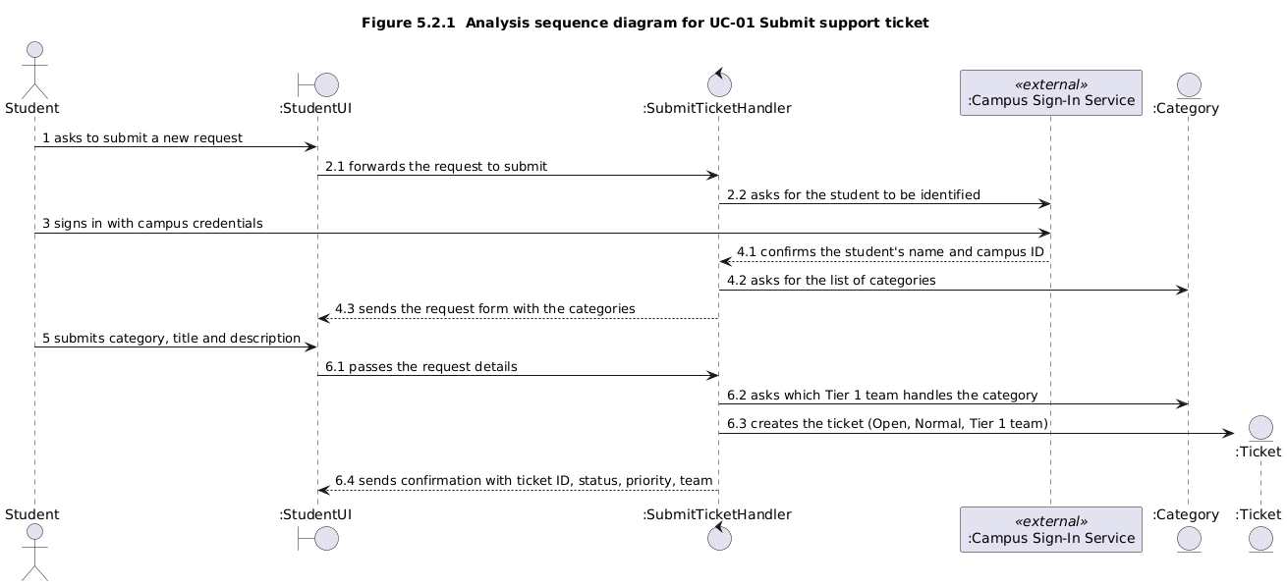

Figure 5.2.x Analysis sequence diagram for UC-xx; message numbers match the scenario table

5.3 Consistency cross-check
Check | Result (pass, or what failed) | Fixed in
K1 Every item in an actor column (4.2) is an attribute in the domain model (5.1) | Failed at first. “Campus credentials” in UC-01 step (3) is not in the domain model. It is held by the external Campus Sign-In Service and never stored by CometAssist, so it was left out deliberately. Every other actor-column item is an attribute. | 5.1 table note; 4.3 last row
K2 Every object on a sequence diagram is a domain class or a declared interaction object | Pass. StudentUI, StaffUI, SubmitTicketHandler, and QueueHandler are declared interaction objects. Campus Sign-In Service is external.
K3 Every message on a sequence diagram corresponds to exactly one scenario-table row | Pass. Every message number matches one table row.
K4 Every non-trivial step in 5.2 (a) has at least one scenario-table row | Failed. 4.1 listed UC-01 as (2), (6) and UC-03 as (2), (6), (8), but UC-01 step (4) and UC-03 step (4) also need objects | 4.1 updated
K5 Every analyzed use case traces to at least one functional requirement | Pass. UC-01 traces to FR-01 and FR-02, UC-03 to FR-04 and FR-05, and UC-04 to FR-08.
K6 The last messages of each diagram make the use case postcondition true | Pass. UC-01 message 6.3 stores the ticket in its team’s queue, and UC-03 message 8.2 makes the ticket Resolved.

6 High-Level Design (Architecture)
Chapter 8. The rule now reverses: a high-level design that does not say where things run, what they are built from and what that choice cost has not been done.

6.1 Architectural drivers: quality-attribute scenarios
QAS | Quality attribute | Stimulus | Artifact | Response | Response measure | From
QAS-01 | Performance | A signed-in user submits a ticket or opens a ticket list, with 25 tickets stored | Ticket Management | The confirmation or list is shown | Within 10 s for all 25 timed actions | QR-01
QAS-02 | Reliability | The application is restarted normally after 25 tickets and a settings change are saved | Data Store | All tickets and settings are restored | 100% match the values before restart | QR-02
QAS-03 | Security | A user requests a ticket or setting their role or team doesn’t allow | Access Control | The request is denied with no data shown and nothing saved | 100% of the four QR-04 test cases blocked | QR-04
QAS-04 | Performance (timeliness) | An Open, Normal-priority Tier 1 ticket reaches the escalation time limit | Escalation Scheduler | The ticket moves to Tier 2 at High priority, once | Within 5 minutes, across 20 test tickets | FR-06

6.2 Architectural style and alternatives
Style considered | Drivers it serves | What it costs | Verdict
Layered (three-tier) client-server | QAS-03: every request passes one server-side access layer. QAS-02: one database. QAS-01 at this load. CON-02: one free host. | The single server is a single point of failure, scaling is limited, and layers add some pass-through code. | Chosen
Microservices | Independent scaling and deployment of services | Network calls between services, data split across services makes QAS-02 harder, access checks repeated in each service, and far more operations work than this team or load justifies | Rejected
Event-driven | QAS-04: escalation as a timer event | Needs a message broker, is harder to trace and test, and makes escalate-only-once harder to guarantee. A scheduled job inside the layered design is expected to meet QAS-04, and spike S-01 tests this. | Rejected

6.3 Component view
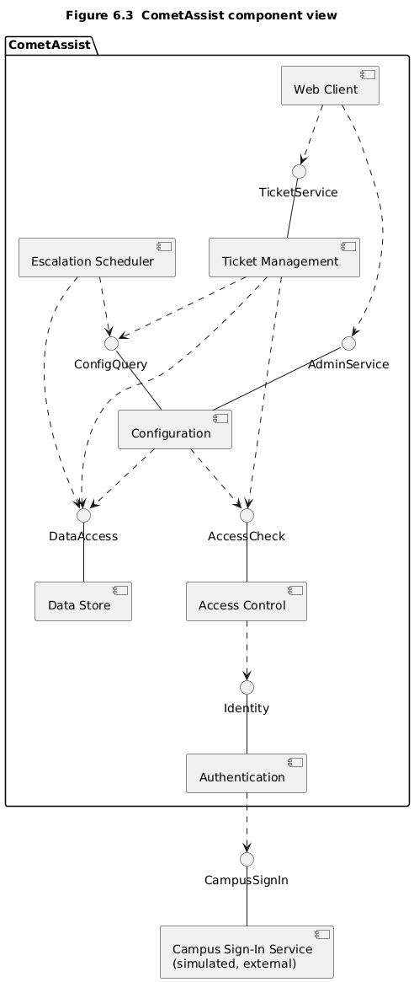

Figure 6.3 Component diagram: components, provided and required interfaces, external systems

Component | Responsibility (one sentence) | Provides | Requires | Answers to (UC / QAS / ADR)
Web Client | Shows students, staff, and administrators their views and passes their requests to the server | — | TicketService, AdminService | UC-01, UC-03, UC-04, QAS-01
Ticket Management | Submits, routes, lists, and updates tickets | TicketService | AccessCheck, ConfigQuery, DataAccess | UC-01, UC-03, QAS-01
Configuration | Stores categories and the escalation rule | AdminService, ConfigQuery | AccessCheck, DataAccess | UC-04, FR-07
Escalation Scheduler | Finds overdue Tier 1 tickets and escalates each one once | — | ConfigQuery, DataAccess | FR-06, QAS-04, ADR-03
Access Control | Checks every request against the role and team rules | AccessCheck | Identity | QAS-03
Authentication | Signs users in through the campus sign-in service | Identity | CampusSignIn | UC-01, CON-01, ADR-02
Data Store | Saves and retrieves tickets and settings | DataAccess | — | QAS-02, ADR-04

6.4 Deployment view
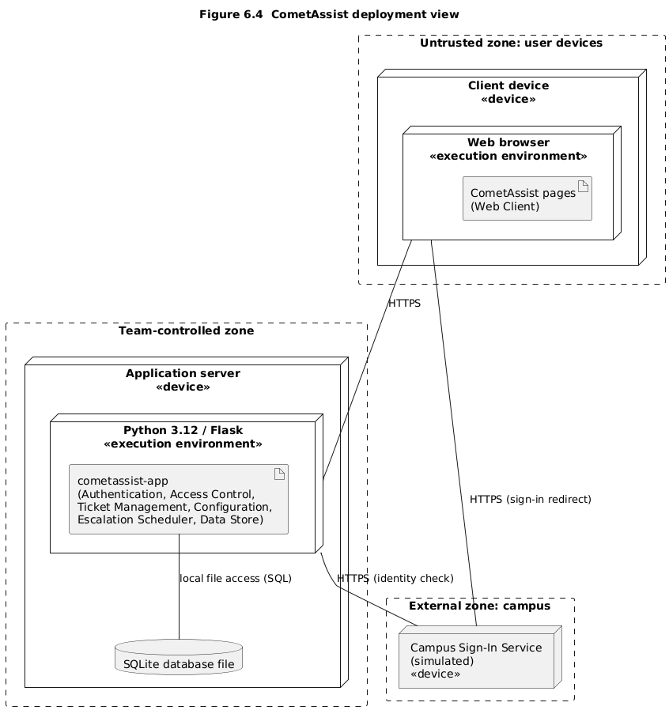

Figure 6.4 UML deployment diagram: nodes, execution environments, deployed artifacts, communication paths with protocols, trust boundaries

Node | What runs on it (artifacts, components) | Communicates with (protocol) | Trust zone
Client device (web browser) | CometAssist pages (Web Client) | Application server (HTTPS); Campus Sign-In Service (HTTPS, sign-in redirect) | Untrusted: user devices
Application server (Python 3.12 / Flask) | cometassist-app: Authentication, Access Control, Ticket Management, Configuration, Escalation Scheduler, Data Store; SQLite database file | Client device (HTTPS); Campus Sign-In Service (HTTPS, identity check); database (local file access) | Team-controlled
Campus Sign-In Service (simulated) | Sign-in simulation standing in for campus SSO | Client device and application server (HTTPS) | External: campus

6.5 From analysis to architecture
Analysis object (from 5.1 and 5.2) | Component that owns it (6.3) | Note (split, merged, external)
Ticket | Ticket Management | —
Category, SupportTeam, EscalationRule | Configuration | —
Student, StaffMember, Administrator | Access Control | Split: identity comes from the external sign-in service, while roles and team membership are held by Access Control
StudentUI, StaffUI | Web Client | —
SubmitTicketHandler, QueueHandler | Ticket Management | —
Campus Sign-In Service | External | Wrapped by Authentication

6.6 Design principles applied
Principle | Where it shows in your design | Evidence (component, interface, ADR)
Separation of concerns | Sign-in, access rules, tickets, settings, and escalation are separate components | 6.3
Information hiding | Authentication hides whether sign-in is simulated or real, and Data Store hides how data is stored | Identity, DataAccess, ADR-02
Low coupling | Ticket Management and the scheduler read settings only through ConfigQuery, never directly from storage | ConfigQuery
High cohesion | Escalation Scheduler does nothing but find and escalate overdue tickets | Escalation Scheduler, ADR-03
Design for change | Real campus SSO can replace the simulation by changing only Authentication, and categories and time limits are data, not code | ADR-02, FR-07, FR-08
Keep it simple (KISS) | One layered application on one host with one database, instead of services or a message broker | ADR-01

7 Design Rationale

7.1 Architecture decision records

ADR-01 Layered three-tier client-server architecture
Status | Accepted
Date and owner | 11/7/2026, Himesh
Context (drivers) | QAS-03 needs one access check for every request, and QAS-02 needs one consistent data store. CON-02 limits us to free hosting.
Options considered | (1) Layered three-tier with one server and one database. (2) Microservices. (3) Event-driven with a message broker.
Decision | Layered three-tier client-server, as chosen in 6.2.
Consequences | Favors security and data consistency through one access layer and one database. The cost is a single point of failure and no independent scaling.
Evidence | None yet; spike S-01 (section 8) runs on this stack.
Related | QAS-01, QAS-02, QAS-03, CON-02, ADR-03, ADR-04

ADR-02 Simulated campus sign-in behind the Authentication component
Status | Accepted
Date and owner | 11/7/2026, Yousif, Saket
Context (drivers) | CON-01 requires campus SSO or a labeled simulation, and A1 says real SSO may not be available to us.
Options considered | (1) Real campus SSO now. (2) Our own password login. (3) A labeled simulation behind the Identity interface.
Decision | Option 3, with roles and team membership held by Access Control.
Consequences | Favors modifiability, since real SSO later changes only Authentication. The cost is that real SSO integration stays unproven.
Evidence | None yet; open question in section 11 on what real SSO returns.
Related | CON-01, A1, QAS-03, UC-01, ADR-01

ADR-03 Escalation by a scheduled job inside the application server
Status | Accepted
Date and owner | 11/7/2026, Michael, Huzaifa
Context (drivers) | FR-06 and QAS-04 require overdue Tier 1 tickets to escalate once, within 5 minutes. UC-04 requires a new time limit to apply to existing tickets.
Options considered | (1) A job every minute with one conditional update. (2) A timer event per ticket through a broker. (3) Escalate only when a ticket is viewed.
Decision | Option 1, which skips already escalated tickets so each escalates only once.
Consequences | Favors timeliness with little machinery, and it picks up rule changes on the next run. The cost is constant polling, up to one minute of lag, and no escalation while the server is down.
Evidence | Spike S-01 (section 8) measures this against QAS-04.
Related | QAS-04, FR-06, FR-08, UC-04, ADR-01, S-01

ADR-04 One SQLite database file behind the DataAccess interface
Status | Accepted
Date and owner | 11/7/2026, Uchenna, Nathan
Context (drivers) | QAS-02 requires all data to survive a restart, and CON-02 requires free tools. The data volume is small and runs on one server (ADR-01).
Options considered | (1) SQLite file on the server. (2) Hosted PostgreSQL free tier. (3) JSON files.
Decision | Option 1, accessed only by Data Store through DataAccess.
Consequences | Favors reliability at zero cost through durable transactions. The cost is one writer at a time and data tied to one host that needs a persistent disk.
Evidence | None yet; the QR-02 restart test will verify it.
Related | QAS-02, CON-02, ADR-01, ADR-03

7.2 Trade-off summary
Quality favored | Architectural move | Cost accepted | Recorded in
Security and data consistency | One layered application and one database | Single point of failure, no independent scaling | ADR-01
Modifiability and schedule | Simulated sign-in behind an interface | Real SSO unproven | ADR-02
Timeliness and escalate-once correctness | One-minute scheduled job | Constant polling, up to one minute of lag | ADR-03
Reliability at zero cost | SQLite file behind DataAccess | One writer at a time, data on one host | ADR-04

8 Prototype Evidence: Architecture Spike
Spike ID and title | S-01
Risk or decision it addresses | R- / ADR- / QAS-
Question (answerable yes or no)
Set-up | Stack, data, what was simulated; folder in the repository
How it was measured
Result (numbers)
What it changed or confirmed | Which ADR, QAS or requirement
Where to see it | Commit hash, /spikes/S-01/, screenshot or log file

9 Traceability

9.1 Extended traceability matrix
Requirement | Use case | Analysis classes | Component(s) | QAS / ADR | Evidence
FR-01 | UC-01 | Student, Ticket, Category | Ticket Management, Authentication, Web Client | QAS-01,  ADR-02 | S4.2, S5.2
FR-02 | UC-01 | Ticket, Category, SupportTeam | Ticket Management, Configuration | _ | S5.1, S5.2
FR-03 | UC-02 | Student, Ticket | Ticket Management, Access Control | QAS-03 | S3.5, S6.3
FR-04 | UC-03 | StaffMember, SupportTeam, Ticket | Ticket Management, Access Control | QAS-01, QAS-03 | S4.2, S5.2
FR-05 | UC-03 | StaffMember, Ticket | Ticket Management, Data Store | QAS-02, ADR-04 | S4.2, S5.2
FR-06 | UC-03, UC-04 (indirect) | Ticket, EscalationRule, SupportTeam | Escalation Scheduler, Configuration, Data Store | QAS-04, ADR-03 | S6.1, S7.1
FR-07 | UC-05 | Administrator, Category, SupportTeam | Configuration, Access control | QAS-03 | S5.1, S6.3
FR-08 | UC-04 | Administrator, EscalationRule, SupportTeam | Configuration, Escalation Scheduler | ADR-03, QAS-03 | S4.2, S6.3
QR-01 | UC-01, UC-02, UC-03 | Ticket, Student, StaffMember | Web Client, Ticket Management | QAS-01 | S6.1
QR-02 | UC-01 - UC-05 | Ticket, Category, EscalationRule | Data Store | QAS-02, ADR-04 | S6.1, S7.1
QR-03 | UC-01 | Student, Ticket, Category | Web client | _ | S3.2, S6.3
QR-04 | UC-01 - UC-05 | Student, StaffMember, Administrator, Ticket | Access control, Authentication | QAS-03, ADR-02 | S3.2, S6.3
CON-01 | UC-01 - UC-05 | Student, StaffMember, Administrator | Authentication, Access control | ADR-02 | S6.4, S7.1
CON-02 | N/A | N/A | All deployed components | ADR-01, ADR-04 | S6.2, S7.1

9.2 Gap analysis
Gap | Items | What you did about it
Requirements with no component | None | Every requirement is mapped to at least one component in section 9.1.
Components with no requirement, QAS or ADR | None | All components in section 6.3 support at least one requirement, use case, QAS or ADR
Use cases not analyzed (and why that is acceptable) | UC-02, UC-05 | UC-01, UC-03, and UC-04 were prioritized because they cover the main workflows and architectural risks. UC-02 and UC-05 are still included in the traceability matrix.

10 Project Plan (updated; was P1 section 4)

10.1 Roles and working agreement
Team member | Role for P1 to P2 | How the team makes a decision when it disagrees
Michael Maranville | Team Lead | Consult the requirements and documentation and come to a majority-vote decision on how to move forward together.
Saket Dwivedi | Authentication Lead | -
Nathan Simpson | Database and Backend Developer | -
Himesh Anumala | Requirements and Documentation Lead | -
Huzaifa Nizami | Quality Assurance and Testing Lead | -
Uchenna Okoko | Support Queue Developer | -
Yousif Al Khafaji | Student Facing UI/UX Developer | -

10.2 Plan to P3
Milestone | Date | Owner | Done when
Complete architecture spike and finalize implementation plan | 11/13 | Michael, Uchenna, Huzaifa | Spike results documented and implementation tasks assigned
Implement database and backend | 11/19 | Nathan | Ticket data and settings are stored and retrieved
Implement authentication, ticket submission, routing and staff queues | 11/26 | Saket, Yousif, Uchenna | Core ticket workflows function together
Complete escalation and administrator settings | 11/30 | Uchenna, Nathan | FR-06 through FR-08 function as specified
Run tests and record results | 12/04 | Huzaifa | Test results, failures and limitations are documented
Complete documentation and prepare demonstration | 12/07 | Himesh, Michael, entire team | Report, traceability, contribution evidence and demo are ready
Submit P3 | 12/09 | Michael, entire team | Final PDF containing repository URL submitted before 11:59 PM CT

10.3 Risks (updated)
Risk | Status since P1 | Likelihood / impact | Mitigation and owner
R1 — No Campus SSO access | Mitigated by ADR-02; real SSO remains unverified | High / Medium | Authentication Lead will use simulated campus sign-in as described in ADR-02.
R2 — Low user adoption | Still open; user feedback needed | Medium / High | Quality Assurance and Testing Lead and UI/UX Developer will gather student feedback and review usability before P3.
R3 — Students select incorrect ticket categories | Still open; category validation is not yet confirmed. | High / Medium | Requirements and Documentation Lead will review category options and routing assignments with the Support Queue Developer.
R4 — Unauthorized access to tickets | Still open; access control is addressed in QAS-03 but requires verification. | Medium / High | Authentication Lead will implement role-based access control. Quality Assurance and Testing Lead will verify QR-04.
R5 — Escalation fails and tickets remain unresolved | Still open; ADR-03 defines the escalation approach. | Medium / High | Support Queue Developer will verify one-time escalation within five minutes using spike S-01 and QAS-04, supported by the Quality Assurance and Testing Lead.
R6 — Application server failure | New architectural risk introduced by ADR-01 and ADR-03. | Medium / High | Database and Backend Developer will verify restart recovery and persistence using QR-02 and ADR-04. Escalation recovery after downtime will also be checked.

10.4 Repository
https://github.com/michmara13/CometAssist

(/P1 and /P2) within both of those is a /old_versions folder for older versions that weren't the final copy.

10.5 Use of AI tools in P2
Member | Tool | What it was used for | What you checked or changed
Himesh | Claude | Wording | I used it to clean up my wording for section 7 and make it more concise.

11 Open Questions (updated; was P1 section 5)
ID | Question | Raised by | Owner and due date | Status or answer | Assumption meanwhile
Q1 | Does escalation mean higher priority, moving to a senior tier, or both? | P1 Requirement Team (Yousif Al Khafaji) | Himesh Anumala (Resolved in P1) | Resolved in design (FR-06 specifies both high priority and transfer to senior tier) | Follow FR-06 unless another stakeholder requires a change (if so, then change management process)
Q2 | How long can a ticket sit before it escalates? | P1 Requirements Team (Yousif Al Khafaji) | Himesh Anumala (Confirm before starting P3, 11/22/26, deadline is provisional) | Subject to change, the requirements show 24 elapsed hours in P1 section 3.1 but section 5 Q2 assumes 1 business days which are different mechanically. | Whether our group/team intended elapsed hours or business hours, and whether stakeholders have approved the specific threshold or if it’s still unresolved as well
Q3 | What categories should students choose from, and which team owns each? | P1 Requirements Team (Yousif Al Khafaji) | Himesh Anumala / Uchenna Okoko (Confirm before starting P3, 11/22/26, deadline is provisional) | Partially resolved; six ticket categories were proposed in P1 and FR-07 allows administrators to configure team assignments, but actual support team assignments remain unconfirmed | Here, the six proposed categories from P1 will be utilized with the specific team assignments
Q4 | Can we use campus SSO, or a test version of it? | P1 Requirements Team (Yousif Al Khafaji) | Saket Dwivedi (Confirm before starting P3, 11/22/26, deadline is provisional) | Partially resolved, ADR-02 selects simulated campus SSO for development but real campus SSO remains unverified right now. | The assumption is to use the simulated campus SSO until integration for the real version is confirmed.
Q5 | Do staff or students need email alerts? | P1 Requirements Team(Yousif Al Khafaji) | Huzaifa Nizami (Confirm before starting P3, 11/22/26, deadline is provisional) | Provisionally resolved, email alerts are assumed unnecessary as student can track their tickets through CometAssist but stakeholder needs should be confirmed before being marked as resolved | The assumption meanwhile is to assume just the email alerts are unnecessary and that the student and staff will manually check the ticket status.
Q6 | Can the system escalate tickets in 5 minutes without escalating the same ticket twice? | P2 Architecture Design (Michael Maranville. Huzaifa Nizami) | Michael Maranville. /Huzaifa Nizami (Confirm before starting P3, 11/22/26, deadline is provisional) | Pending verification, as according to ADR-03, the team plans a scheduler that runs every minute but still needs to be verified via Spike S-01. | We assume checking the tickets every minute will allow them to escalate them on time without redundantly escalating the same ticket twice.
Q7 | What happens to tickets that should have been escalated when the server was down? | P2 Architecture Design (Michael Maranville. Huzaifa Nizami) | Michael Maranville. /Huzaifa Nizami (Confirm before starting P3, 11/22/26) | Open, Because the system won’t escalate tickets while the server’s down but no action has yet to be decided to those tickets once the server comes back up. ADR-03 does not fully define recovery behavior. | We assume once the server is backup, the scheduler will automatically check for any tickets overdue the defined window and automatically escalate them.
Q8 | Will tickets and settings be saved after the application starts? | P2 Architecture Design (Michael Maranville. Huzaifa Nizami) | Uchenna Okoko / Nathan Simpson (Confirm before starting P3, 11/22/26, deadline is provisional) | Pending verification, as ADR04 defines SQLite to store ticket and settings but restarting behavior fro the system hasn’t been properly tested/verified. | We will assume SQLite will store the tickets and settings after reset.

12 Baseline v1.0 Declaration (was P1 section 6)
We declare this document, version 1.0, the baseline for P2. Sections 1 to 9 describe what we will build in P3. Any later change to them is recorded in section 0.2 with its reason.
Team member | Signature or initials | Date
Himesh Anumala | HA | 11/7/2026
Michael Maranville | MM | 11/8/2026
Yousif Al Khafaji | YK | 11/8/2026
Saket Dwivedi | SD | 11/8/2026
Huzaifa Nizami | HN | 11/8/2026

How P2 Is Marked
Delete this page and the next before submitting. 60 points: 48 for the shared team artifact (80%) and 12 for individual contribution evidence (20%).
Criterion | Points | What full marks look like
Baseline, change control, plan and repository (sections 0.2, 1 to 3, 10 to 12) | 6 | Every point of the P1 feedback is answered in 0.2. Requirement IDs are preserved and withdrawn items marked. The plan to P3, risks, AI-use declaration, open questions and signed v1.0 baseline are up to date. The repository is accessible and, before the deadline, holds this PDF, the diagram sources and the spike, with the tag p2 on that commit.
Use-case analysis (section 4) | 8 | At least three use cases expanded turn by turn with step (0), one turn per row, an acknowledgment at the end, real alternate flows, and no technology. Preconditions are true assumptions, not hidden alternate flows. The self-review log records what each check found, including any defects fixed.
Domain model and object interaction (section 5) | 10 | A conceptual domain model with attributes and multiplicities that contains every item the actor columns mention. At least two use cases carried through non-trivial steps, a five-column scenario table and an analysis sequence diagram whose messages match the table row for row. The six cross-checks are run honestly.
High-level design (section 6) | 10 | At least three quality-attribute scenarios with response measures. A named style chosen over at least two alternatives for reasons tied to those scenarios. A component view in which every component answers to a use case, scenario or decision; a UML deployment view with protocols and trust boundaries; every analysis object mapped to a component; design principles pointed out in the design itself.
Design rationale (section 7) | 6 | At least three decision records, each with real alternatives, a decision and a stated cost. The trade-off summary agrees with them.
Prototype evidence (section 8) | 4 | One spike that answers a real architectural question with a measured result, committed with its README before the deadline, and linked to the decision it changed or confirmed.
Traceability (section 9) | 4 | Every requirement realized by the analyzed use cases is traced through analysis classes to a component, and to the scenario or decision that shaped it where one exists. Every other MUST requirement reaches at least a component. Gaps are named, explained and acted on.
Document quality | up to −3 | Deducted from the team points, not awarded: guidance, example or warning boxes left in, placeholders, sections out of order or renumbered, unreadable diagrams, or a document far beyond its length budget.
Individual contribution evidence (section 0.1) | 12 each | 12: owns specific sections or artifacts, with own commits or pull requests before the deadline and at least one review of a teammate's pull request. 9: specific ownership and own commits, but thin or no review evidence. 6: specific claim with indirect evidence only (issues owned, or work uploaded explicitly on the member's behalf). 4: specific claim with no repository evidence. 2: vague or duplicated claim. 0: no credited work. A member with no credited work at all (absent from the contribution record and with no commits) may also lose the team portion, because the syllabus does not allow credit for work completed by others. This applies to individual non-participation only, never to a whole team.

