CE / CS / SE 3354 · SOFTWARE ENGINEERING · FALL 2026
Project Deliverable P1
Proposal and Requirements — Team Template
Weight 4% · Due Sunday 18 October 2026, 11:59 PM Central · Submit one PDF per team on Canvas
Field | Your entry
Project title | Comet Assist
Team number and section | Team 8, Section 010
Team members (name · net ID) | Michael Maranville - mrm230009  Yousif Al Khafaji - dal147540  Himesh Anumala - dal813094  Nathan Simpson - nis230000  Saket Dwivedi - sxd240045  Uchenna Okoko - coo210002  Huzaifa Nizami - hxn230018
Repository URL | https://github.com/michmara13/CometAssist
Document version | 0.5
Date | 10/18/2026

0 Revision History and Contribution Record
Both tables below are graded. The contribution record carries the individual 20% of this milestone and must be consistent with your repository history.
Version | Date | Author | Summary of change
0.1 | 10/12/2026 | Michael Maranville | Initial baseline for P1, wrote 1.1 and 1.2
0.2 | 10/14/2026 | Michael Maranville | Wrote 1.3 and all section 2.
0.3 | 10/17/2026 | Yousif Al Khafaji | Sections 3.1 to 3.5
0.4 | 10/18/2026 | Himesh Anumala | Section 5
0.5 | 10/18/2026 | Nathan Simpson | Section 4

0.1 Individual contribution record
Team member | What this person produced for P1 | Evidence in the repository
Michael Maranville | Wrote sections 1 and 2. | Created repo and first commit.
Yousif Al Khafaji | Wrote sections 3.1 to 3.5 | CS3354_F2026_P1_Version0_3.docx, Sections 3.1 to 3.5
Himesh Anumala | Wrote Section 5 | Version 4 docx, Section 5, Commit
Nathan Simspon | Wrote Section 4 | Version 5 docx, Section 4

1 Introduction
1.1 Purpose of this document and of the system

This document is the P1 proposal and requirements baseline for CometAssist, a student support ticketing system. It is written for the course instructors, the project team, and the students and support staff whose needs it records, and it will be expanded into a full specification for P2.

Students with technical or general questions often don’t know which office handles their issue, so requests are misrouted, delayed, or lost, and students can’t see where they stand. CometAssist routes each request to the right team by category, escalates requests that go unhandled, and lets students track progress until resolution.

1.2 Scope

In scope — we will build this | Out of scope — we will not, and why
Ticket submission with a preset category drop-down | Live chat or phone support, which needs staffing that we can't simulate.
Automatic routing of tickets to the team assigned to each category | Our own login system, since we will rely on campus SSO.
Escalation of tickets left unhandled past a set time | AI-generated answers, which are too unreliable to verify.
Ticket status tracking for students and a queue view for staff | Integration with real campus IT systems, which we don't have access to.

Why the exclusions were excluded: Each would add significant effort or depend on access and resources the team doesn’t have this semester. Leaving them out keeps the work on routing and escalation, which is the core of the project.

1.3 Definitions, acronyms and abbreviations

Term or abbreviation | Meaning as used in this project
Ticket | A single support request submitted by a student
Escalation | Moving a ticket to a higher priority and support tier when it needs to be handled quicker.
Category | A preset topic a student selects when submitting a ticket, which determines where it is routed.

1.4 References

[R1]

2 Overall Description
2.1 Product perspective and context

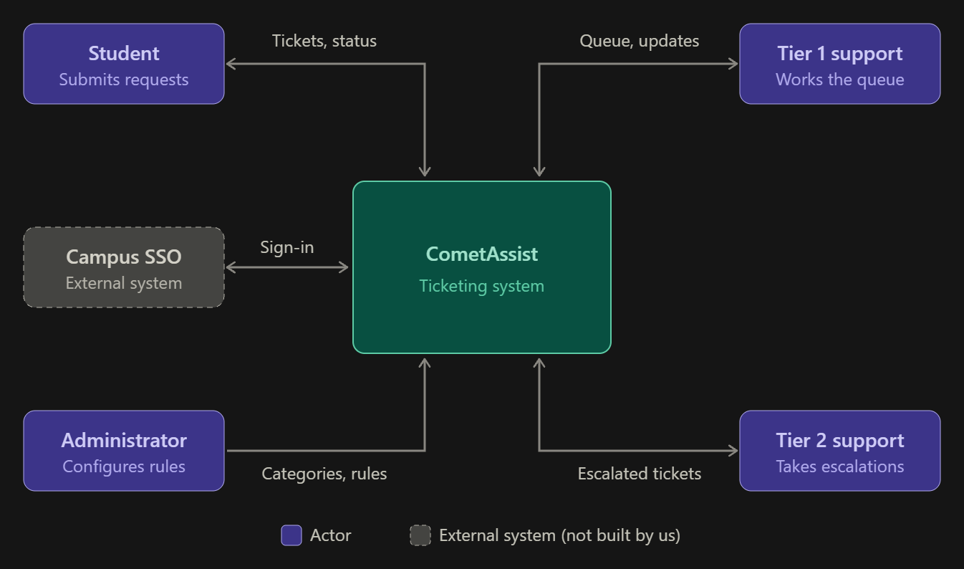
CometAssist is a standalone system covering ticket submission, category-based routing, escalation, and status tracking. Login is handled by the existing campus SSO, which sits outside the boundary because we use it but do not build it. This keeps the team’s work focused on routing and escalation.

2.2 Stakeholders and how you reached them

Stakeholder | Role in relation to the system | What they need from it | How you learned this
Students | Primary users who submit and track tickets | A simple way to get help without knowing which office to contact. | We are all students that have to go explore the UTD websites forever just to find who to contact.
Campus IT | Would operate and maintain the system | Low maintained effort plus SSO login compatibility. | Assumed
Administrators | Maintains categories and escalation rules | A way to change categories and time limits without code changes | Assumed
Support | Handle incoming tickets in their queue | Tickets that arrive in the right queue with enough detail to act on it | Assumed

2.3 User characteristics

Students. They are comfortable with web apps and SSO but can't be assumed to know how IT support is organized or which office handles what. Many will submit tickets from a phone, often while already frustrated or in a hurry. So, the form must be quick to complete on a small screen.
Support staff. Staff know the technical subject matter and work at a desktop during shifts. They need to scan and act on many tickets quickly, so the queue view matters more to them than a polished design. They can’t be assumed to have time for training on a new tool.
Administrators. Administrators are experienced IT staff who understand how support is organized. They make changes infrequently, so the configuration screens must be clear without relying on memory of how they worked last time.

2.4 Constraints

The system must use the existing campus for single sign-on service for login. The team must use free or student-licensed tools and hosting.

2.5 Assumptions and dependencies

# | Assumption or dependency | What breaks if it does not hold
A1 | Campus SSO can be used by a student project or simulated well enough for development. | Login must be built in-house, adding work and contradicting the 1.2 scope.
A2 | Support requests fall into a small, stable set of categories that students can choose between. | Routing by category fails if students can’t pick the right one, and tickets get misrouted anyway.
A3 | Support staff will check the CometAssist queue regularly without email alerts. | Tickets sit unnoticed, and escalation becomes the main way anything gets handled.

2.6 Feasibility summary

Feasibility gate | Verdict | Evidence behind the verdict
Technical | Feasible | Ticket submission, routing, and status tracking are standard web app features.
Operational | Feasible with Risk | Students already use web forms for campus services.
Schedule | Feasible if scope holds | The 1.2 exclusions keep the work to four core features.
Economic / resource | Feasible | Free or student-licensed tools and hosting cover the build.

3 Specific Requirements

3.1 Functional requirements

Tickets will have three possible statuses. Open, In Progress, and Resolved. Open means the ticket hasn’t been worked on yet. Resolved is the final status. The active queue has Open or In Progress tickets. New tickets have Normal priority. Escalation raises the priority to High and moves the ticket from Tier 1 to Tier 2 while keeping the Open status.
A ticket can be escalated when it is still Open with Normal Priority in Tier 1 and its age reaches the time limit set. Age is measured in hours from submission. The initial limit is 24 hours, and each ticket should escalate only once.
Students may only read the tickets they have submitted. Support staff may read and update the tickets only assigned to their team. Only administrators may change categories or escalation settings. Users who aren’t signed in shouldn’t have access to tickets or configuration settings.

ID | Requirement — one “shall” sentence | Priority | Source | Acceptance criterion
FR-01 | The system shall let a signed in student submit a ticket with a title, description and a category from a drop-down list. | MUST | Students Section 2.2 | Blank required fields prevent the submission. Submit two filled out tickets, and each should get a different ticket ID with Open status and Normal priority.
FR-02 | The system shall send each new ticket to the Tier 1 support team that is listed for its category. | MUST | Students and Support  Section 2.2 | Submit tickets under different categories. Each ticket appears in the queue listed for its category.
FR-03 | The system shall let students view the details and current status of their own ticket. | MUST | Students  Section 2.2 | A student can see their submitted information, status, priority, and assigned team. Their tickets remain after signing out and signing back in. Another student’s tickets are hidden.
FR-04 | The system shall let support staff view active tickets assigned to their team. | MUST | Support  Section 2.2 | Staff see only their team’s Open or In Progress tickets. High priority tickets appear first, then the oldest within each priority. Opening a ticket shows its description and current status.
FR-05 | The system shall let support staff change a ticket from Open to In Progress or from In Progress to Resolved. | MUST | Students and Support  Section 2.2 | Assigned staff make both changes. The student sees the saved status after refreshing or signing back in. Resolved tickets cannot be reopened.
FR-06 | The system shall automatically send an unhandled ticket to Tier 2 support with High priority once it reaches the set time limit. | MUST | Support  Sections 1.2 and 2.2 | Set the time limit to one hour. An Open Tier 1 ticket that reaches the one hour mark moves to Tier 2 at High Priority within five minutes. In Progress, Resolved and already escalated tickets do not move.
FR-07 | The system shall let an administrator add or edit a ticket category and the support team for that category. | MUST | Admins  Section 2.2 | Save a category name with a Tier 1 team. Reopen settings to confirm the change. New tickets follow the saved choice. A blank name or missing team prevents saving.
FR-08 | The system shall let an administrator change the time limit and Tier 2 team used for escalation. | MUST | Admins  Section 2.2 | Save a positive whole number of hours with a Tier 2 team. Sign out and back in to confirm the values. Zero, negative, fraction or missing hours and a missing team prevents the settings from being saved.

3.2 Quality requirements

ID | Requirement — with threshold, condition and method | Priority | Source | How it will be verified
QR-01 | The system shall finish a ticket submission or display a ticket list within ten seconds on the test computer with one signed in user and up to 25 stored tickets. | SHOULD | Students and Support  Section 2.3 | Time 25 actions covering ticket submission, the student ticket list and the staff queue. Each result appears within ten seconds of the action.
QR-02 | The system shall keep 100% of saved tickets and settings after a normal application restart with up to 25 stored tickets. | MUST | Students, Support, and Admins  Section 2.3 | Save 25 tickets with different statuses. Save a settings change. Close and restart the application. All saved details, statuses and settings match the values before the restart.
QR-03 | The system shall show all three ticket fields and the Submit button without sideways scrolling at widths of 360 and 1280 pixels. | SHOULD | Students  Section 2.3 | Check the ticket form at both widths. The title, description, category, and Submit button are fully visible by scrolling vertically, with no cut offs.
QR-04 | The system shall block 100% of requests that break the access rules in section 3.1 | MUST | Students, Support, and Admins  Section 2.2 | Check four cases.  - A signed out user opens a ticket  - A student opens another students ticket  - A student changes admin settings  - Staff from another team change a ticket  Each request is denied without showing protected data or saving a change.

3.3 Constraint requirements

ID | Constraint — one sentence | Source | Why it cannot be negotiated
CON-01 | The system shall use the campus SSO for signing in, with a clearly labeled simulation used. | Section 2.4 and 2.5 | The scope excludes creating a separate password system.
CON-02 | The system shall use only tools that are free to the team. | Section 2.4 | The project plan relies on free resources.

3.4 Initial use cases

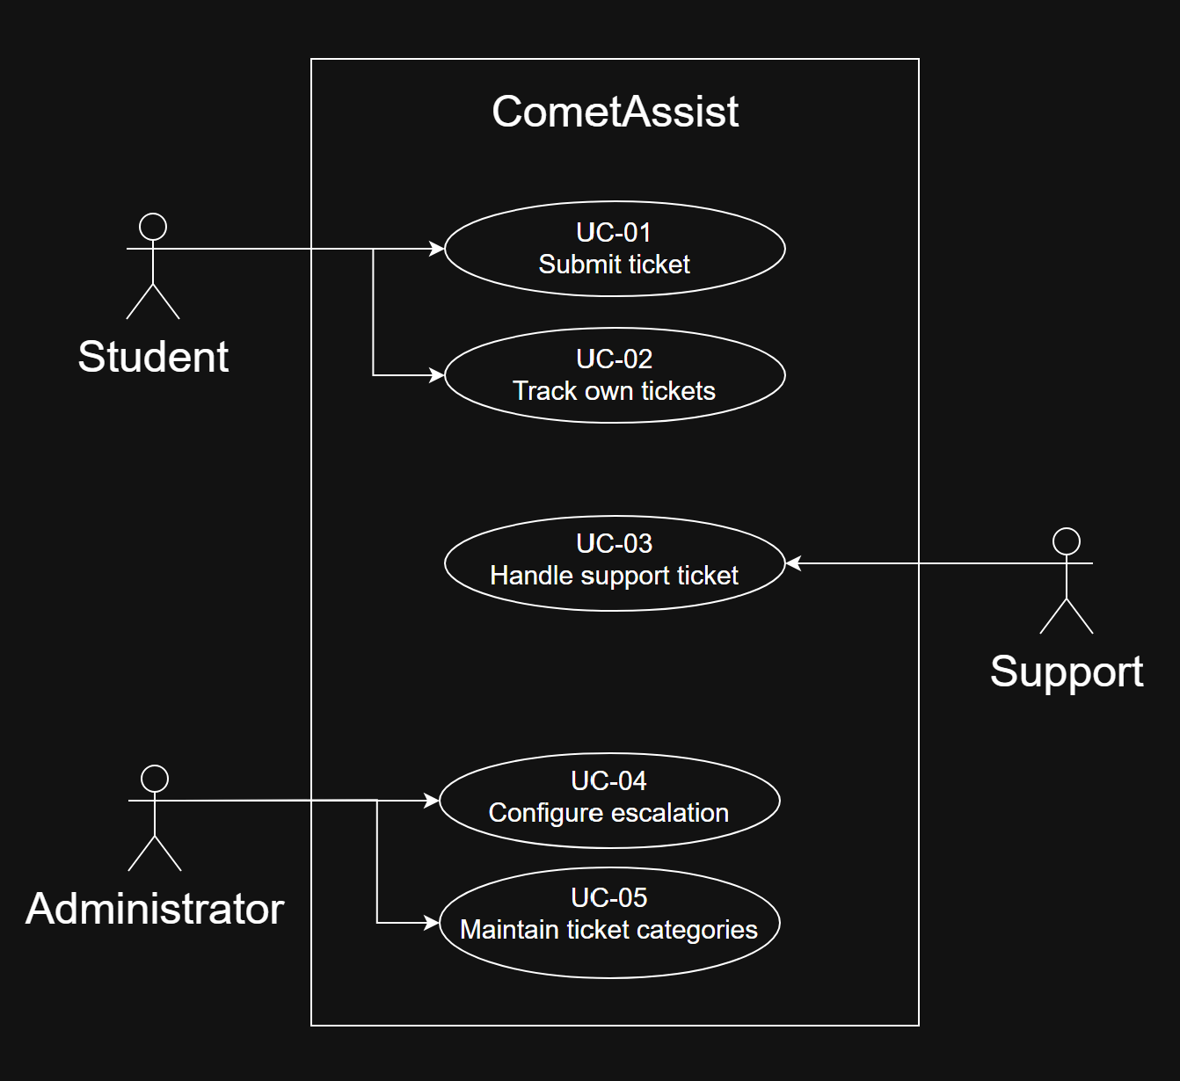

Expanded UC-03
Field | Content
Identifier and name | UC-03 Handle support ticket
Primary actor | Support staff from the assigned Tier 1 or Tier 2 team.
Supporting actors | None. Escalation is automatic system behavior supporting this goal.
Preconditions — what must be true before it starts | The staff member is signed in and belongs to a configured support team. Tickets may already exist in that team’s queue.
Trigger — what starts it | The staff member opens their team’s ticket queue.
Main success scenario — numbered steps | - The staff member opens the assigned team queue  - The system lists that team’s Open and In Progress tickets, showing High Priority first and then oldest submission first within each priority.  - The staff member selects an Open ticket.  - The system displays the ticket details and current state.  - The staff member marks the ticket In Progress when work begins.  - The system saves the new status and makes it visible to the student.  - After addressing the issue, the staff member marks the ticket Resolved.  - The system saves the resolution status for later viewing.
Alternative and exception flows | 2a. Empty queue - the system shows that no tickets are assigned, the use case ends.  3a. Already In Progress – the assigned staff member open that ticket and continues from step 7 after completing the work.  3b. Ticket moved to another team before it is opened, the access is then denied and the queue is refreshed.  6a or 8a. A save fails – the previous saved status stays and the staff member can try again.
Postconditions — what is true when it succeeds | The ticket is saved as Resolved and the submitting student can see its final state. The ticket stays stored for viewing later.
Requirements realized | FR-04, FR-05, FR-06, FR-09, and FR-12.  QR-01, QR-02, and QR-04.

Expanded UC-04
Field | Content
Identifier and name | UC-04 Configure escalation
Primary actor | Administrator
Supporting actors | None.
Preconditions — what must be true before it starts | The administrator is signed in with the admin role. At least one Tier 2 support team is available for selection.
Trigger — what starts it | The administrator opens the escalation settings.
Main success scenario — numbered steps | - The system displays the current escalation time and Tier 2 destination.  - The administrator enters a positive whole number of hours.  - The administrator selects an available Tier 2 support team.  - The administrator selects Save.  - The system validates both values and stores the rule.  - The system confirms the change and displays the saved values.  - The saved rule applies to existing eligible Tier 1 tickets and new tickets.
Alternative and exception flows | 2a. Hours are missing, zero, negative, or a fraction. The saving is rejected. The system goes back to the previously saved rule.  3a. No available Tier 2 team is selected. The saving is rejected until a valid team is chosen.  4a. The administrator exits without saving. The existing rule stays applied.  5a. A save fails. The previous saved rule stays applied and the administrator can try again.
Postconditions — what is true when it succeeds | The rule is stored and remains available in future sessions. Open Tier 1 tickets already older than the new time limit escalate within five minutes of the change. Tickets already assigned to Tier 2 keep their assignment.
Requirements realized | FR-06 and FR-08  QR-02 and QR-04

3.5 Requirements to use case traceability

Requirement ID | Use case(s) that realize it | If blank — why, and what you will do
FR-01 | UC-01
FR-02 | UC-01
FR-03 | UC-02
FR-04 | UC-03
FR-05 | UC-03
FR-06 | UC-03, UC-04
FR-07 | UC-05
FR-08 | UC-04
QR-01 | UC-01, UC-02, UC-03
QR-02 | UC-01 to UC-05
QR-03 | UC-01
QR-04 | UC-01 to UC-05
CON-01 | UC-01 to UC-05
CON-02 | n/a | Resource constraint, checked by reviewing tools.

4 Project Plan
4.1 Team roles and working agreement
Team member | Role for P1 to P2 | How the team makes a decision when it disagrees
Michael Maranville | Team Lead | Consult the requirements and documentation and come to a majority-vote decision on how to move forward together.
Saket Dwivedi | Authentication Lead | -
Nathan Simpson | Database and Backend Developer | -
Himesh Anumala | Requirements and Documentation Lead | -
Huzaifa Nizami | Quality Assurance and Testing Lead | -
Uchenna Okoko | Support Queue Developer | -
Yousif Al Khafaji | Student Facing UI/UX Developer | -

4.2 Plan to P2

Date | What will be finished | Owner
10/22 | Review P1 requirements and resolve ambiguities, conflicting requirements and missing criteria. | UI/UX Developer + Testing Lead
10/28 | Resolve any questions about SSO access and decide what authentication simulation is required if access to SSO is denied. | Authentication Lead + Backend Developer
11/1 | Draft the dropdown menu items and determine the routing to different teams. | Requirements Lead + Support Queue Developer
11/4 | Establish a draft of all interactions between the front end, back end, database, and authentication slices. | Backend Developer
11/6 | Gather student feedback and complete a staff test to determine the user experience and usability requirements. | Testing Lead + Requirements Lead
11/8 | Review the work done on P2, ensure consistency between the documents, and record all remaining unnamed changes to the schema/requirements. | Team Lead + Entire Team

4.3 Risks

# | Risk | Likelihood | Impact | Mitigation — action and owner
R1 | No access to Campus SSO. | High | High | The Authentication Lead will ask the professor to request SSO integration by 10/30 because students may not.
R2 | Nobody uses it. | Medium | High | The Testing Lead will collect user feedback from student volunteers and do a staff usage demonstration before 11/6.
R3 | Students don’t use the right dropdown and submit tickets to the wrong team. | High | Medium | The Requirements Lead will validate the dropdown options by asking the OIT Support Desk and establishing what the different support teams are by 11/1.
R4 | A security oversight allows students to access tickets they shouldn’t. | Medium | High | The Authentication Lead will develop a role-based access system that restricts users’ permissions and test it. Tests will include students accessing other students’ tickets, staff accessing other teams’ tickets, and students changing staff/admin settings.
R5 | Escalation fails and tickets go unresolved. | Medium | High | The Support Queue Developer will write timed tests and ensure that tickets are escalated properly, and tickets are assigned to be resolved.

4.4 Repository and tooling

Repository Link: https://github.com/michmara13/CometAssist/tree/main
We have agreed to ensure that all commits are accompanied by a comment explain what was changed, and to follow the naming convention of the previous version for consistency. Branches will be created for each feature. They will be merged frequently but only after extensive testing.
Issues will be used to trace the work of each member and ensure problems are addressed and recorded.
Currently, only the team and Professor Seker have access. This project is not open source.

4.5 Declaration of AI tool use

Tool | What it was used for | Who used it | How the output was checked
Claude AI | Refining questions/helping find out who can help answer questions. | Himesh | I read through the output and checked if the “Who can answer it” section answers existed/made sense.

5 Open Questions

# | The question | Who can answer it | Needed by | What you assumed in the meantime
Q1 | Does escalation mean higher priority, moving to a senior tier, or both? | UTD OIT Help Desk | 25 Oct | Both, within the same team.
Q2 | How long can a ticket sit before it escalates? | UTD OIT Help Desk | 25 Oct | One business day with no staff response.
Q3 | What categories should students choose from, and which team owns each? | UTD OIT Help Desk | 1 Nov | Account and Login, Wifi and Network, Software, eLearning/Canvas, Registration, Other.
Q4 | Can we use campus SSO, or a test version of it? | UTD OIT Help Desk | 25 Oct | We use DUO login.
Q5 | Do staff or students need email alerts? | Support staff and students | 1 Nov | No, email alerts are unnecessary for function.

6 Baseline Declaration

We confirm that the requirements in section 3 represent our agreed baseline as of the submission date, and that every team member has read this document in full.
Team member | Signature or typed name | Date
Himesh Anumala | Himesh Anumala | 10/18/2026
Nathan Simpson | Nathan Simpson | 10/18/2026
Saket Dwivedi | Saket Dwivedi | 10/18/2026
Michael Maranville | Michael Maranville | 10/18/2026
Huzaifa Nizami | Huzaifa Nizami | 10/18/2026
Uchenna Okoko | Uchenna Okoko | 10/18/2026
Yousif Al Khafaji | Yousif Al Khafaji | 10/18/2026

How P1 Is Marked
P1 is worth 4% of the course grade. Following the syllabus, 80 points are for the shared team artifact and 20 for individual contribution evidence.
Criterion | Points | What full marks look like
Problem, scope and context (1.1, 1.2, 2.1) | 10 | The problem is a problem somebody actually has. The out-of-scope column is filled and the exclusions are justified. The context diagram's boundary matches what sections 2 and 3 claim.
Stakeholders and elicitation (2.2, 2.3) | 10 | Stakeholders include at least one who will never use the system. Every need has a stated basis, and assumptions are labelled as assumptions rather than disguised as findings.
Requirements quality (3.1, 3.2, 3.3) | 25 | Every requirement is one testable “shall” sentence with an identifier, a priority, a source and an acceptance criterion. Quality requirements carry a threshold, a condition and a method. Constraints are distinguished from quality requirements.
Use cases and traceability (3.4, 3.5) | 20 | Use cases are at actor-goal level, not steps. Two are written out in full, including alternative flows. The matrix is complete and the team says what the gaps mean and what they did about them.
Feasibility and plan (2.6, 4) | 10 | Each feasibility verdict is backed by evidence a reader can check. The plan has dates and owners. Risks are future events with actionable mitigations.
Open questions and baseline (5, 6) | 5 | Real open questions, with an owner and a date, and an honest statement of what was assumed in the meantime.
Document quality | — | Guidance boxes removed, sections in order, within the length budget, readable. Marks are deducted here, not awarded.
Individual contribution evidence (0.1) | 20 | Every member's contribution is distinguishable and traceable to something in the repository a reader can open.

