Michael Dang – 16257750

MATH434

HW4

9.

a.

Smoker data set.

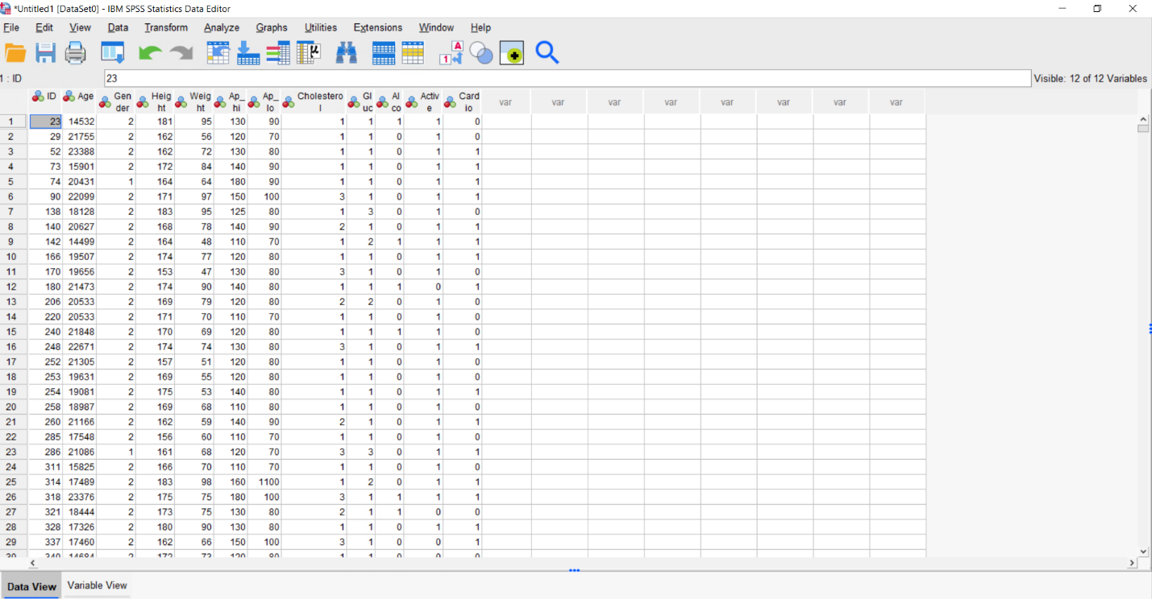

Male non-smoker

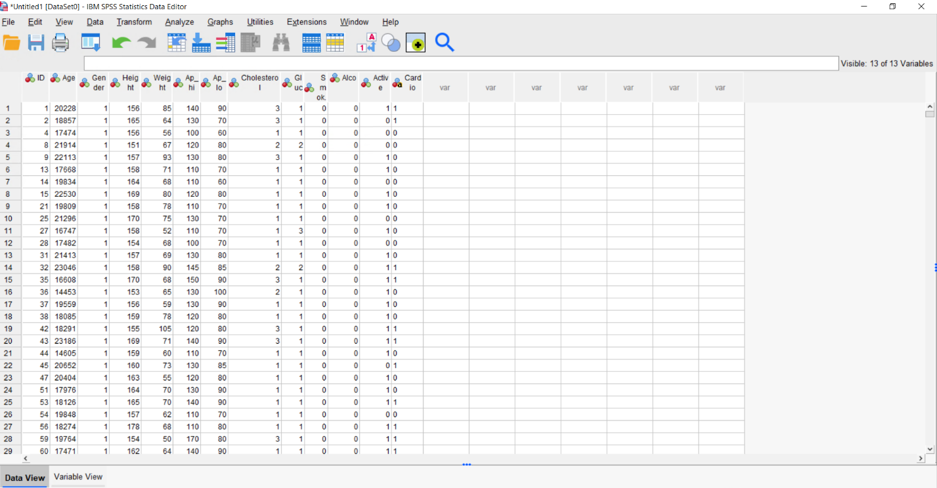

Female non-smoker

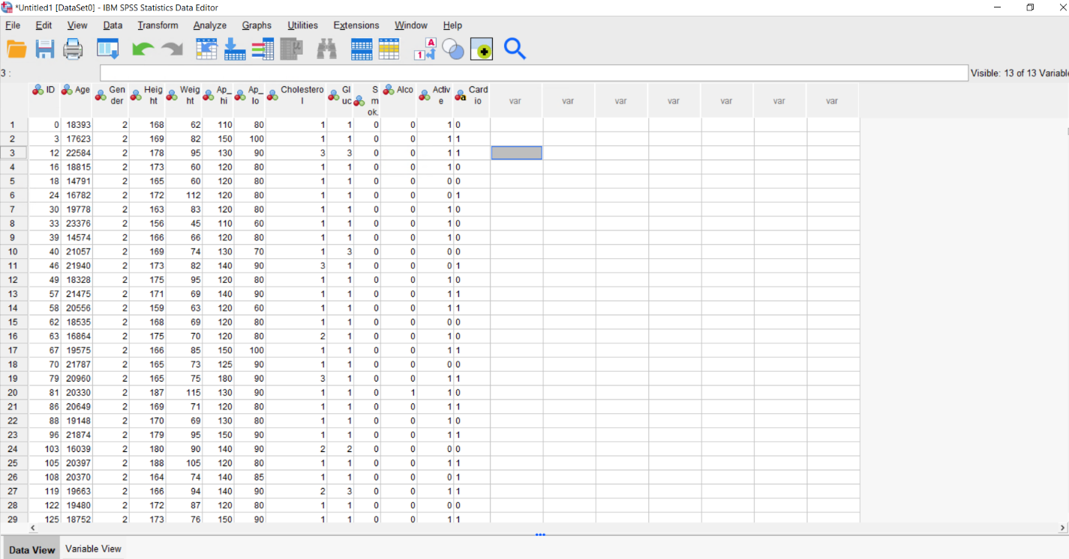

b. & c.

Smoker

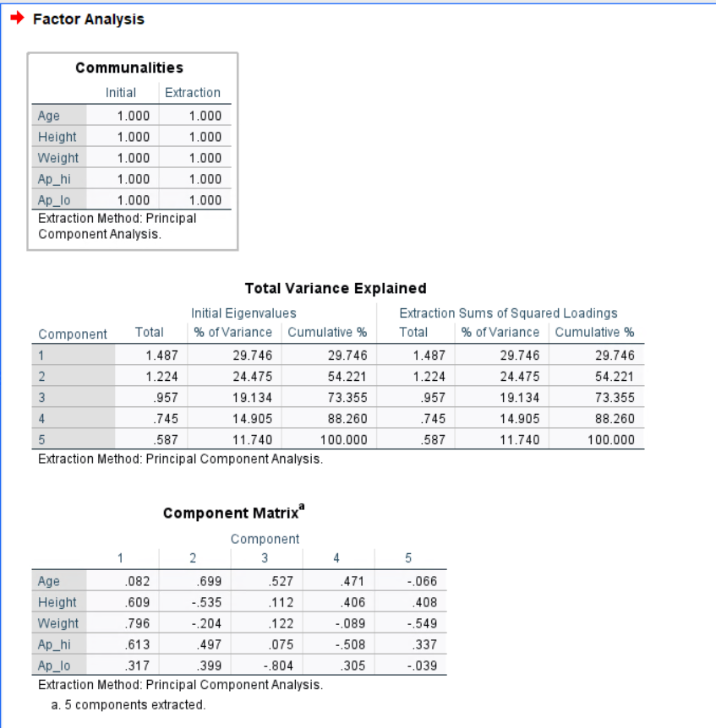

Male non-smoker

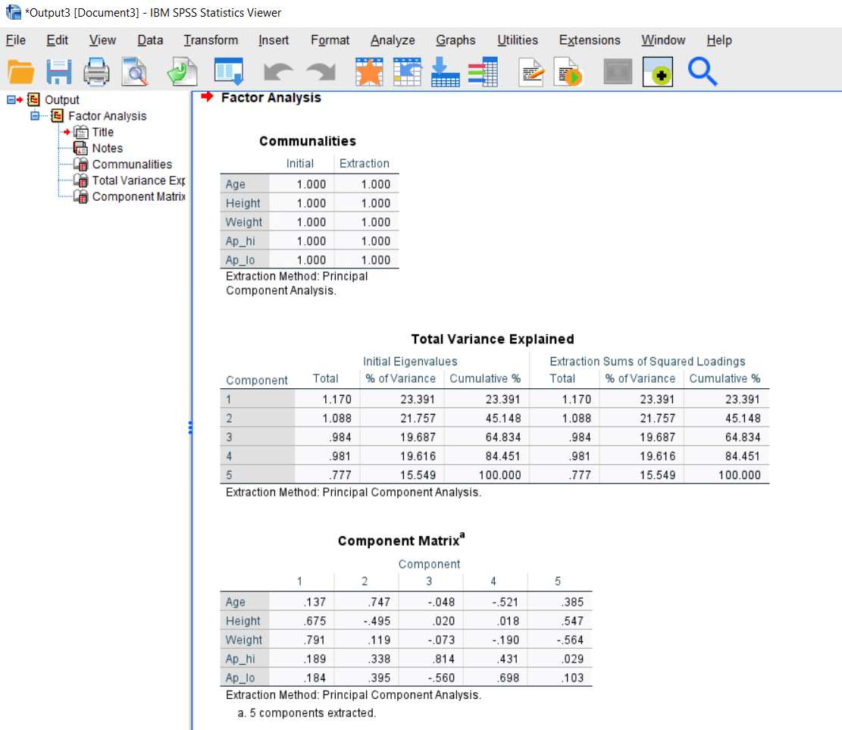

Female non-smoker

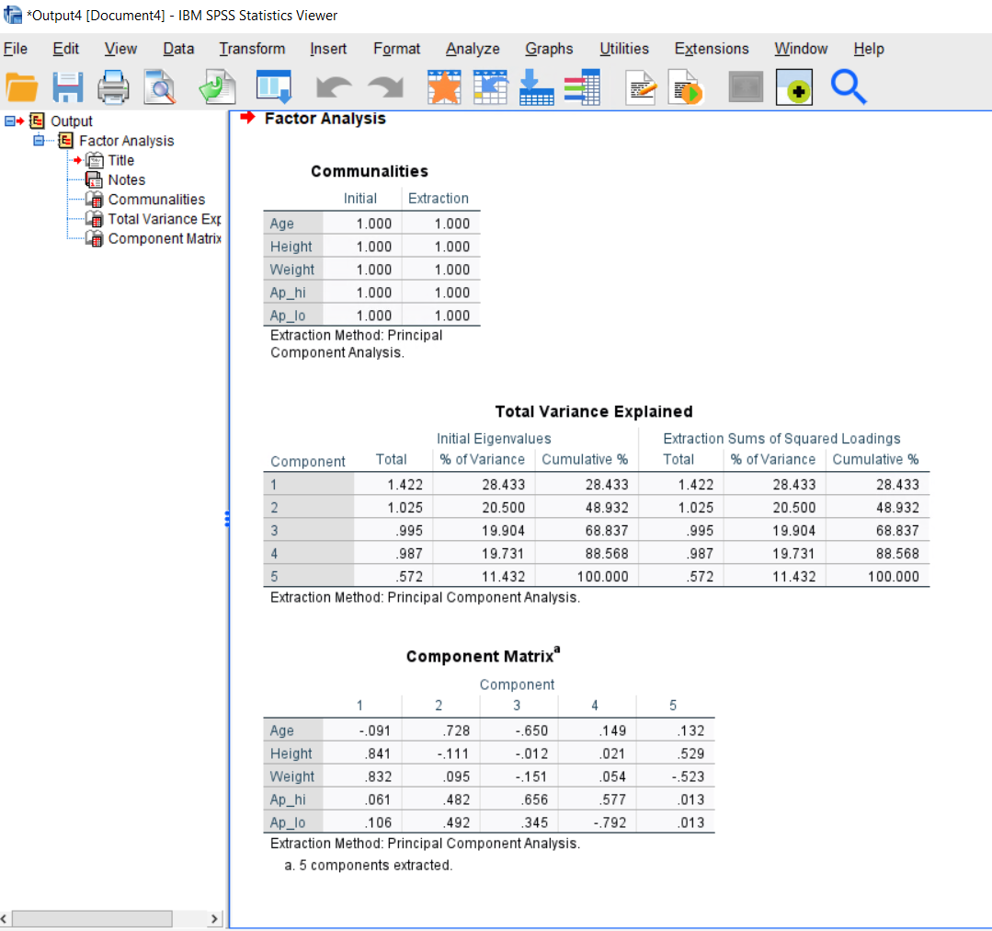

d.

For smoker, the total variance capture at the accepting percentage is PC3 or PC4. Because it captures more than 73%, which is pretty good.

For male non-smoker, the total variance capture at the accepting percentage is PC4. Because at that level it captures more than 84%, also pretty good.

For female non-smoker, the total variance capture at the accepting percentage is PC4. Because at that level it captures more than 88%, incredibly good.

Note: I used the eigenvalue greater than 0 to get this analysis.