Michael Dang – 16257750

MATH434

HW2

#1

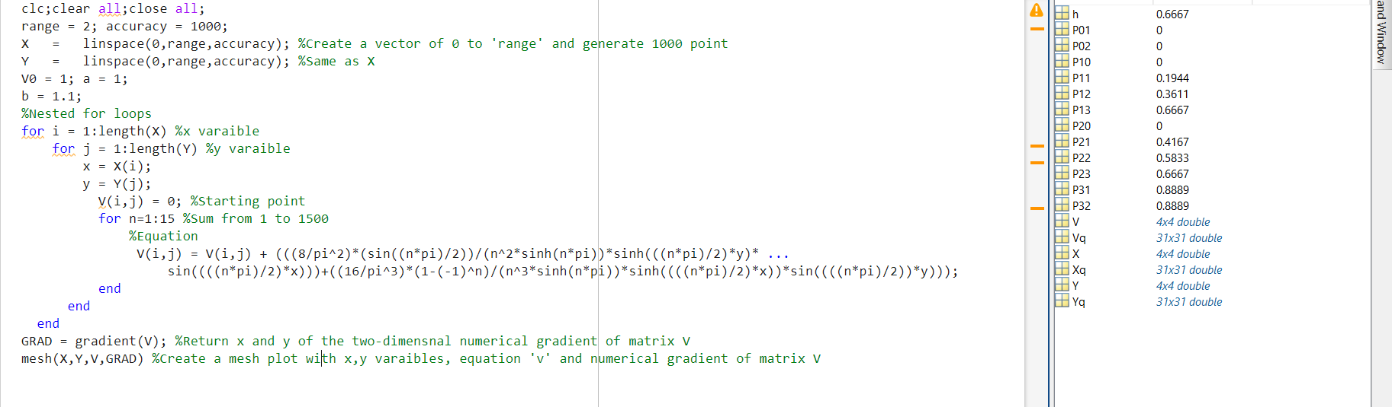

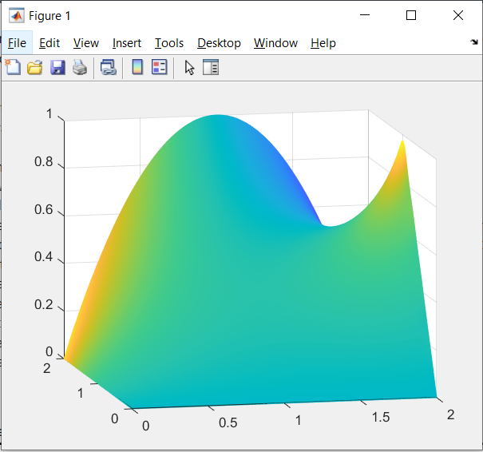

b.

On another file.

I try to code this problem based on Dr. Brunton’s lecture!!

d.

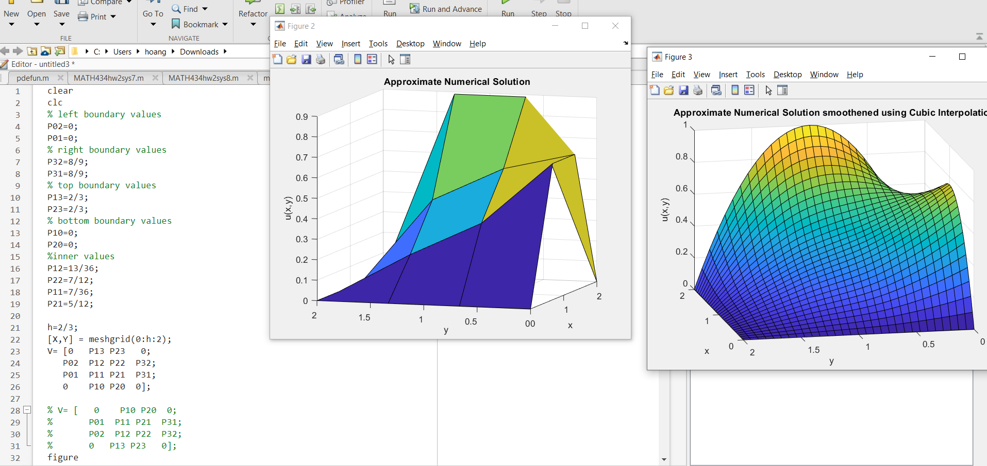

e.

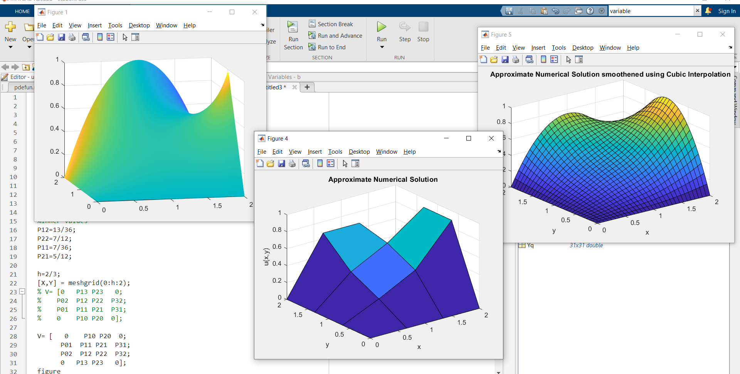

No, it doesn’t match. Because figure 1 is different compared to figure 4 and figure 5 as the shape.