Michael Dang – 16257750

MATH434

HW3

#3

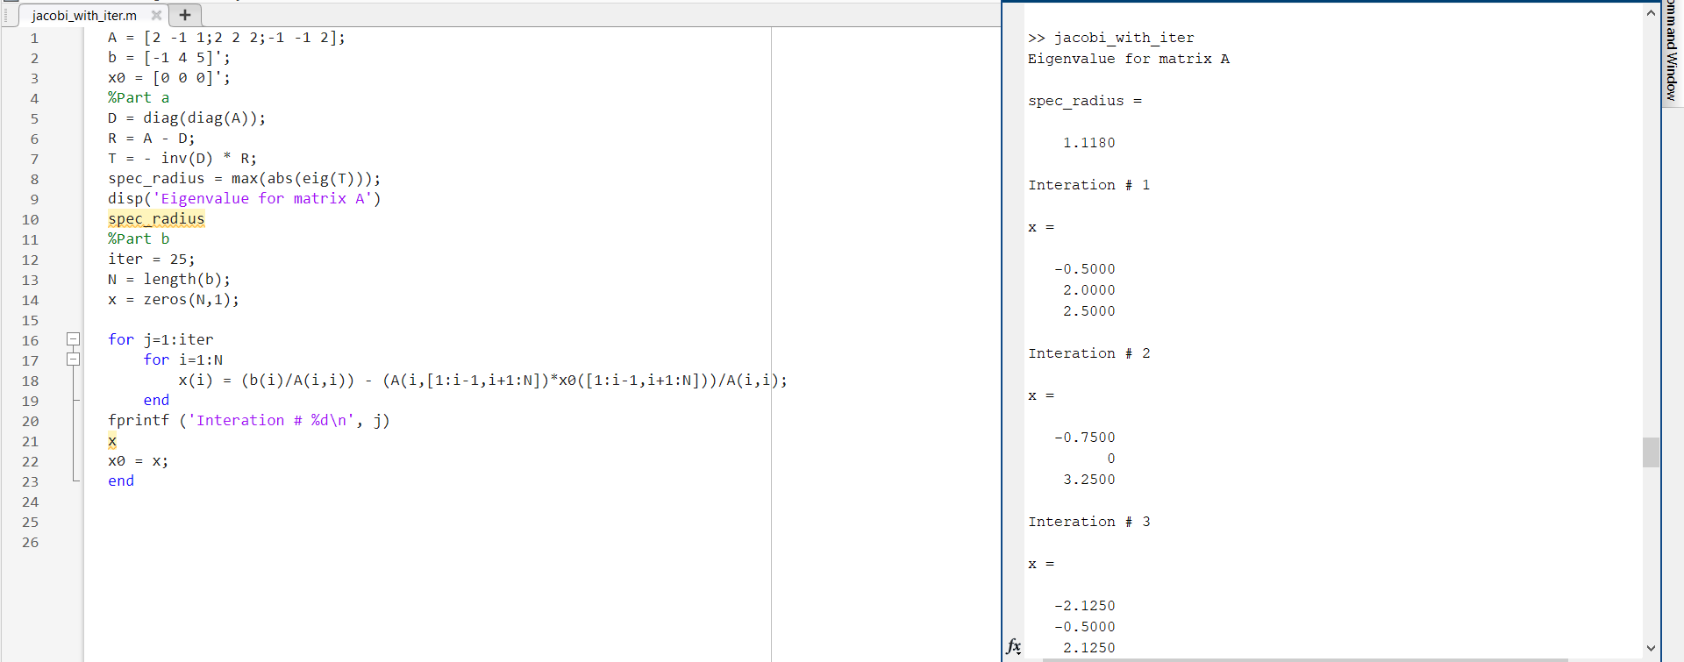

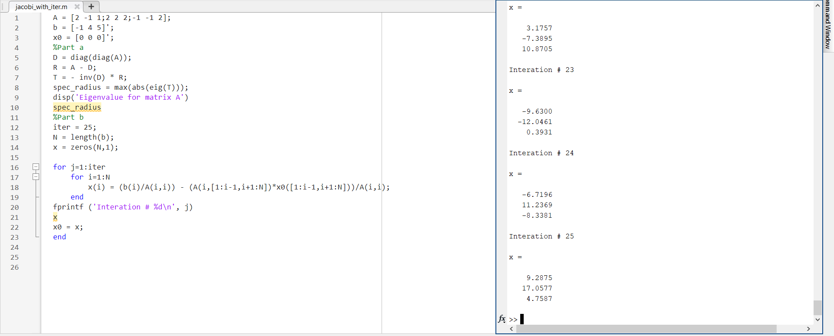

After 25 iterations, Jacobi method fail. The approximate solution is far away from the exact solution.

c.

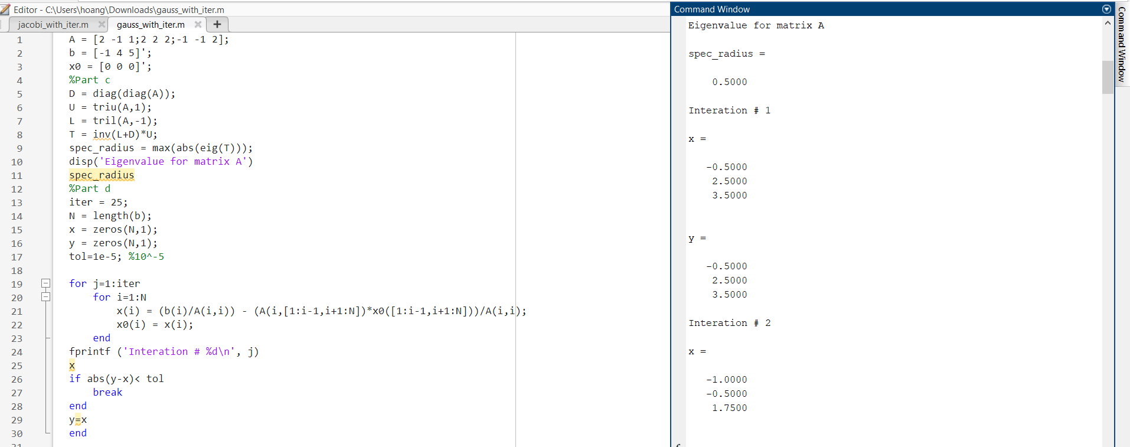

d.

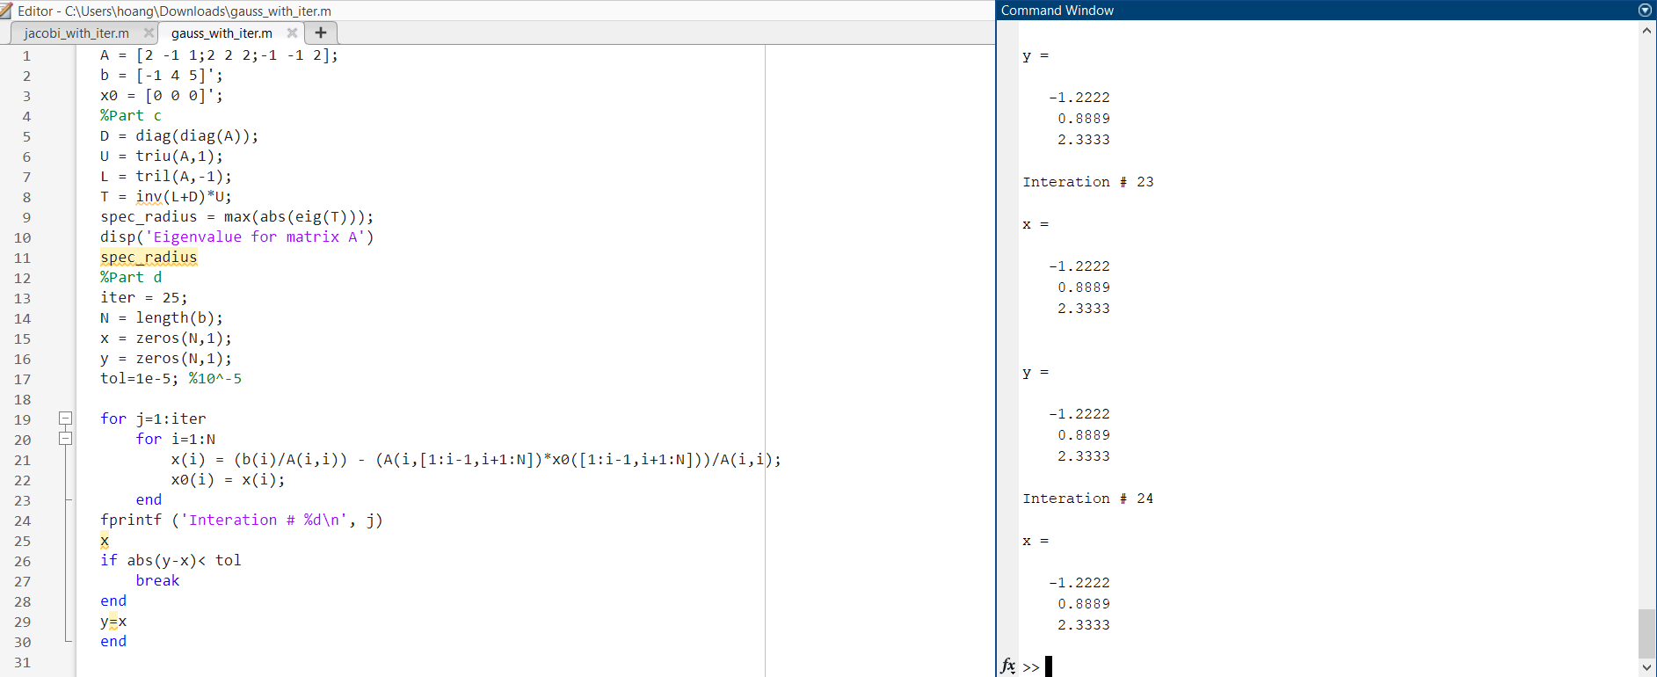

I’m not sure want you mean by within 10^-5 in l infinity norm.