Michael Dang – 16257750

MATH434

Lab2

1. 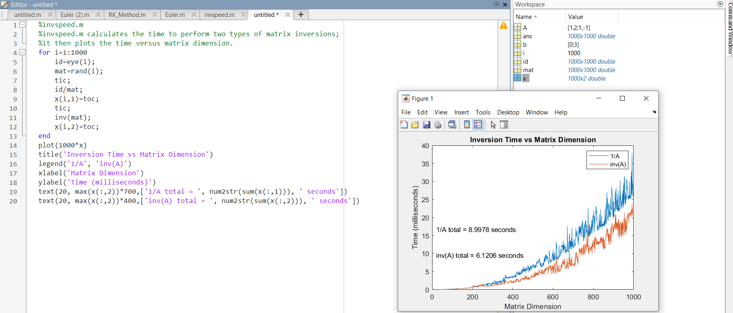
2. a.

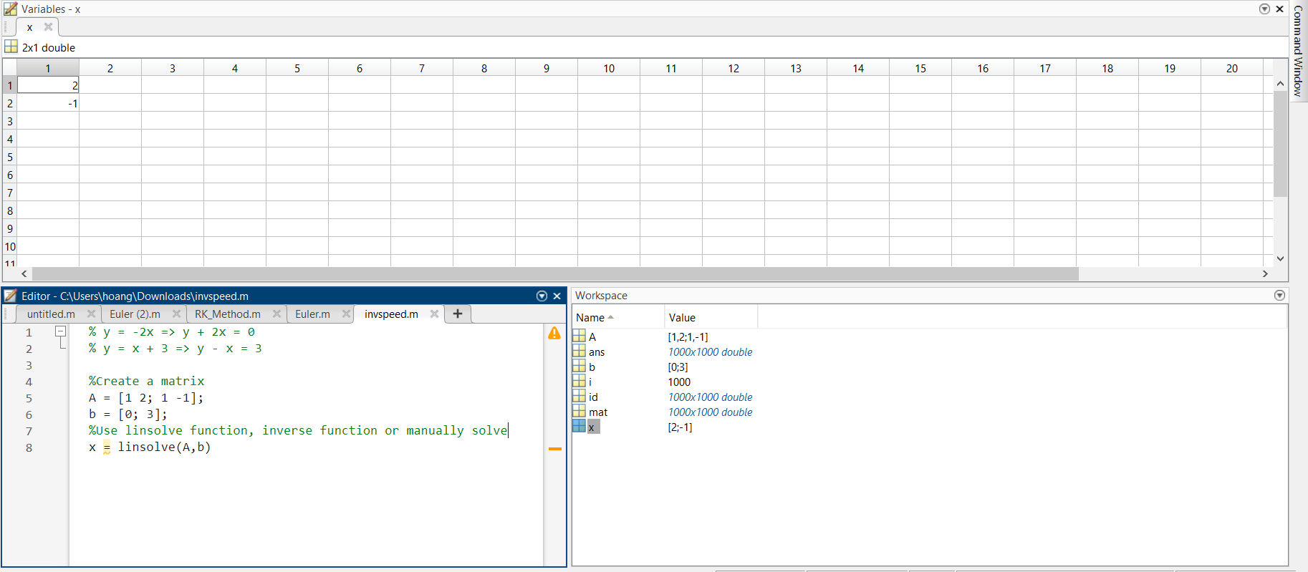

b.

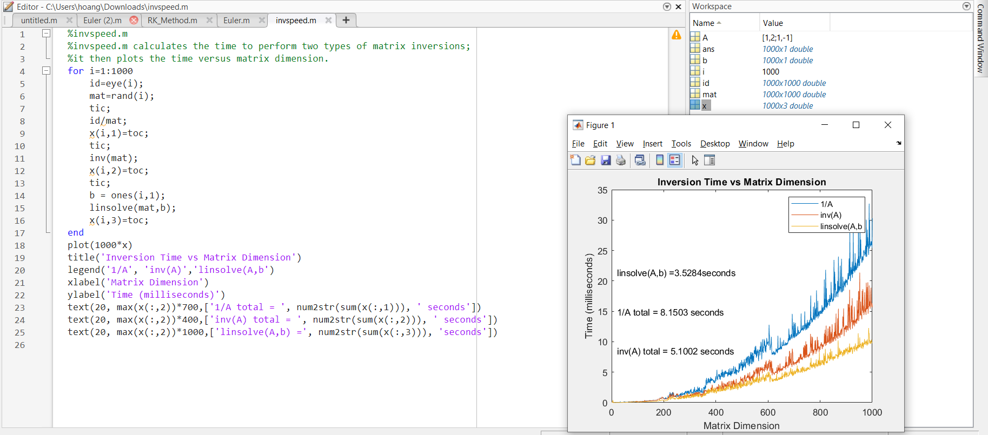

1. a.

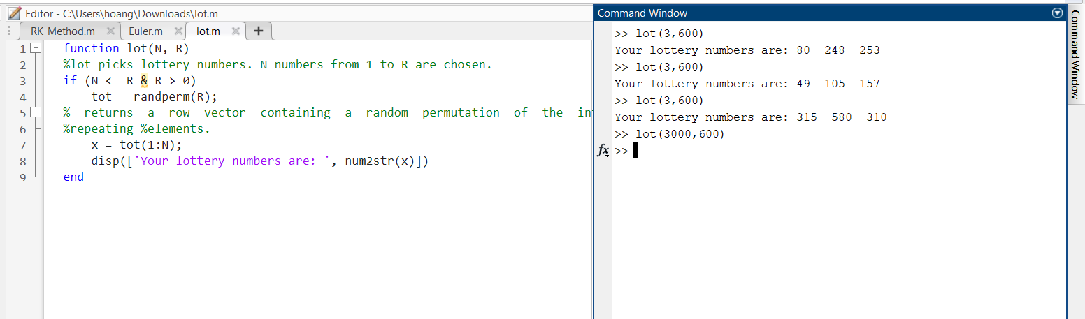

b.

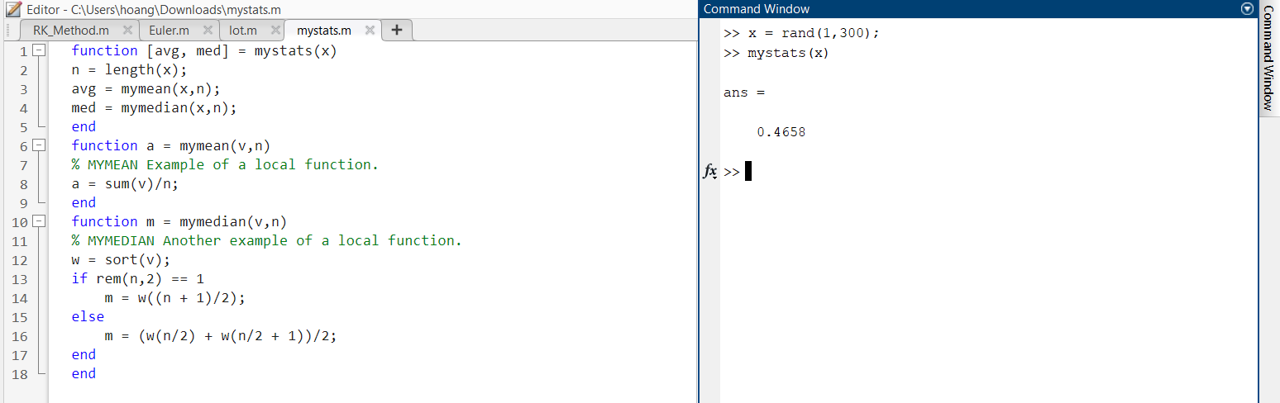

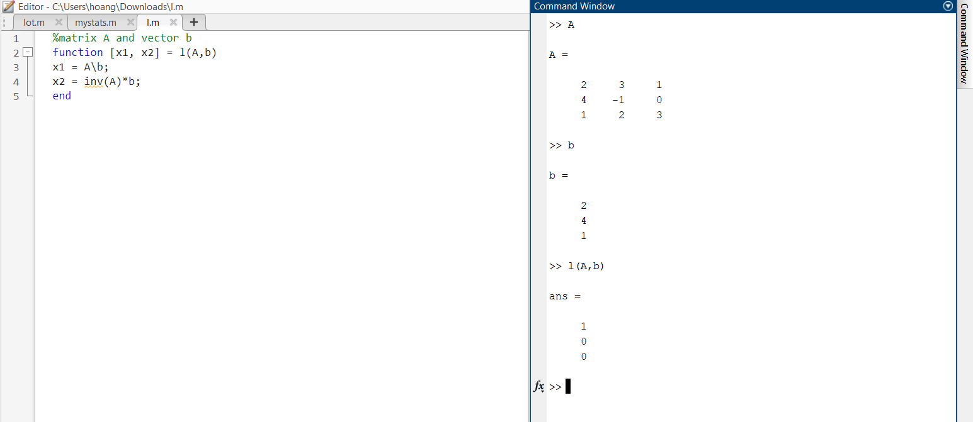

1. 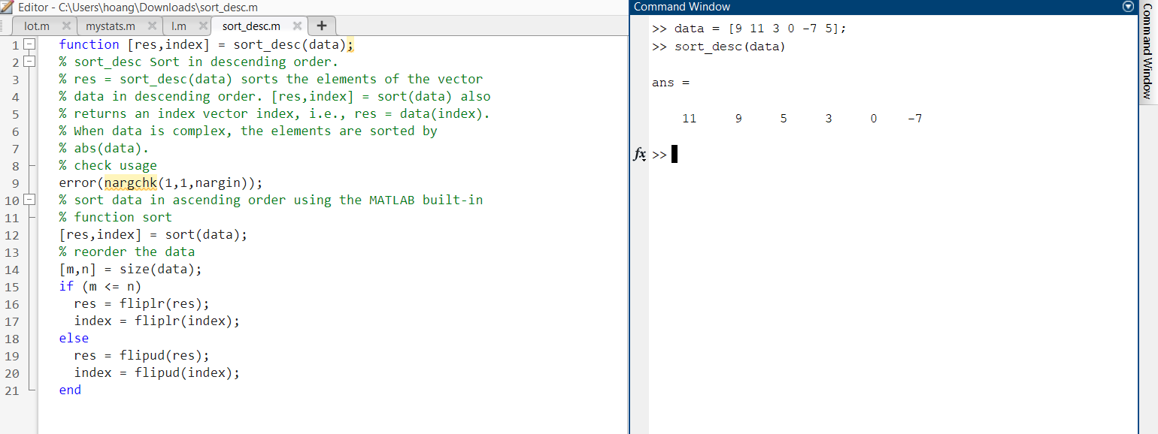

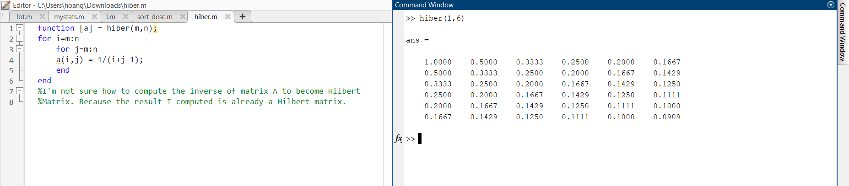

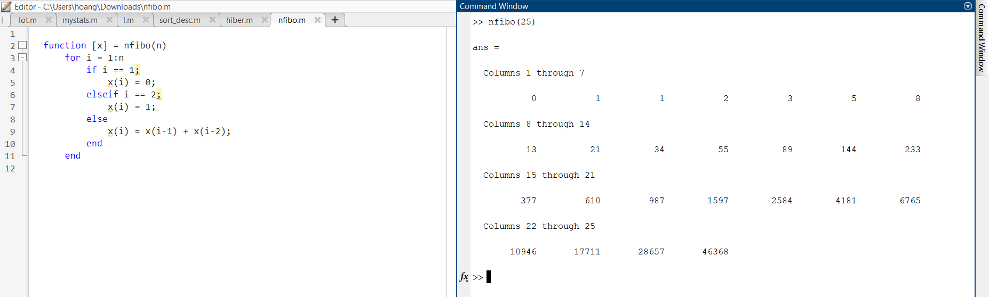

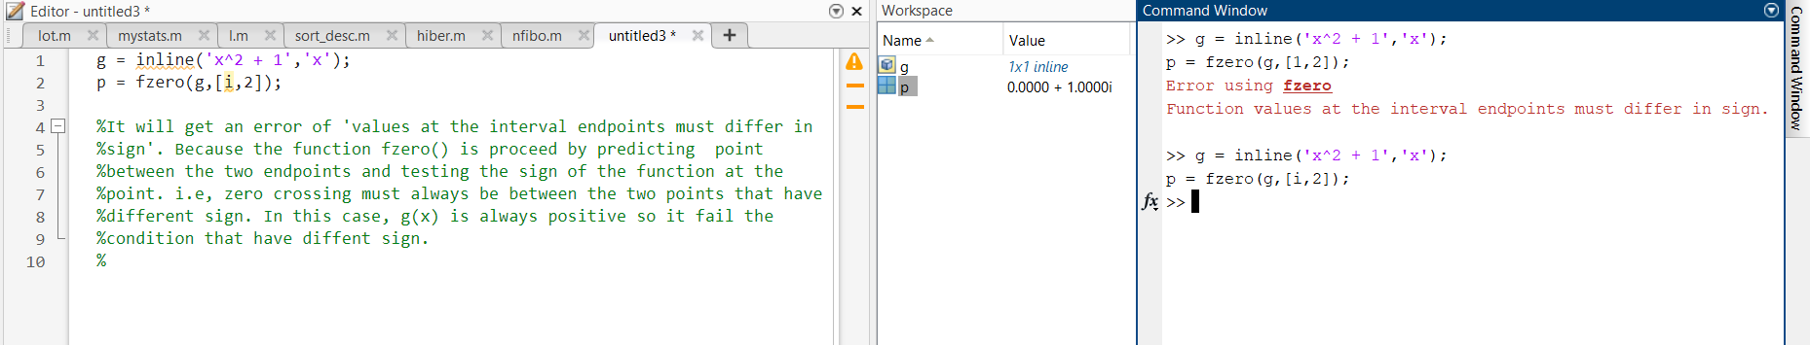

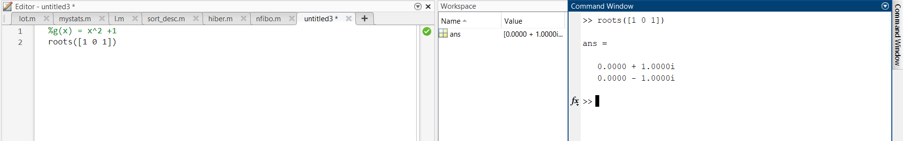

This computation of eigenvalues in MATLAB can determine as the root() function for polynomial. As the professor demonstrated in class, the result shows the same. i.e, we can use root() to find the eigenvalues of the matrix as long as we can get the characteristic equation.

