Michael Dang – 16257750

Math434

Lab3

1.

a.

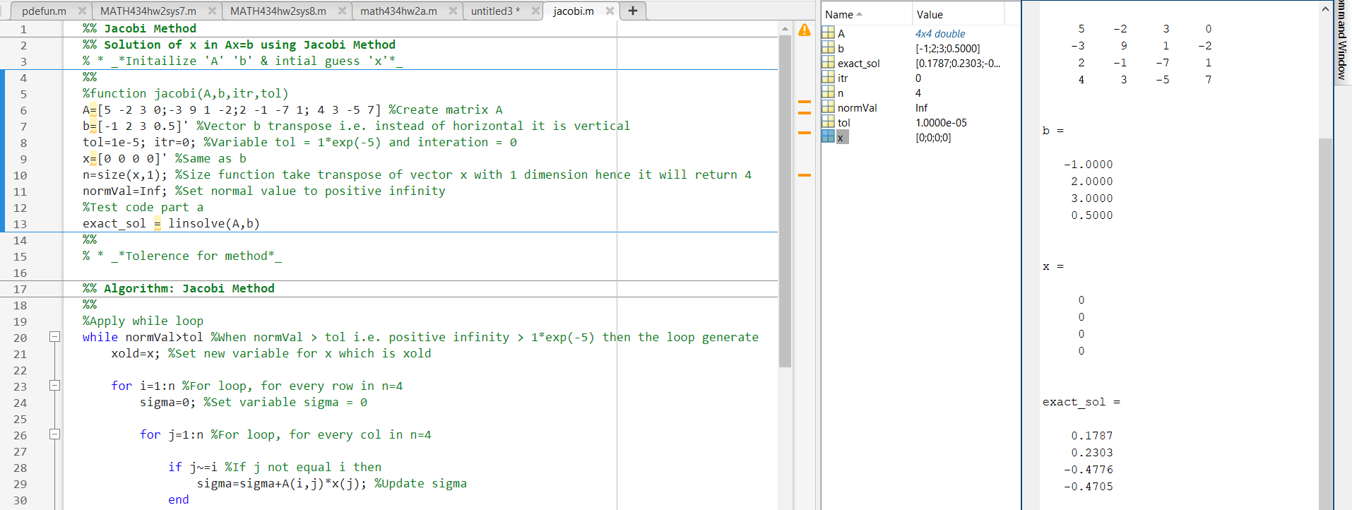

b.

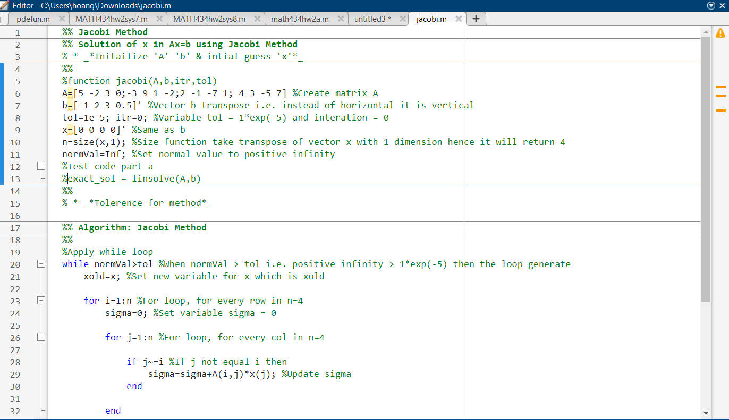

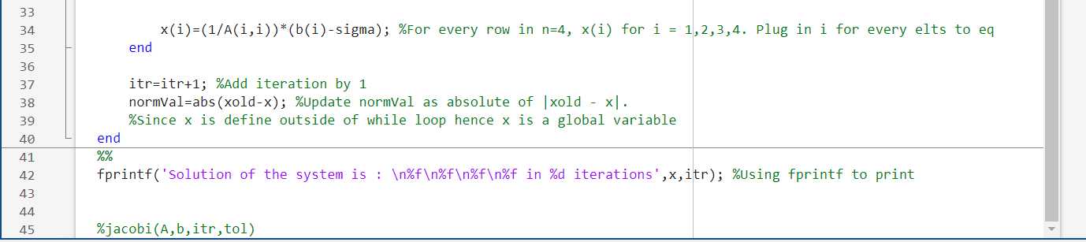

c.

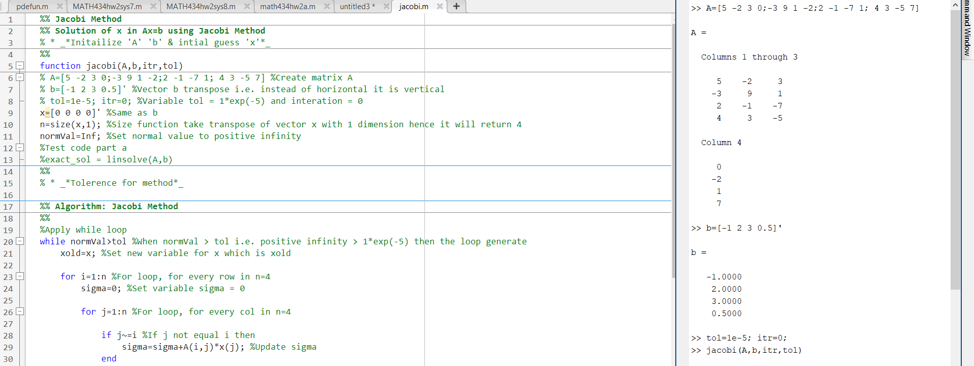

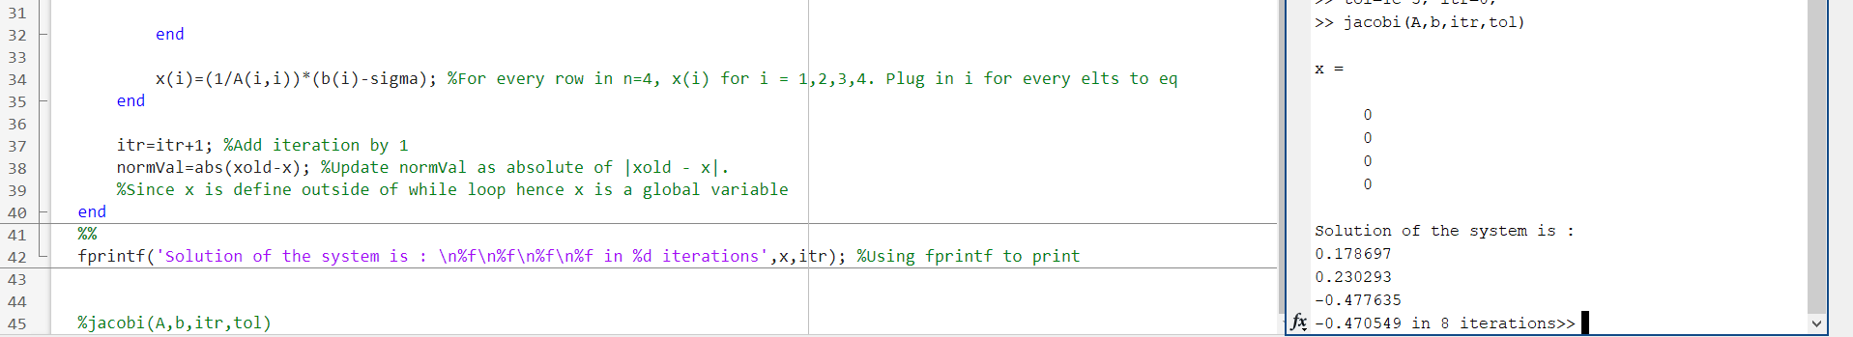

d.

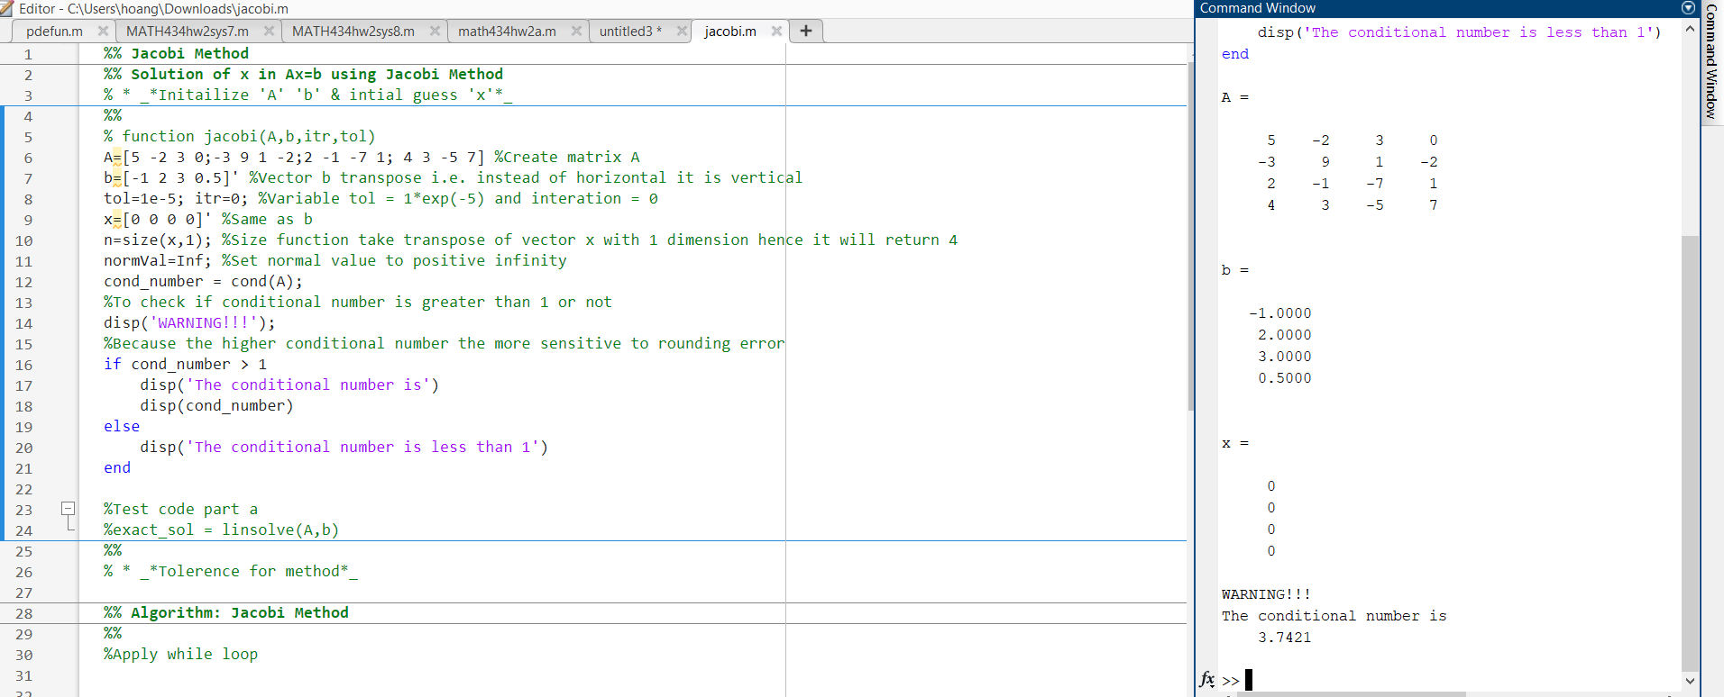

e.

I tried to code this but it not working. This is what I have from matworks

<https://www.mathworks.com/matlabcentral/answers/511902-making-a-matrix-strictly-diagonally-dominant>

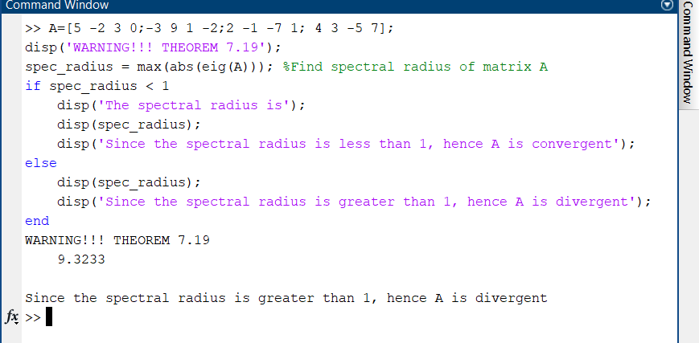f.

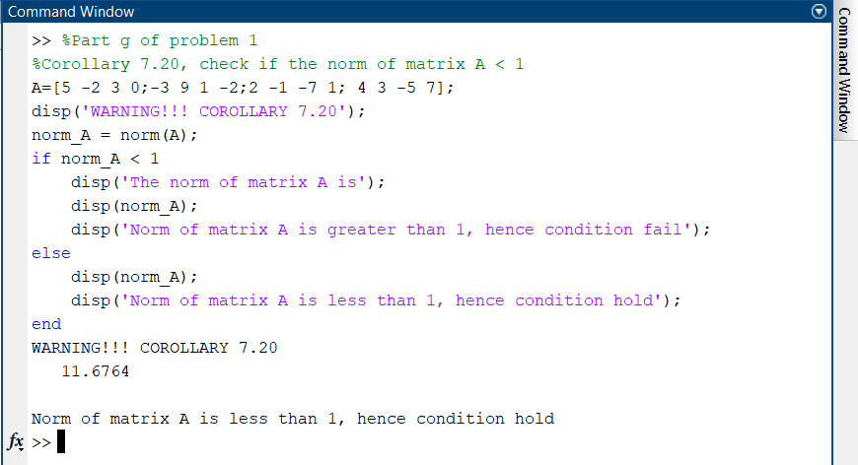

g.

f.

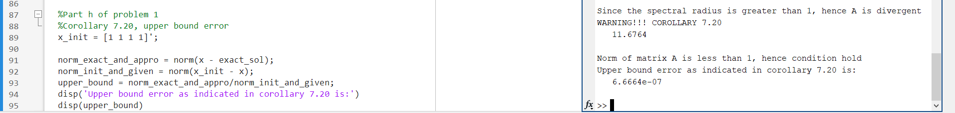

2.

a.

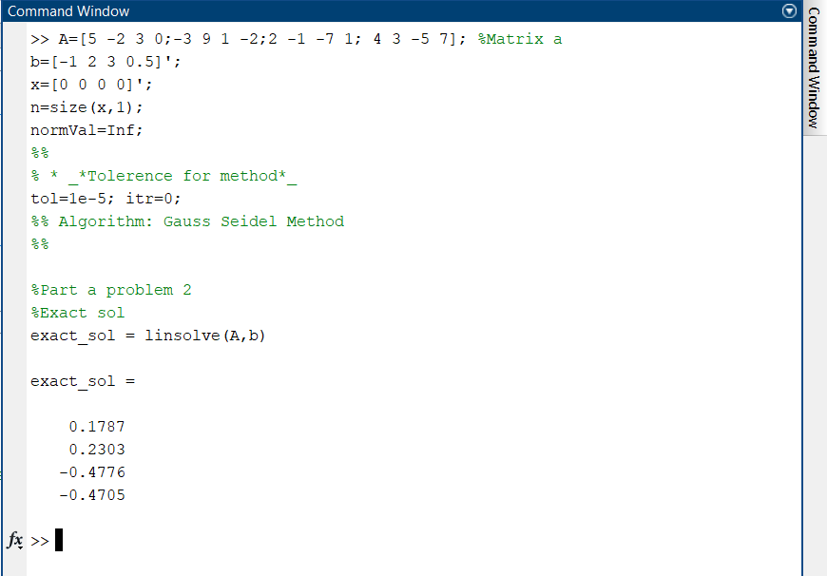

b.

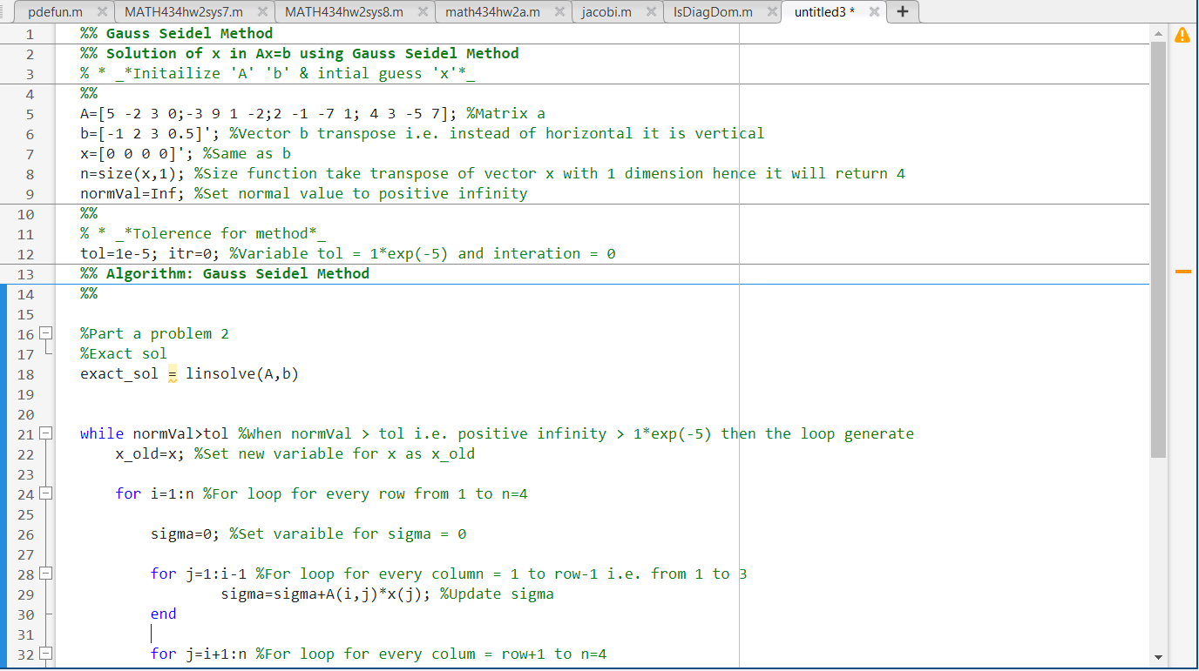

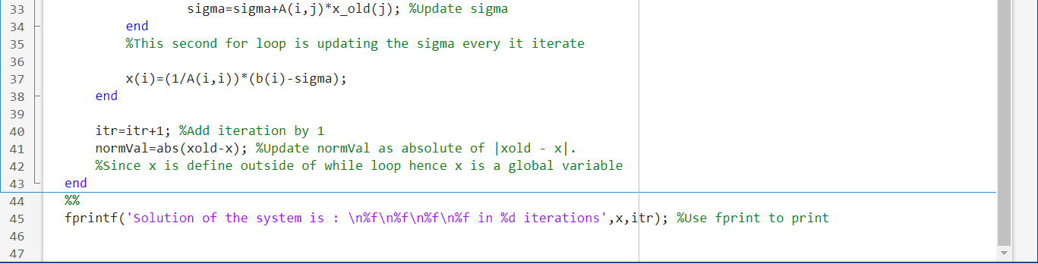

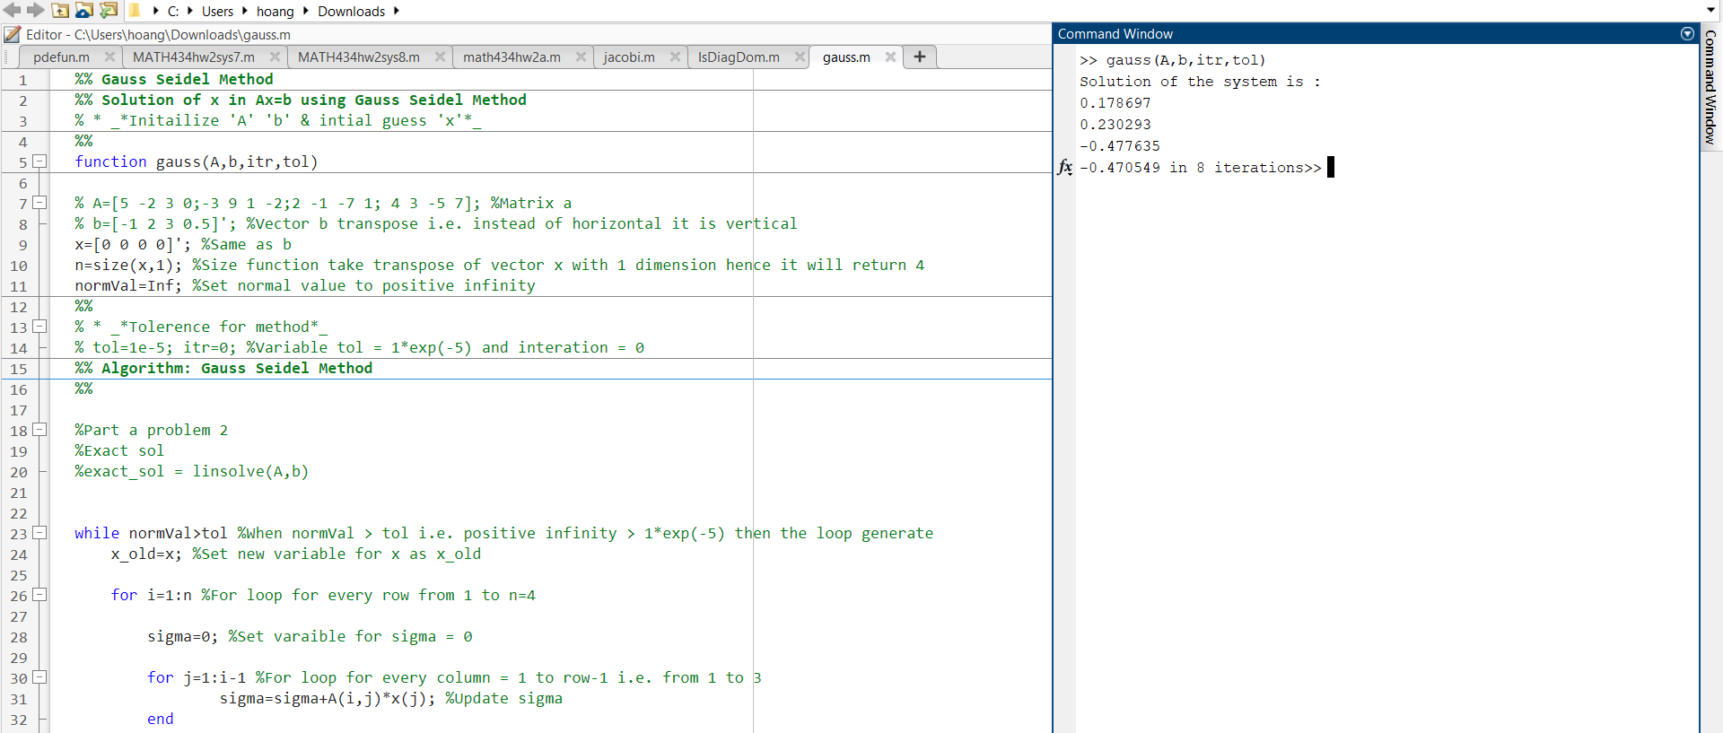c.

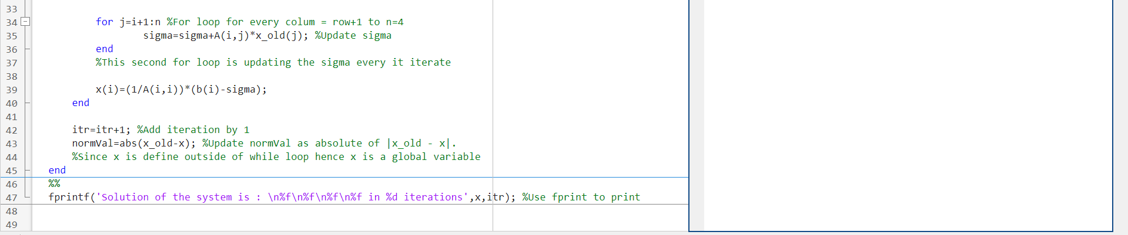

d.

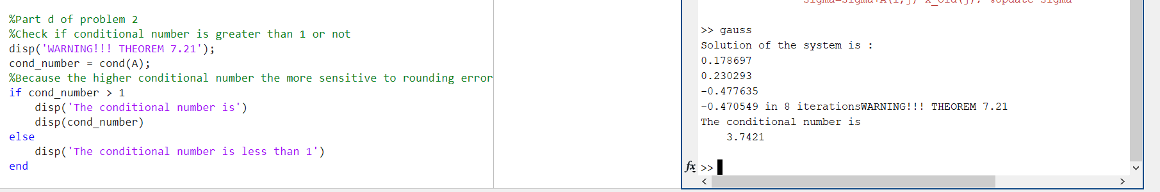

e.

I tried to code this but it not working. This is what I have from matworks

<https://www.mathworks.com/matlabcentral/answers/511902-making-a-matrix-strictly-diagonally-dominant>

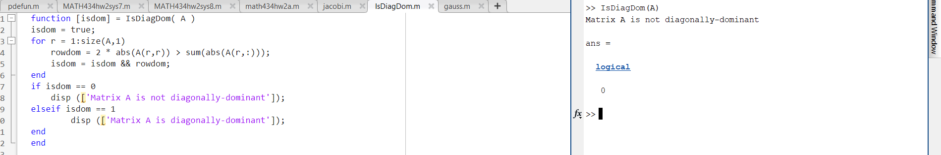

h.

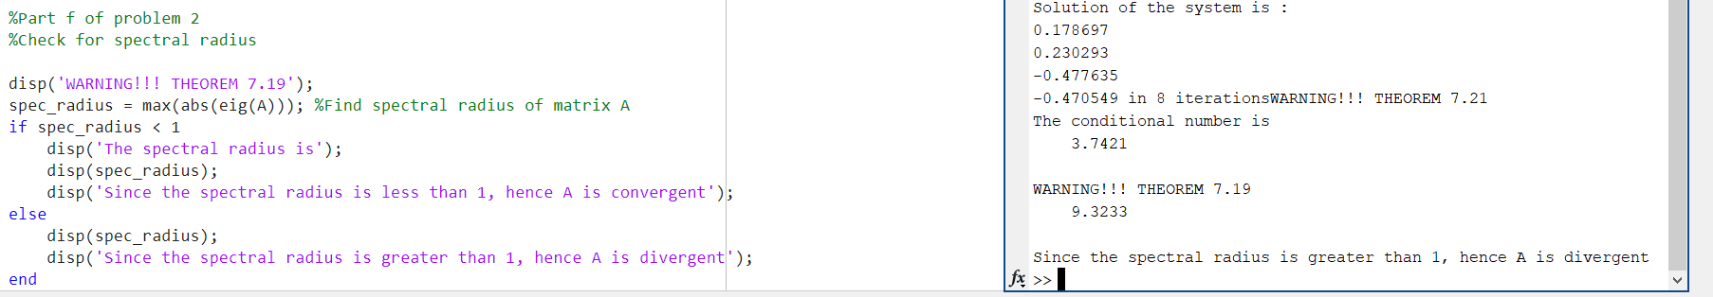

g.

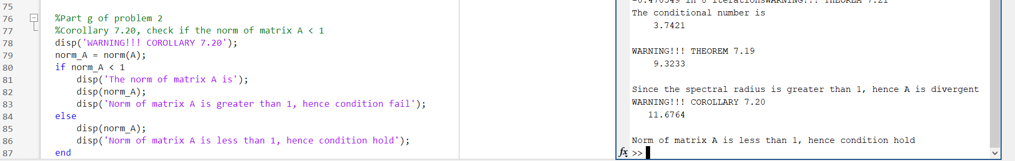

f.

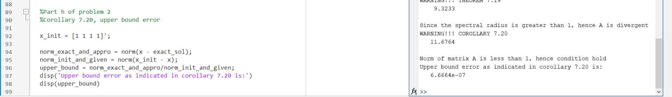

3.

a. Based on the observations, as long as w increase the answer become smaller and larger to infinity. When w = 1.2, it is 10^36 and when w = 1.8, it is 10^93.

b.

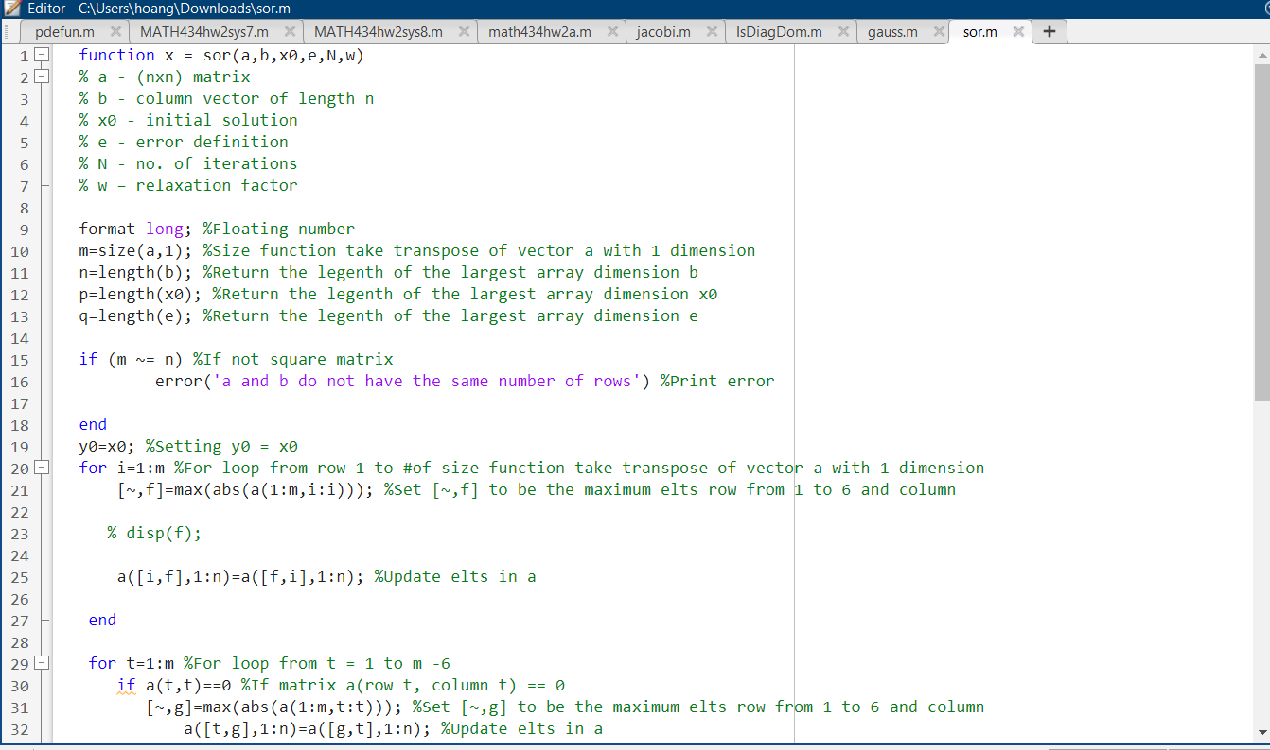

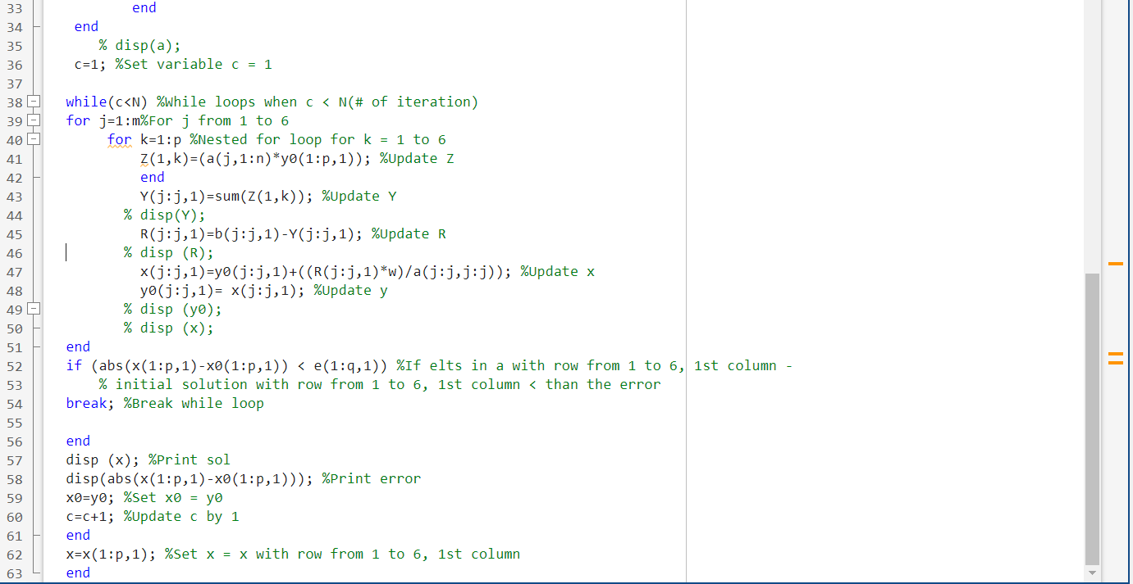

c.

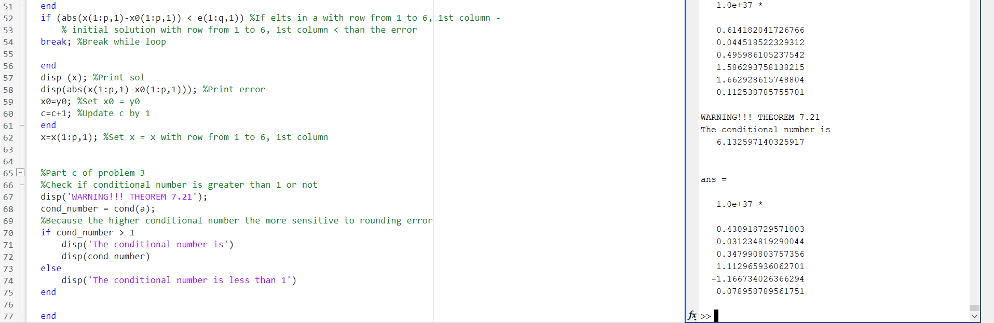

d.

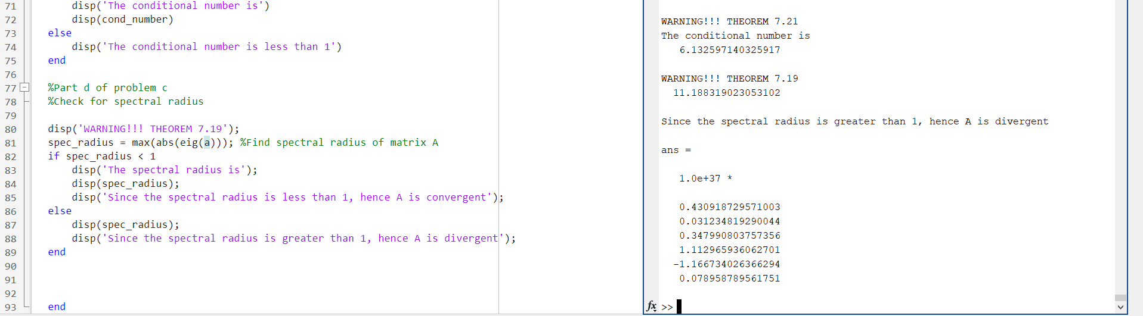

e.

The smaller the spectral radius implies that the |relaxation factor – 1|. Relaxation factor larger which accelerate the speed of convergence (Based on Stein-Rosenberg theorem i).

g.

