Michael Dang – 16257750

MATH434

Lab4

1.

a.

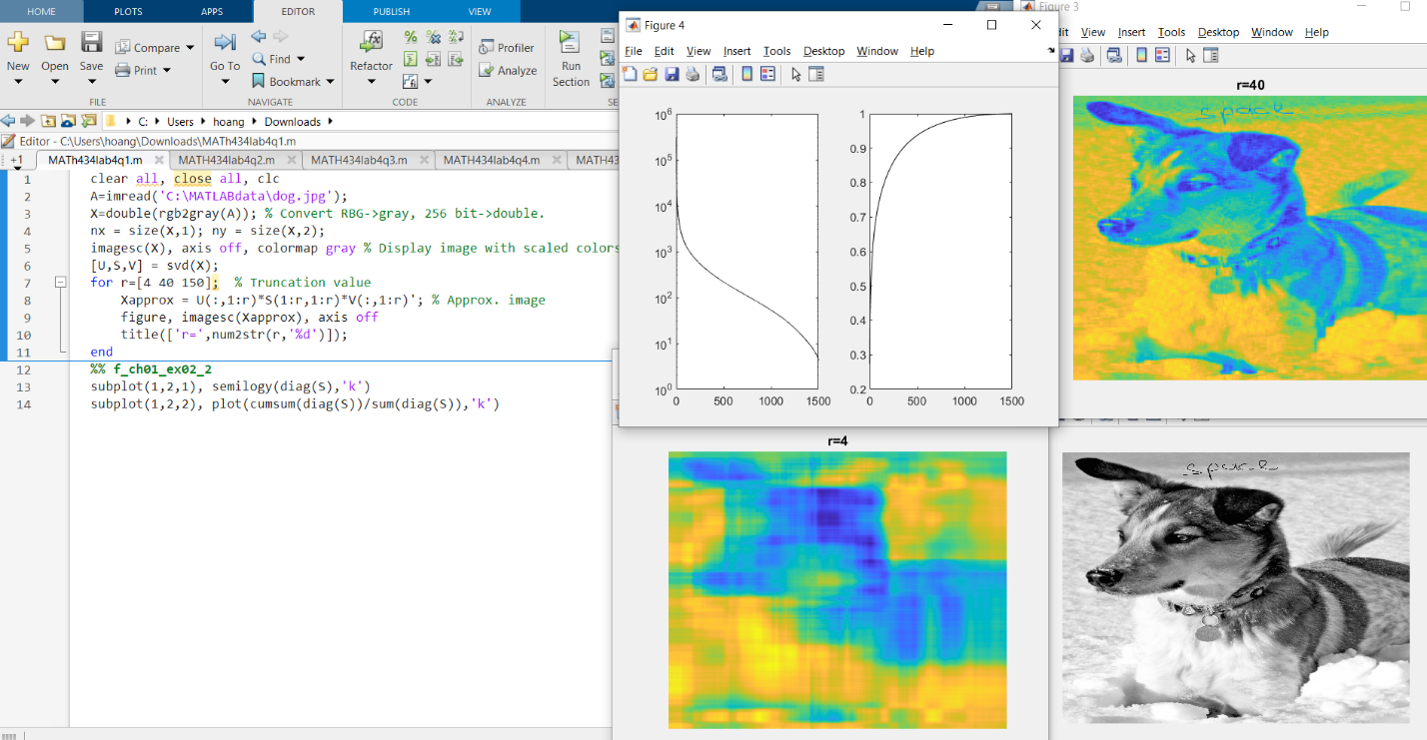

b.

The smallest r value when the five-letter word is readable is 40.

c.

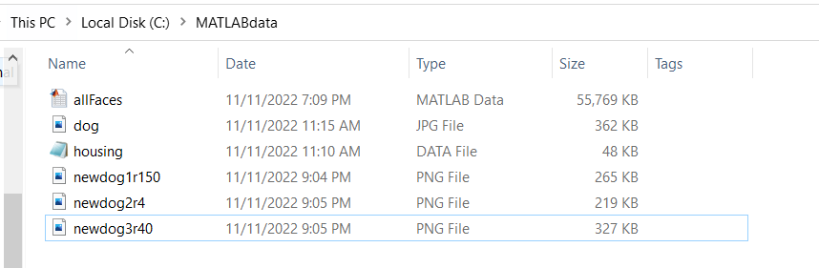

d.

The new images look pretty much the same as the original beside the size is reducing.

e.

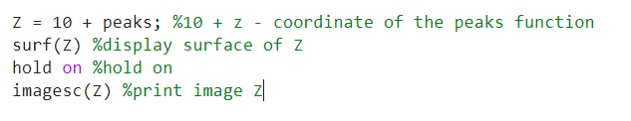

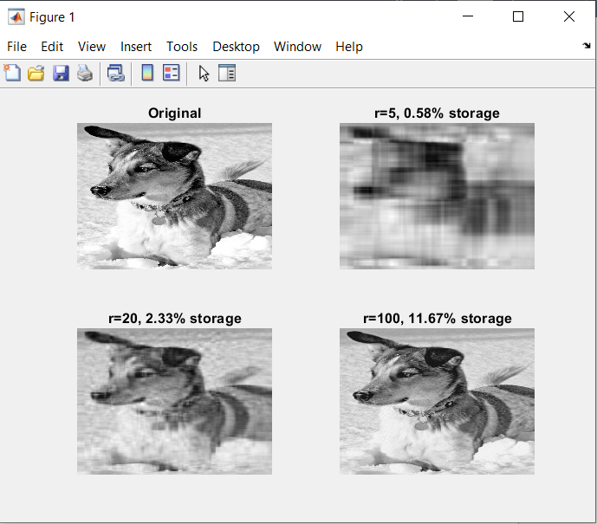2.

Original: original image of the dog.

r = 5, 0.58% storage: using 5 SVD, only capture 0.58% of variance, hence image is blurry.

r = 20, 2.33% storage: using 20 SVD, capture 2.33% of variance, hence image still blurry but can see it is a dog.

r = 100, 11.67% storage: using 100 SVD, capture 11.67% of variance, the image is clear but not clear as the original. With only 11.67% of data, the original image can be decomposed and saving more storage which lower the cost.

3.

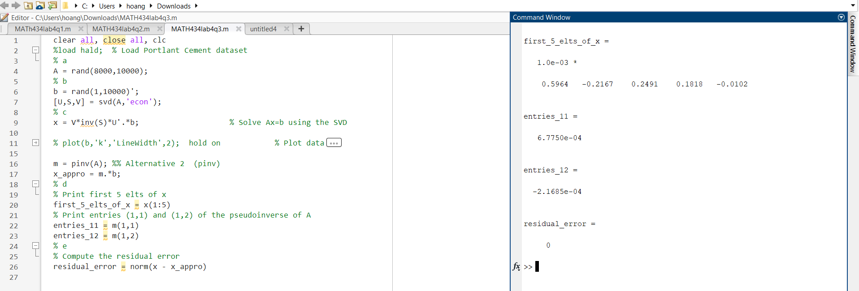

My laptop takes 4min to compute this data. I’m not sure if the residual error is correct.

4.

It provides 2 model of multiple regression. The left is unsorted data and the right sorted by home value. The 2nd figure showing significance of factors contribute to the regression.

Method have been implemented in the following code is multiple regression.

5.

It provides a model of noisy cloud of data.

Method have been implemented in the following code is PCA. It generates that the first 3 standard deviation ellipsoids (red) and 2 SV vectors (green). It captures most of the data.

Nice code!

6.

It provides 2 figures. Figure 1 is the singular values and figure 2 is the clustering of samples that are normal and those that have cancer in the first three principal component coordinates.

Method have been implemented in the following code is SVD and PCA.

7.

a.

It generates 64 different images of a face under different light conditions.

b.

Method have been implemented in the following code is SVD and PCA, where U are the eigenfaces. It generates 64 different images of a face under different light conditions. i.e., a large column vector with 192 x 168 = 32256 elts.

c.

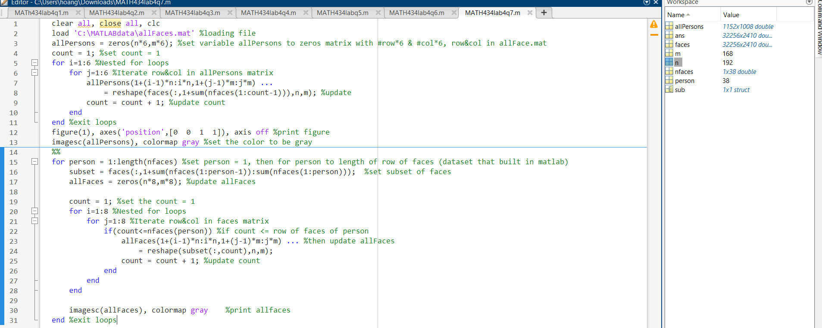

8.

a.

Figure x value from -2500 to 500 and y value from -4000 to 4000 with red rectangle and black diamond

b.

Projection of all images from two individuals onto the 5th and 6th PCA modes. Project images of the first individual are indicated with black diamond, and projected images of the second individual are indicated with red triangles.

9.

a.

Figure a, show the underlying low-rank signal. Figure b, show the signal with noise. Figure c, truncate using optimal hard threshold. Figure d, truncate using 90% energy criterion.

b.

Method have been implemented in the following code is truncation when using SVD.

10.

a.

Figure a, show the data consisting of ones with a squares sub-block of zeros. Figure c, show its SVD spectrum. Figure b, show if rotate the image by 10 degrees. Figure d, the SVD spectrum becomes significantly more complex.

b.

Method have been implemented in the following code is alignment when using SVD.